# Lecture 1 – 5/6/21: Data Structures and Algorithm Analysis

* Dr. Gou has worked in the car industry and has developed vehicle to vehicle networking protocols and communication systems
* We will learn how to analyze and assess the time complexity and memory usage of a program before it even runs or even written
* I can use c++ to do my hw and projects
* 2hr midterm exam, open book, open note
* Projects I can turn in up to 3 days late with 10% penalty each day
  + Hw cannot be turned in late
* ADTs – Abstract Data Types
* Algorithms – time and space complexity analysis
* CIS 405: Course goes more in depth with algorithm analysis and design – an extension of this section of 350
* Generic programming
  + Reusability of code and its components
* Selection Problem
  + 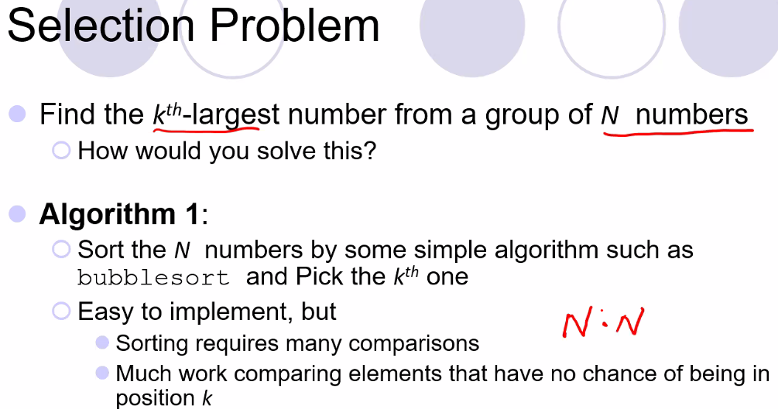
    - Above, N^2 time complexity for solving the problem, so for sorting N = 1 billion, then it would be up to 2billion executions which is a lot; we need a more efficient algorithm to solve the problem
    - 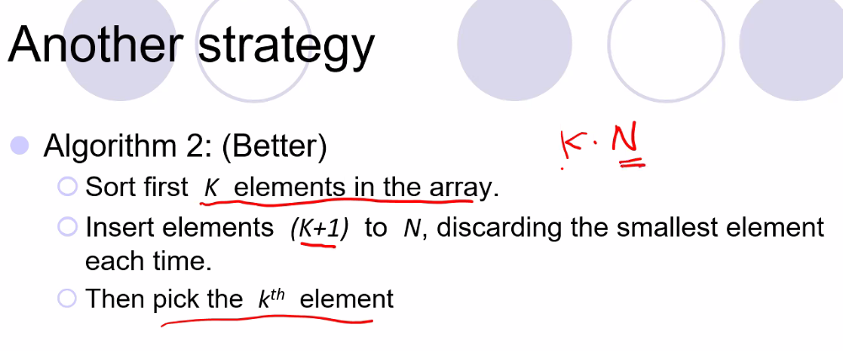
      * Above, is a better approach, but this will still face a large runtime execution value if k is large (and N is large); so if N is large, but k is small, it is still better, but if k and N are large you can still end up with a scenario of up to N^2 or less but still a very large value
    - 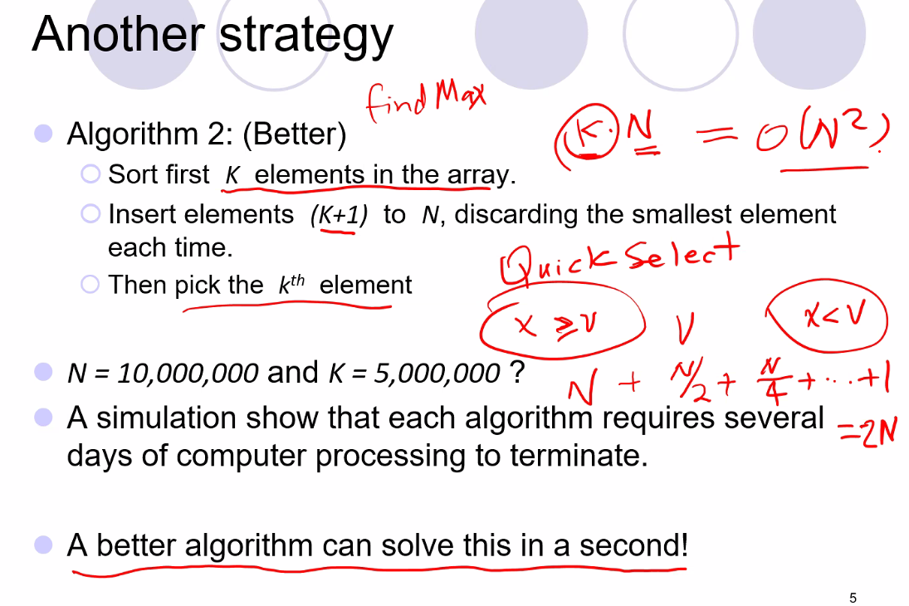
      * Quick select is the best algorithm that can solve it in a second!
      * This will allow you to roughly only do half the number of comparisons as you only have to compare between two groups, with one group larger than the other
      * So, the complexity becomes N + N/2 + N/4 … +1 = 2N 🡪 on **average**.
      * Moral of story: don’t write an algorithm that just works, but one that is the most efficient
      * One idea for picking v: take a sample of the N elements, say 10 sample values, add them together and take the average and set v equal to that number
        + Worse case is that the two groups are largely unequal and the kth value is larger than the smaller group, and you still may have to search a very large group of elements
  + Word puzzle problem
    - 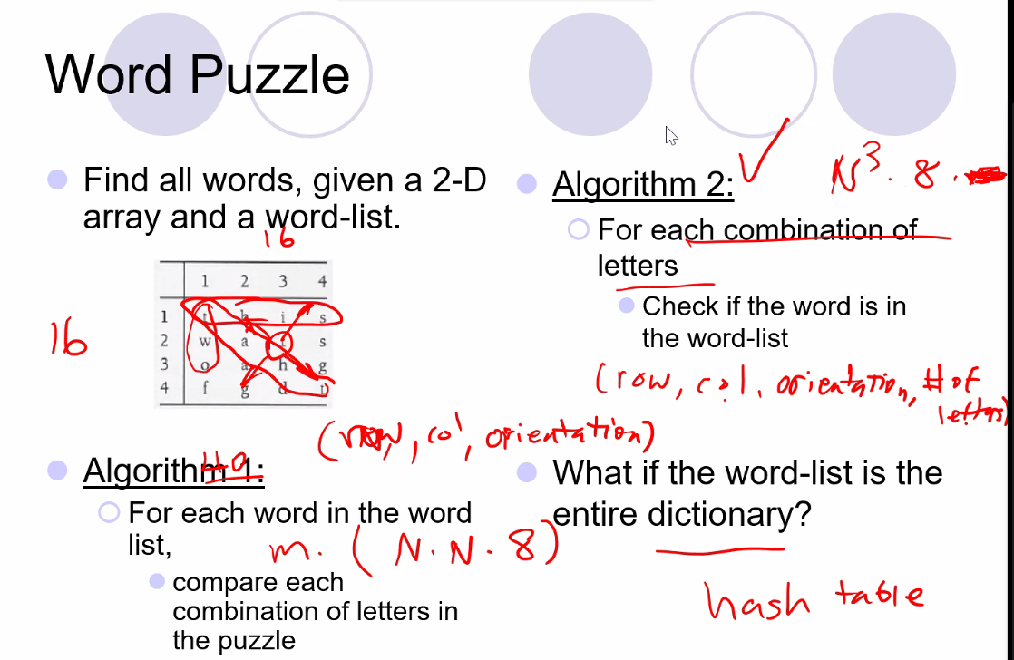
    - One strategy is to use a hash table for very large dictionaries, which can solve the problem in constant time no matter size
    - Orientation above in the example refers to each direction you can move in from a letter (up, down, left, right, and the 4 diagonal directions)
* Recursion
  + 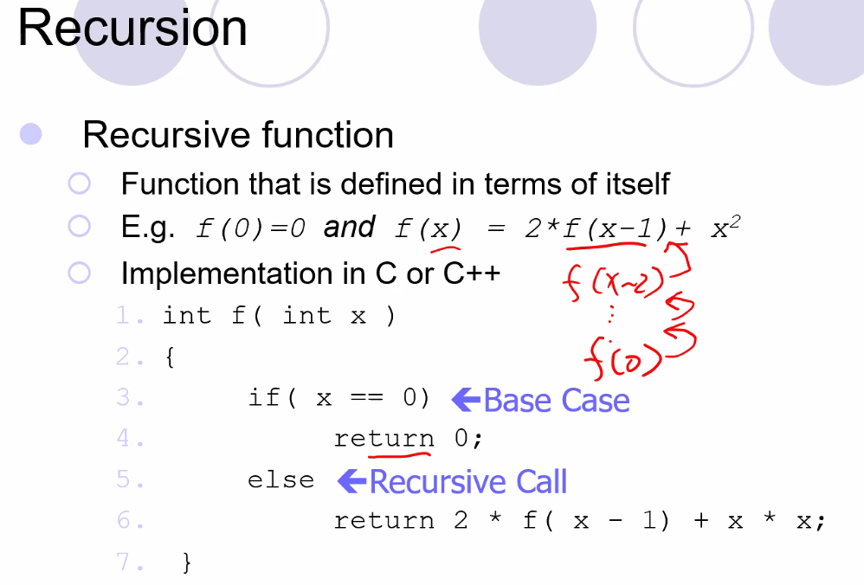
  + 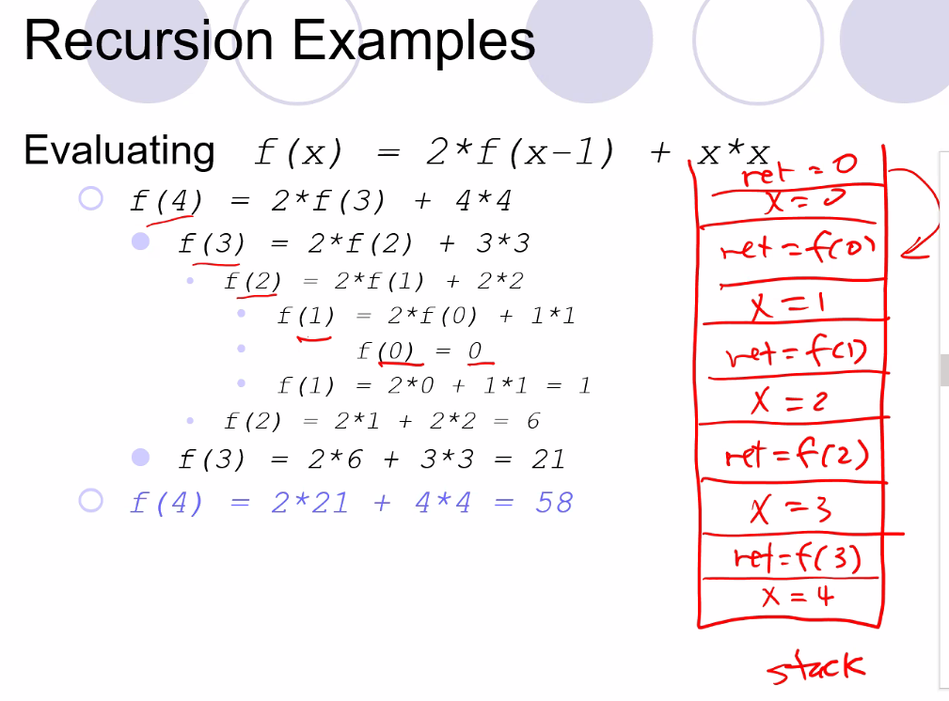
    - Recursive call grows the stack and thus can use a lot of memory, and each call will create its own set of the local variables of the function on the stack
  + Always make sure a recursive function has a base case and that no matter what it will in fact terminate (reach the base case) at some point
    - Make sure also that each recursive call is making progress towards the base case
    - Make sure to heed the Compound Interest Rule: never duplicate work by making same recursive call twice
    - 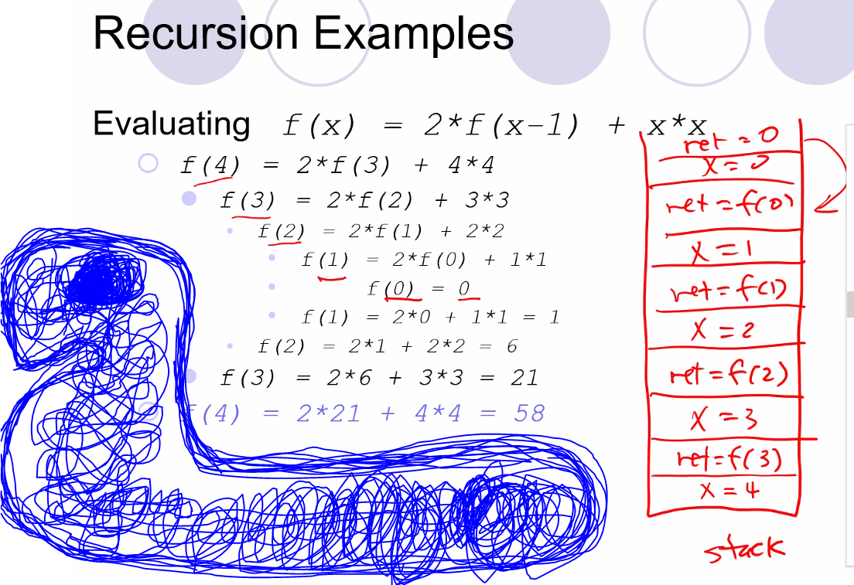
  + Fibonacci sequence problem to show compound interest rule that will cause a function to grow exponentially on the stack or runtime executions
    - 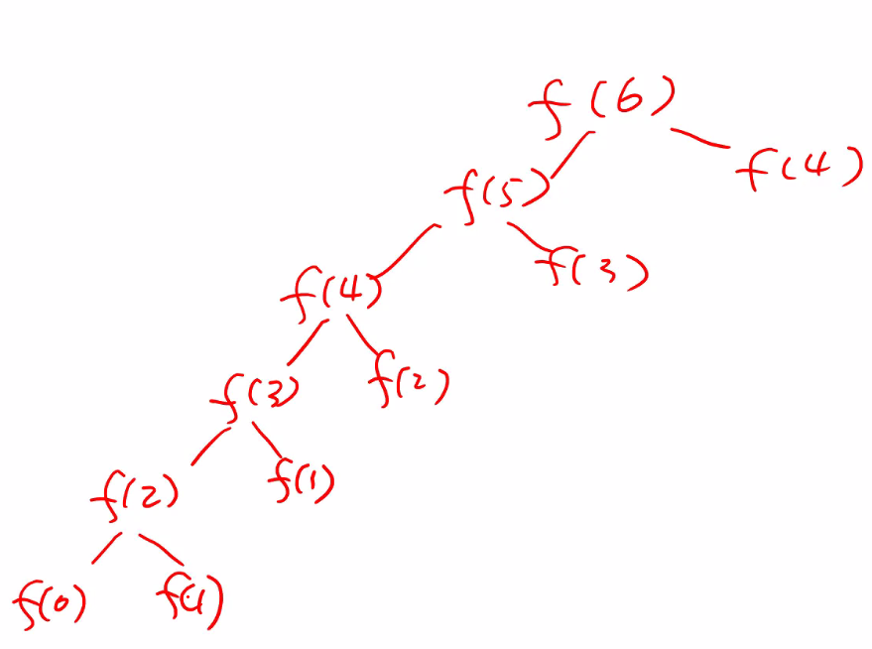
    - 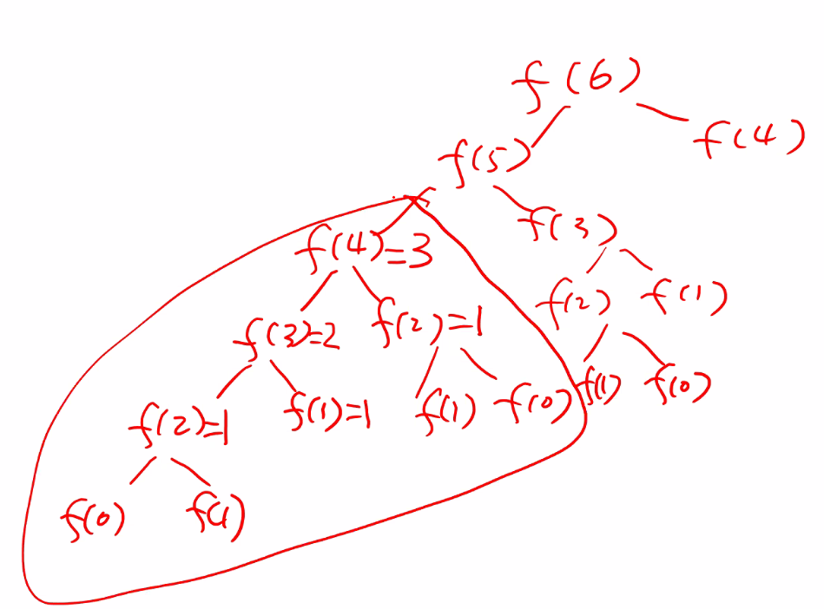
    - Above, we have to recompute many values, including f(4) because the values move off the stack, thus:
    - 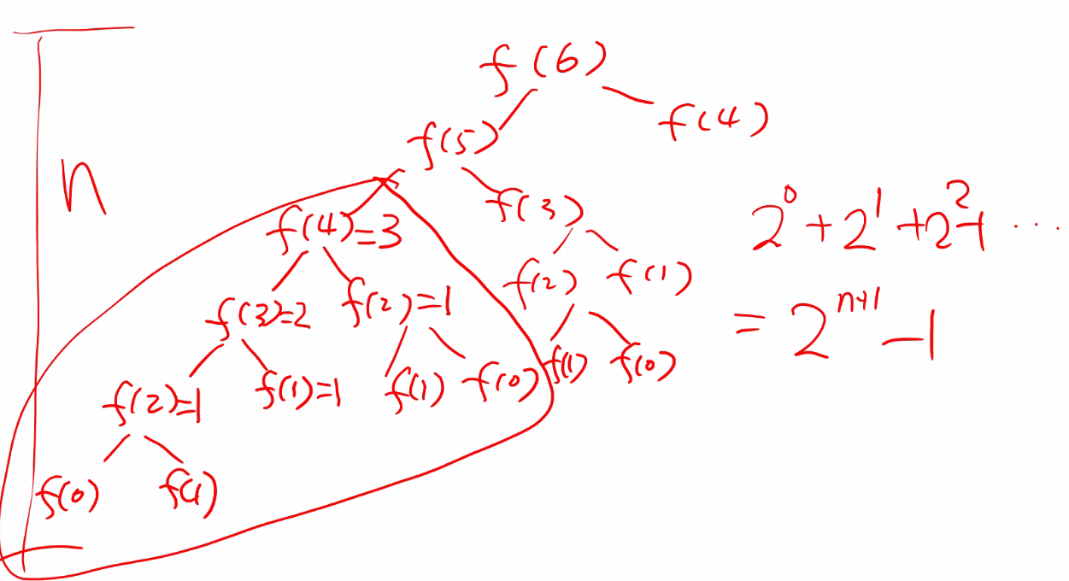
      * Time complexity is: 2^(n+1) -1 ; which is terribly inefficient and would use large memory; it is because we have to repeat a lot of work
    - So, to make a better way to solve f(x) Fibonacci function, save all values that are solved in an array so we don’t have to repeat work when we are solving for the next value to add:
      * 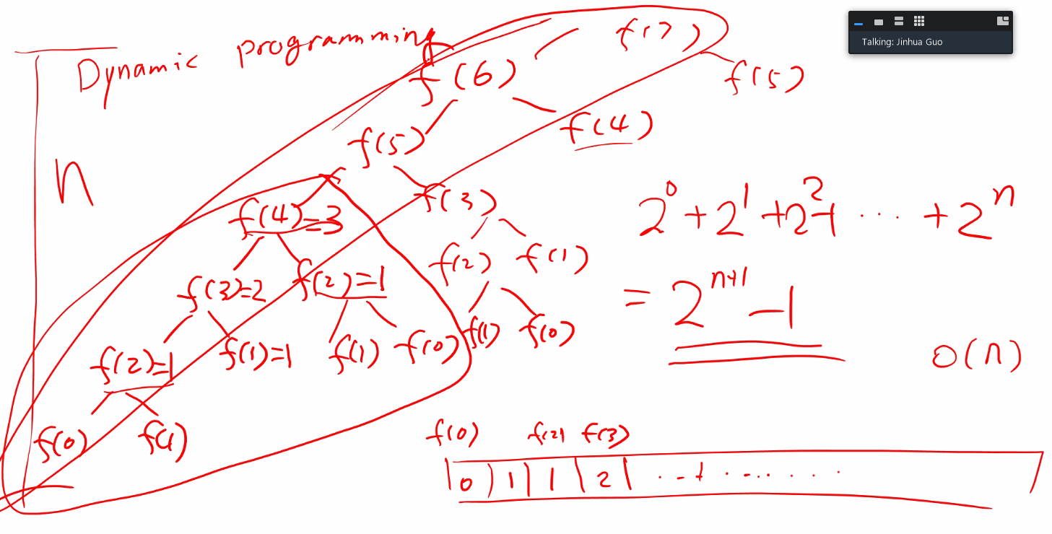
      * Using an array, we save ourselves the redundant work; still using N memory, but still saving a lot in comparison; also make sure you go from bottom up: we need to remember the bottom up approach because we first need to remember the smaller values ( f(0)..f(1)…etc) before we solve the higher values (f(8)…f(20)…etc.)
* C++ review
  + Explicit constructors
    - Use keyword **explicit**: Avoids automatic type conversion (and resulting bugs); so if you input a char when the function parameter is an int – even though char is really an int, it will not do the automatic type conversion
      * 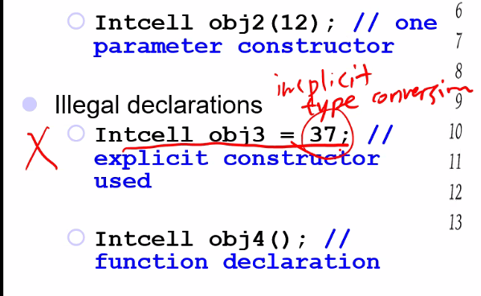
  + 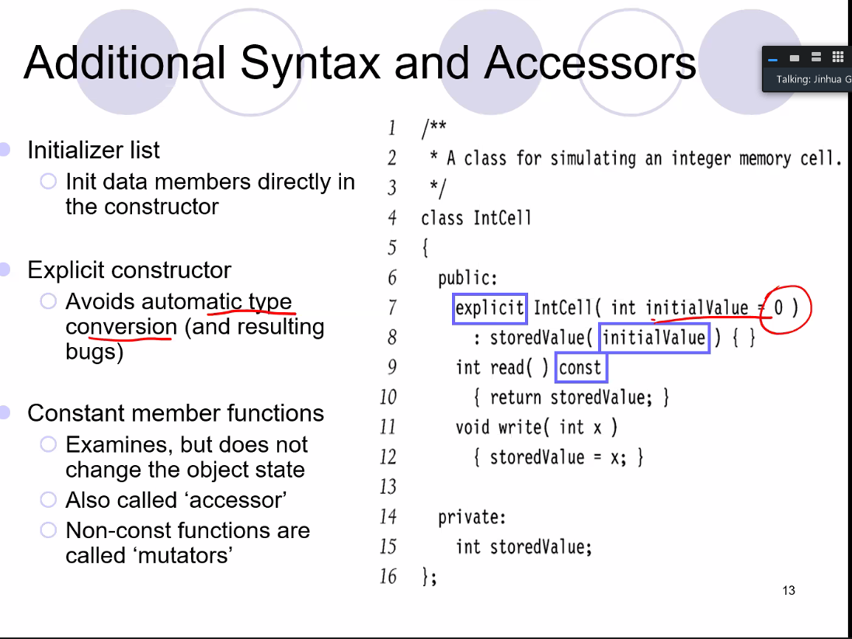
  + Remember: default parameters are only specified in the interface (.h file) not in the implementation file (.cpp)
  + Remember vectors are arrays; but they use extra memory in its protocols so that when you increase its size/add an element, there is already memory allocated; it does this to try to avoid having to reallocate the entire array in the background when a new element is added (popped on the end) or if a few elements are deleted it may decide to not delete and reallocate the entire array
    - This is will be on our first project
  + Remember, pointers store the address of a memory location of another object (variable..etc)
    - They store the address, which can be 32-bits or 64-bits depending on the system architecture/application type
  + 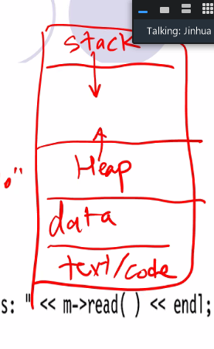
    - Above: the structure of the program in memory; the stack and heap are flexible (they grow and shrink during runtime): dynamically allocating memory with the new operator allocates memory in the heap, stack is used to hold functions in memory, and other variables including pointers; so you might have a pointer in the stack, and when you allocate memory (and set the pointer equal to the address of the dynamically allocated memory) on the heap, the pointer which is on the stack points to that dynamically allocated memory on the heap;
      * function parameters and local variables are stored in stack; dynamically allocated memory stored on the heap
      * remember in c++: we must manually delete the dynamically allocated memory in the heap: every new must be followed by a delete at some point in the program
        + for local variables of functions, they are stored on the stack, and are automatically deleted when the function exits (unless of course we use the keyword ‘static’; thus an implicit delete is called and memory is automatically reallocated for use)
    - Java does GC (garbage collection) automatically thus it ensures no memory leaks (allocated memory in the heap is no longer pointed to by any pointer variable); but the tradeoff is that the process is very costly operation

# Lecture 2 – 5/11/21: Data Structures and Algorithm Analysis

* Call by value: typically used for primitive data types (int, float, char, etc)
* Call by reference: need to change value of original argument of a created object
* Call by constant reference: pass in objects that are needed for some operation but that should not be changed
  + We avoid pass by value because of the memory cost of possibly very large object (in comparison to primitive data types)
* Return pass
  + 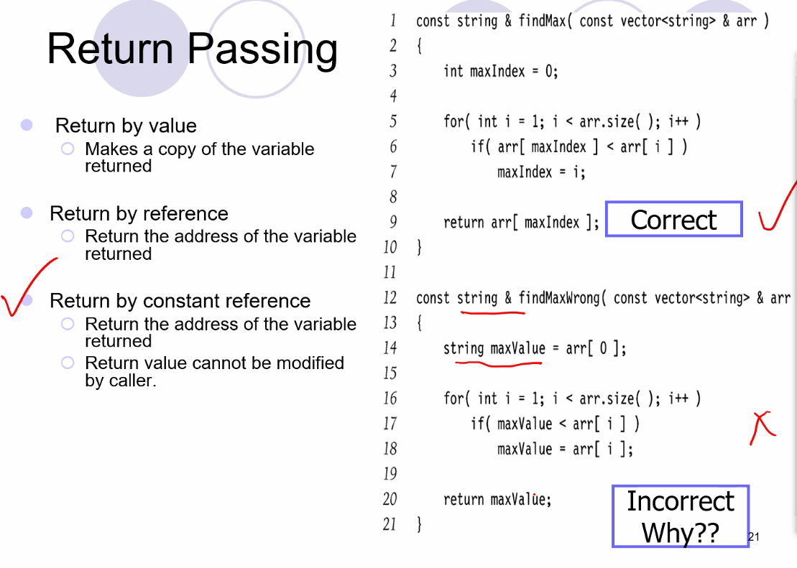
    - Above, it is incorrect because maxValue will be returned but maxValue will be destroyed as it is a local variable, and the function is supposed to return a const reference to a string; you cannot reference a memory location that has be deallocated/destroyed
    - For returning a constant reference: the address (reference) returned cannot be modified (the data cannot be modified at that address location) by the caller
* Reverence v pointers
  + Fundamental difference: for reference variable after you initialize it you are not allowed to modify it anymore; **reference variables = constant pointers.**
  + 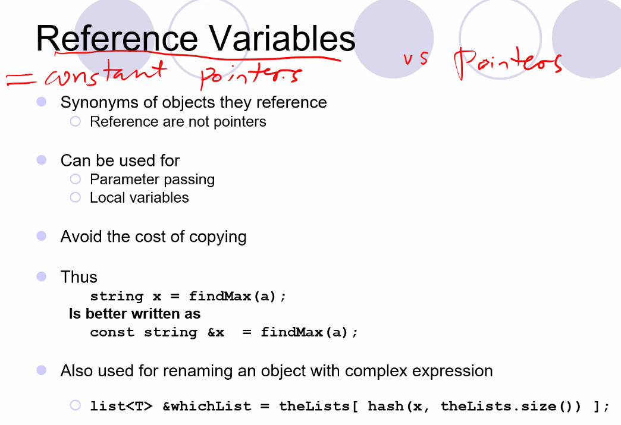
  + Reference variables provide an alias for constant pointer; they are usually used for return by reference and pass by reference; and remember they save the cost of copying!
  + Also remember for constant objects: they CANNOT BE MODIFIED AFTER THEYARE INITIZLIAZED and they must be initialized only once (at declaration)
* Remember you call the destructor to delete memory allocated in the heap using the new operator since the default destructor will not deallocated dynamically allocated memory
* 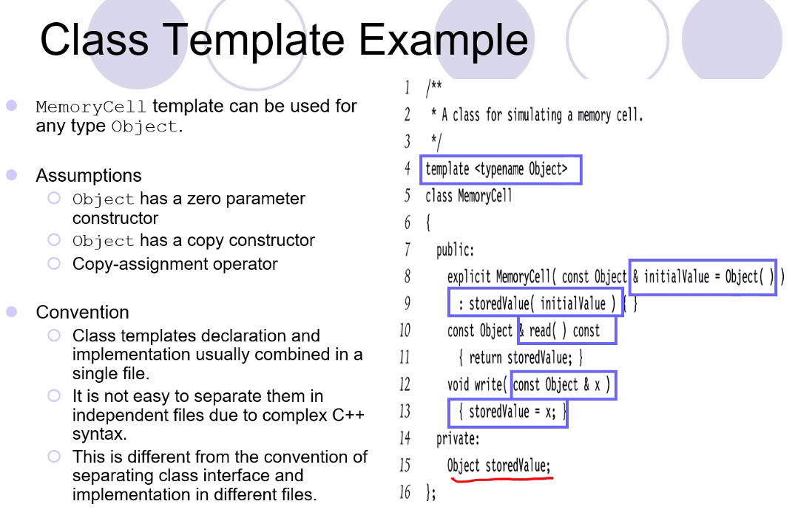
  + Above, this is what I discovered that when I include a class template in my code, I have to include the .cpp file for the class as well as the .h file (or only include the .cpp file) in my main file since template classes will actually create several classes based on how many types of that template is created
  + That’s why when you include the c++ vector class, you do #include<vector> and not #include<vector.h>
* 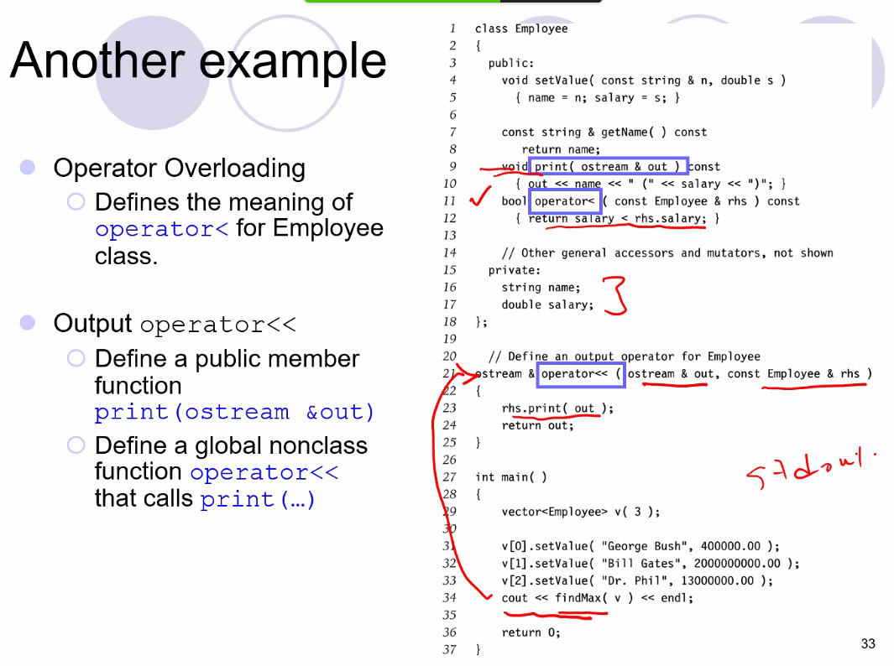
  + Above, notice since operator<< is defined globally, cout << findMax(v) function call will work since for Employee class there is a method (but a global one for this case) to output the class;
  + also findMax(v) will work since the operator< was also defined in the Employee class.
* Function Objects
  + Using a template, the following will allow a case-insensitive comparison: 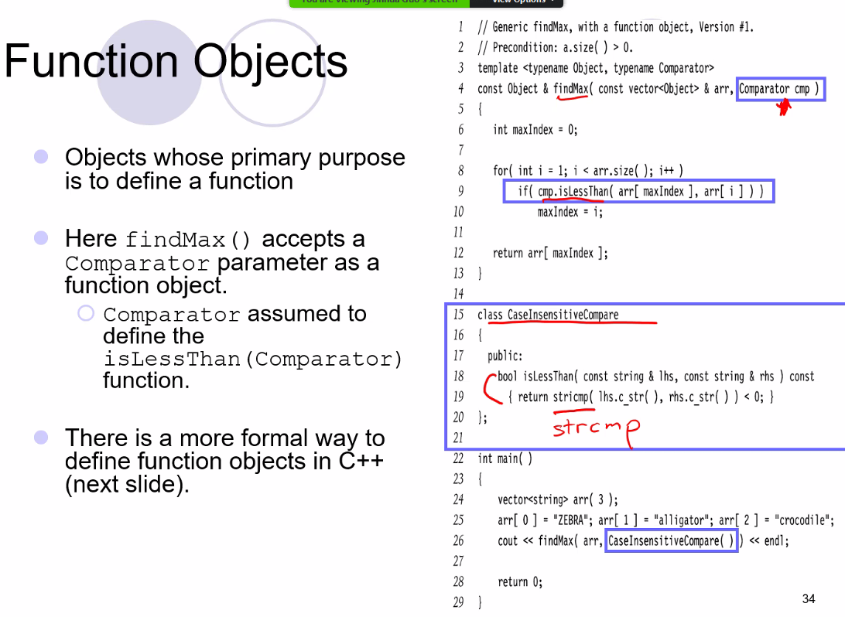
* Matrix class
  + 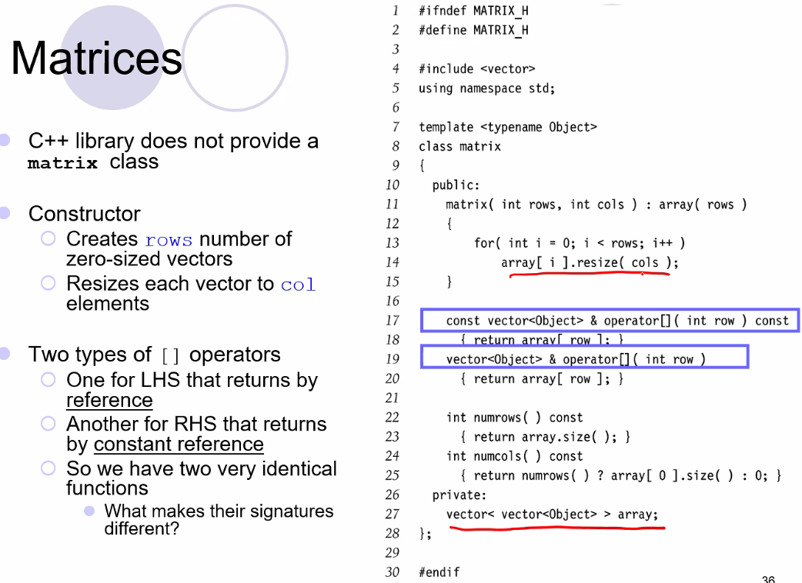
* C++ is the most complex upper-level language type of all the programming languages, so it takes more work to write programs but as a tradeoff you have more control over system hardware/memory thus you have more ability for resource optimization
* **New lecture: Abstract Data Types (ADTs), Iterators and Vector Implementation:**
* An iterator is the same as a pointer, but it is inside a container (stack, list, queue, vector, etc..)
* It is just like in CIS200 how we learned how to use the iterator (pointer) inside of a file and move the pointers sing ++ and – operators.
* Containers need a begin and a end functions that return a reference to the start and end (or after end of the structure)
* Data structures that support iterators are called containers
* Random access pointers in a container (such as n array) is the fastest for a CPU; it is best when a container supports this type of iterator (random access iterator)
* 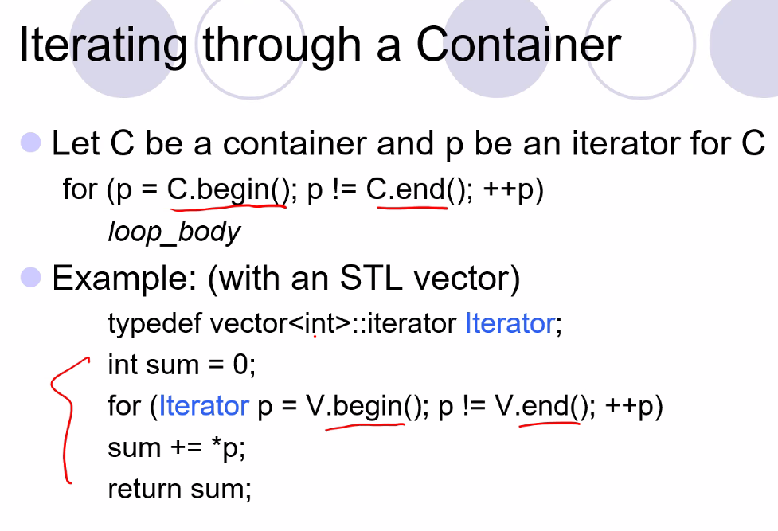
* Iterators support any container even ones that do not support indexes
* 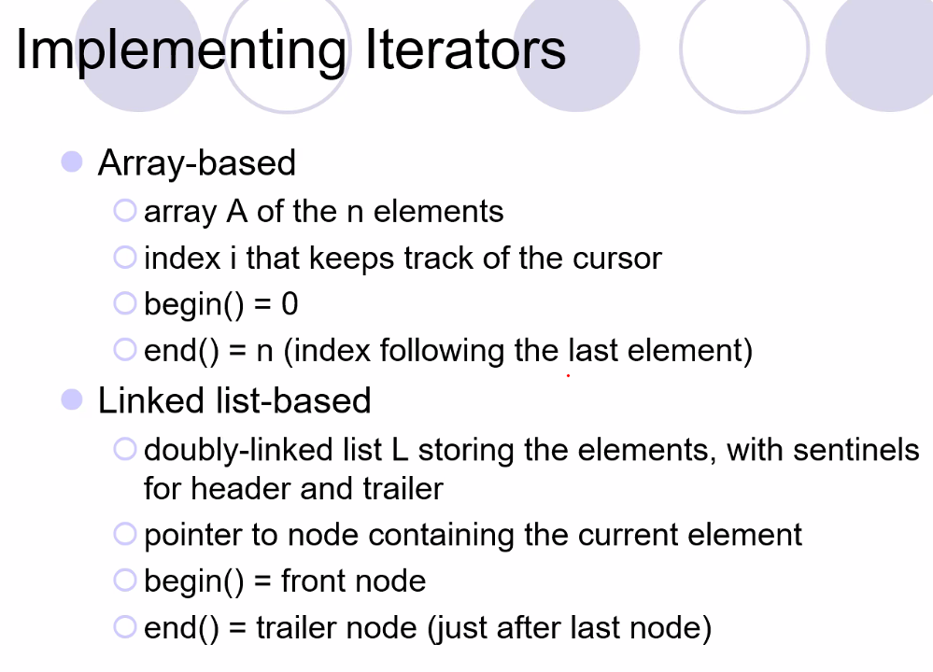
* STL = Standard Template Library
  + Iterator is a part of the STL class (library)
* 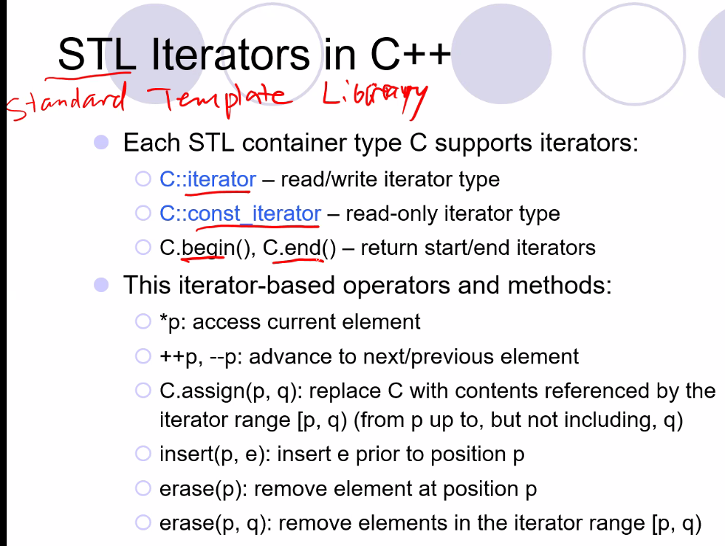
* For each container class: you need to implement the iterator functions
* 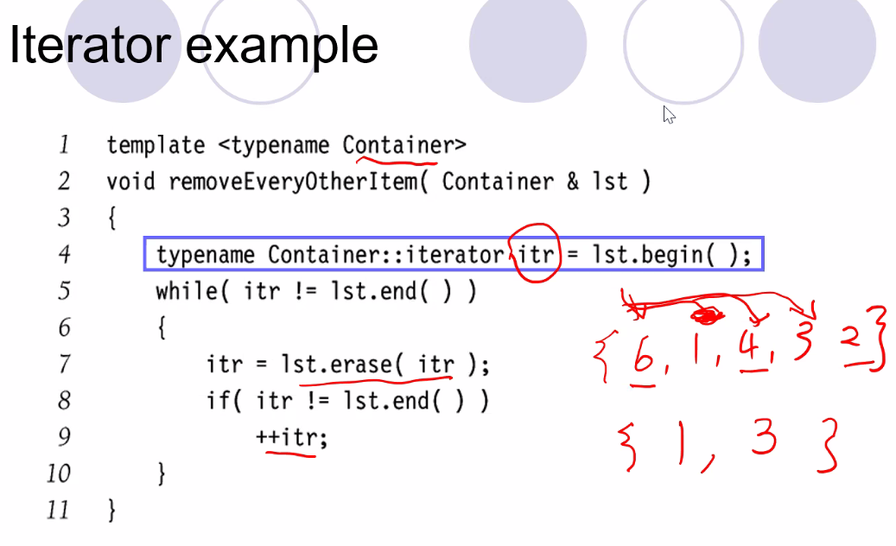
  + above, an iterator itr of scope Containor is declared and initialized as pointing to start of list lst
* why use iterators over pointers?:
  + 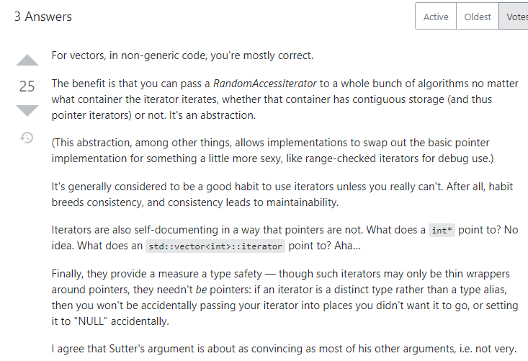
  + Other benefits of using iterators:
  + 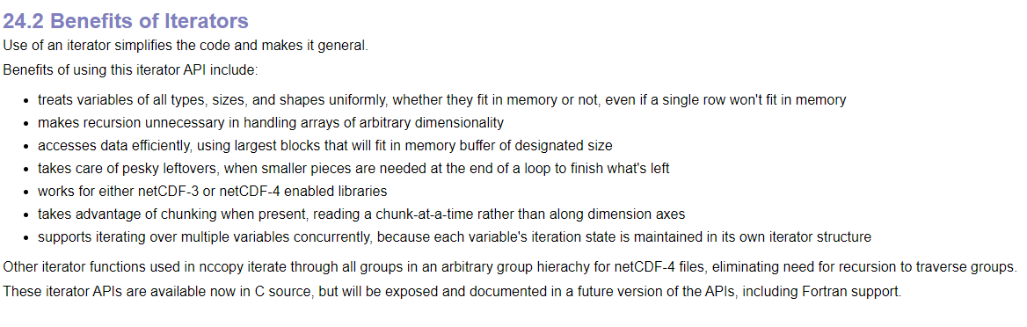
* constant iterators:
* 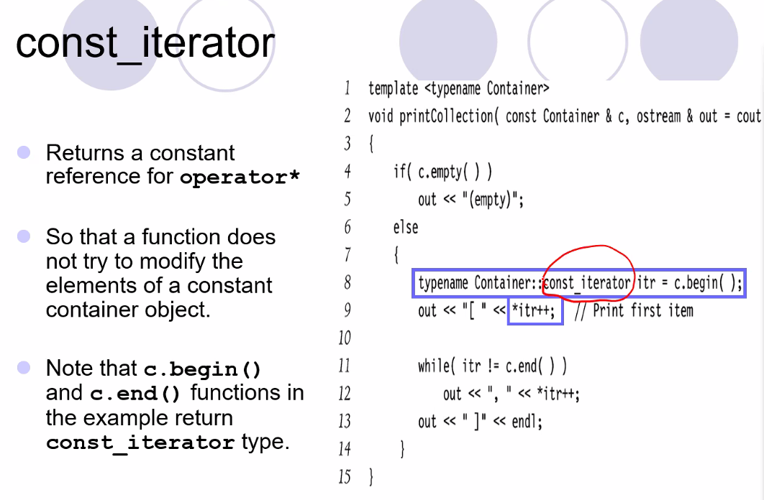
* Vector ADT
  + 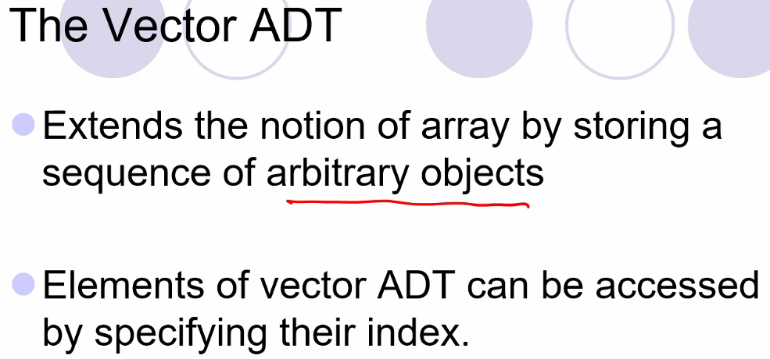
  + Remember adding objects to front of vectors is not supported because that operation is very expensive
  + 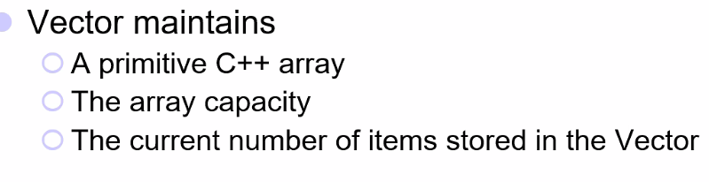

# Lecture 3 – 5/13/21: Vector ADT

* 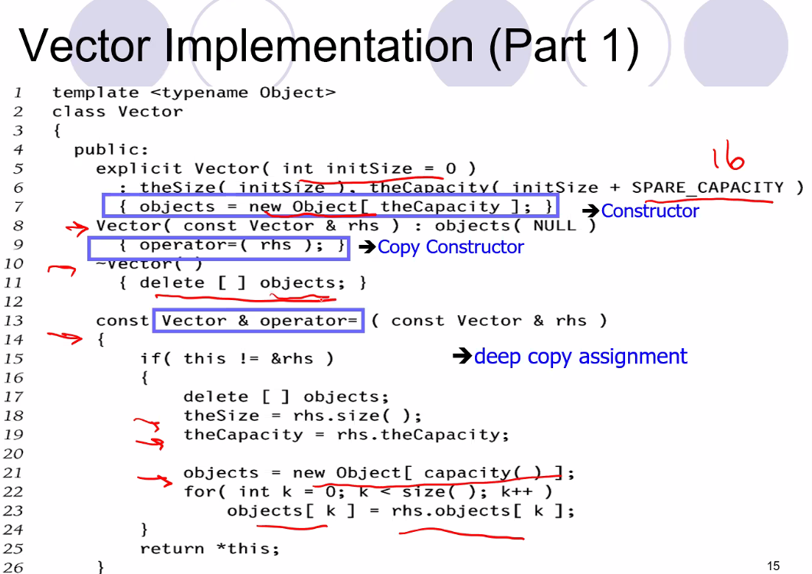
* Since memory allocation process can be so expensive with large arrays when performing copy operations or other operations that require the array to be resized and thus all elements copied to another array, vector class has a capacity of 2x the space needed to store the elements at initialization
* Remember for popback, no need to delete last object in the vector since we allocated an array, so simply change the pointer, no need to delete and also because if you push back onto the vector you will needed that allocated space
* For program 1 we can mostly imitate vector class
  + Similar to vector class, but our vector will always sort the elements in nondecreasing order (increasing order: smallest to greatest):
  + 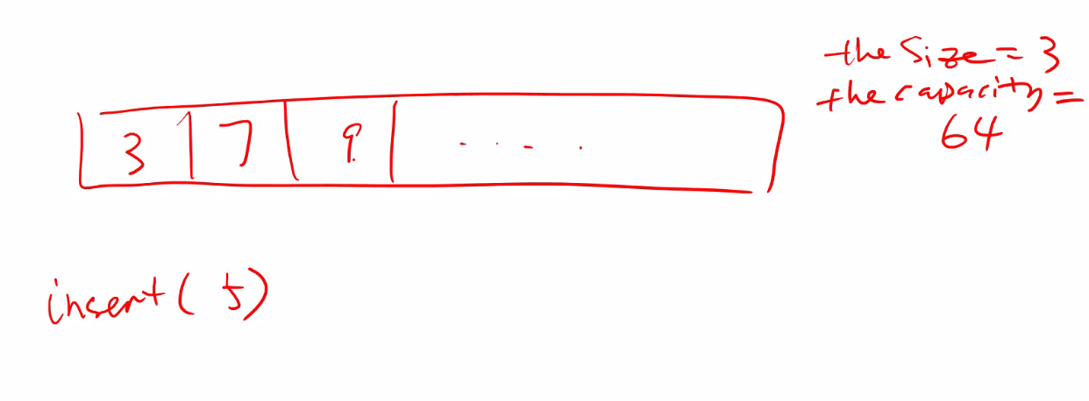
  + 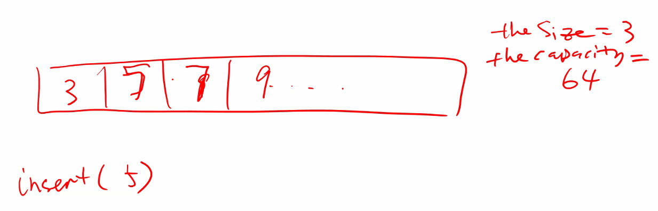
  + We are not allowed .h file; we have to use the skeleton he provided for us in the .h and .cpp file
  + When dealing with template classes, notice where he includes a .cpp class; he included the .cpp file at the end of the header file; but remember I found out that with templates since classes are dynamically generated based on instances declared of the template class; so it is no different than when I included the header, and then the cpp file of my template class in my other programs, also I could put the cpp in the header file; it is exactly the same as compiling the h file, the seeing the next include for the cpp file whether it be in main or in the .h file, the it compiles those files
  + Make sure to do additional testing outside of the main file he provided for testing the program
  + Describe problem = describe functions
  + Need additional test cases: at least test each method; make sure they work, or we will lose points
* Lists, stacks, and queues (linear structures)
  + Iterators is essentially a c++ implementation of a nodepointer class that can point to various data structures and iterate through them
    - An iterator has a begin, end, and current position
  + with lists, using linked lists, you can insert at any position including the front of the list
    - however arrays are still preferred over linked lists whenever possible because CPUs can process contiguous blocks of memory most efficiently and you don’t need the extra storage space for storing nodes like with linked lists
  + stacks and queues are known as adaptors
  + with stacks: you are only allowed to operate on the top of the stack: for adding elements and removing elements; it is more restrictive than the list or vectors but it has that structure on purpose
    - this allows to avoid unnecessary errors for a particular application
    - remember stack is how programs work too when loading into memory to be executed; and offset positions on the stack are operated on (such as moving to next line on the stack, or jumping to a particular byte on the stack..etc)
    - a stack is also how a program reads and evaluates expressions with brackets and braces..compiler does syntax error check using a stack ADT with the bracket symbols being pushed and popped at top of stack
  + queue can be implemented as a vector or a list; likely a list since it is FIFO
  + queues are used for buffers (multicore CPUs, CPU data registers..etc.), breadth first search, simulations, producer-consumer problems
* **Algorithm Analysis** – how to estimate runtime of algorithms without implementation
* We can analyze runtime and space (space usage)
  + You might have an efficient algorithm with a fast runtime, but there may not be enough memory (space) to implement it depending on operations needing to be performed and the size of what is operated on
  + Also sometimes a small improvement that will not be noticeable or useful to the user may be unnecessary
  + We need to make sure we have best performance by analyzing:
    - Correctness
    - Maintainability (others can easily read and make changes to your code: there is an entire field for this = software engineering)
    - User friendly (GUI is most user friendly because it maps program operations graphically through a mouse and keyboard and a screen, CLI is mostly for professionals now); GUI is more advanced and intense to develop but the result is a much more user-friendly program
    - Security must be maintained
* 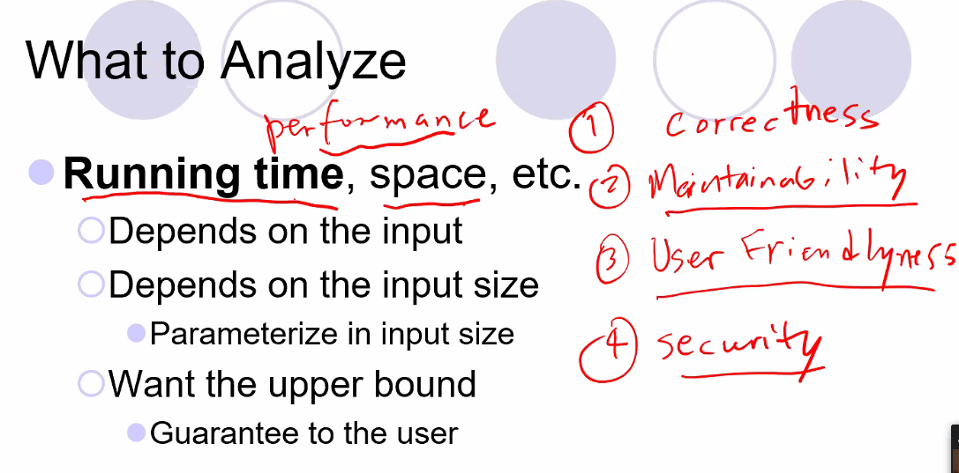
* Sometimes we can trade efficiency for the purpose of improving other aspects of the program such as user-friendliness
* Input refers to byte size of elements, and for example the status of the input (very random, partially sorted, already sorted?)
* Input size refers to size of the number of elements that will be operated on
* Sometimes worst case is very bad, but uncommon when compared to average case so we may still choose to implement a certain algorithm with those characteristics
* Note: if average case is a strong average, then likely best case happens often??
* Worst case depends also on the machine (what hardware is the program running on?)
* Asymptotic analysis: so if a hardware is much stronger than another, it can win, but as n🡪 infinity, the smaller hardware/less speedy hardware will beat the speedier hardware because of more efficient time complexity of an algorithm if it is faster on the smaller machine than running on the larger one; need n🡪 infinity otherwise hardware differences may make it appear that the speedier hardware runs the algorithm more efficiently when in reality it could just be because of its faster hardware which needs to be tested further (as n🡪 infinity) to see if will hold true
* 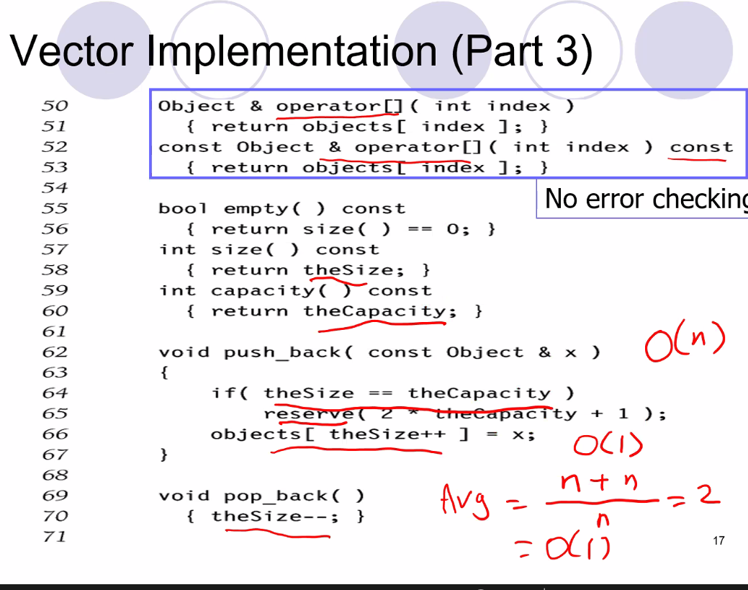
  + Above, demonstrating average case time complexity for vector class function push_back
  + Worst case is O(N), best case is O(1), average case is O(1)

# Lecture 4 – 5/18/21: Time Complexity analysis

* 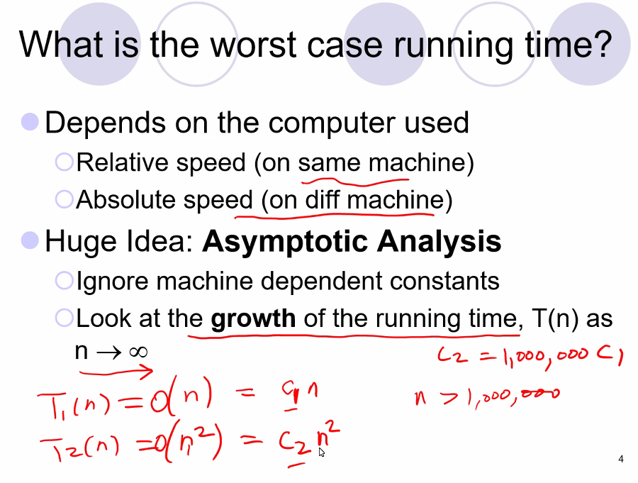
* Remember for asymptotic analysis we ignore constant multipliers and lower-order effects; pay attention to the highest power
  + Constants could refer to for example having more processors; more processors is simply improving speed with more CPU units but not necessarily a proper analysis of the actual algorithm growth when ignoring hardware advantages
* 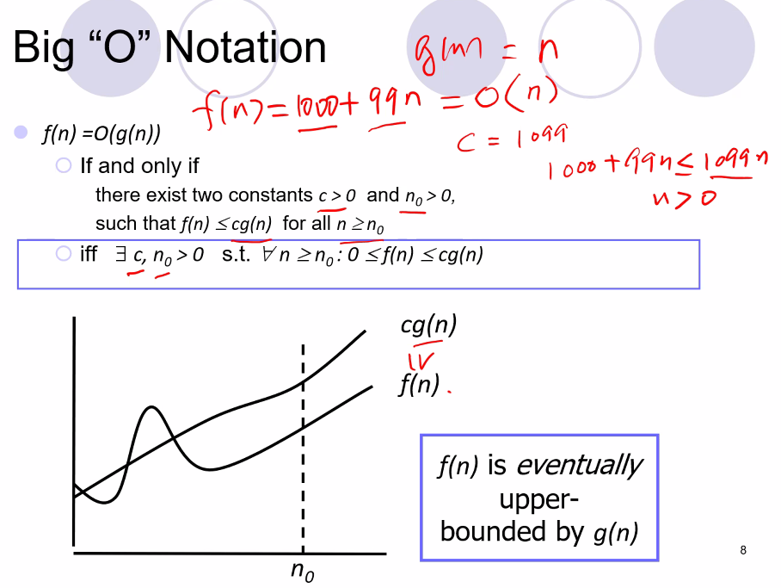
* 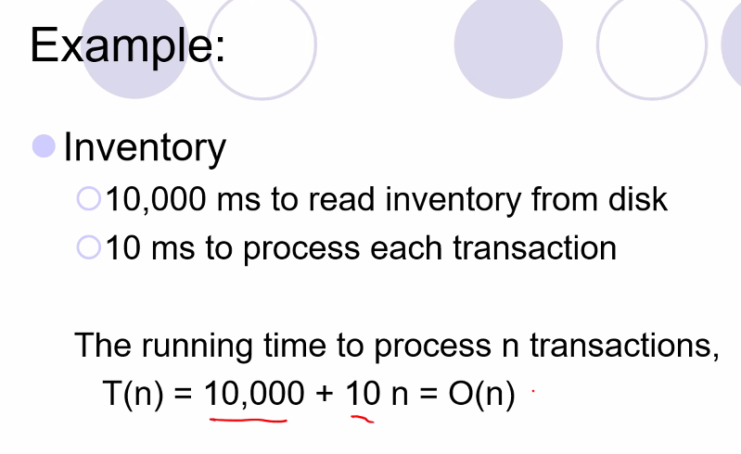
  + The constant and the constant factor could be scaled up or down because of hardware speeds, but as n approaches infinity then we get the upper bound and we understand that n is the important thing when assessing the time complexity of the algorithm independent of machine speeds
* 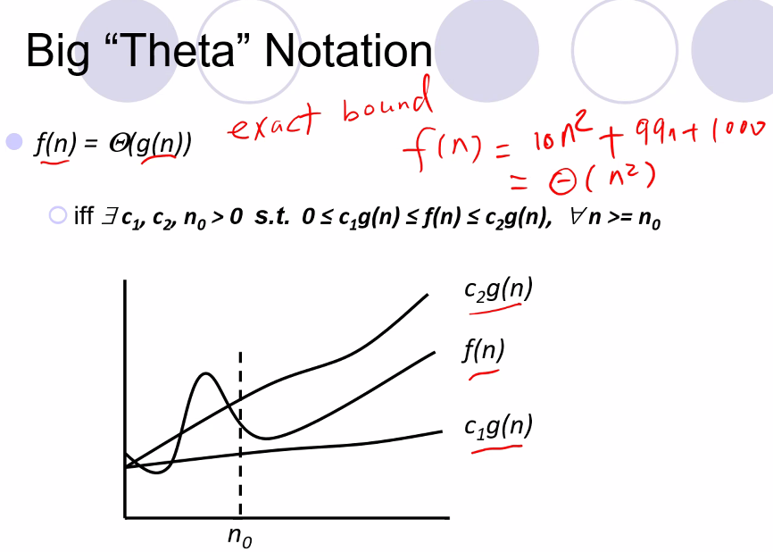
  + Above, also called exact bound
  + It is not always possible to find a big theta
* There is also big Omega notation where f(n) is bounded below cg(n)
* 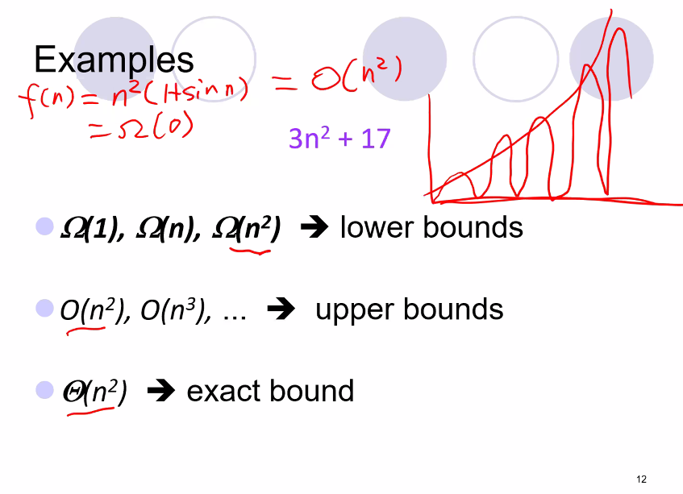
* Little “o” notation (boundaries described are not as precise as they could be)
  + 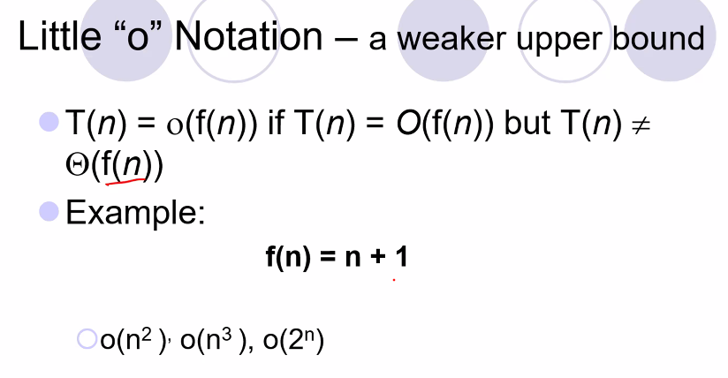
  + It is preferred to find the exact bounds so we can better see how efficient the algorithm is
* 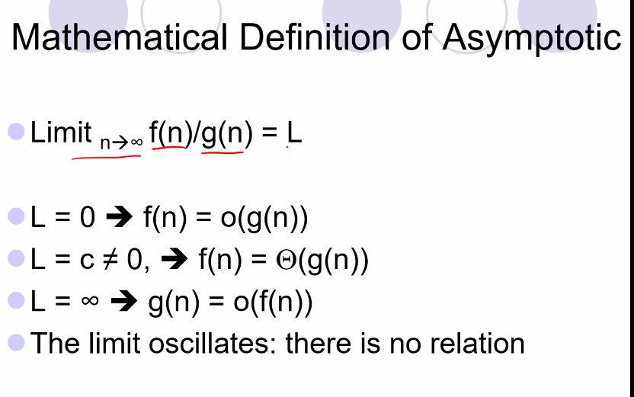
  + If L = constant that is not 0, then we have found the Big Theta notation
* 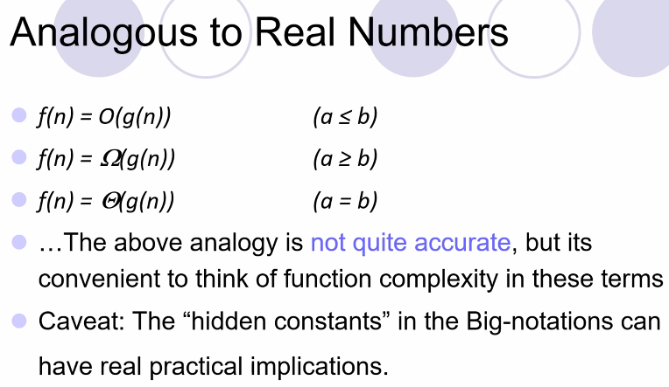
* Big O is upper bound, Big Omega is lower bound, Big theta is exact bound
* But remember, even though we ignore the constant factors and other constants, they are still important in the real world when we form an algorithm because we must assess the size of the input! So in practice you may have to do empirical studies even if theoretically and for large inputs one algorithm would eventually end up more efficient.
* 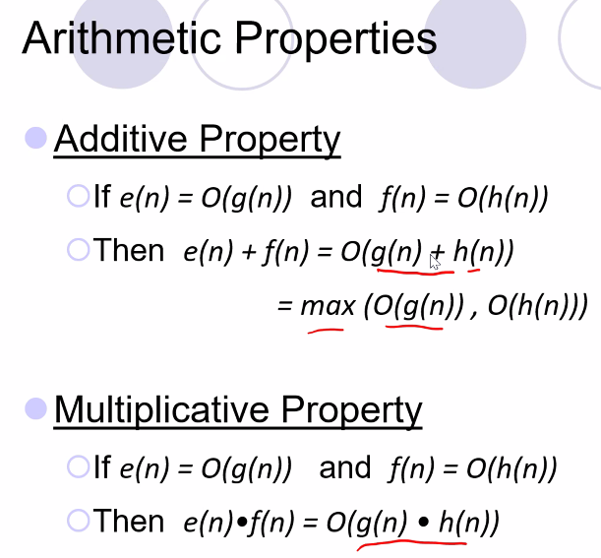
* O(1) indicates an algorithm is constant
* When you are able to organize your data in hierarchical structures, (binary for ex), then many algorithms associated with it will be very fast and efficient O(log(N))
* In general, algorithms above n^7 are considered almost useless
* (solve a rubik’s cube; algorithms are n^3 )???
* 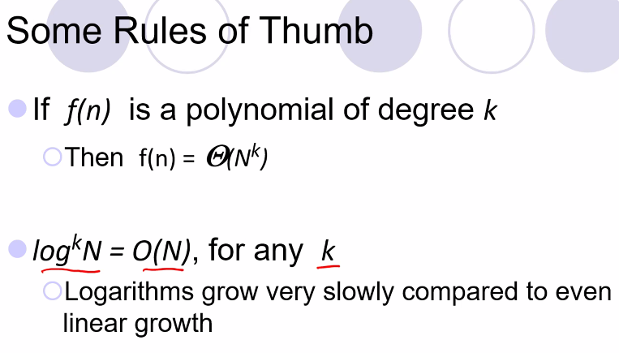
* 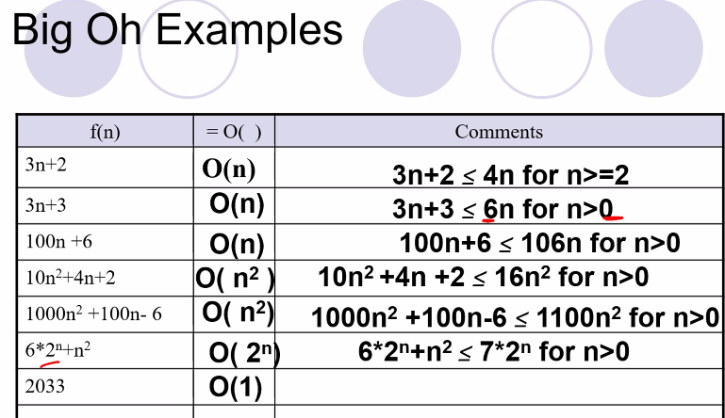
* 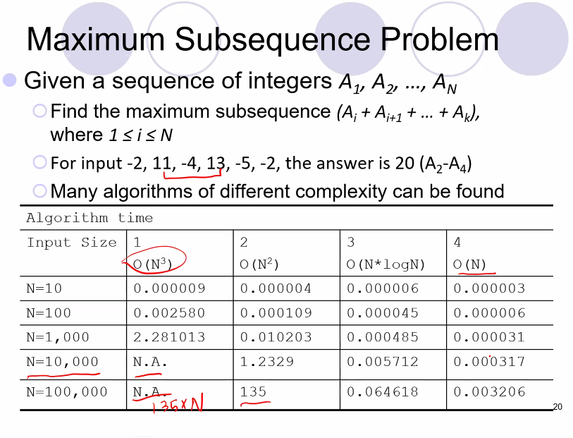
  + So notice above, for small N, time doesn’t matter; small differences, but as N gets very large, then efficiency of the algorithms will greatly matter
  + 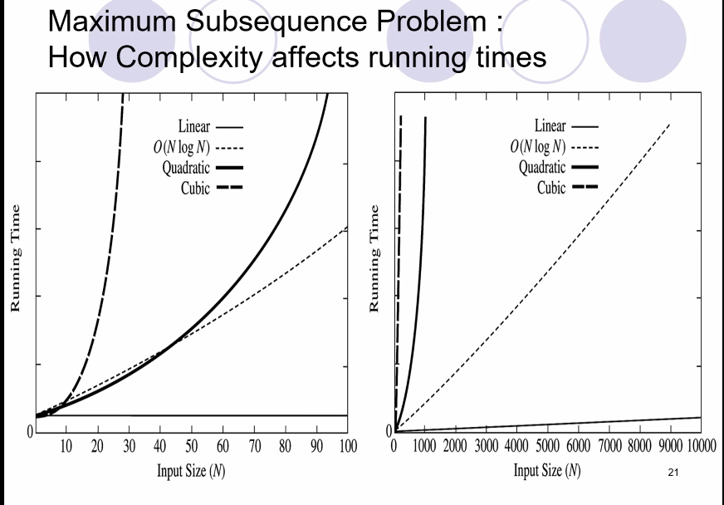
* 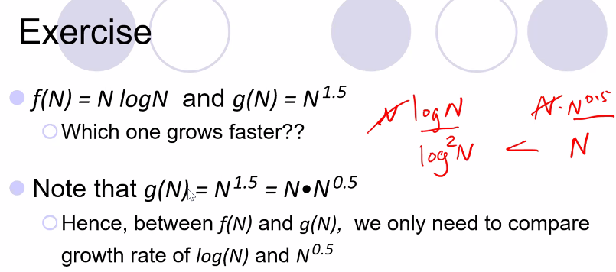
  + Notice how the problem was transformed so that we can easily see and apply known rules as to which one grows faster
  + 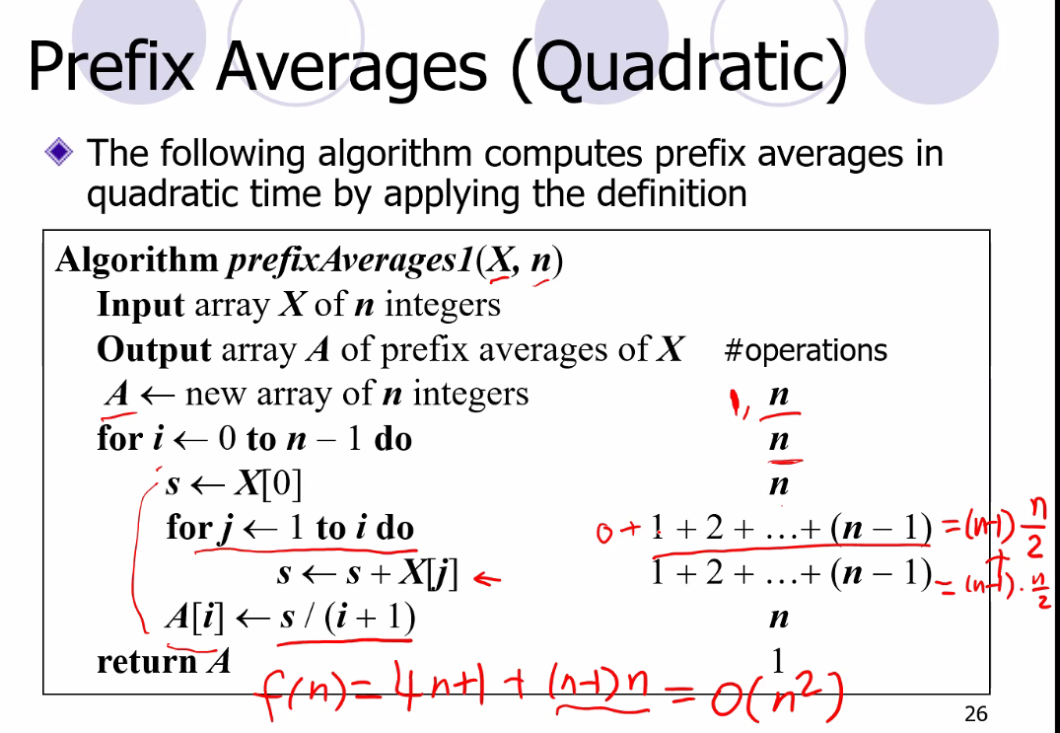
  + A[i] refers to prefix average; it refers to getting the average of first i terms in the array
  + A more efficient algorithmic approach:
    - 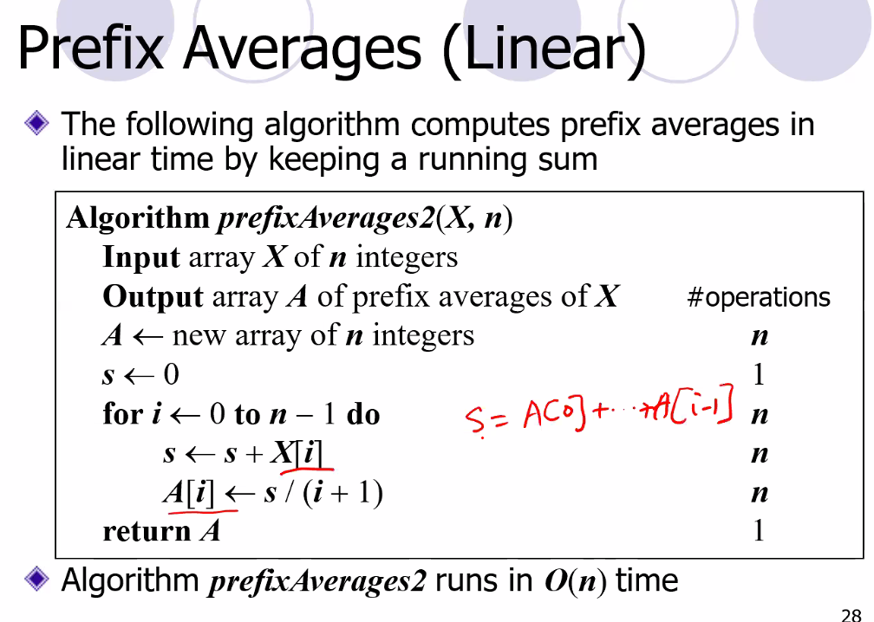
  + Each operation is called an atomic operation: you can describe an n complexity for each part (atomic) of an algorithm
* 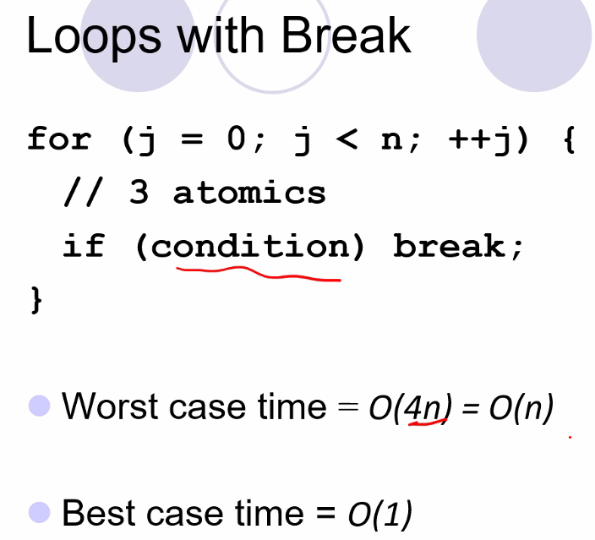
  + atomic operation is a simple operation from a loop such as i++
  + we have to assume condition is not met so we treat it as always being true for each iteration
* 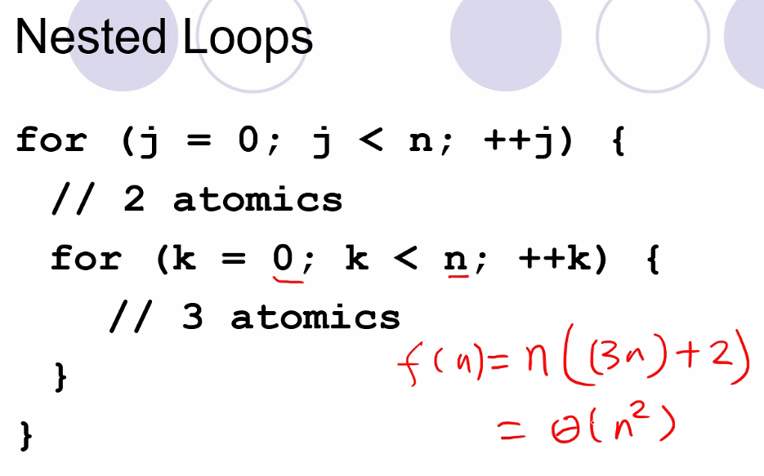
  + Working from inside, out
* For our assignment professor only wants big O notation for **worst** case.
* 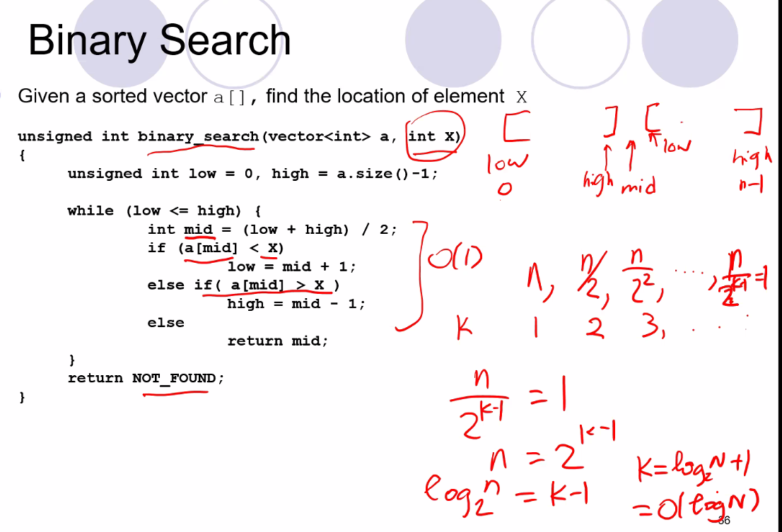
  + Base doesn’t matter for logarithm because it is essentially a constant factor
  + Remember we like to use sorted arrays because we can implement binary search which has O(logN) which is a very efficient algorithm
* 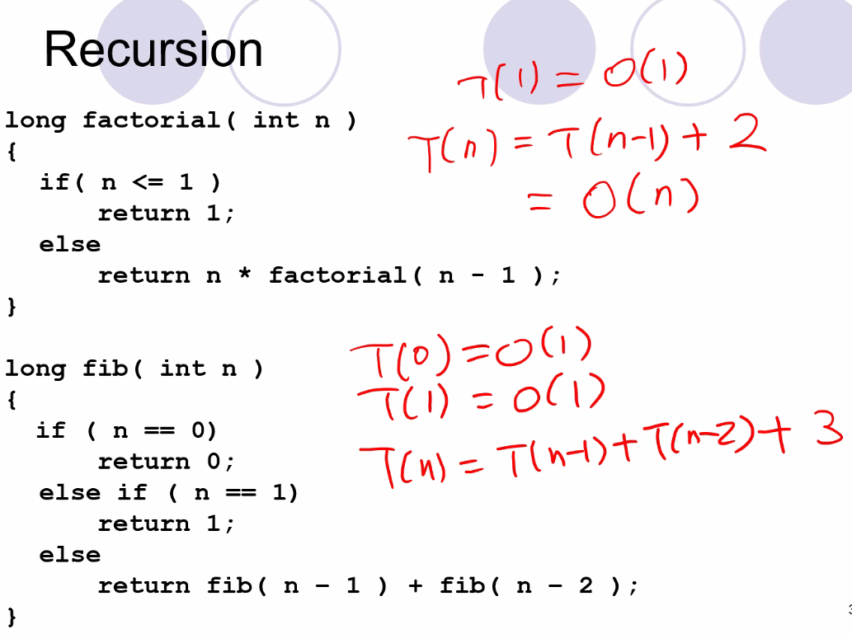
  + Above is an easy algorithm, but it is exponential and it is very inefficient and slow
  + It is a very expensive algorithm

# Lecture 5 – 5/20/21: Space Complexity analysis

* Binary search time complexity
  + 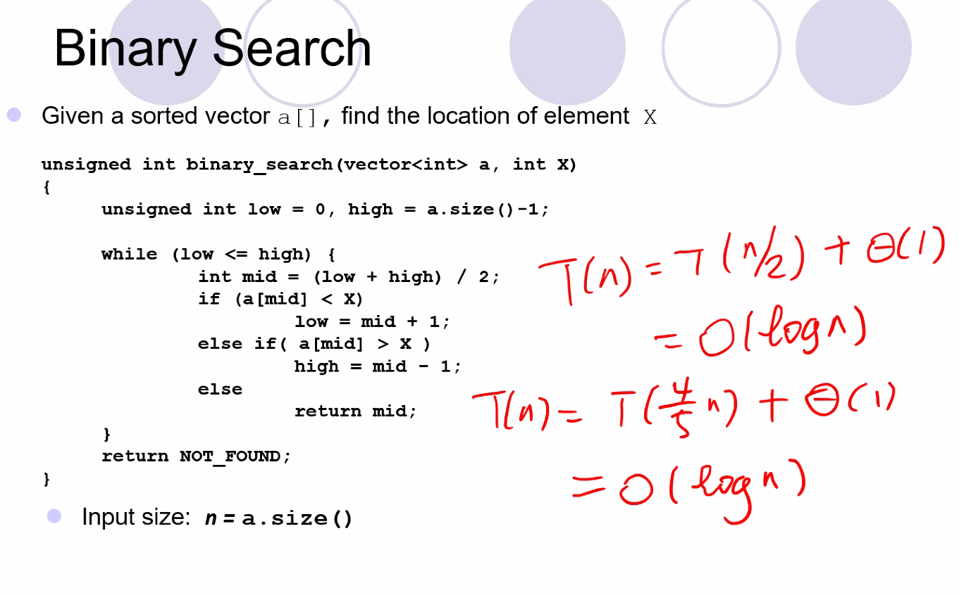
* Remember for space analysis (space complexity), recursive calls are the least efficient because you may use too much and run out of memory to run an algorithm/function to complete (for very large inputs particularly)
* 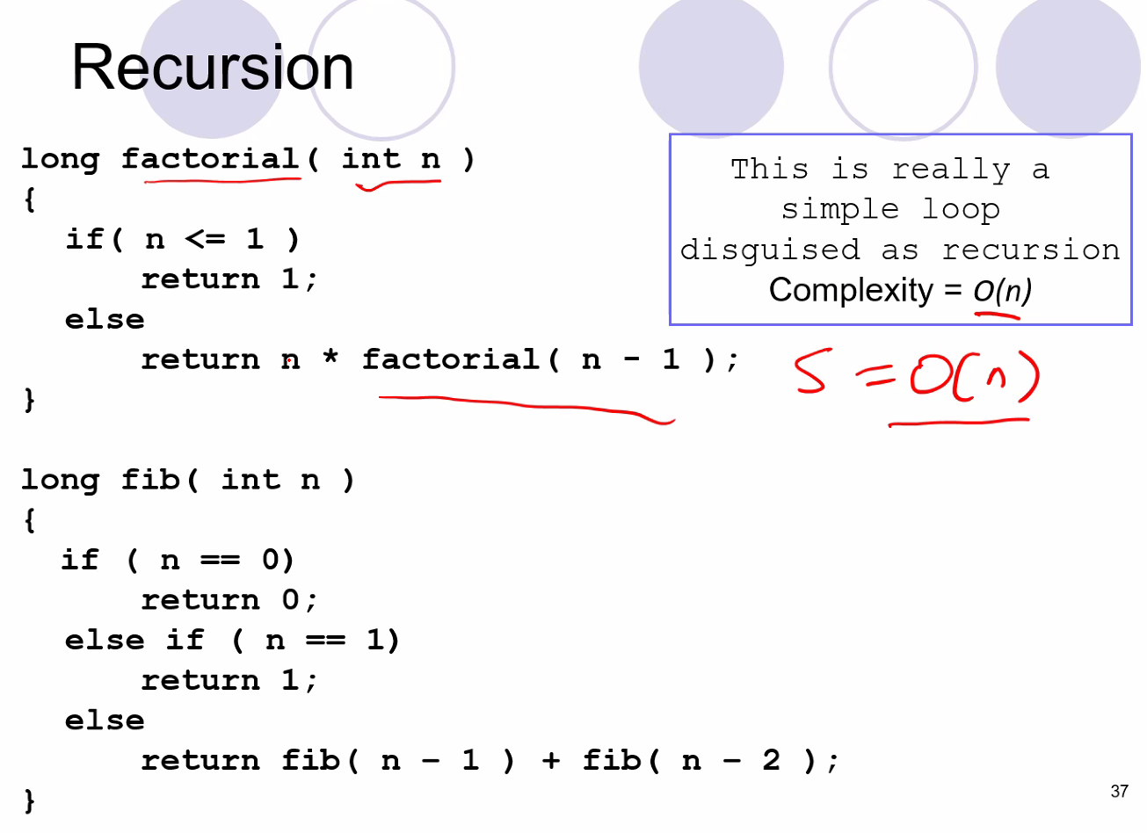
  + Above, the Fibonacci sequence sum algorithm is very inefficient and redundant because you have to keep computing inputs that were already computed
  + Better approach would be to maybe store some known solutions into an array
  + 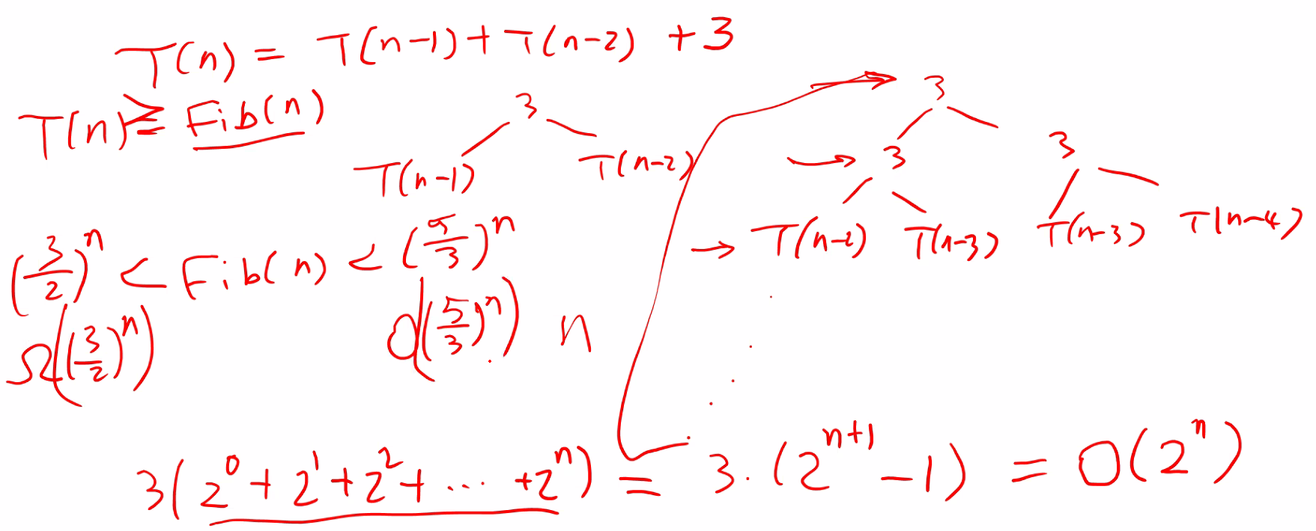
  + Notice even the lower bound (big omega) is exponential!
* Euclid’s Algorithm
* 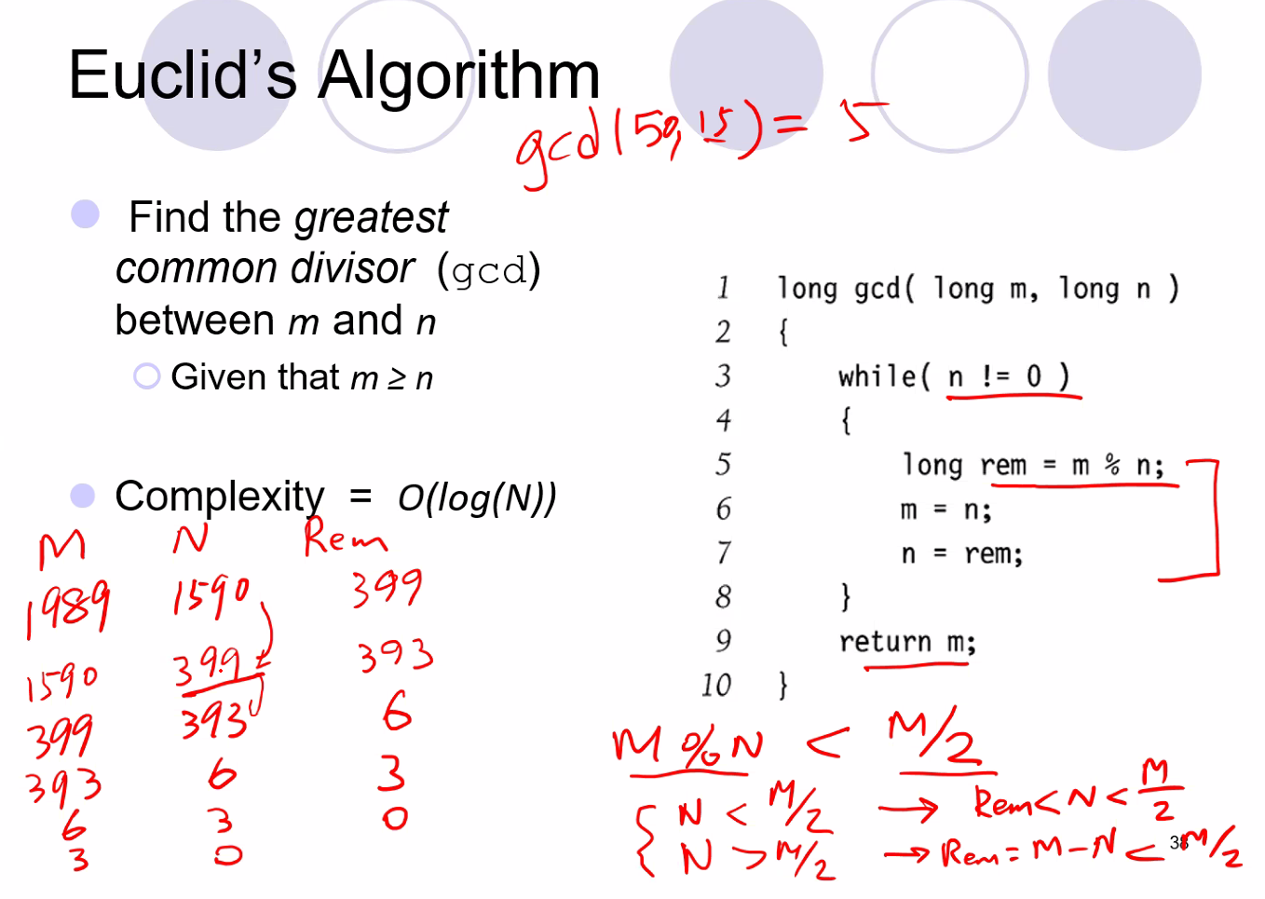
  + So above, every two runs, M will be reduced by at least half, thus, on average, the algorithm reduces m (the input) by ¼ on every one
* Exponentiation
* 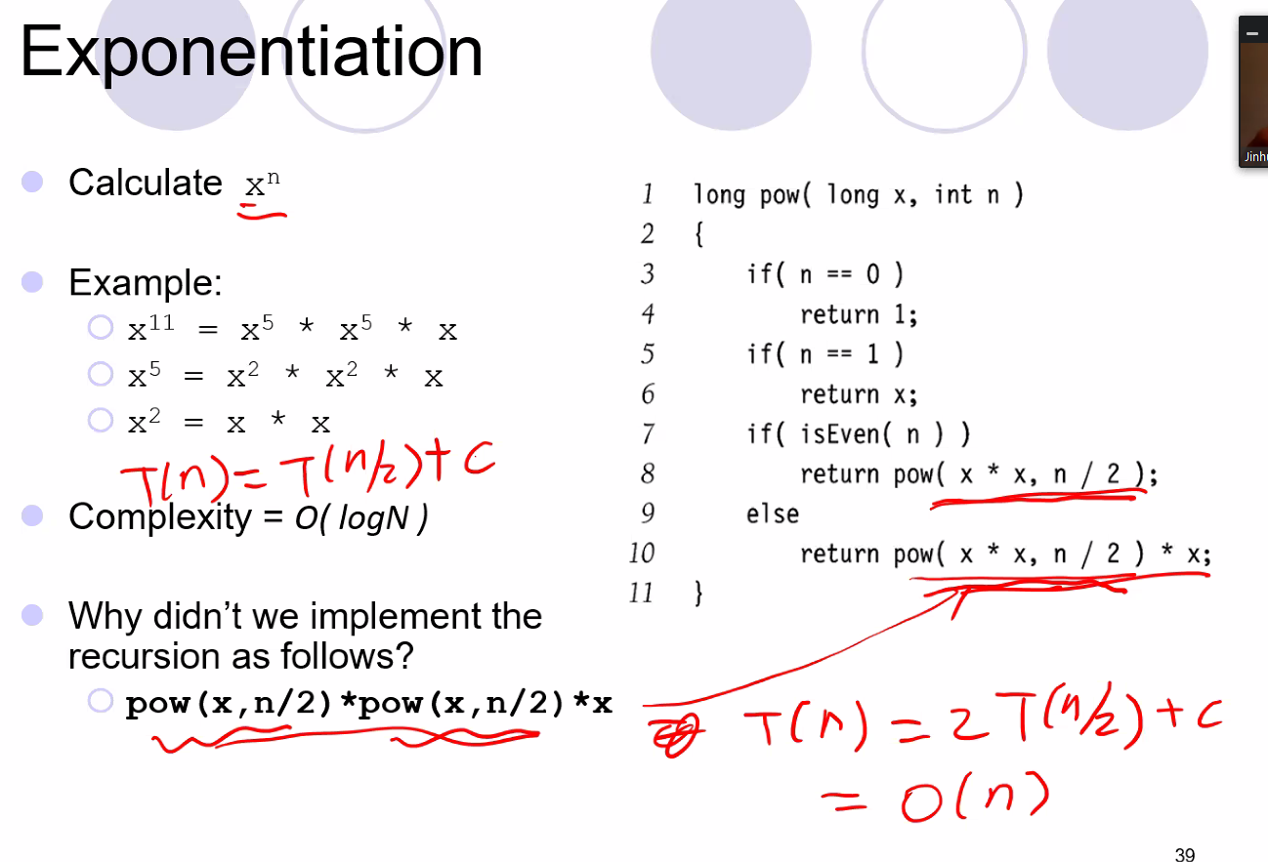
  + Algorithm has O(LogN); it is often used for encryption and decryption algorithms with really large inputs
* **Space Complexity**
* First of all, for space analysis of any algorithm you add in the fixed size for constants and instructions (your code you write for the algorithm which will automatically be placed on stack at compile time (global and static variables) for the function call)
* Of course any time “new” is called then we are using space
* 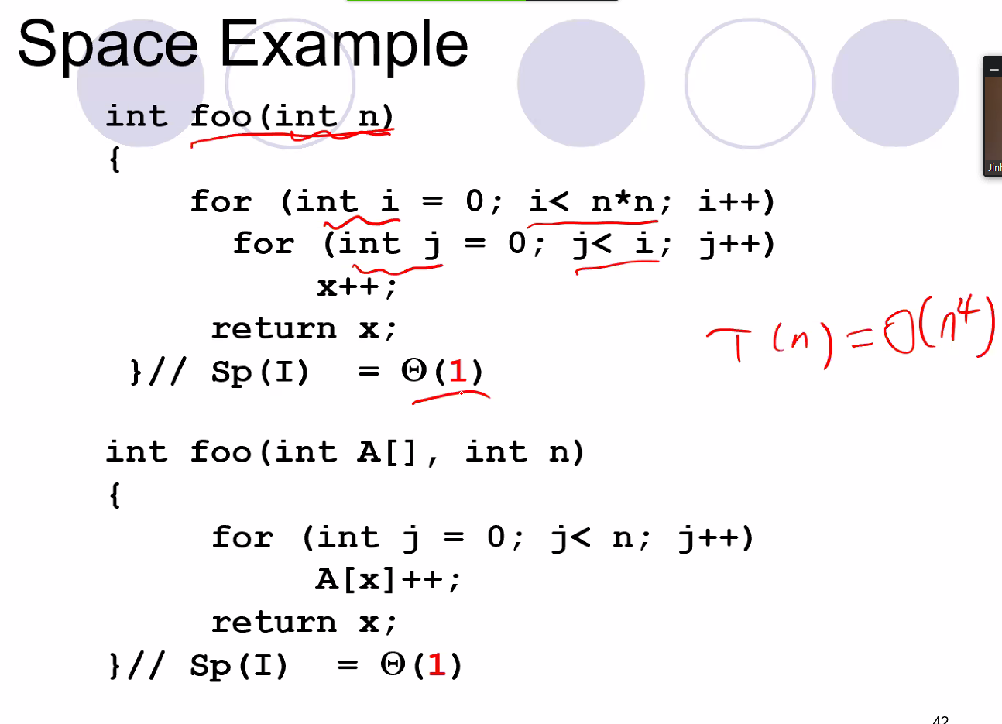
  + Above, time T(n) = n^4, but space is constant space BIGtheta(1) since you only have to allocate a few local variables (which are essentially serving as constants in an equation of memory space usage)
* 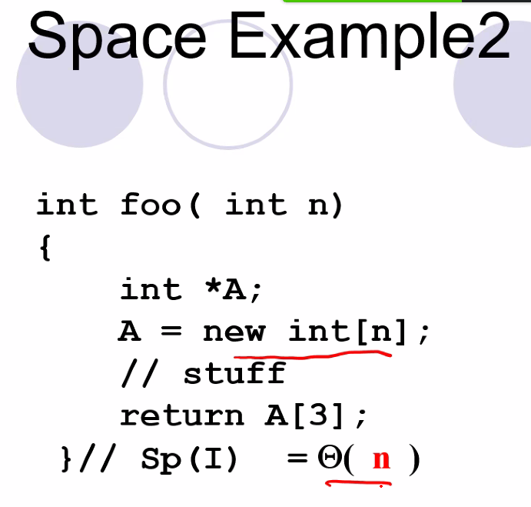
* 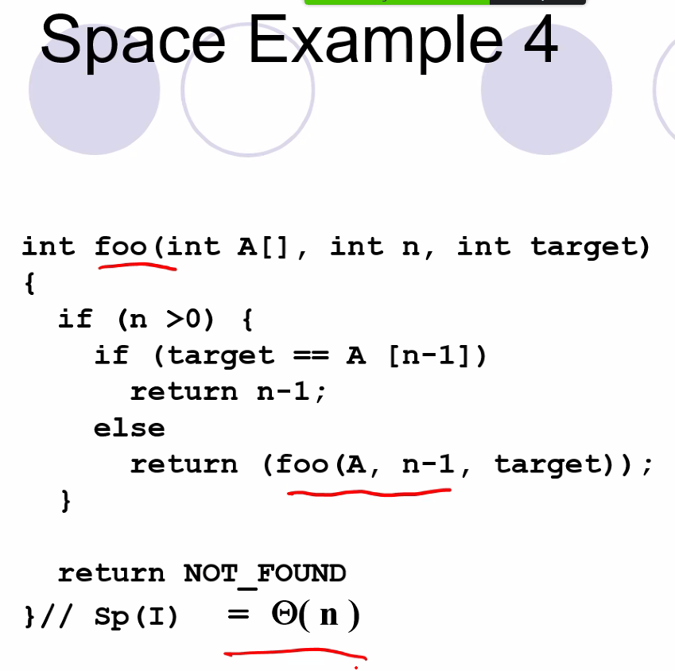
* Also, binary search with recursive calls has complexity BigTHETA(logN)
  + Remember bigTHETA is exact bound
* **TREES, BINARY TREES, AND BINARY SEARCH TREES**
* 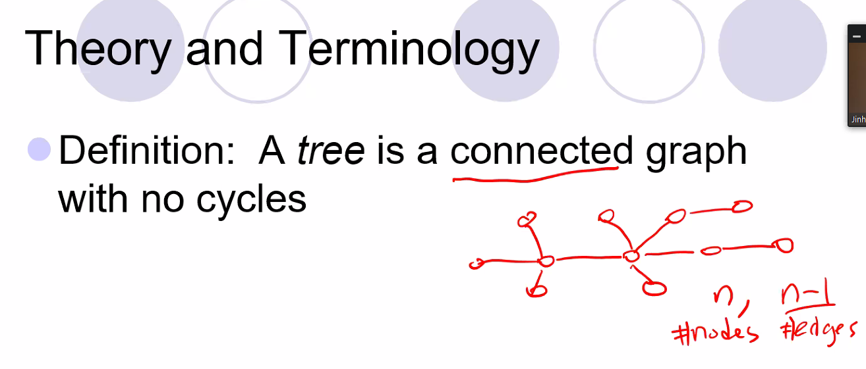
  + Cannot have n or more than n edges otherwise you will necessarily have a loop; you must have n-1 edges for the number n of nodes. (if edges is < n-1 then you won’t have a tree because not all nodes will be connected to the entire tree network; it will be isolated)
* Depth
  + 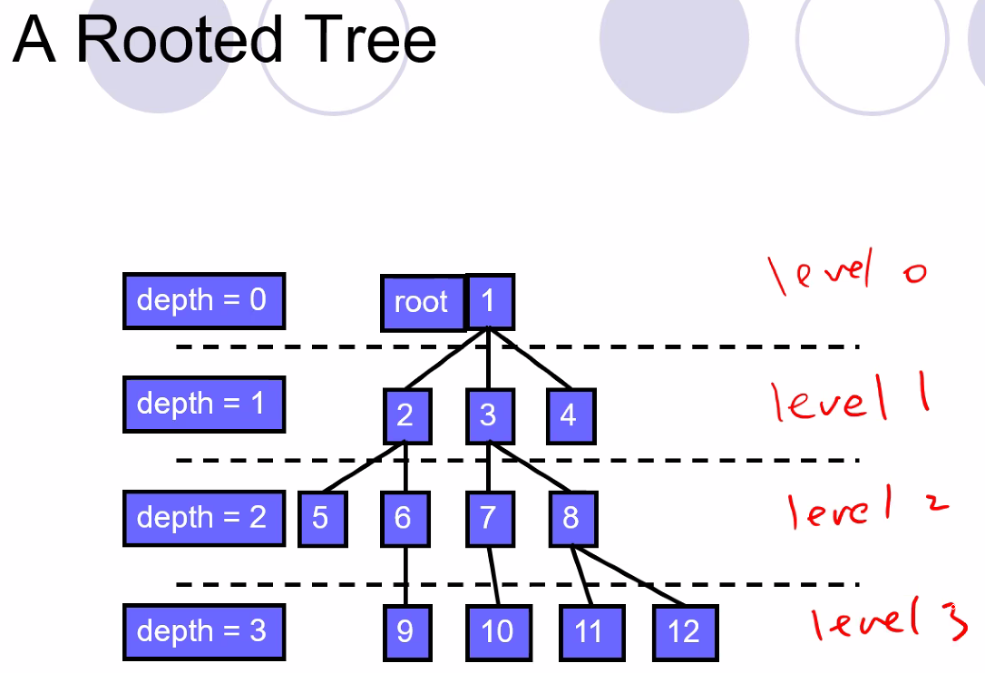
* 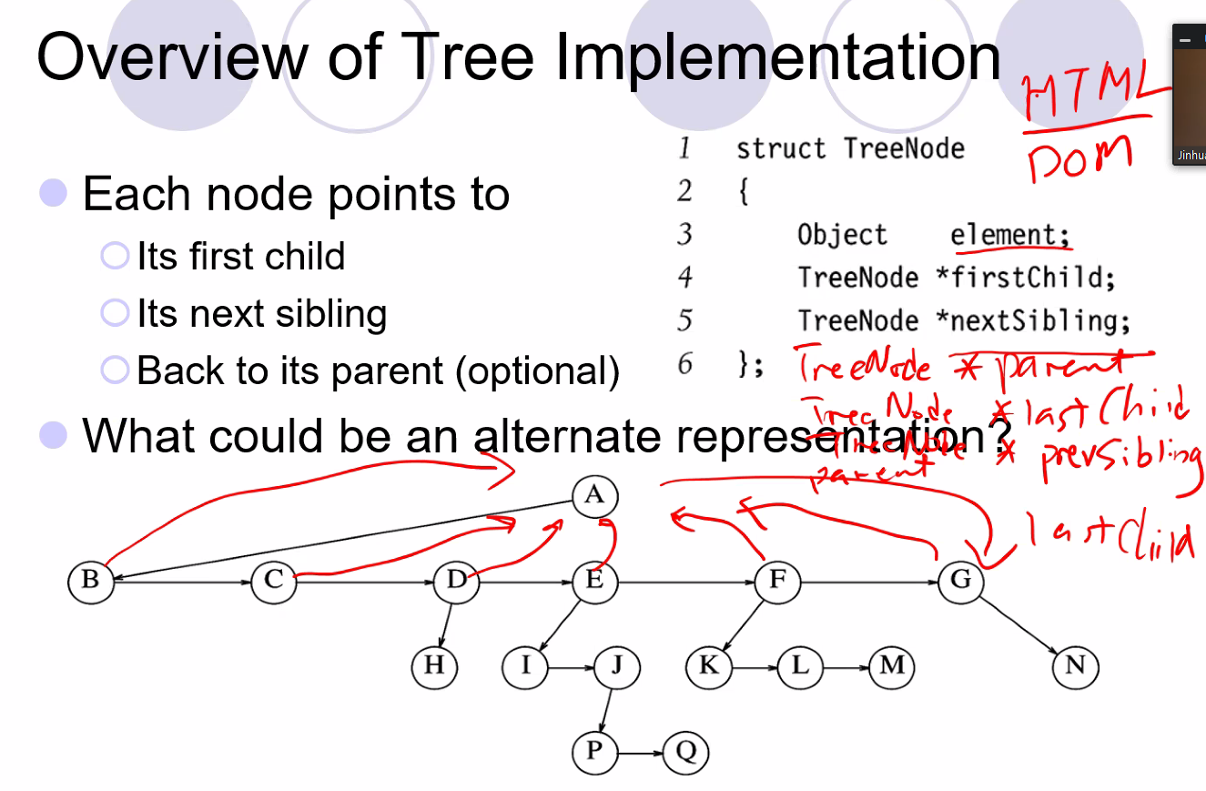
  + So above, node A would have first child set to B, and next sibling would be set to NULL; and thus B’s next sibling will point to C but have its first child point to NULL
    - Thus, B C D E F and G are all siblings and thus children of A; this is a slightly different way than I have seen a tree node be set up to traverse or map a tree structure
* Pre order tree traversal
  + 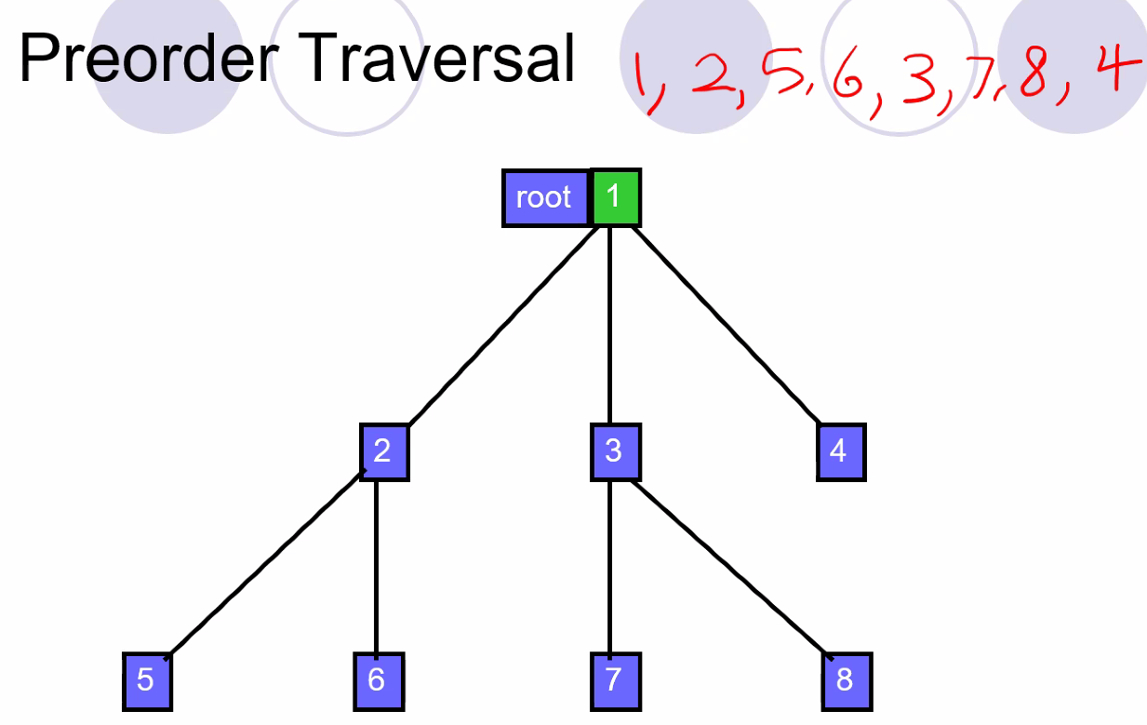
* Real world example of preorder traversal:
  + 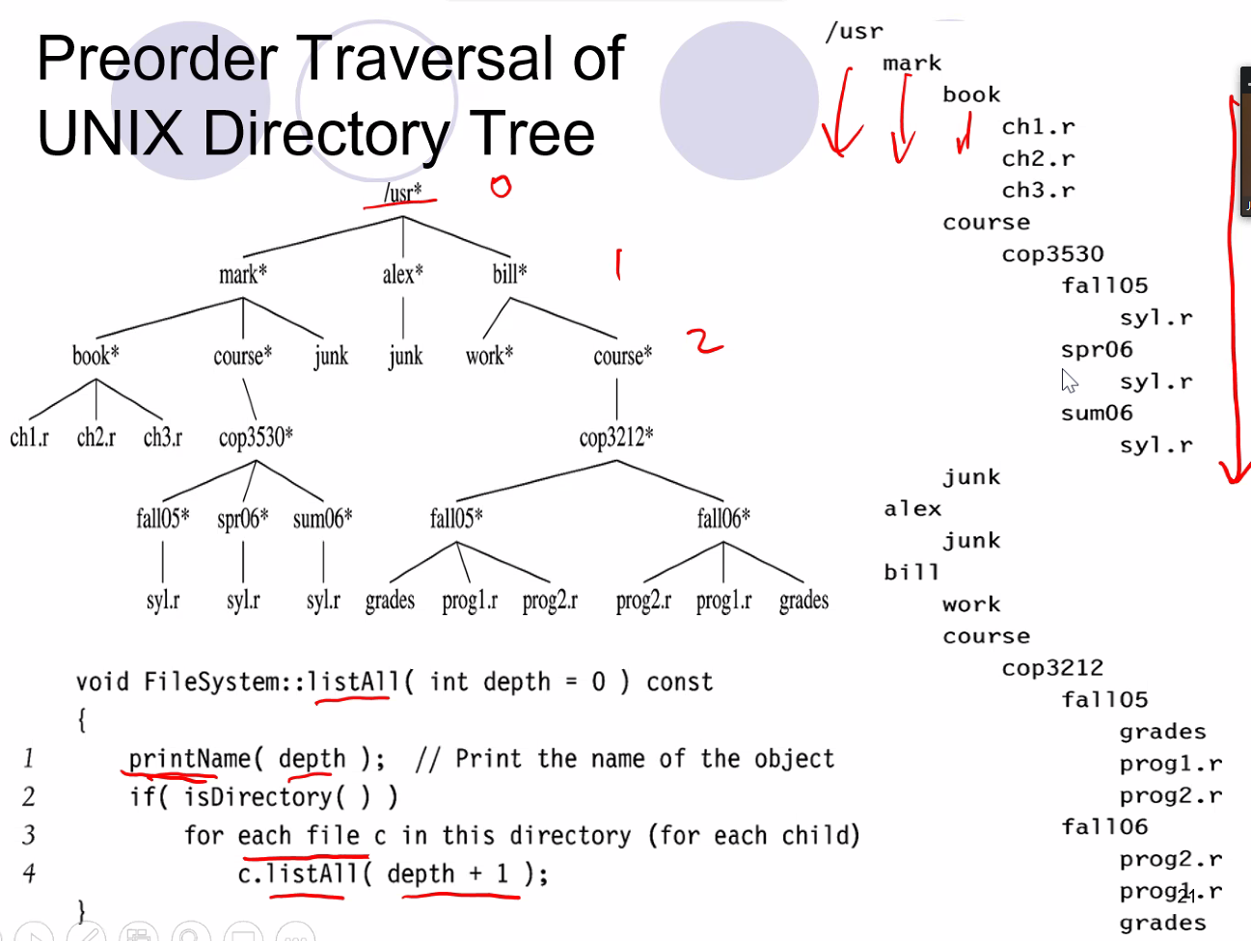
  + Notice how above the directory is indented and displayed according to preorder traversal
  + Each indentation is a different depth level; so /usr is depth 0, and mark, alex, and bill have indentations at depth 1…etc…just as we defined a tree and defined what depth was for a tree
* Post order traversal
  + 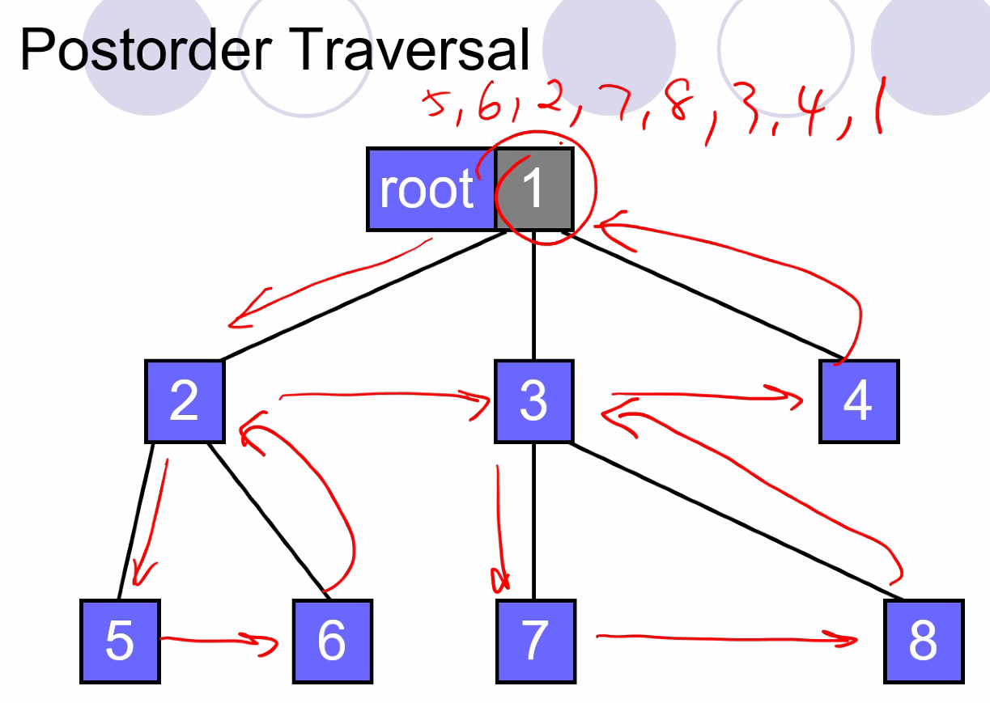
  + Also a depth first search like pre order but all children are visited first
  + Example of calculating size using post order traversal:
  + 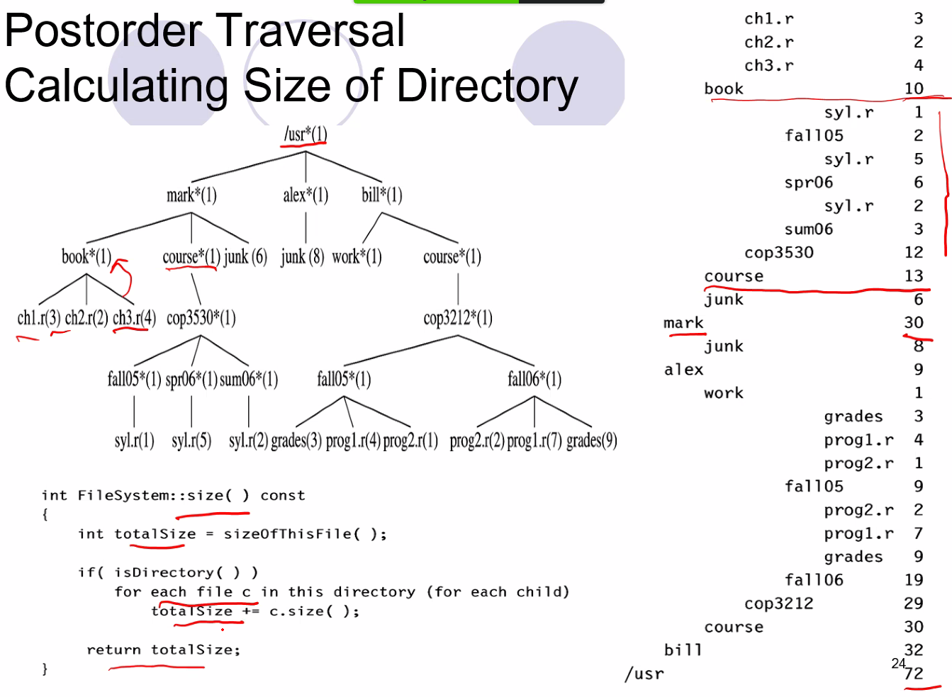
  + Preorder you traverse upon arrivals (but is still depth first search)
  + Post order you visit each node upon departure (but still depth first search)
  + Can use recursion for each traversal type to implement the tree traversal
* Level order Traversal
  + Can only use queue based approach (using an array to set up the queue for order of visitation of tree traversal); cannot use recursion based approach
  + Left to right, level by level:
  + 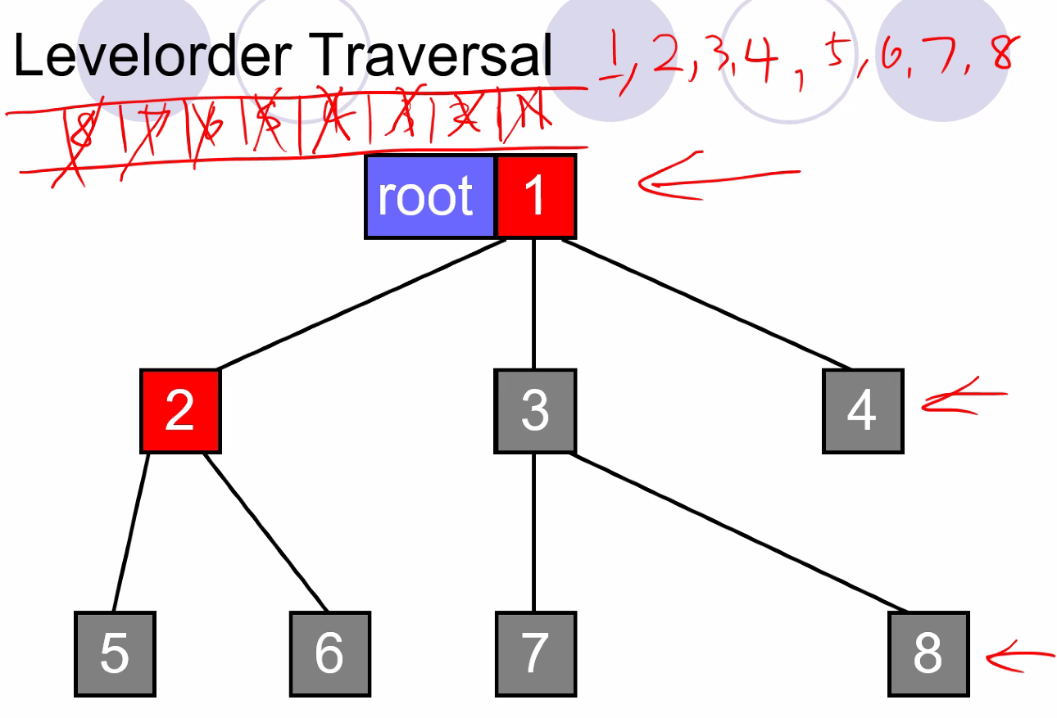
  + Breadth first search; start enqueuing beginning with the root
* 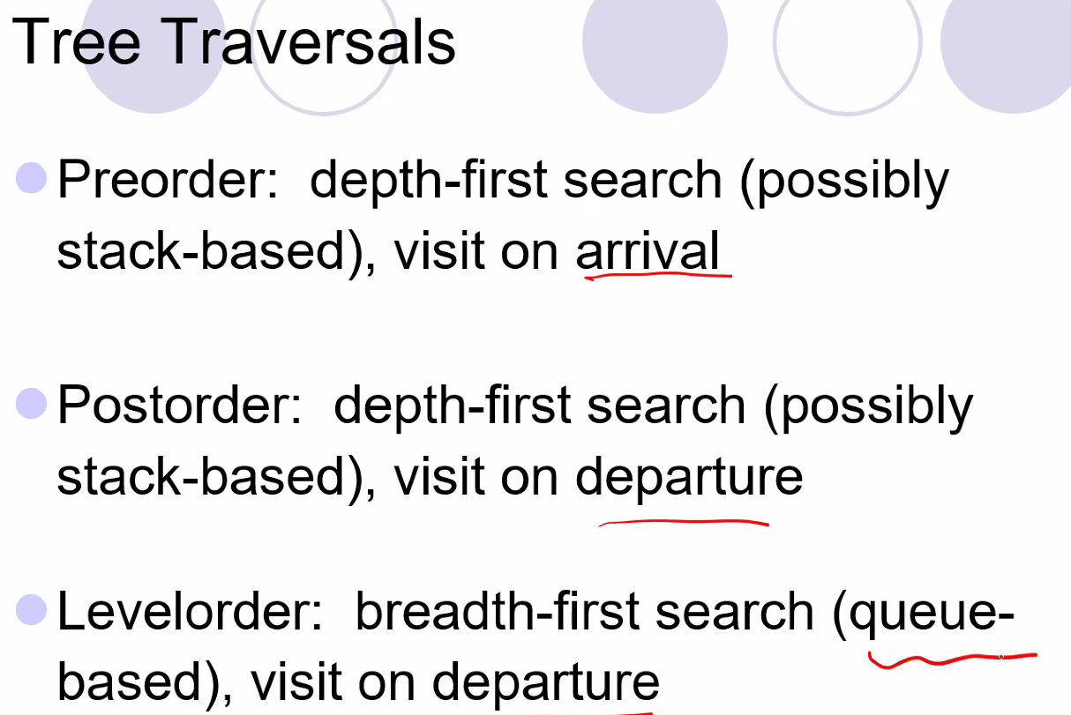
  + And remember you cannot implement level order using recursion
* HTML is an example of a preorder traversed tree
* **Binary Trees**
* Nodes can have at most 2 children
* Binary tree is different than general tree; you can have the struct point to left and right child since each node can have 0-2 children
* Inorder Traversal with binary tree
  + 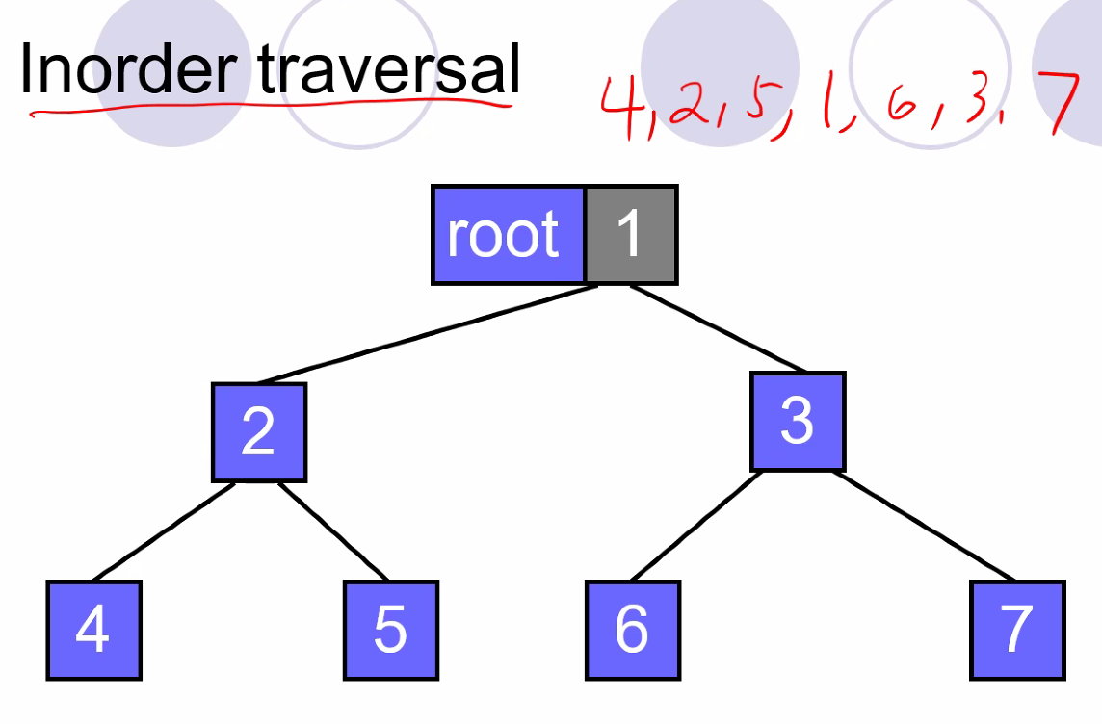
  + 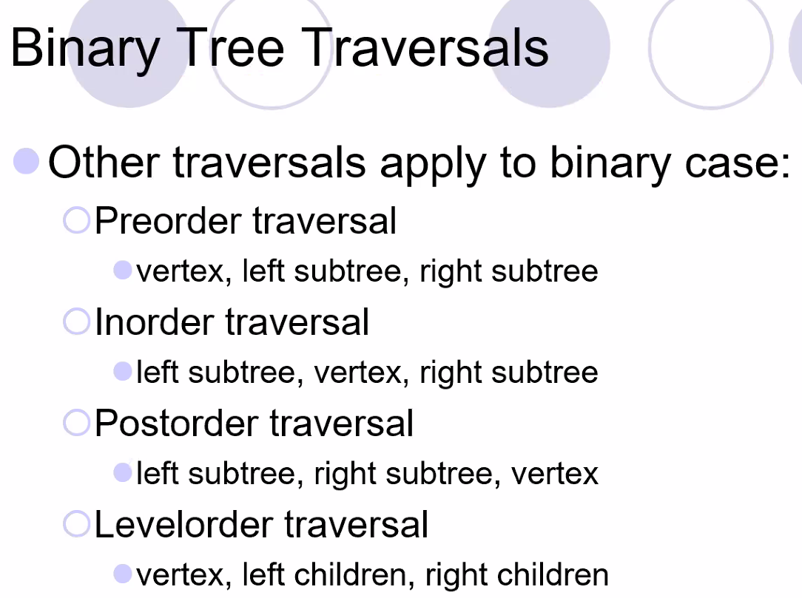
* Expression Tree: A binary tree with all non-leaf nodes containing expressions
  + 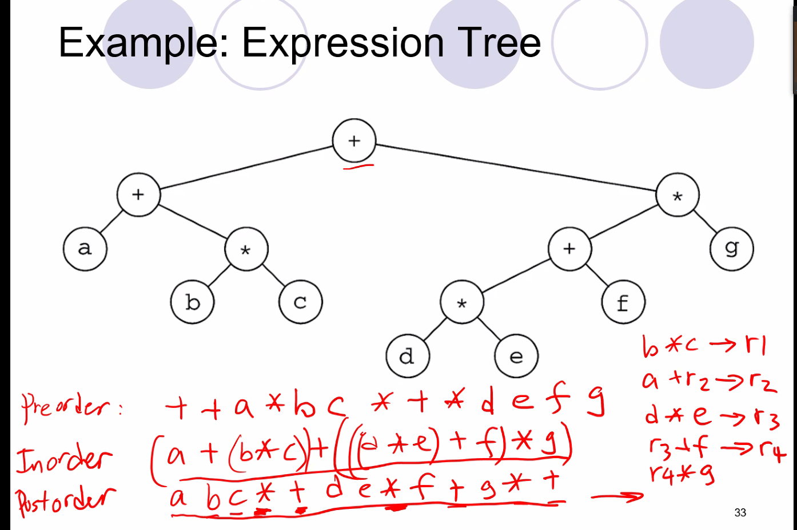
  + In order is easier for humans to read; but post order is very easy for the compiler to translate
  + These trees are used for compilers to generate the correct corresponding code into lower level languages
  + Above, try to see if you can solve the post order traversal how a compiler would and why it would be easier for compiler to do it

# Lecture 6 – 5/25/21: Binary Tree Structures and Hashing

* Advantage using a complete binary tree structure
  + 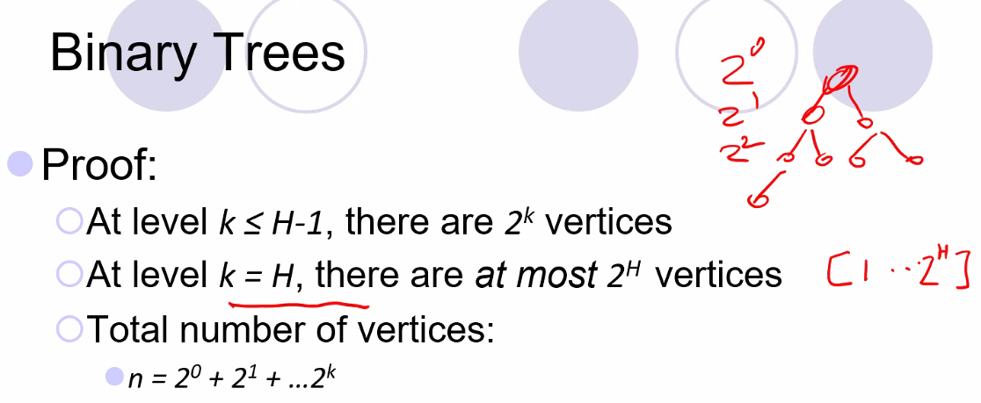
  + 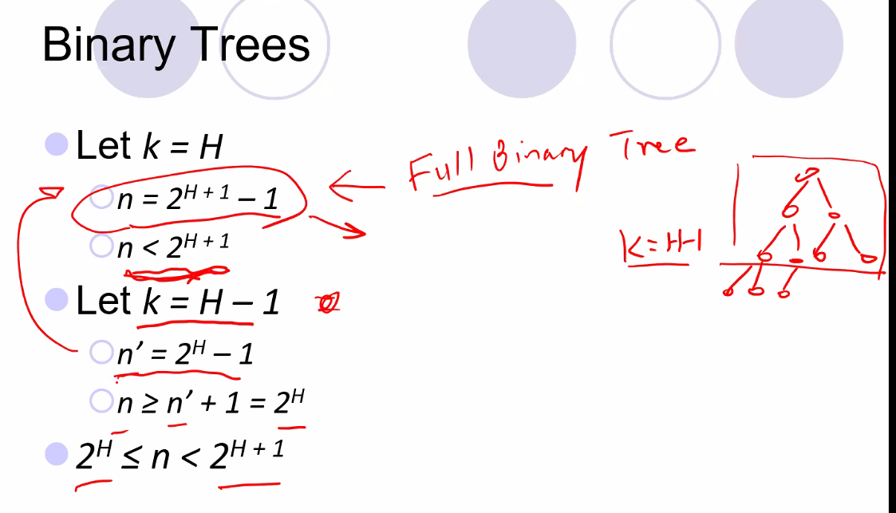
    - Use the above formulas to determine number of nodes for a full binary tree and a complete binary tree
    - The k = H -1 case is essentially knowing that a complete tree can be broken down into a full tree + 1 extra level that is not full with children (but still complete; all nodes to the left); that is what the tree above demonstrates
* 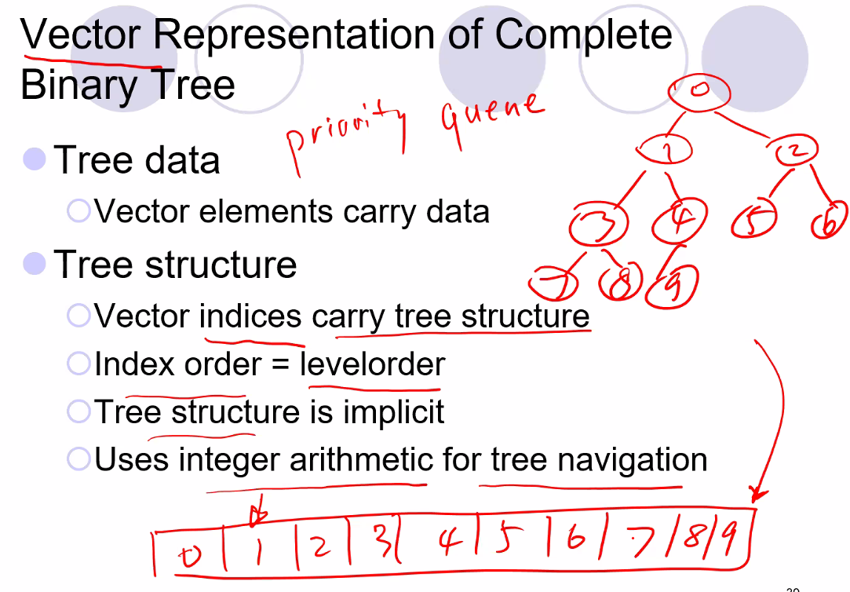
* We can take advantage of complete binary trees to store the tree in a vector and use a formula to easily calculate parent and child nodes of a given node; this can obviously help improve algorithm efficiency or save memory…etc
  + 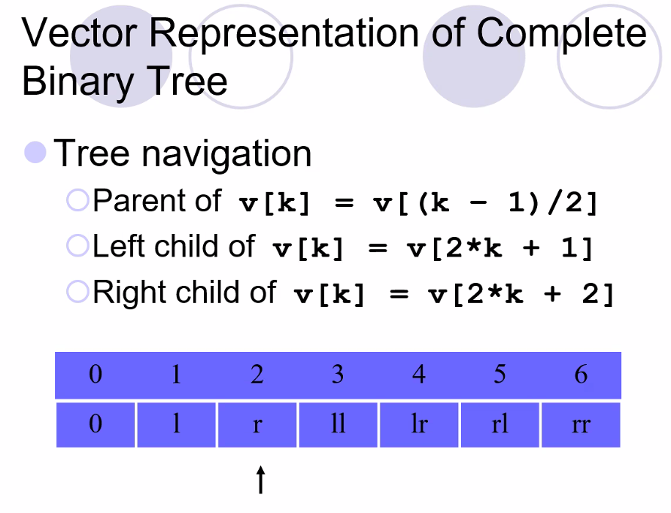
  + So we can take a tree structure and set in in a vector
* **Binary Search Trees (Totally Ordered Tree)**
* Avg time for insert, delete, and search are O(logN) time
  + If tree is imbalanced worst case is O(N)
  + Thus, we need to make sure to use algorithms to balance the tree and keep it balance after insert and delete operations
* All nodes on left sub tree is less than parent, and right subtree is greater than parent node
* Nodes are totally ordered, so if you use the appropriate order output, you will output a sorted list
* We can do many of the same operations as in project 1 but more efficient for most operations
* Smallest element for a BST is the left-most node, and the largest is the right-most node
  + But for an sorted array, it is faster at finding the smallest node and largest node; it can find them I constant time
* Print out nodes using in-order traversal to print out the BST as it is sorted already
* Search is easy, just moving to left or right node depending on search value and if the left or right node is >, <, or =
  + Every time you move to the left or right node, the total number of nodes to search is halved; hence BST search is avg time O(logN)
* 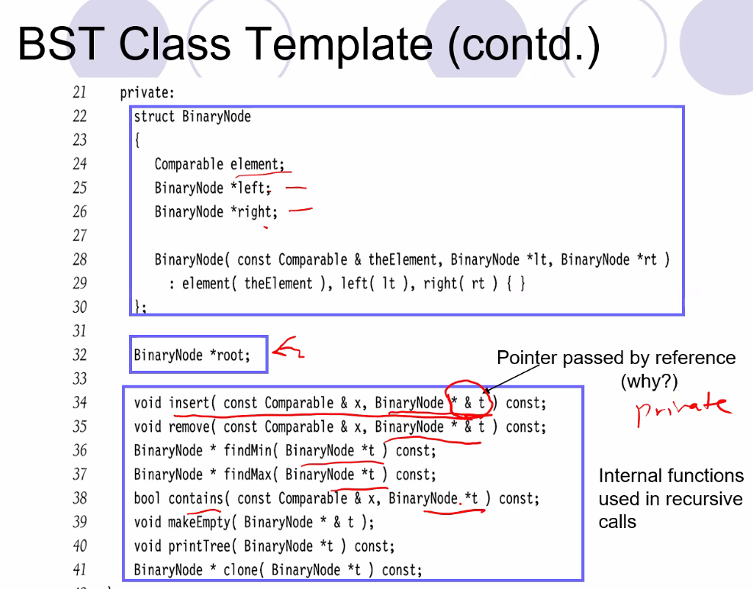
* You can do an inexact search (using binary search algorithm, and instead of finding an exact node that matches, simply use >=, >, or <=, or <…in order to find a node that is at least suitable, search time on avg is still Olog(N)
* Code for insert is almost exactly the same as binary search for an element
* Delete is a little bit complicated
  + Different method for deleting a node with 2 children, and deleting a node with 1 child
  + 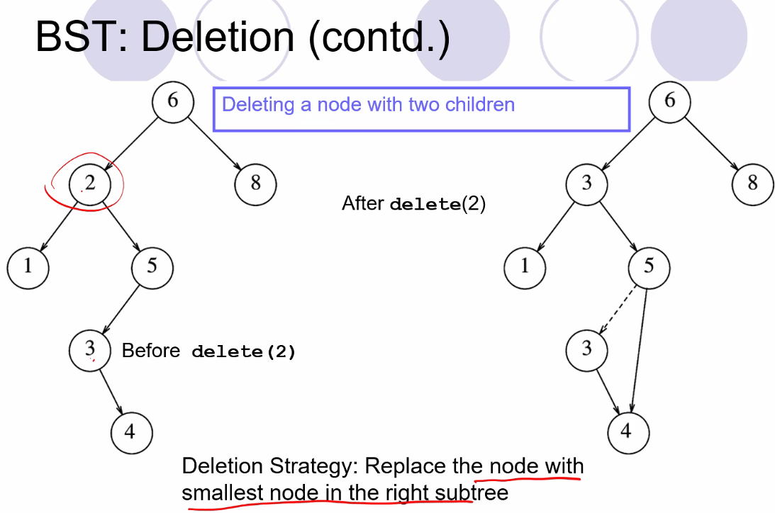
  + Or you could (for deleting a node with 2 children) replace with the largest node in the LEFT sub tree
* You can do a lazy deletion and just mark the node as deleted, but it wastes space, but it is useful if the tree is small and space is not a concern
* Deletion will take O(n) time because it has to visit each node in order to deallocate them
* 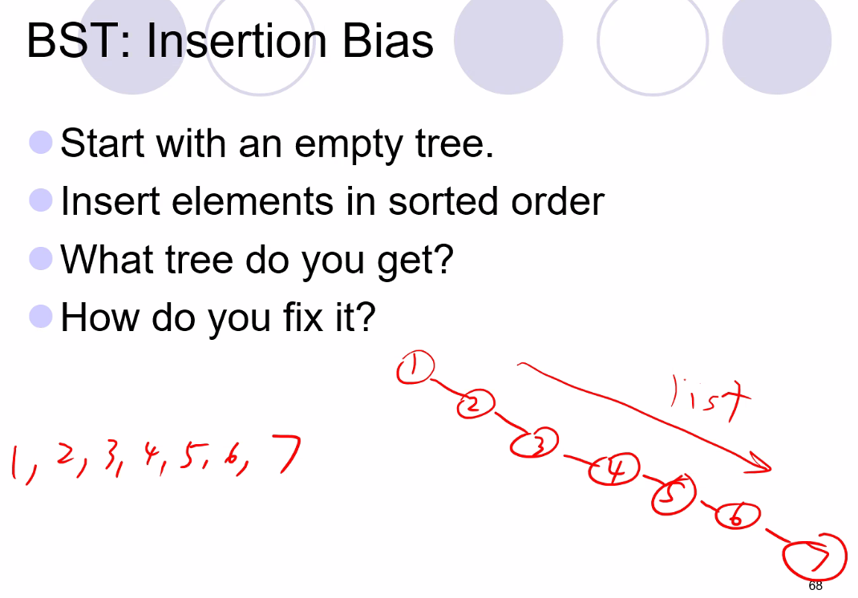
  + Above, many functions now become O(n) because tree is unbalanced and not really a tree at all but a list
  + Solution: AVL, or Splay tree, to balance the tree or to balance a tree that gets out of balance (deletion bias)
* **Hashing**
* 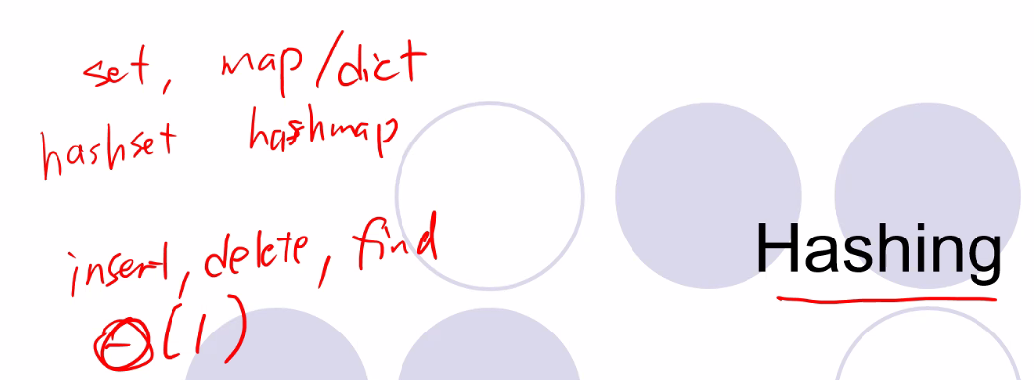
* Runtime as you see above is a lot more efficient even than binary tree
* But hashing requires more memory, and you cannot find min, or max, or print elements in order
* Non-initial insertions cost a lot of memory and cause you to have to re hash, thus you do not want to do insertions often or deletions often
* Can tell you if a value is in a data base or not, and can retrieve the value if you need it
* 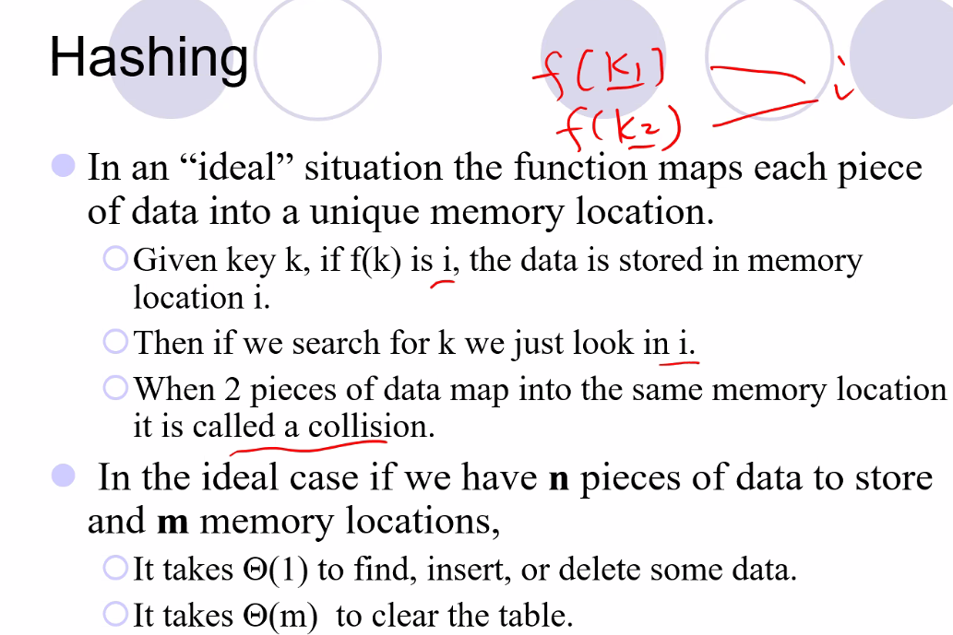
  + It takes constant time to find, insert, or delete, because there is simply a function (hash function) used to determine which memory locations belong to a given key
* 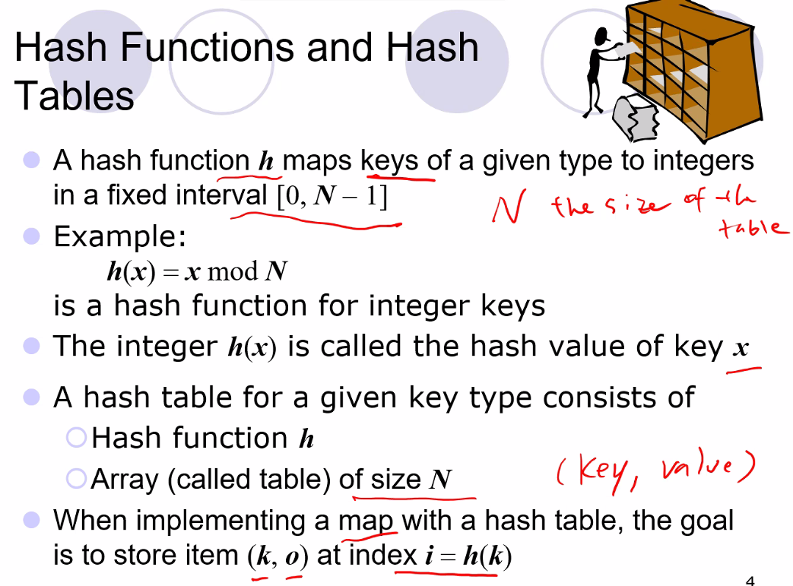
* 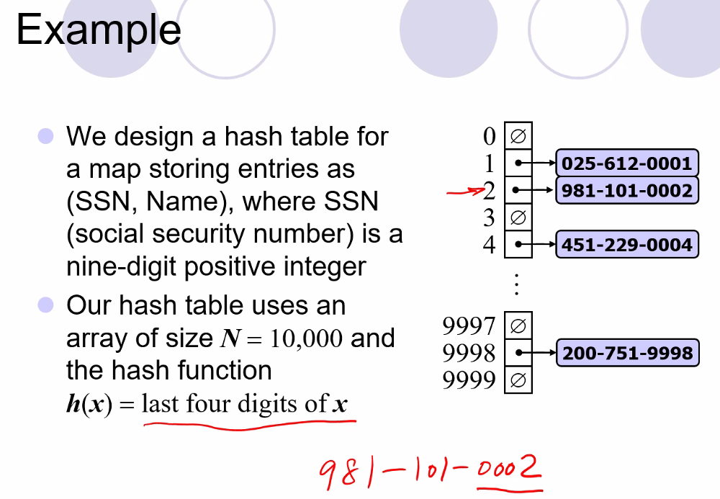
  + Above, you can store not only the key at the memory location evaluated, you can store other information
  + To solve collisions, you can do something called “chaining”, where you put a list in the element of the hash element location
  + Also you want to have usually more elements (memory) allocated than will be needed; so above you would use N=10,000 for say, 5,000 employees (usually double is a good value to use); so half the table is empty, half is used, so you can have good performance, but of course then Hash tables cannot be too full to reduce collisions but as an exchange they use a lot more memory that goes unused
  + Rule of thumb: we don’t want the table to be more than half full
  + If you need a hash table that is too big and would require using too much memory, then it is good to consider using another data structure such as b trees
  + 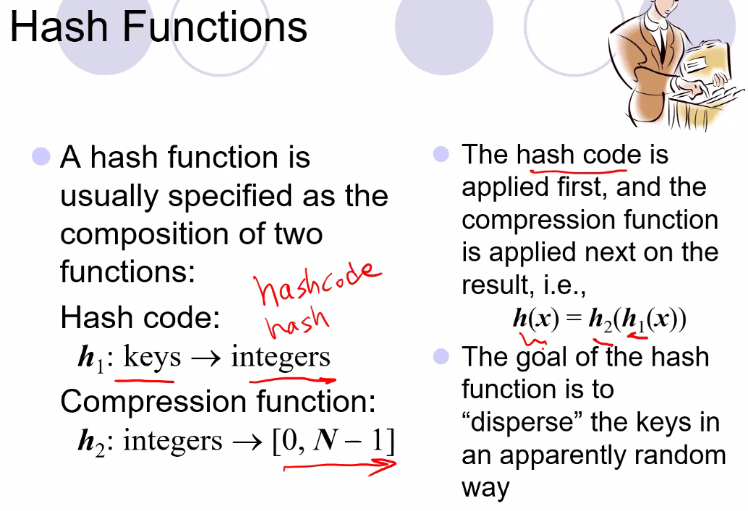
    - Then we can use vectors to store the elements
    - We want the random order to reduce collisions
* 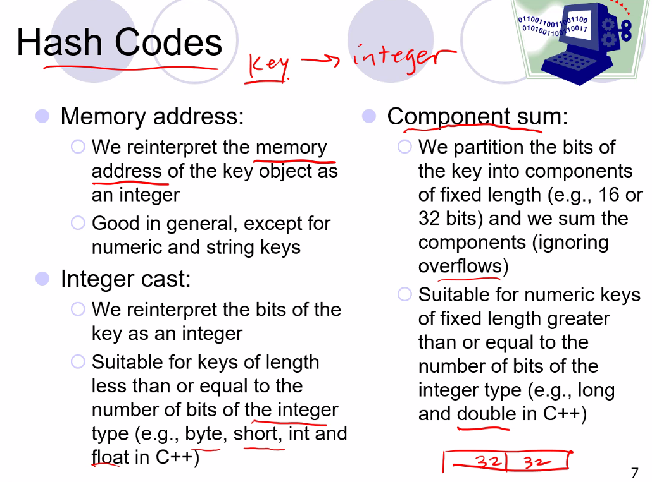
  + If you base it on address (which is a 64-bit or 32-bit integer depending on operating system), then every time you run your code the hash table created won’t be the same as memory allocation will likely be different every time the program runs, is terminated, and then ran again
  + Goal is to map a key to an integer
* 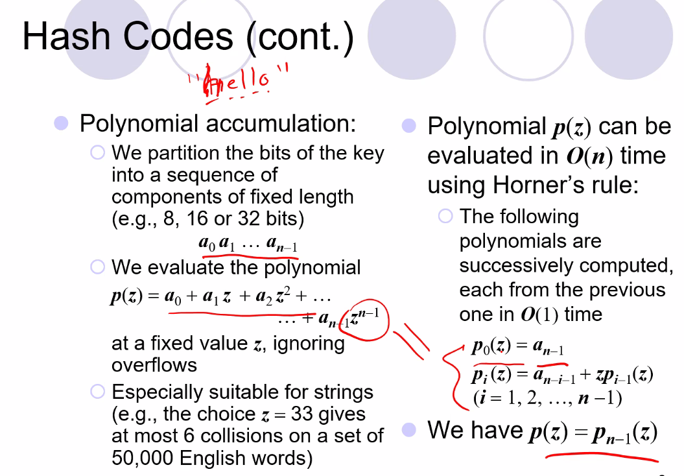
* 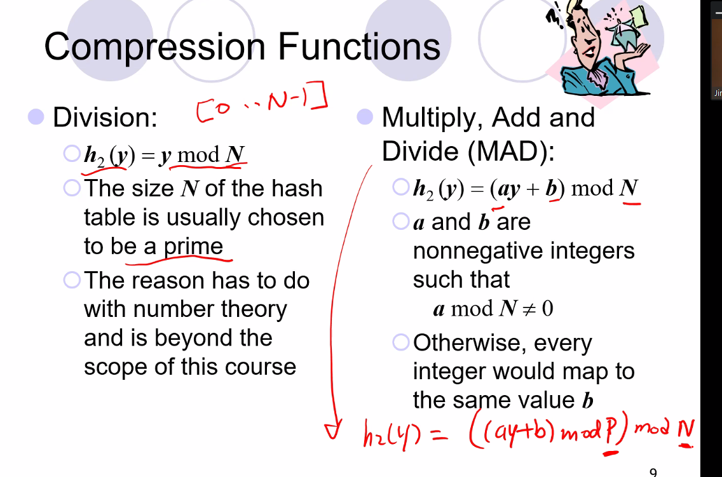
  + Above, if you use P and N, where P is a large prime number, then N (the size of the table) can now be any integer and is not bounded to be a prime number to reduce collisions

# Lecture 7 – 5/27/21: Hash Tables

* 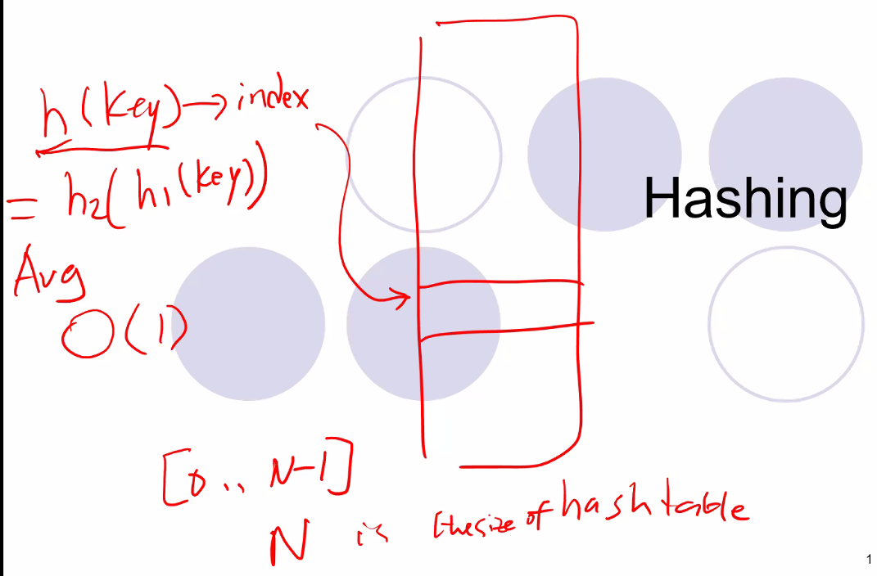
  + For insert, delete, and find, average time is constant time: O(1), and worst case O(N) for when a hash function is very bad
* 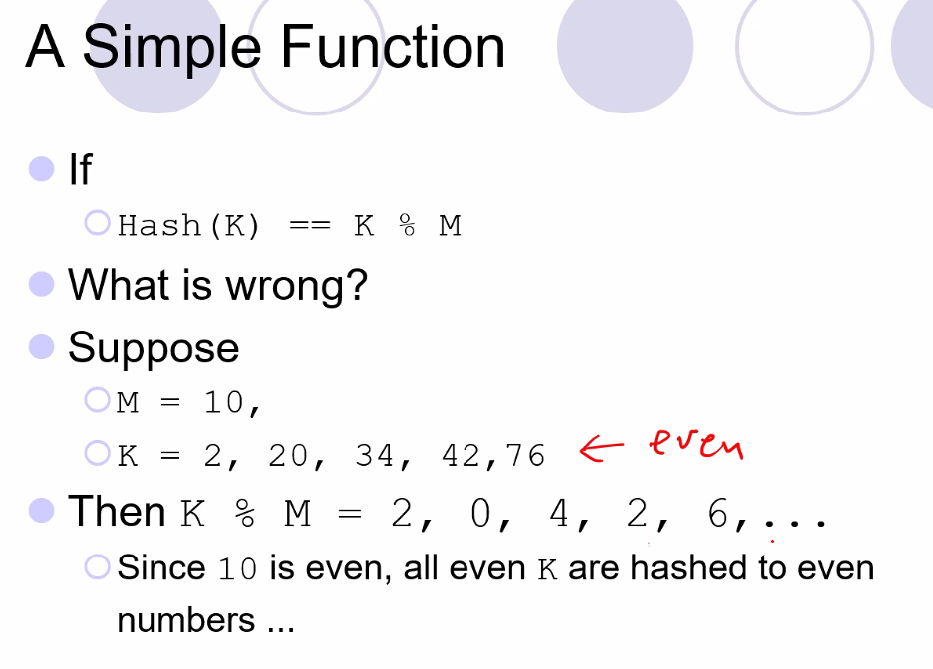
  + Notice this would cause a lot of **collisions**
  + Also with all even input, you would end up using only half of the memory (with every other memory location unused)
* 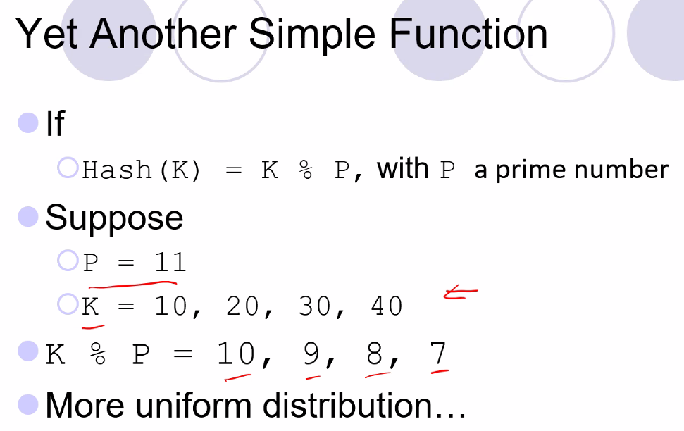
  + Use prime numbers because they don’t typically share common factors
* Another solution: use the MAD function: Multiply, Add, Divide
  + 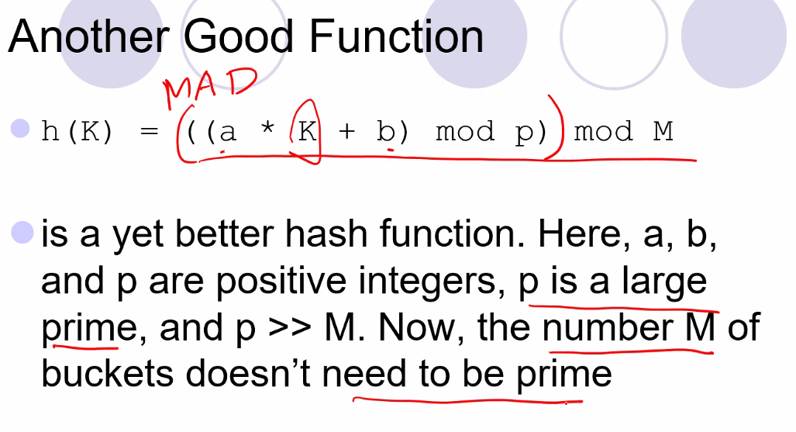
  + In doing this, you can make your hash table size any size
* 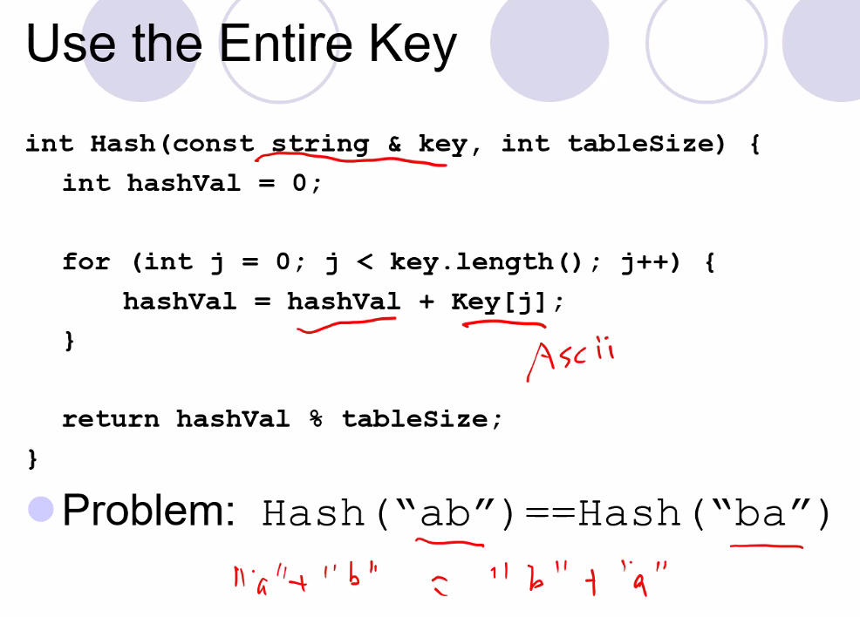
* 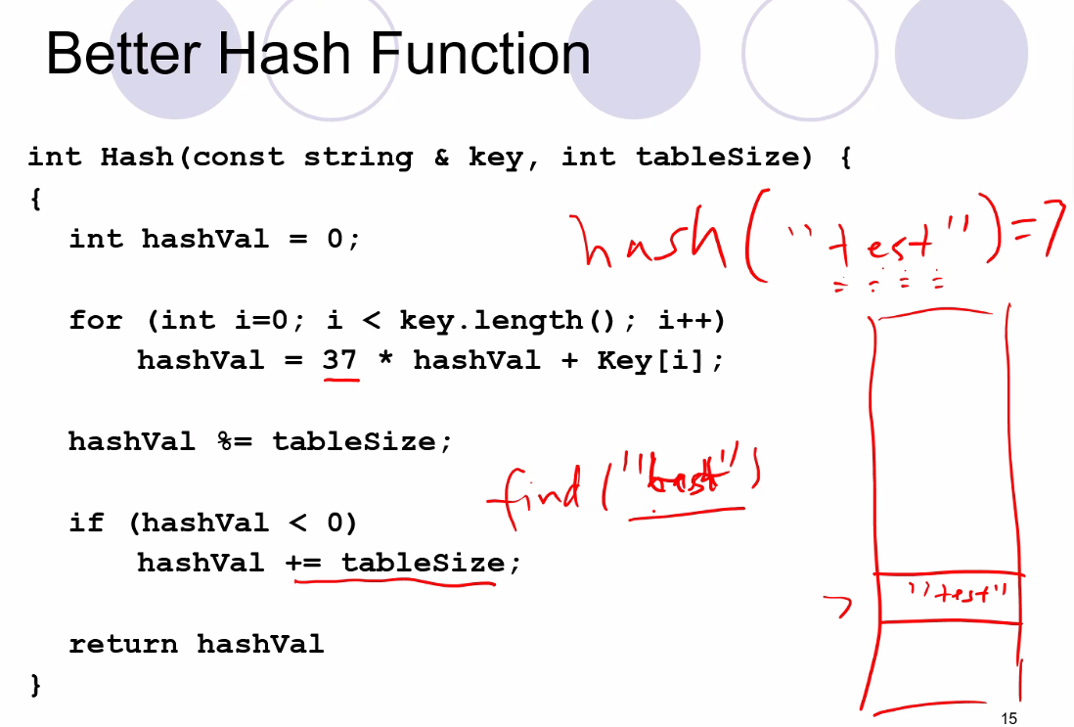
  + This is the implementation of a polynomial hash function
  + 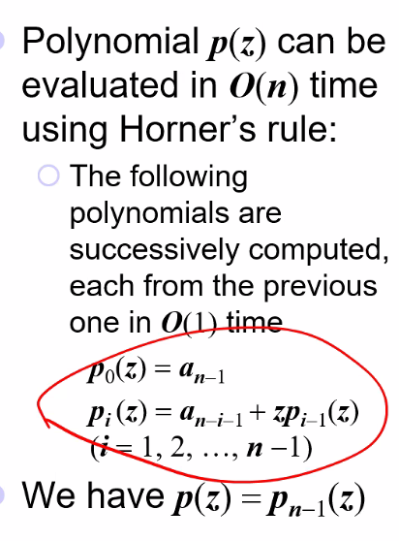
  + Also, notice above, to store “test” (a key), put it through hash function to get a table entry value (7), and then insert the key at that table entry value to store the value
  + To find “test” key, put it through hash function and also get the table entry (7), then go to that index and retrieve “test”
    - This is why it is very random in terms of where elements will be stored in the hash table; it must go through then function, and the key that is returned/assigned is where the value will be stored in the table/array
* Chaining
  + each table entry stores a list of items
  + 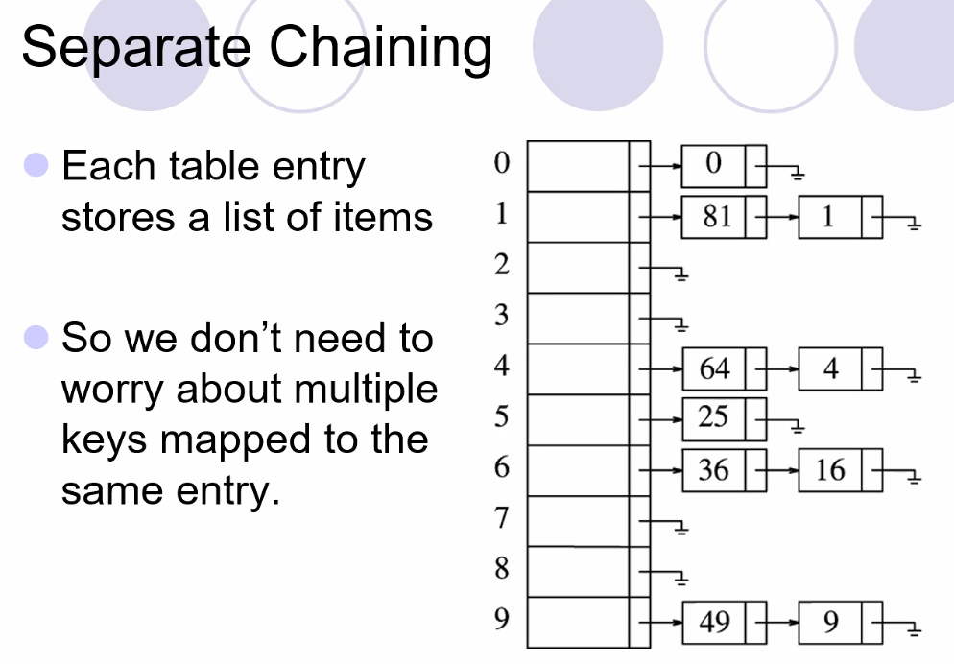
* What about a 2D HASH TABLE (where each dimension, I J, has separate functions to generate 2D table entry values)
  + Professor says this would provide no advantages; its better to use a “2D” structure in terms of using a vector of lists (chaining)
  + But also Maybe I should look into this! Maybe it could provide some kind of advantages?????
* You can hash, for example, different data members of a class; example: if you have an employee class, you could use the name, id, salary…etc..as the has value of the employee by passing that value into the hash function
* Also, often times, the list is sorted at the vector’s list locations, as can be noticed above, each list is in decreasing order
* 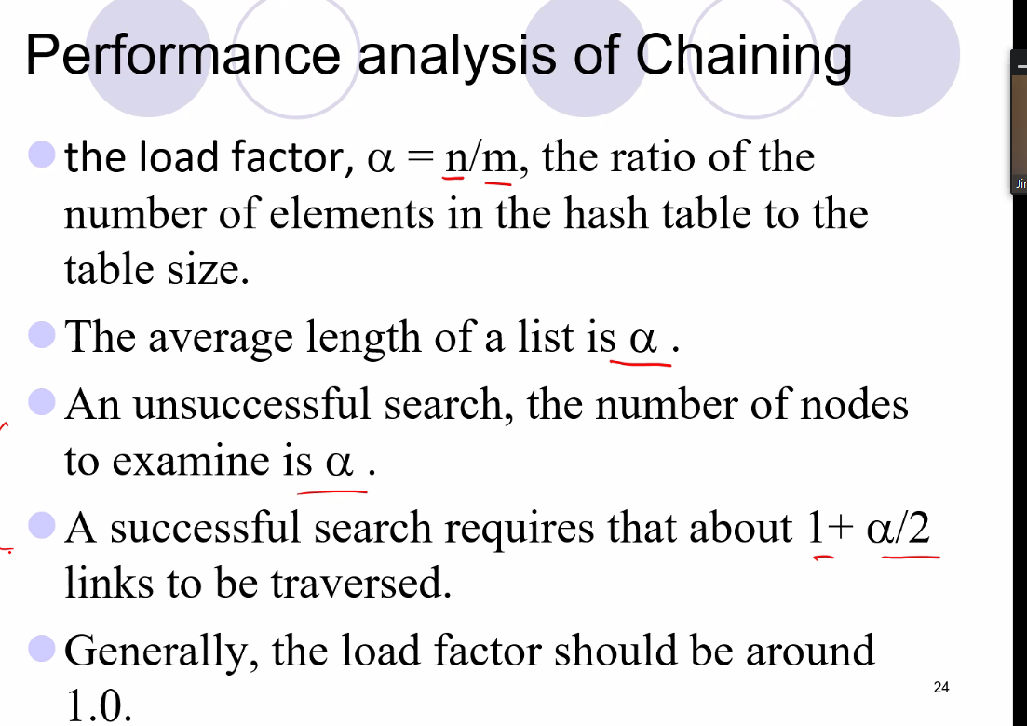
  + Above is why for chaining, it is still constant time for search functions for average case; it all depends on the lists not getting too big and most elements being inserted in a separate location in the hash table (not stacked in a list at the same hash table entry location)
* Hash tables without chaining is typically more efficient and faster and easier to implement and more popular
* 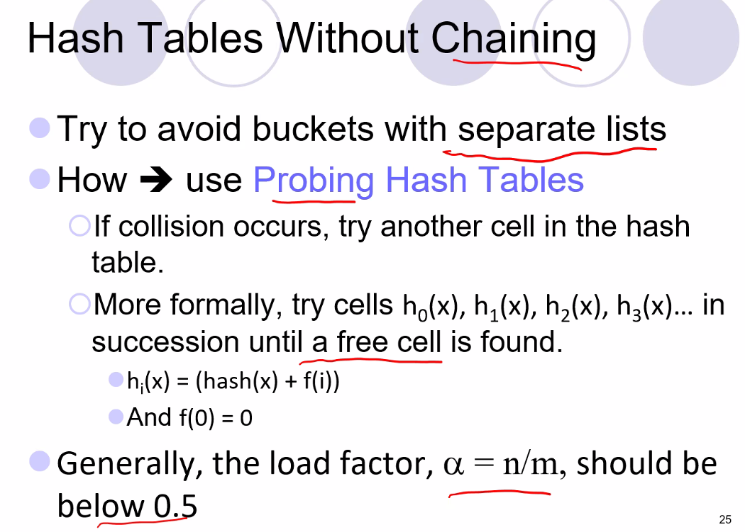
  + Notice load factor ½ of hash table with chaining, meaning it is loaded with half the capacity as a normal hash (even despite probing which will give entries a key if their entry is not free); so that means chaining is more efficient in terms of space (memory use); however linked list (pointers need space) is more space costly for chaining, so in reality it is hard to say if chaining or probing is more space efficient.
  + A probe key is used instead of inserting into a list, so that this key is incremented and added to hash entry value returned until an empty space is found
  + 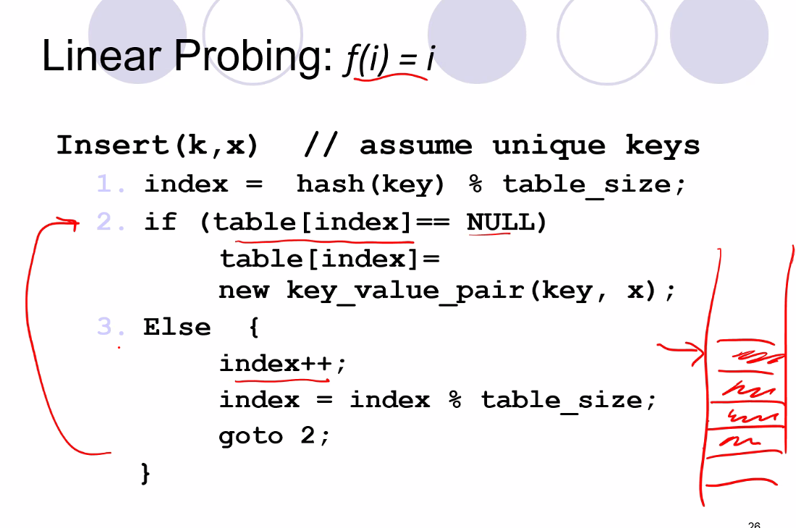
  + 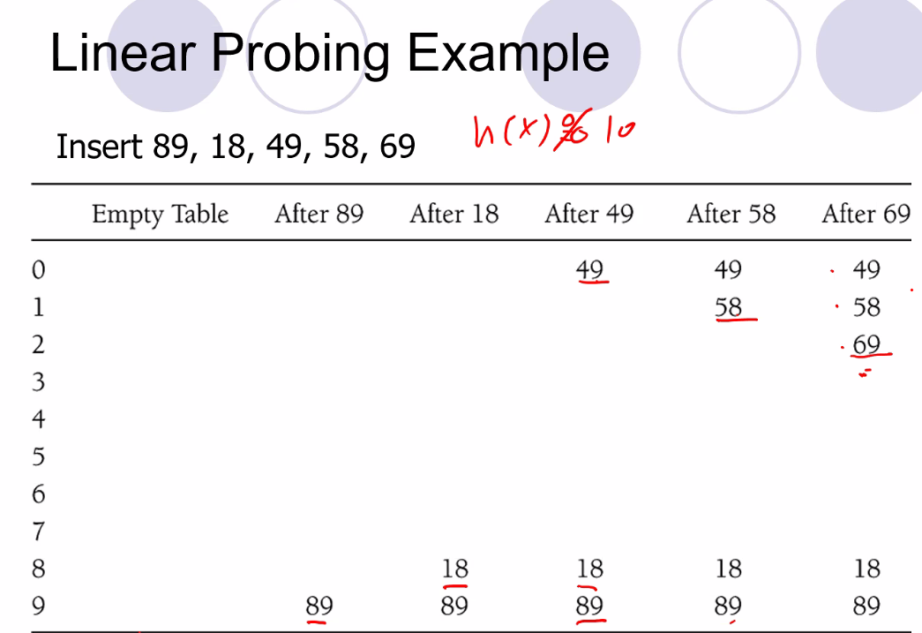
  + Notice, insert 69 last, hash entry is 9, but 9 is occupied, so then it is give a key of 0, but 0 is occupied, so probe key keeps incrementing until key 2, which is a free slot in the table, and so that is where it is assigned
  + Simplest delete strategy is to delete an item, but still not allow items to be inserted at that location
    - 3 information at each table cell: active, empty, deleted
  + 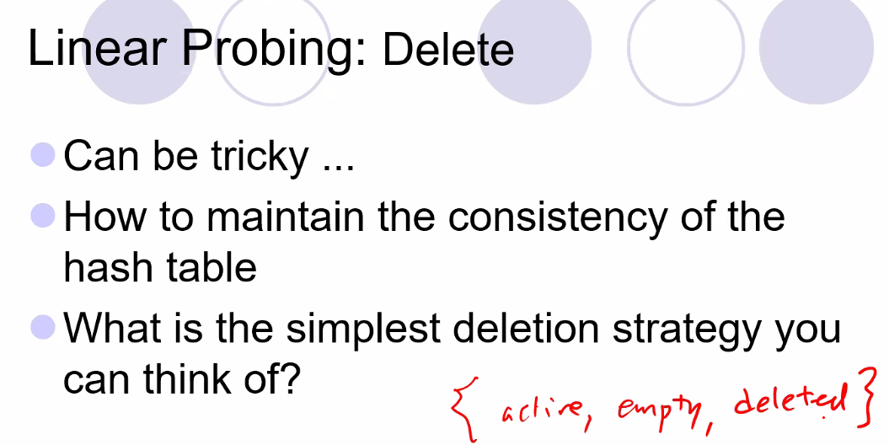
  + So deletion method can be complex, so it is just marked as deleted or empty, and its probe values stay the same so that new insertions and or searches will not be affected from deleting a value
    - Tradeoff of this easier “deletion” strategy is a loss of memory; so loss in memory efficiency
  + 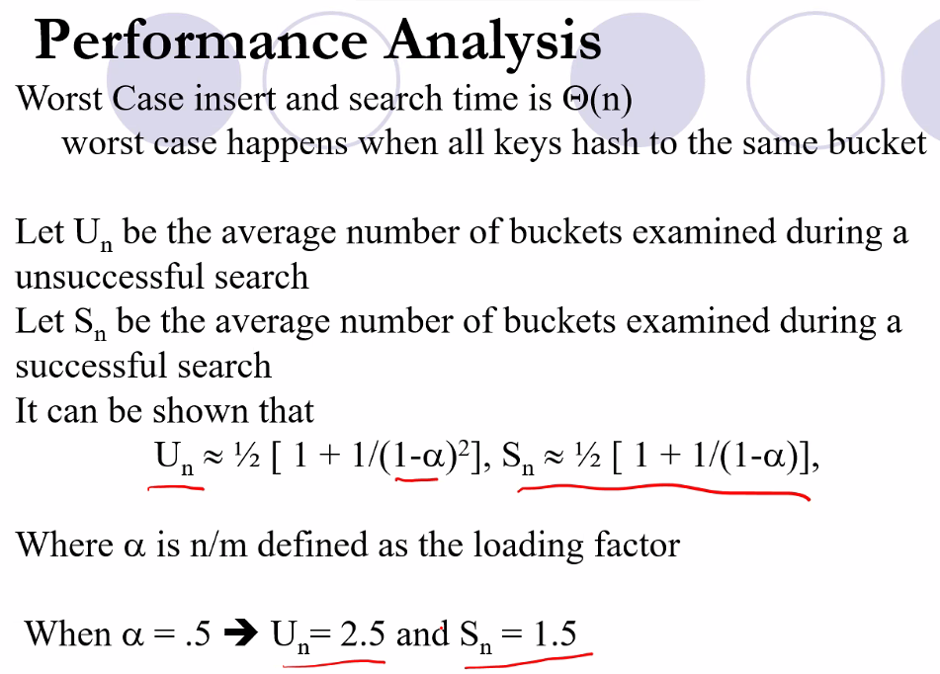
  + So based on the formula, notice we must limit alpha at a certain value range so that an Un and Sn will not approach infinity
  + You want to keep alpha at or less than 0.5
  + 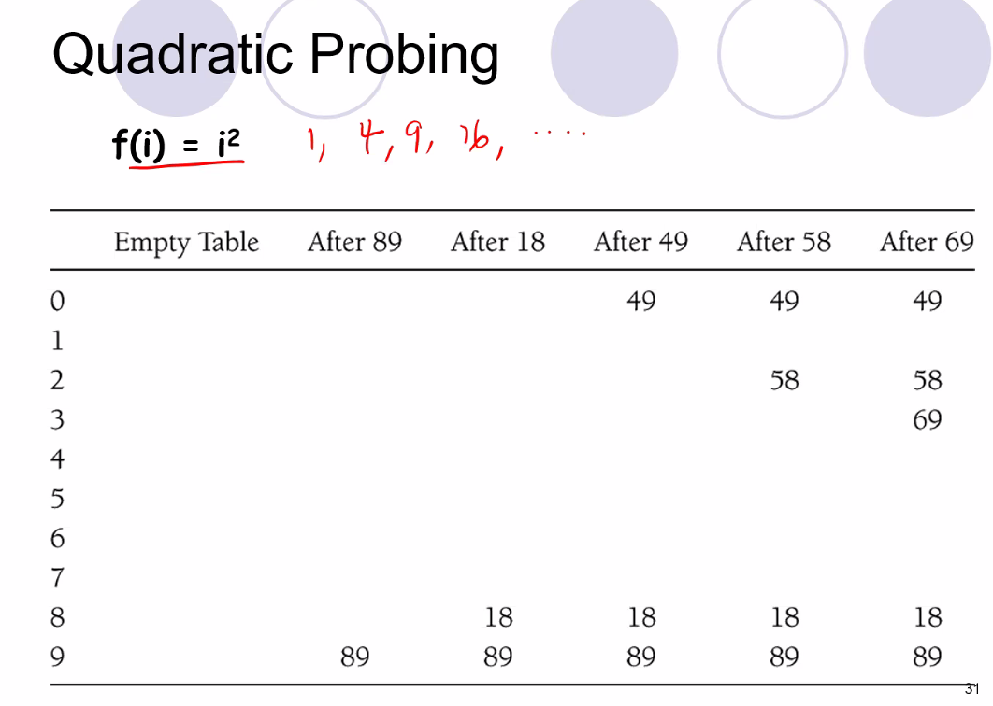
    - Same idea as linear, but probe values are incremented as a function of i^2
    - This will help leave additional spaces for new entries by avoiding clustering; but its no guarantee it will be better to use quadratic over linear probing
  + 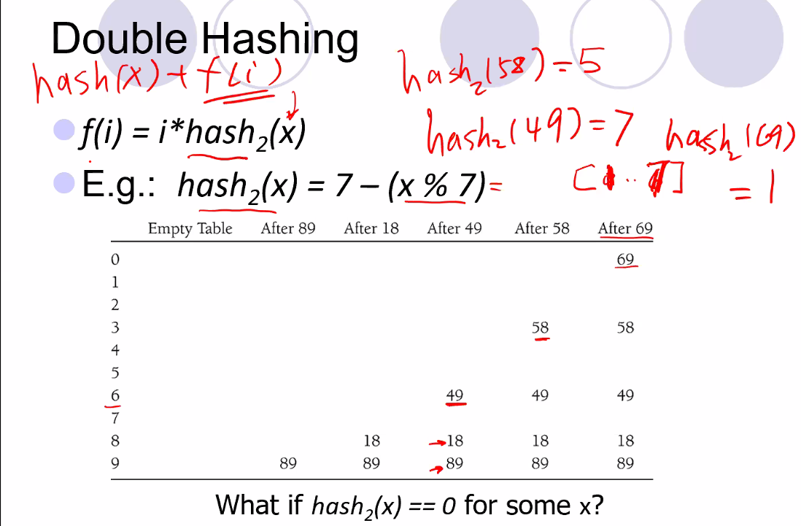
    - Probing depend on object itself
    - We still do the initial hashing
* 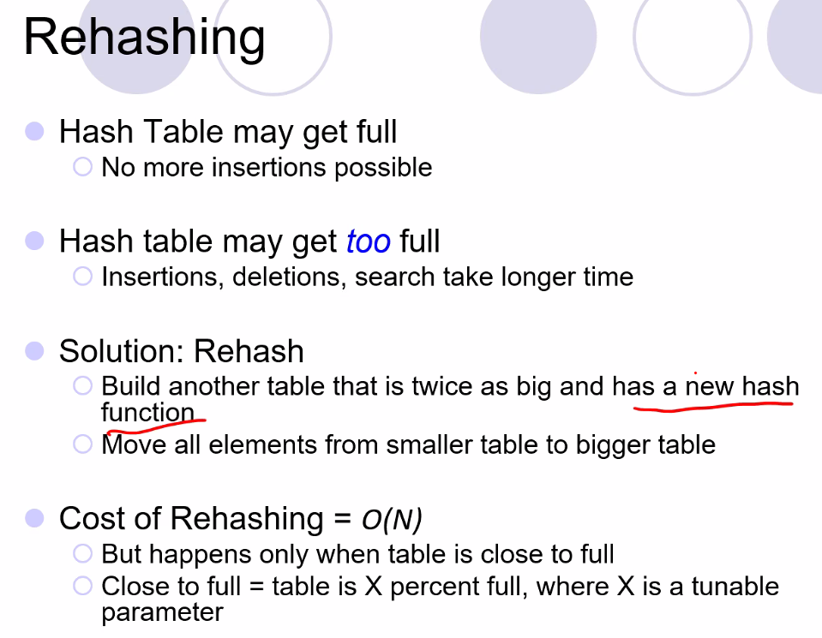
  + Cost of rehashing is very expensive (takes linear time), so it should be avoided by ensuring that table does not get too full too quickly; also keeping in mind how many items will need to be inserted and at what rate (make predictions)
  + You don’t know if entries are empty or not, so the entire table must be scanned which is why time is linear, O(n), where n is length of hash table (not number of elements in the table)
* 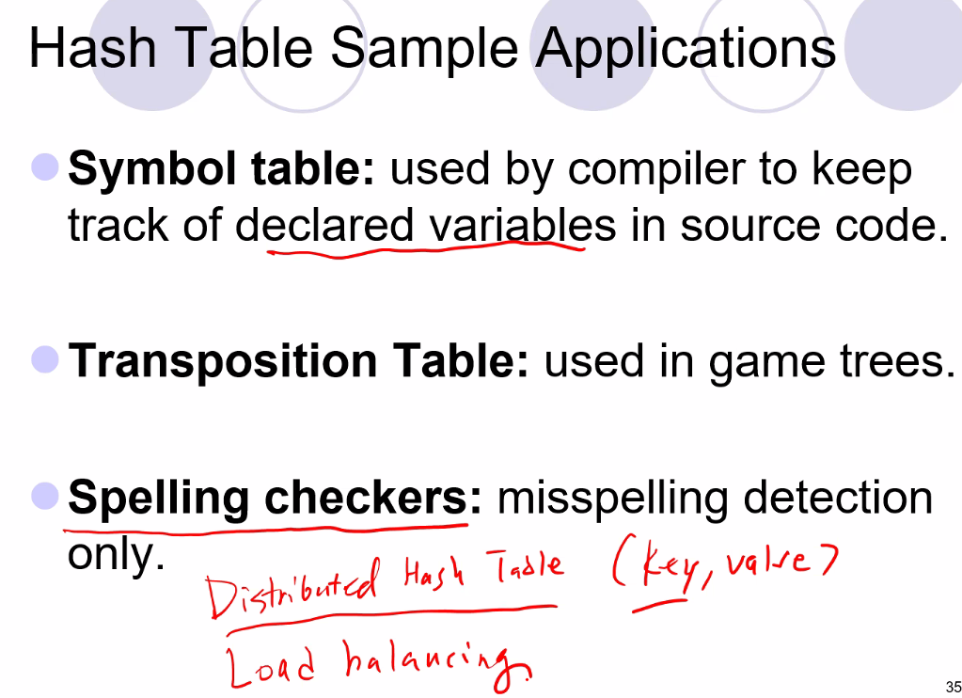
  + Distributed hash table used to say which server will store which items (say for a facebook user id and their posts, or comments..etc..)
  + Load balancing in terms of memory storage or bandwidth
* Project 2 NOTES – spell checker using hashing – this is how real spell checkers work!
  + Number of buckets = size of hash table (for hash table, we call spaces where elements can be stored a bucket)
  + 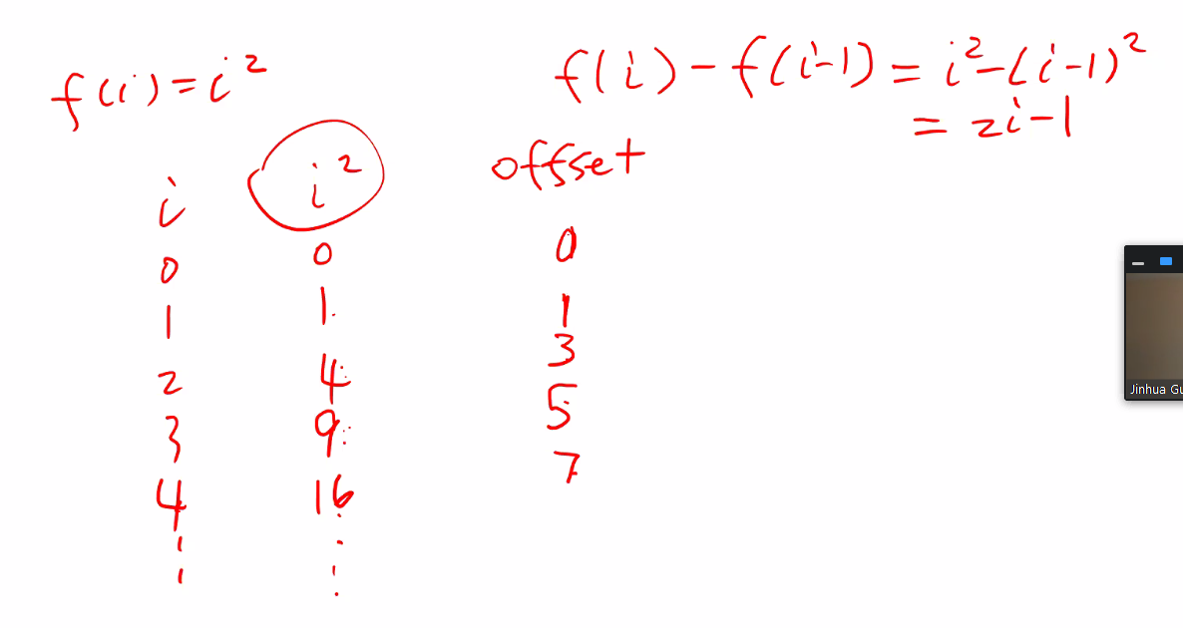
    - Instead of i^2, we use a method that is equivalent to calculating I^2, take 2*I -1, and add the previous value
  + isActive function simply says if a cell is empty or not (not deleted
    - active = element in the bucket being used
    - empty= no element in the bucket
    - deleted = element in the bucket but marked as deleted
  + nextPrime function will return the next prime number greater or = to the current value
  + also most implementation is in the header file because we are implementing template classes
  + 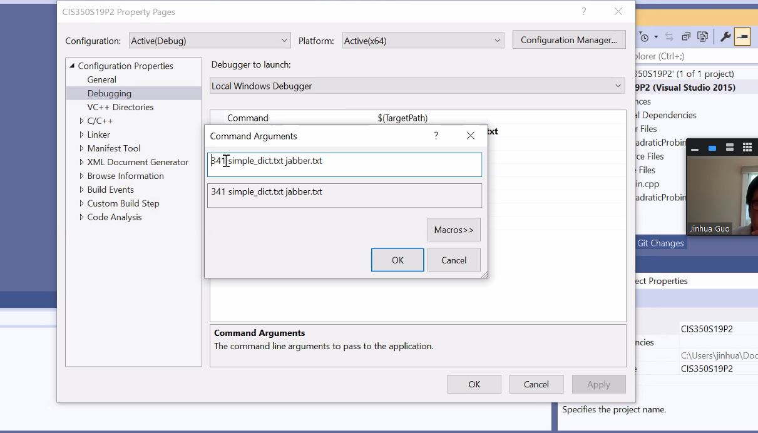
  + Go to property page and go to debugging
  + Load factor is simply = number of elements/number of buckets (table size)
  + May need to go to office hours to see what he was doing with the debugger tool property page; he changed command argument to dictionary file
  + Recommend we copy and make a new function by another name of the findPos function (that is used by the insert function only) so that we ca collect stats only for insert function; the other functions can use the other find function

# Lecture 8 – 6/01/21: AVL trees

* Project 2 notes
  + Remember make a separate copy for the find position function so that the insert and find methods will not change the stats of the find pos function which I need to have a private data member in those functions in order to track collisions
* Make sure to run the program using command line parameters
  + 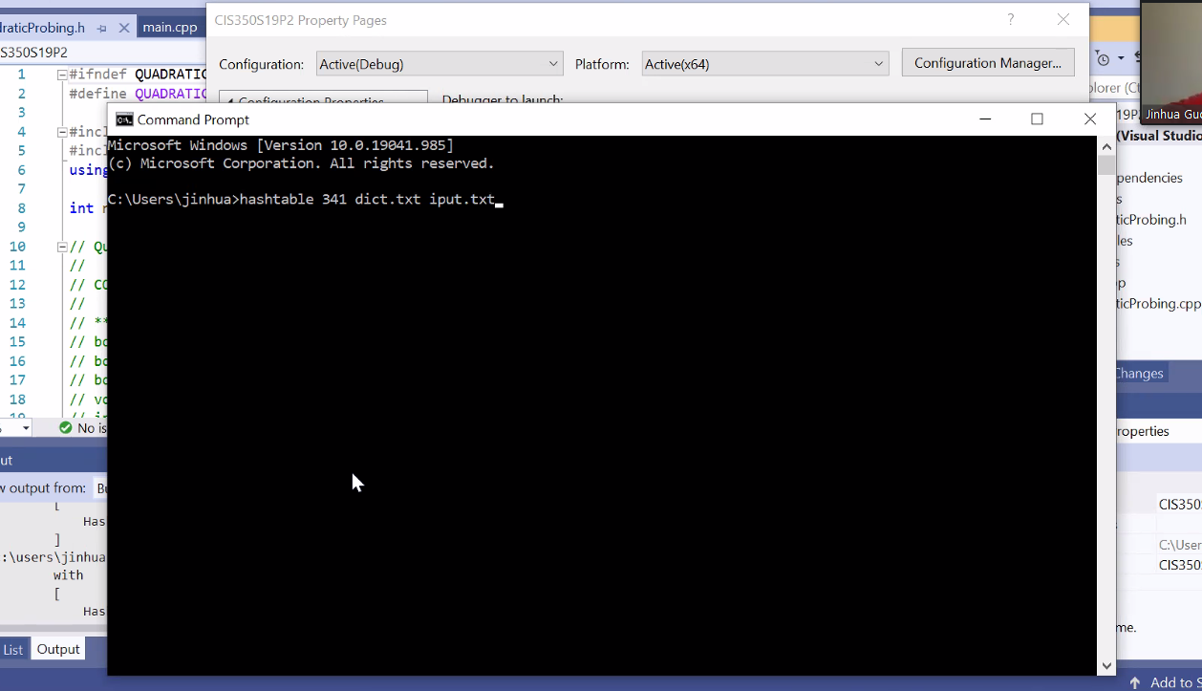
* 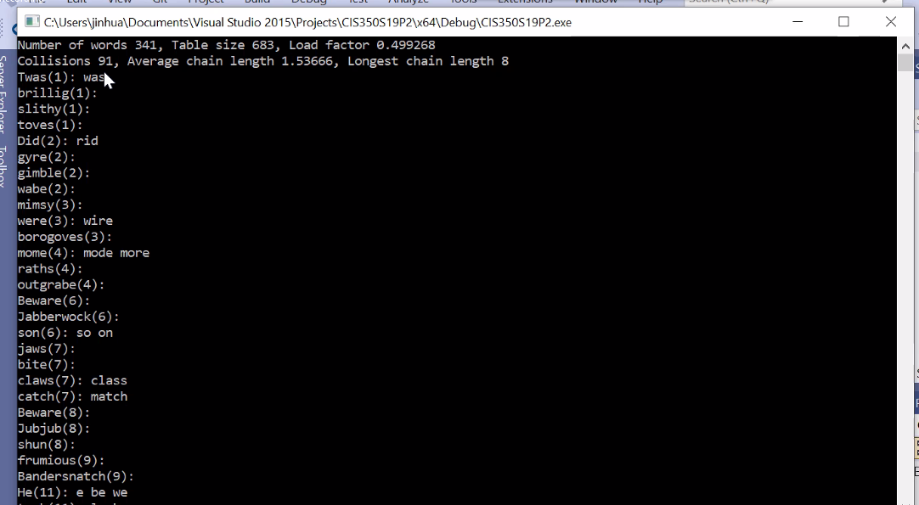
* The number refers to a line number
* The words after : are suggestions (if any suggestions can be formed from the program)
* 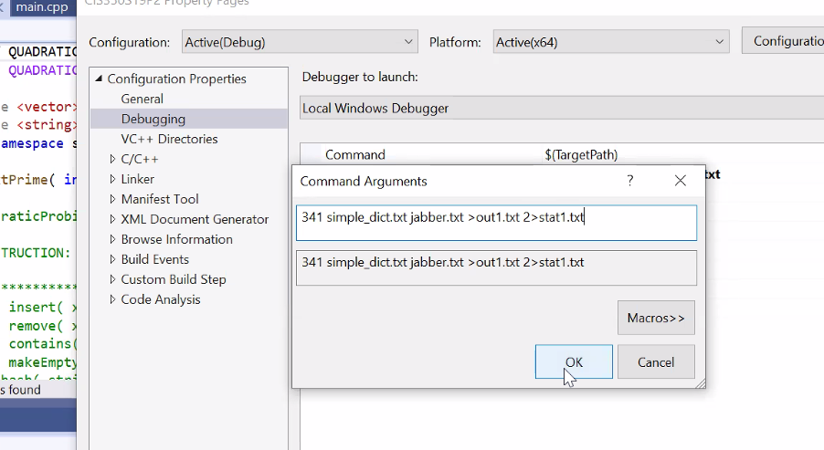
  + Above also, professor showed how to redirect the std out and std err output to a file instead of the default (to the screen)
* Command line functions are parameters to the main function (arg c, arg v)
  + 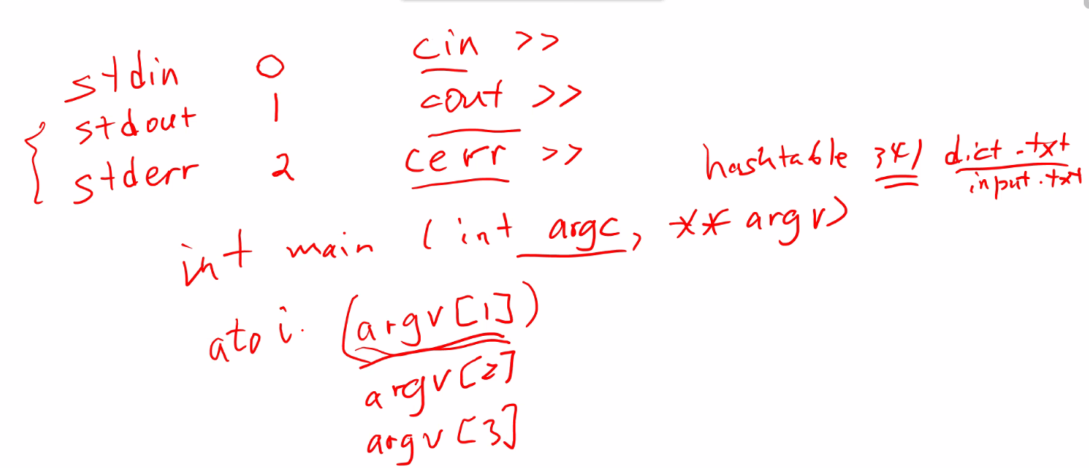
  + Arg c tells number of parameters
  + Arg v is a double ptr to strings that tells you the referenced parameter
    - Arg v is a string pointer (so that’s why you put file name in each parameter); and of course we want to point to a memory location containing text to use for input or a location used for text output
* Note: all correction suggestions to a word should be in the dictionary
* We are only working with lower-cased letters, no need to include capital letters
* There are 4 separate methods (functions) needed to generate corrections as specified in the project 2 insutrctions
  + But Remember: to check if a word is in the dictionary it takes constant time using a hash table, so it won’t take that long to execute even though we are checking 26 letters at every position of a word for a given correction suggestion method
* Call c++ split function after you add a space in place of all punctuation in the text file to be spell checked order to then put each word on a new line
  + Another choice is to use stringstream so that you can acquire only the word and ignore spaces using the ss class functions
* For worst case time analysis, you may need to define several variables:
  + 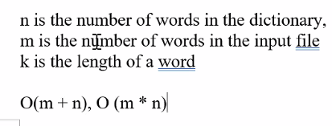
  + Insert, delete, and contains, you need to do AVERAGE AND WORST case analysis
* In submission: include the hash stats output txt file for huge dictionary, and also include the output txt for results of spell check for both input files
* Delete test hash values so it does not mess up your stats (don’t include the TestQuadraticProbing.cpp in final run)
* HW 1: questions
  + Question 2: only need worst case time and give a few sentences explaining how you do analysis (not too much analysis)
  + question 2-6:
  + 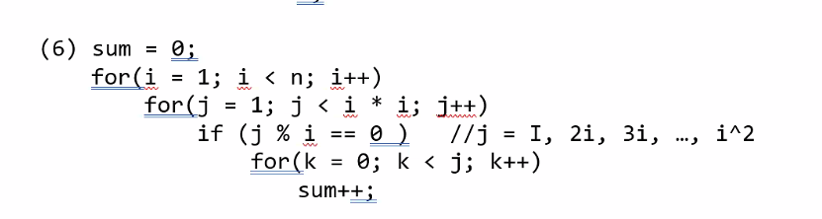
  + J must be a multiple of I for the k for loop to be executed so this will affect analysis; make sure not to simply always include the k loop (thus answer is not n^5, it is smaller)
  + Question 4 refers to full binary tree
    - You could prove by induction
      * Assume base case
  + Q 5: simply traverse tree in the 3 different orders
  + Q6-b: 2 options; set new root to smallest node in right sub tree, or largest node in left sub tree
  + Q 7: maybe use a recursive function to compute a - c
    - B: recursive relationship: num leaves in left sub tree + num leaves in right sub tree
    - Then make sure to have a base case so recursive function terminates
    - 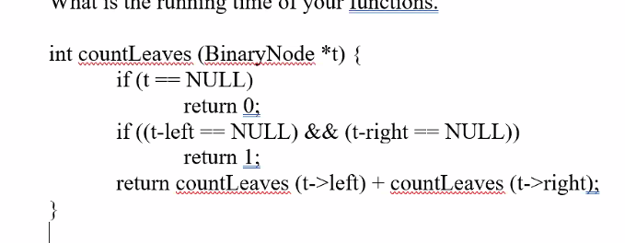
    - run time is O(N); this recursive function will visit each tree in the node
    - we can right it as actual code, or as pseudo code
    - full node == a node has 2 children
* Balanced binary search trees (AVL trees, red-black trees, splay trees)
* 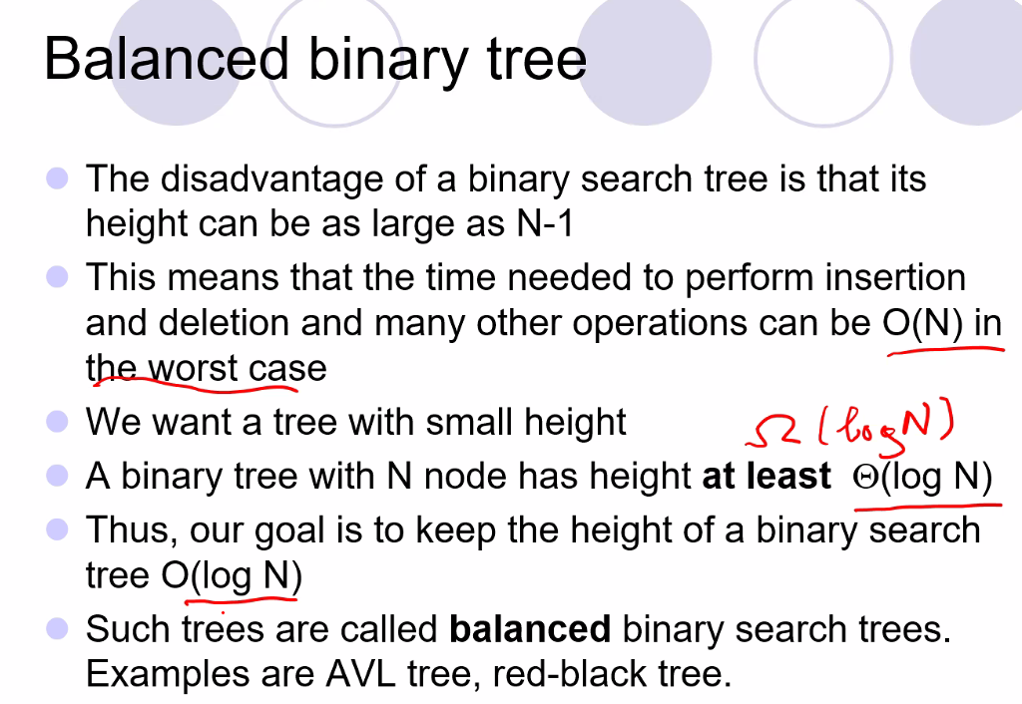
* AVL tree
* 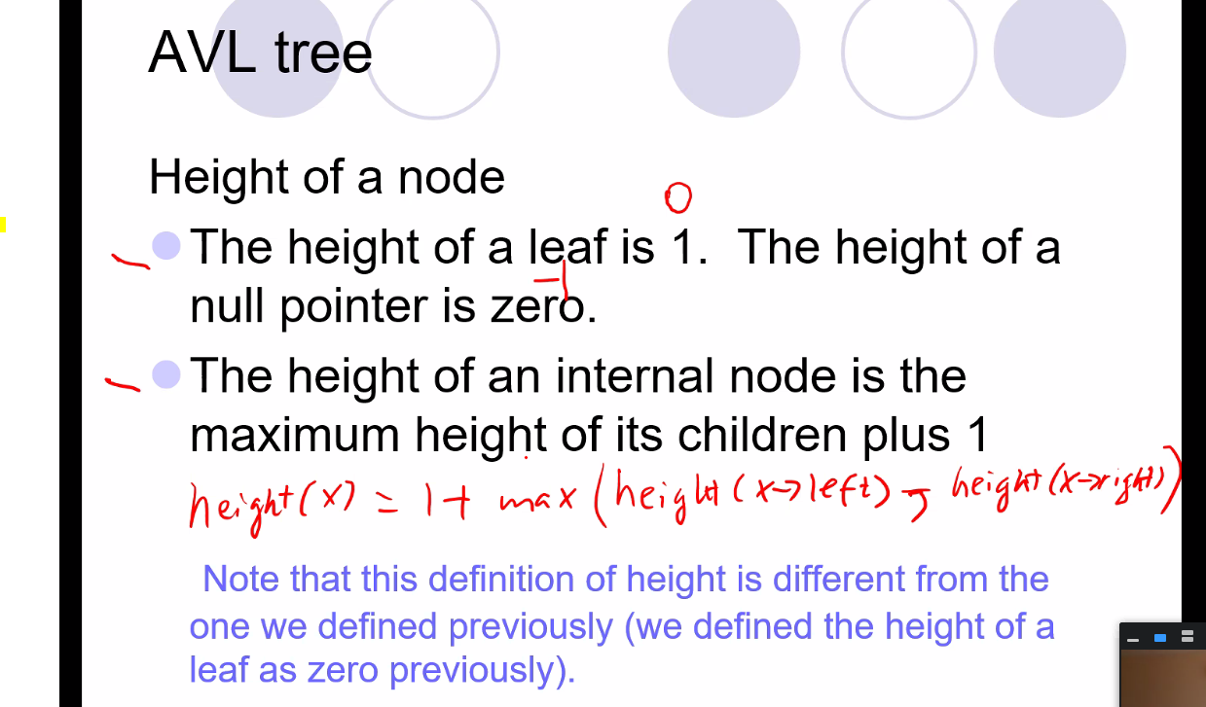
* 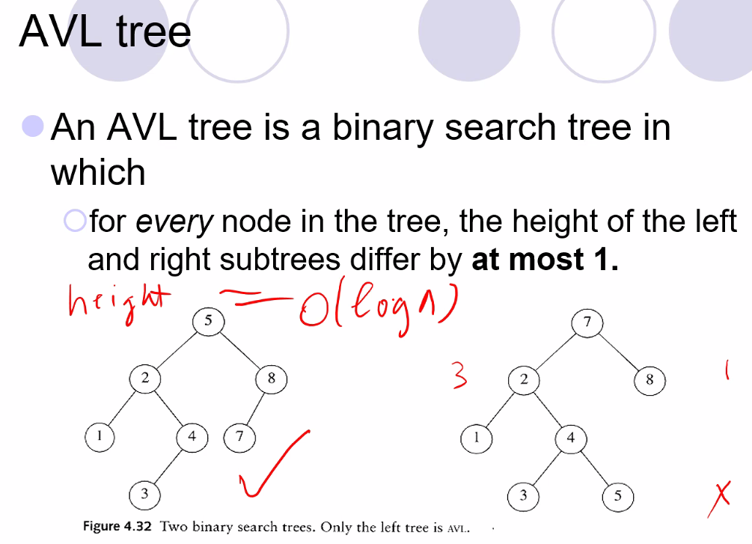
* 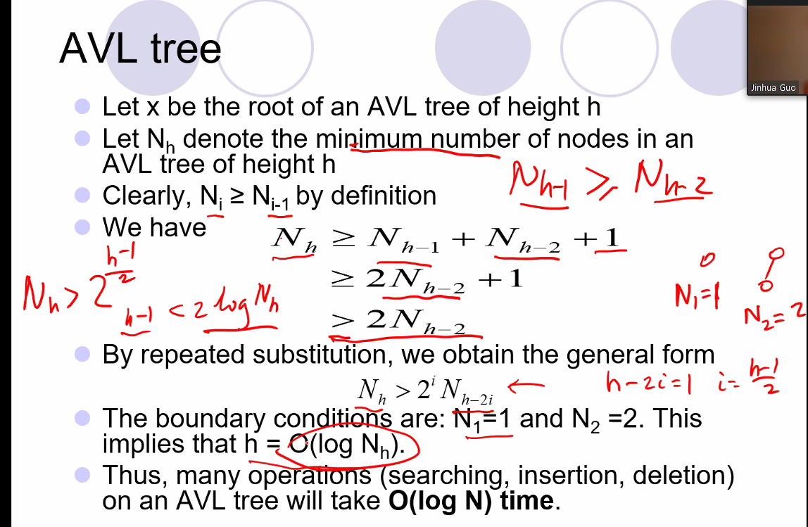
* 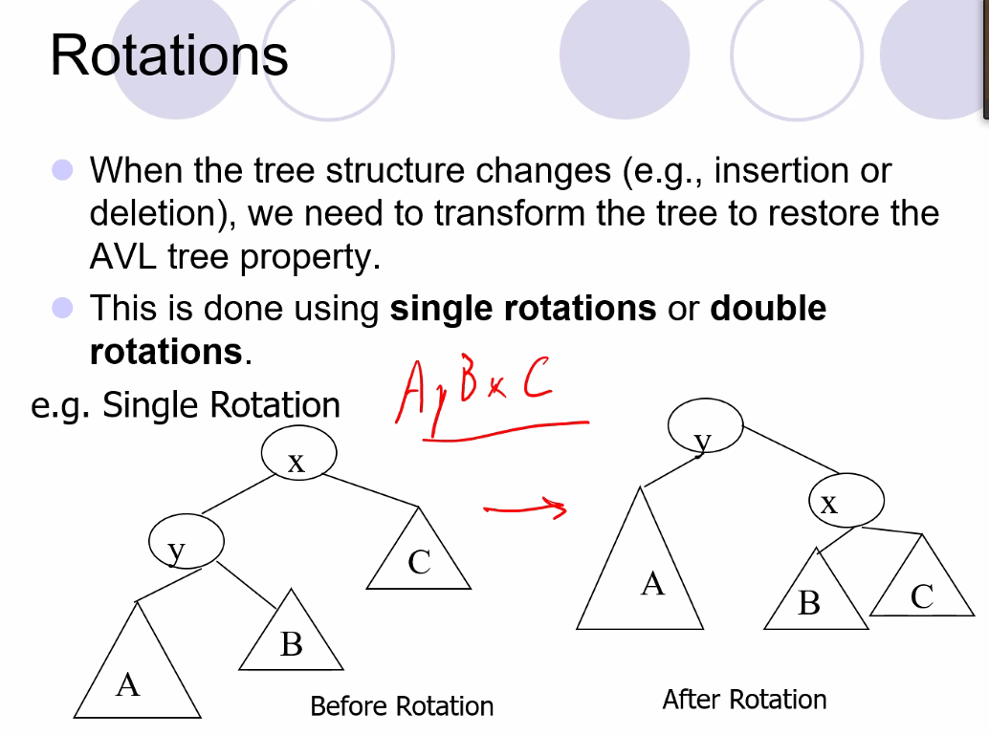
  + In order traversal is still totally ordered (non decreasing) even after the rotation
* You need to know the heights of each node in an AVL tree, so this means you should have a variable to keep track of node height
* Remember for AVL, current location of a node begins at height = 1 (not 0)
* 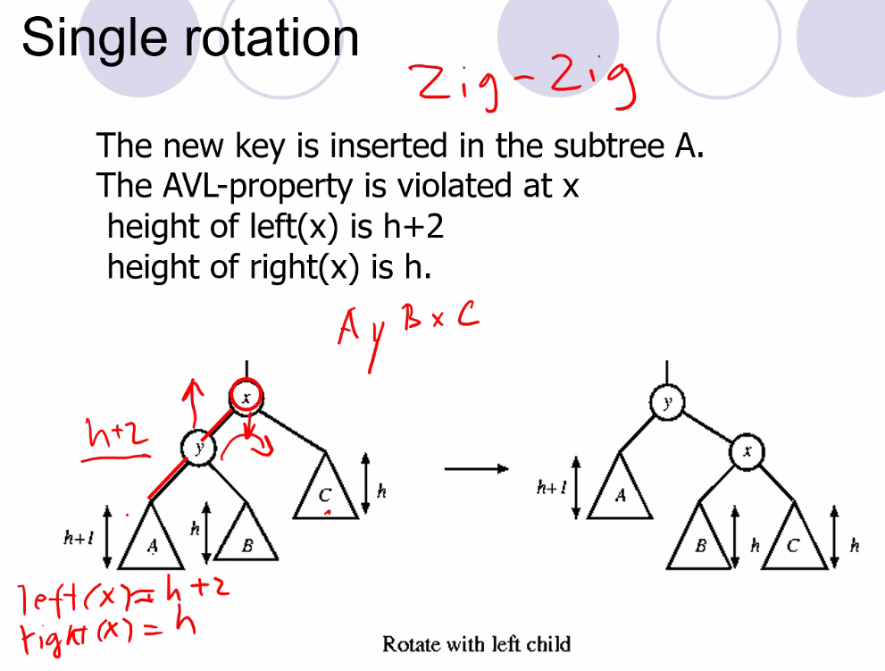
  + Zig referring to “left”
* 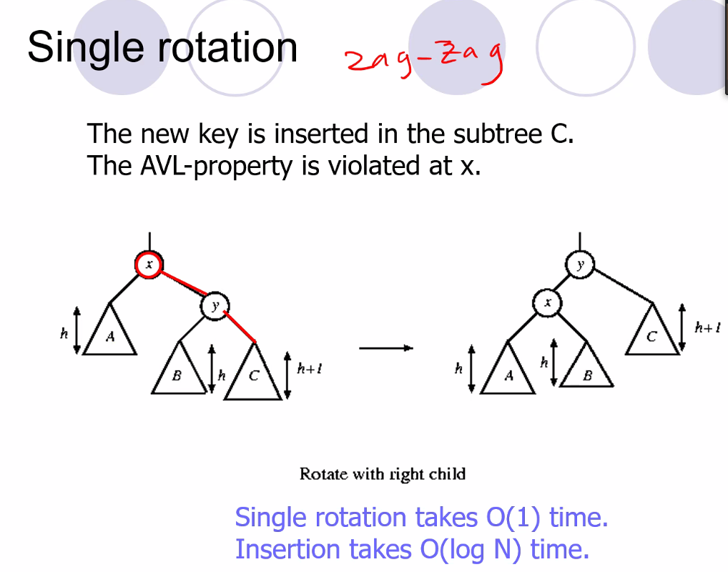
  + Zag referring to “right”
* 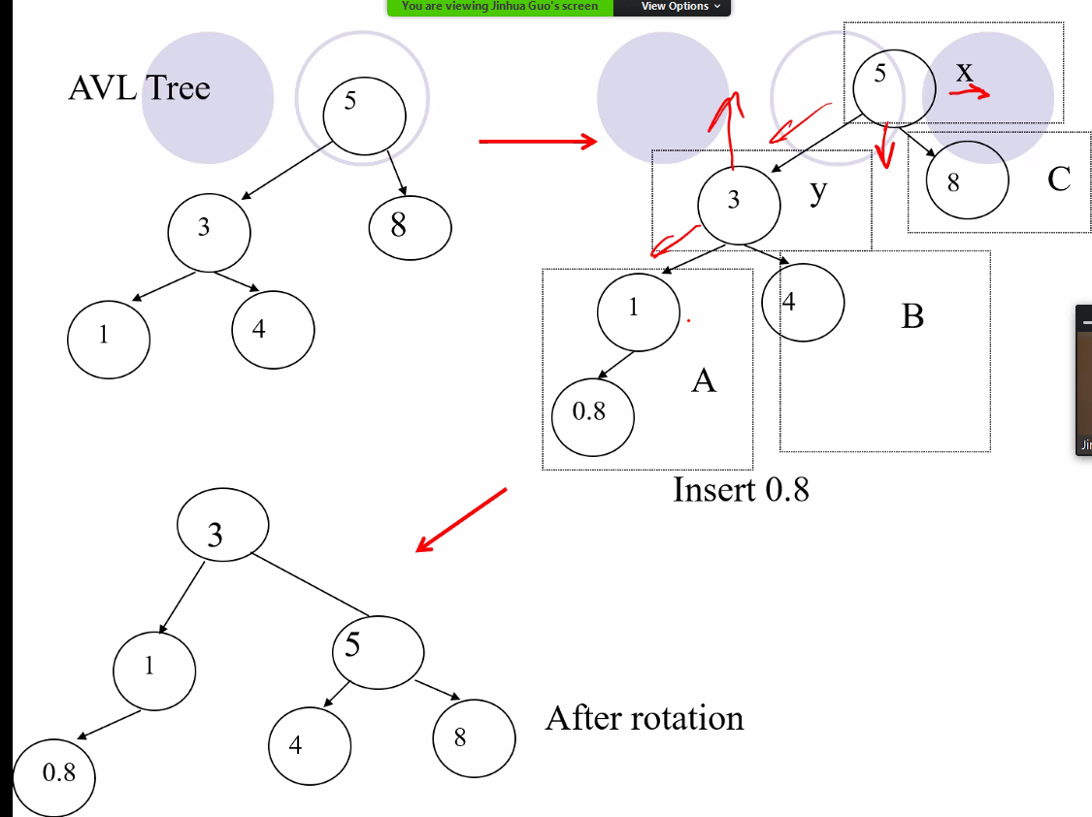
* We simply change pointers
* Double rotation have: zig zag and zag zig
* Zig zag double rotation case:
  + 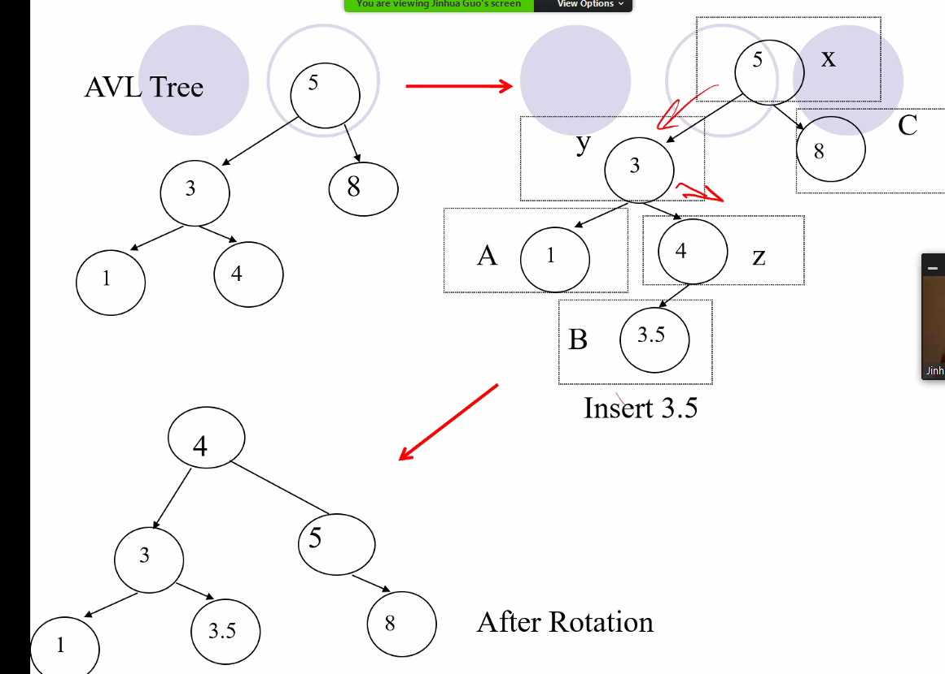
  + Remember structure is different but in order traversal should remain the same (remains a binary search tree)
* Having to include a height variable is additional cost
* Remember you only need to do one rotation at the lower nodes, it will automatically update and fix upper node so that AVL is balanced

# Lecture 9 – 6/03/21: AVL trees cont’d, and Splay Trees

* Big omega is lower bound
* Big O is upper bound
* Big theta is bound between big omega and big o
* For AVL:
  + 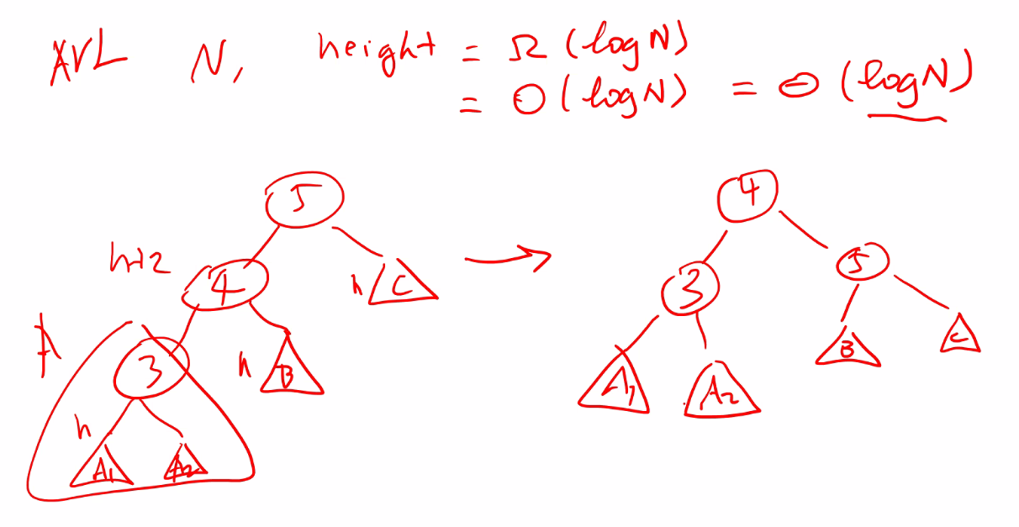
  + Zig-zig case above; apply a single rotation
* Zag-zig – do double rotation:
  + 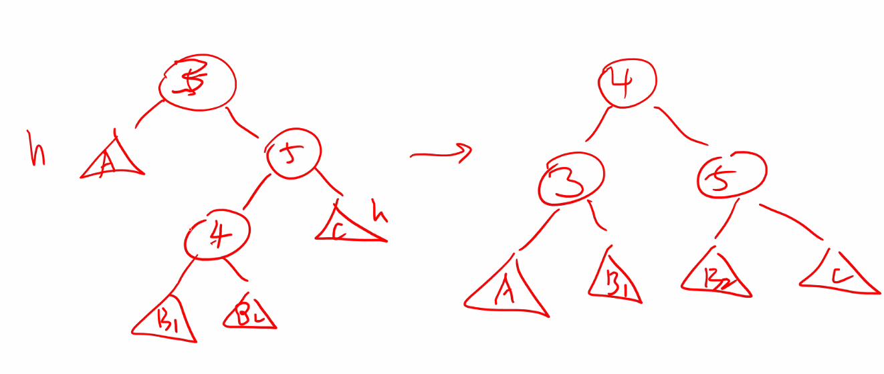
* Example inserting 1 – 7 in an AVL tree:
  + 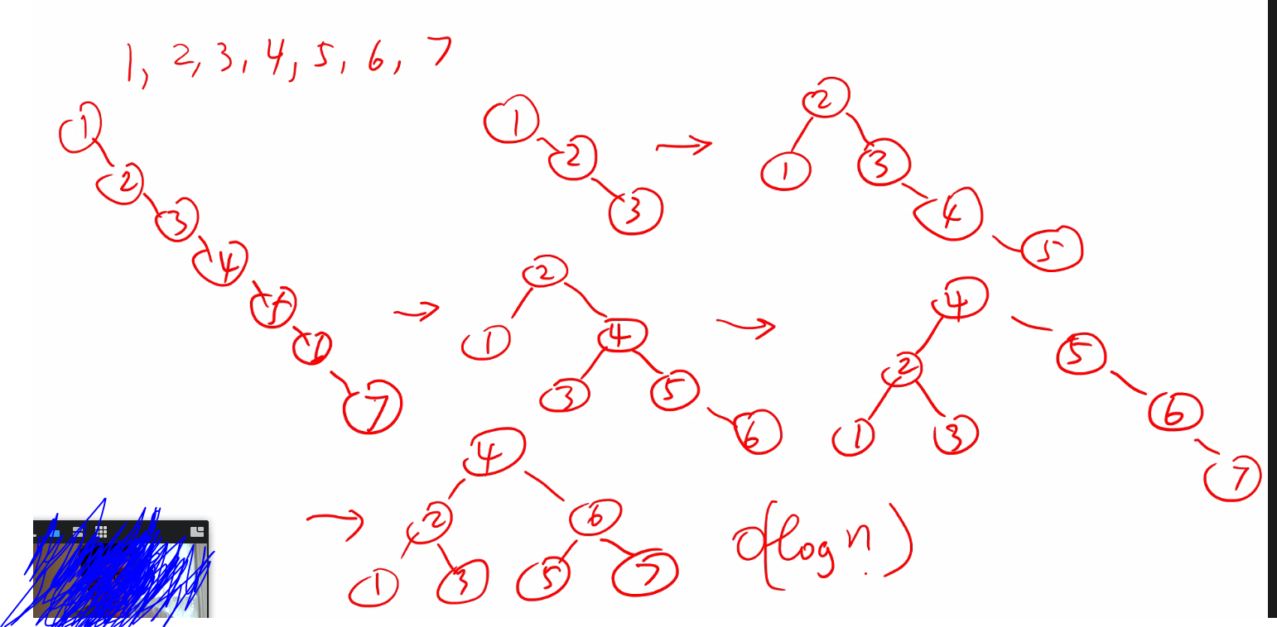
* 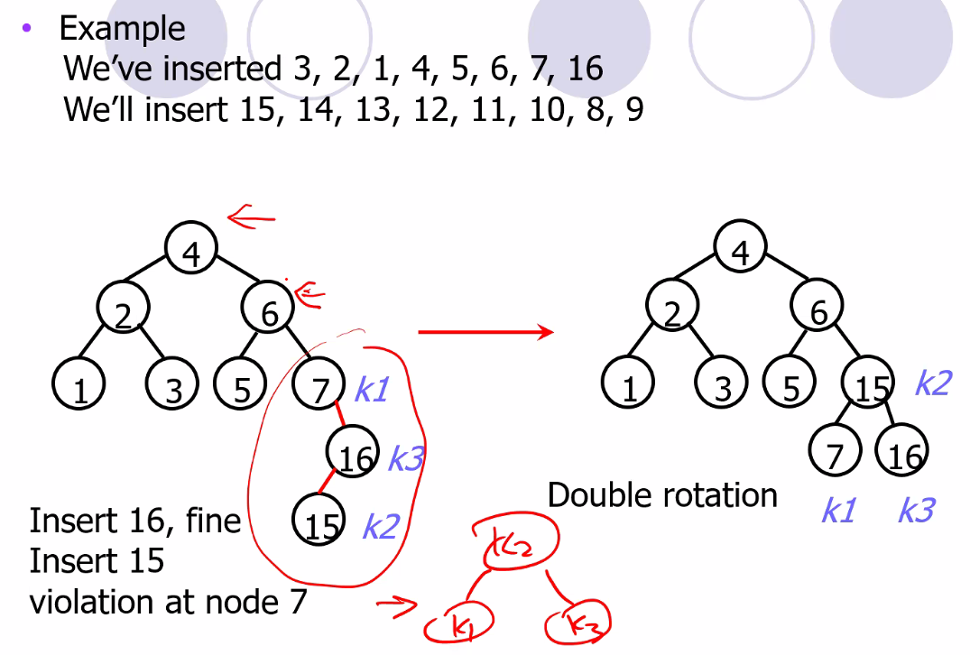
* 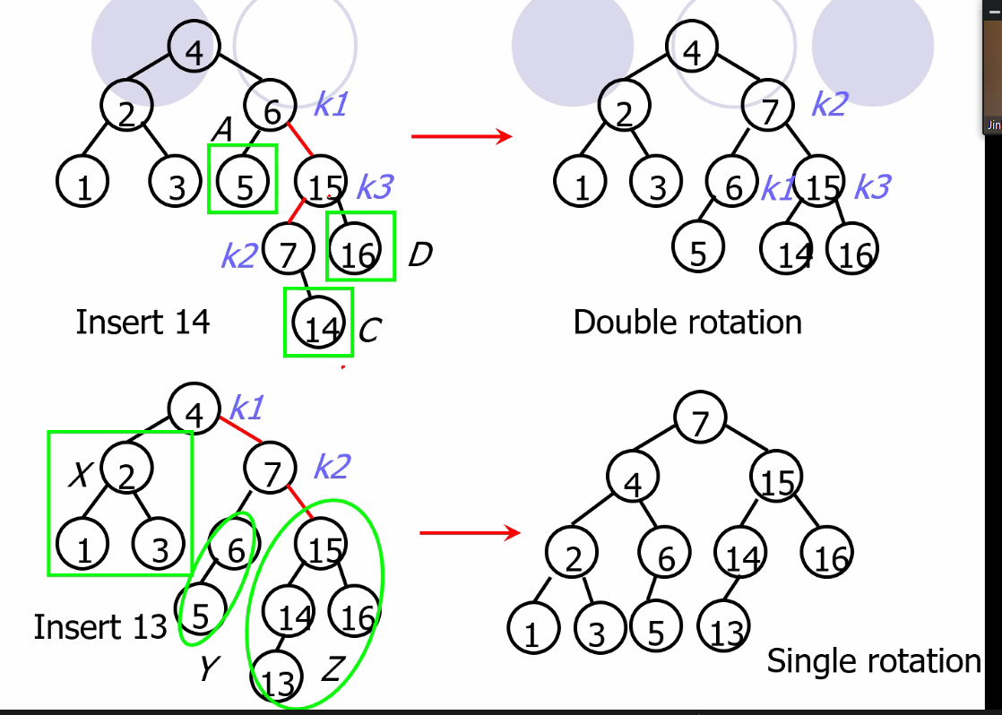
* 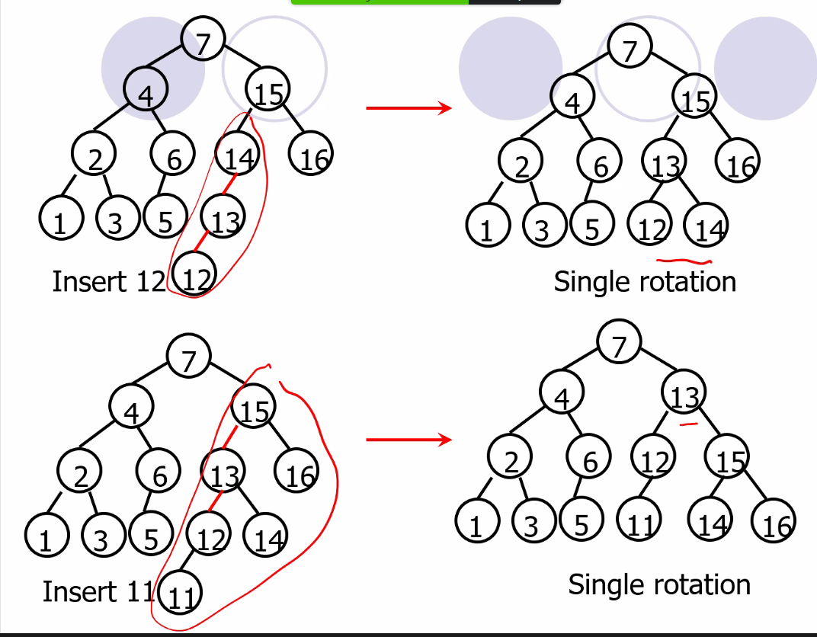
  + You take bottom-up approach and compare sub trees and make sure their height differs by no more than 1; thus, for example, the node at node 15 is the tree that is first out of balance as we compare starting at lowest node and working up comparing sub trees
* Remember you need to maintain the height of each node for an AVL in order to keep tree balanced during functions such as insert and delete..
* 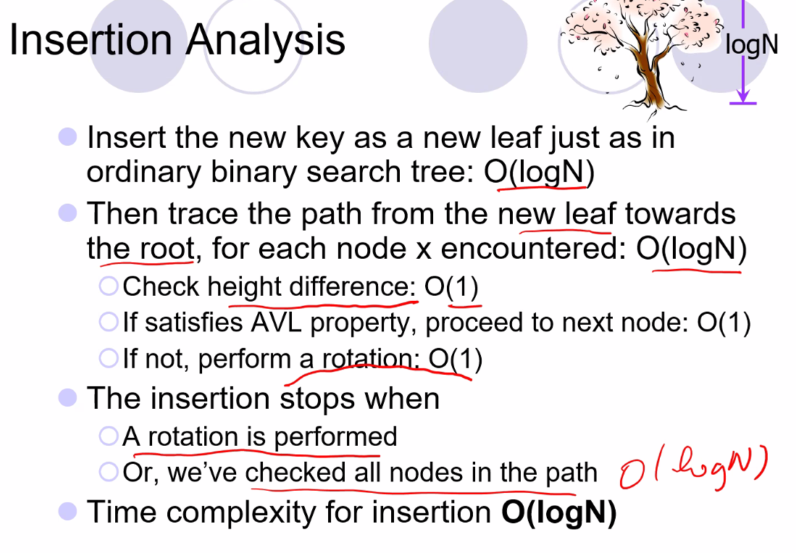
* 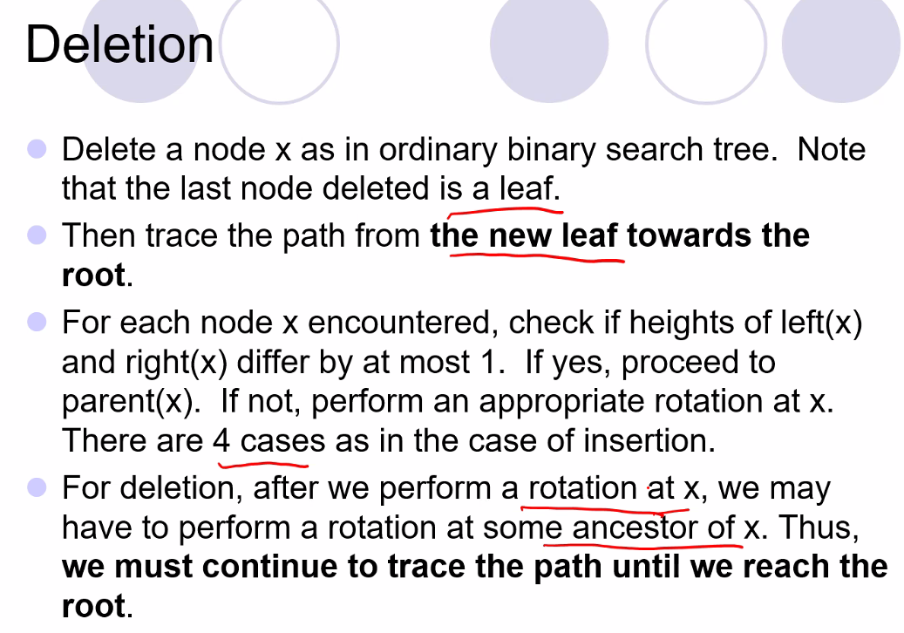
* 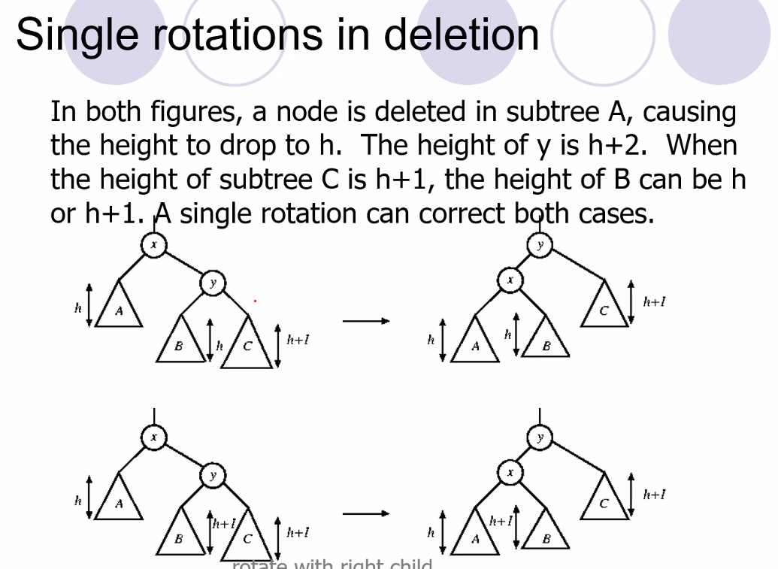  
  + The triangles represent sub trees
* 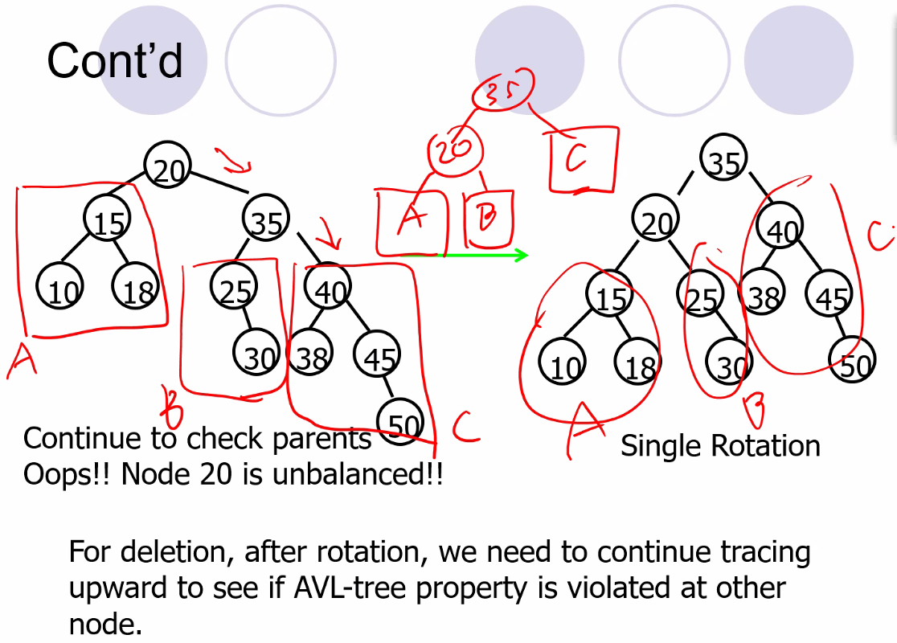
  + Above we are balancing a tree after deleting a node
* 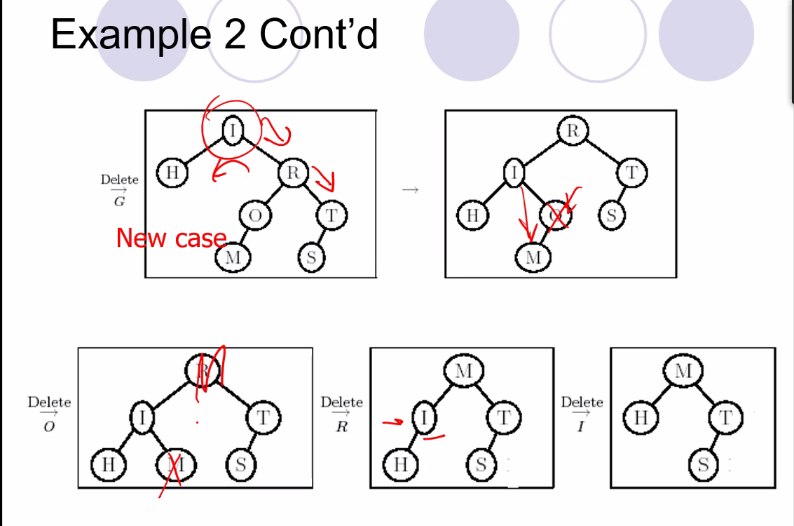
  + Remember when deleting the root, you can replace it with the largest value of the left sub tree (right most value), or the smallest value of the right subtree (left most value in right sub tree)
    - Must choose though for AVL tree based on keeping the tree balanced
* **Splay Trees**
* 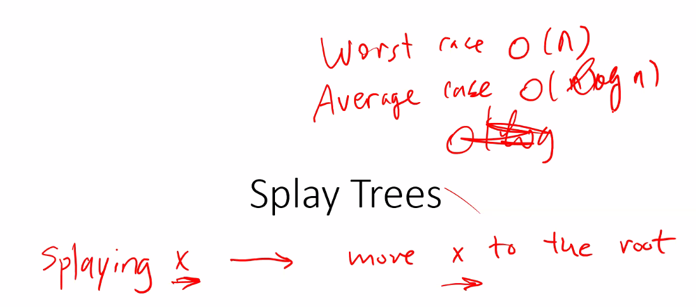
  + The idea is to move nodes that are more frequently accessed to the top of the tree
  + Disadvantage though is that this could cause tree to be out of balance, so worst case is O(N), but you have a better average case at O(logN), and you have the chance to improve the best case to less than O(logN) (up to even constant time!)
* 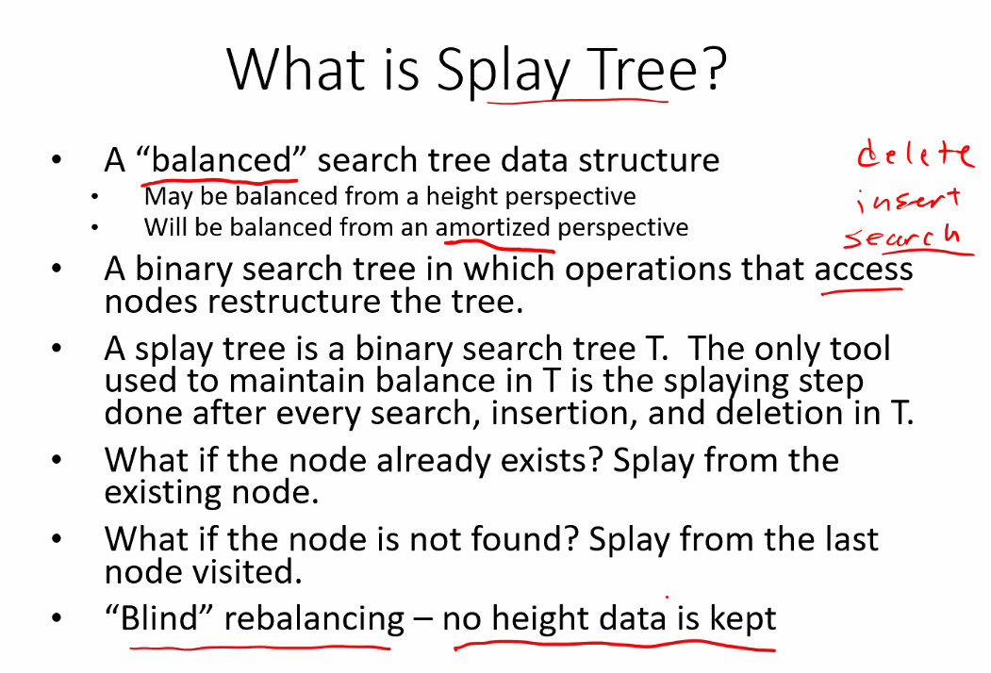
  + Amortized refers to on average
  + In practice it is very efficient (even better than AVL) even though the last node accessed is automatically splayed (made the new root, and the tree rebalanced blindly though only to ensure the tree stays in increasing or decreasing order: remains a BST)
* Video about splay trees:
  + <https://www.youtube.com/watch?v=IBY4NtxmGg8>
* Splay trees take advantage of
  + Time locality: accessing the same item
  + Space locality: accessing nearby items of a frequently accessed item
* 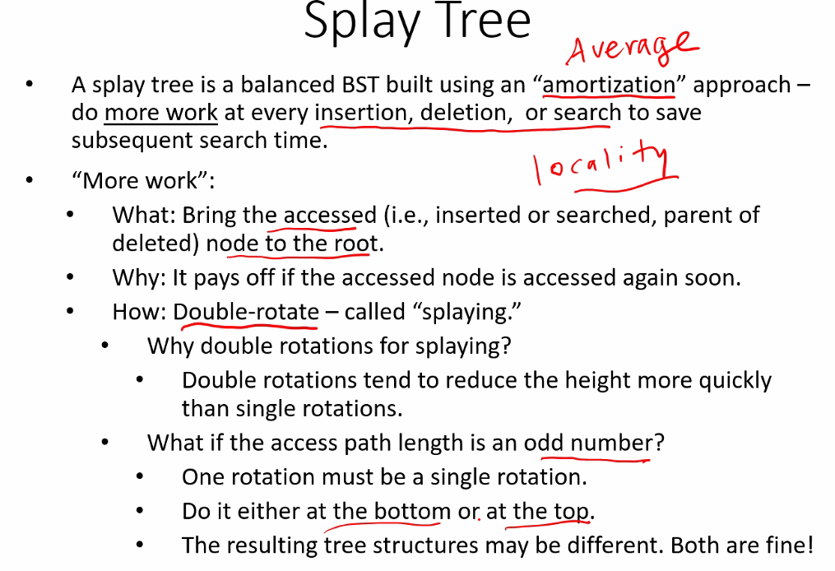
* 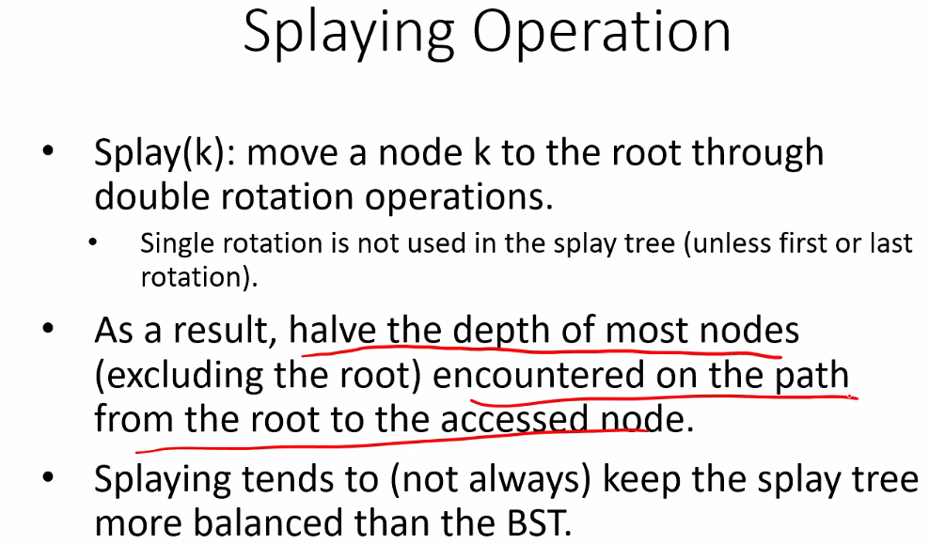
  + But remember we do not keep track of height of each node
  + But double rotation usually reduces height of the tree which is why most often we do a double rotation
* 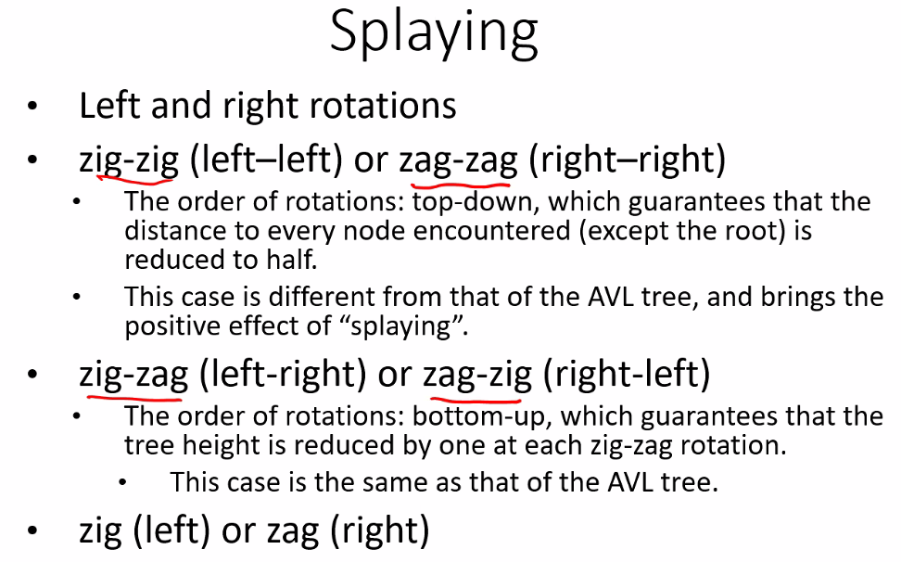
  + Similar to AVL, but you do double rotations for them all except for single zig or zag you do single rotation
* 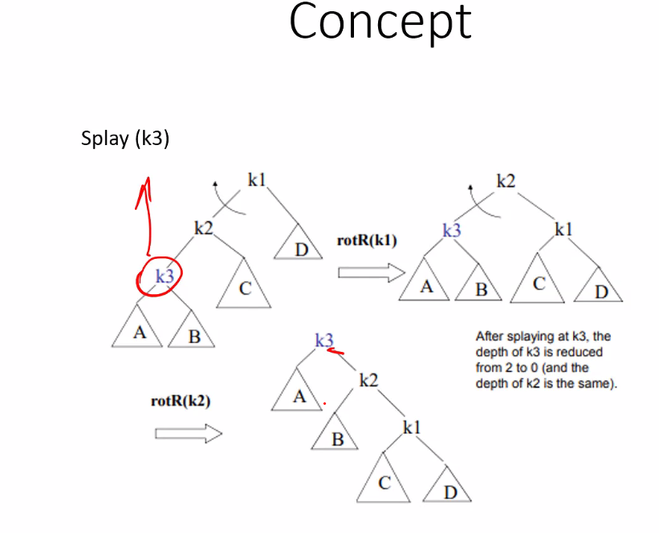
  + Above, a double rotation: rotate k1 and k2, then rotate k2 and k3
* Zag zig case:
  + 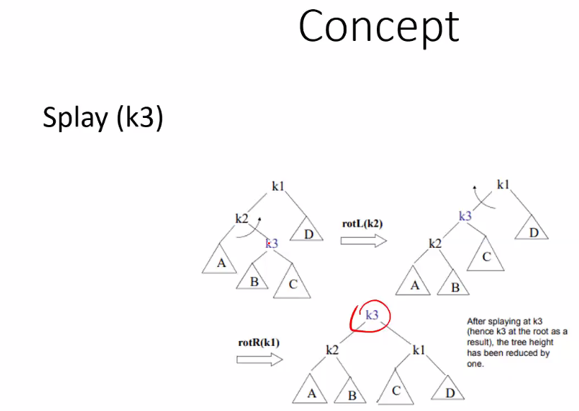
  + Remember the node to be splayed is the most recently accessed or searched (inserted, searched, or deleted)
  + Rotations don’t guarantee tree will be balanced or height reduced but, as we said before, usually it does do at least on of those
  + Here is an example, from insertion operations, followed by 1 search:
  + 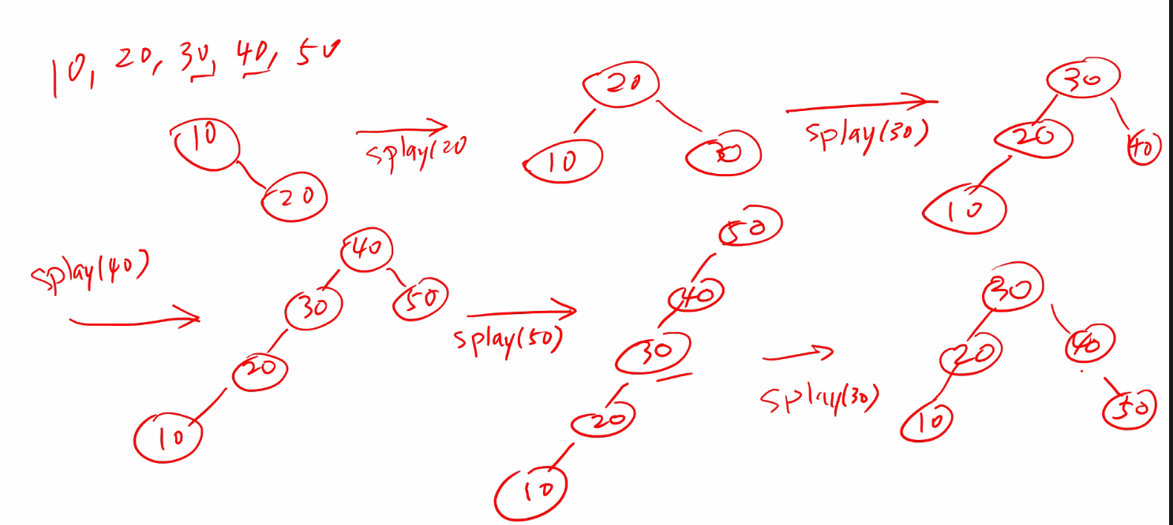
  + And here is if instead of searching 30, we searched 10 and then of course have to splay(10)
  + 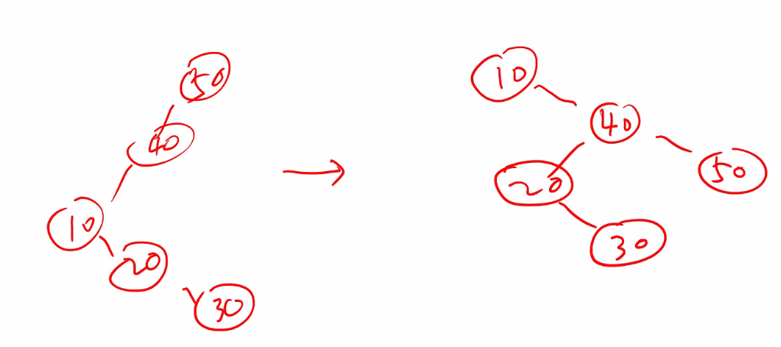
  + So again, doesn’t guarantee balanced tree, but in an amortized way (average), even after an expensive operation such as splay(10) and search 10 for a completely unbalanced tree, that operation will help cause all subsequent delete, insert, or search operations to go much quickly, so this cycle of very cheap and very expensive operations on average (amortized) is very efficient
* Rules for search
  + 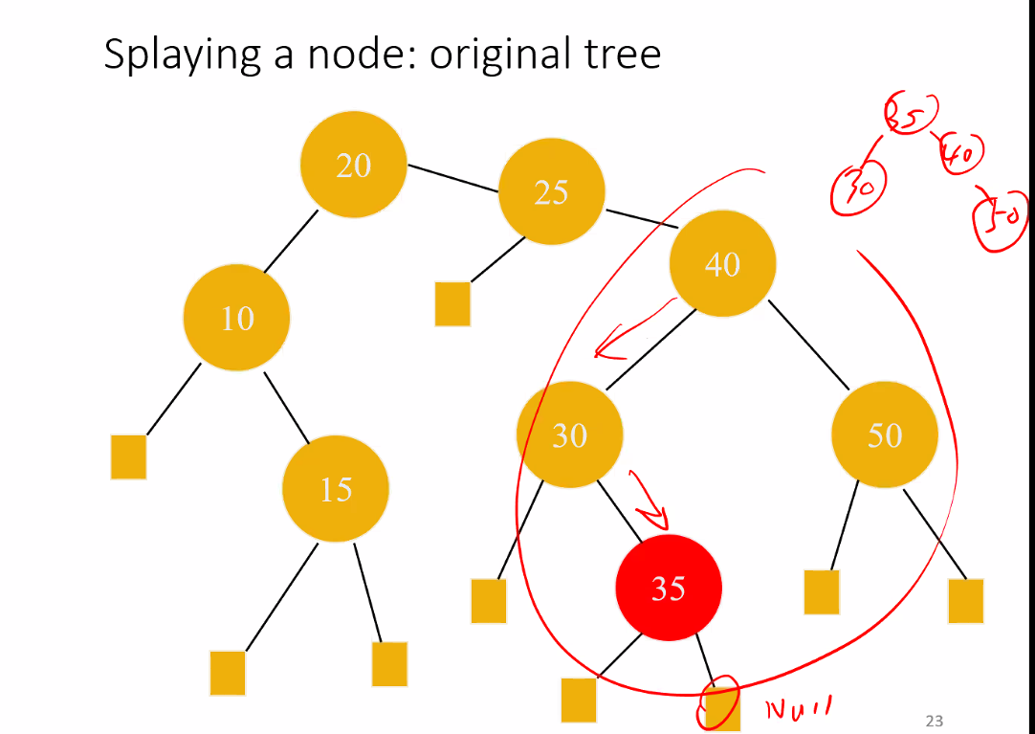
  + 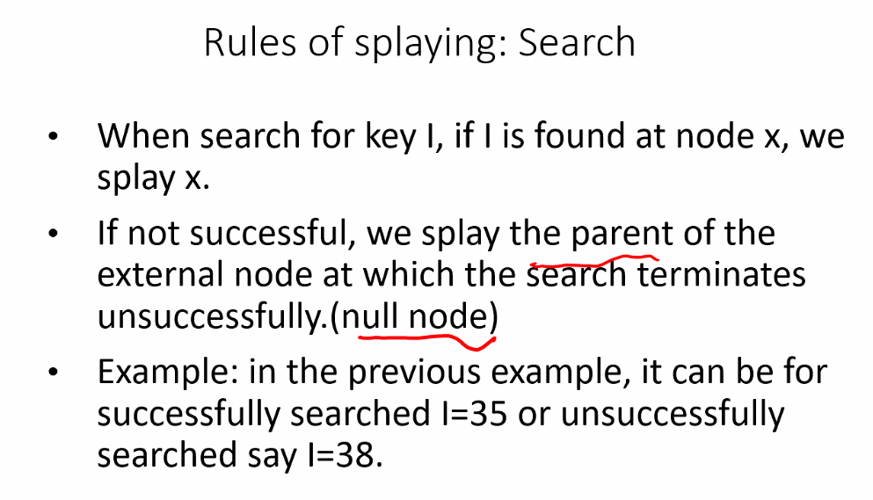
    - Notice in the above example, if you search for 38, you will reach a null node with 35 as the parent, so you splay(35); but if you search 35, you will successfully find it, thus splay that node 🡪 splay(35)
* When deleting root, first switch the root with the smallest node in the right sub tree and delete old root, then splay from the parent node of the previous smallest node in right sub tree that was made the new root
  + This is because it follows the principle that the most recently accessed node should be splayed (made the new root), so in the case of deleting a root, the next most recently accessed node is the node before the root
* When deleting a non-root node, move the node to be deleted to the root by splaying it, and then doing a standard root deletion by replacing it with standard: smallest root in right sub tree or largest node in left sub tree
* 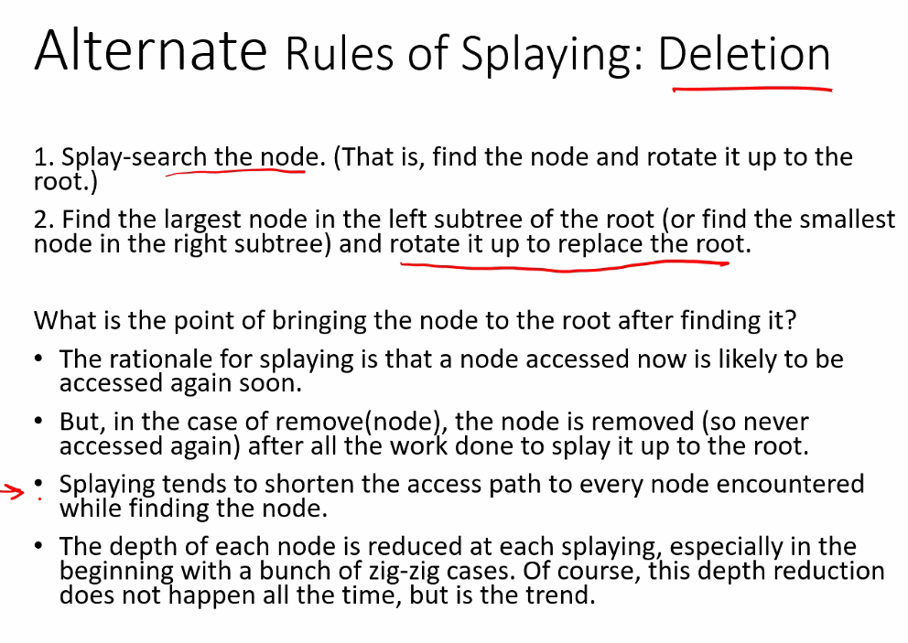
* 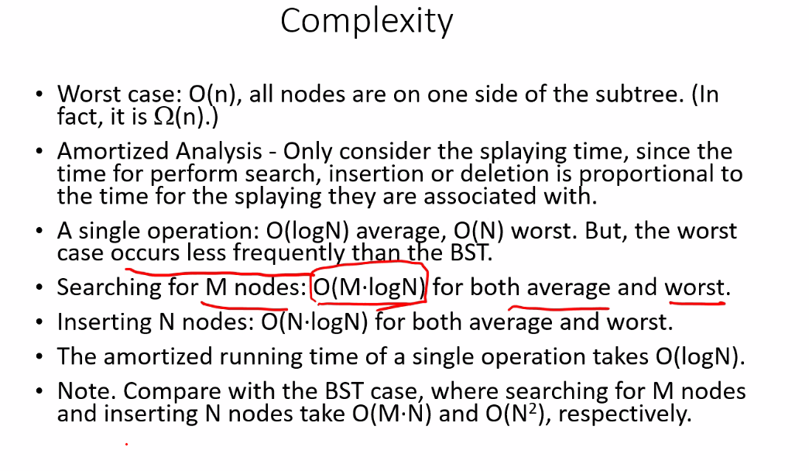
  + This is what amortized analysis refers to; multiple operation analysis, not just one operation; and we know with splay trees if you do multiple operations, the overall balancing act will give efficient complexity O(logN)

# Lecture 10 – 6/08/21: Splay Trees Continued, Priority Queues

* Remember for project 2, my stats won’t exactly match the professors stats that he provides, it may be just a little off; so my output should match sample output pretty closely
* No class next Thursday: exam day
* 3 more topics for rest of semester: splay tree, priority queue, and e Tree and B tree
* Remember we use splay tree when we will access certain nodes often; it can be a an optimal/efficient implementation choice
* Remember even for worst case, it rarely happens and is balanced out with best case so that average case is still as good or better than standard BST
* 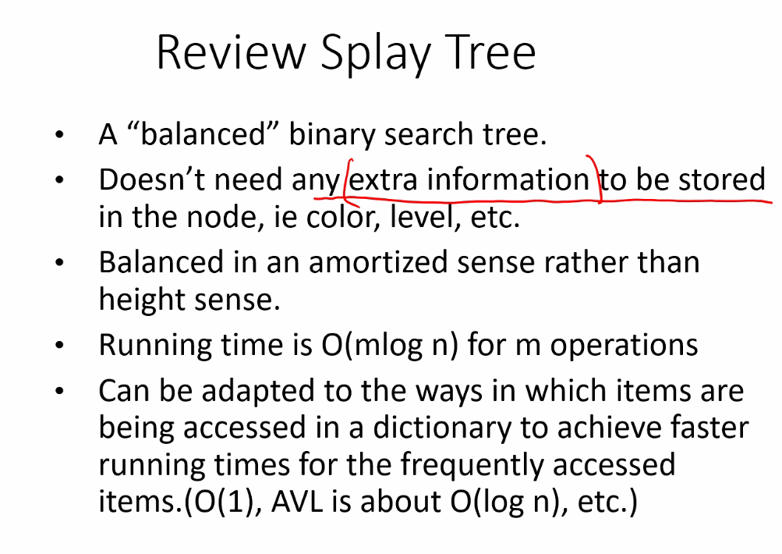
* Rotations in AVL v Splay tees:
  + 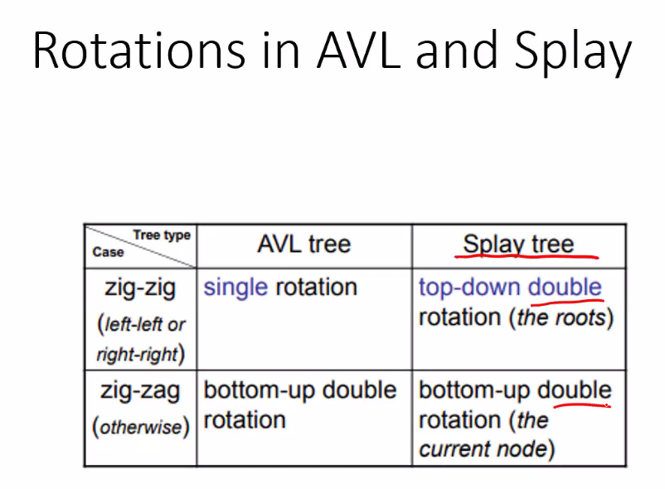
* We have splayed from bottom up (finding node by going from root to access node, then splay that accessed node to the root)
* We can do Top-Down approach, which is the more efficiently coded splay tree
* 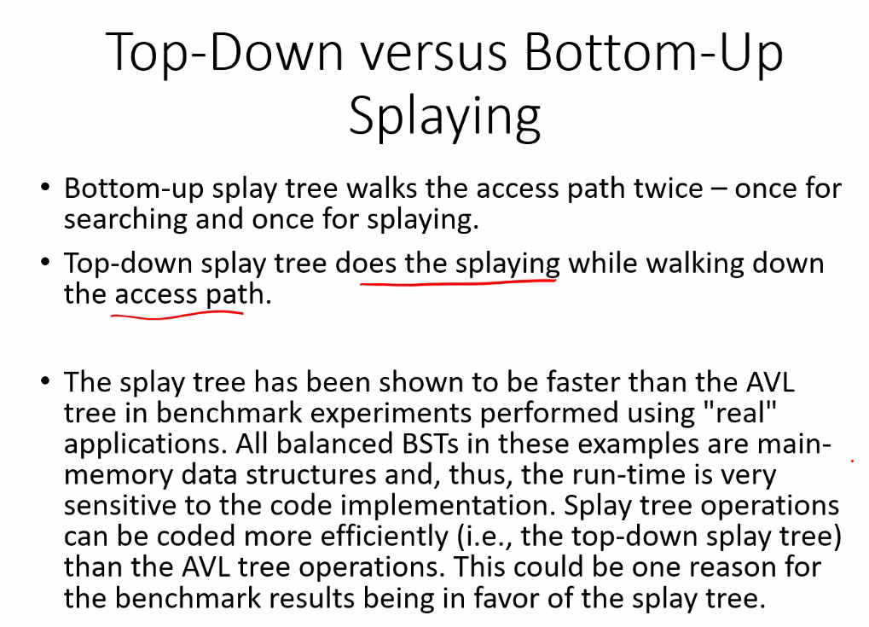
  + Asymptotically AVL and Splay trees have same analysis at O(log(n)); but in real life Splay works better
* top down splay example: you splay each node (or every other node depending on how you implement it) as you work down the tree to the searched node to splay
* preventing worst case from happening often in splay tree:
* 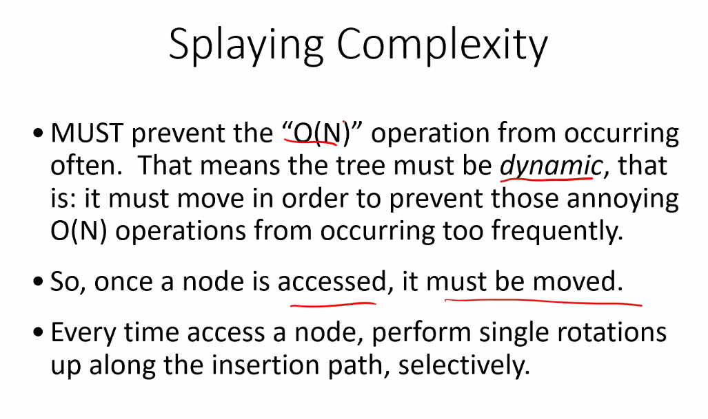
  + This is why even when doing a search, the node searched is splayed
* Splay examples:
* 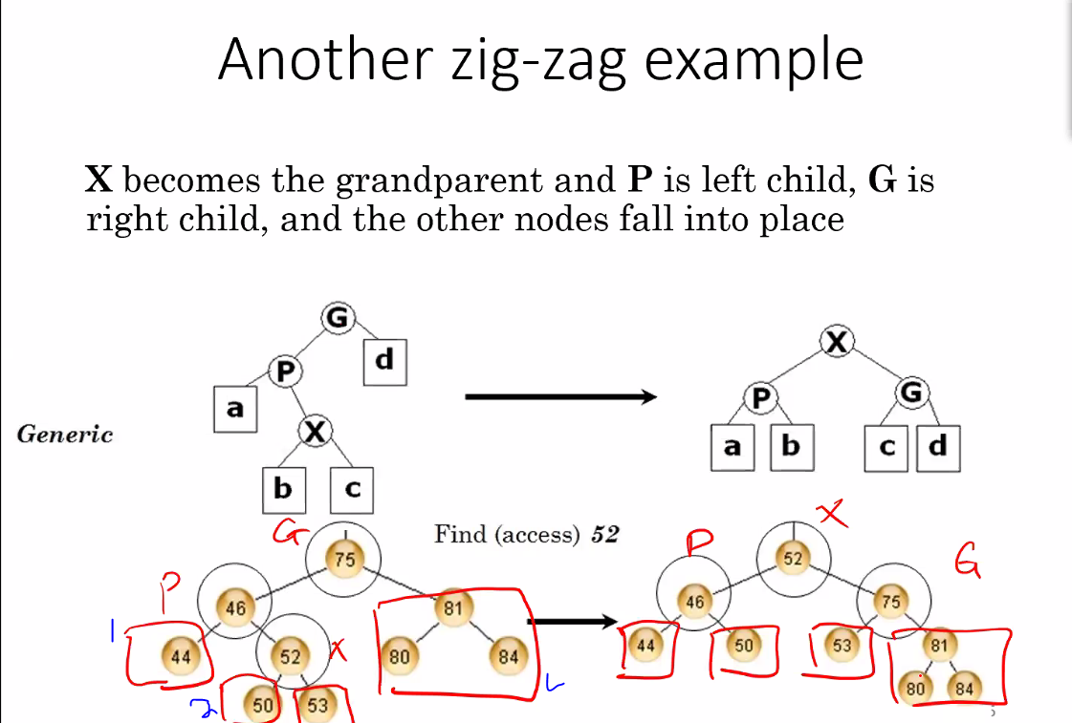
* 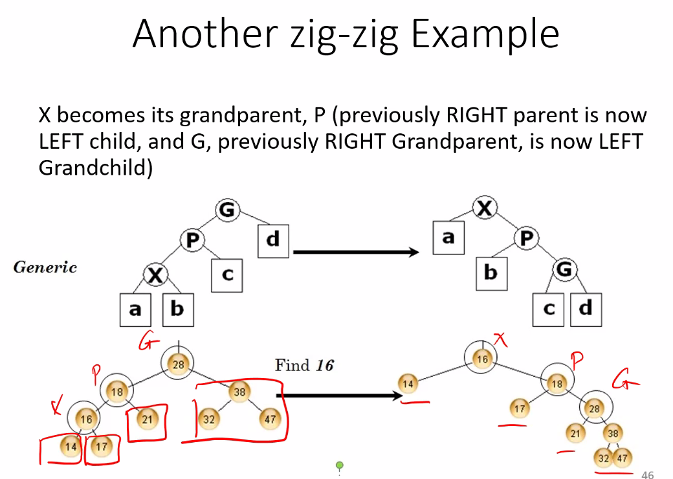
* 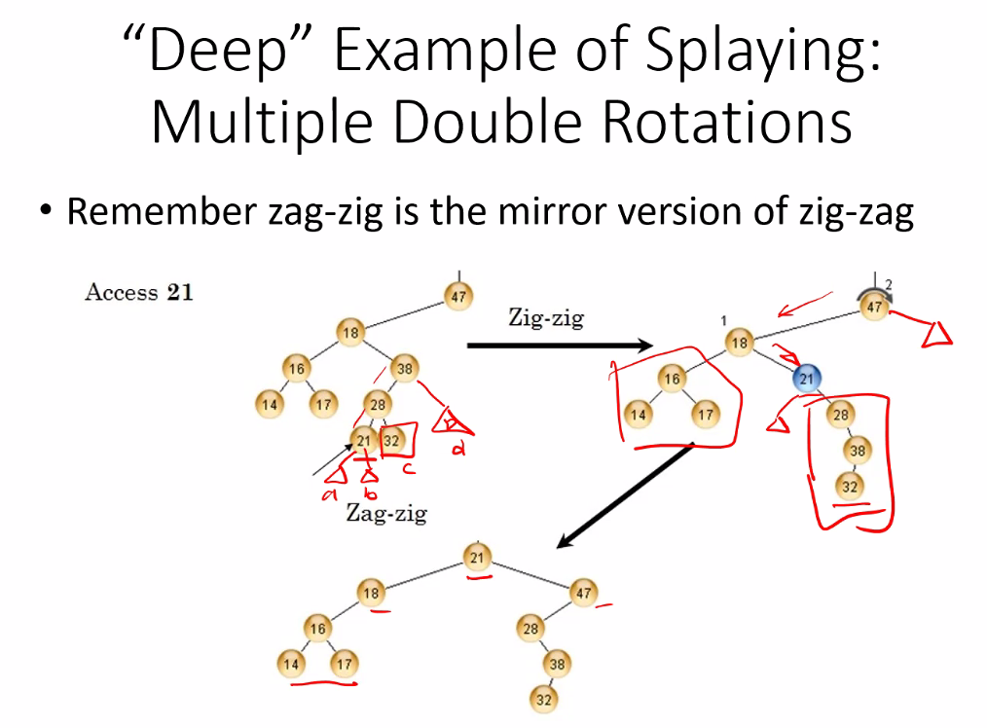
* (remember for splay tree we don’t need to and we don’t keep track of height, we just do rotations every time we splay to help balance tree)
* 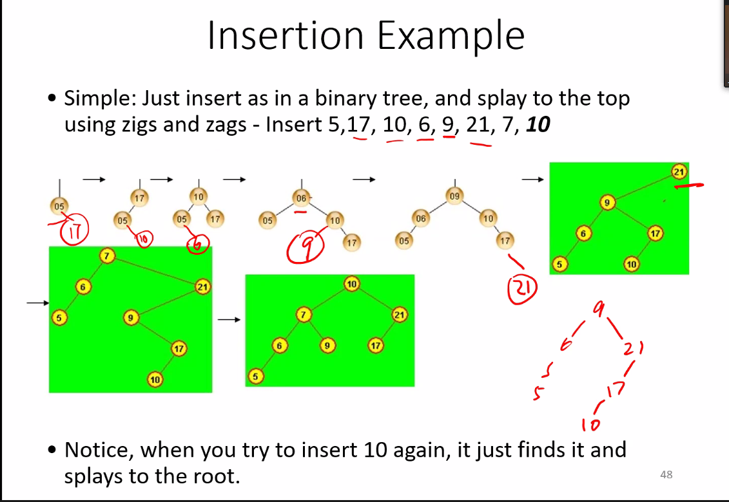
* Deletion methods in splay trees:
* 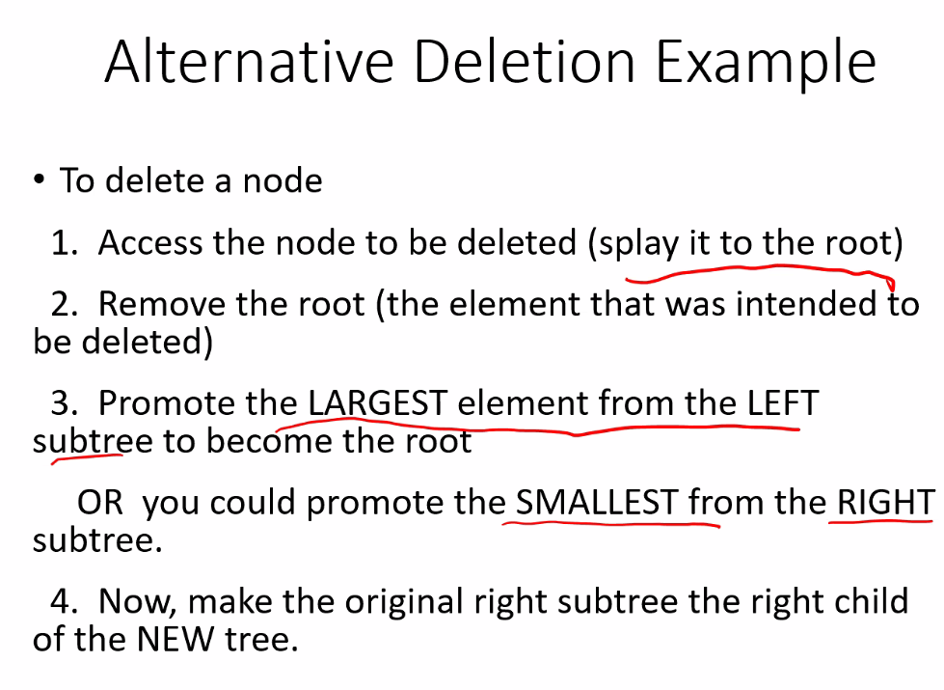
* 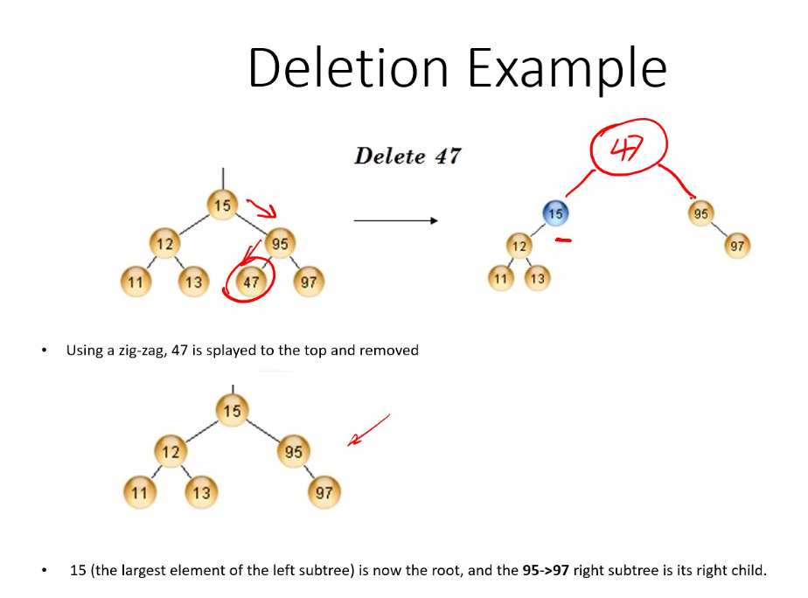
* 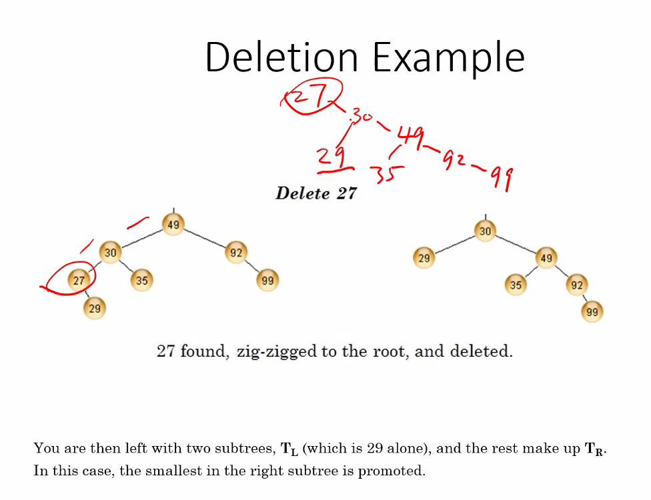
  + Above is a special case where after splaying the node to be deleted, the result has only one child, thus simply make that child the new root and delete the old root which was splayed for deletion; no need for replacing root using smallest node in right tree, or largest node in left tree
* Be able to do these practices to be prepared for the exam
  + 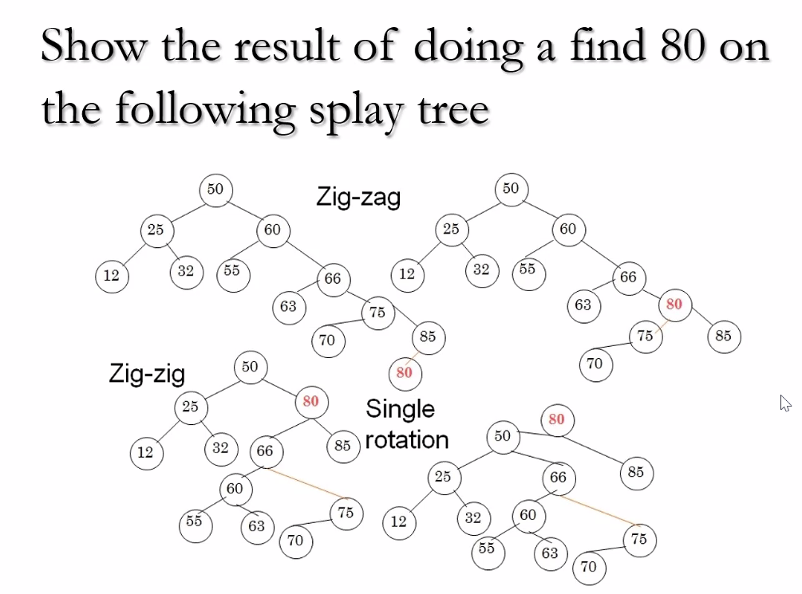
* **Priority Queues Abstract Data Type**
* Used especially in networking: for example VOIP packets have a higher priority than other data packets that arrive at a switch or router
* First in, first out approach
* Any kind of service where you need to treat people different (airlines, IP packets, etc…) use this kind of abstract data type
* You can have a Min or a Max priority queue
  + 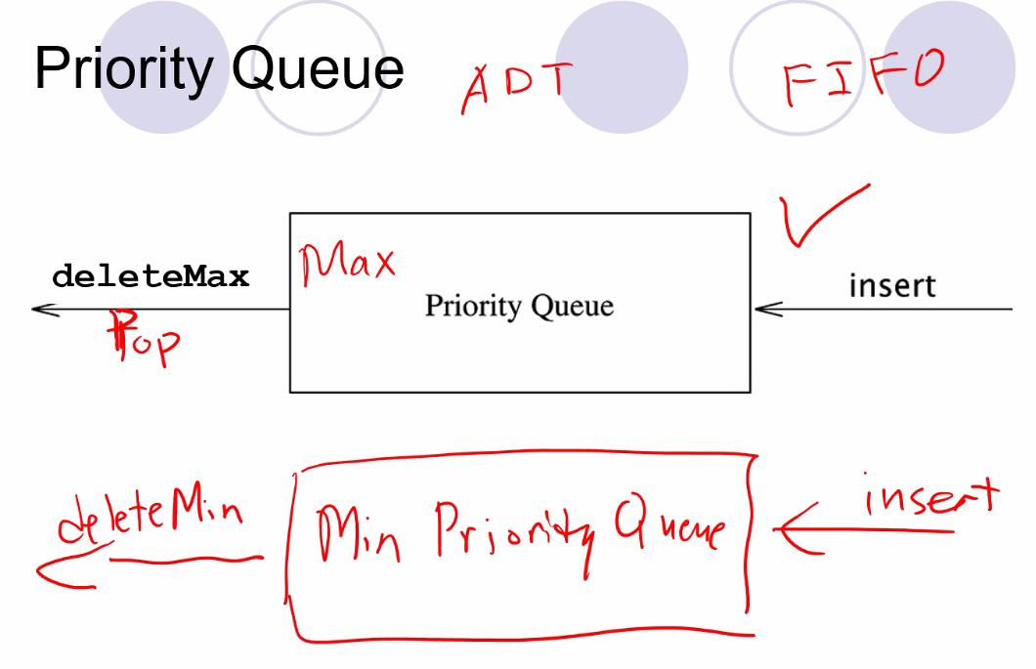
* C++ template has a priority queue template class
* Top function == get max for max queue
* Pop means access and delete the max node (first in line for the queue)
* Most priority queues are set up to where it is only efficient to delete min OR max efficiently, unless you implement the queue using binary search queue
* 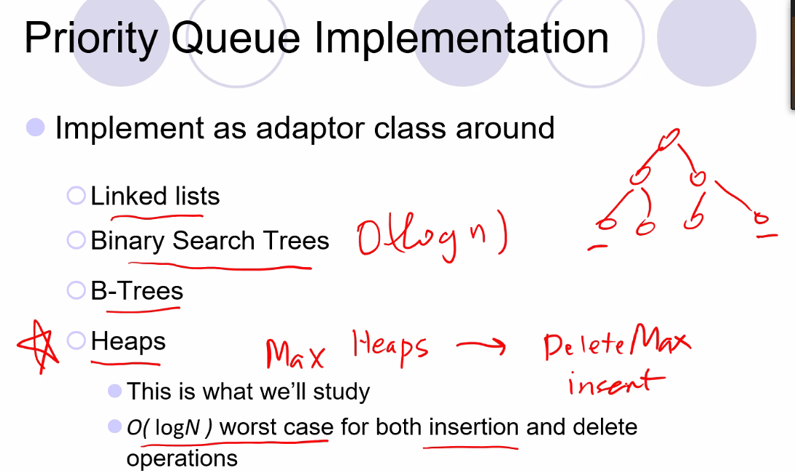
  + Heaps are more efficient than implementing queue using binary tree but are optimized only for deleting min OR max
* **HEAPS**
* Partially Ordered Tree (unlike BST which is Totally ordered)
* 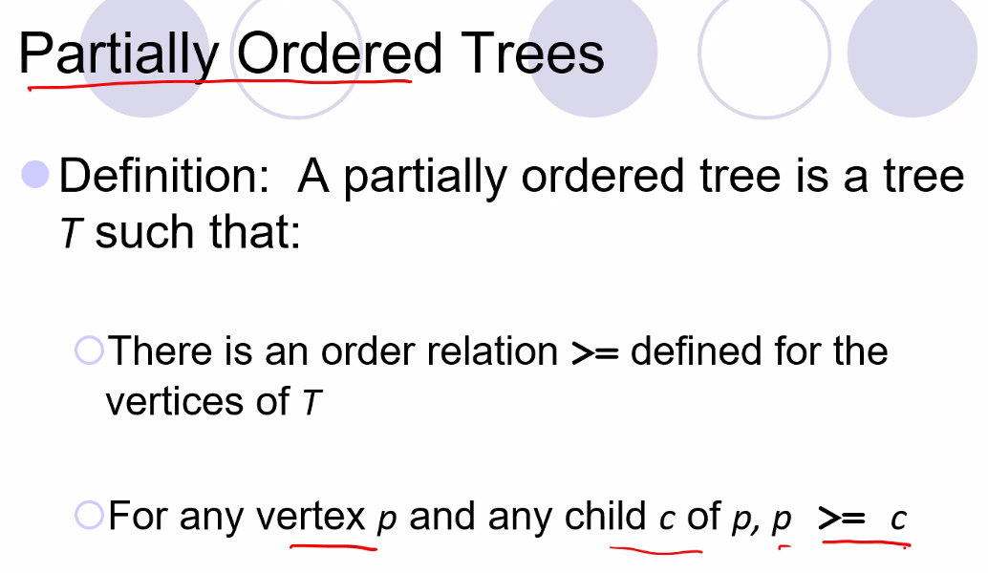
* 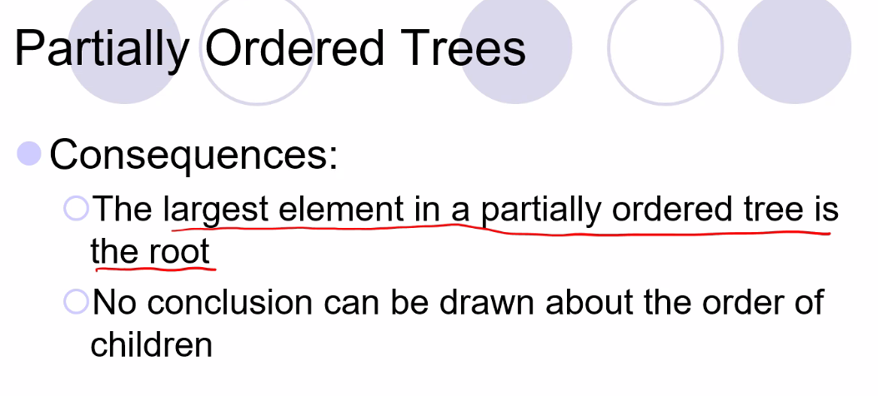
  + Thus left and right child can be in any order, but for sure their parent will be larger
* 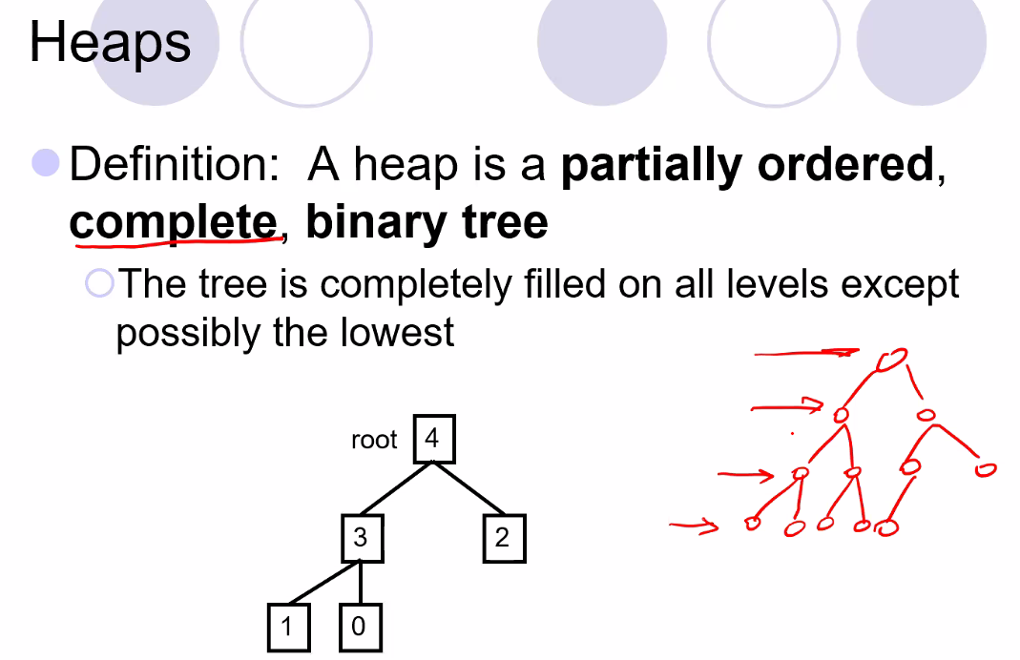
  + Remember every level in a complete Binary tree is filled with all children except last level, where all nodes are as far left as possible
  + Thus we only know for Heaps that one level in the tree is larger than or smaller than another level, but we cannot distinguish which is larger than another node on the same level
  + 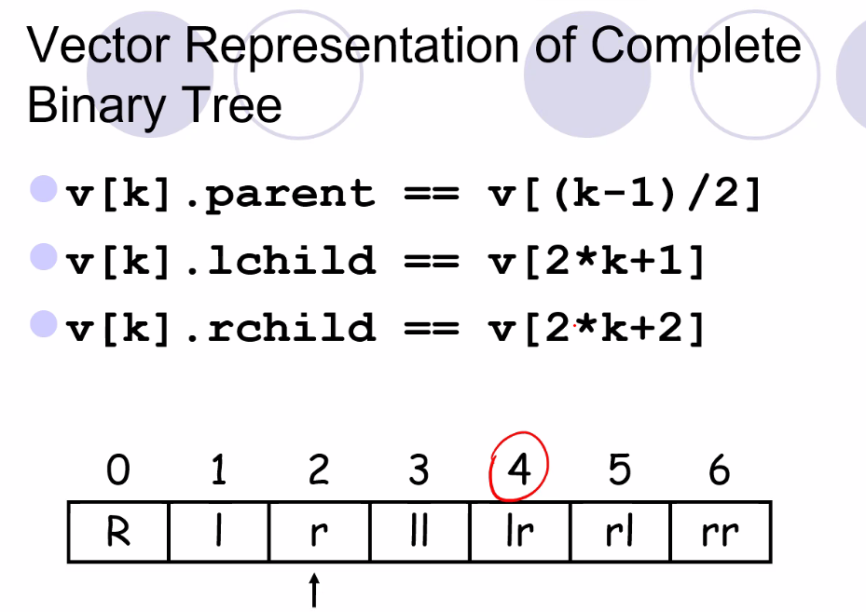
  + 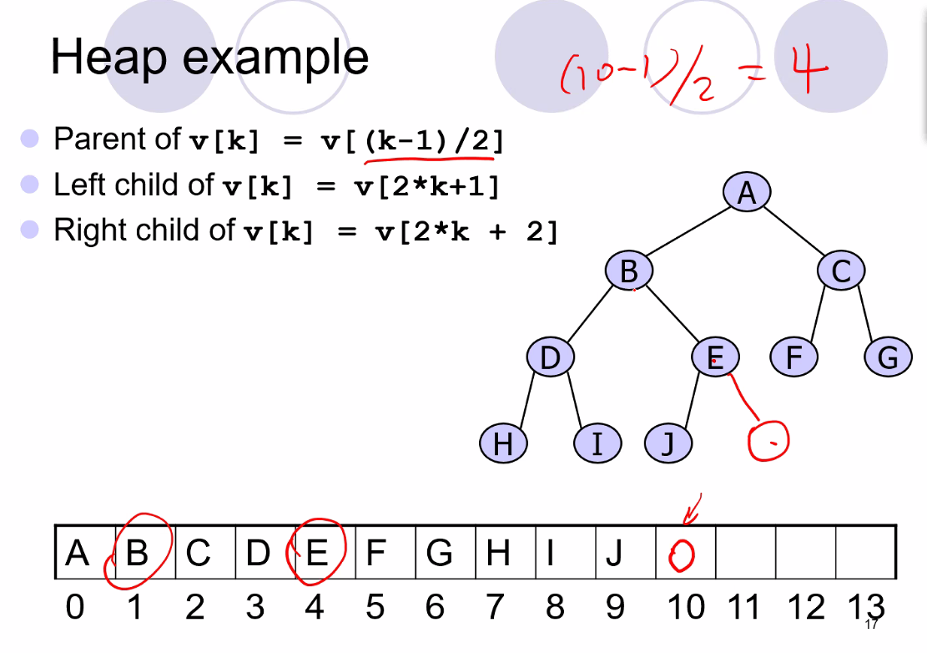
  + Because the tree is a complete BST, we don’t need to store any pointers, so we can simply use a vector equation to find the corresponding parent, left child, and right child of a given node
* Push Heap Algorithm
* 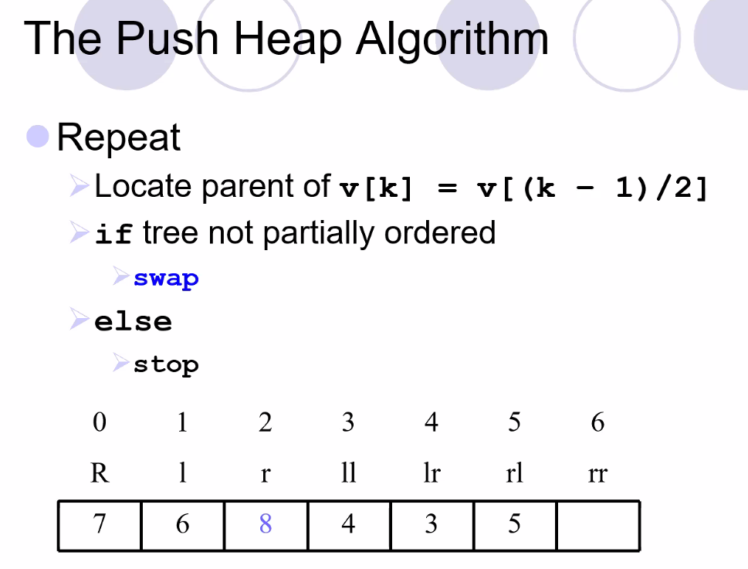
* This will keep tree partially ordered
* 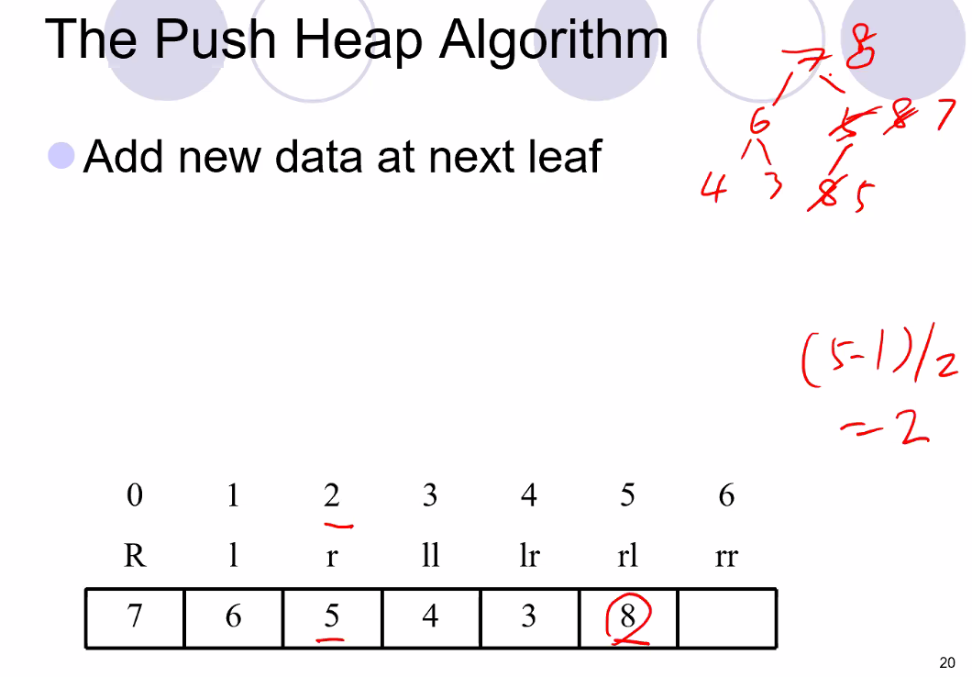
* Remember Heap internally is an array, but an array that represents a Heap BST, so when we add an element we simply add it onto the end of the array, then we take that value and use the advantage of a heap structure to use equations to make sure the tree is partially ordered and a complete BST. The equations is what gives heap such an advantage, much less space required to move nodes to correct locations
* 
  + The tree will always be perfectly balanced using this algorithm
* Same idea with pop algorithm, you use equations after adding or deleting elements to keep tree complete and partially ordered
* 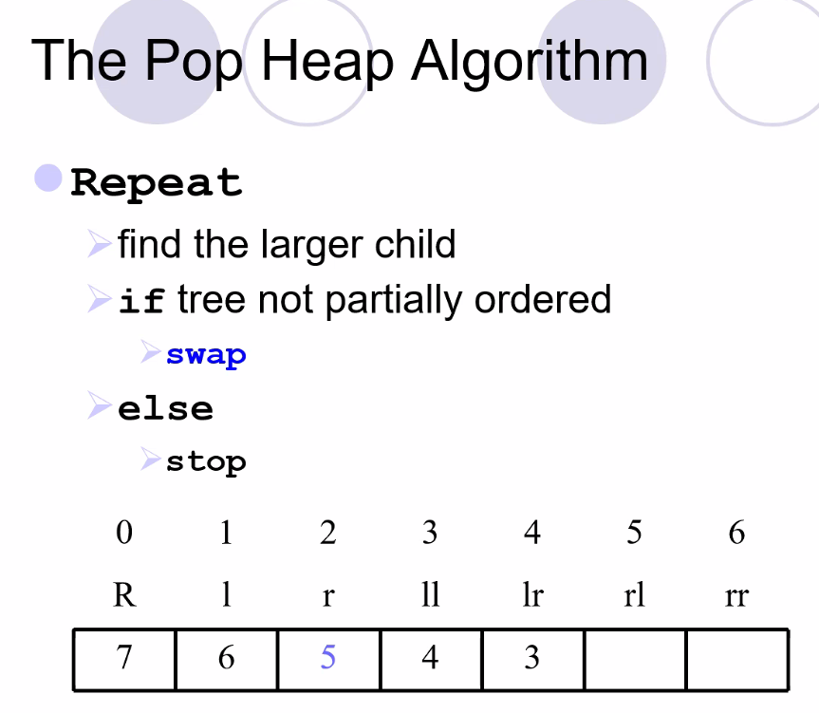
  + Remember complexity is O(logN)
* Examples:
* 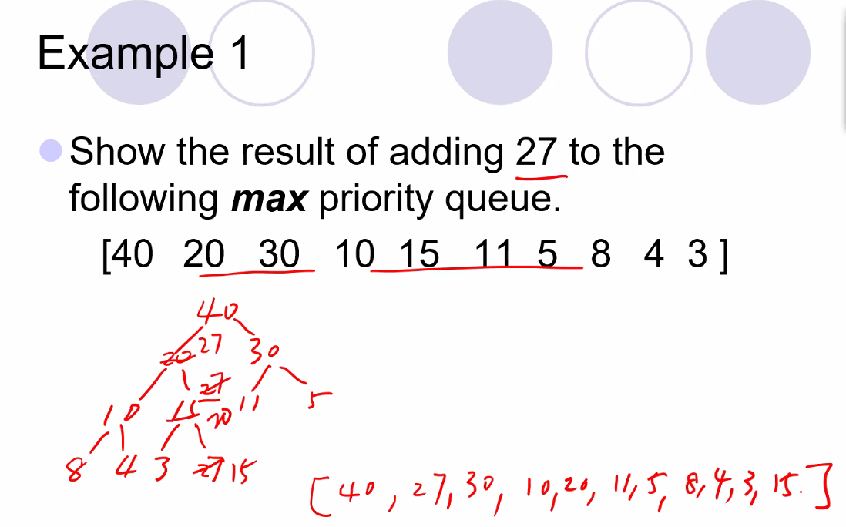
  + Remember largest value must always be stored at the root node
  + Then every node must be larger than their children
  + Level order: so to write the tree of a heap vector: simply go level by level: level 0 = 2^0 = 1, level 1 = 2^1 = next 2 nodes..2^2 = 4 nodes for level 2..etc…
  + To write the vector of a heap, simply go left to write starting at root and moving level by level
  + The swap function is what makes it O(logN) in conjunction with the bst structure
* 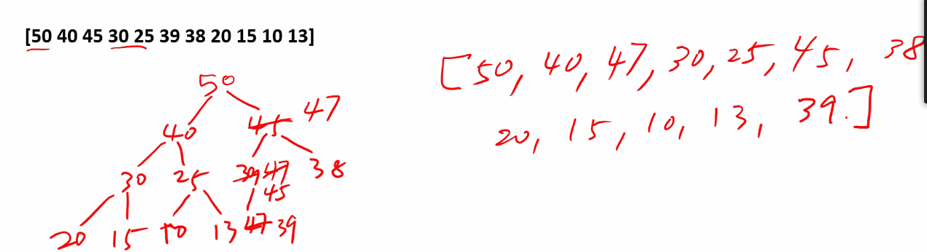
  + Remember internally for a program, we use the equations but for us we write out the tree
  + Also remember heap is not designed to search, only efficient to delete max (or min if it is a min heap)
* 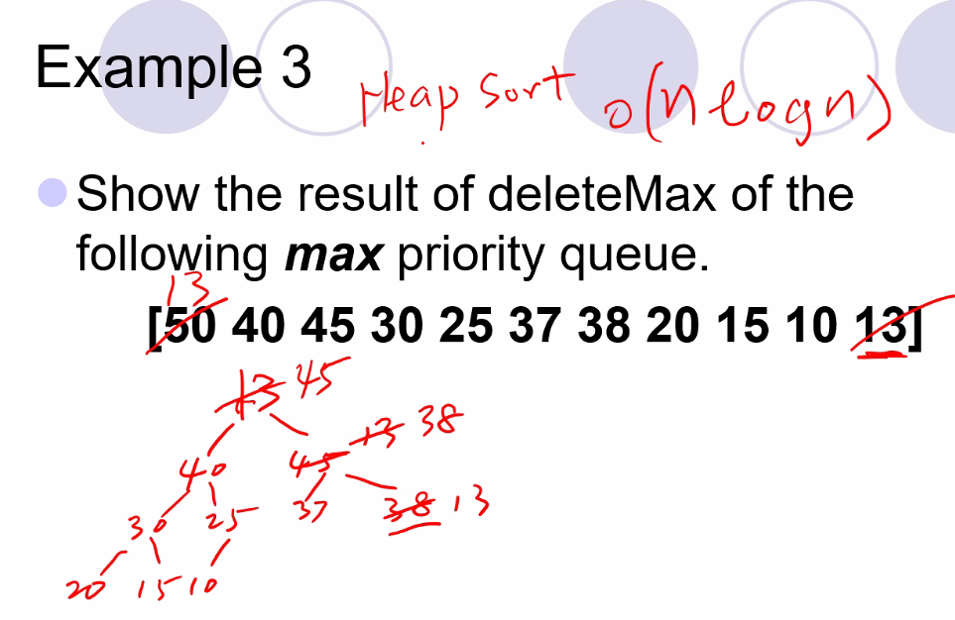
  + To delete max, replace it with last node in the heap vector, and then perform swaps as necessary to keep tree a BST and a complete tree
  + Also heap sort function is O(nlogn)
* Building the heap
  + 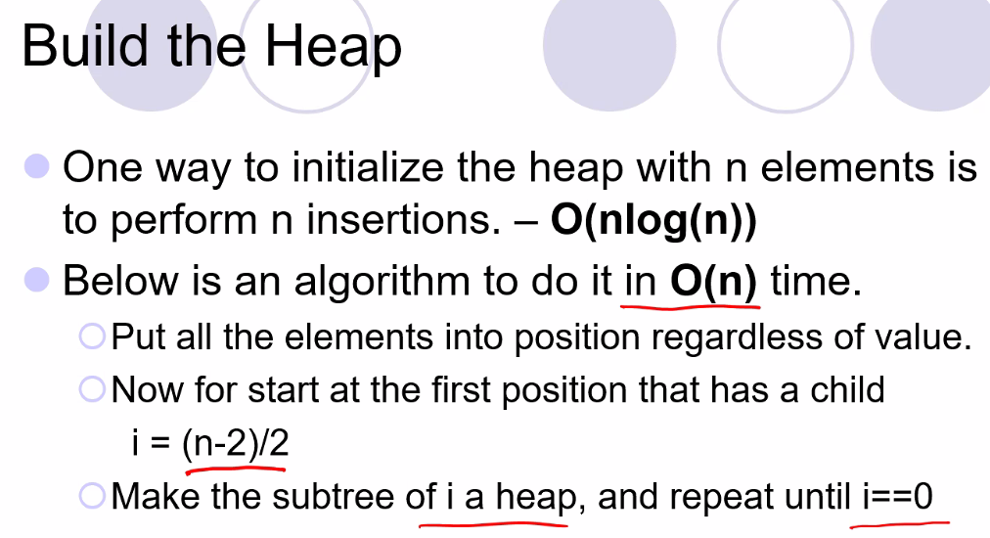
  + 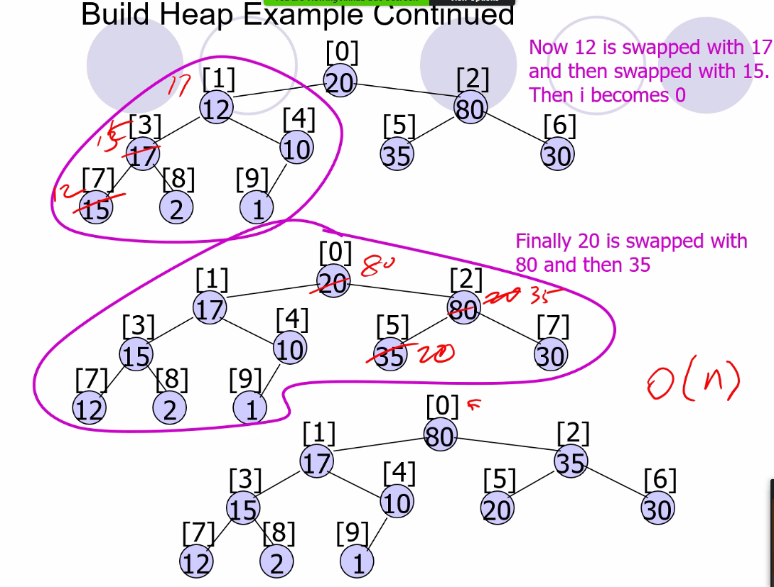
  + Note: its O(n) because you only need to check one branch and work down that one branch; also first the two children are compared, and then the larger of the two children is used to compare then to the parent and see if a swap is needed
* But here is building the heap the slower way inserting 1 by 1
  + 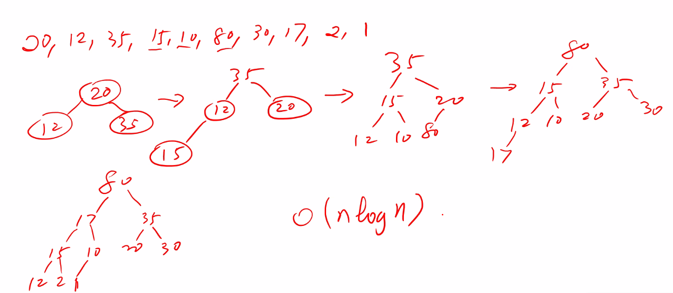
  + So the tree is complete, but also it can be differently ordered than doing the linear algorithm (NOTE FOR HW 2).

# Lecture 11 – 6/10/21: B/B+ Trees (tree is in disk space; not in RAM) – no lectures next week! Today is last lecture of semester before mideterm!

* B stands for “Balanced”
* Used for hard drive or solid state drive memory storage; used especially for database memory management RDMS (DB man syst) applications; also used for file system directories (such as windows NTFS, and Lennox EXT) (directories used to be stored in a single list and not a tree list structure)
* Have to read and write from a secondary storage device in blocks
* 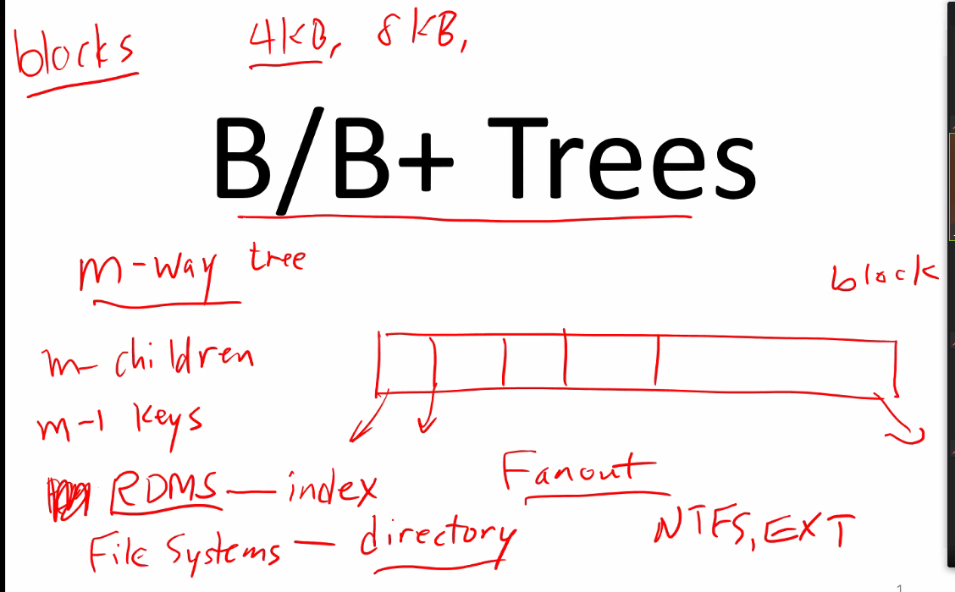
* So for example, HDD and SSD if you want only want 1 Byte, you cannot only read in one byte, you have to read in blocks, for example, 4KB to read that 1 byte that you want
* Fanout is large to minimize number of disk operations; tree does not go that deep
* Of course it takes a lot longer (a lot more clock cycles) to access disk space (SSD can be a lot faster than HDD, but still a lot slower than RAM)
* 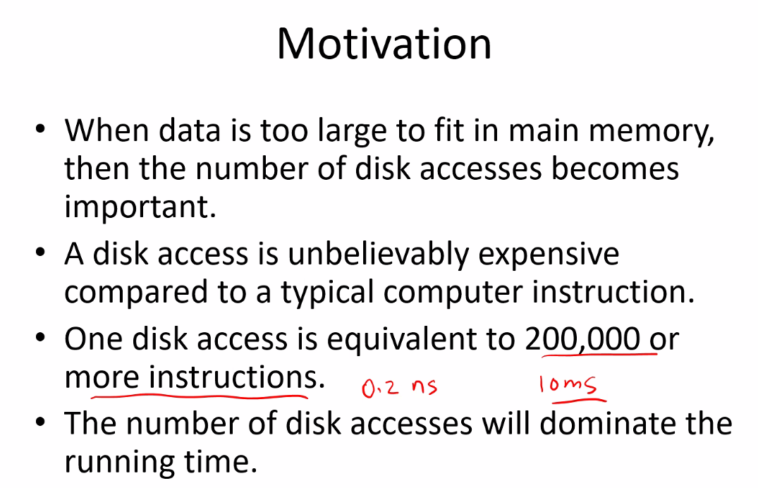
* This is also why when accessing disk space the standard is to read several blocks that minimizing disk space access since it is so slow
* So what to do? Change log base from binary search into log base m, where m can be a base much larger than 2, so that we can reduce disk access but at cost of reading in more blocks
* 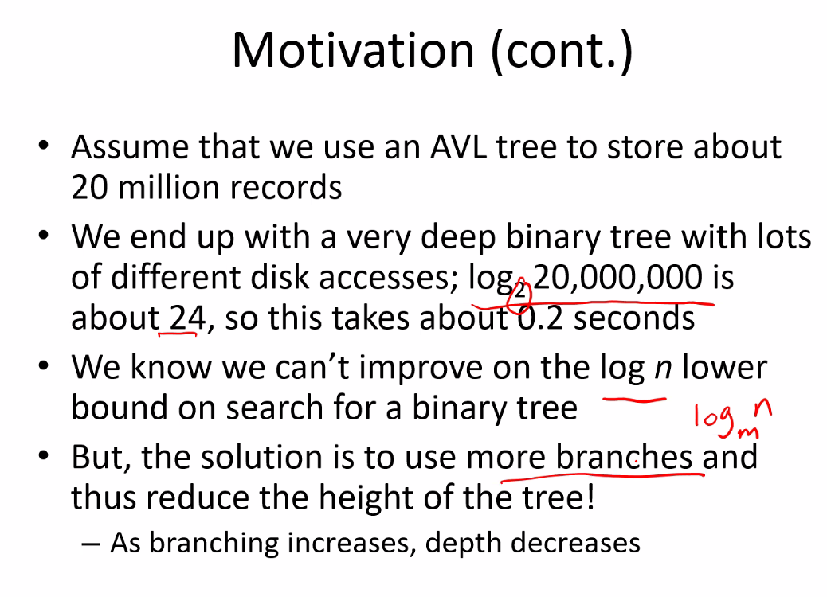
* **So here is the main idea: in order to work on data, it must be in memory, so B and B+ trees are used to read larger blocks of stored data from disk space (which is much slower access) to the RAM, and then from RAM do operations on that block of data to retrieve whichever bytes you wanted, but then you also need the B and B+ tree structure in the same way to then save that block of memory read into RAM that has been accessed and/or changed back to the disk space.**
* 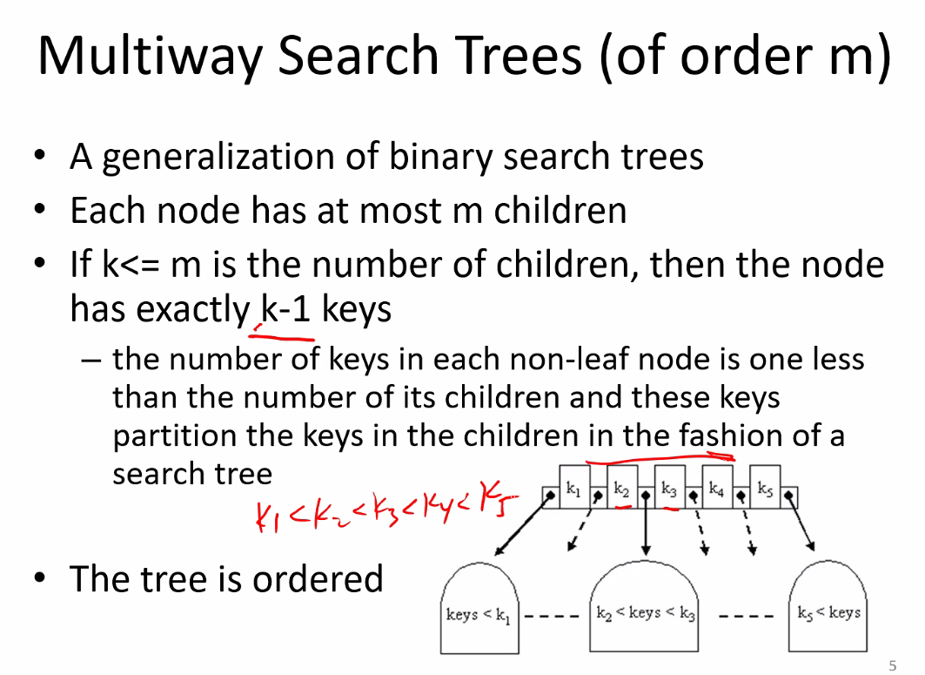
  + So not as efficient at searching as BST, but however they will fan out very large so that you reduce number of Disk access; **so each node will be the entry point for a large block of data**
* 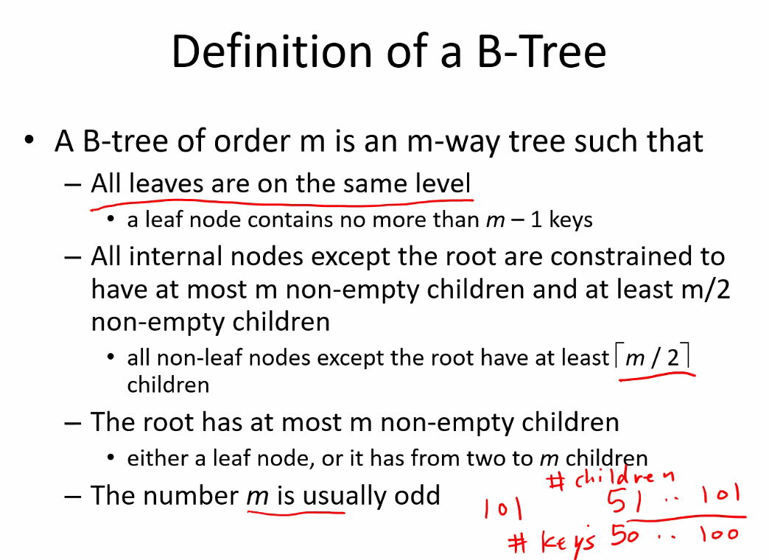
* 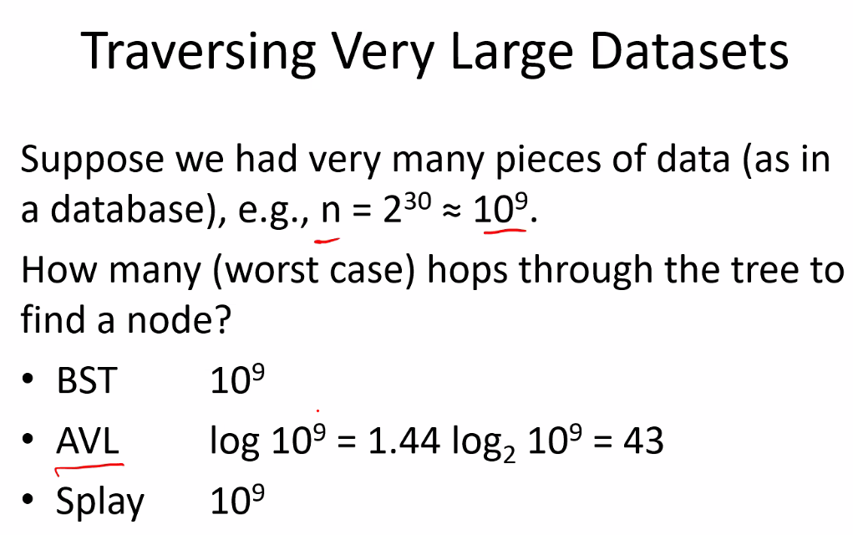
* 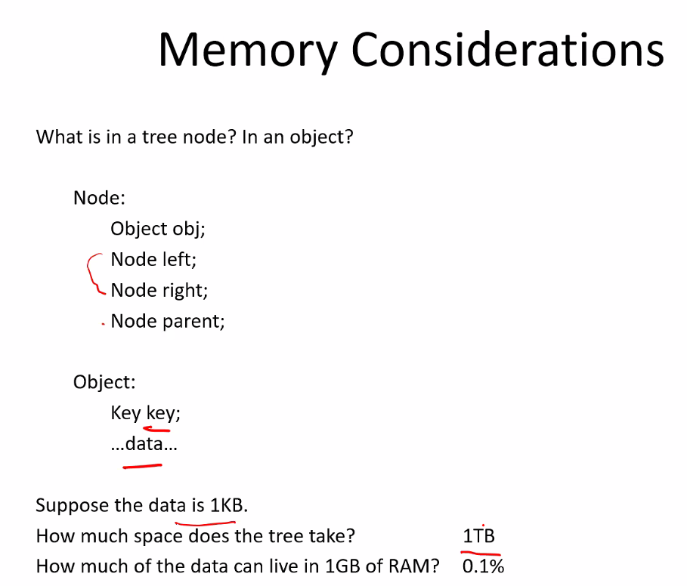
  + Notice above, demonstrating again the idea that majority of the data is stored on disk and RAM can only have a limited amount of data stored on disk loaded into it (for starters, the OS is stored on Disk and loaded into RAM)
* 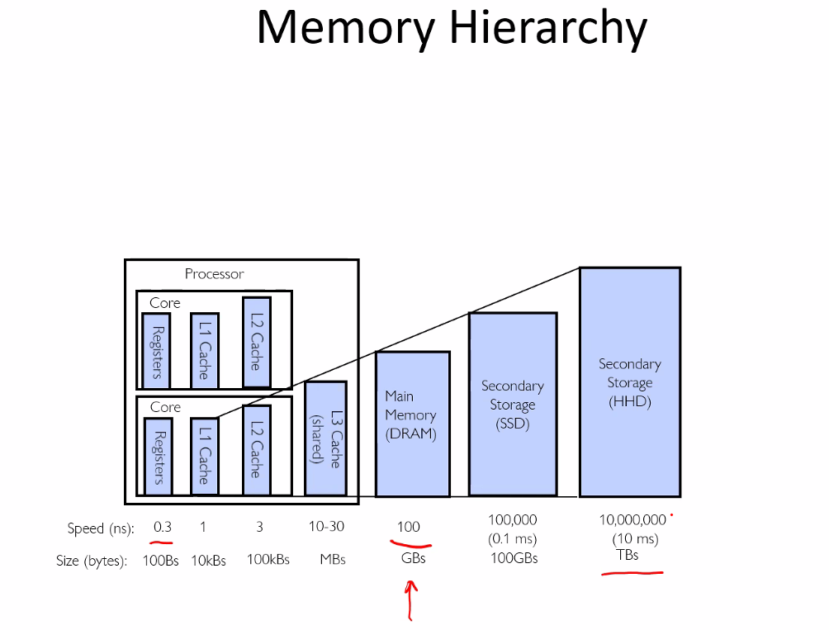
  + Most cell phones use SSD drives which aremuch faster than traditional HDD (so SSD is 100* faster); it is more expensive but it is becoming less expensive so many PC are not using SSD
  + Remember you always have to erase th block of data from the disk first before you can rewrite that data block from the RAM back to the disk
  + Phones are using the new RISC architecture instead of X86, so that is why they are more battery efficient, and faster, able to handle multiple executions in 1 cycle (probably using parallelism of methods with CPUs..etc)
* You do not want to have to hop through the DISK during a search because access is so slow!:
* 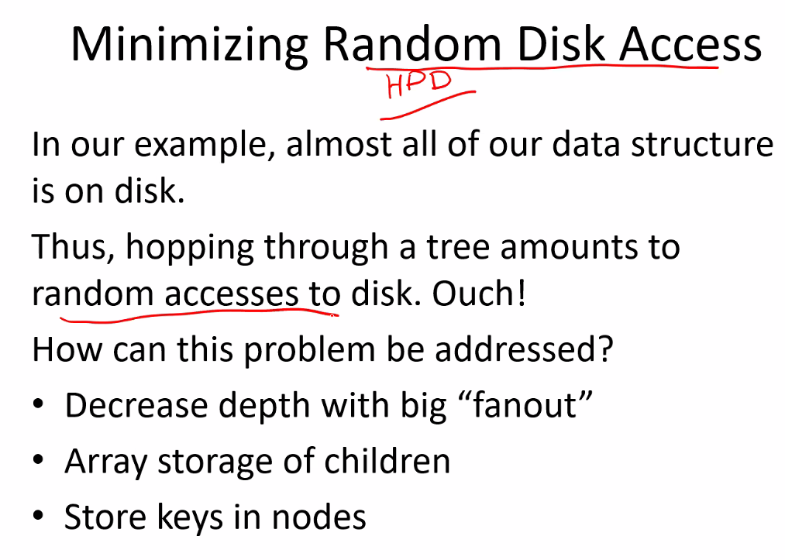
* B trees are always balanced:
* 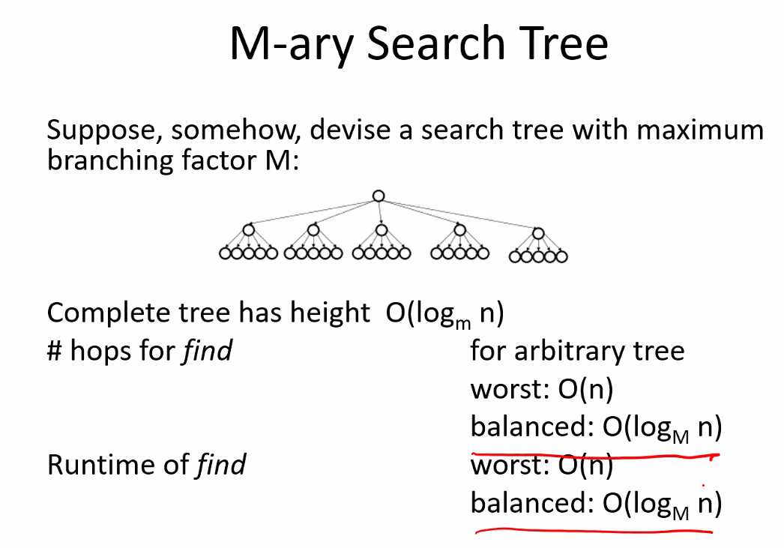
* 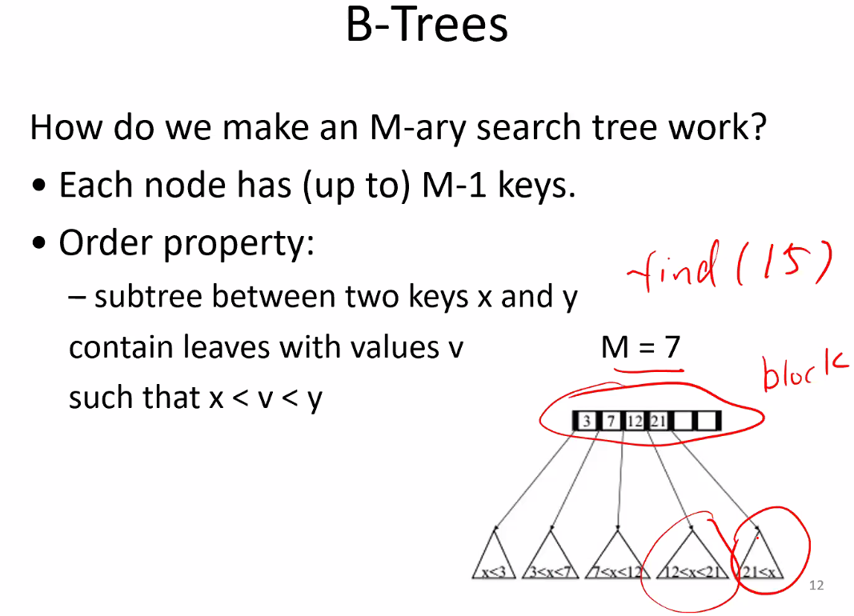
  + Each node is a block that is loaded into memory and searched, but only 1 at a time until it finds the value
* 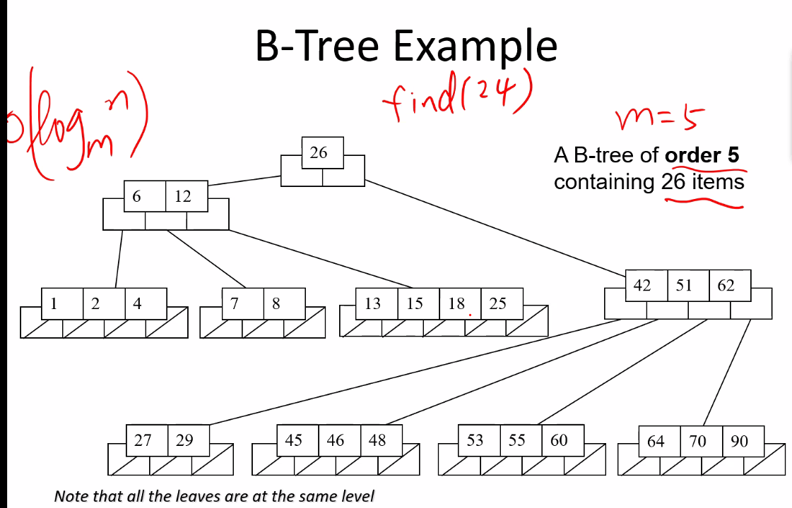
  + M = 5; k = m-1 = 4 (m children at max, 4 keys max stored in each node)
* 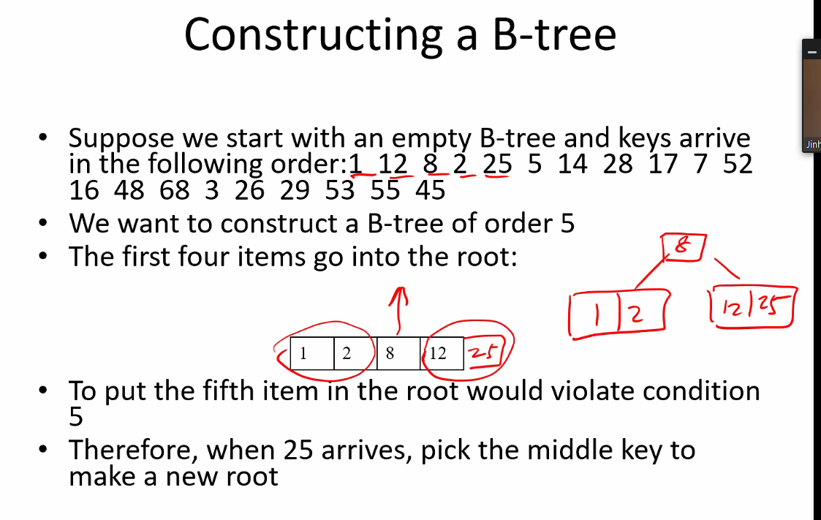
  + Remember, these operations are conducted in memory; you can only work on data efficiently in memory thus that is always what is done, then the sorted blocks of memory are written back into disk memory
    - and this is what makes it more efficient using B tree because location where it must be written in memory is easy to find and needs to be accessed less on disk
* 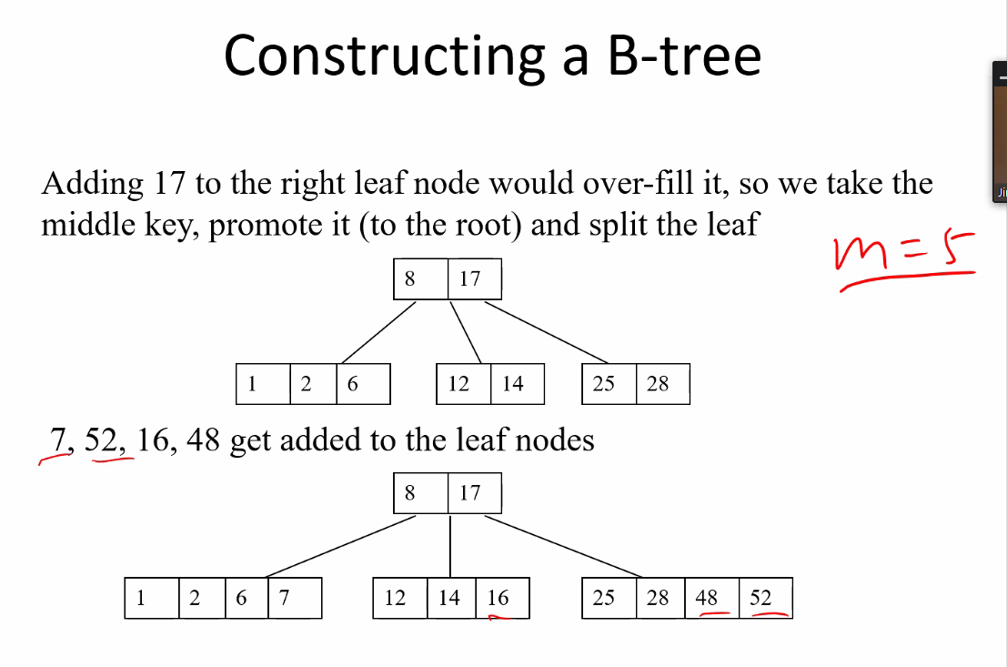
* 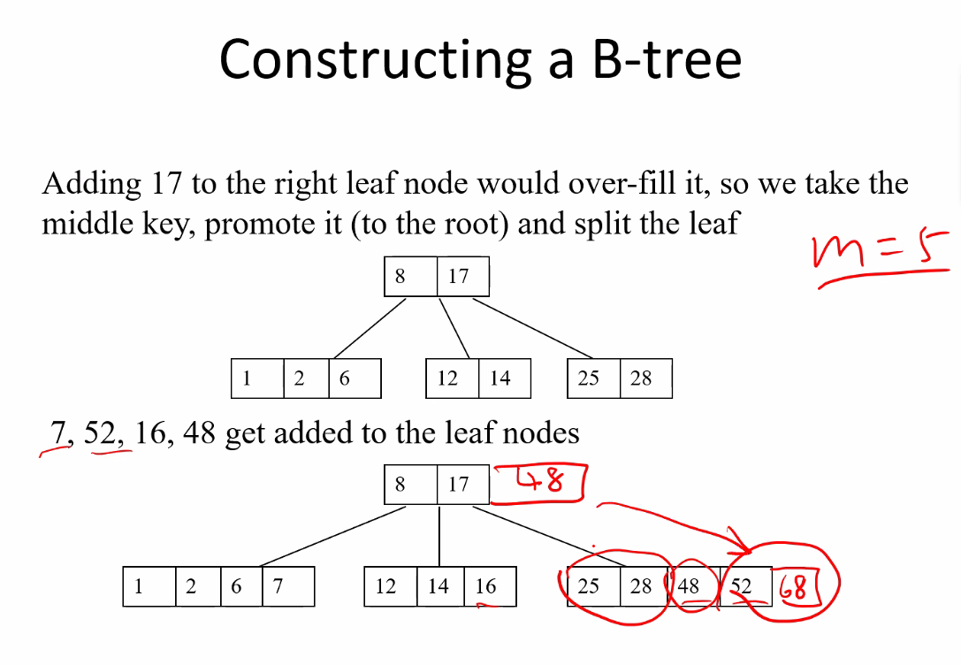
* 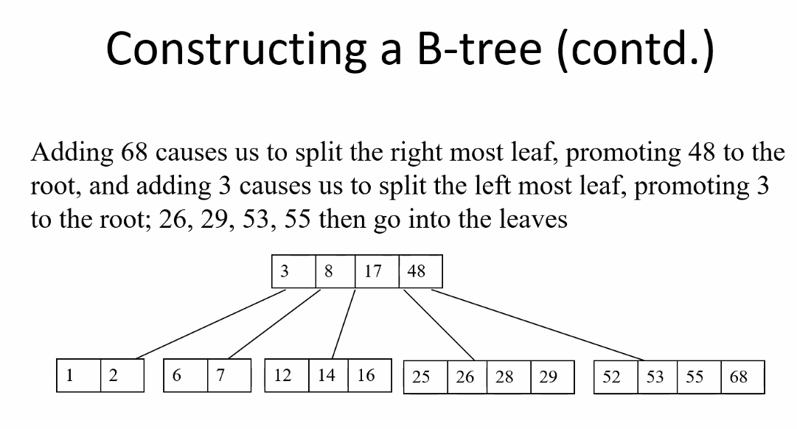
  + Notice how 48 is promoted since keys in the proper node was full
  + Remember each node is 1 disk block (block is whatever size specified for the given algorithm and B tree)
* 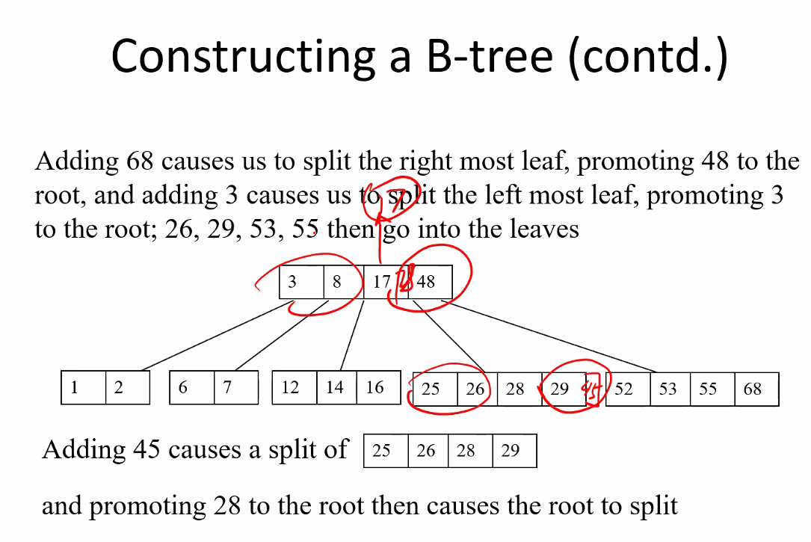
* 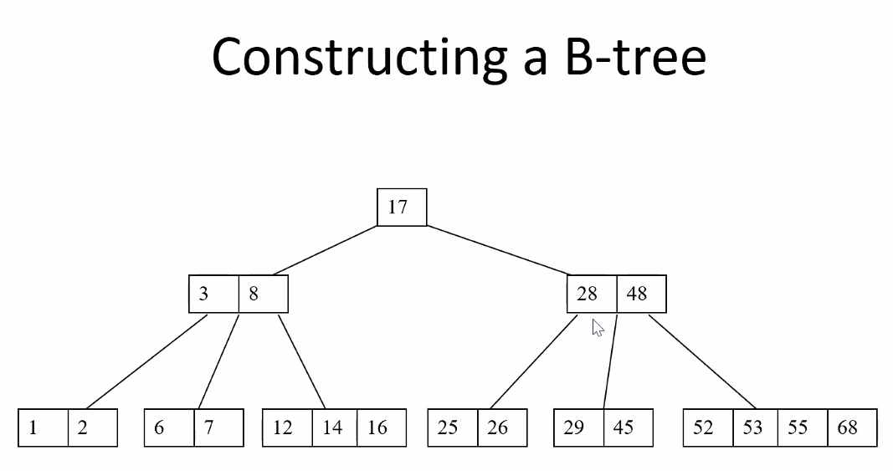
  + If a new root is created, it can have only at most 2 children
* Deleting from a B tree
* 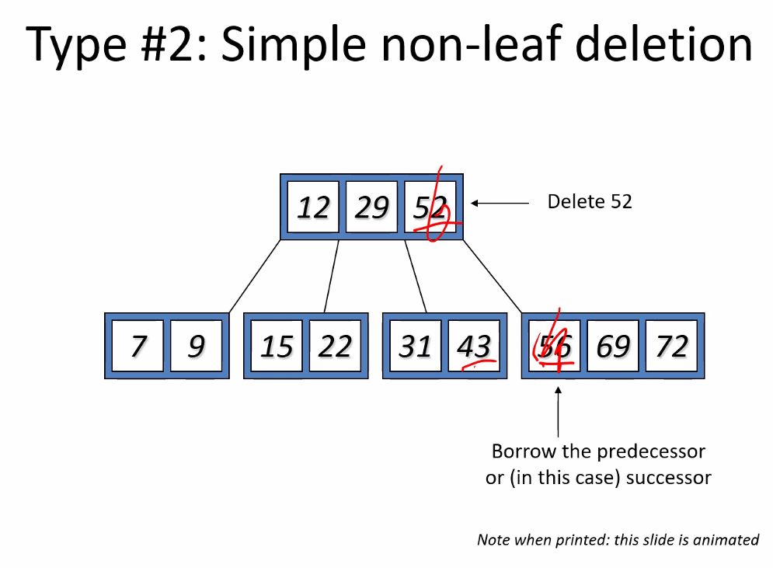
* 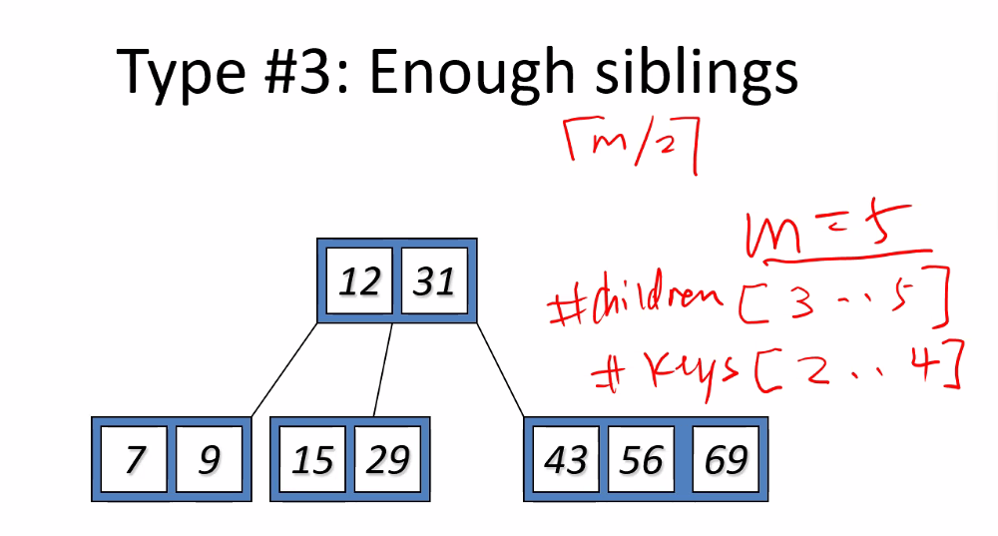
* Remember we do the combining or promotions to satisfy the #children and #keys for each node; this algorithm is used to ensure that the blocks of memory read in (every node is 1 block to be read in) do not have too few keys to be searched, or too many which would be a waste and cause unnecessary disk access; so this helps keep the tree balanced based on the M value
* 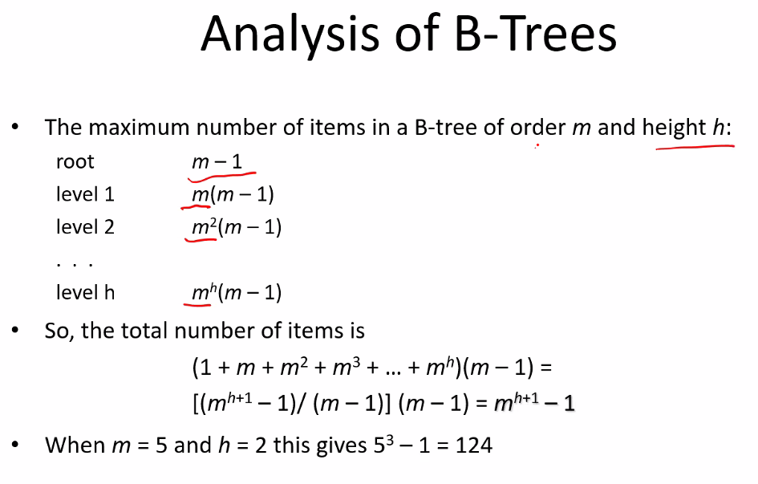
* 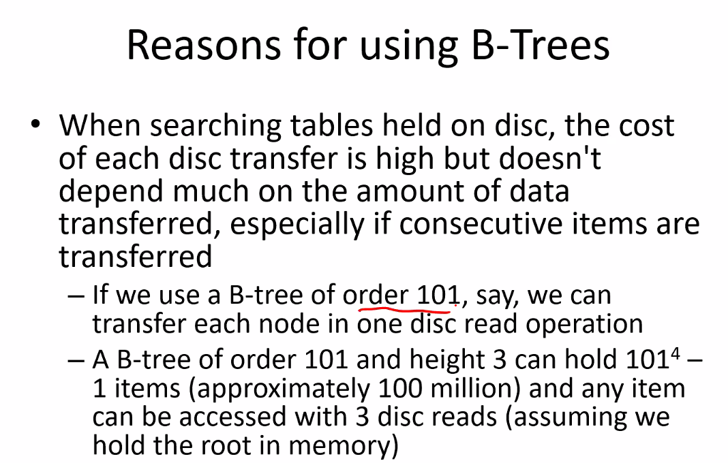
* 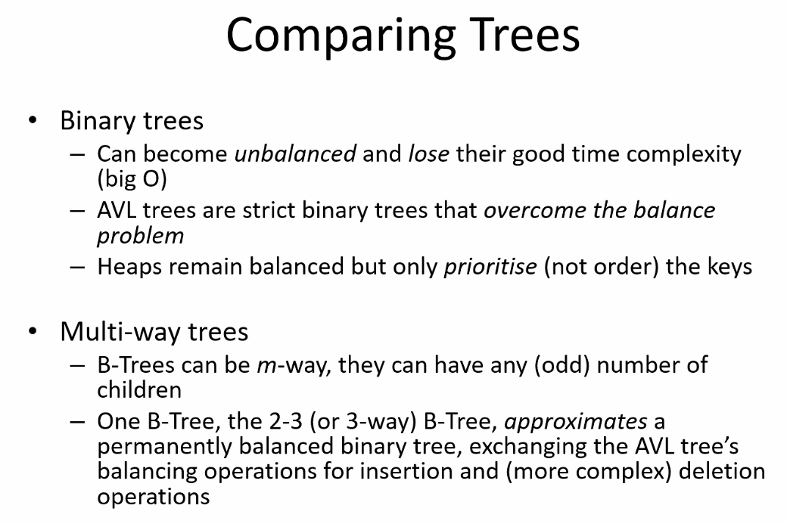
* B+ TREE (a variation of the B tree) (they are more widely deployed)
  + Major difference: Search keys contain no data; they are only used as an index
  + 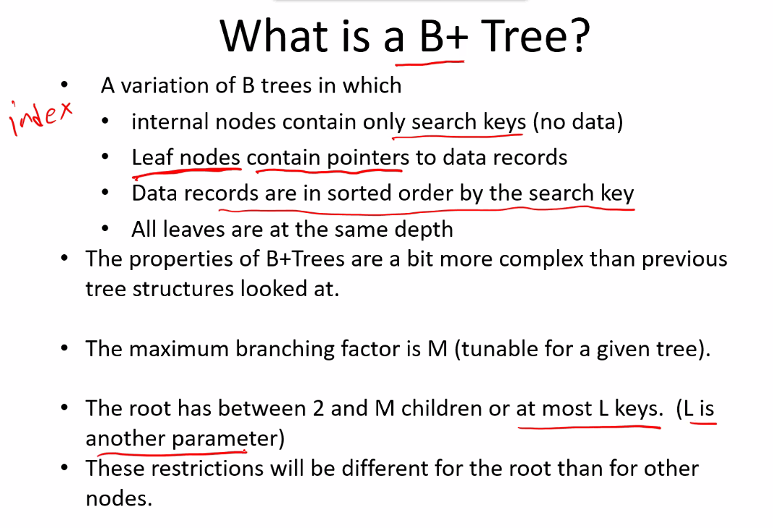
* 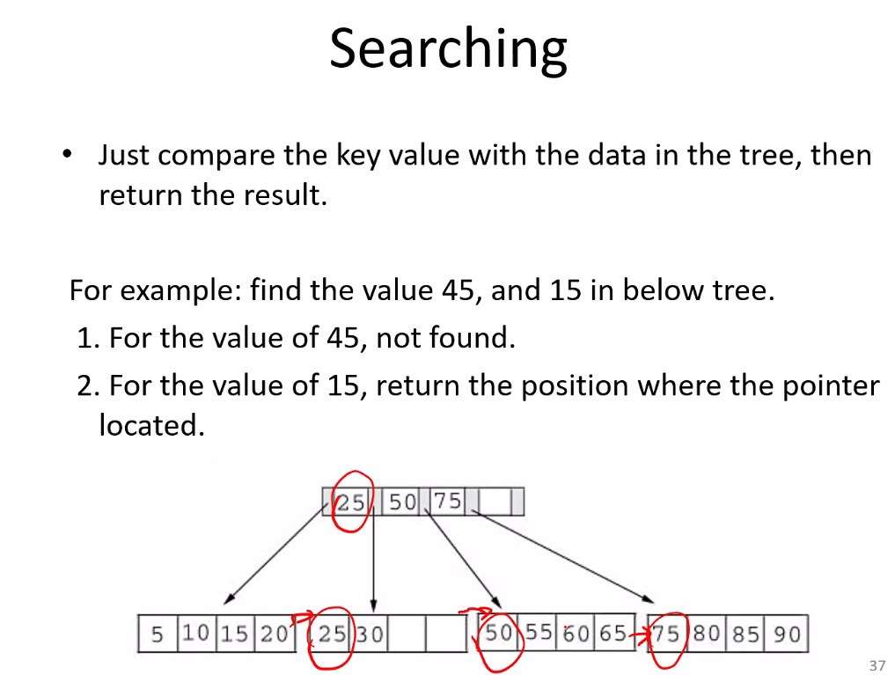
* Time complexity for B and B+ trees is the same
  + But for B+ only through leaf nodes can you access the data
    - Internal nodes mainly for search (except the data for the first node of each list is known because you still need the address/entry point of where that list starts): **KEY IDEA: ONLY THE LEAVES CONTAIN THE DATA FROM MEMORY**
    - So this is why it is used more widely or applications of indexing a table for a database and directories;
    - This makes search nodes (internal nodes) more easy and efficient to implement since each internal node does not contain the data of all keys in its list; it only has the first key in a list (a pointer to the start of the list which goes to another internal node, which eventually goes to a leaf node where the data is actually stored)
* 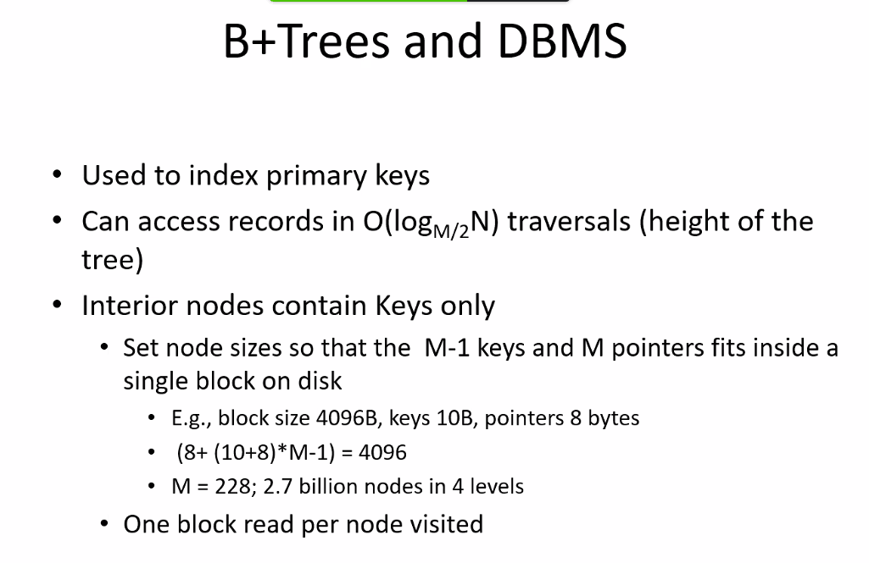
* For exam: we only need to understand what B and B+ trees are, the difference between them, the typical applications; basic concepts; no need to know insertion and deletion operations  
  *PROF GOU TEACHES CIS **427 this semester**, 450, 475, 437

# SUMMER 2021 SEMESTER II – with Thomas G. Steiner – DOCUMENTATION AND PLANNING AND TESTING ALL MODULES IS EVERYTHING

# Lecture 12 – 7-1-21 - Graphs

* Shortfall of higher level languages: unlike assembly language which, yes, takes more lines of code for a programmer to write (and is more portable), you cannot take advantage of the entire hardware/registers/computer architecture so as to maximize speed and efficiency; you are bound to how the higher level language utilizes the registers for given defined operators.
  + Assembly language (machine language) is EXTREMELY FAST; WAYYY faster than running a program from an upper level language that does the same funciton
  + This is especially why database programs are written in assembly language especially because of HEAVY DUTY MEMORY ACCESS; you cannot afford to lose efficiency and waste hardware resources and power/capabilities
  + And language of choice (what level?) and of course data structures is a key piece to deciding how and in what manner to write a program depending on a given application
  + This is why we have many different kinds of search and sort algorithms, etc.
  + So: before writing a program, make sure to think about how to design and approach the problem, and plan it, then write the program.
  + PLANNING IS THE BEST APPROACH AND SAVES TIME, A LOT OF TIME, IN THE LONG RUN
  + Less lines of code is always best: always go for efficient, short, and sweet logic/algorithms as best as possible
  + Think about how data will be accessed: will the data already be sorted? Will it be very random? A mix? Will there be a lot of data, or a little? How often will the data be accessed? What sequence does the data need to be in (high to low, low to high, is it irrelevant?); what is the capabilities of the hardware and its resources (memory size, cpu speed, etc). will the program need to be changed or evolved over time, and how often? How flexible and portable and expandable should the program be? all of these questions and considerations should be made.
    - For example: for B and B+ trees, the size that each node can be depends on the hardware capabilities (memory availability on a database server, for example)
* Always TEST: and every time changes are made, all the modules should be tested to make sure everything else still works
* **GRAPHS (can be especially important for computer network architectures) (also see these concepts from my notes from CIS 275 Discrete structures I course)**
* 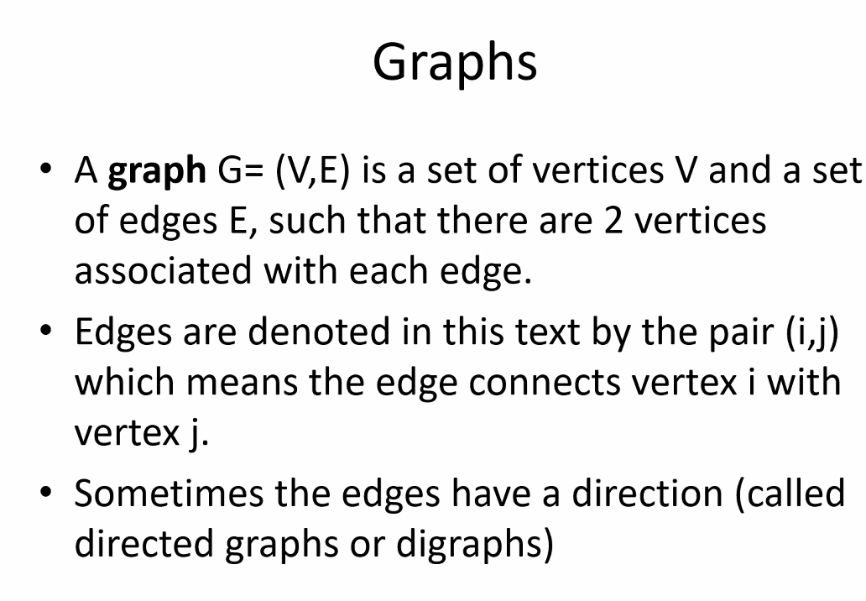
  + Example of a directed graph: roadways and streets
* 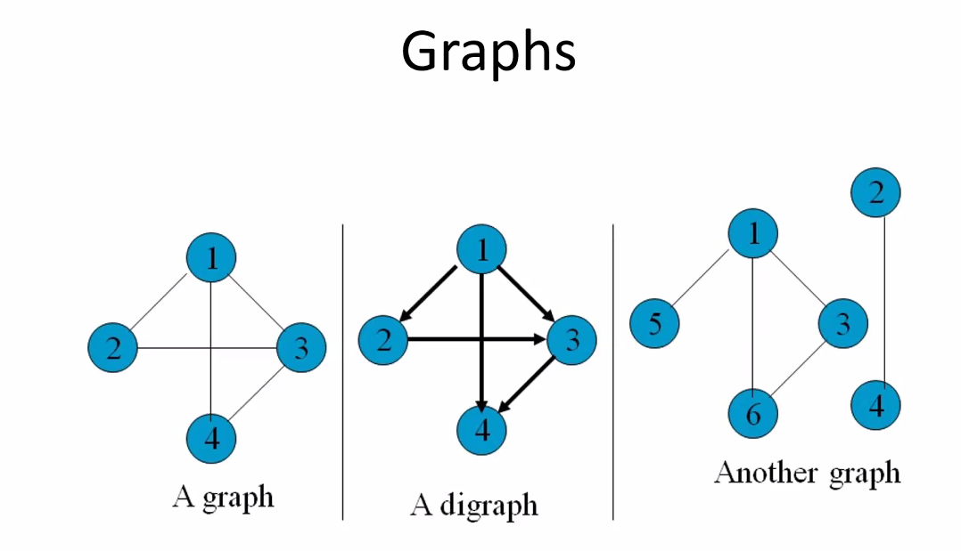
* Empty graph: no vertices or edges
* Graphs can be disjoint as shown
* Even nodes with no edges connecting them can still be considered a graph
* 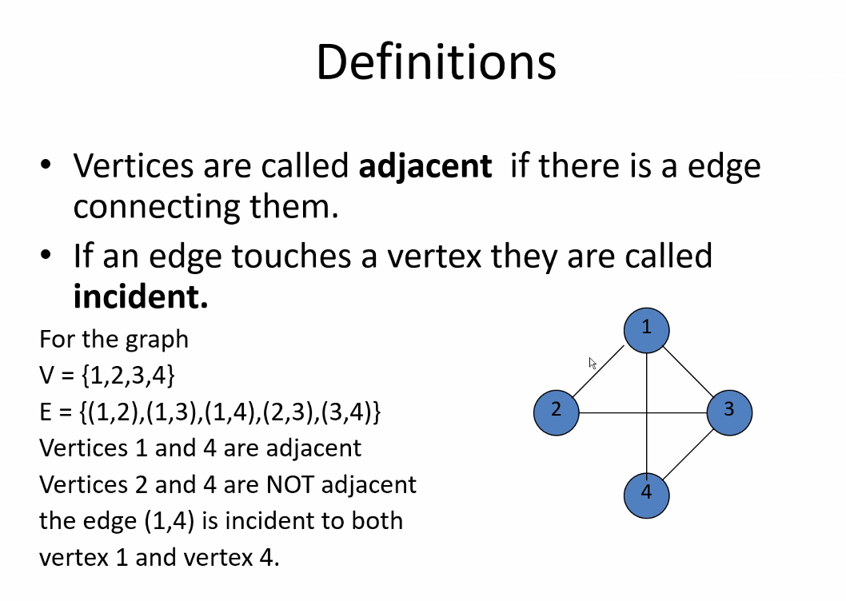
* 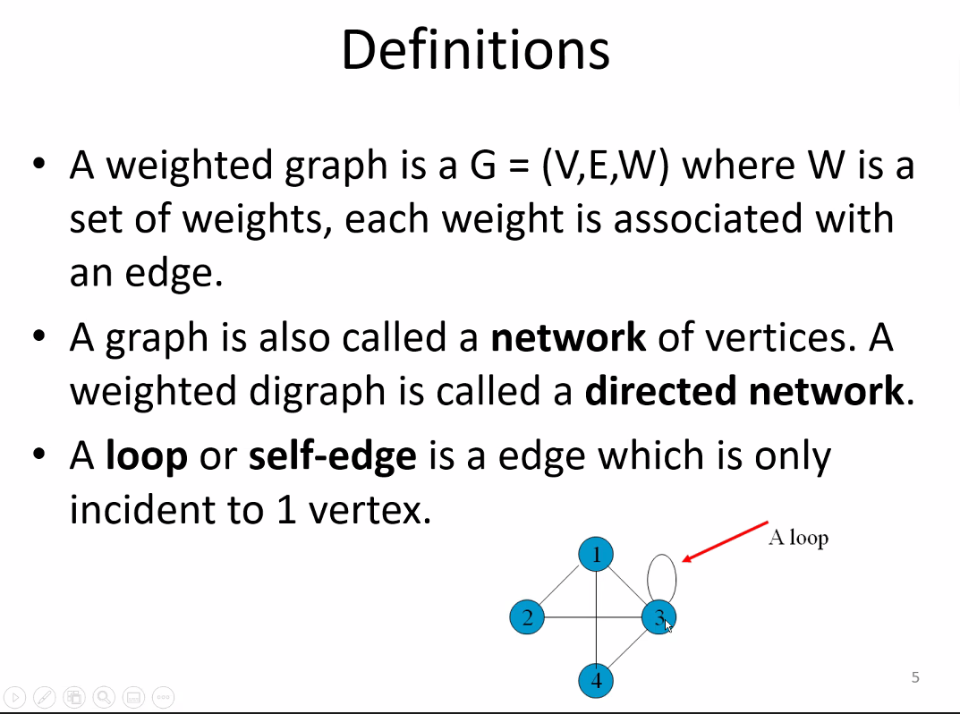
* See how directly connected this is to computer networks
* Weights can be anything that we define as we use it for planning; there could be several weights as well; for example, speed, and distance weights of an edge
* 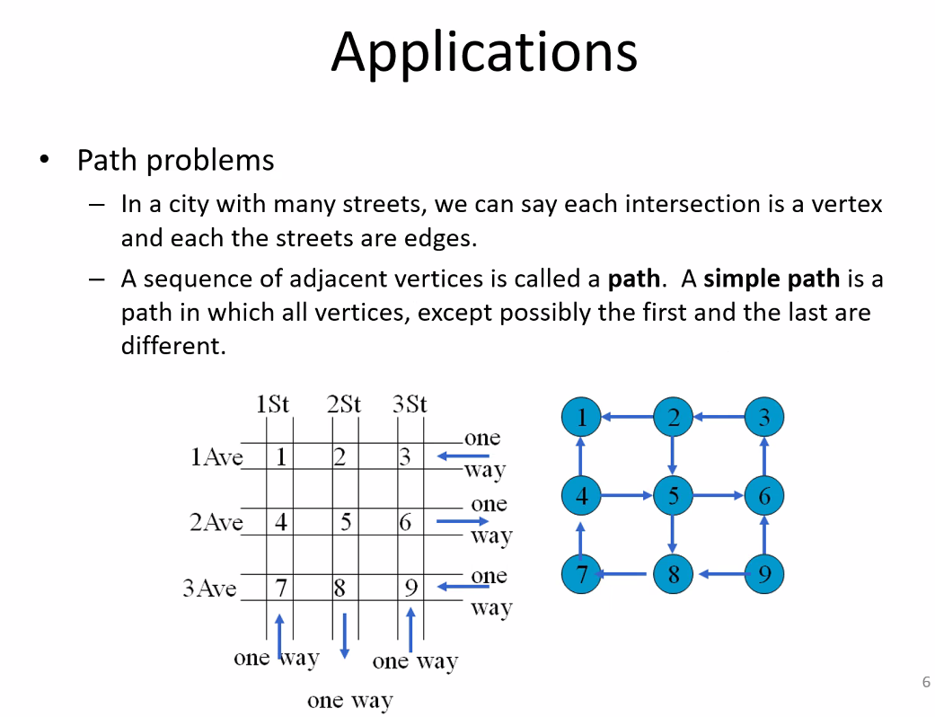
* 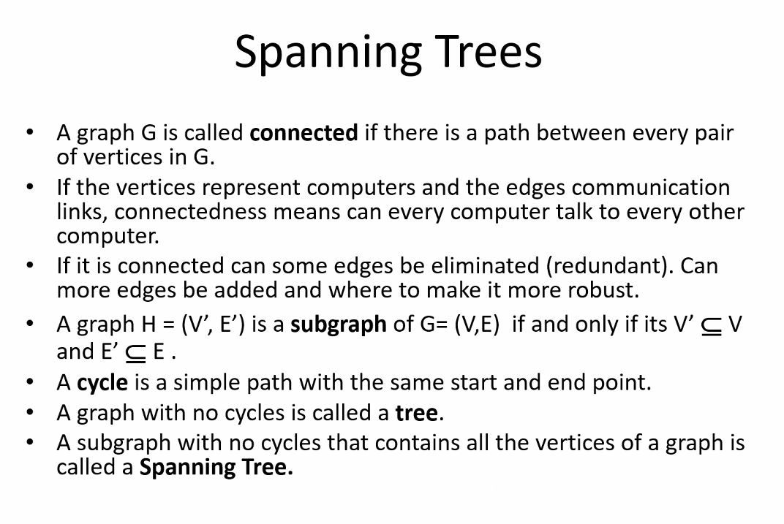
* (remember STP: Spanning Tree Protocol from computer networking)
  + Especially helpful for deciding redundancy needs; which is especially important for computer networks so that they are reliable and flexible for making changes and having outages/downs
* Think About GPS: it is also a computer network that is heavily and purely a graph problem.
  + “I want most economical route”
  + “I want shortest distance”
  + “avoid tolls”
  + “avoids construction”
  + “avoid highways”
  + All of the above are examples of a graph problem with the addresses of locations are nodes/vertices and the above are based on weight values of the edges
  + One example that saved millions of dollars for transportation companies like FEDEX and UPS and AMAZON: routes with no/as little left turns as possible (of course as long as it is practical to take a given route that is not too long or too slow to cancel out the gain); so a left turn variable was added into route calculations for delivery trucks since left turns don’t typically allow turn on red and generally take a lot more time to make versus right turns: especially in local city routes with many turns or for very long routes with lots of turns
* Our first program for this 2nd semester will be a spanning tree program
* 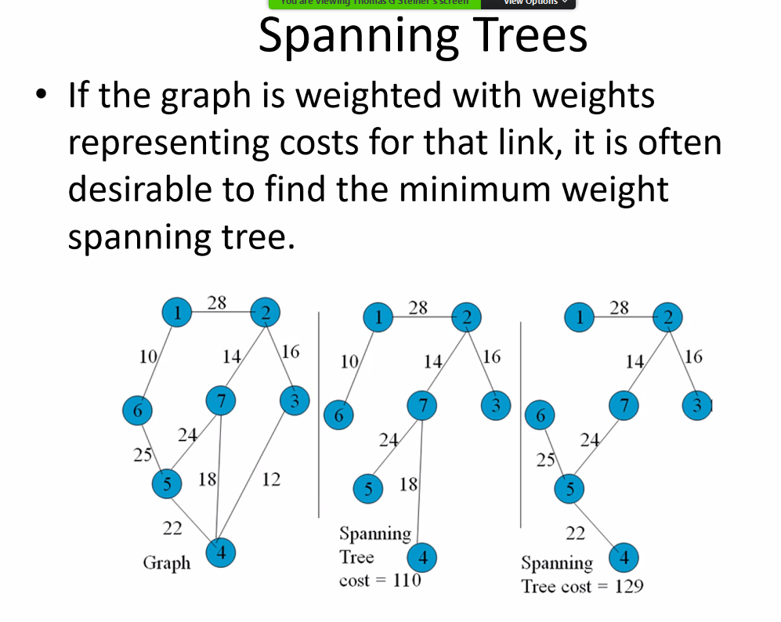
  + With spanning trees we are especially concerned with weight, and finding the minimum weight spanning tree
* 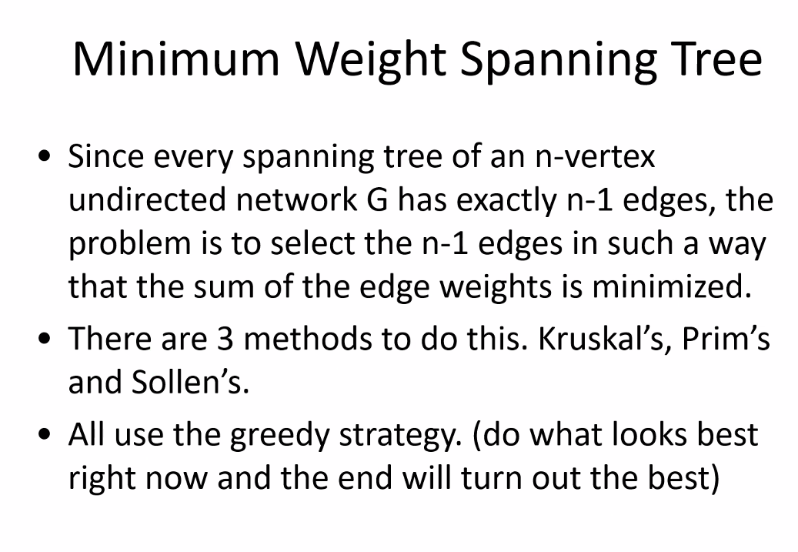
* 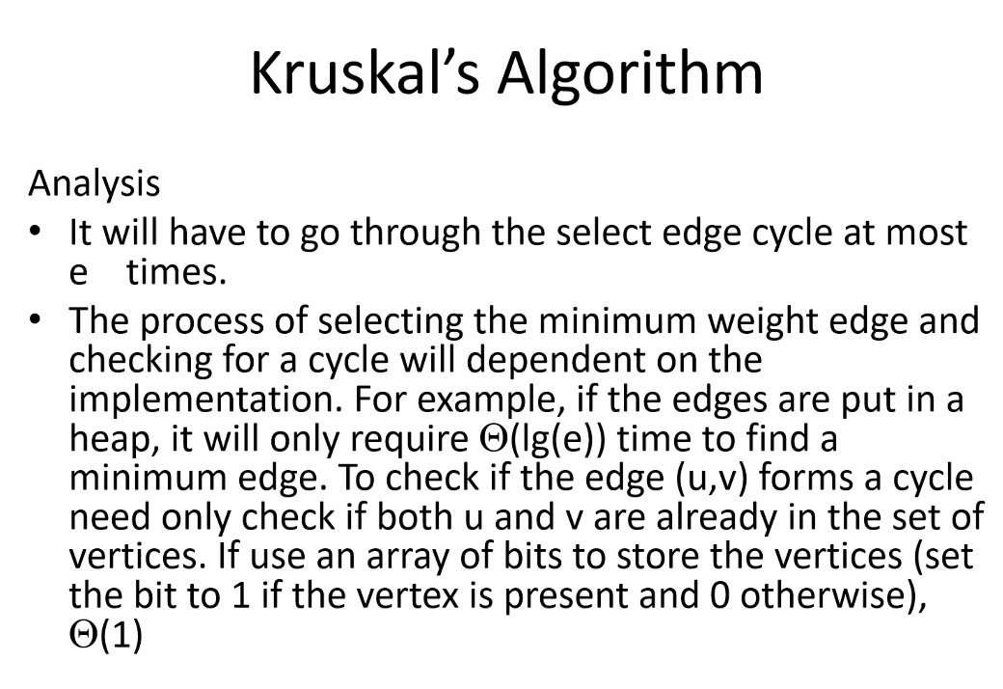
* Remember minimum spanning trees cannot have cycles; this important to the algorithm
* 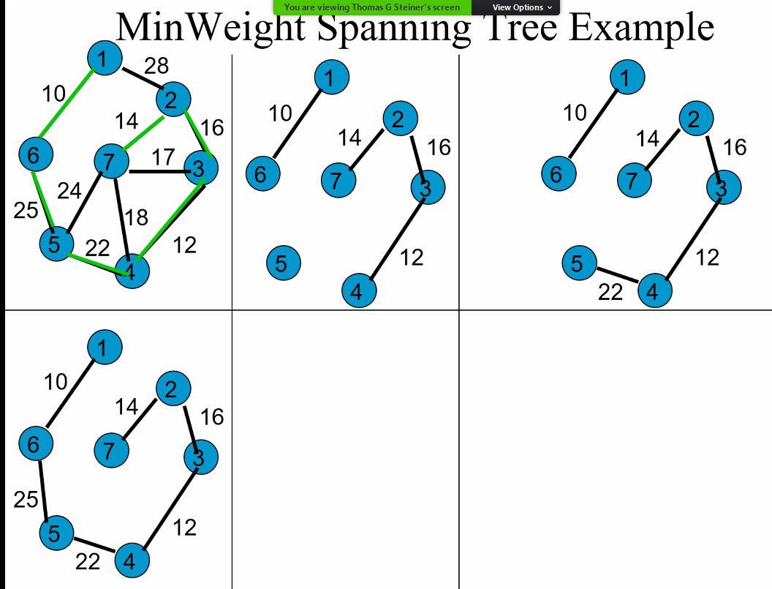
* So for example; to implement Kruskal’s algorithm you could use/build a min Heap that stores the **EDGES (min heap: smallest to largest sortation)**; where each edge data structure stores the vertices to which it is connected (possibly); you could stores these edges in a sorted array from smallest to largest (implement the min heap into an array); statistics of the data structure could also include if the edge was added to the tree (in case of a future rebuild of the tree potentially)
* Then use another array to store data about the vertices to say whether or not it has been added to the spanning tree yet; perhaps use a bubble sort (or whichever sort moves items to front or back of array after it has been accessed or added to the tree or some sort of algorithm like that so that when vertices are checked over and over to see if it has been added, we can have all the vertices that have not been added at the front or back of array; this is a potential idea but it may not be necessary if it does not really save time/or make it more efficient by any large enough margin to introduce potentially unnecessary complexity in the code)
* Continue selecting the smallest edge connection in order and add them as long as they don’t create a cycle; if they do, discard and move to next edge and try to add it
* You know to stop when number of edges = number of vertices – 1.
* All vertices added, no cycles, and #edges = 1 – vertices.

# Lecture 13 – 7-6-21 – Graphs cont’d

* 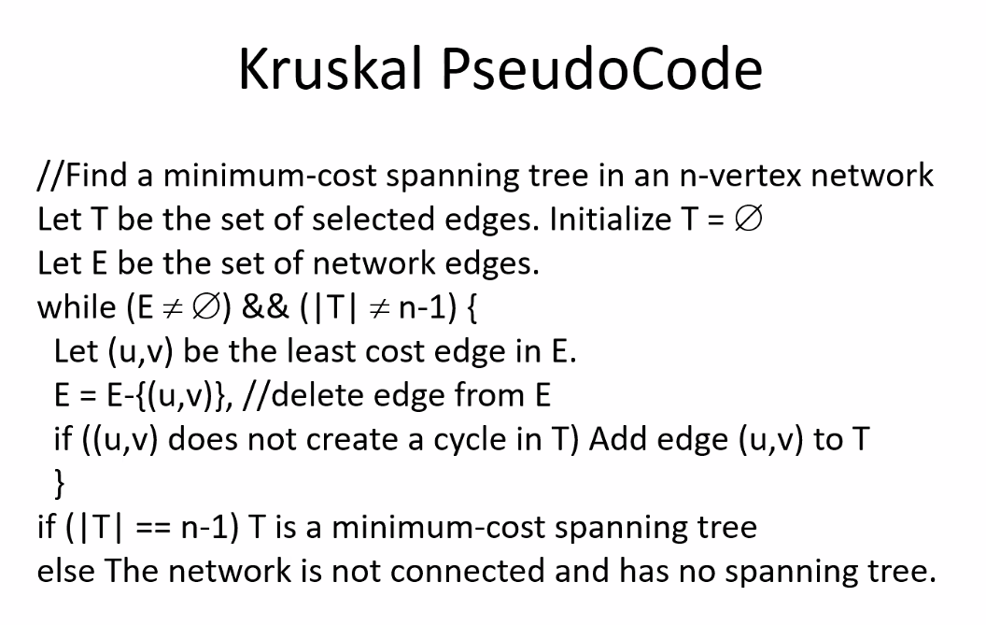
* 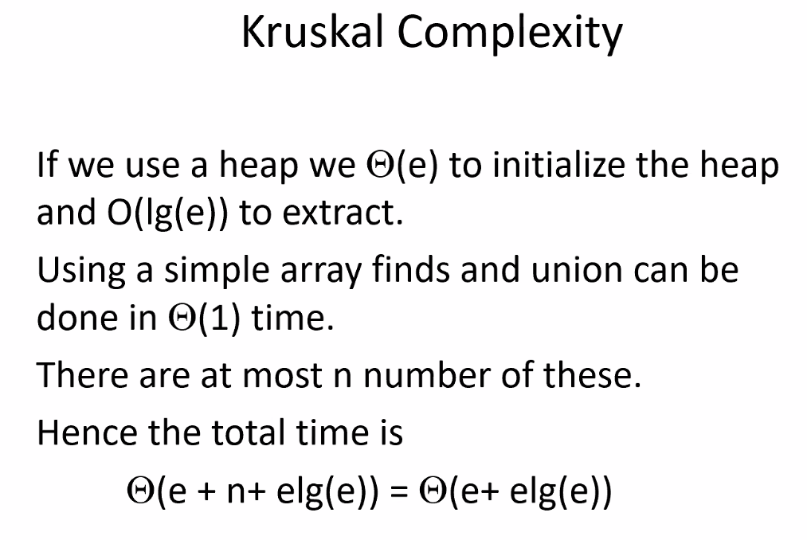
* Prims method for Minimum Spanning Tree
* 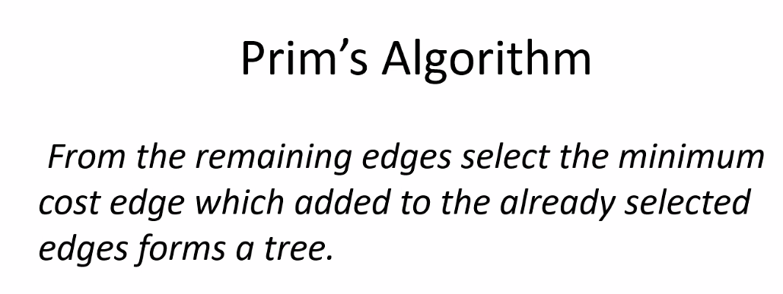
* 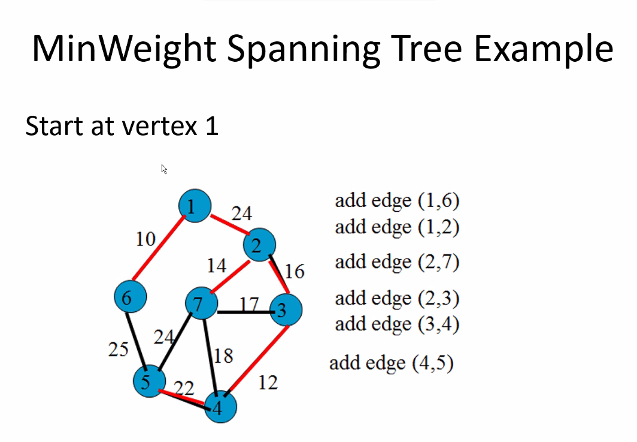
* Notice after making a connection (adding the minimum edge), then you have to select the next smallest edge from all other connections
* Start at a specific (any vertex) vertex; add smallest edge from that vertex, then repeat process considering all unadded edges that are added to the tree from connecting the next node
* Remember there can be more than one min spanning tree, which of course will all have the same total edge costs.
* The reason that we want min spanning trees is: Find the minimum cost (the lowest cost) to link all nodes in graph (relating to some real life project); this happens to mean cycles must be excluded. Cycles can be good for redundancy, but they add costs; so we always start with a min spanning tree, and then perhaps add redundancy links (cycles) where/if necessary.
  + We always want to know lowest cost, especially base case lowest cost
* 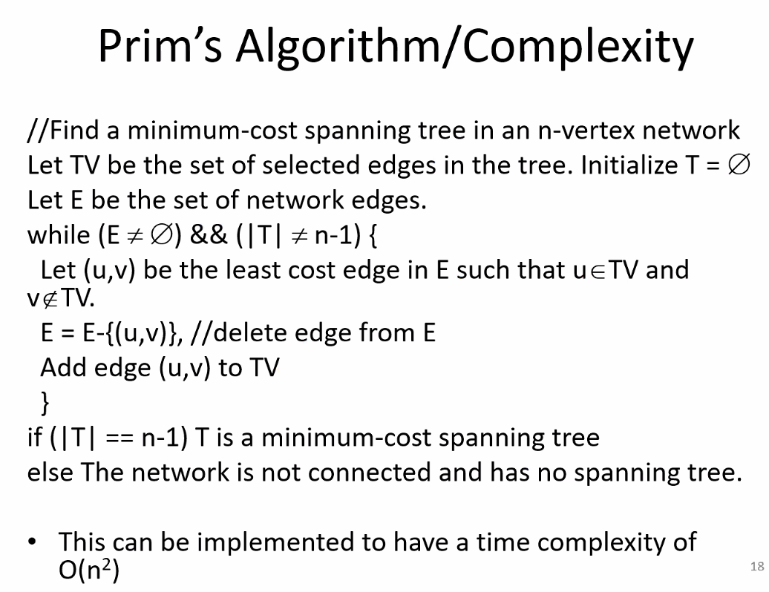
* 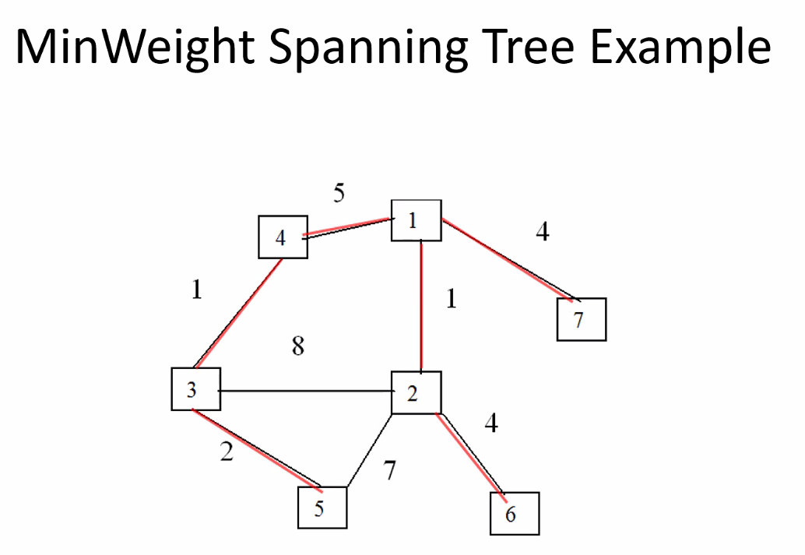
* Remember: you can start at any vertex, you will still get same net cost min span tree
* If there is a tied cost between two or more edges, arbitrarily pick any edge (whichever first comes to top of heap) (unless for example some extra/special criteria is required)
* This will likely be on exam
* Min spanning trees can also be used for layouts on a plant floor for example
* 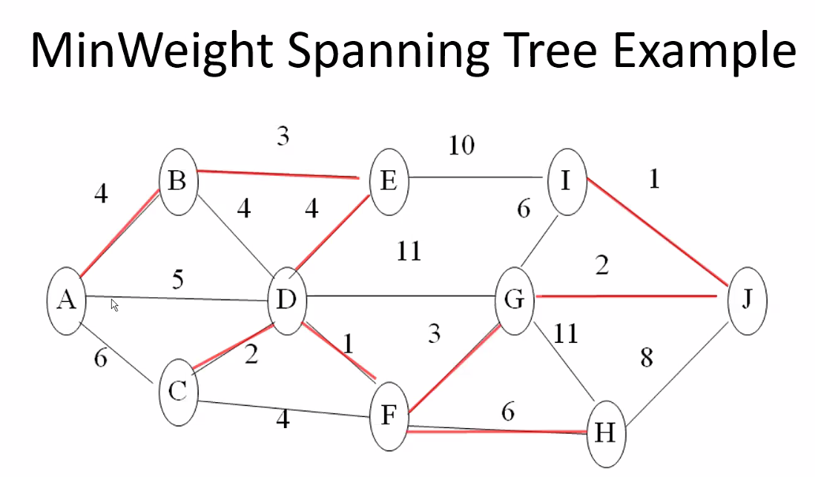
* Bipartite graphs
* 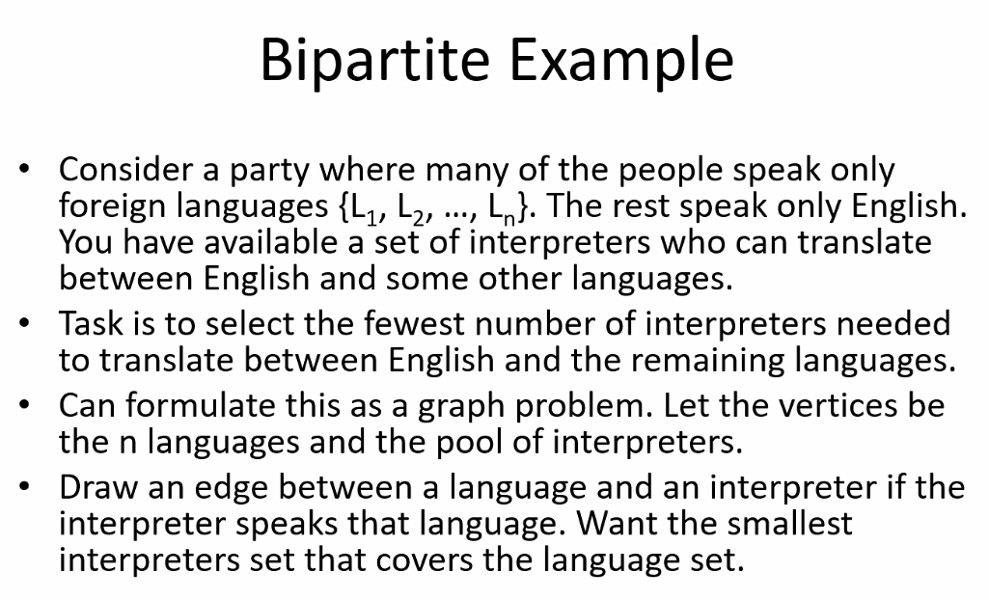
* 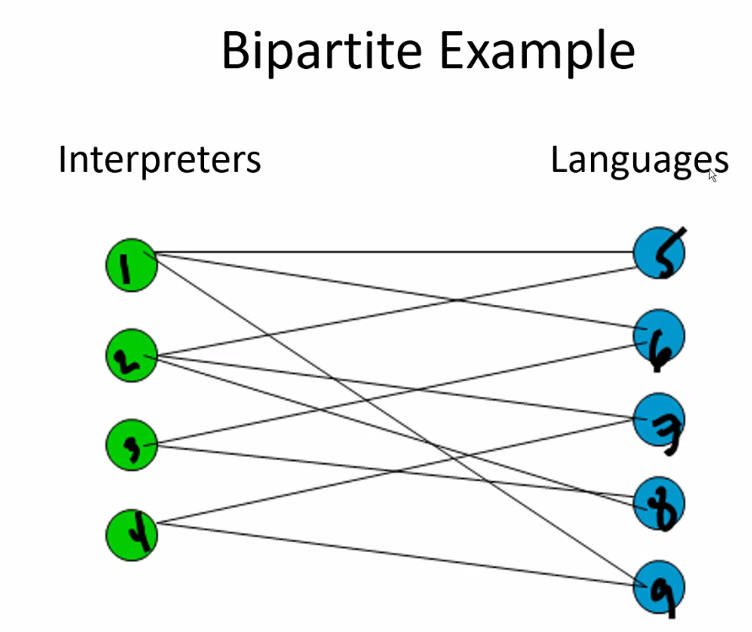
* Start off with selecting the interpreter(s) that can interpret the most languages, and with the least amount of intersections with other interpreters who can interpret the same languages
* 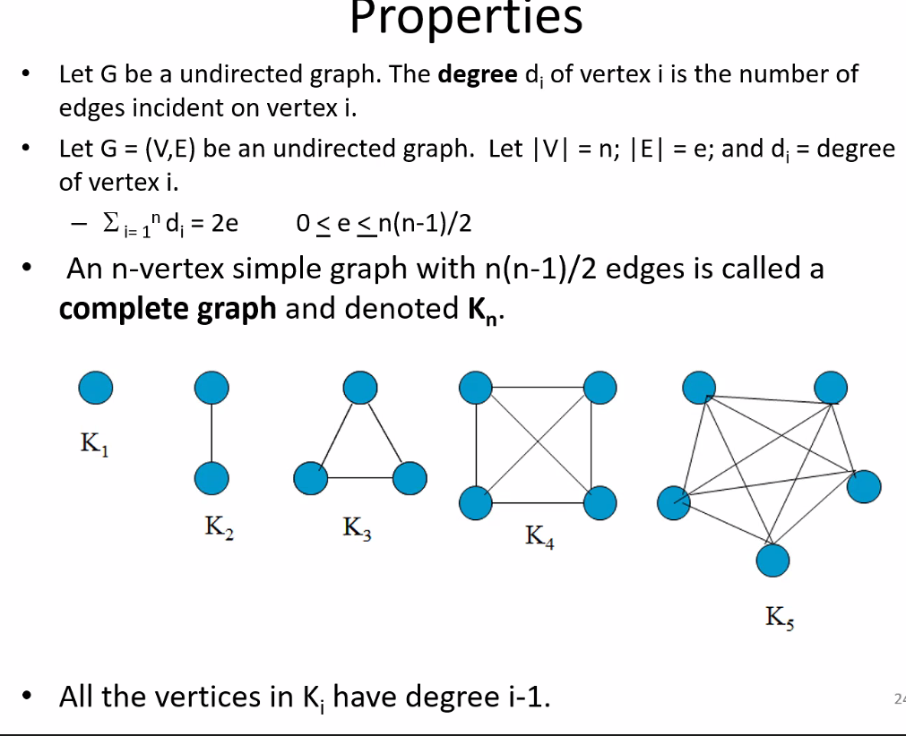
* Sum of total degree of a graph is 2e because each edge must touch two nodes
* Simple graph means it is an undirected graph
* Complete graphs are simple graphs and cannot have a looped edge (edge that goes from one node and back to the same node)
* 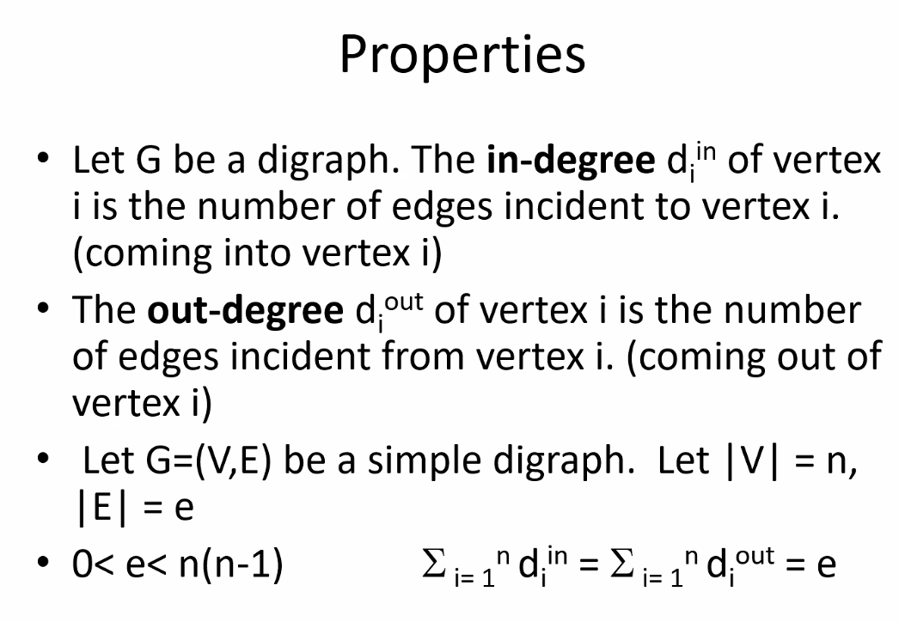
* 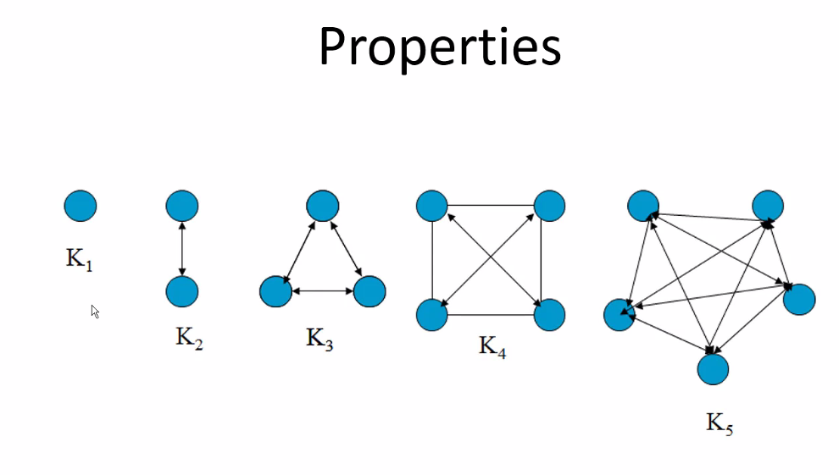
* Graph ADT
* 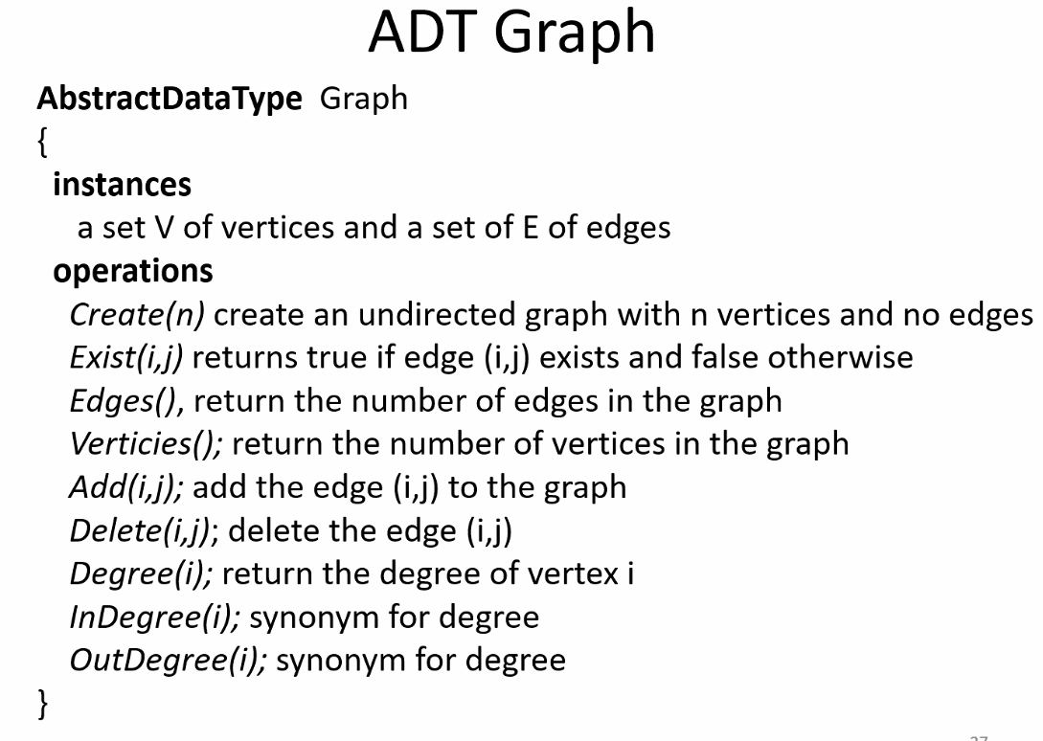
* Remember a graph consists of a set of vertices, and a set of edges
* EXISTS (I,J) is FOR SURE the same as exists (j,i) if the graph is not a directed graph; if it is a directed graph this is not automatically true
* Have to make your graph ADT depending on If graph is directed or not
* 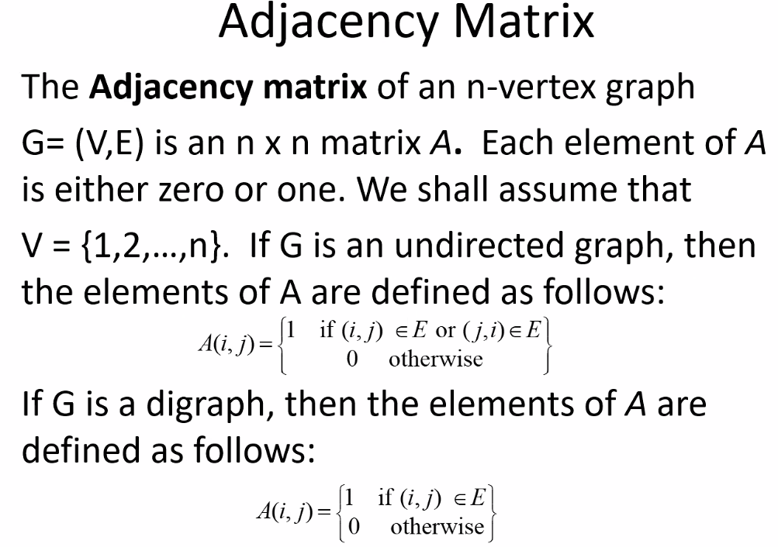
* Remember a matrix is just an array; in this case the matrix is a 2d matrix (array) refers to two 1d arrays (nodes and edges)
* 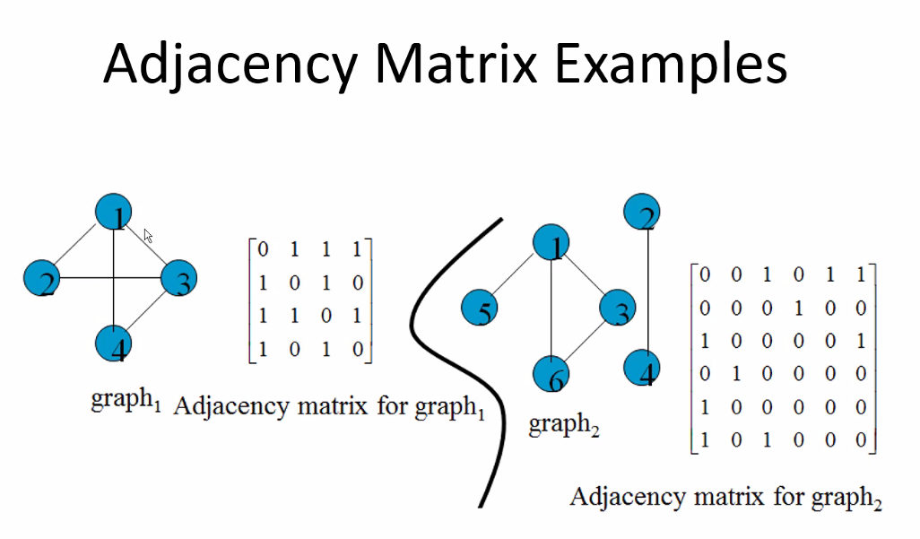
* Row refers to the node, column in a given row refers to if there is a connection to the corresponding node (1) or not (0)
  + Thus a row (node) of all 0s means a node is connected only to itself (no edges connected to it)
  + You can see how reduced row echelon form from Linear Algebra can be used by a computer to help possibly compute the adjacency matrix and find some layout of efficient or plausible connectivity; reduced row or echelon form; perform elementary row operations; etc.
* 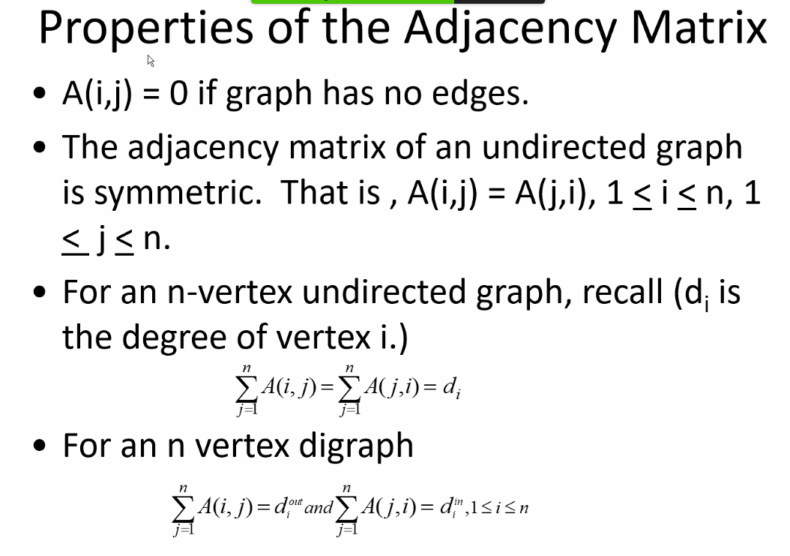
  + So you can use linear algebra and take advantage of the fact that computer run off of using matrices for their fast computation in order to even help solve graph problems!
  + You could build the adjacency matrix for a given graph, and then a computer could take that matrix and reduce it to potentially find the min spanning tree! Or some other useful graph..
* 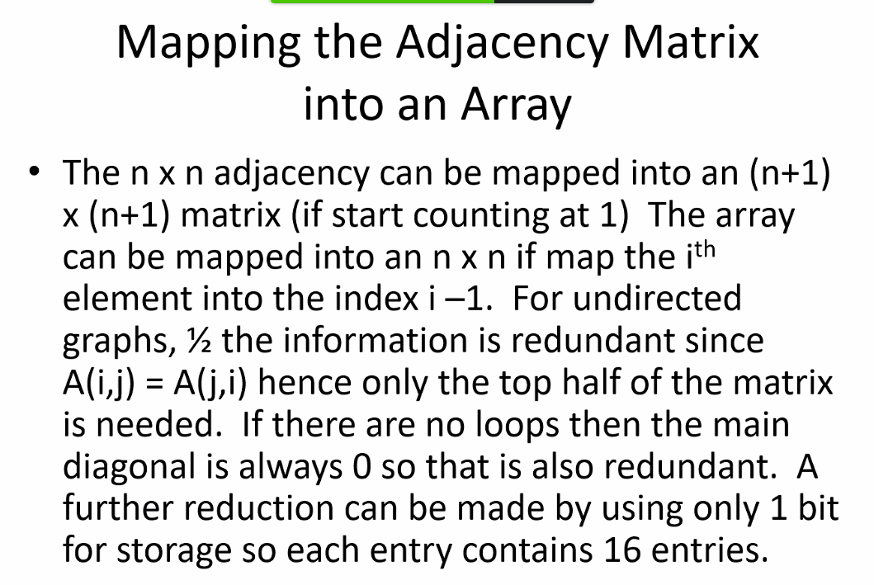
  + Remember linear algebra concepts about diagonal matrices..etc..and remember spanning sets!
* 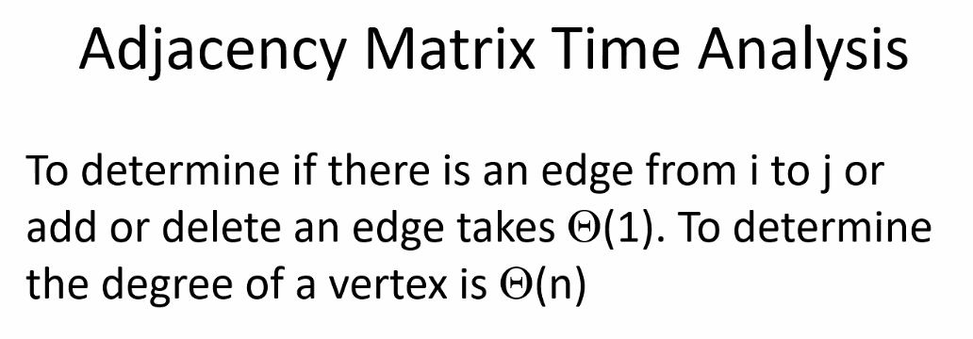
* Side note: size wise Boolean values are the same as integers and they are also stored as integers; they work because programming languages take advantage of the flags provided by the computer architecture in that allow for comparisons (remember CIS 310 EFLAGS registers)
* 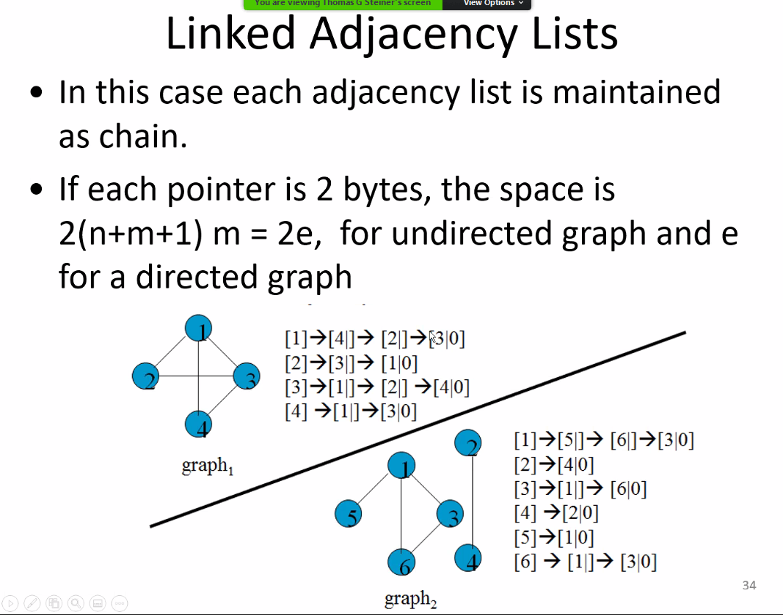
  + Does exact same thing as adjacency matrix does; just a different approach
  + The 0 at end of each list refers to NULL
* 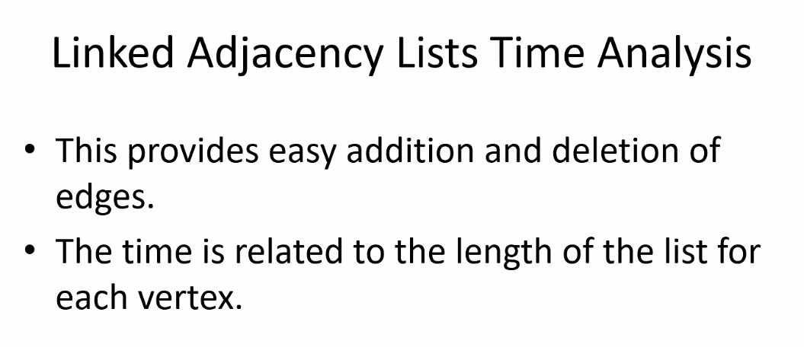
* Of course linked list is easy to add and delete at any position; but of course it is not as space efficient, and arrays are contiguous and provide much faster access and search algorithms
* 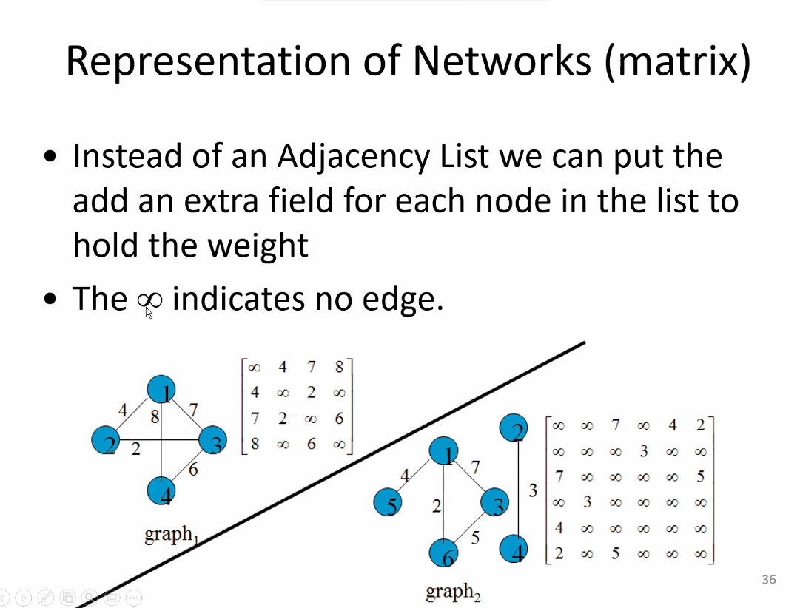
* 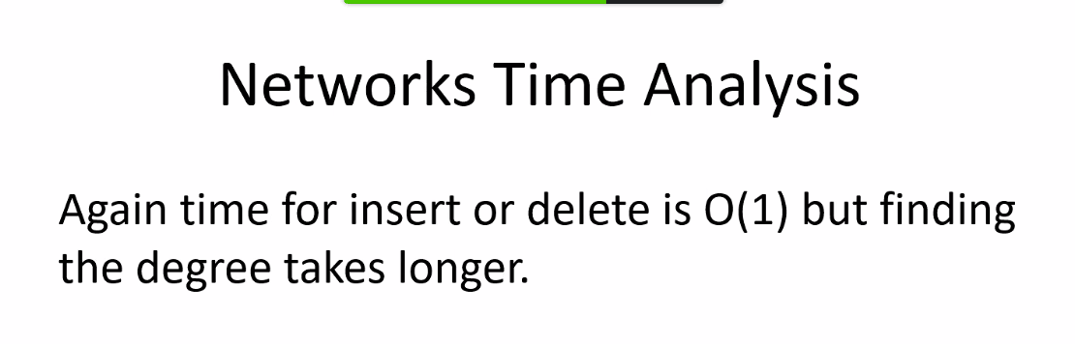
* 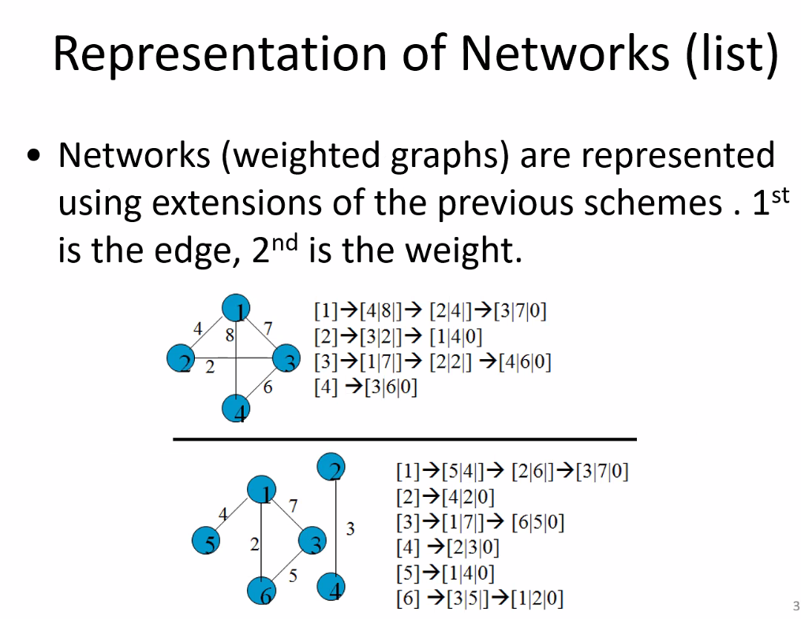
* Add additional data: shows weight; so for example: 1 is connected to 5 with an edge weight of 4.
  + Could be many pieces of additional data segments with necessary information based on implementation needs of the customer/problem set
* Topological Sorting: break down complex problems – a divide (decompose/simplify) and conquer method; break down complexity as much as needed in order to digest and solve a complex problem; do this break down as often as necessary for each sub problem that is derived from higher problems; and take sequence and order into account
* 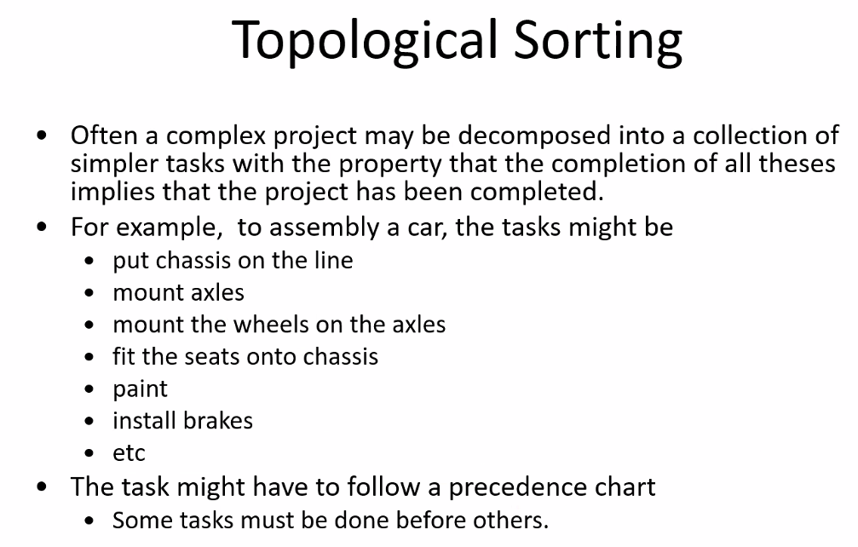
* 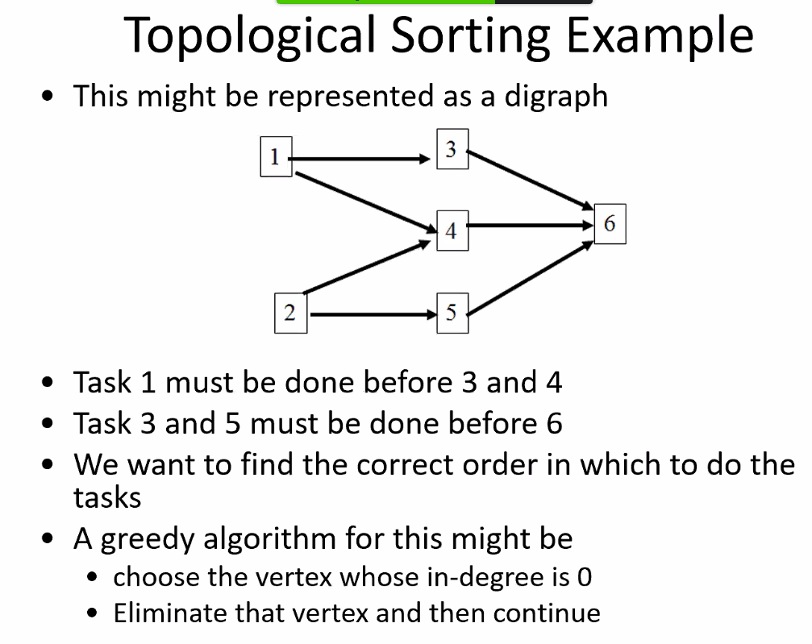
  + Think about when you are taking classes for school; make sure you take pre reqs first before taking the upper level, more complex courses
* 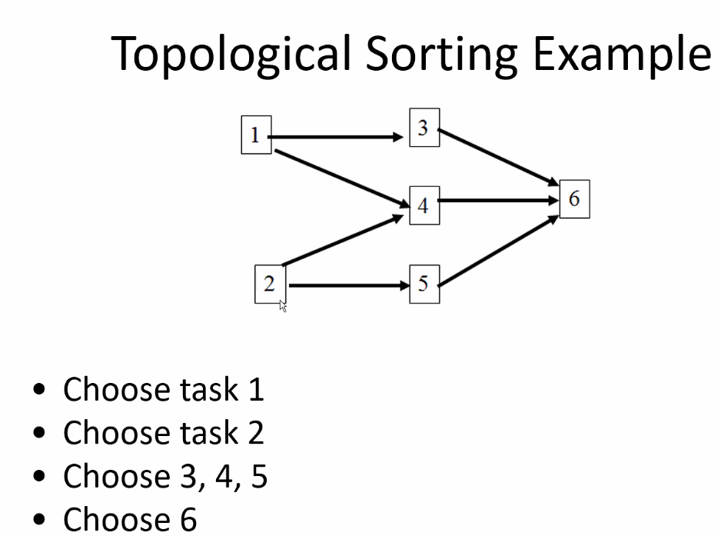
  + Above, still think for example of each node referring to courses; say 1 and 2 are cis 275 and cis 150 for ex; and then 6 could be CIS 350 for example
* 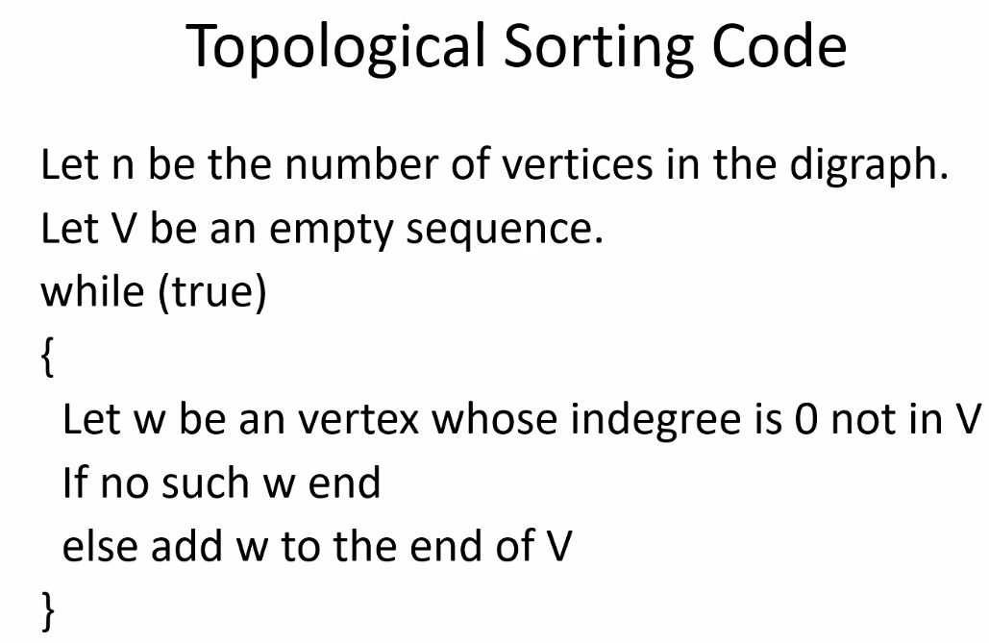
  + so as you see, you could write a computer program to help solve all sorts of problems, by representing these graph structures into a computer program implementation
  + 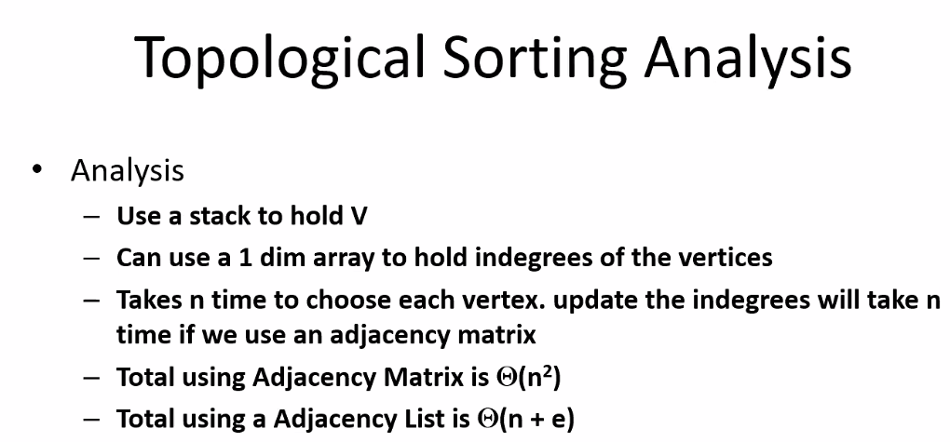
* 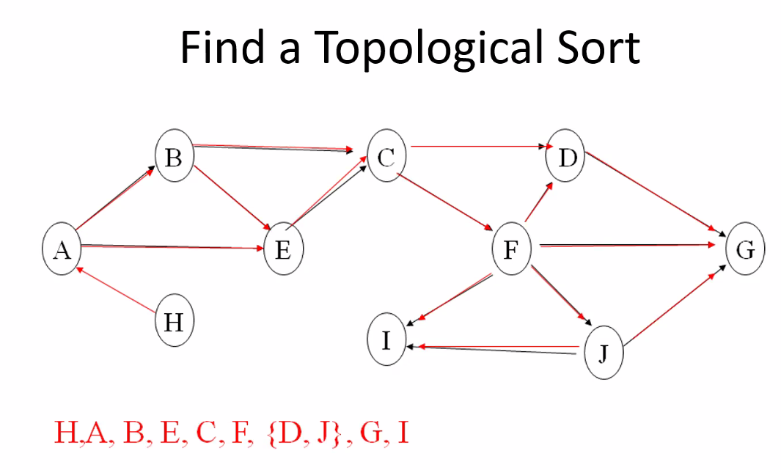
  + Start with H; in-degree of 0
    - Select edge going to A; now A is considered edge with in-degree of 0; do not count edges as in-degree if they have already been added to the graph
    - Etc
    - If there is a tie; choose either one
    - So topological sort is all about lowest in-degree
  + If every node has a predecessor (no node has in-degree of 0): you could either break down the problem more until you have a node/task with in-degree of 0; or you could add a dummy node with no predecessor (in degree 0) pointing to the node we want to start with based on some criteria and add it in the graph (say, dummy node points to node with smallest in-degree, for example.)
  + 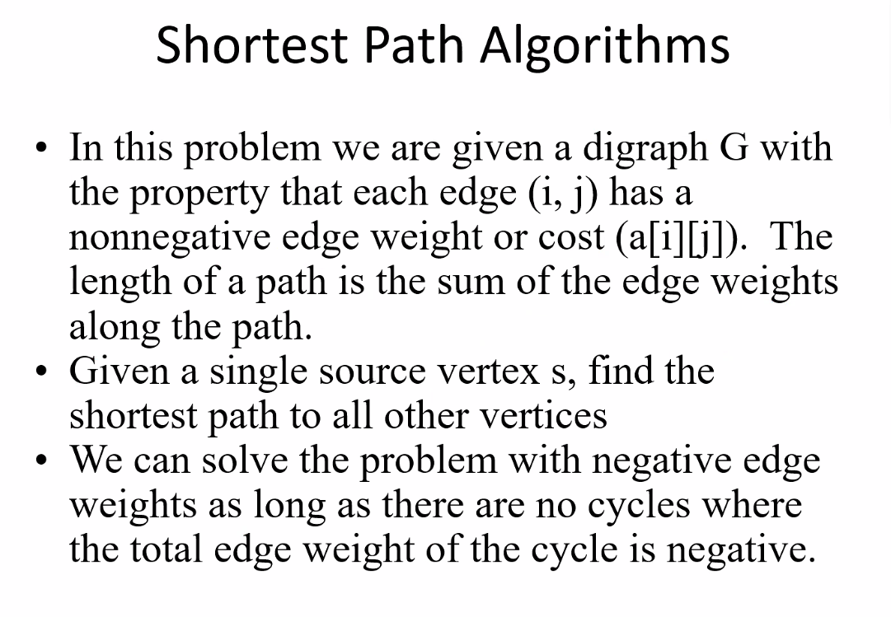

# Lecture 14 – 7-8-21 – Coding Projects Overview, and Program 3

* Each layer moving down becomes more detailed:
* 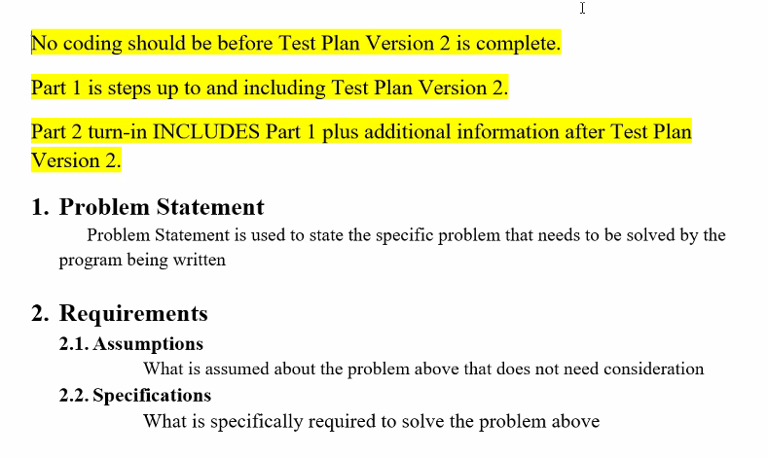
  + Remember: assumptions is something that everyone agrees to about some aspect of the problem; it is not an assumption in the sense that you can assume it on your own.
  + Above, many companies many times have the following layout for a template for any program that is written or updated; thus, Steiner will have us use this template for our course coding projects
  + 1 week to complete part 1 (design, test plans); turn it in
  + Then another week for part 2, where you add on to part 1 and write and finish the code, then submit code and new part 2 documentation
  + Problem statement: typically comes from customer
  + Part 1 typically done by a separate team
  + Part 2 takes results from part 1 and actually completes the code based on part 1 plans
  + Specification refers to logic perspective used/needed in order to define what needs to be done to solve the problem (try not to write pseudo code; just more talking through the logical process; **a general overview)**
  + 1 and 2 was from business perspective; number 3 forward is from IT perspective:
  + 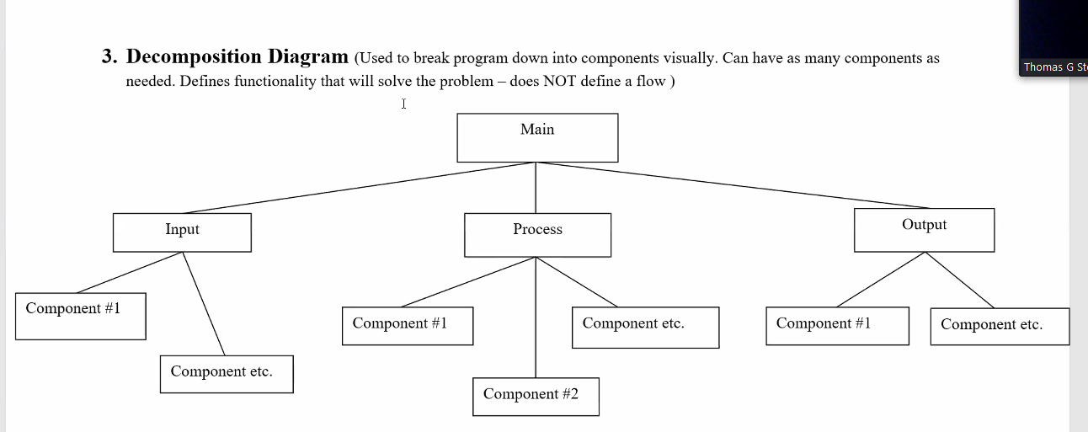
  + Everything in the specification should be in the decomposition; if decomposition has something extra after tracing it with specifications, then make sure you take it out unless it is really needed, then if it is determined that it is actually needed, can be added to specifications.
* 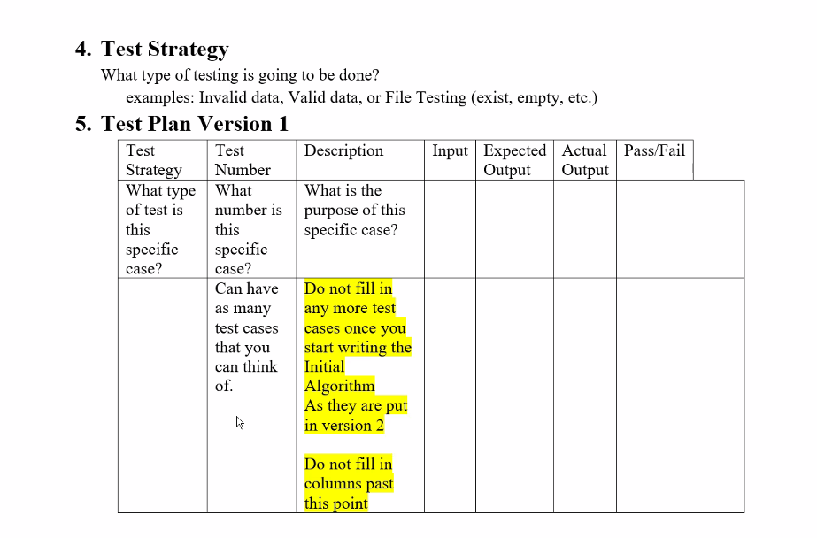
  + Test plan v1 is business perspective (could be high-level pseudocode)…so we stop at input column and beyond
  + Also need to test performance of various components/aspects
  + We run tests to prove a specification to solve a given problem outlined has been completed
    - We plan these tests even before doing the code so it is easier as we develop, and to make sure each component correctly solve its respective problem that was outlined
    - So it is not about so much testing the algorithm, its about testing if the problem was addressed and solved
* 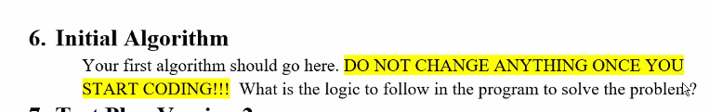
* 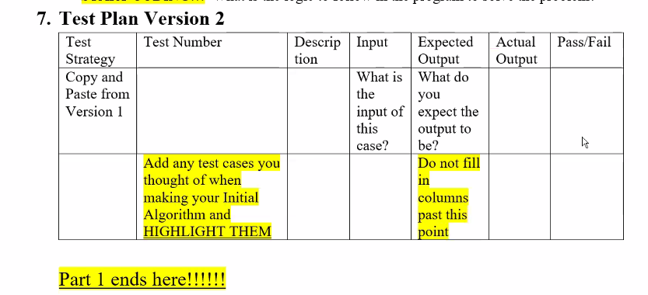
  + Test plan v2 is IT perspective; same as v1 but now we have more details because we have an algorithm that we will use so we can fill in up to input and expected output columns now
  + Then after the code is actually written you can make a version 3 table to finally completely fill out the entire table
* Part 2:
* 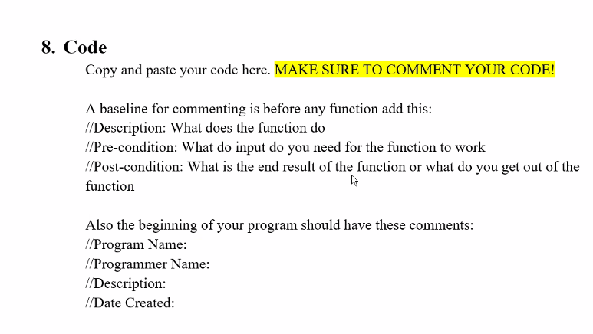
* 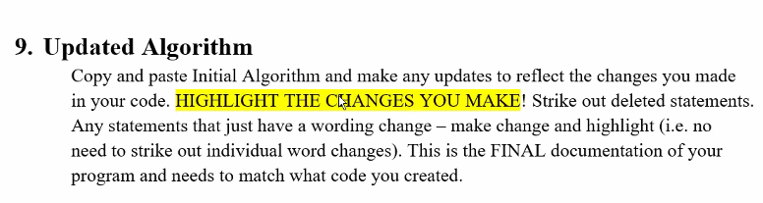
* 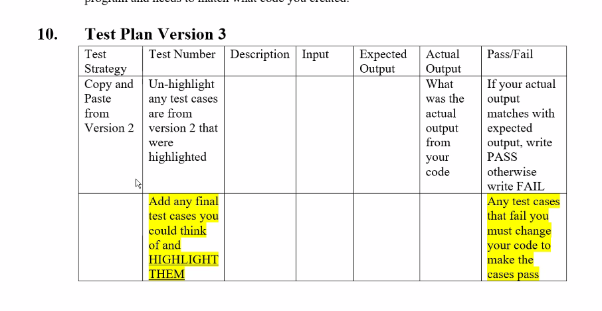
* 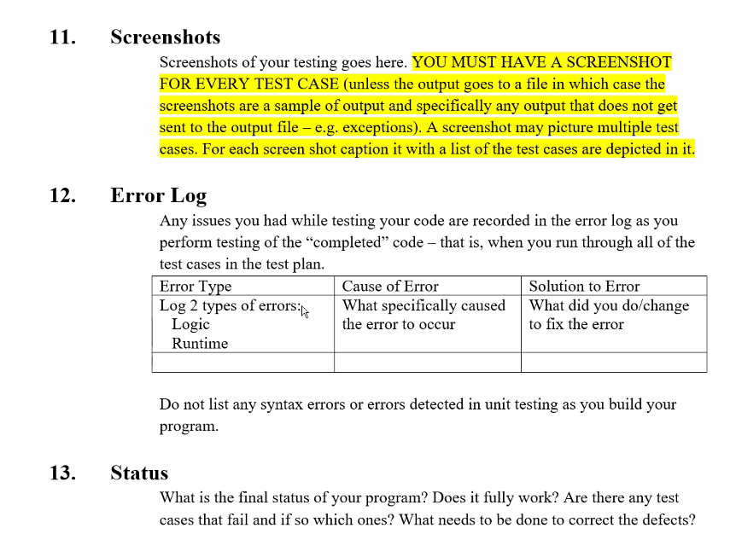
* Remember to use test variables and assert.h, and try catch blocks…etc..to help track data to find logic errors and runtime errors
* Can use bullet points and small paragraphs to complete these parts from 1 and 2; don’t need long dissertations
* For project, we need to re-display (echo-back) what we input so user will know what they input into the program
* Graph input will be a connected graph, i.e., you can make a MST because all vertices are connected.
* If an edge has a value of 0 or less; edge has an invalid weight
* Graphs input for project will be undirected graphs only; so there will be symmetry/bidirectional properties that automatically apply
* For number 3, getting down chunks of processes that need to be completed (as shown as example from program 3 part 1 given)
* Remember for number 2 and 3, you should be able to map everything in 2 to some part in number 3.
* We will use a priority queue (struct pqData)
* You should also be able to trace your algorithm (number 6) to number 2 (specifications)

# Lecture 15 – 7-13-21 – Priority Queues

* If encounter an edge in the program from project 3 that was already encountered and added and then reached again later in the file, then simply output/account for the duplication by ignoring it and stating “edge already added” for example
  + Add this to the test plans!
* Don’t touch part 1 at all, it is done; any updates are all added only to part 2
* Remember for spanning tree, the tree structure does not allow for loops (source and destination of an edge is the same; thus print out error message)
* Priority Queues:
* A data structure
* 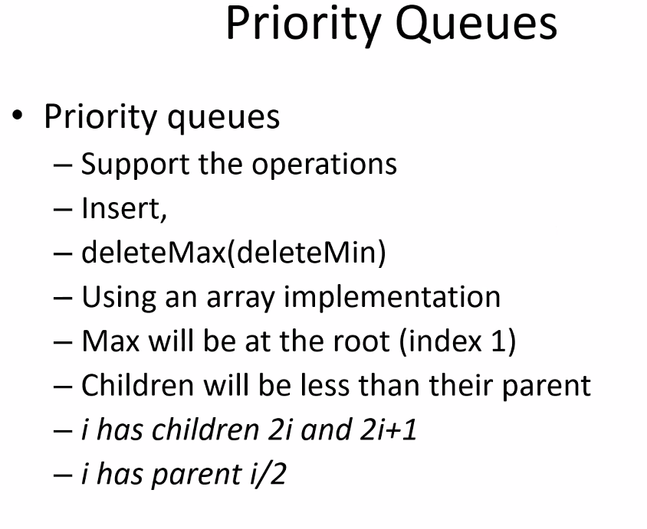
* Do not necessarily have to be a heap; but for program 3 we must use a heap as it is specified to implement the priority queue
* Some applications it is easier and makes sense to implement a priority queue without using a heap
* Data structures made up of other data structures
* Remember a tree structure can be used and implemented as an array or as a linked list; but usually array is best and faster for processor
* 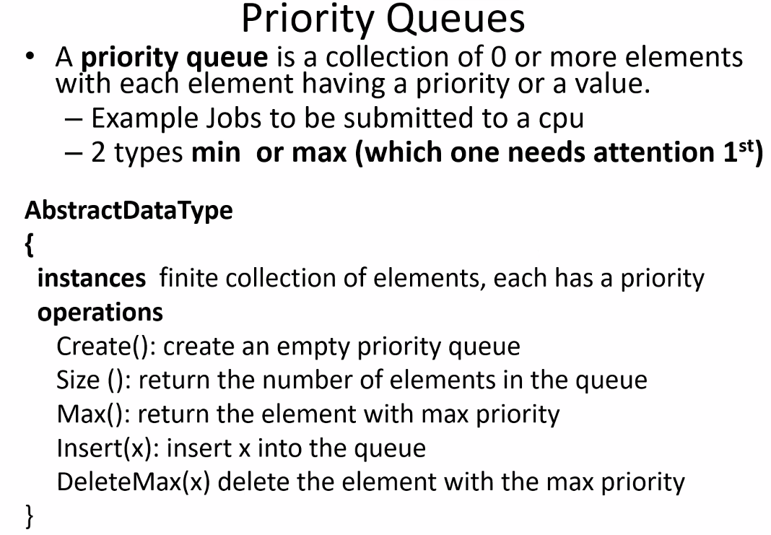
* There can be multiple priority parameters to check against, each with its own specified priority over the other priority parameters
* 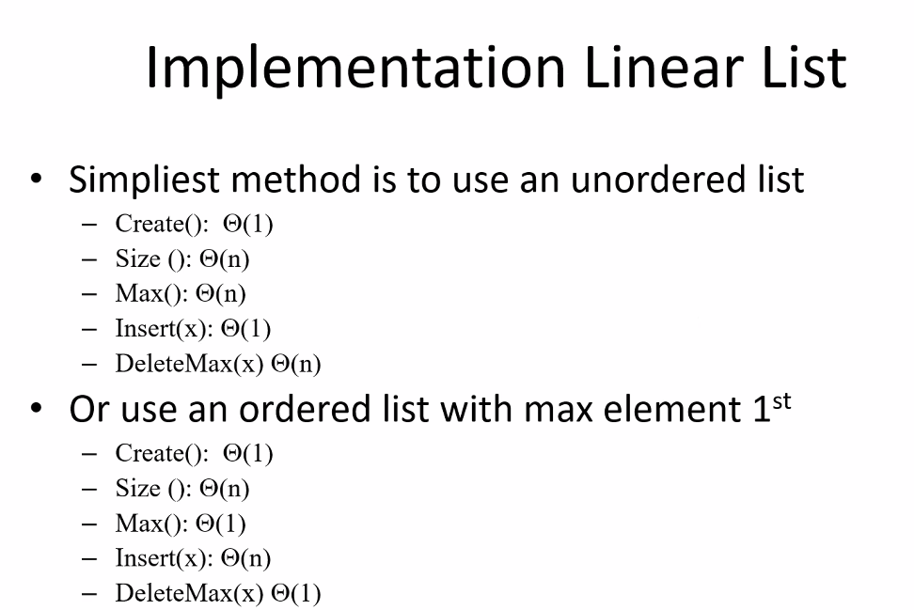
  + Using an array/vector structure
  + Notice the difference between ordered and unordered; they make perfect sense
  + If you insert into an ordered list, of course complexity is worst case O(n) since you have to in theory check all elements and find where to insert the new value
* HEAPS
* 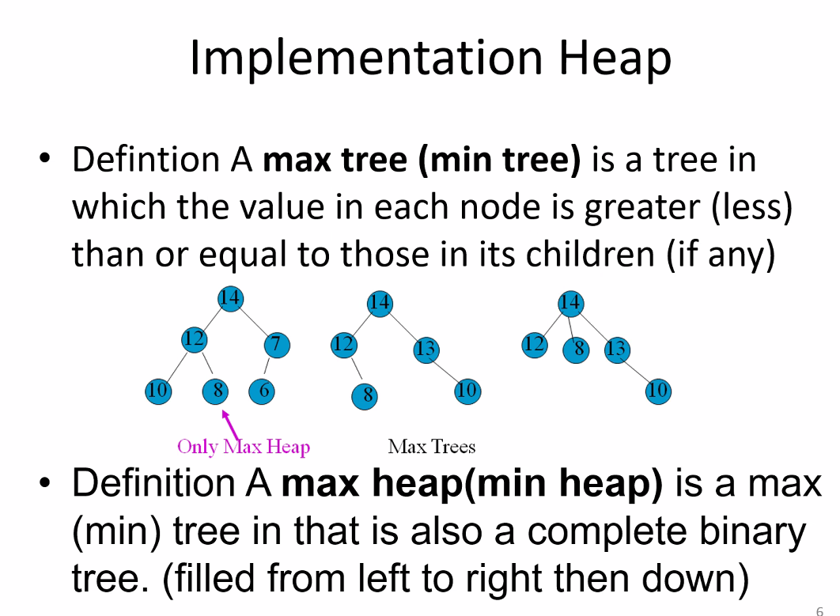
* Notice how it doesn’t matter where the left and right child is; as long as they are less than or equal to their parents
* 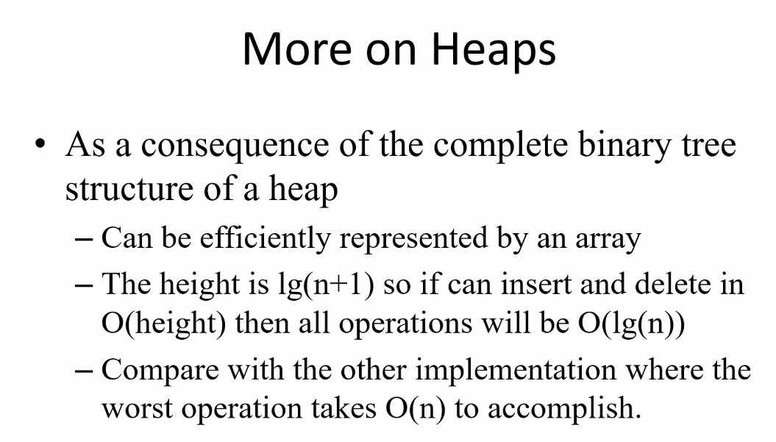
* 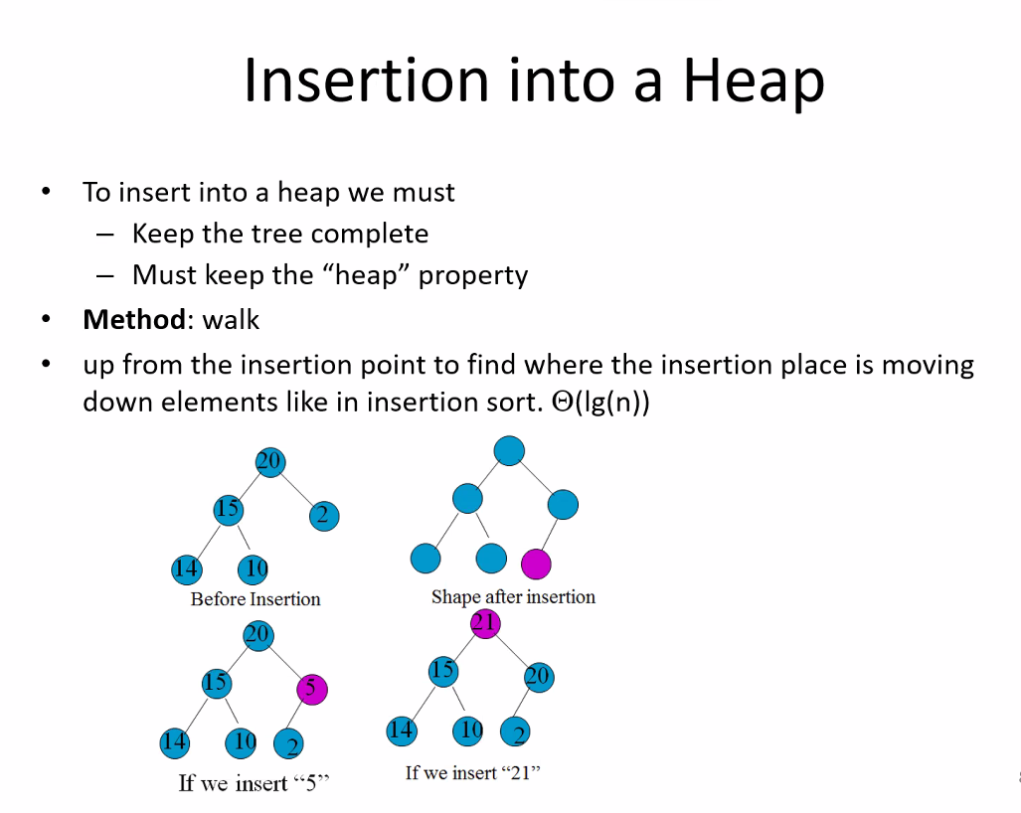
* Notice after the insert, the greatest value will always end up at the root node after performing the insertion sort algorithm (walk algorithm)
* Remember, initial insertion must be inserted at the next location at the left most empty child so as to keep the tree a complete tree
  + Notice because of this property and the order of magnitude on each level that for insertion, only one half of the tree is dealt with; so half the tree is completely ignored
* 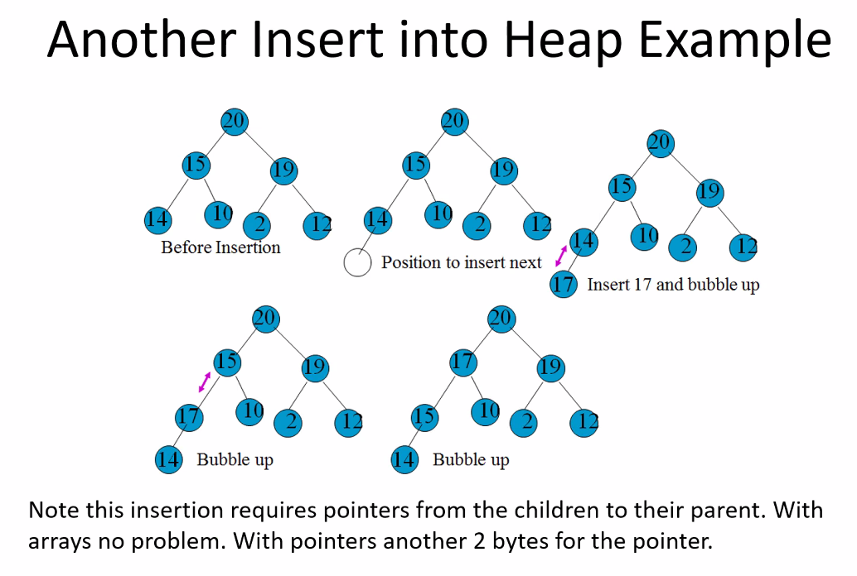
  + Side note: you could have a pointer that always points to next insertion position so it is easier to insert, and then perform the swap algorithm as necessary
* 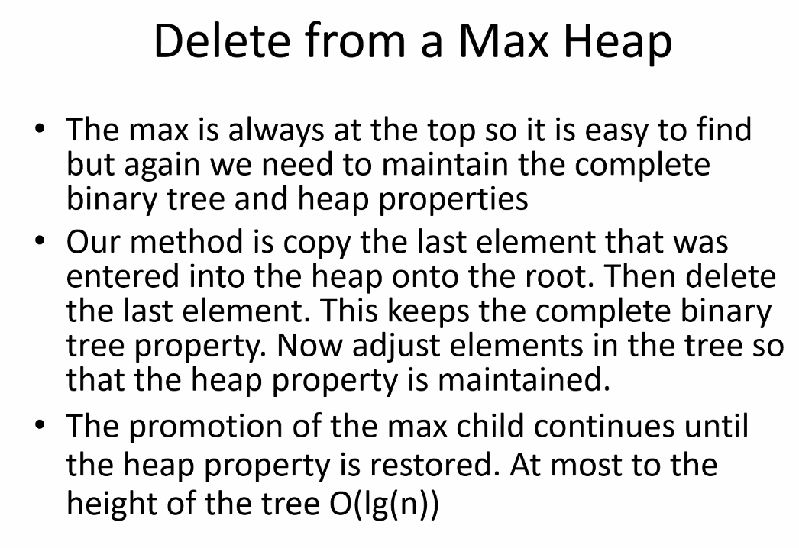
* So for delete, take child from lowest level and promote it, then perform swap, but this time going down the tree
* 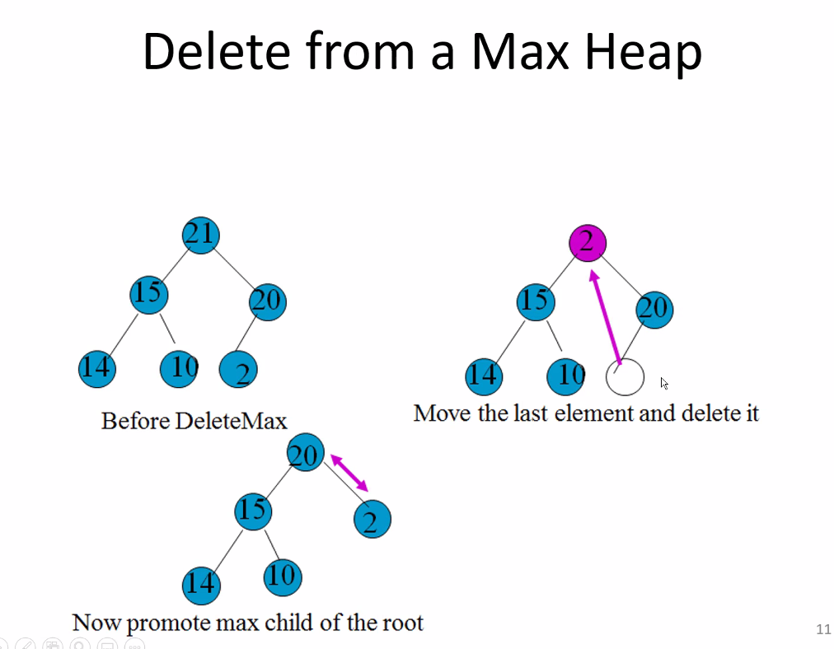
* This is a brilliant way of deleting the root node (max element/node) and taking advantage of the order of the complete binary tree (where elements are ordered by level; elements of upper levels are greater than the elements on the lower level) of the heap structure
* 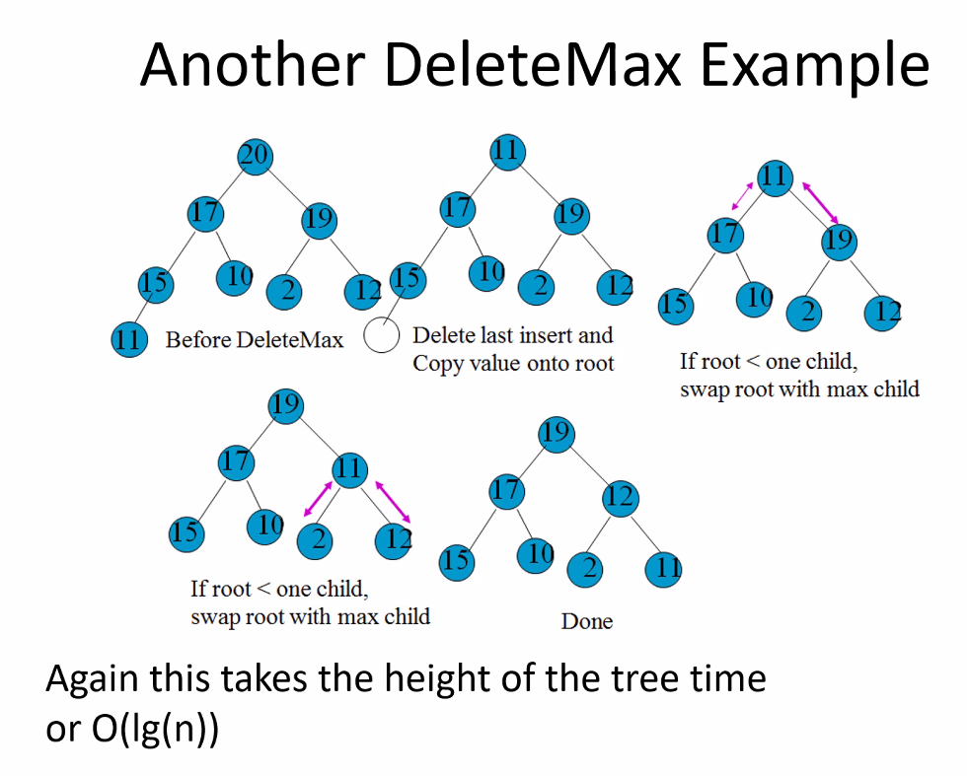
  + N still refers to total elements/nodes, but log(n) will essentially resolve to be equal to the height of the tree
* 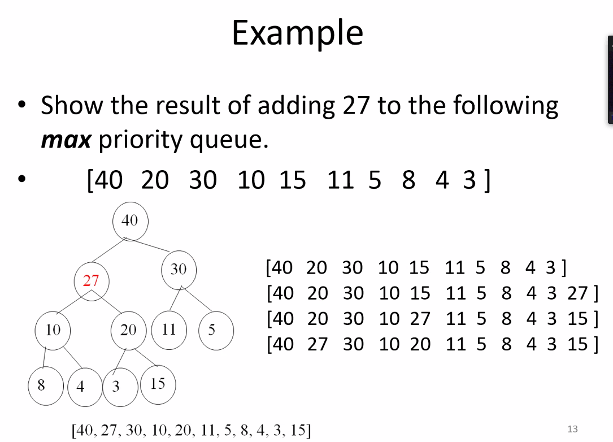
  + When heap is implemented as an array to represent the tree structure, because heap is a complete binary tree, we can use simple mathematical calculations to resolve the location of any given nodes children, and thus you can easily perform swaps after deletion and insertion operations; remember, resolving simple arithmetic operations are extremely fast for CPU, so it is okay if we have to resolve lots of basic arithmetic to find child locations
  + So end of the array is the next location where an element should be initially added into a heap (complete binary tree, that is level ordered), so notice 27 is simply added to the end of the array (which is very efficient!) and then perform the swap operations as necessary by checking the parent (children for delete)
    - Notice we can check parents using an array by using the calculations for parents and children
* 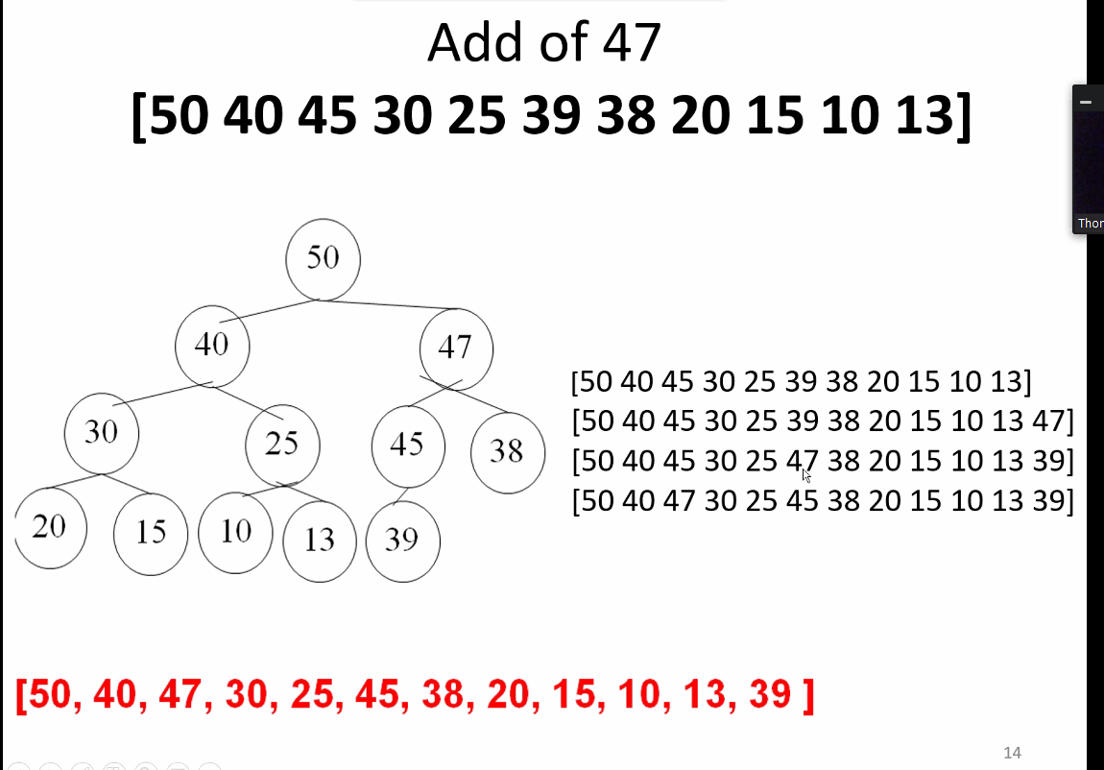
* 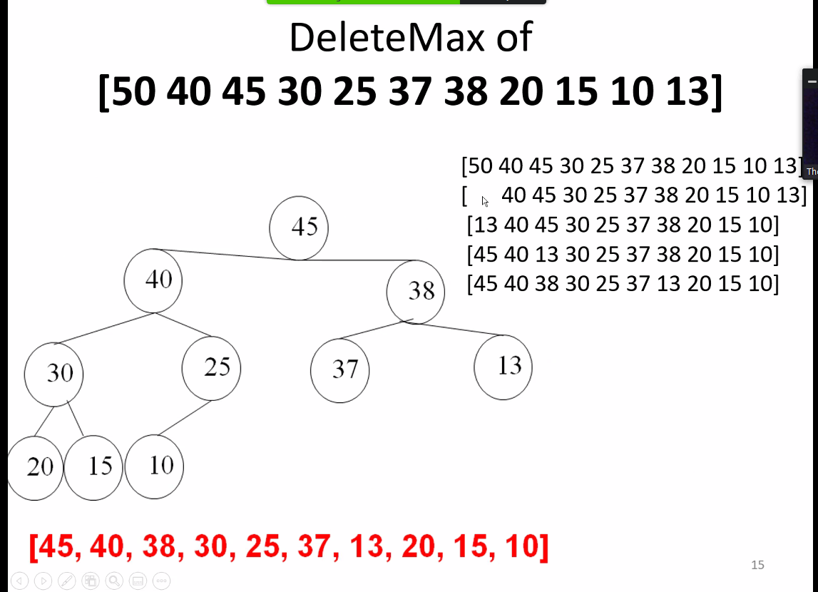
* Simply delete element at start of array (element 0)
  + To avoid deleting element 0 literally, you simply take last element and over write element 0! This is why it is also brilliant! Avoid reallocating array or shifting all elements up one position; and then thusly, you perform swap operations as necessary to maintain the heap level ordered-ness (completeness already maintained!); thus just perform necessary arithmetic operations to compare new root to children and swap (walk it/move it down the tree) until it ends up at its correct location
* 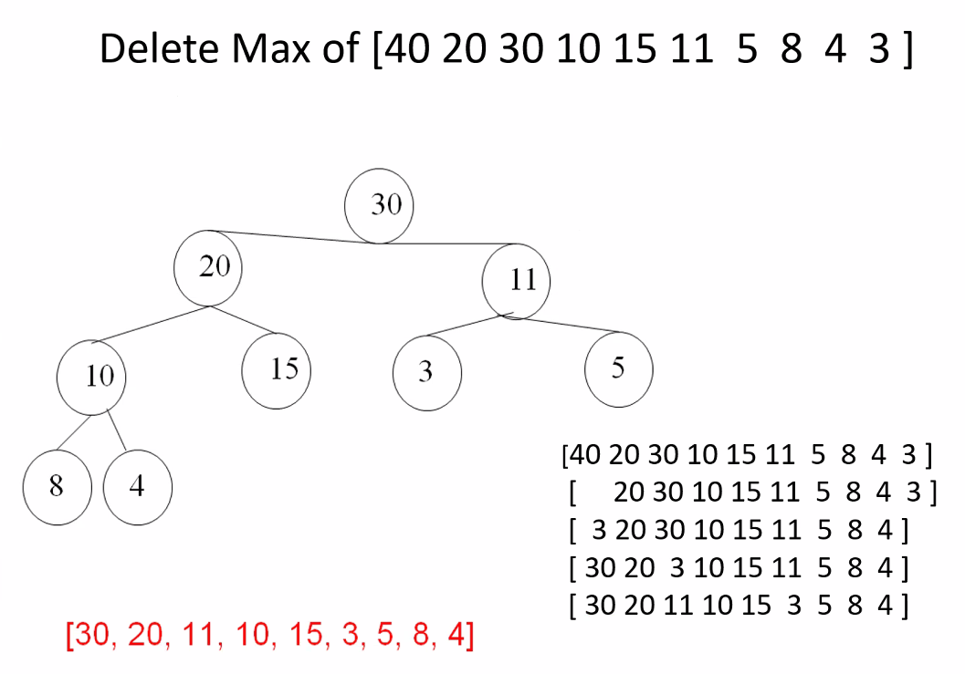
* Max heap initialization (inserting a large set of elements to start with; or adding lots of new elements into heap, it may be efficient to perform the initialization build heap function again rather than the normal insertion procedure)
* 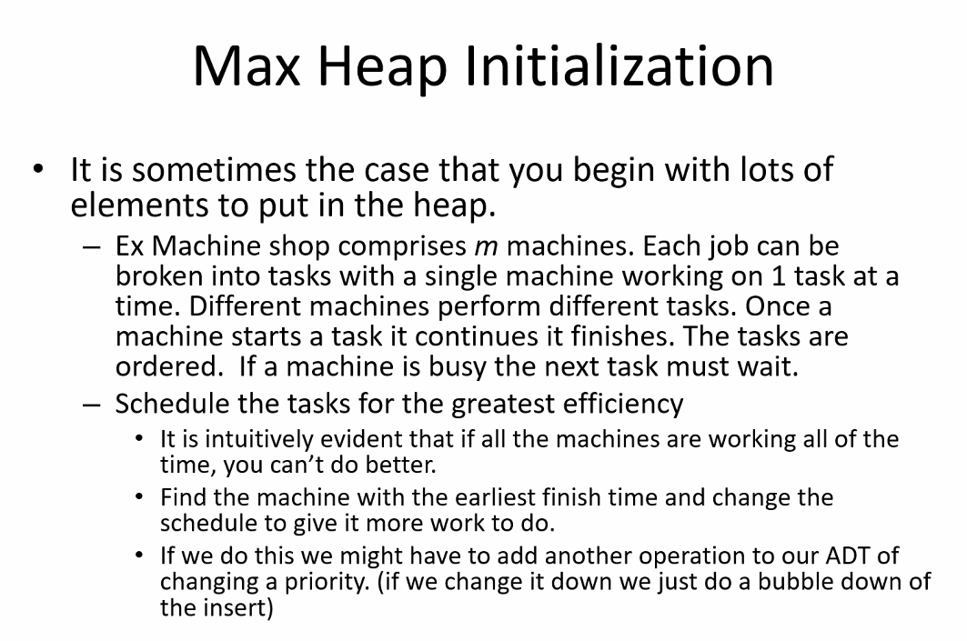
* 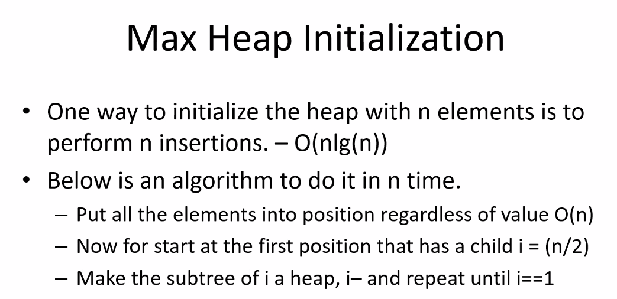
* 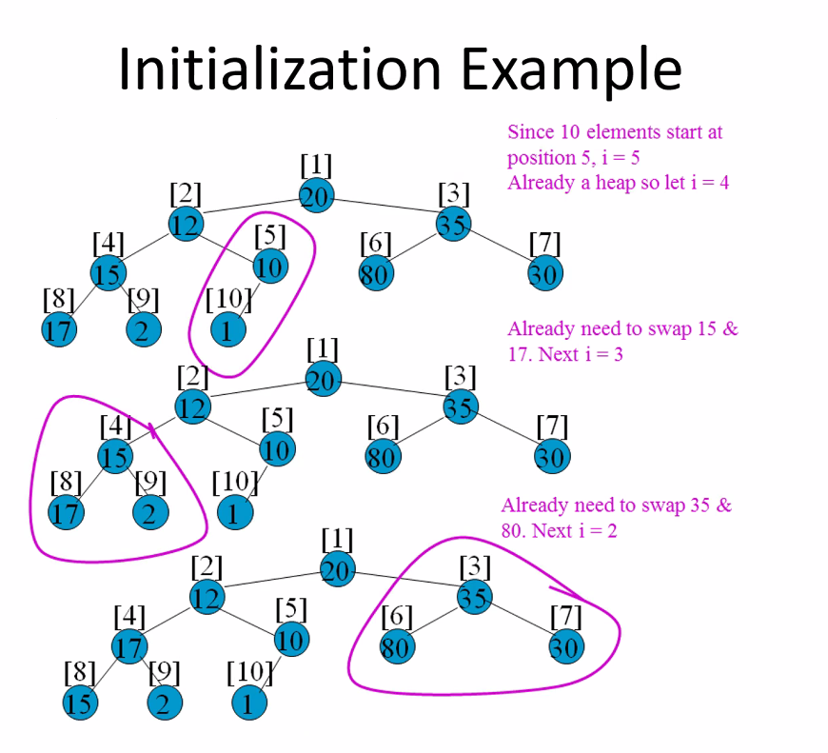
  + Remember this from midterm exam and summer 1 notes (there are 2 methods, linear, and something else, to initialization!!! Should be in this document
  + Start in middle based off size, so you can arrive at last element with a child in order to build sub heaps; no point in starting with node with no children since there is no swap comparisons to make
  + So start with first node with a child (middle element; size/2); build sub heap (i), then repeat process for next sub heap (i-1..i-2..etc.); simply consecutively moving down to the next element and building heap base don’t hat location! Simple but brilliant!
  + Notice you only have to check half the elements and perform swap algorithm, i = size/2, then i--…
* 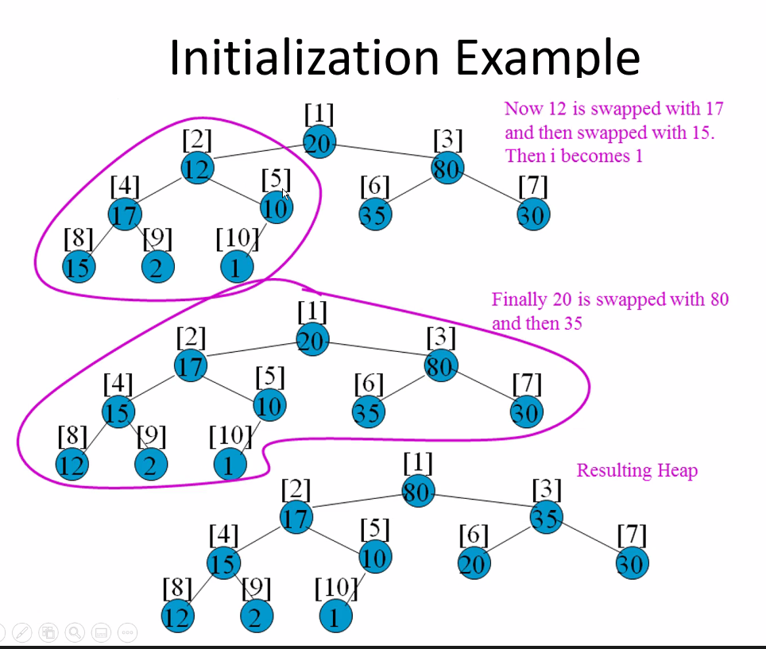
* So this is a much easier way to do n inserts, in less than n times for a heap, whether starting from a new heap, or adding a large amount of elements for an already existing heap (reinitialize the heap using the initialization heap algorithm)
  + Much more efficient; of course if number of elements being added at a given time at the same time is not a lot, then reinitializing would end up being less efficient than conducting standard insert operation
  + Remember this brilliant idea to save time takes advantage of the fact that the tree is a complete binary tree that should be level-ordered
* 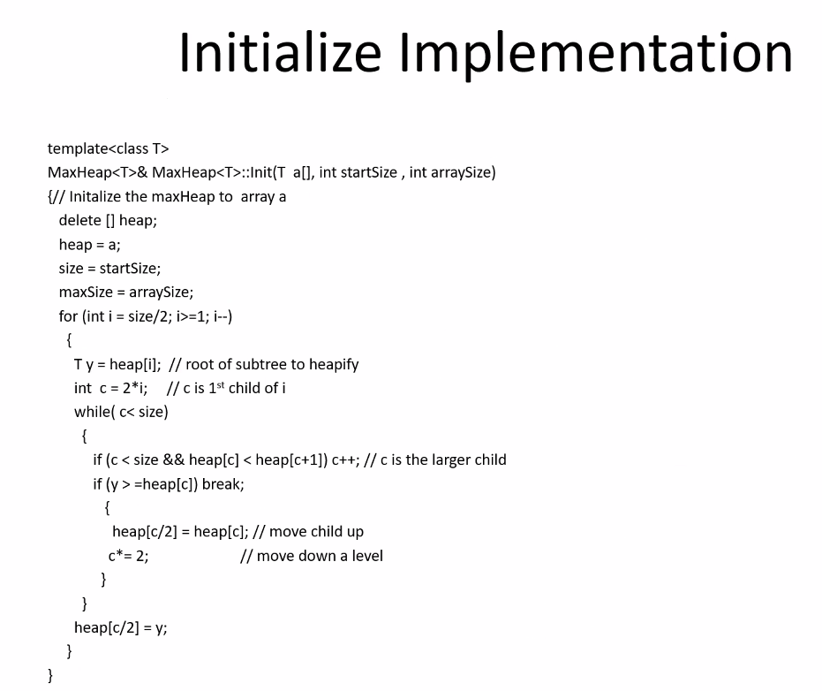
* 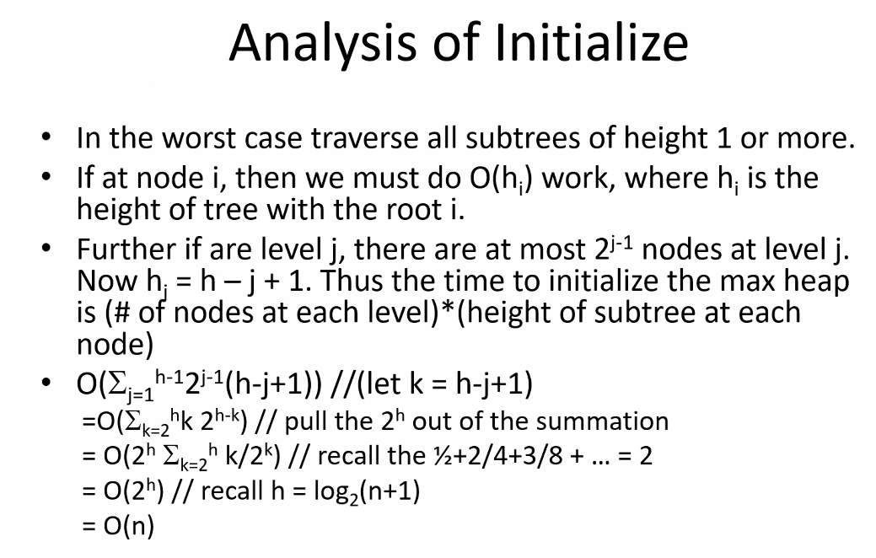
* HEAP SORT
* 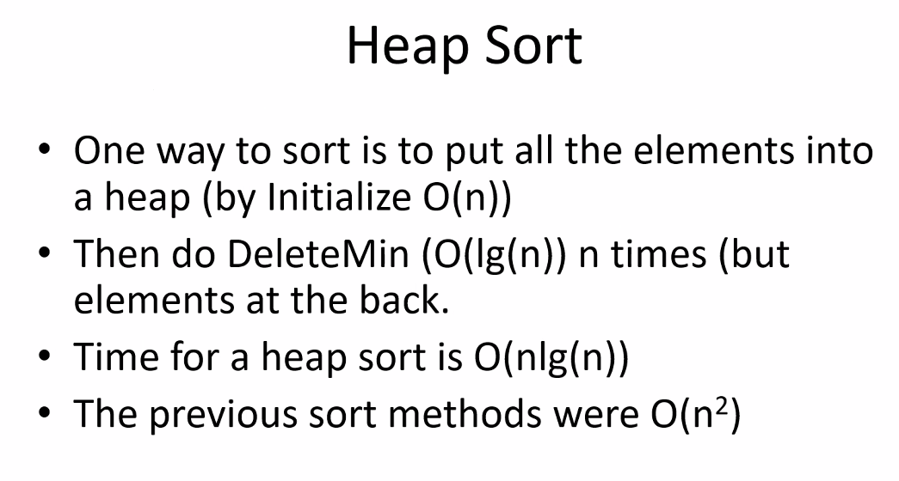
  + Take advantage of heap implementation algorithms to sort elements
  + This is a BRILLIANT idea! By taking advantage of a min heap or max heap algorithm, and then simply take the root node (max or min) and pop it off, and then of course let the heap algorithms work to keep tree sorted according to heap properties and moving next max (or min) value to the root!
  + So if you want to put things in ascending or descending order, you could use a heap! (and especially the heap initialization/reinitialization algorithm as well to sort a large group of elements)
* 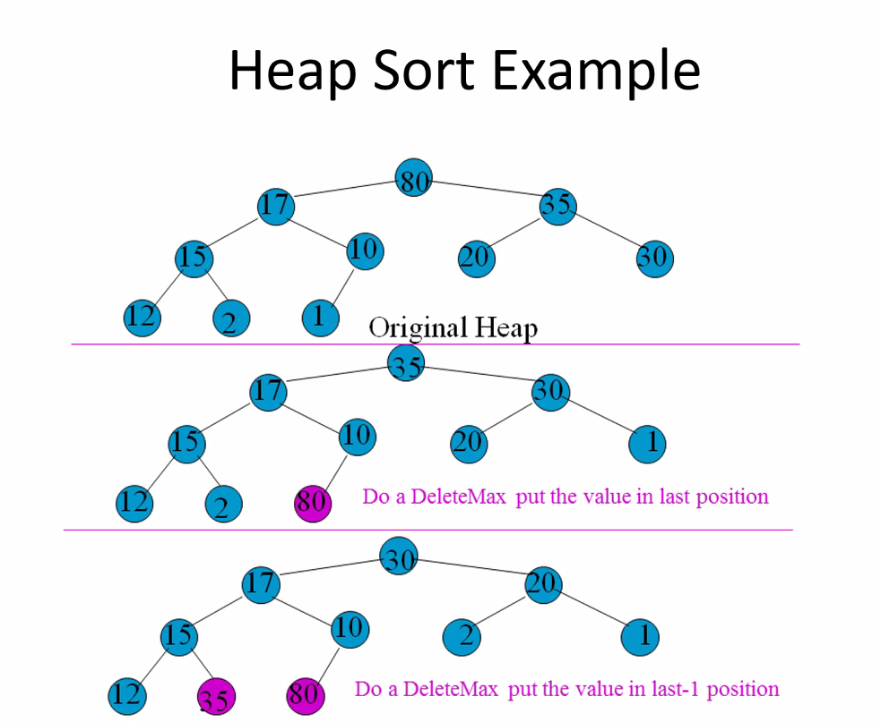
* 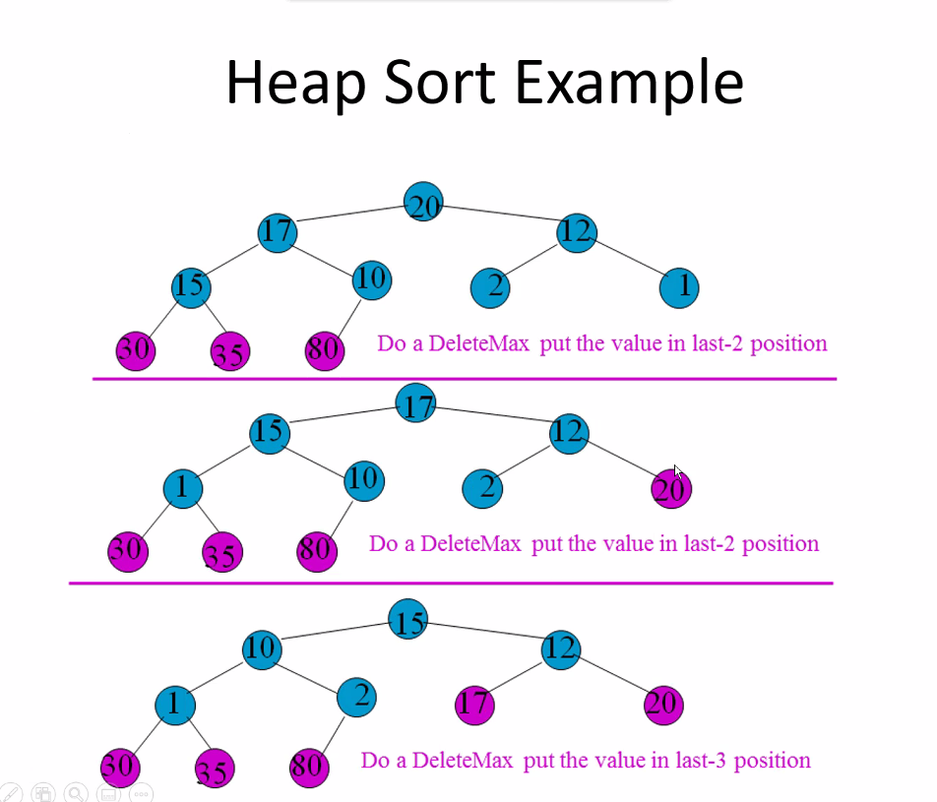
* This algorithm will give you a complete tree, where if you walk through level order you will end up getting elements from least to greatest!
  + If this is in an array, you don’t have to do anything now! You simply have an array now that is in ascending order (least to greatest, so in this example 80 would be at the end of the array so you can now pop it off of the array or vector!)
* 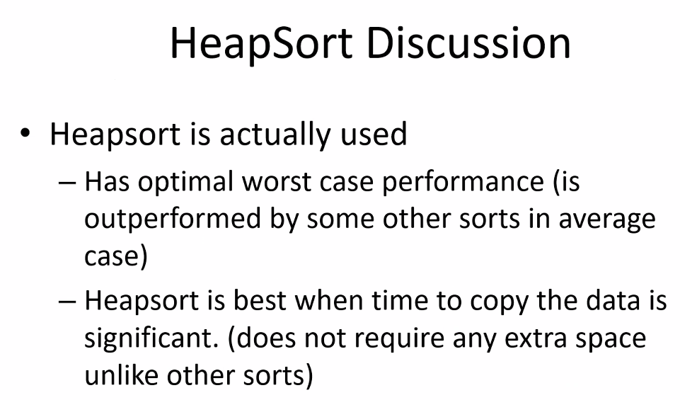
  + Remember, it all depends on the data being taken into account (type, size, quantity, initializations, frequencies, etc..)
  + Try to pick best data structure for the given scenario to get the best efficiency, and that is adaptable as necessary if possible
* 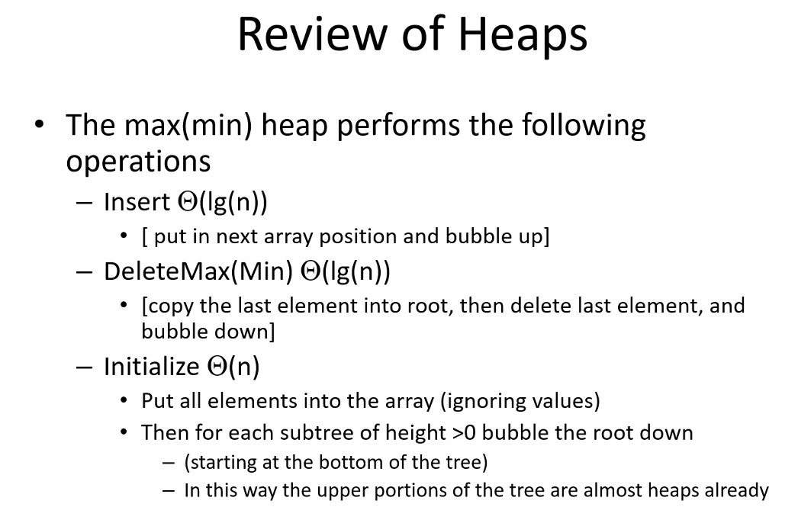
* 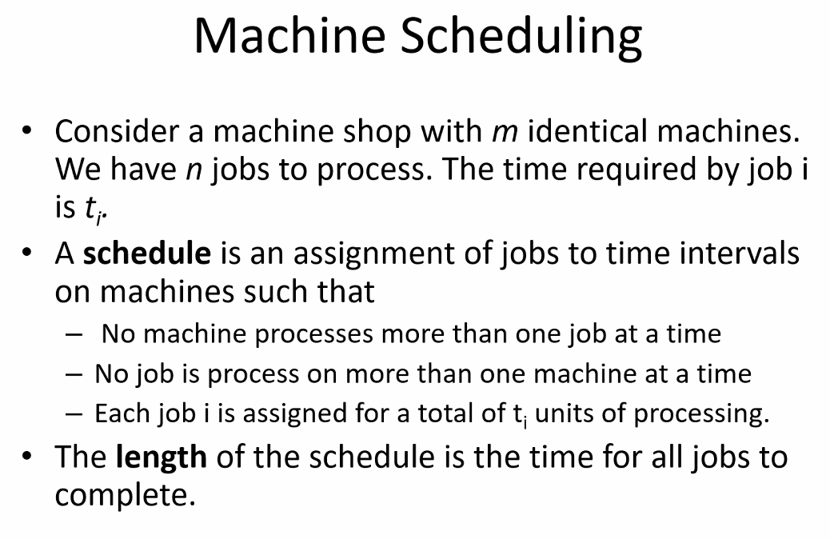
* 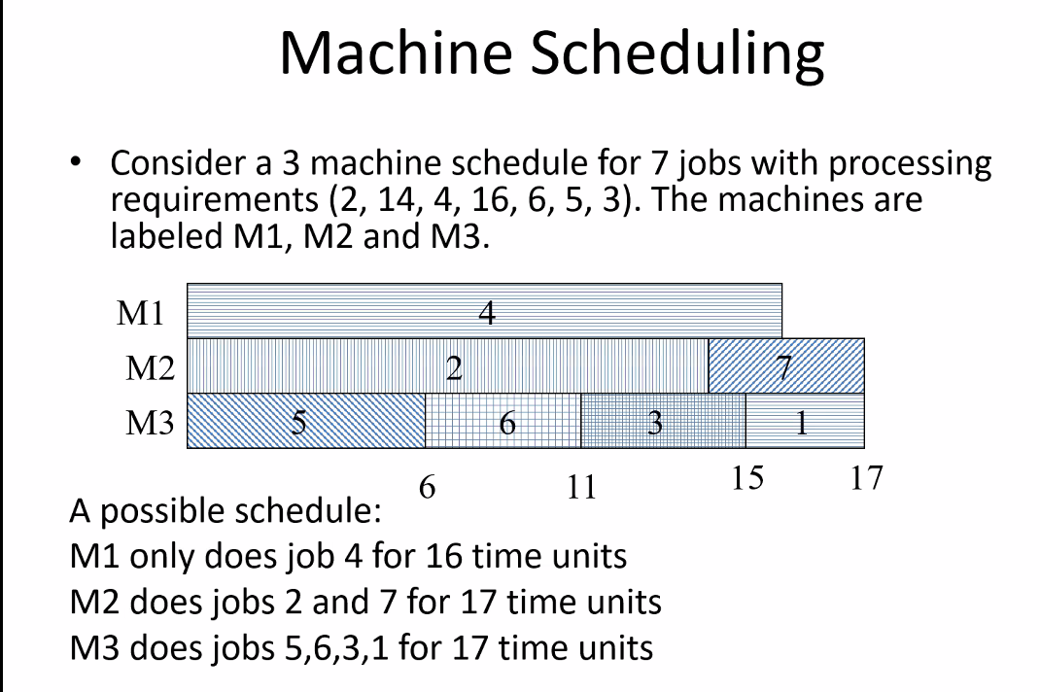
* 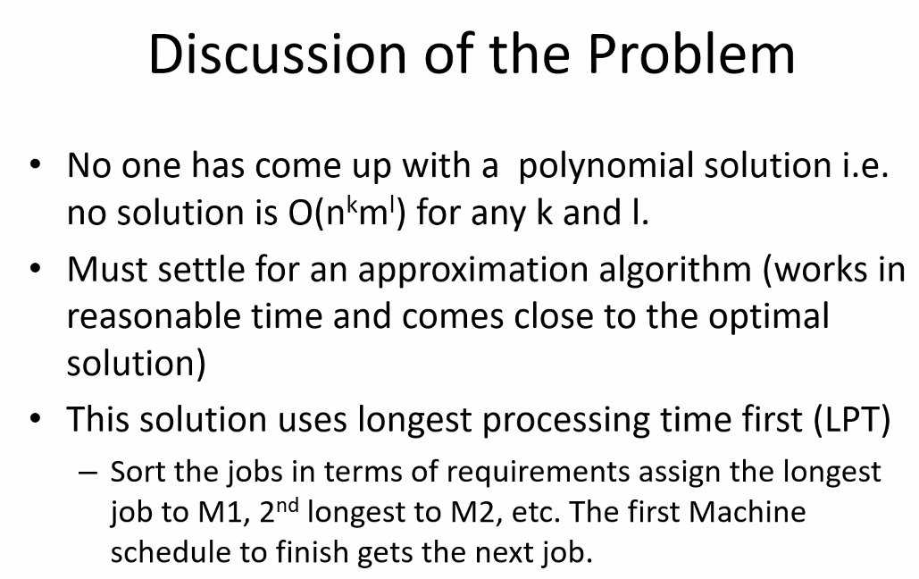
* 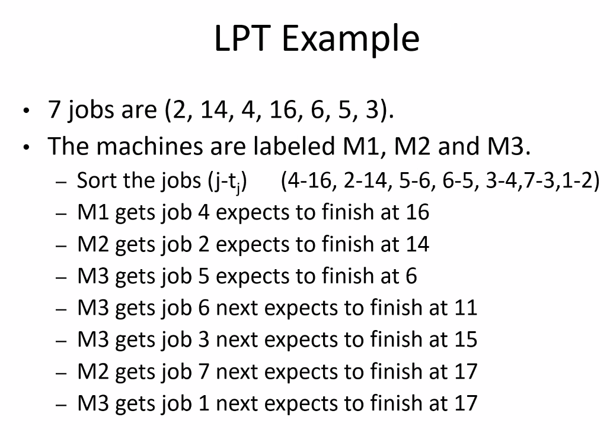
* 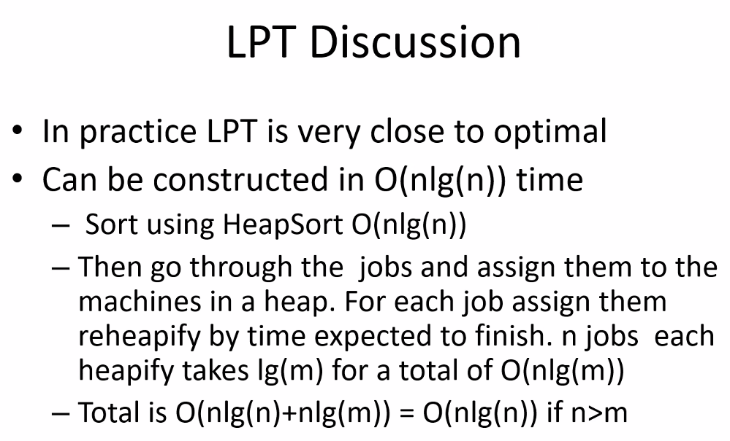
  + Is P = NP???; no polynomial solution found for this problem (as of ye and is related to that class of problems! If we solve if P = NP? Then we could potentially then find the polynomial equivalent instead of only the approximation to solving the problem!
  + But so far, our near optimal solution is very close optimal; also typically creating code that is close to optimal is often more easy to implement

# Lecture 16 – 7-15-21 – Shortest Path Algorithms

* 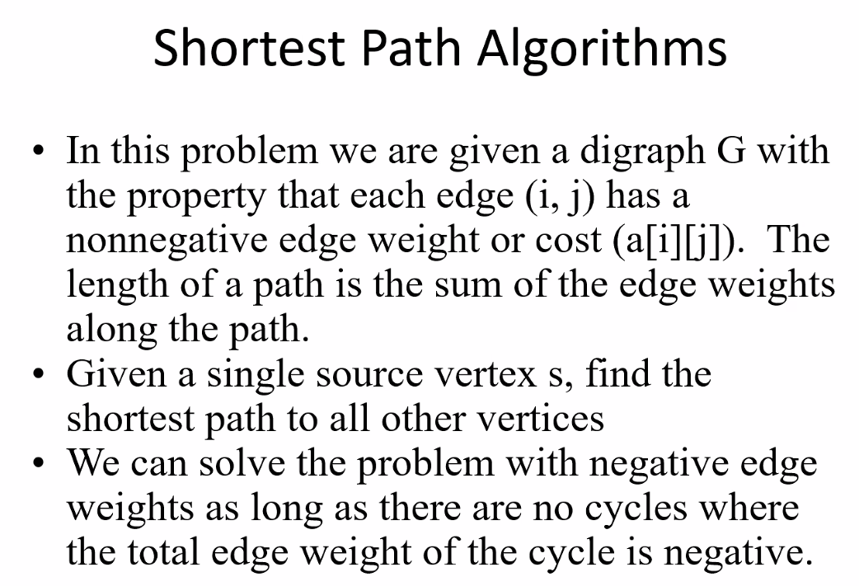
* **Next program will be SPF protocol!!!**
  + Will also use Prim’s algorithm and min STP protocol to implement a Shortest Path Algorithm!!!!
  + So I have to get program 3 right exactly so that my program 4 based on SPF will work and be easier to write a program for as it will implement program 3 min STP
* Shortest time; most economical, least toll roads…etc..etc..
* Will need to take a graph and be able to find the SPF between any two vertices
* Delivery and navigation systems like GPS especially use this! (Amazon, FEDEX, etc…including constraint “least amount of left turns as it is feasible to save time”
  + Shortest path could refer to any weight: time, distance, or a combination of weights by priority..etc.
* Same idea is used for networks for roadways, computer networks, sewage systems, water grid…etc.

# Lecture 17 – 7-20-21 – Program 4 - Shortest Path Algorithms

* Program 4
* Start point (part 1) will be the updated/finished algorithm from part 2 of Program 3
  + Initial test plan will be the final test plan from program 3
* So part 1 of program 4 is trying to splice the finish product of program 3, with the new additions that; for reference: program 3 and 4 the professor usually made one program
  + Now he broke it into two parts
  + Thus, program 3 needs to work 100%
* 130pts total for the 20% project-second-half from programs 3, 4, and 5
* You will use the heap from program 3 in program 4
* Depth-First Search
* 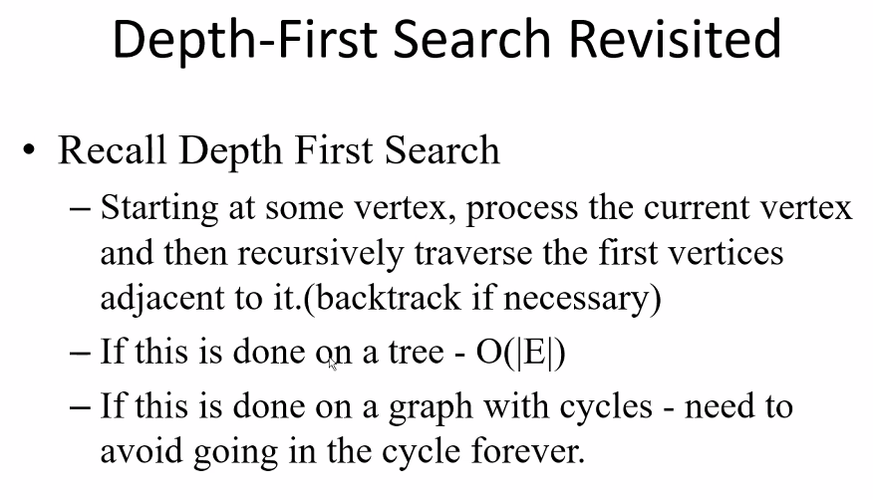
  + Think of in-fix, pre-fix, and post-fix, always went from left to right (generally) in some order
* 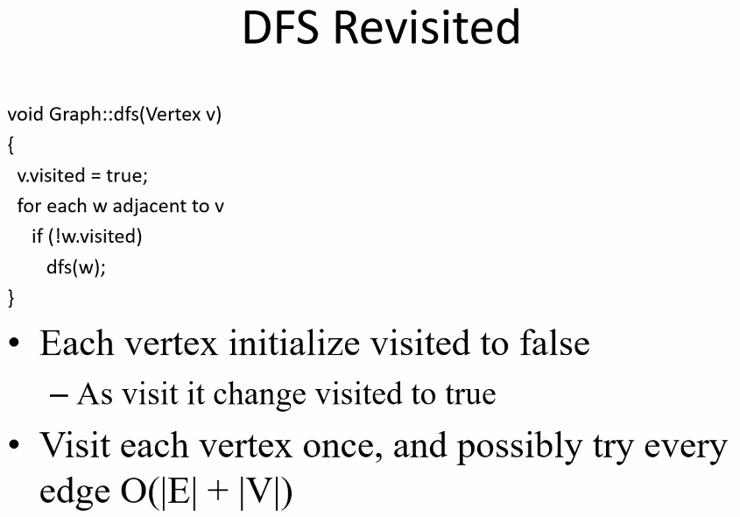
* 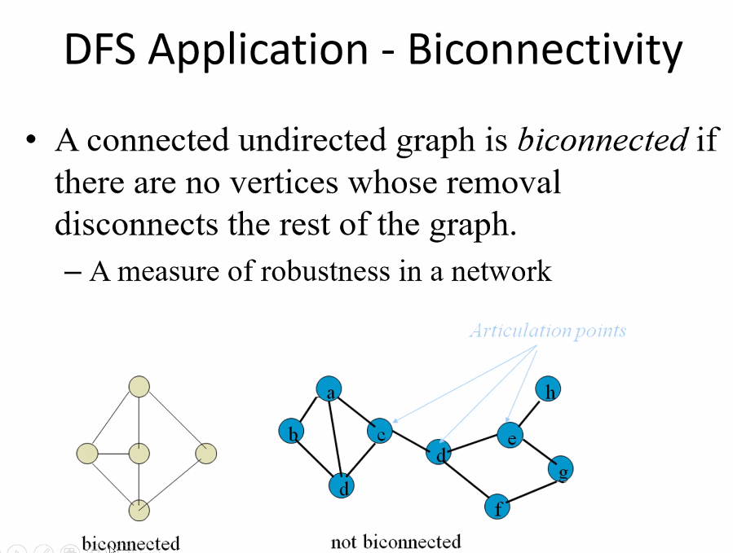
* 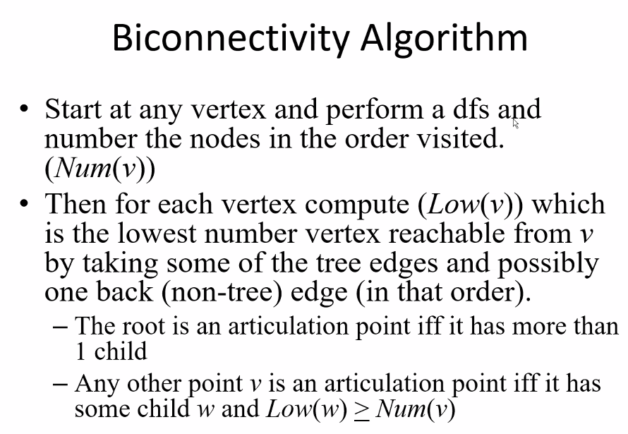
* Depth-First-Search allows you to find if and where there is/are an articulation point in a network/graph
  + It is strategic to have a biconnected network graph so that connectivity is not dependent on a single node; more than one node needs to go down in order to affect connectivity to all the rest of the nodes; this is especially good for computer networks
  + Could be used for other types of graphs that represent other things too
* Entropy
* 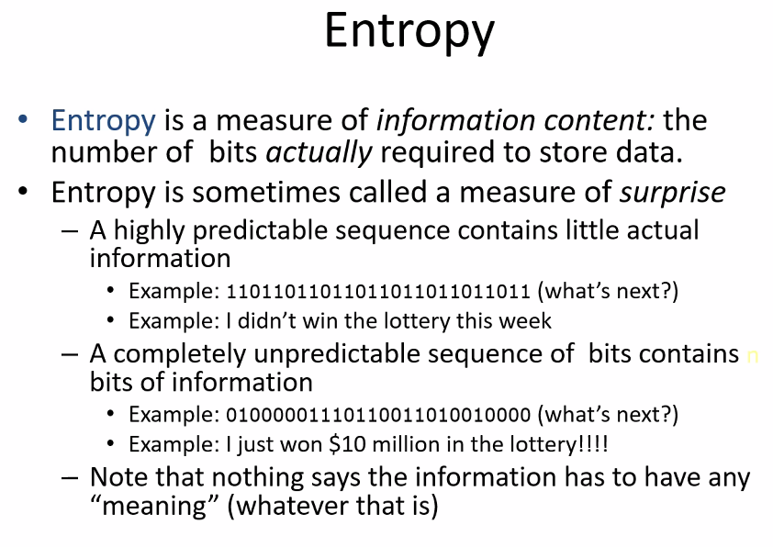
  + Important for the implementation of compressing data in order to store it most efficiently in terms of space
  + Highly predictable sequences can be easily compressed – simply store the original string of bits and then somehow indicate number of repetitions for the pattern
  + Of course if pattern is not predictable, you cannot use some algorithm to more efficiently store the data; so you will have to store all the data without any compression to save space
* 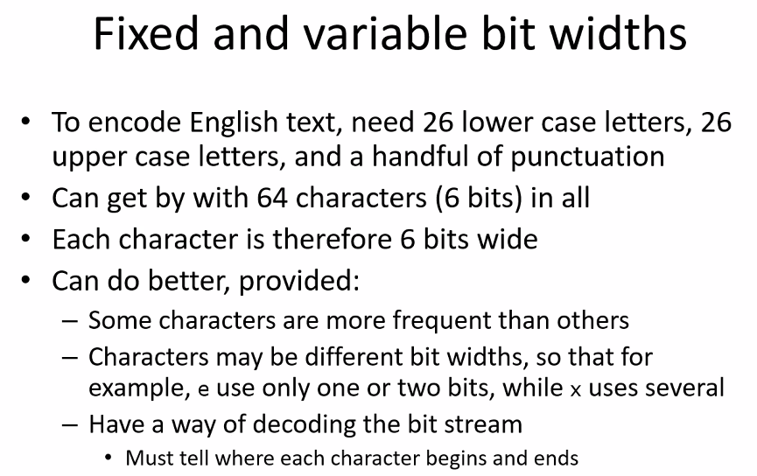
* Huffman code allows for the telling where each character begins and ends
* 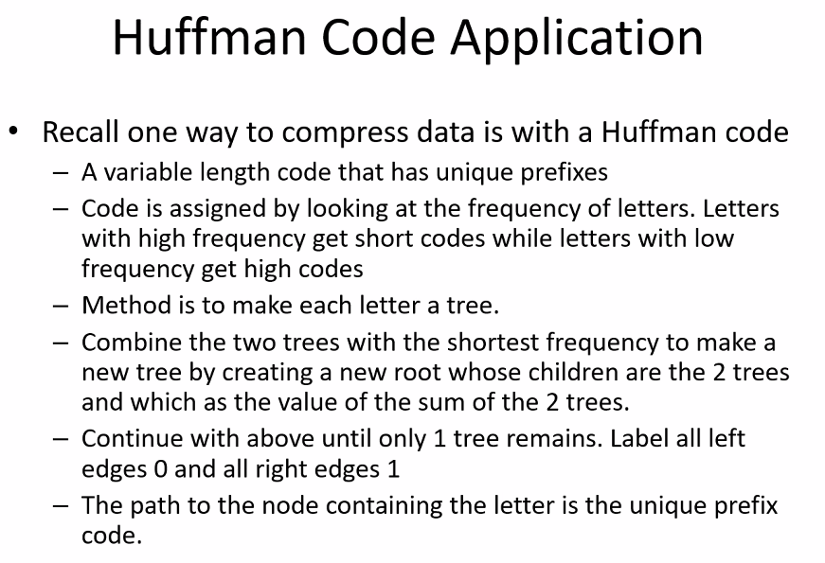
* The idea is to account for frequency of use of characters in order to make the bit mapping more space efficient
* 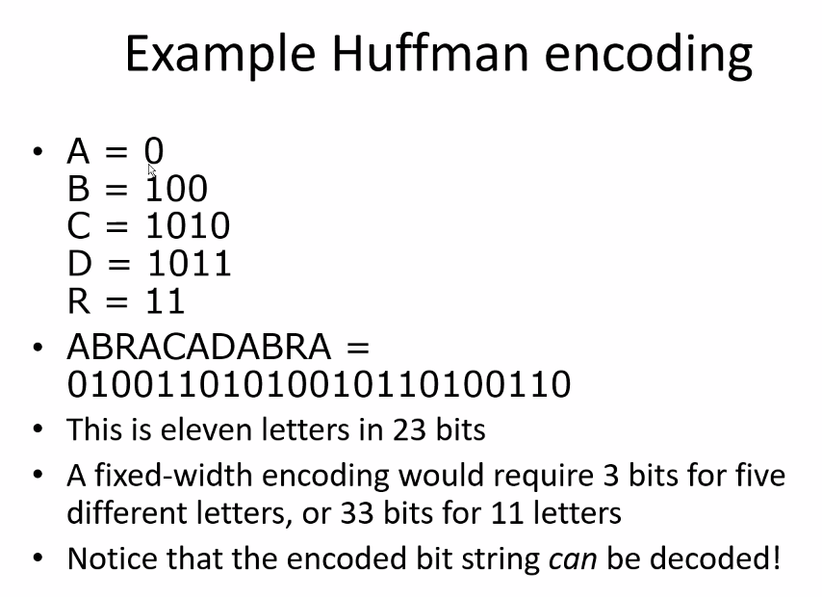
  + Notice there is no prefix that is the same and selected such that you can easily distinguish between letters; also notice A is most frequent so it is given less bits for its encoding bits
  + Need at least 3 bits (2^3 = 8 combinations = represent up to 8 char); so for 11 letters you would need 33 bits for fixed-width, but with Huffman encoding you only need 23 bits to store the 11 letters
* 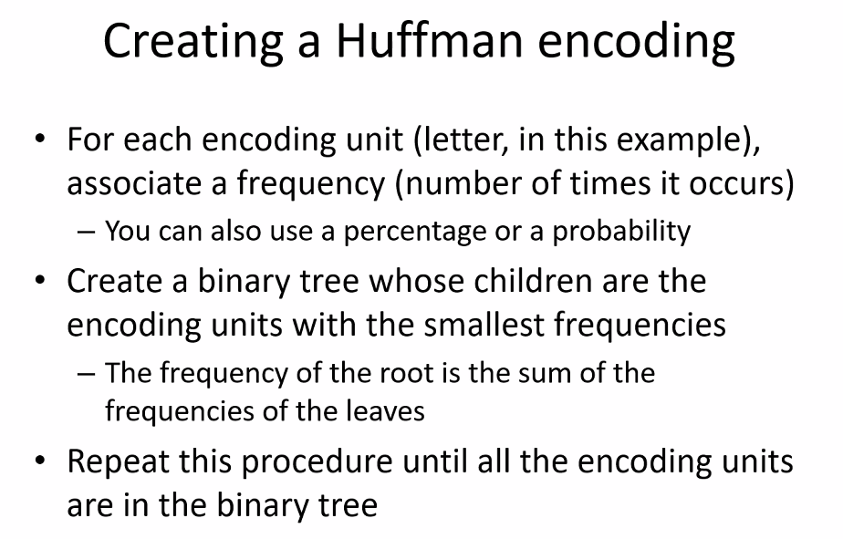
* 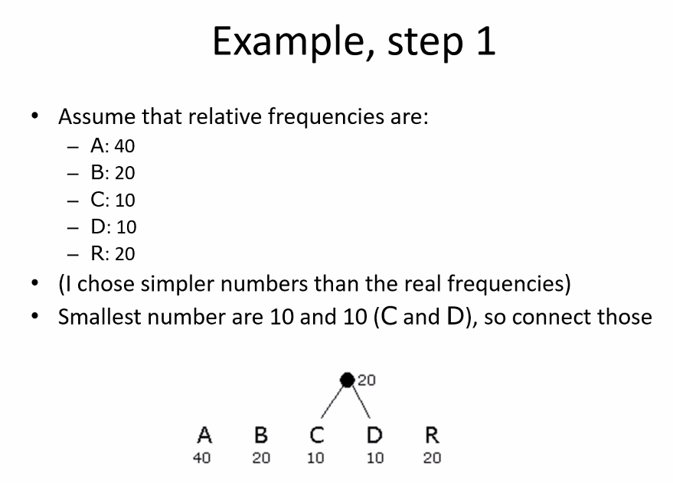
* Remember this from discrete structures 1 (CIS 275)
* 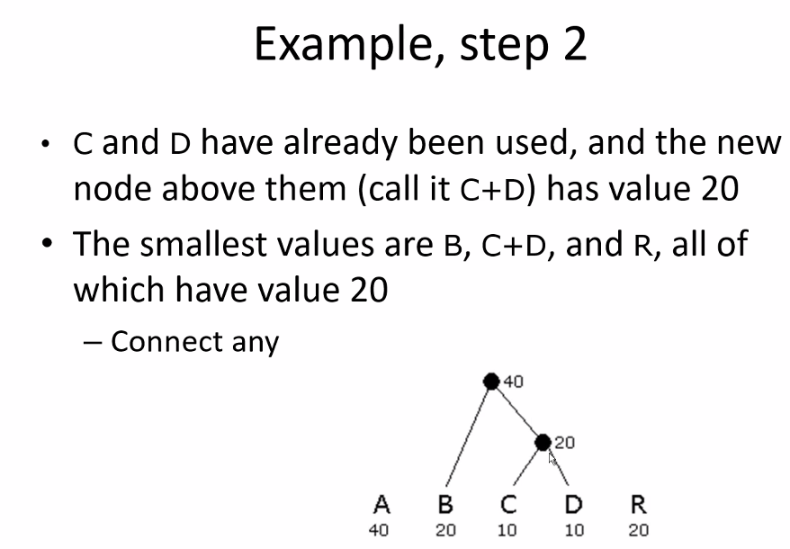
* I think I did this on the final exam too from CIS 275
* 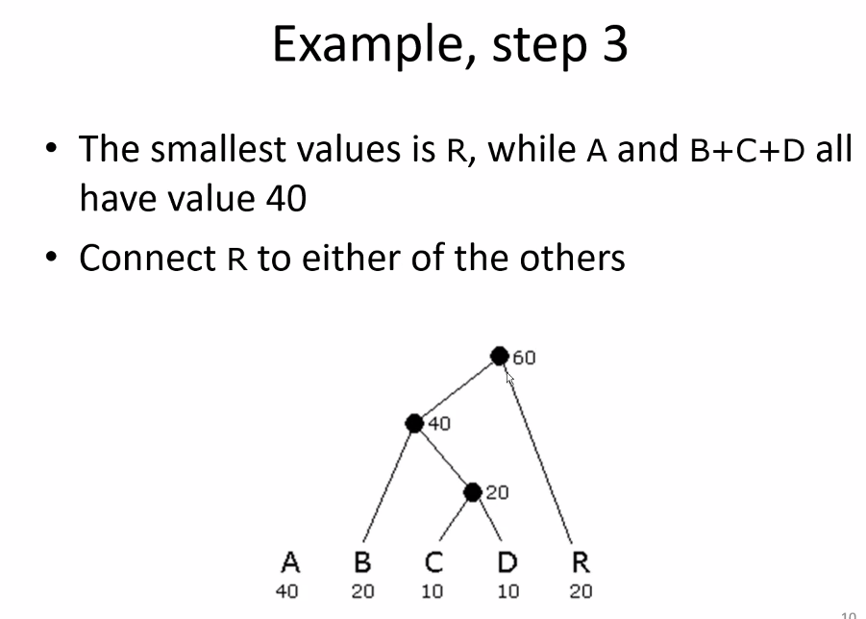
* so it was such that it takes you to visit more nodes (more bits) in order to reach an encoded value that has less frequency;
* the values in coded could be letters, characters, a sequence of characters…etc…anything can be encoded in order to save space
* Huffman code algorithm is implemented as a program where you can input characters into the encoded table, and decoded through another table to get back to the original data
  + There are programs dedicated into analyzing frequencies/distributions and patterns, and based on that output, you can use it as input for the Huffman code table
* 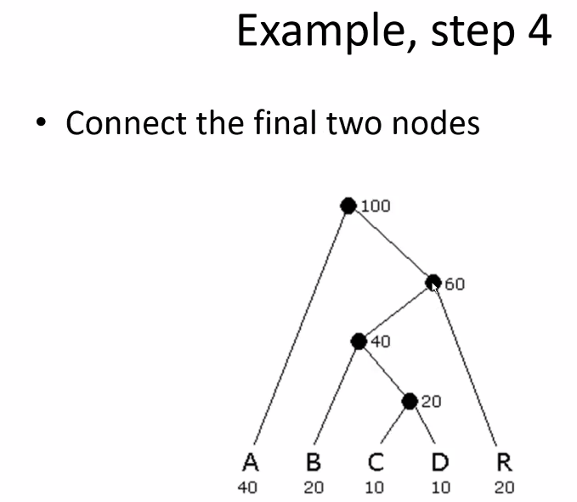
* Notice sum of all trees is equal to value of the root
* 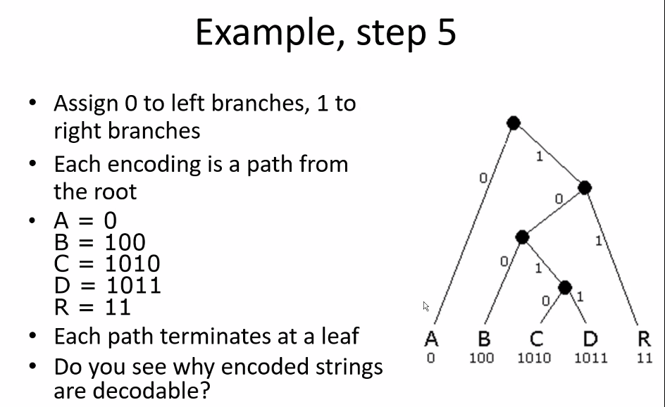
* BRILLIANT!
* 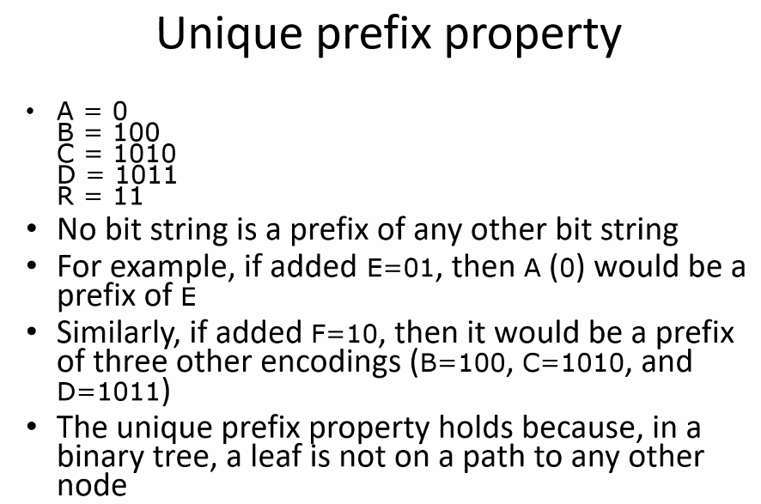
* Notice since each prefix is unique, when decoding, it is easy to find the start and end of each encoded character because default is to take longest string of bits possible until it ends at some encoded char, and then the next char starts directly after and the algorithm repeats
* 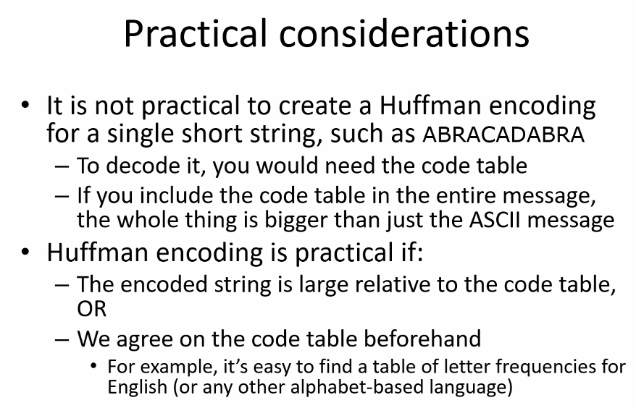
* 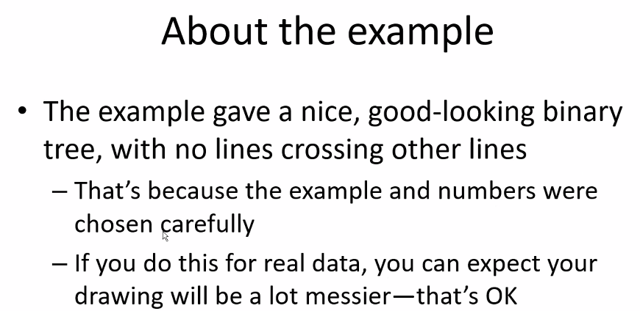
* 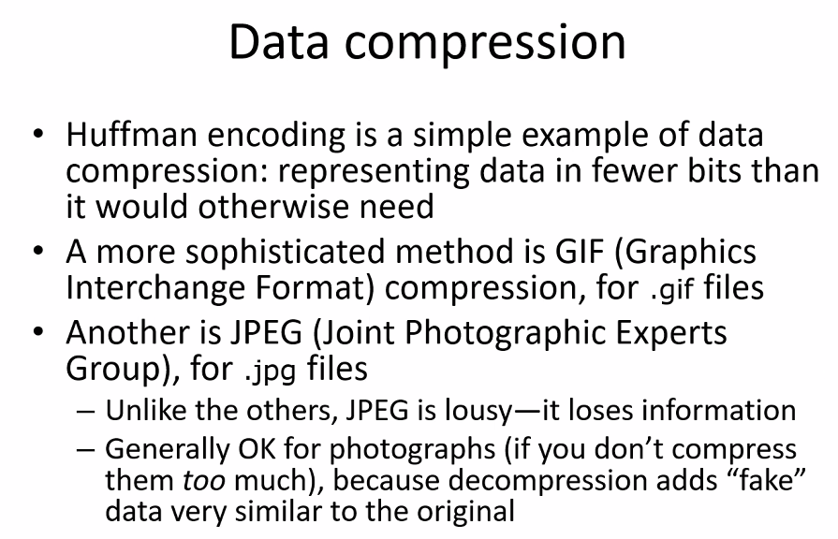
  + Thus for JPEG you might get grainy, pixelated, or discolored images that loses its authentic bit quality/resolution level
* Huffman Encoding can cut down on storage and transmission costs

# Lecture 18 – 7-22-21 – MaxFlow

* Idea is finding best way to maximize flow from a source to destination vertex
* 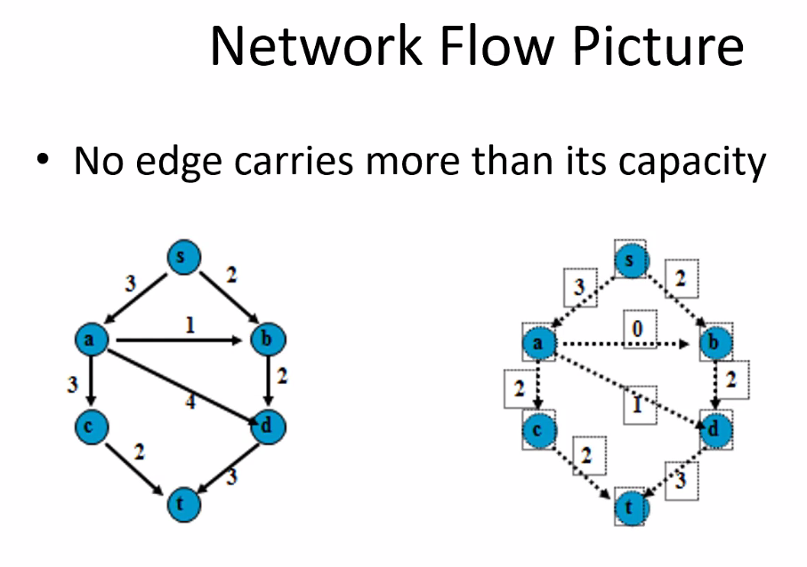
* 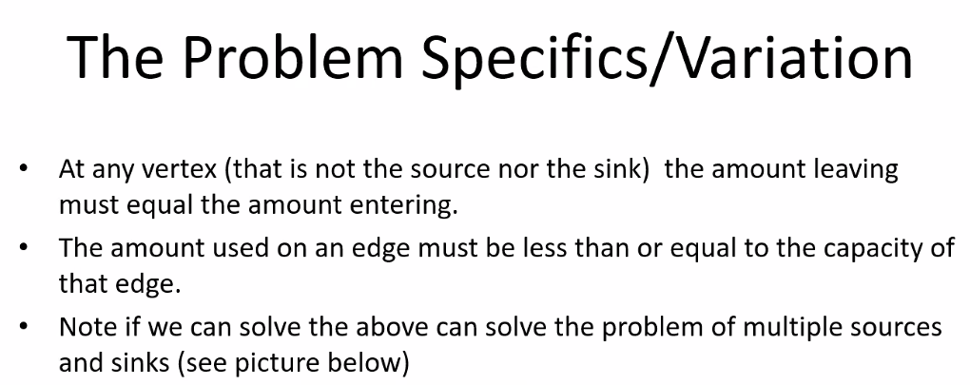
* Sink == destination
* 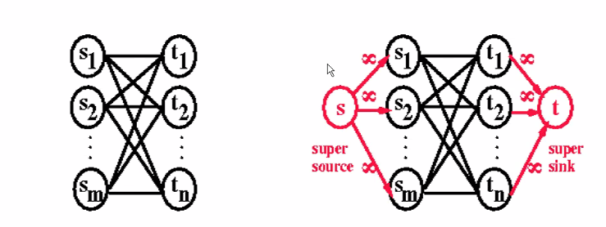
* Remember these concepts from CIS-275
* Use super sinks as starting points/dummy vertex so that we can still run a particular algorithm that requires a single starting point
* 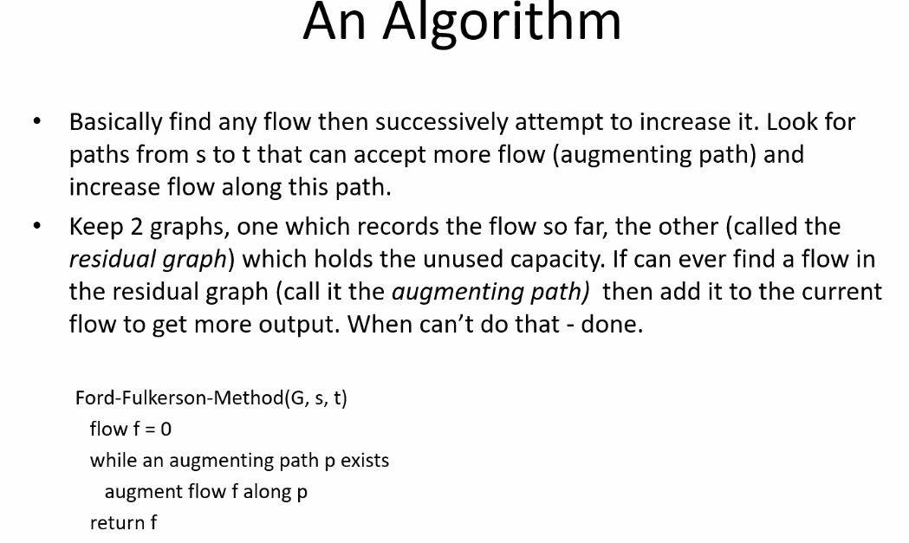
* Remember this algorithm from CIS-275
  + Remember augment flow
* 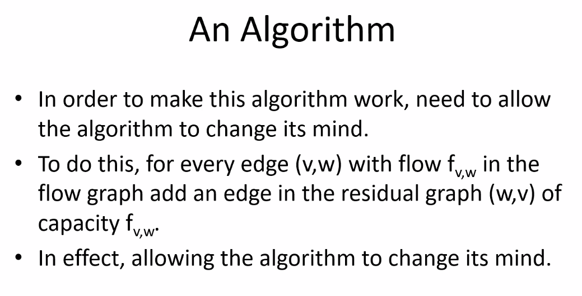
* 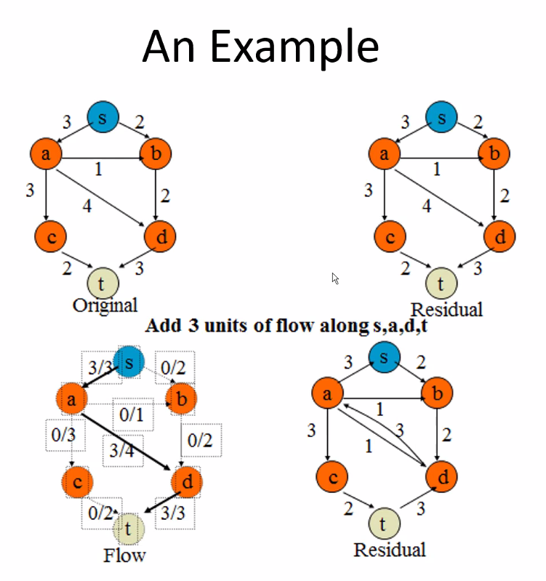
* Remember residual graphs show a backwards edge! See CIS 275 NOTES/HW/EXAMS
* Total capacity at starting source s is 5
* 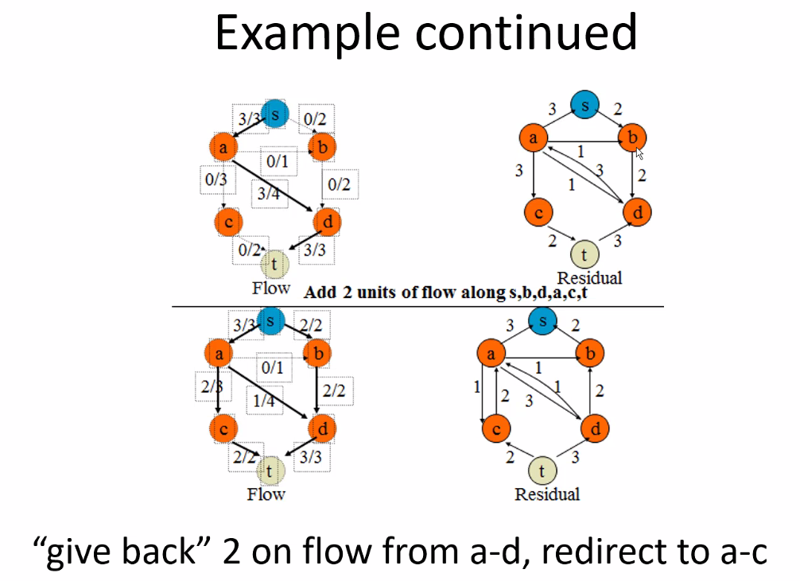
* When all capacity (5 in this case) is flowing from sink to source in residual graph, then we have found a maxflow graph
* 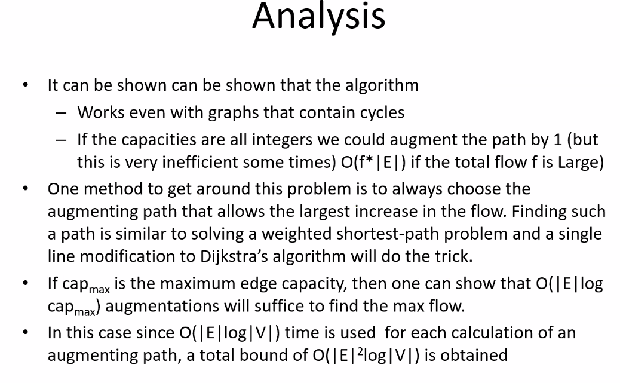
* 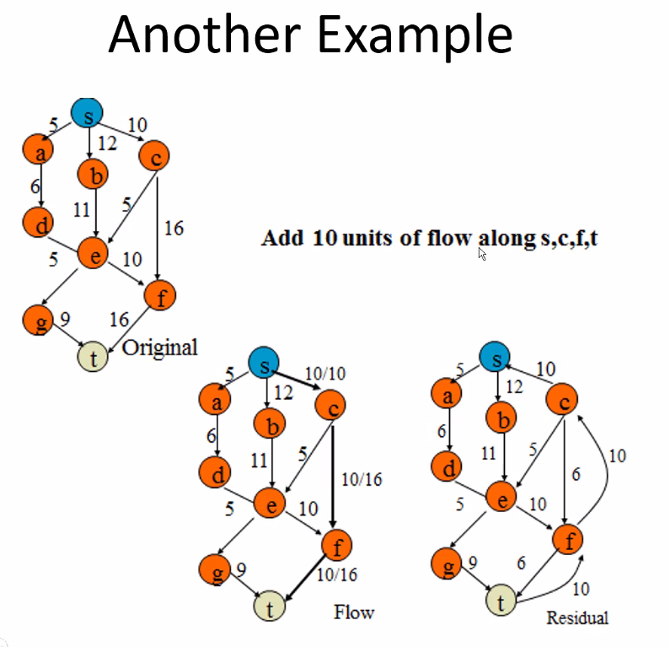
* Output ***capacity*** from source may be greater than the capacity that can go into the sink; simple constraint: the amount coming out of source or other constraining edges must equal to sink; so max flow graph (if there are constraints) will not necessarily mean all capacity of all edges from source to sink will be used; **that’s the point of finding a max flow graph from a source to a sink.**
* Remember we create a residual graph simply makes it easier to see residual capacity remaining on edges after sending flow on a given edge, also we keep the augmented flow paths in there in case we need to redirect flows when finding maxflow graph; **also makes it much more easy/efficient and fast to write an algorithm for finding a max flow graph**
  + It is especially helpful for larger graphs (large computer network, water flow for a city..etc..)
* 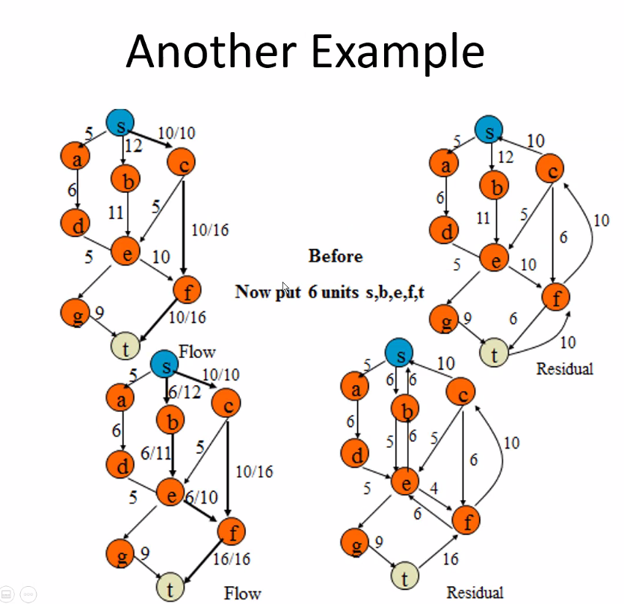
* 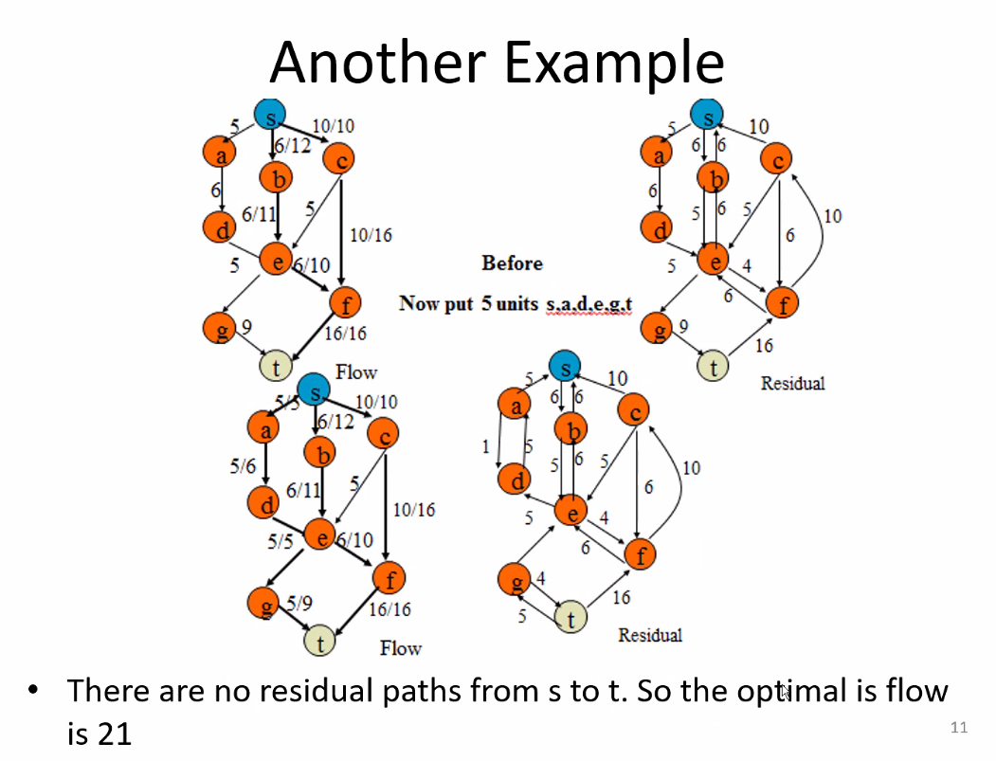
  + 16+5 (from sink in residual graph) = 21
    - No more capacity lefr from e to g, so you know g to t is optimal; same idea applies at other edges in the graph; notice f to t graph already used max capacity (16)
* Maxflow graph will allow you to see max flow and where you can add an edge in order to increase maxflow capcatiy of the graph if possible; necessary to assess costs/feasibility/payback/cost-benefit analysis…etc; so these maxflow charts are very important for infrastructure
  + We use computers often of course to simulate what the best thing to do in real life (oil pipeline/water/computer network (cables = edges; such as fiber optic edges…etc)
  + So it helps save money and make sure scenario is optimal
* 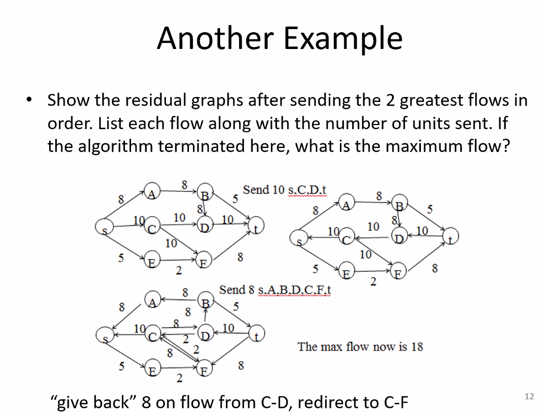
  + Starting from greatest flows and working to smallest, you can potentially reduce iterations in the algorithm to find the max flow (starting with max edges is logical and simple)
  + Minimize number of iterations of finding augmented paths: you will find solution faster if you start with largest edge from source (but either way you will find MaxFlow value)
  + It makes sense to start with largest because more edges will have their capacities used more likely if you send the most flow; then you can take the remaining residual flow with the smallest remaining edge capacities from the source
* 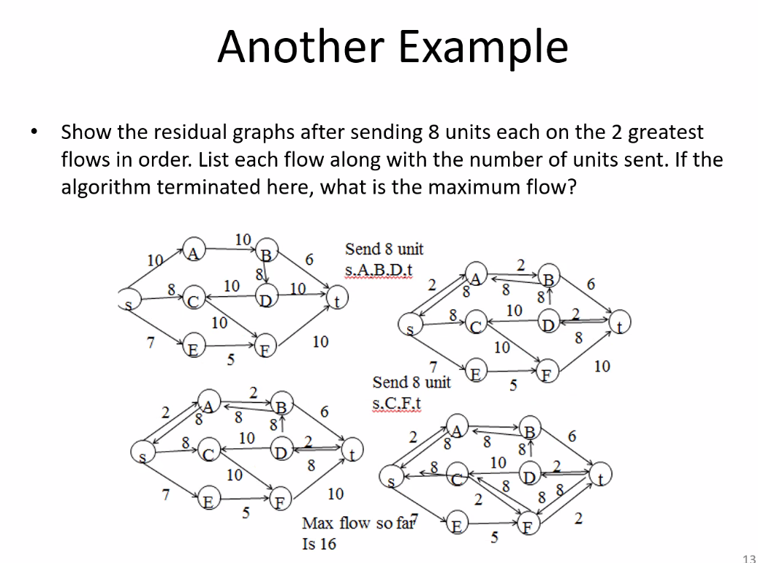
  + Still start with largest capacity edge (go largest to smallest) from the source to reduce iterations of algorithm, even if customer said only send 8/10 on the edges from the source
  + So we started with the capacity edge of 10 from source…find augmenting path to sink
    - Then we move to next largest edge from source (8), then find augmenting path to sink; and use ”give-back”/return flow as seen fit to take advantage of unused edge capacities
  + This will be on EXAM! READ problem carefully in case additional requirements given!

## HEAPS – Leftist Trees and Binomial Queues Details

* 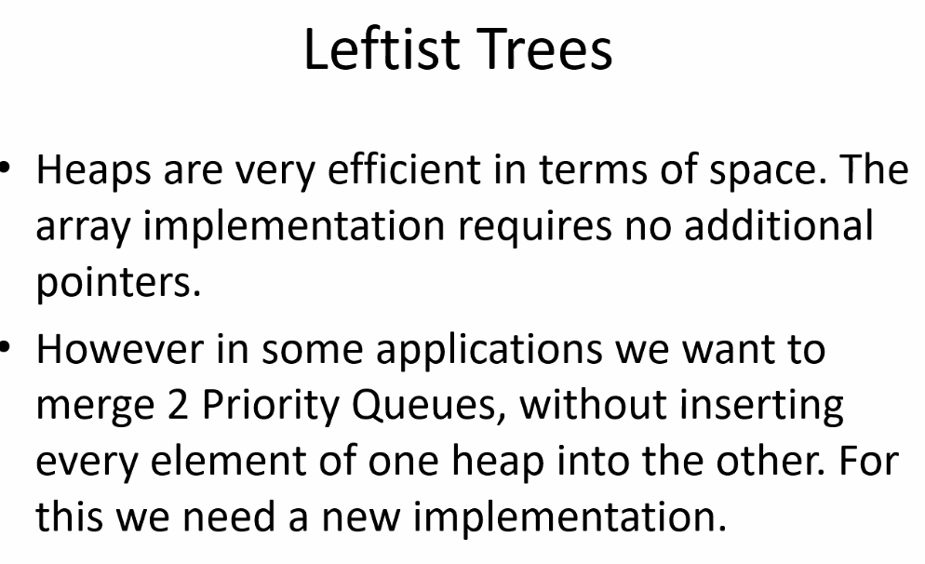
* Even rebuilding heap using initialization algorithm in then real world with large amounts of data/large queues, this is not so feasible, so we still need a new implementation
* 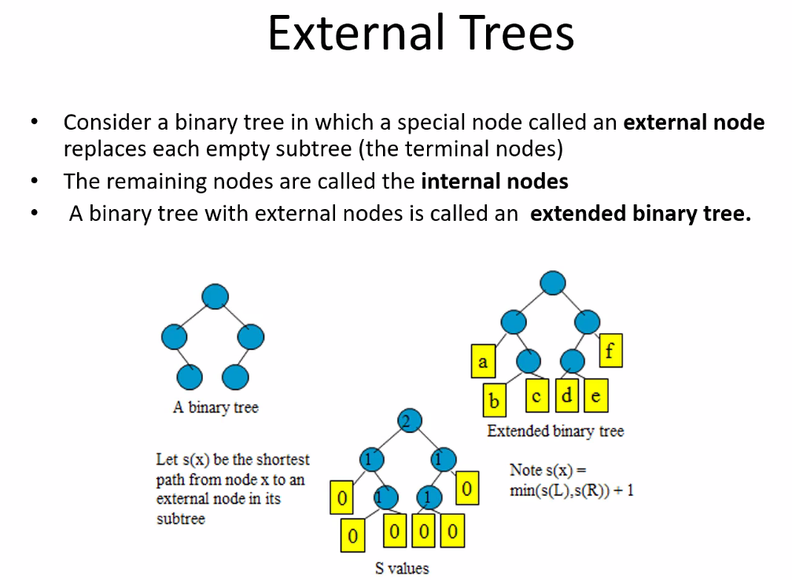
  + Leaf nodes contain no data
  + We only use these external leaf nodes in order to merge with other trees
  + 0 represents that the node is an external node
* 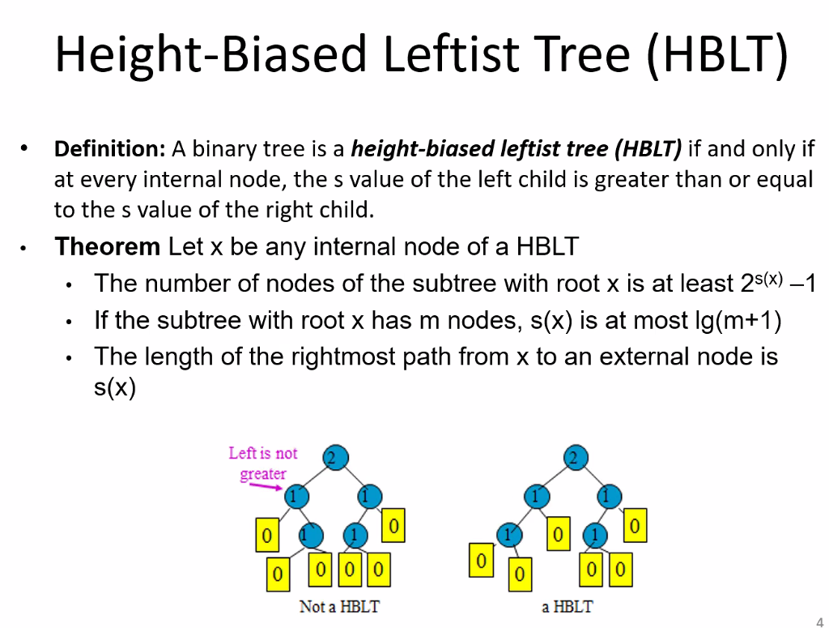
* S(x) = shortest value equation
* 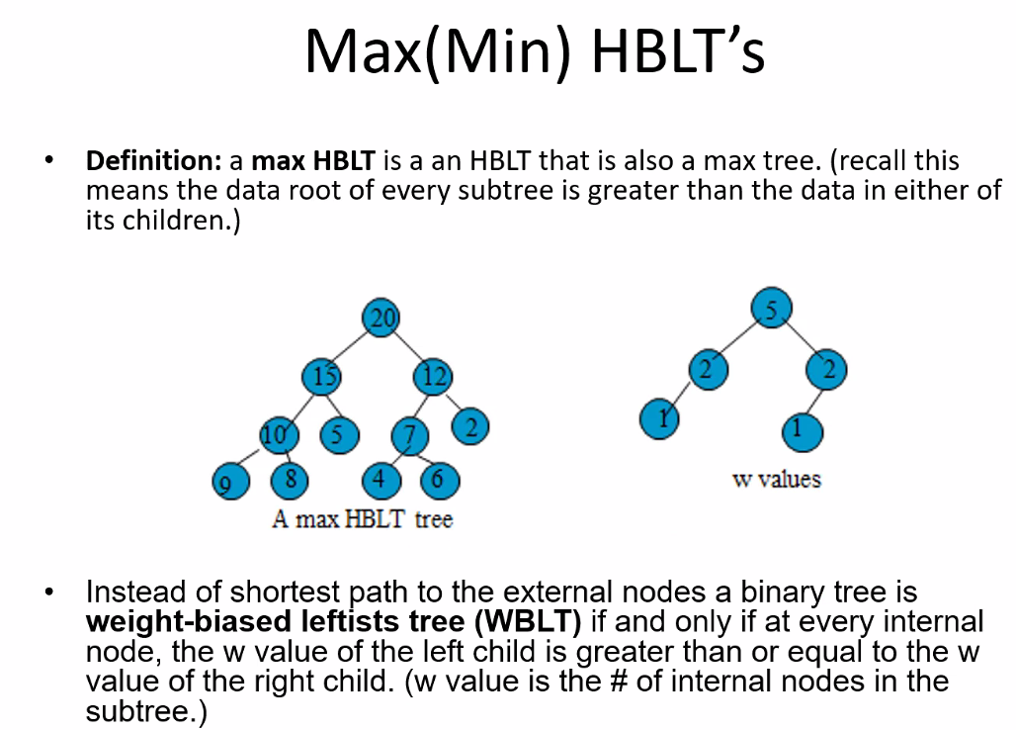
* Note, value stored in node not relevant when determining if a tree is HBLT; just as long as the distance from an external node at a given left node is >= its siblings (right node) distance to an external node
  + Then of course in order to be a heap the tree has to be level-order (each level contains only values stored in the node that are greater than the values stored in the nodes on the level below it)
* For max HBLT it is also >= to the data in either of its children
* For WBLT, consider number of internal nodes attached to the left and right sub tree; number of internal nodes in left must be greater or equal to the number of internal nodes in right sub tree

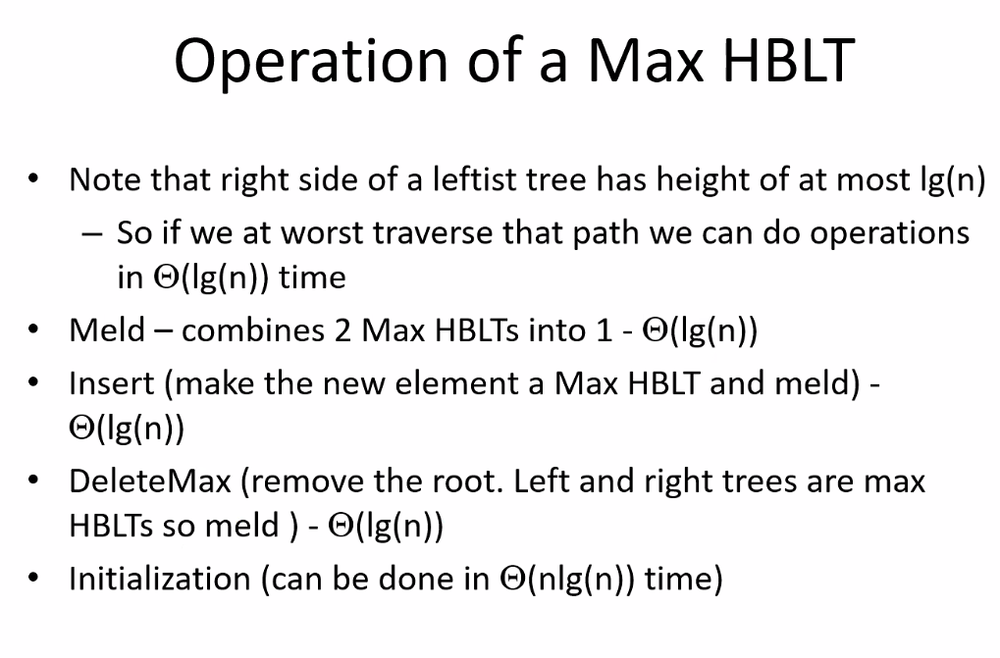

* + Process is very similar to normal heap
  + Delete max and min have different processes however when dealing with HBLT
* 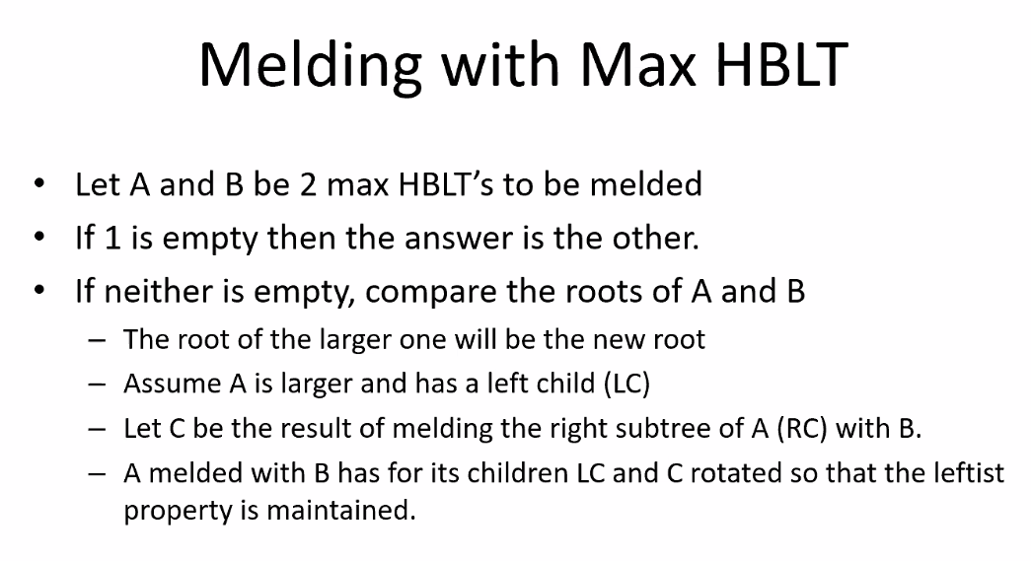
* 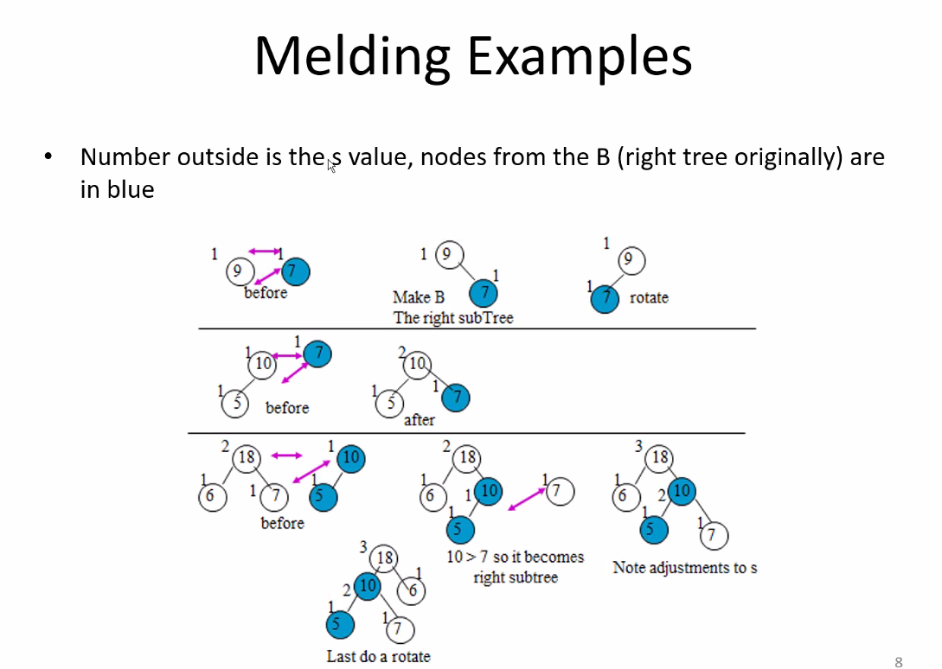
* Melding process reduces number of changes that you have to make versus rebuilding the entire heap using heap initialization; it is much faster for large amounts of data
* Remember you can put HBLT’s into arrays (remember HBLTs are binary trees)
  + Of course can put it into linked list; decide based on situation
* You can get away with not physically put in the null-nodes/empty external nodes; but you will have to work around that; the empty external nodes can make some programming easier

# Lecture 19 – 7-27-21 – Melding Continued

* 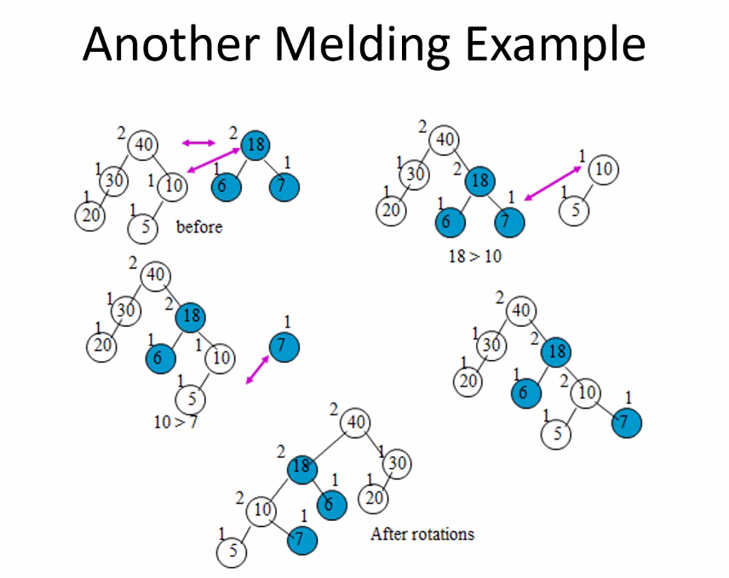
* For this you can use arrays or linked lists
* A lot of companies do not allow programmers to use pointers because they bring lots of complexity and cause lots of loss of data/objects (dangling pointers, memory leaks, etc)
  + Also because of extra space needed for pointers and because computer architecture is designed to use arrays (think about cache from CIS 310)
* As long as a tree structure is a binary tree structure (or some static tree structure: say every parent has 3 children…etc; as long as you can derive some formula for defining parents and/or child nodes), you can always represent it as an array because we know each node has at most 2 children (left and right); if a child is missing we can set it to null (or max INT or -1, or some denotation that the node/child is not used)
  + The only question is: how much space in the array is going to be wasted (empty tree nodes/children); as long as you won’t have a lot of empty space it will be worth it because even though linked lists/pointers do not waste space on empty nodes, the pointers for each node take up a lot of space; even if space is equally wasted or even more (depending on situation) as would be used for the extra pointers in a linked lists, it is still better to use an array often because of less complexity and computer architecture design (CIS 310: cache grabs blocks of contiguous data (arrays) to get cache hits!)
* 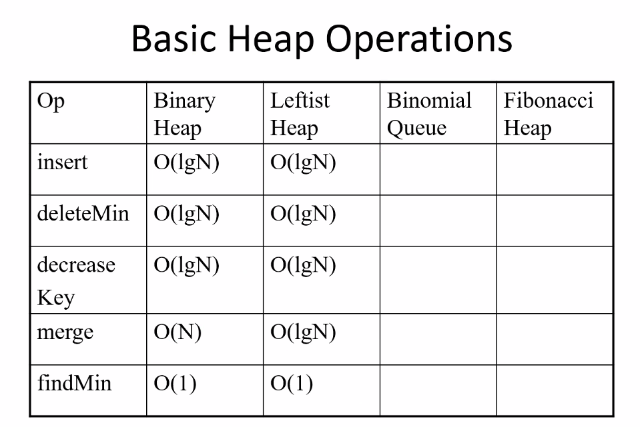
* 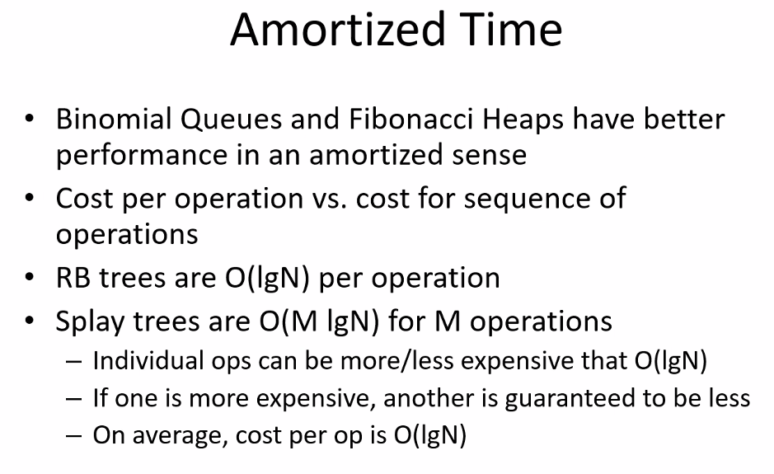
* Remember Big O time complexity or space complexity does not tell you the overall complexity for your function (you may need to analyze multiple variables in the function)
* Amortized == average; big O overall for a function
* Binomial Queus:
* 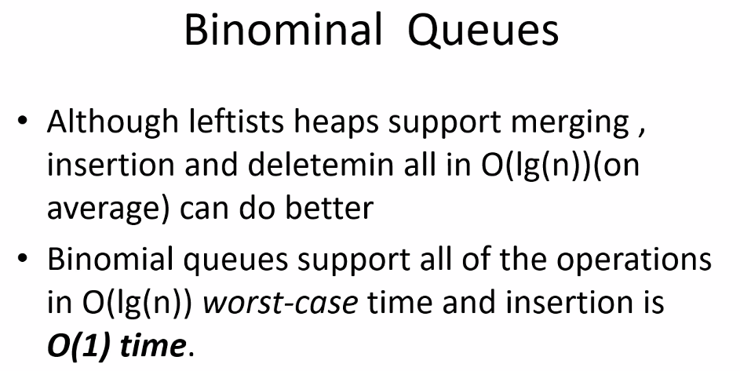
* 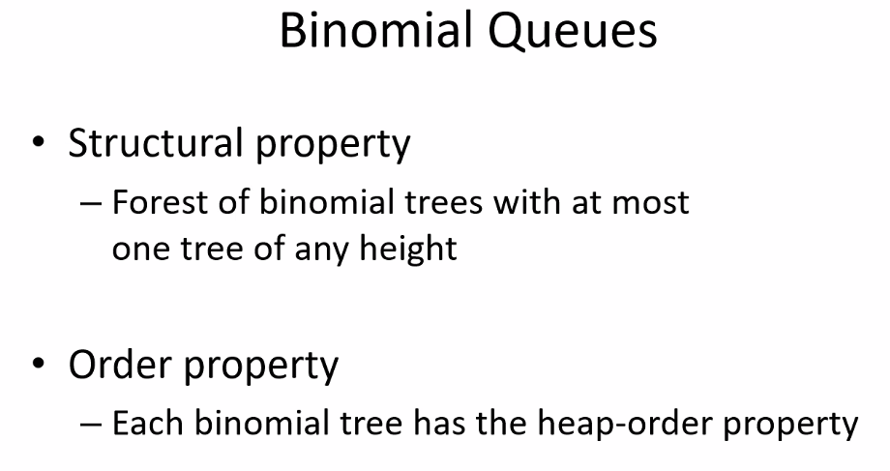
* Forest = group of trees
* 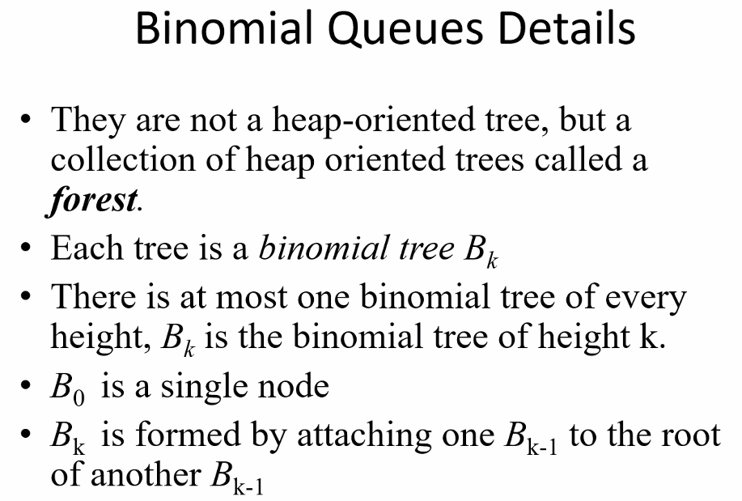
* 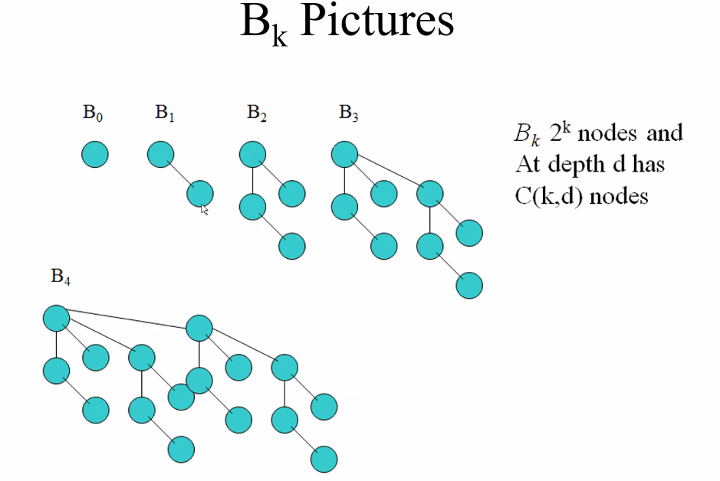
* k represents depth of each tree in the forest; and of course 2^k tells you the number of nodes in each binomial tree
* each tree in the forest is a binomial tree
* remember: each binomial tree Bk is formed by combining 2 Bk-1 binomial trees; and thus also every next binomial tree in the forest will have double the nodes of the previous binomial tree
* 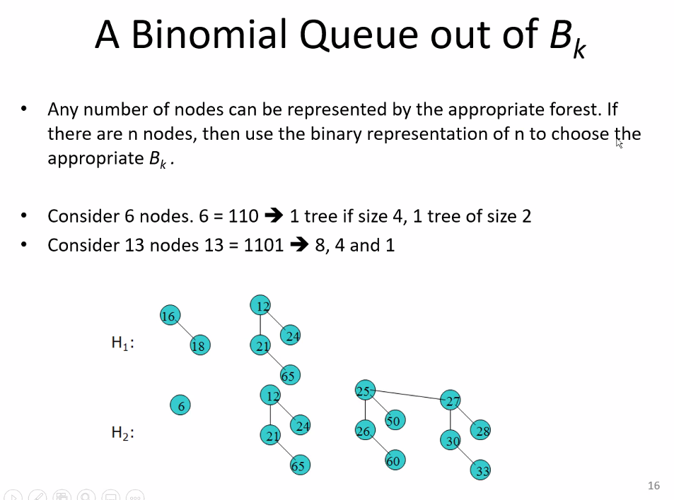
* Notice the binary property of the binomial trees allows you to use the binary number system that computers already use to calculate total number of trees in the forest (the power), and total number of nodes (sum of the polynomial of all powers with a 1 (tree) in the position)
  + This allows you also to do binary addition/subtraction to figure out which trees need to be combined or broken up when adding or subtracting a node
  + For example 110; if we add 1 == 111; thus for this case we simply activate the B0 tree and add the node in that tree
  + Remember there can be only be 1 or 0 of each type of binomial tree Bk; just like in binary each power can have either a 1 or 0 (activated or not activated); so this is very useful for queues using binary!!!
* 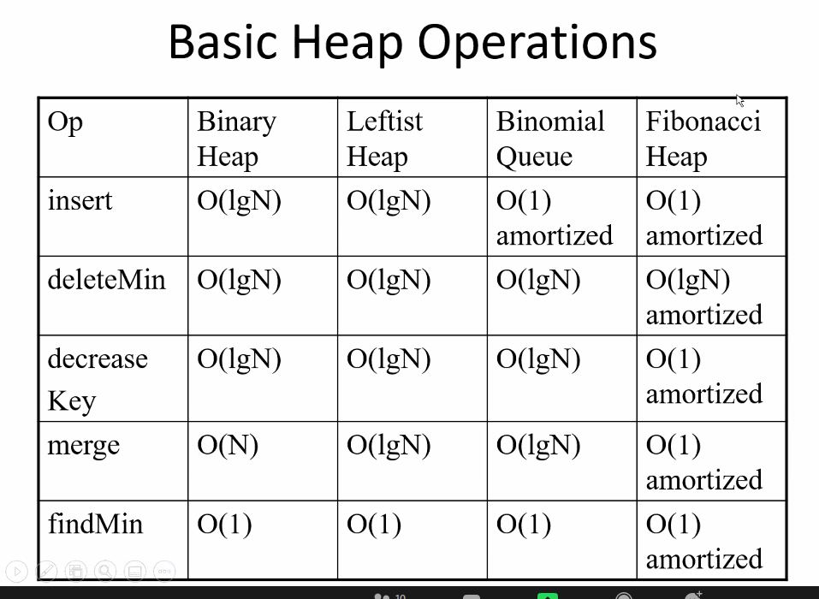
* 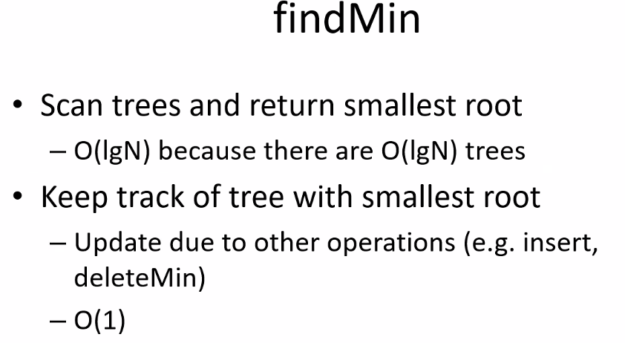
* Keep track of tree with smallest root: first scan you determine which is smallest root; then you store/keep track of that
* 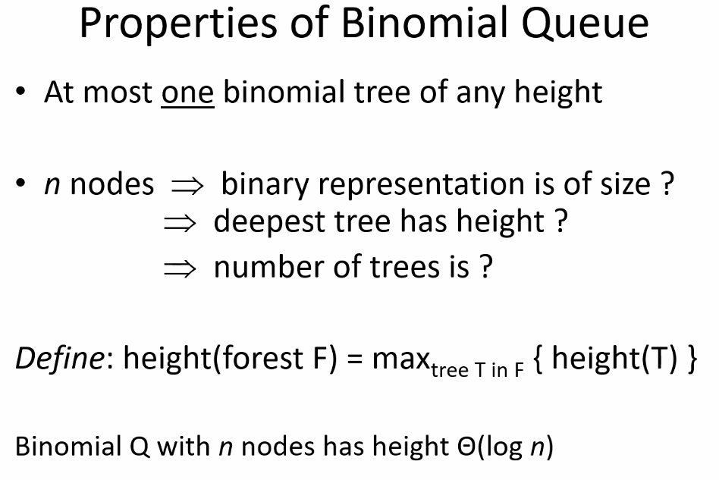
* 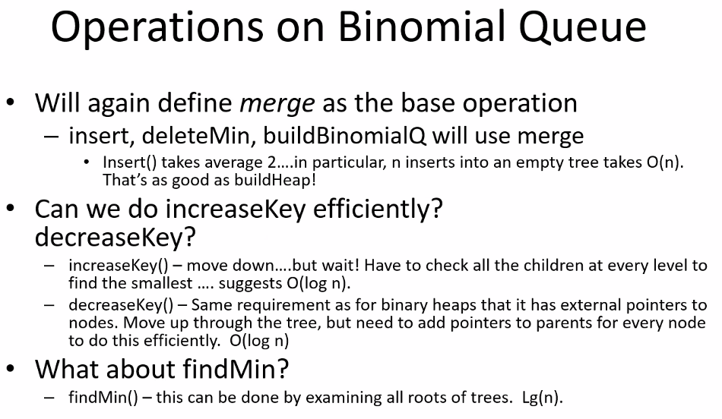
* 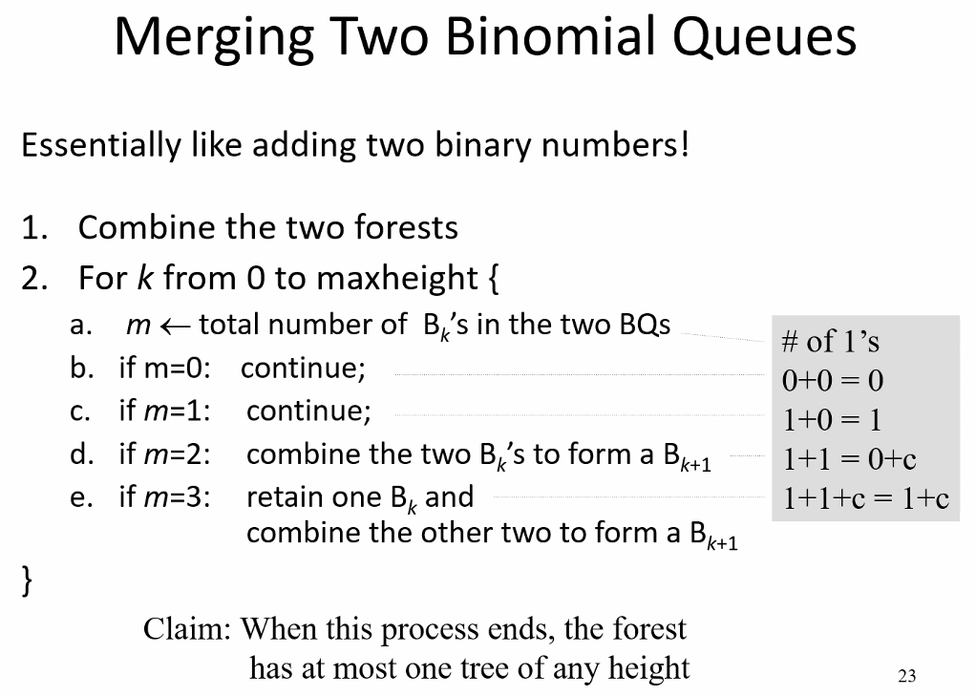
  + Notice: it is simply binary addition!
* 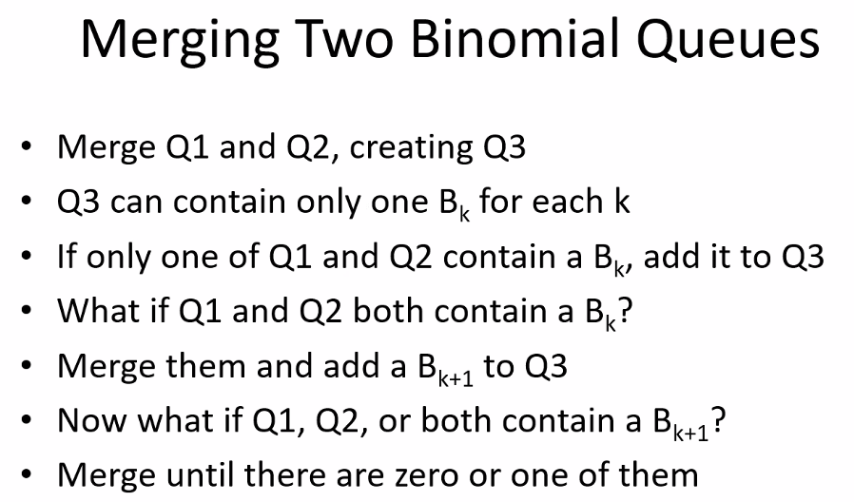
* 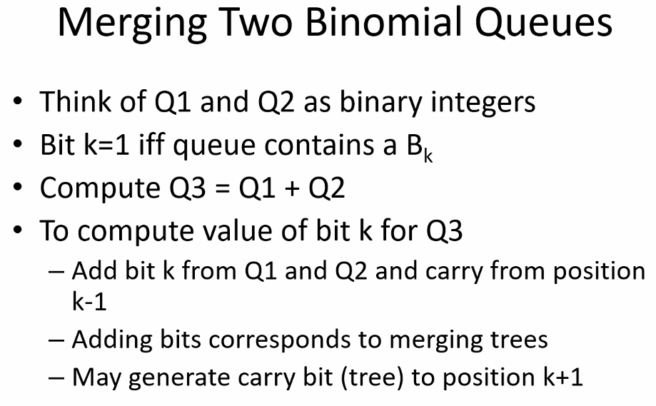
* 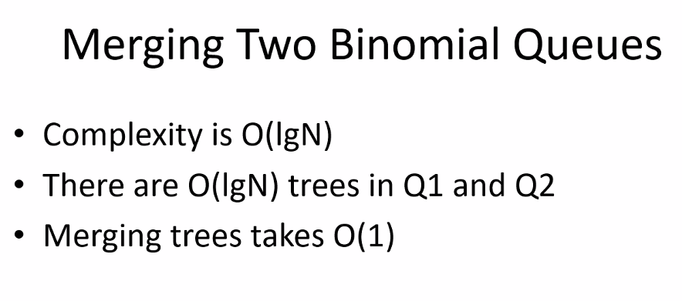
* 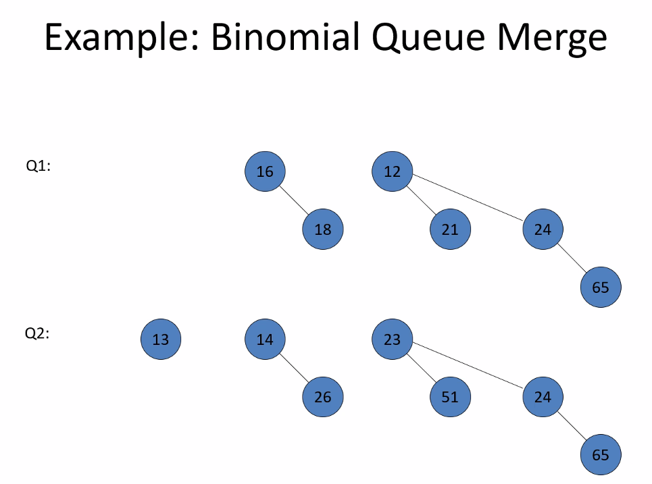
* 110 + 111 =
* Notice you combine roots; because each binomial tree is organized as a min heap (level ordered tree with each level becoming greater than the level above; but it is not complete binary tree 🡪 just level ordered; so you see we simply combine the roots; this always works to combine roots also because the forest of binomial trees can have at only 1 or 0 of each binomial tree Bk)
* 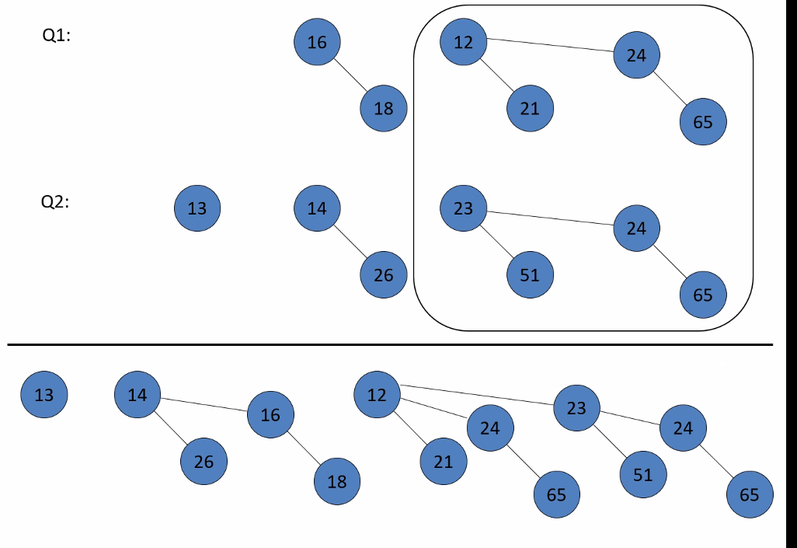
* Notice: because of the polynomial (binary number system) nature of this structure, it can be implemented as an array since you can calculate location of each tree and its children
* Each number of nodes can be represented by exactly one unique binary number; thus you will always know which trees are activated and their children and can calculate that location in the array as long as you know the total number of nodes in the forest made up of binomial tree structures
* 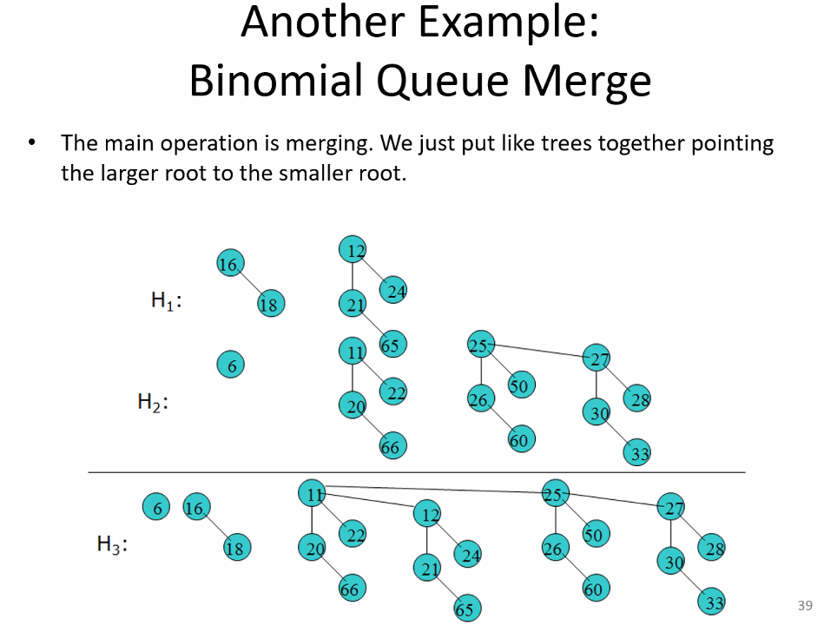
* Notice above the merge is simply adding two binary numbers; you notice at each stage even after combining if you have duplicates, you combine them (similar to adding two 1s you get 0, and carry the 1 to a higher power = a tree with double the size)
* 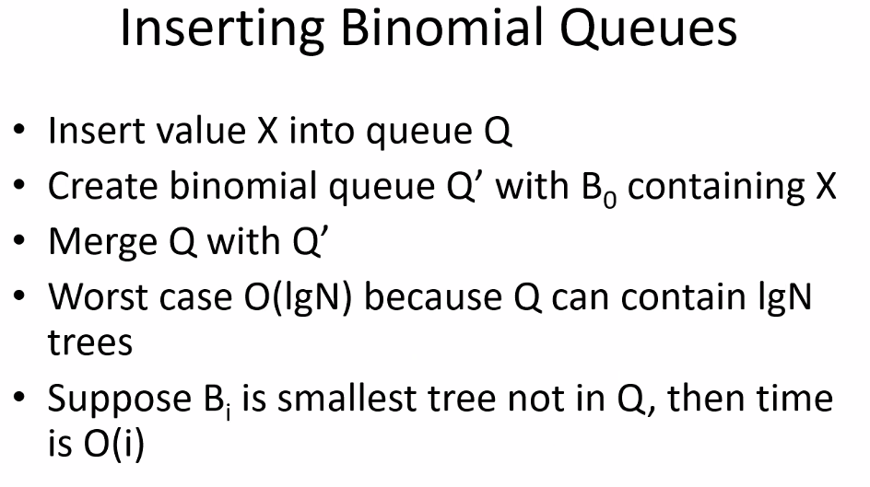
* 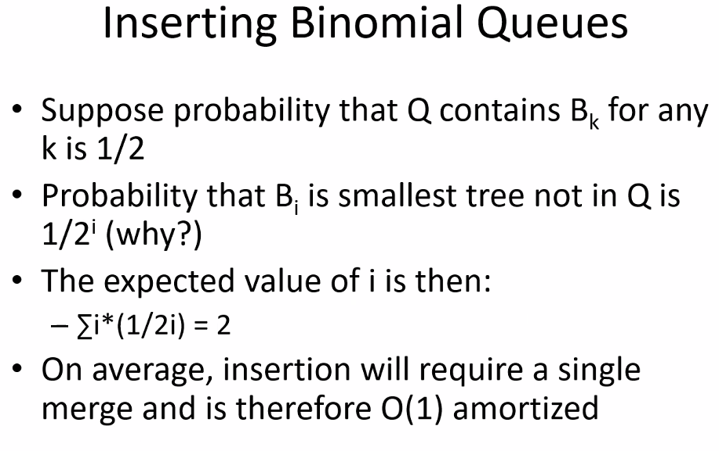
* 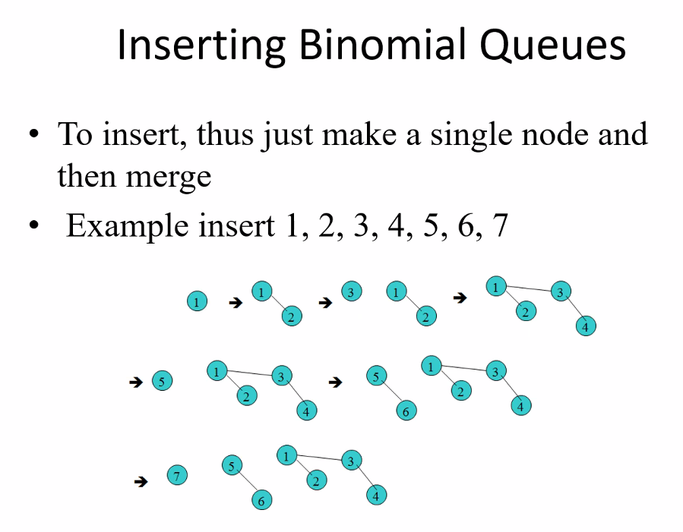
* Notice above, is just adding binary 1 each time; starting with a binary number 0
* 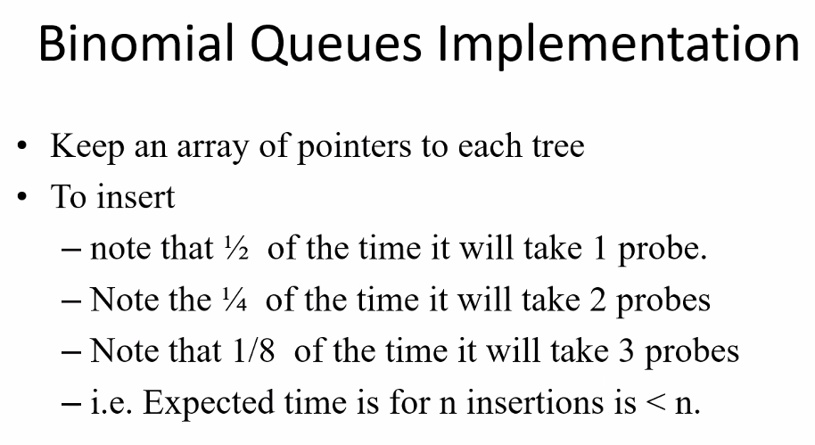
* 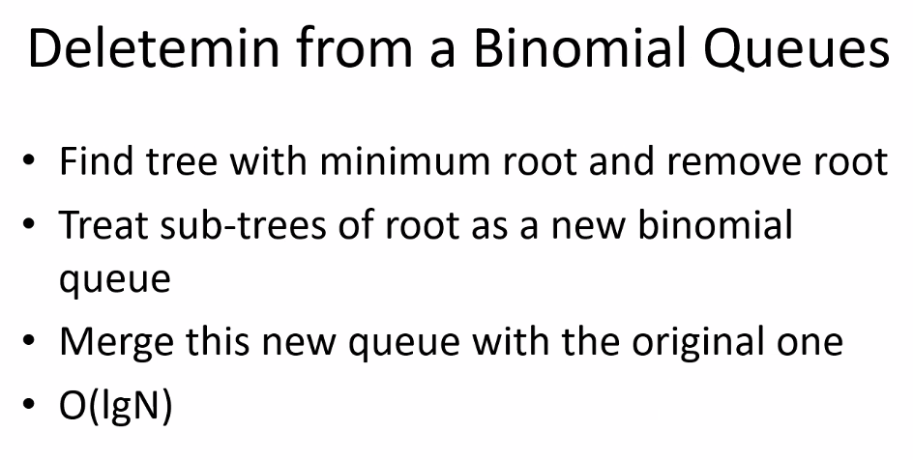
* 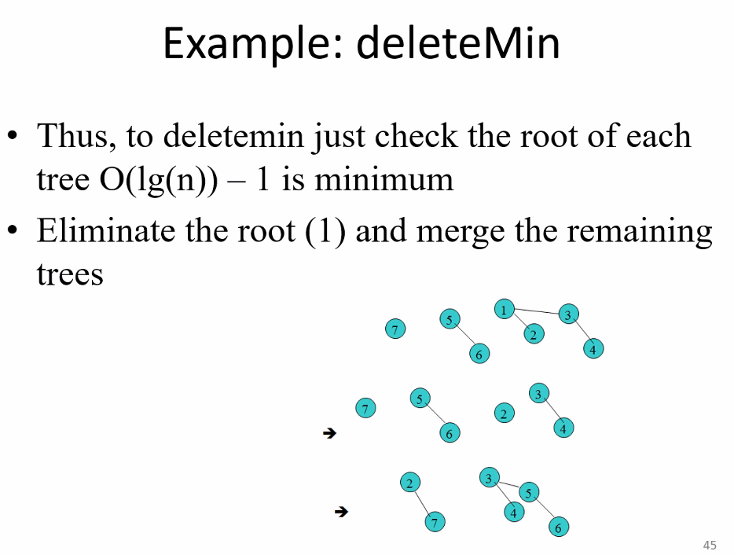
* Check all trees == number of trees == log(n)
* So we have Q and Q’; Q = original structure – Q’; Q’ = tree where root was eliminated
* COULD BE ON EXAM!
* 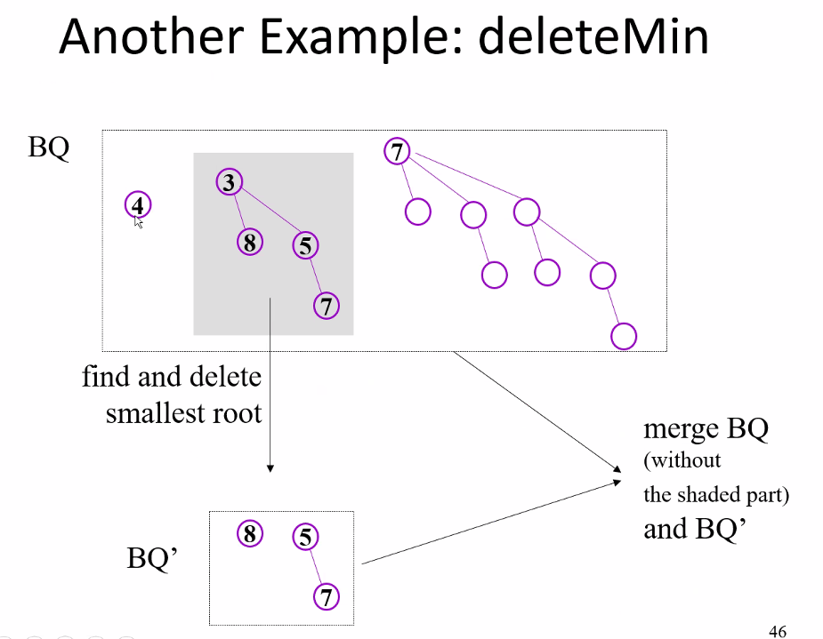
* Remember each individual tree is organized such that the root is smallest node in the tree; level order min heap structure
* Remember when inserting/merging, if we have a min heap binomial queue, make sure to add larger nodes on right, and smaller nodes on left just like standard binary tree
* 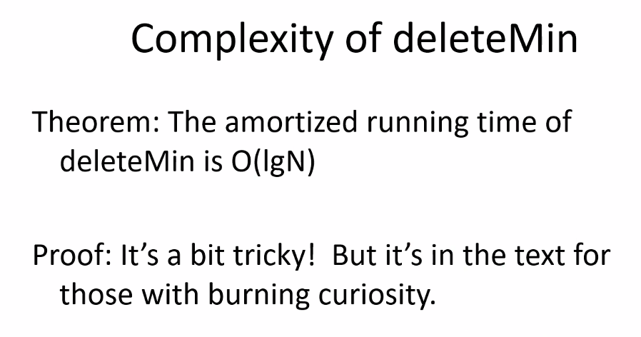
* 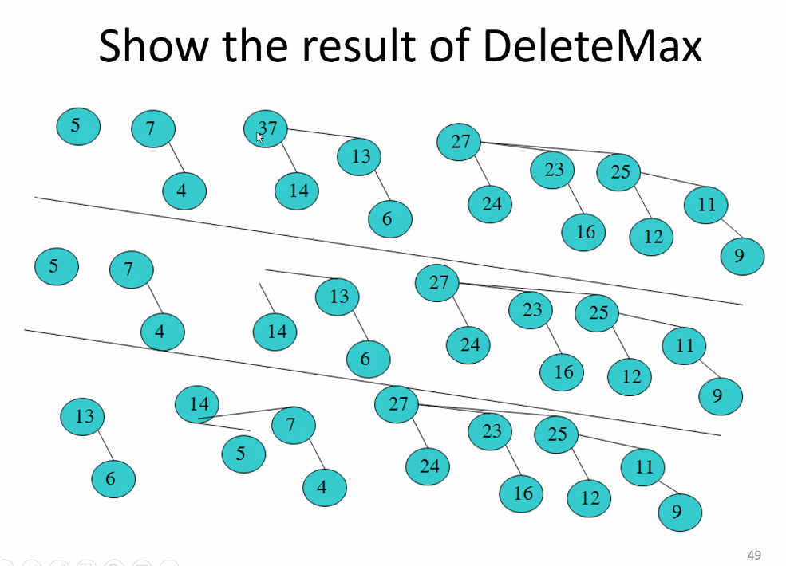
* Remember after doing a delete min or max: then you will have two trees that you will have to merge together (Q – max/min) and Q’ just like example before this one shows
* When doing the merging (binary addition) it is arbitrary which nodes you start to combine to make binomial trees; you will end up with same binary result; (of course if customer asks for something specific then you have to do it that way)
* 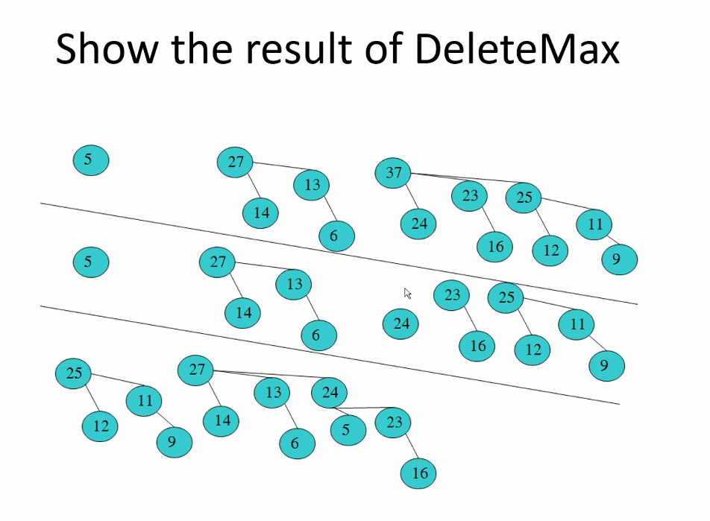
* So: you have the binary representation to start with as 1101; delete max is deleting 37 which means you delete 1 from 1000 == 1000 – 1 = 0111 (remaining positions in binary number 0101 are untouched and will be merged); now merge: 0101(remaining trees from original forest where no roots were deleted) + 0111 (broken up tree from deleted node) == 1100 == our solution! 2 trees: 1 with 4 nodes (2^2) and 1 with 8 nodes (2^3) == 1100.
* 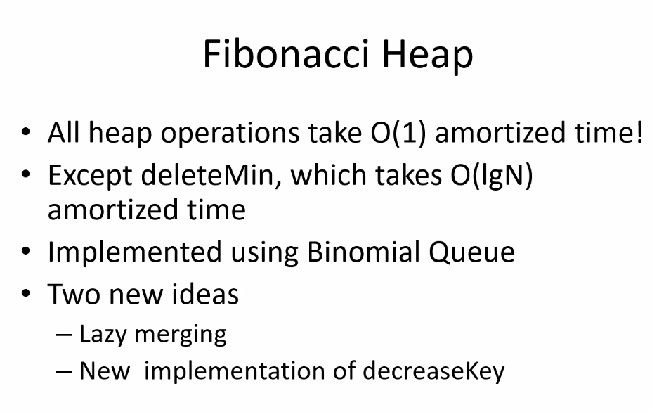
* 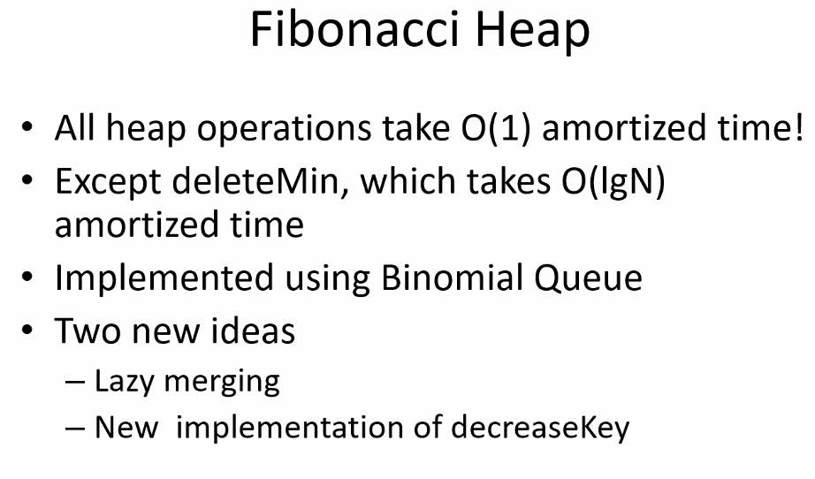
* 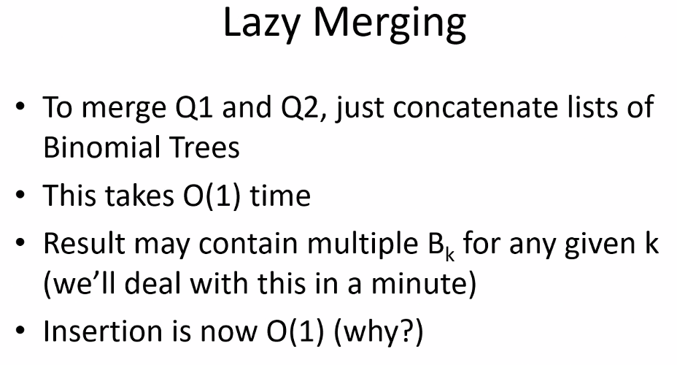
* 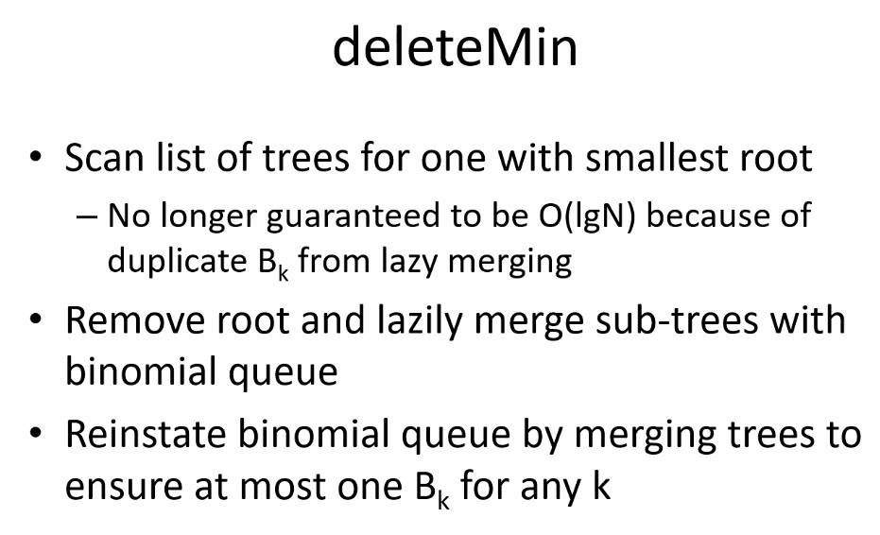

# Lecture 20 – 7/29/21 – Heaps continued

* 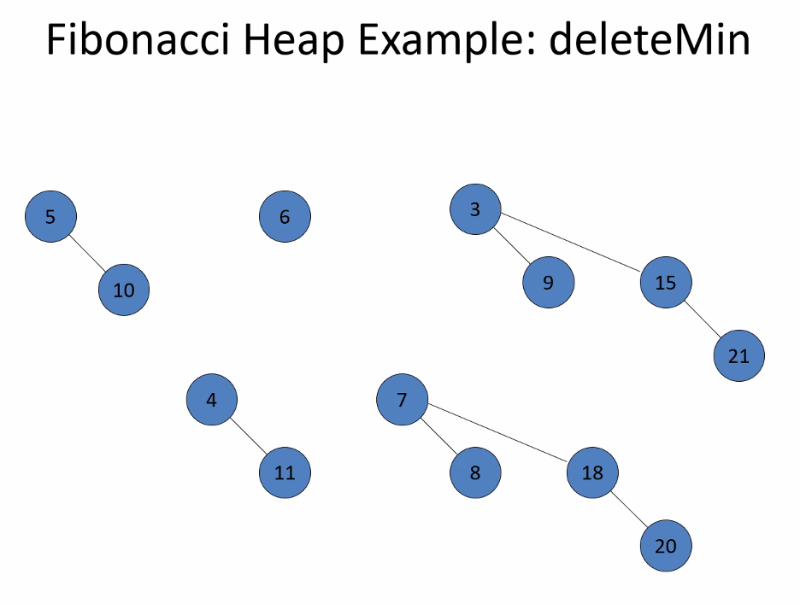
* 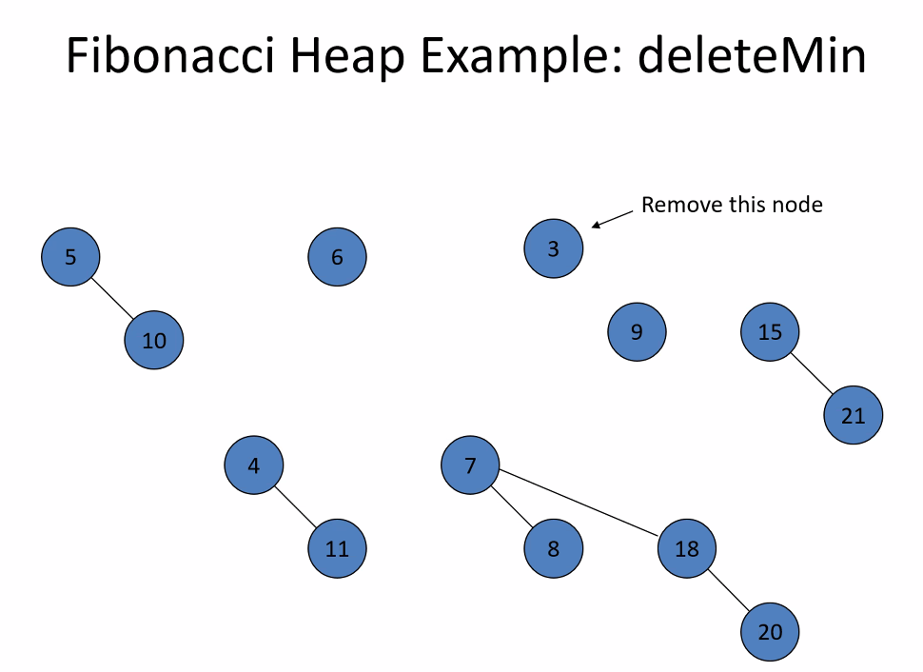
* 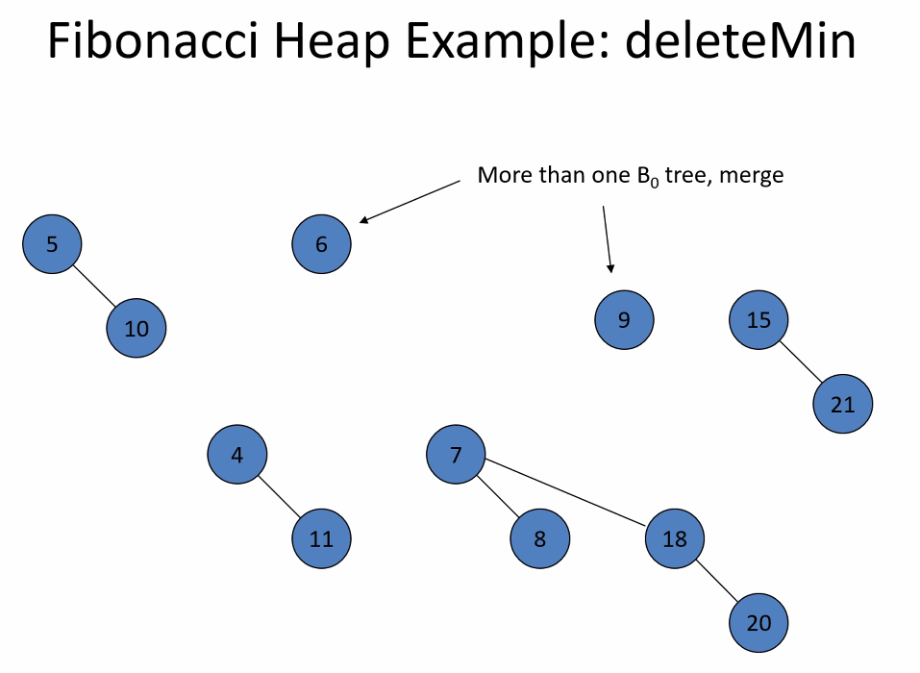
* 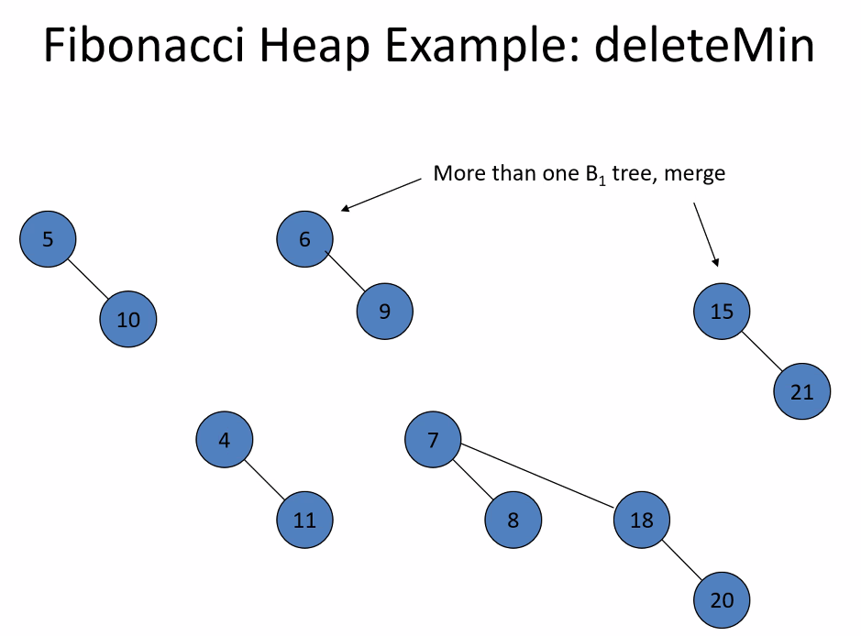
* 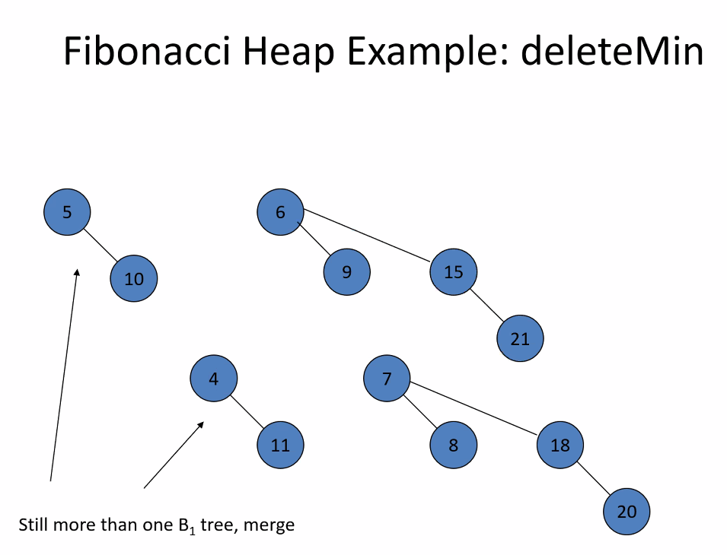
* 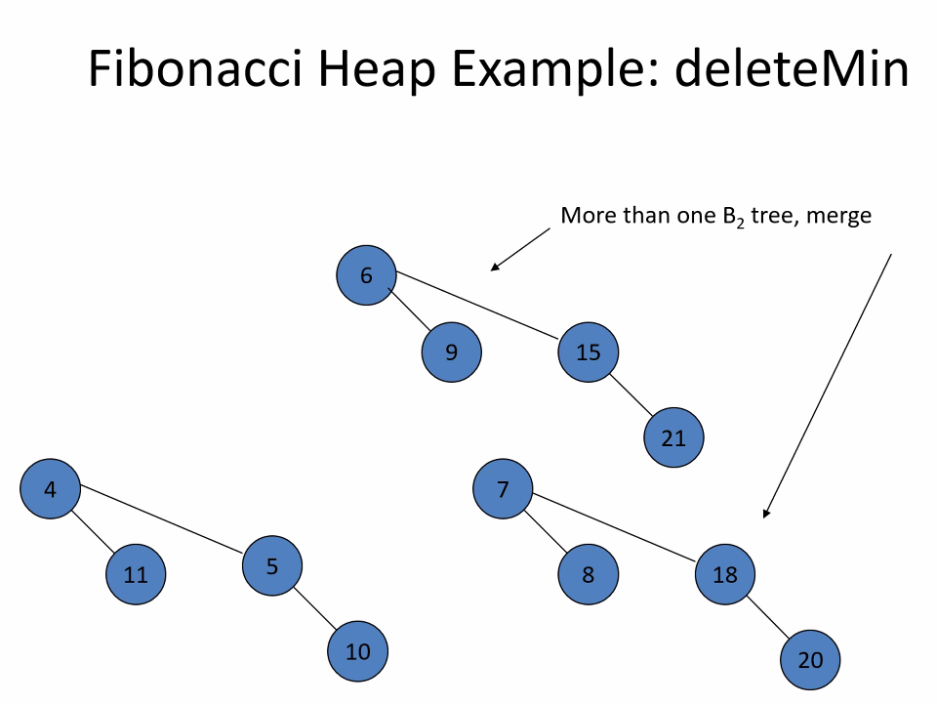
* 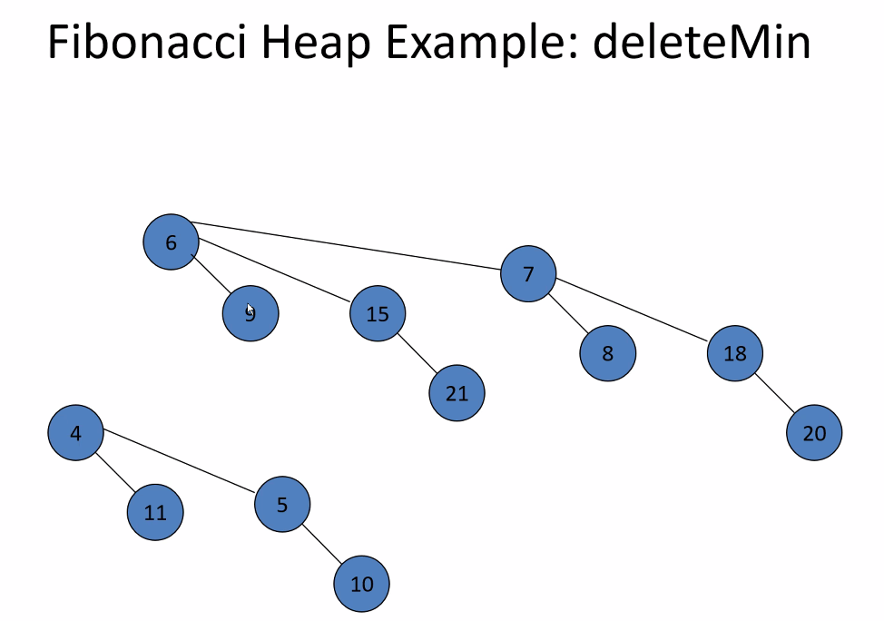
* Done!
* So delete min will correct all of the extra instances of Bks and make it into a normal binomial queue
* 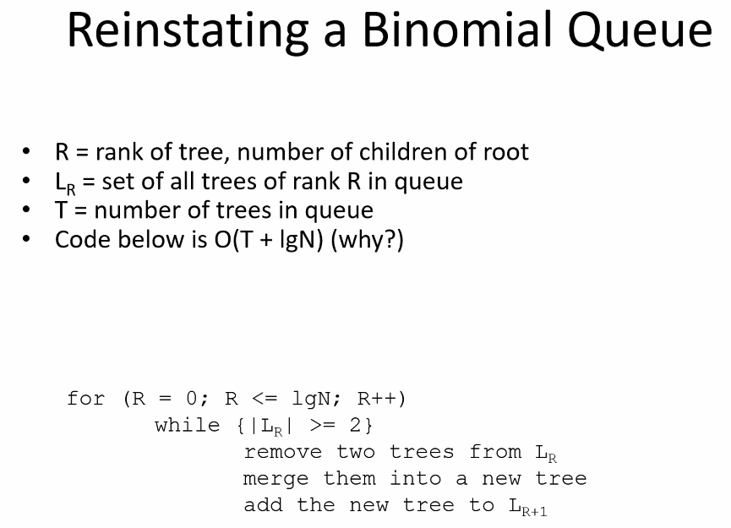
* 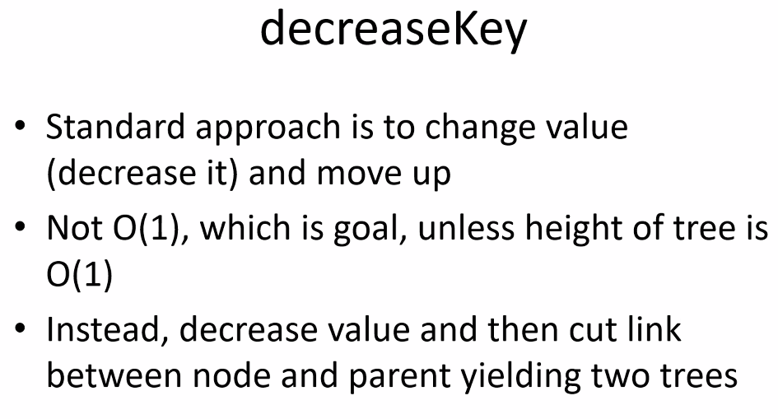
* 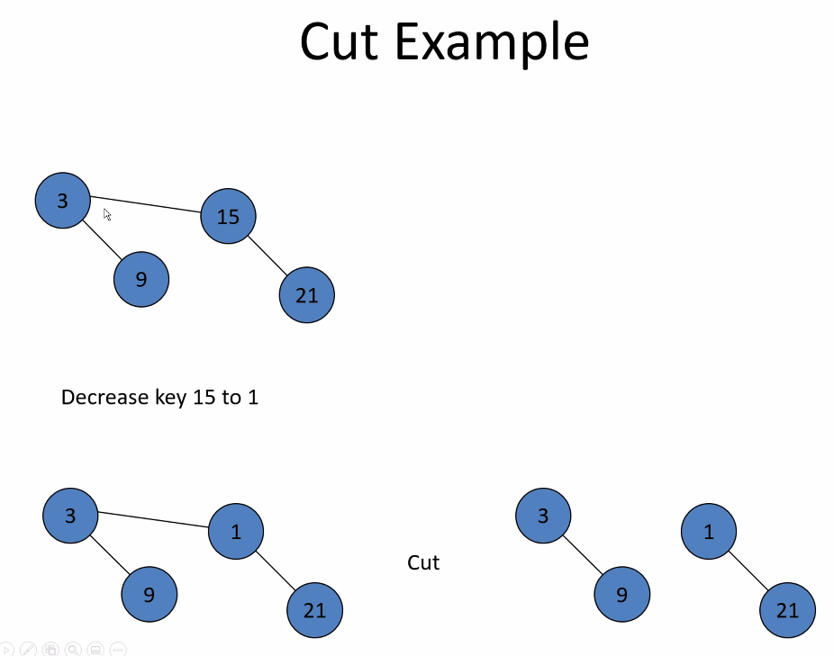
* We want to cut when we are decreasing a value; we can decrease value in order to move a node up in the queue
* Since only roots are checked for finding min, we simply make the cut after decreasing value and moving it up so that on the next deleteMin, that node will be next in the queue or closer to being at the front of queue
* 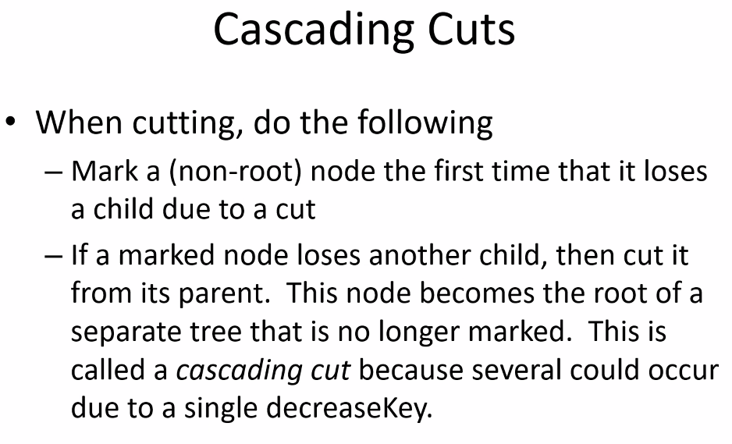
* 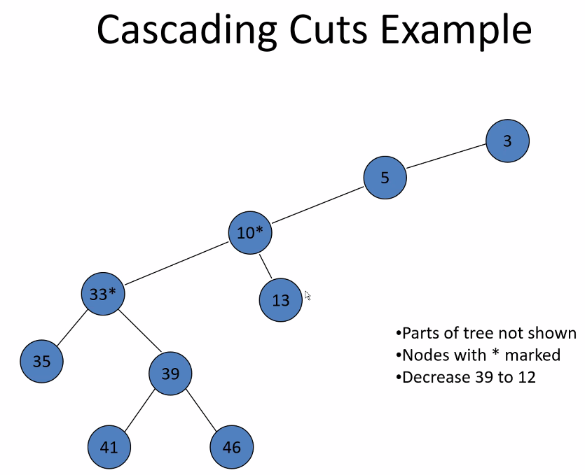
* So 39 will be moved up in the queue after the queue, but it won’t move all the way up to the root (3)
* 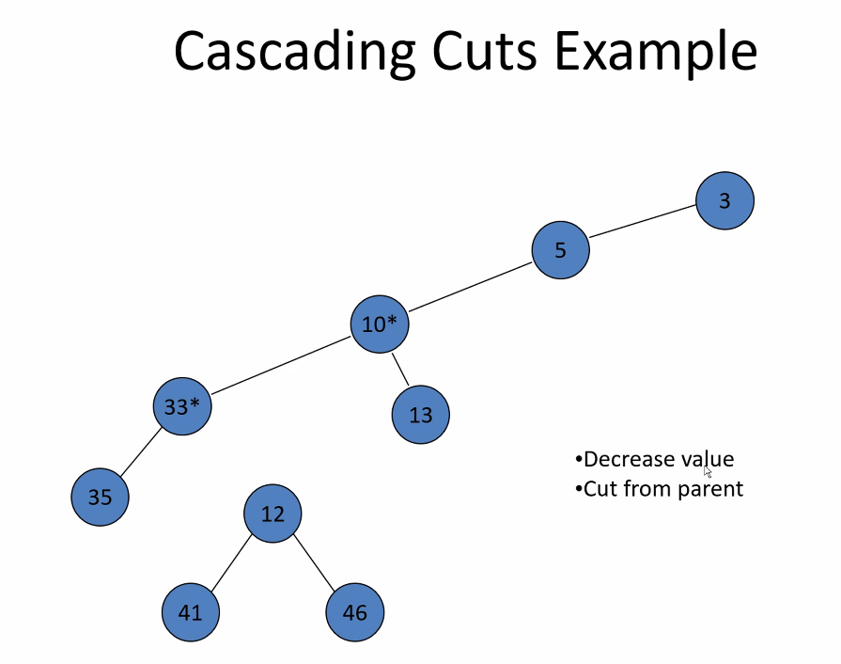
* 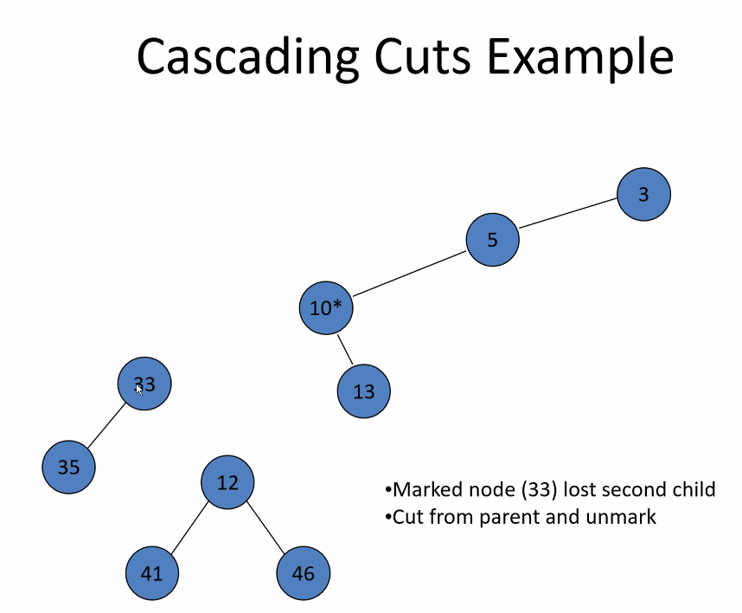
* 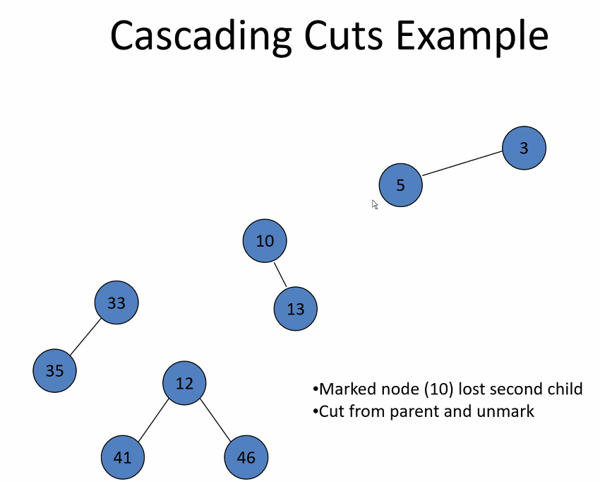
* 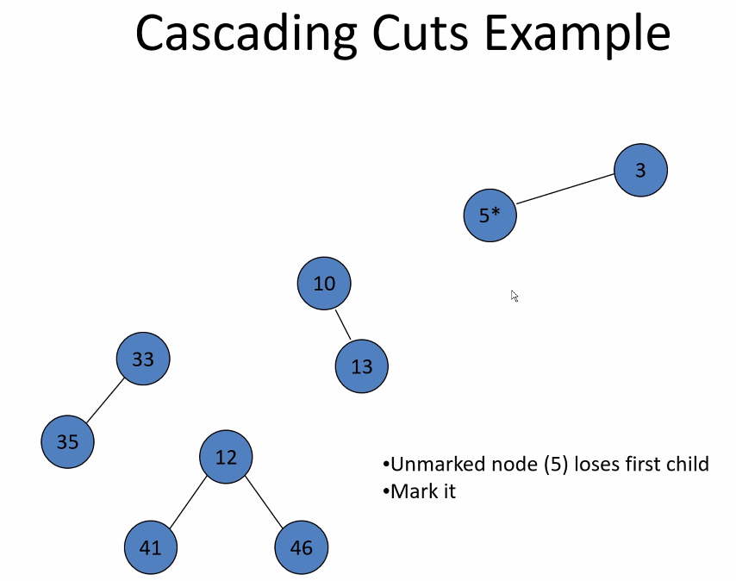
* 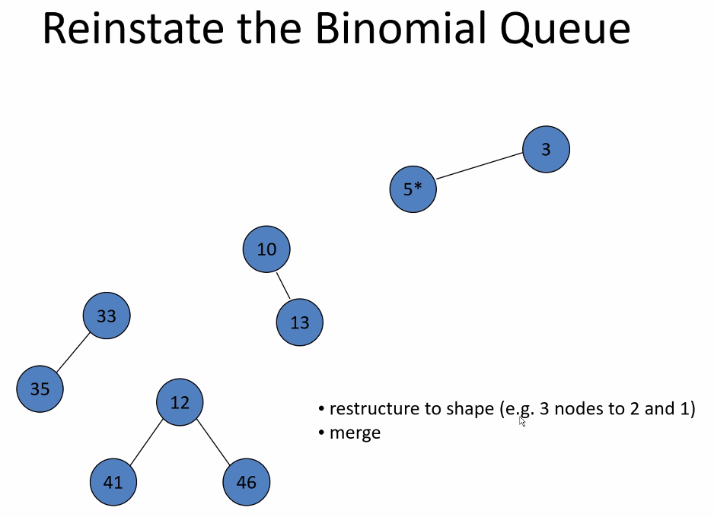
  + Reinstate binomial queue above upon the next deleteMin
* 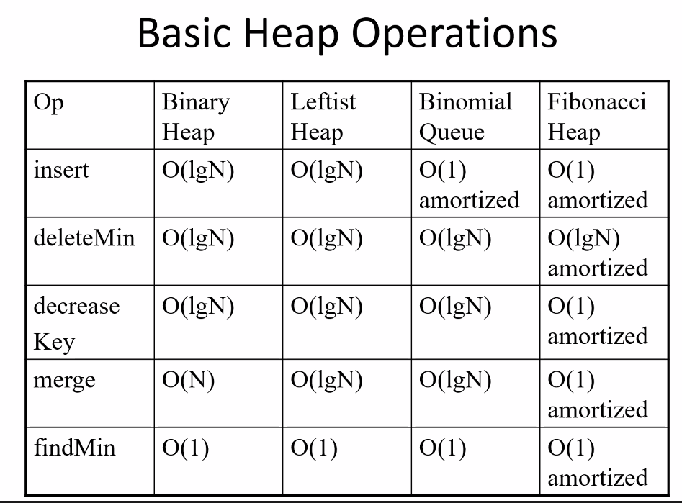
  + Remember deleteMin for Fibonacci heap is because that operation reinstates the binomial structure (only at most 1 kind of each binomial Bk tree)
  + This is why all the merging and inserts is called “lazy”; it only will be fixed into standard binomial structure upon calling deleteMin; but overall Fibonacci heap is faster than all the other heaps (generally speaking)
* Notice: you can do decrease key (cuts) with any heap; of course Fibonacci Heap is fastest (amortized)
* Fibonacci heap is more complicated to explain and in general code
  + Often it is better to have code that is extremely easy to explain
  + But remember it depends on the data you have to process, which type of application you are coding for (how often do you search for minimum? How often will the application insert? Merge? Etc…)
  + If the data is very small to process, then time won’t matter, so choose the easiest heap/code to code for; extra nanoseconds won’t matter if the data is very small quantities/changed less frequently..etc.
  + For databases for example: you will often have lots of data, thus the complexity of code to get extra speed will significantly matter and be worth it in order to greatly improve performance; also databases may also need to move larger quantities of data (elements are larger number of bytes for example because there are a lot of data members in a struct )
  + remember as a computer scientist: you have to understand the data, and the application to choose the best, fastest, most cost and time effective code to solve the problem
  + this is why documentation and planning is important, so you can compare and record alternatives and the chosen solution for a given problem that you code for
  + remember all of computer science is tradeoffs when it comes to using a program to solve a problem with given constraints/requirements/specifications
  + companies will often stick to one method of coding/one programming language so that it is universal in the company and easier for others in the company to understand

## Sets

* 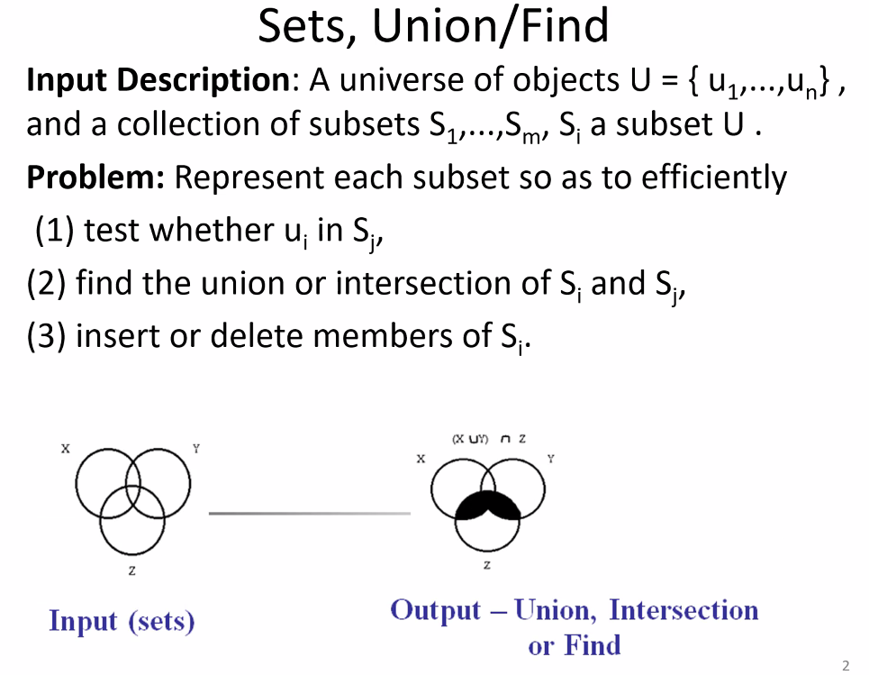
* Disjoint sets:
* 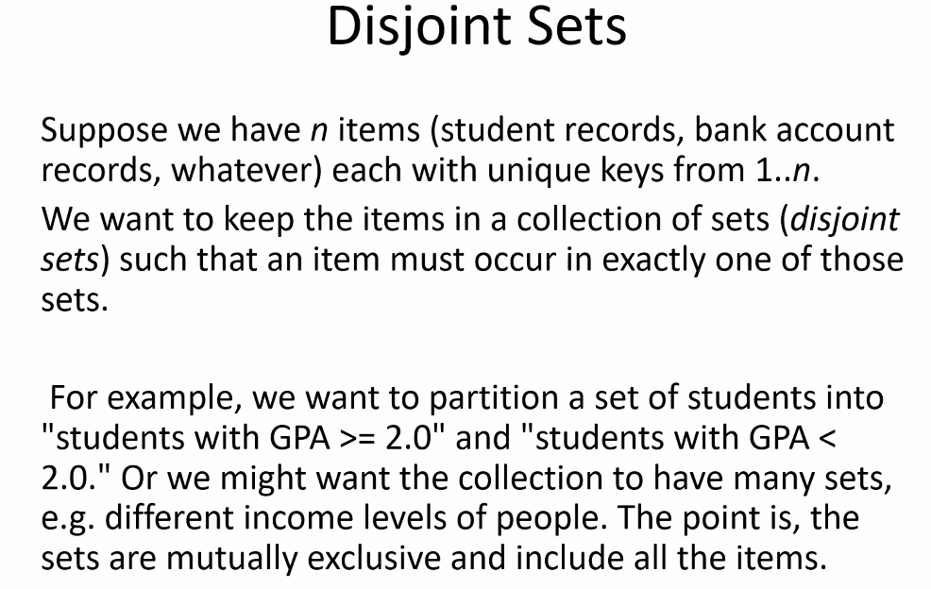
* 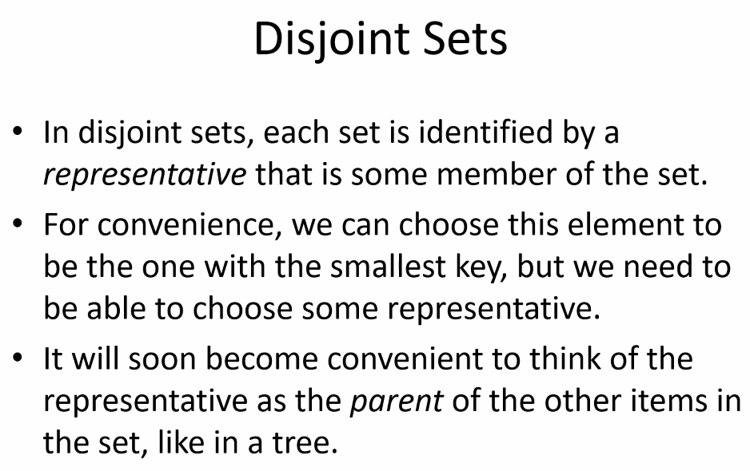
* Disjoint sets are like two trees; with the representative of the set being the parent of each tree
* 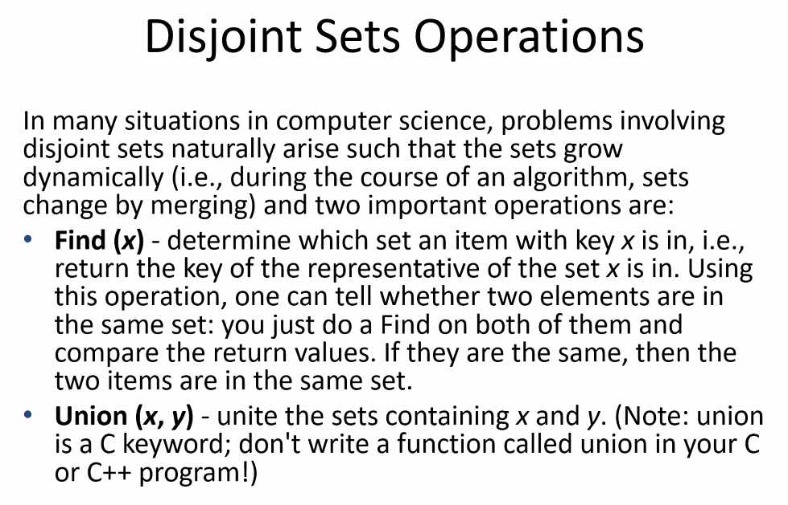
* 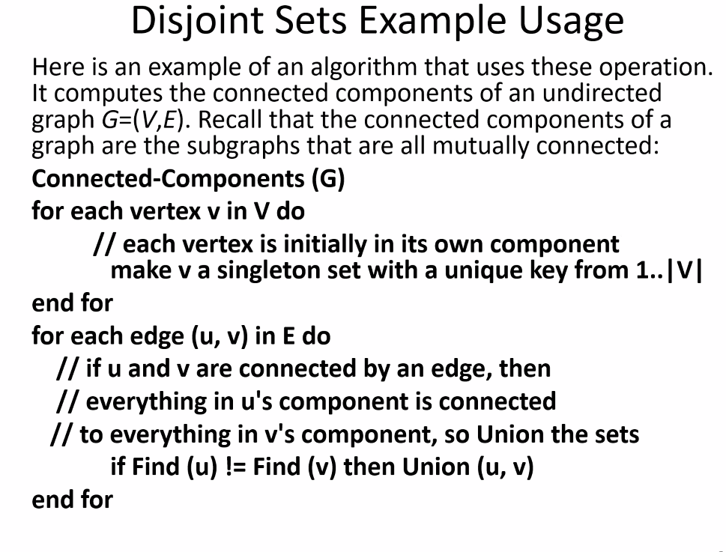
  + Think about our program 3 and 4 as real world example code (which MST can be applied to roads, pipelines, computer networks…etc.): we have to make sure all vertices are connected into one graph; we have to union sets until all vertices are in the same set
* Disjoint sets have a lot to do with: can I get from one location (one set) to another?
* 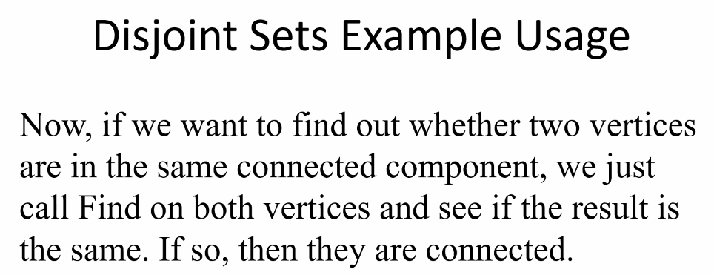
* 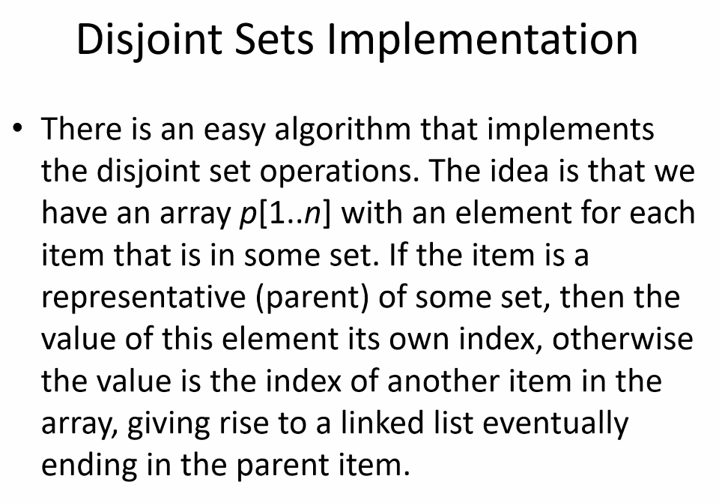
* 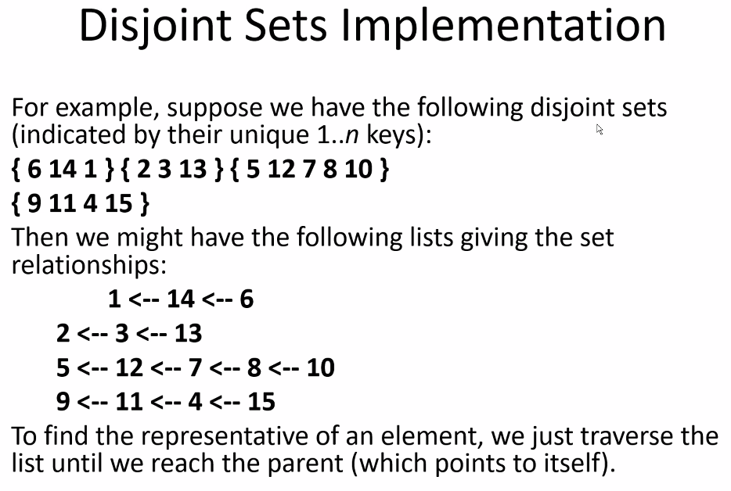
  + Remember the parent = the representative of a set
* 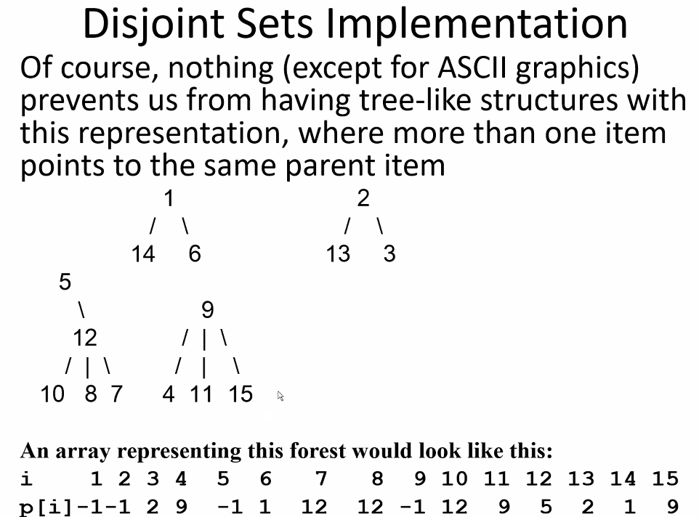
  + -1 represents we are at a parent
  + -1 is under the parents: 1,2,5, and 9
  + Underneath the array i (1-15), the value underneath contains either -1 (If it is a parent) or the value of its parent, so that you can eventually go to a parent representative of the entire set (which will then be a -1)
  + For example: 7 🡪 12 🡪 5 🡪 -1. Done.
  + So if you go to a representative parent and return wen checking a value, then check another value and it returns a different representative parent, then we know the two values are in a different set
* Find compression:
* 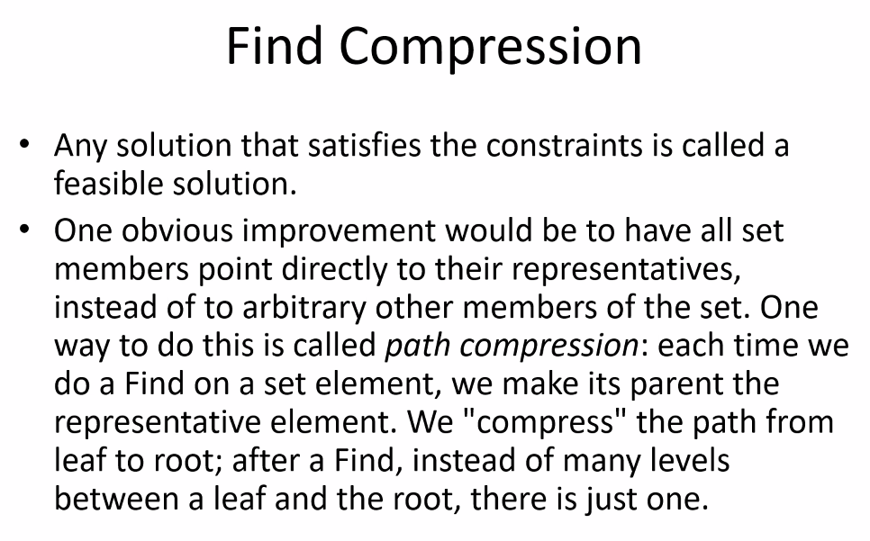
* 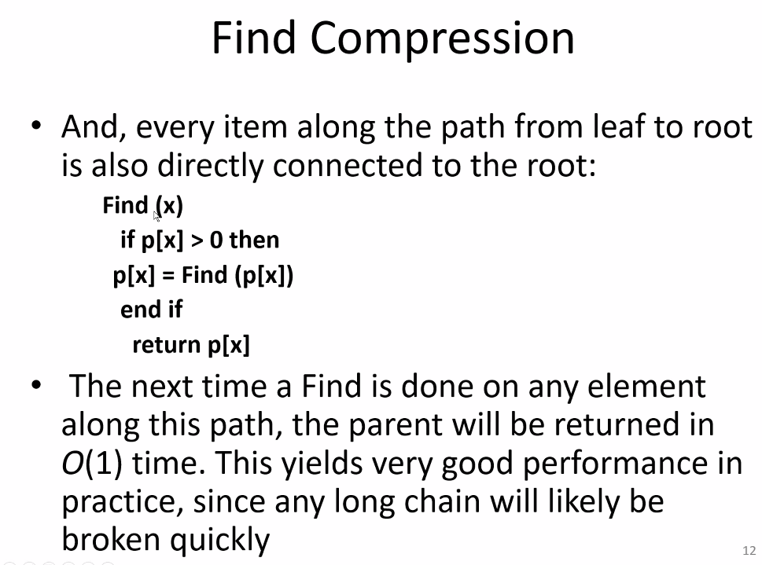
* Above example is based on previous example when representative of a set == -1
* 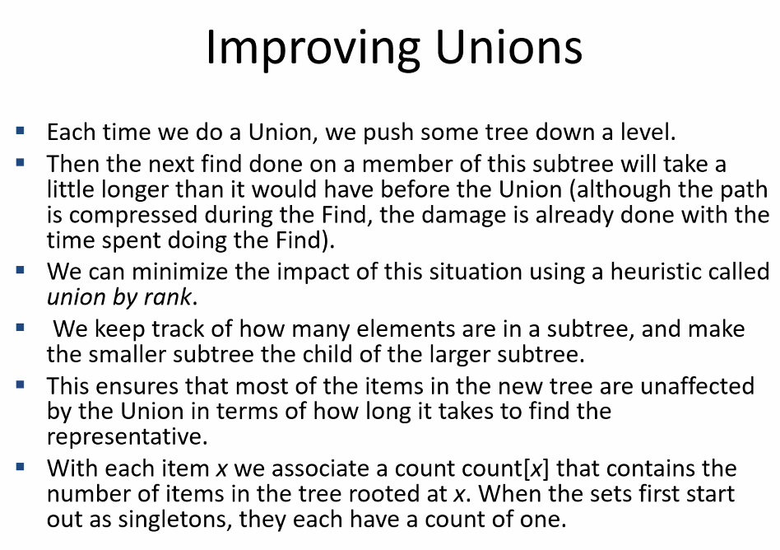
* By making the smaller subtree child of larger subtree, we reduce the depth for most of the nodes in larger tree; only the smaller sub tree will have increased depth for a Find, but for a less amount of nodes; if we do the reverse, then we push down more nodes giving more nodes a bigger depth
* Goal: less nodes at a larger depth, thus make smaller subtree child of larger subtree
* 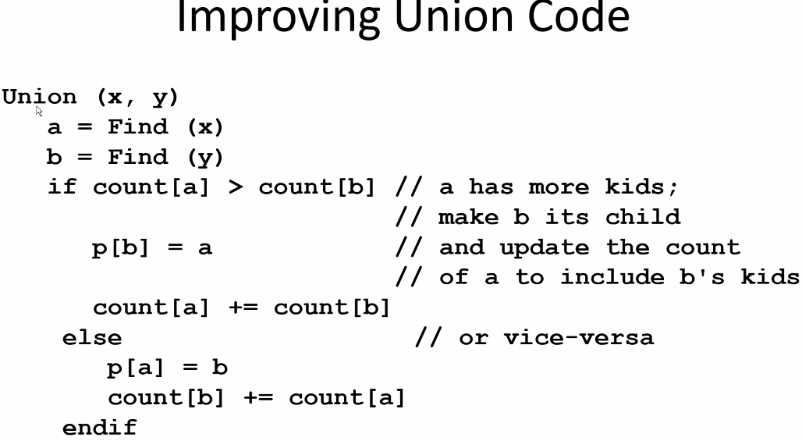
* Side note: comparison is one of the costliest operations; so the above improvement to union code is very important; this is where you can get the biggest reductions for the CPU: comparisons (comparison operations)
* 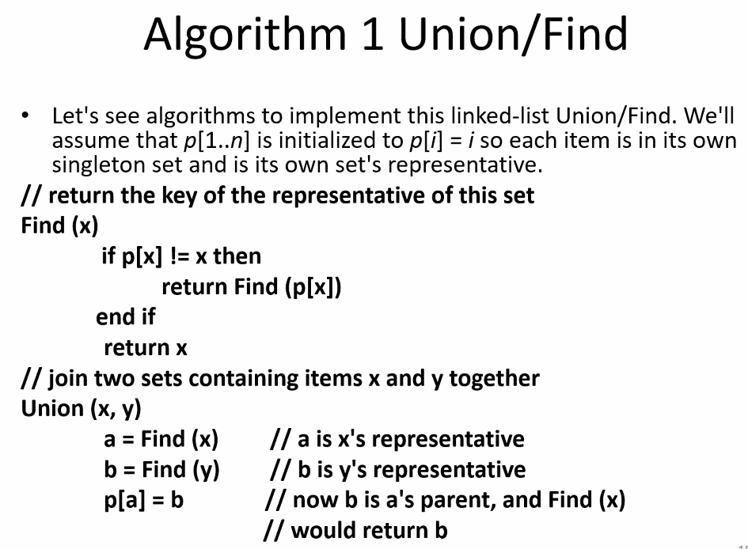
* above joins two sets regardless of size
* 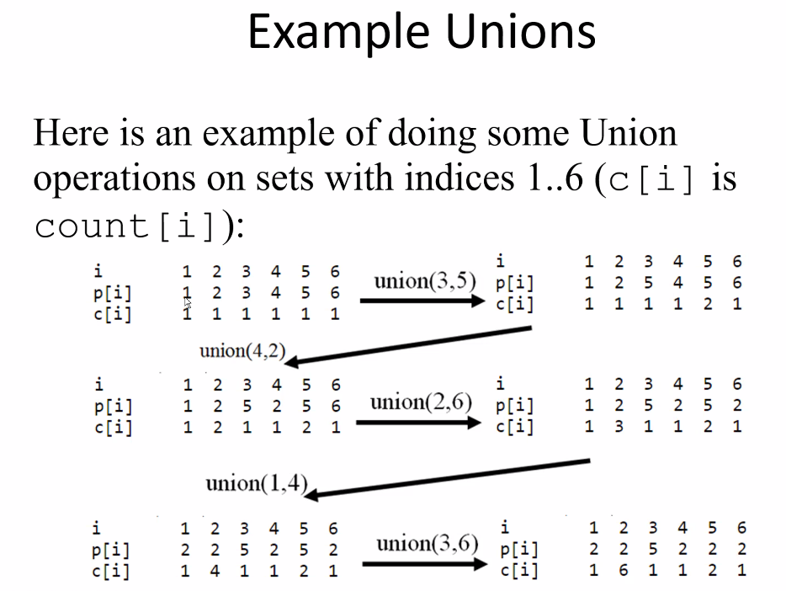
* Notice for first union (3,5), 3’s parent is changed to 5
* C (c[i]) is for count ( number of nodes in the chain) at a given element value (element value itself is 1st in the chain, then all children under it is its own chain and adds to the count)
* Notice for union (2,6), 6 has a chain length 1, and 2 has chain length 2, so attach smallest to largest (thus 2 stays parent to itself, chain length is now 3, 6 now has parent 2 with chain length still 1 🡪 there is still no children off of 6, it was merged into another chain as a child, so length remains as 1 for itself)
* Notice for union(1,4), check parents and length, if lengths are the same but parent is not itself, then compare the parents, and repeat this process until we have one length larger than another
* Notice because 2 is a parent with the most children, eventually all new unions will likely be added to the larger subtree at element 2 as a child of that tree
* **MIGHT BE ON EXAM**

# Lecture 21 – 8/3/21 – Backtracking

* **Recursive** process
* 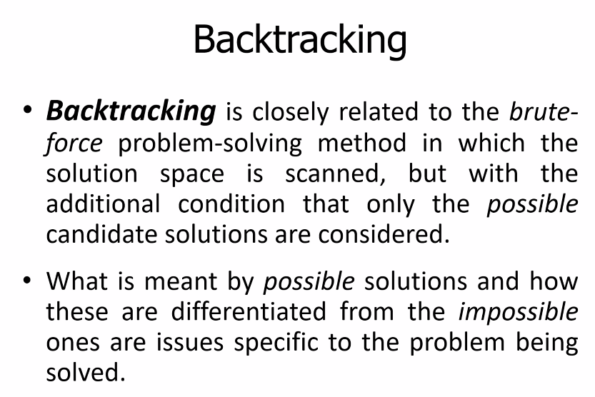
* 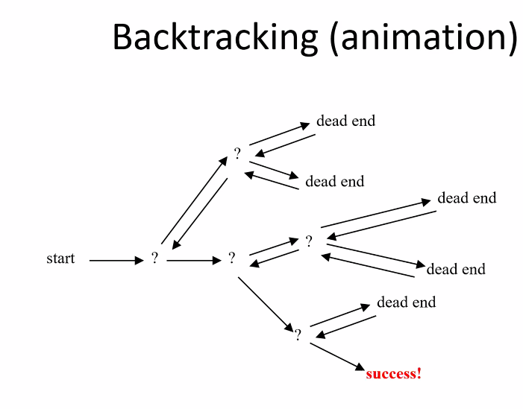
* 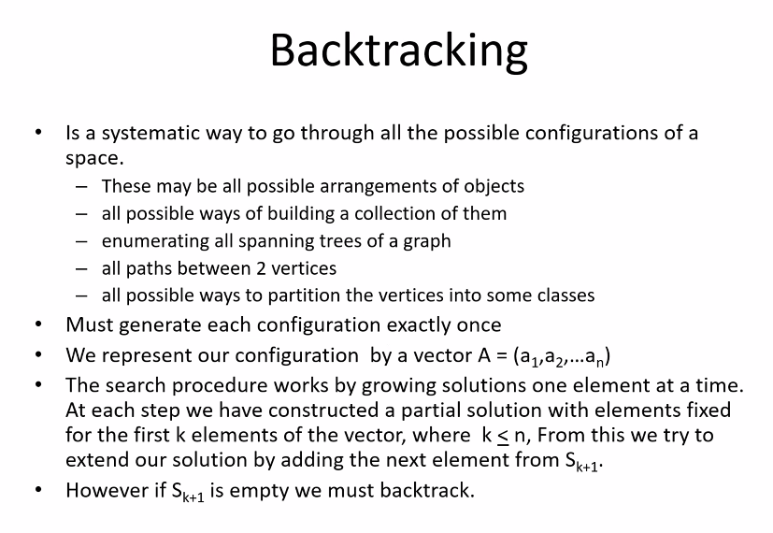
* Can use it to determine all possible paths to a given destination
  + Get the space of a network; build/resolve the network diagram
* Also can be used to visit each node
* Depth First Search Review:
* 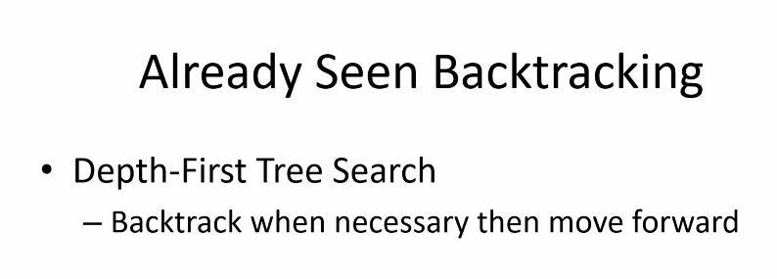
* 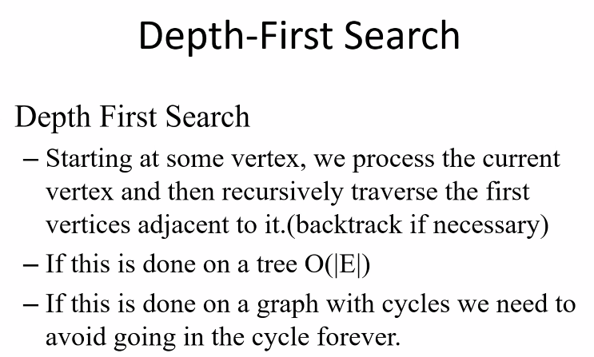
* 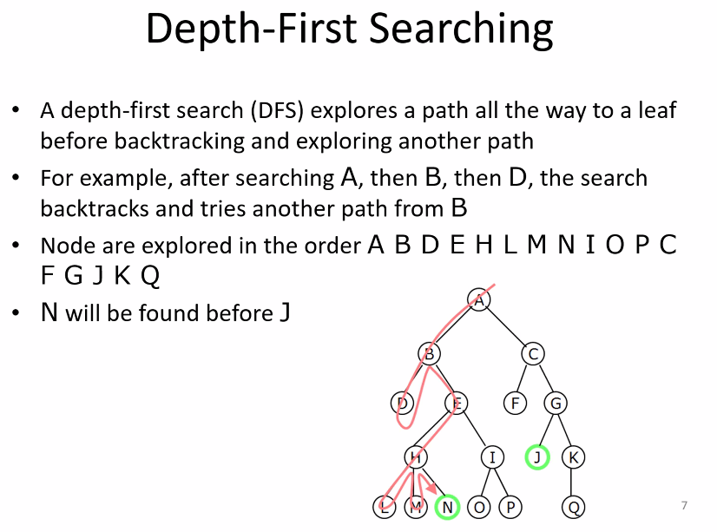
  + N found before J because N is at a greater depth
  + Notice the algorithm does DFS backtracking by starting with searching left nodes first and then proceeding to right node as available after a backtrack
* 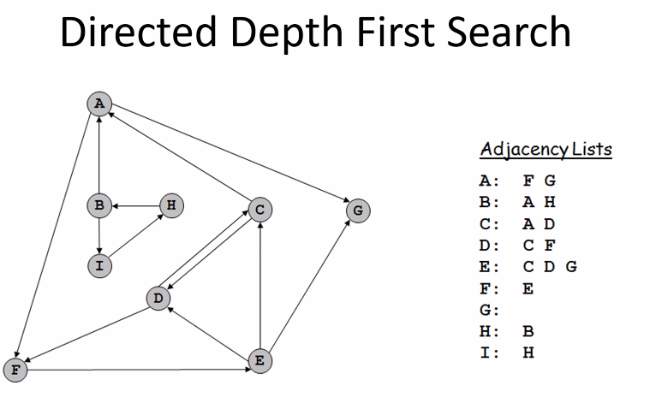
* 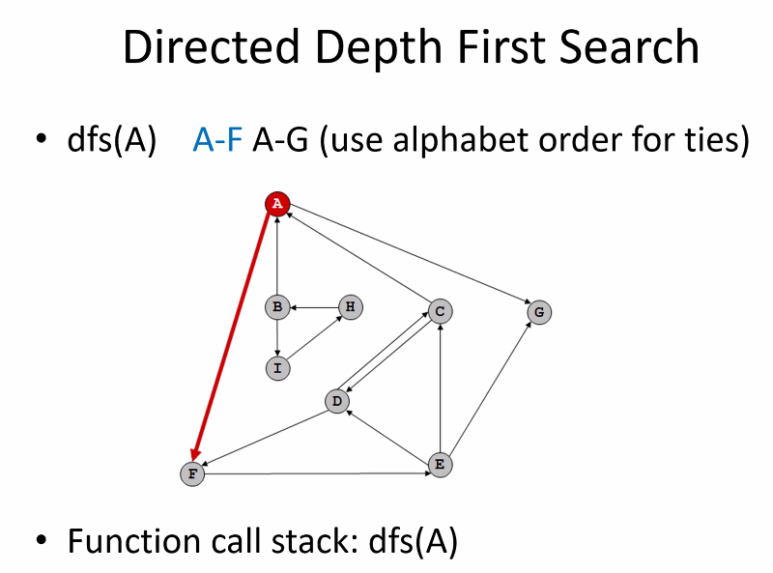
* 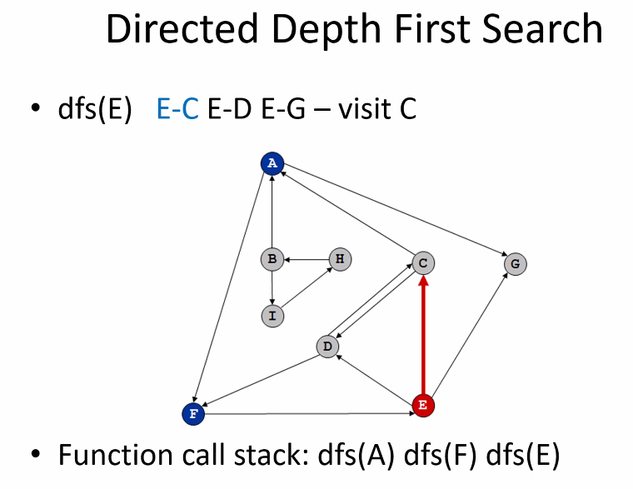
* 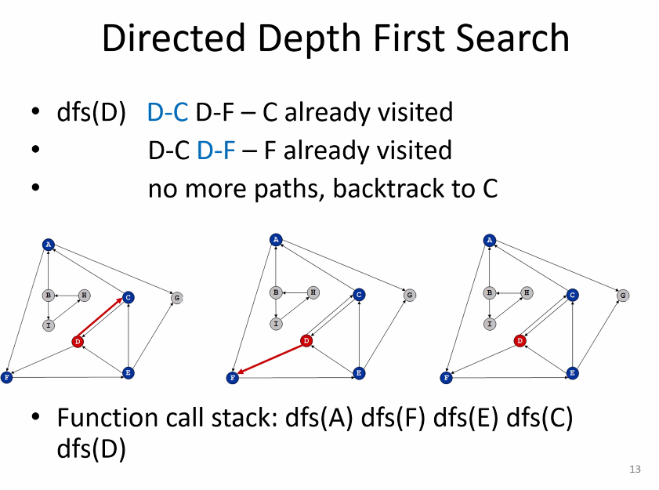
* 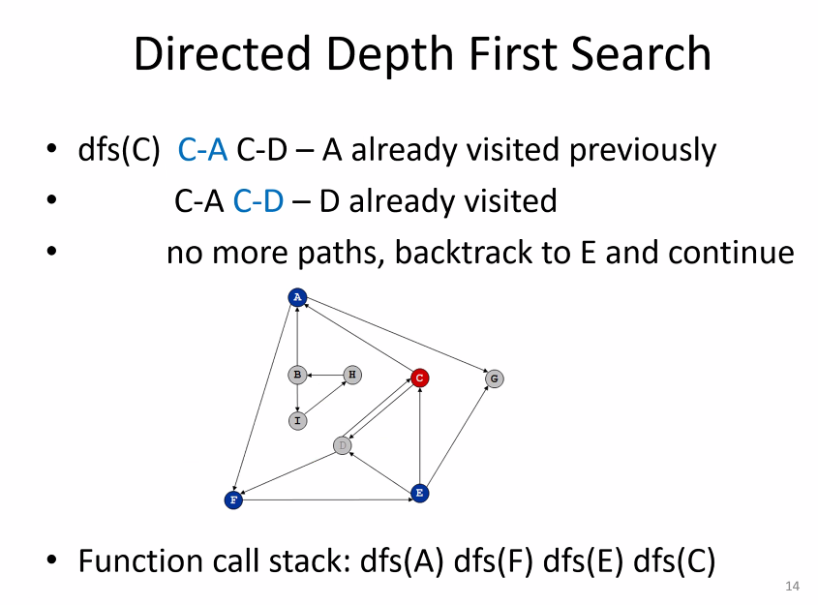
* 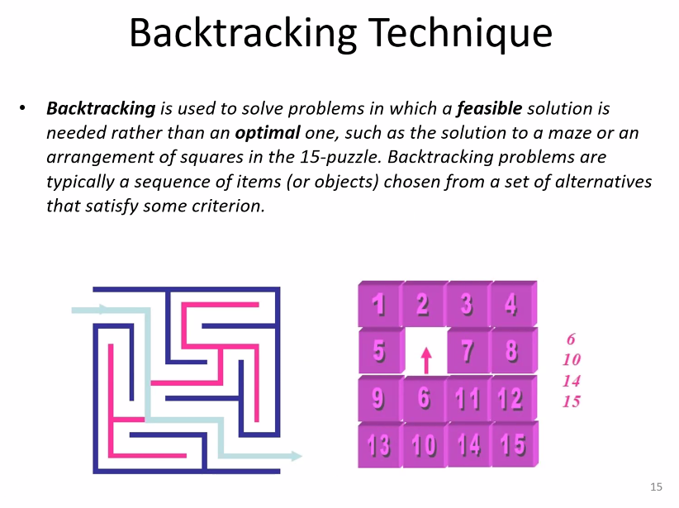
* Think of backtracking as solving a maze; just keep taking paths and backtrack as needed until you find the solution
* 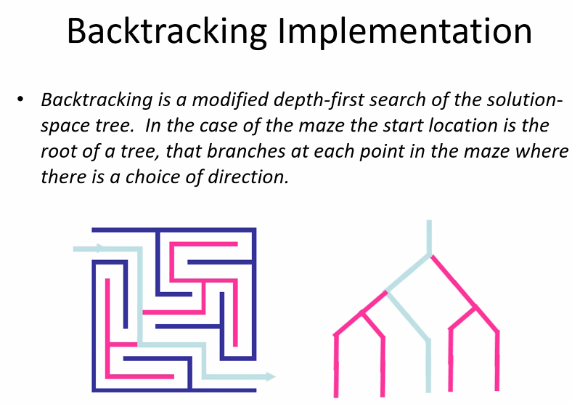
* Example, the n-queen problem:
* 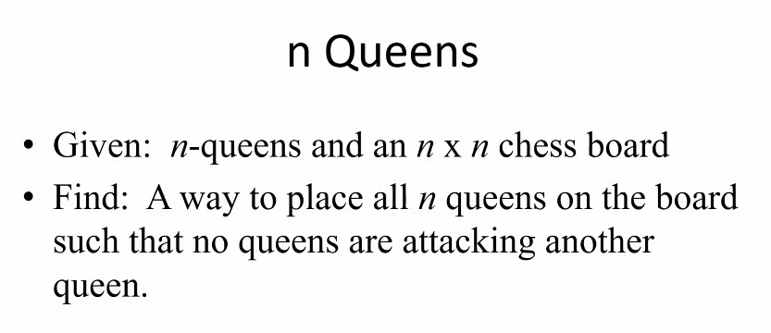
* 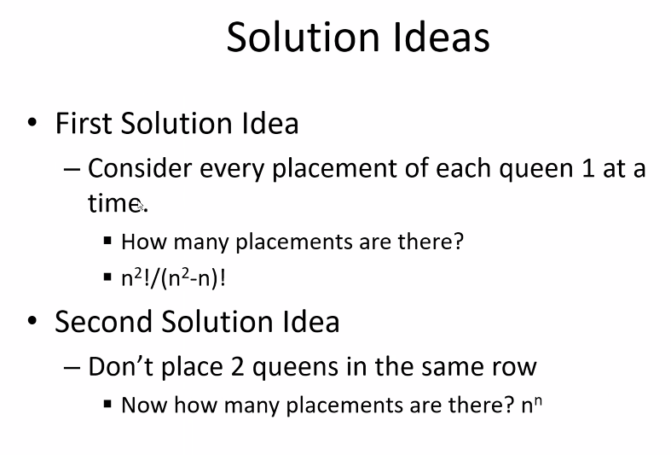
* 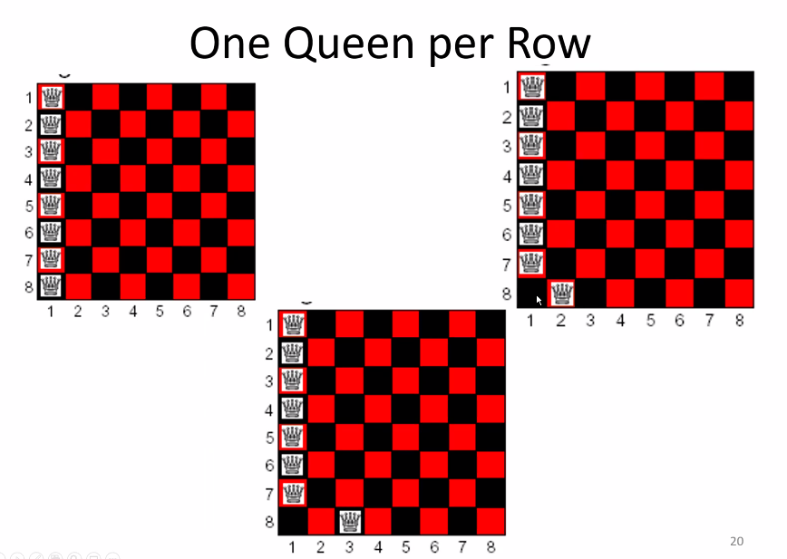
* 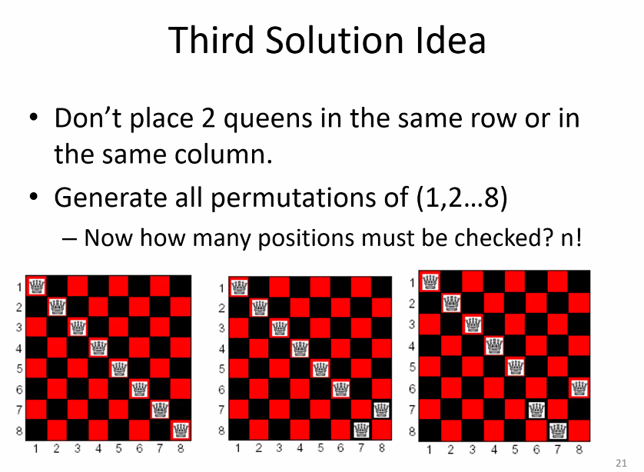
* 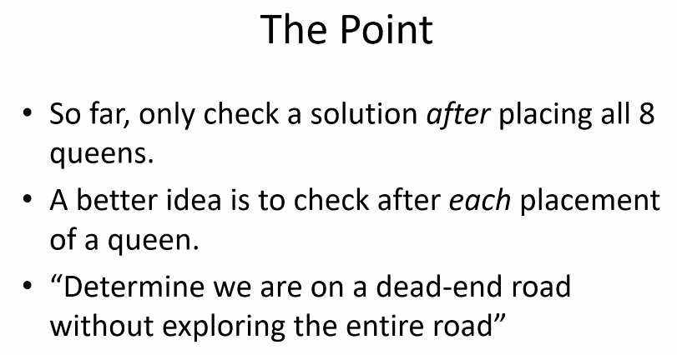
* Four queen problem
* 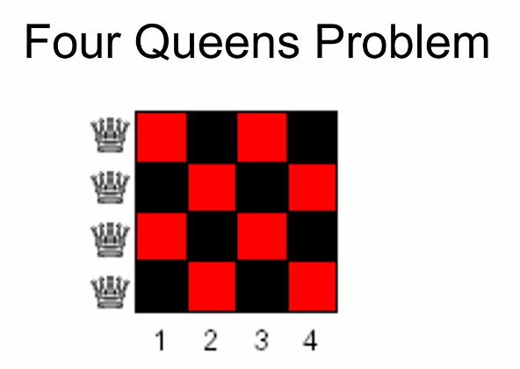
* 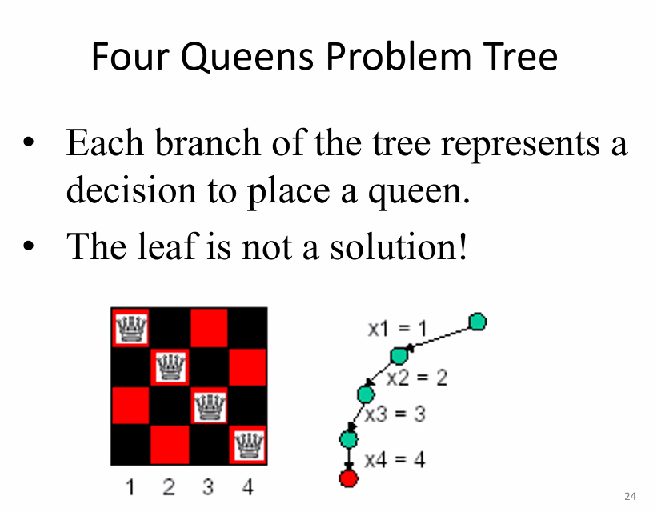
* 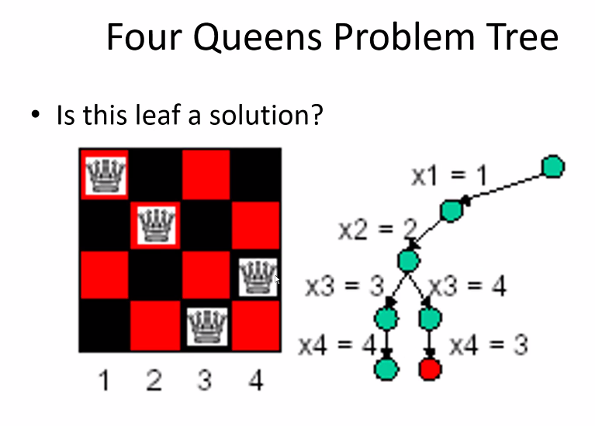
* 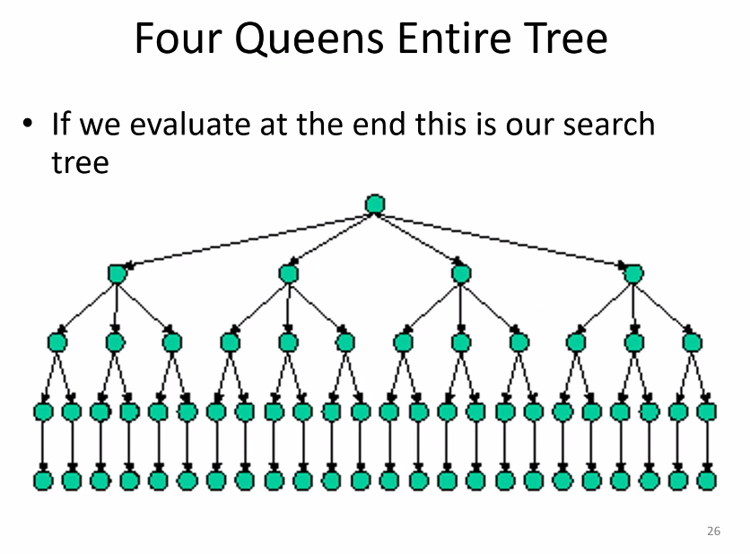
* Above is a state solution tree; shows all possible solutions
  + Of course if you traverse just the greatest depth, you would find a solution and could stop
* 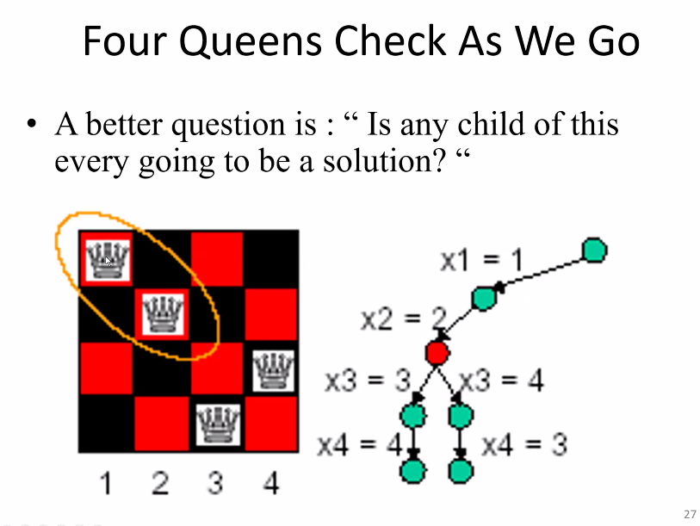
* Above there is a dead end, need to back track
* 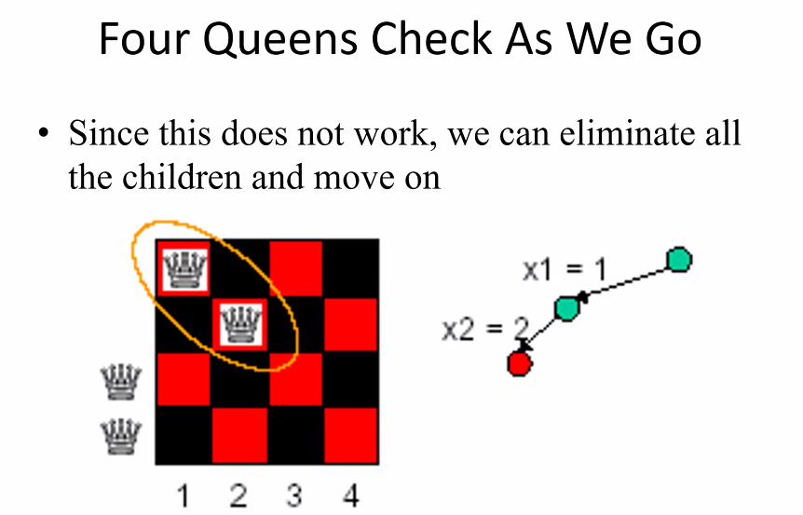
* 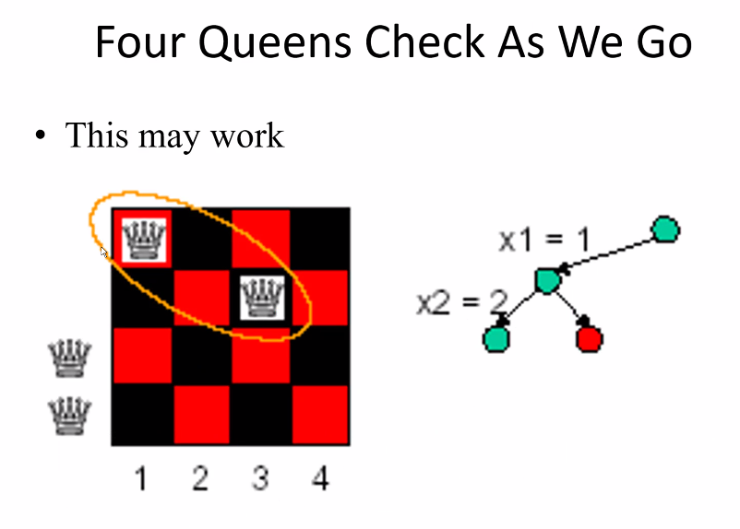
* 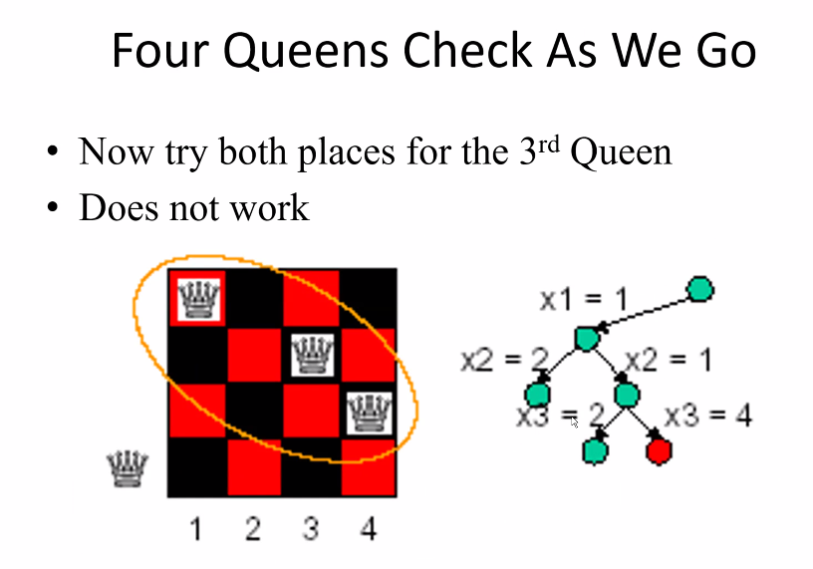
* 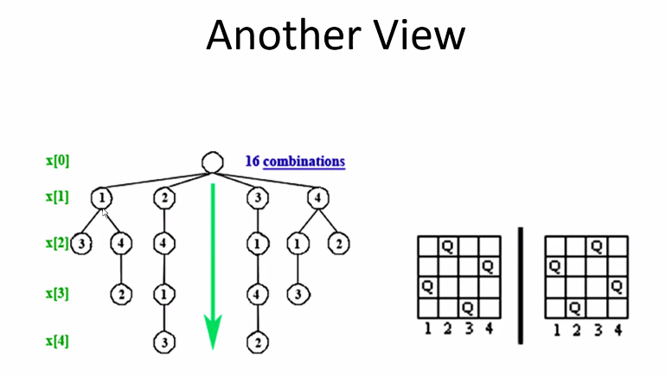
* Backtracking in general is always recursive in nature (recursive algorithm that typically does not do recursive calls because of memory issues – large call stack needed for high number of recursive calls especially for backtracking; this would eat up memory quickly); recursive calls works better for smaller data and with hardware specific for a certain task
* 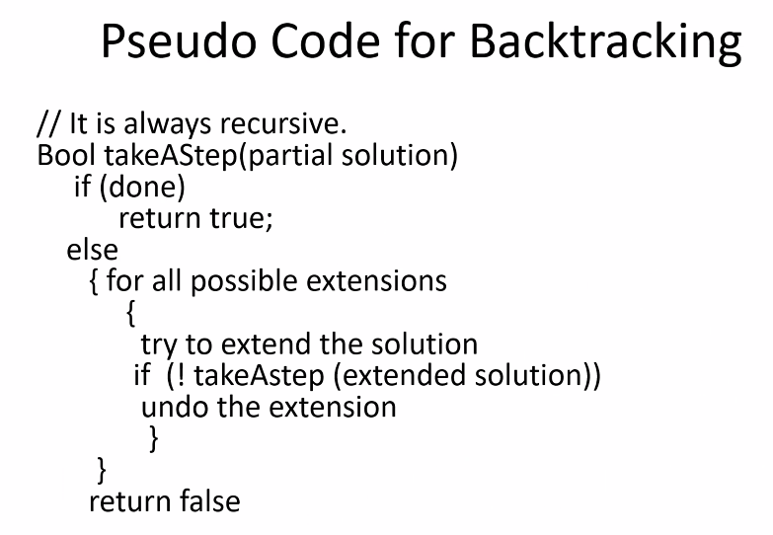
* 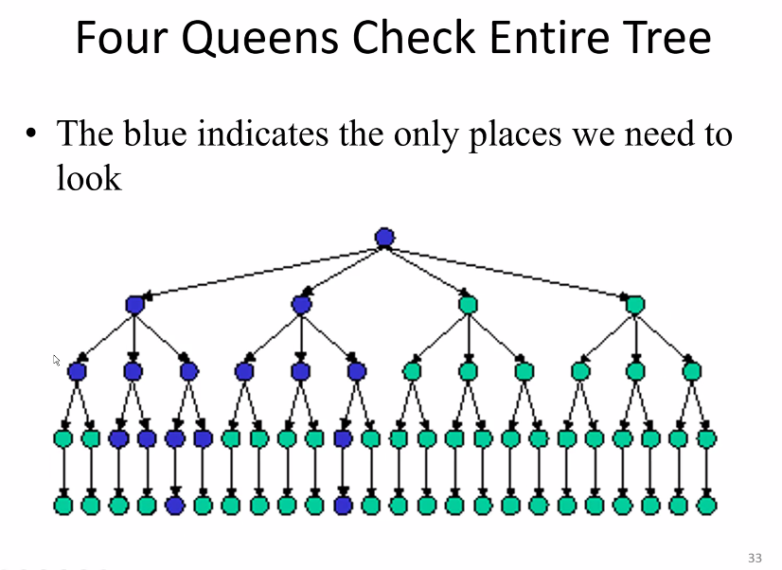
* Notice there was less work needed with backtracking
* Efficiency of backtracking:
* 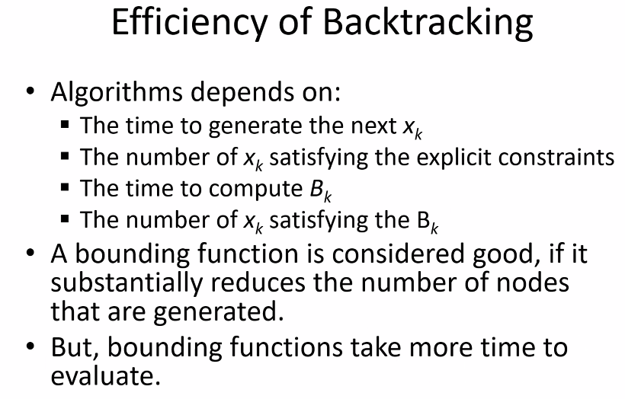
* Hamiltonian circuit problem:
* 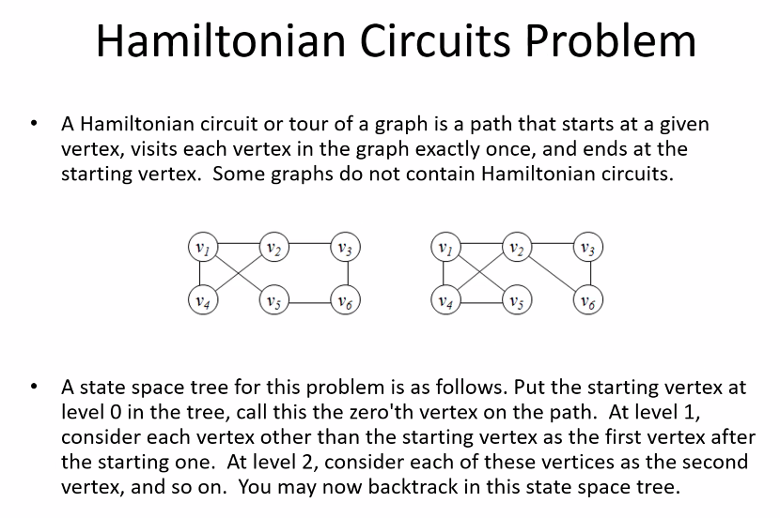
  + Think about depth first search; how you back track; consider the entire path including the back track path and as long as the path can finish at the start vertex, then we have a Hamiltonian circuit solution
* State space tree of a graph:
* 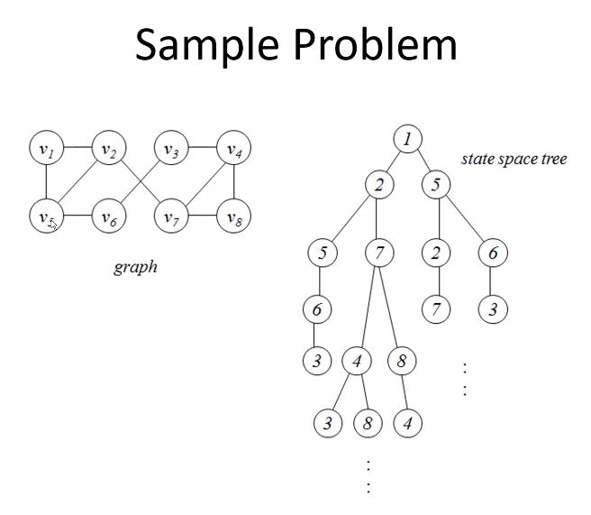
* Game trees:
* 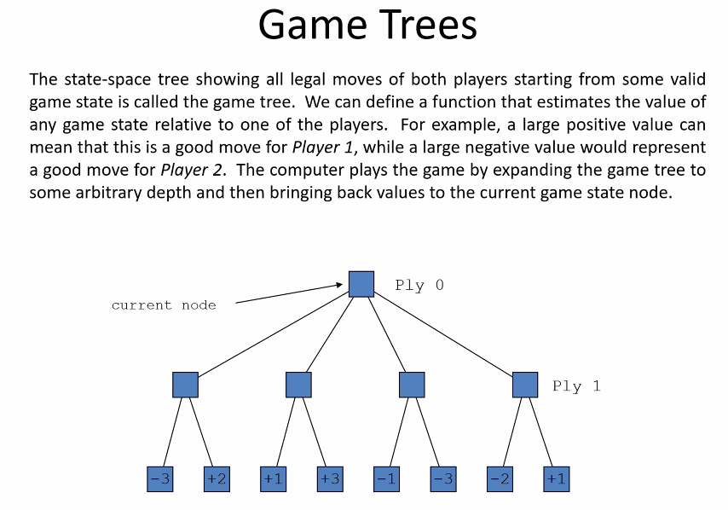
* 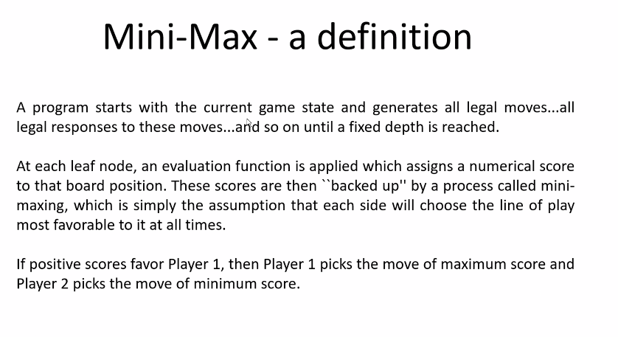
  + Can help determine next best move and final moves that players will make
  + Related directly to game theory
* 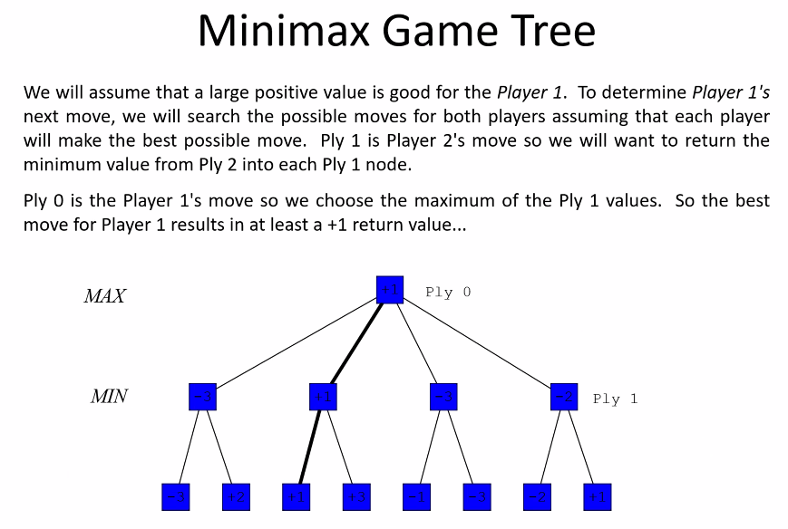
* Think about minMax theorem of game theory too
* Alpha beta pruning rule
* 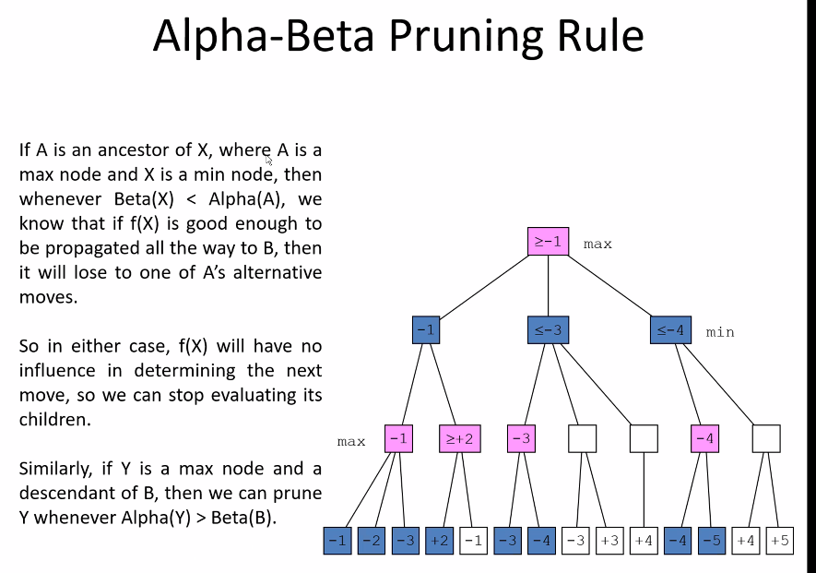
  + Concept: look at values and determine if something is <= to a value we already know, there is no sense in evaluating the rest of that path because we are looking for solutions that will give the best result

## Program 5

* Word search program that uses backtracking technique
* Print out found word or phrase and the start and end location of each word; and then print the entire grid, changing the found word or phrase to capitalized words
* Remember each word must be a straight line; part of the word cannot continue by going in a different direction; once direction is determined (by following the order in which you must search directions) the word must be completed in that direction
* Need also the grid with capital letters of found words for the output file too
* The back track is simple for this program: simply backtrack as necessary on a given row until you find another character that starts the currently searched word, or go back to the same first letter of searched work and check another direction (if no more direction, need to search for another letter that starts the word)
* Maybe use a bool array for each direction (for example: save time if in row 1 because case=false for searching up automatically)
* Remember if you are searching left and find a word, you know automatically you cannot search right, so ignore that case even though it is first in search sequence

# Lecture 22 – 8/5/21 – Sets continued

* Unions continued:
* 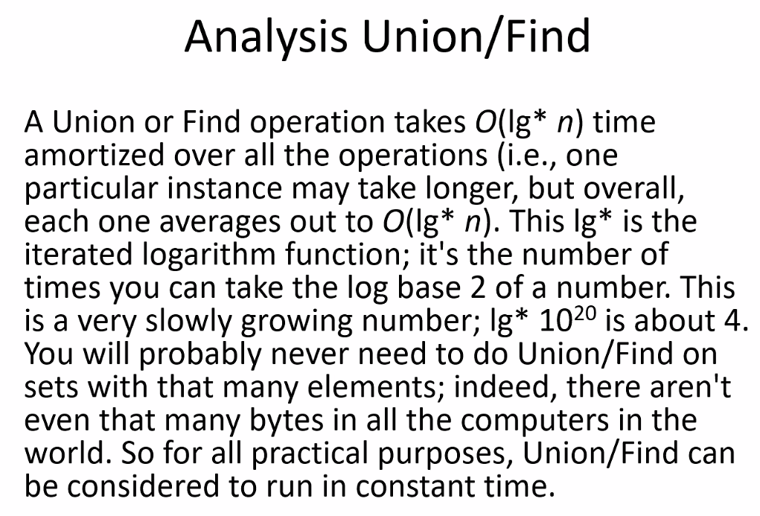
* 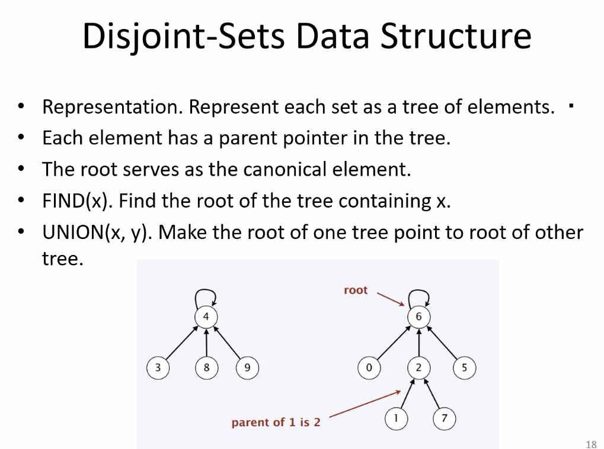
* Above, notice the tree is just as the examples shows for unions
* Union by size: how many elements are in the tree:
* 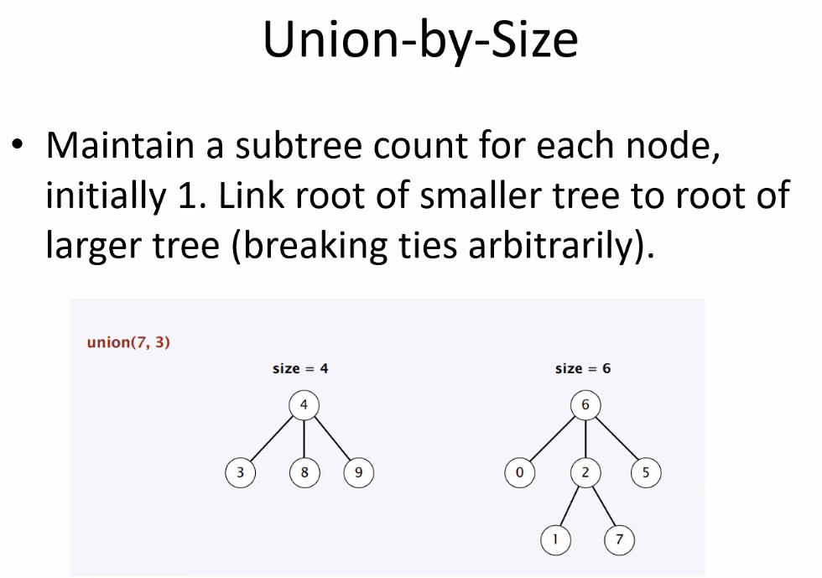
* 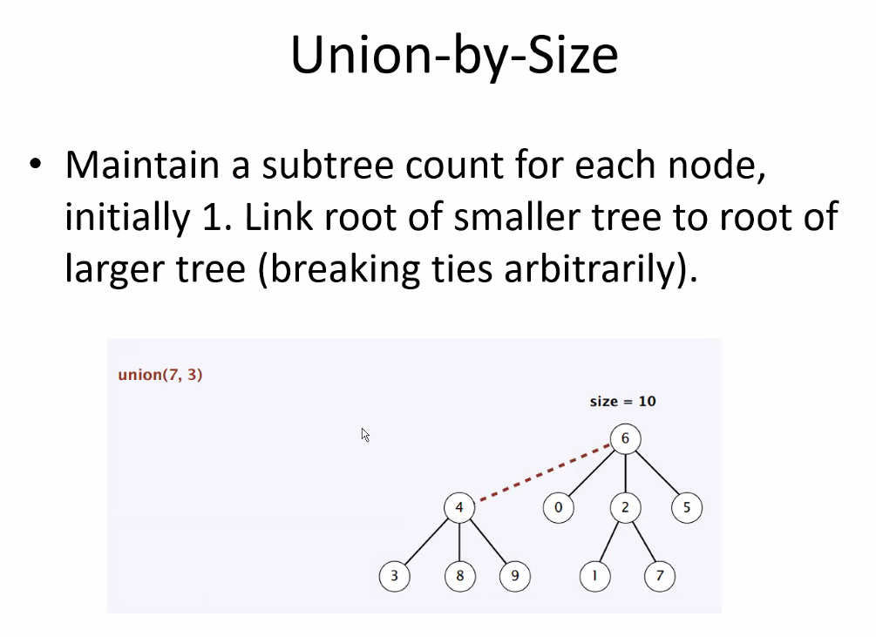
* Remember we link the larger to the smaller tree to minimize depth growth of the resulting tree
* Notice above union(7,3) means merge the sets to which both of those elements belong
* 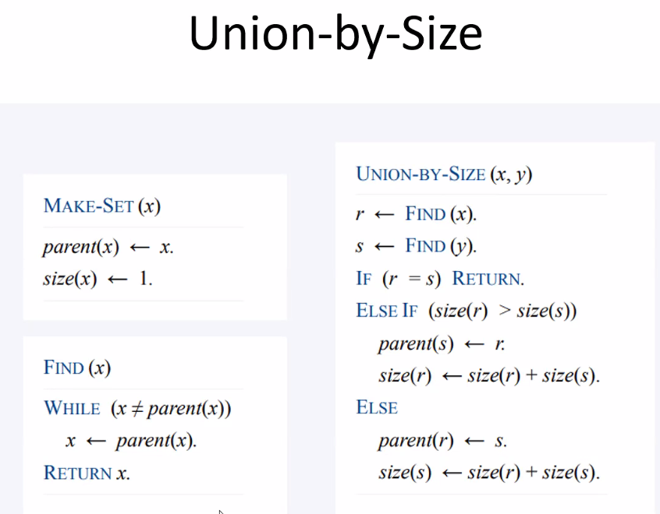
* If r ==s (return; they are already in the same set)
* 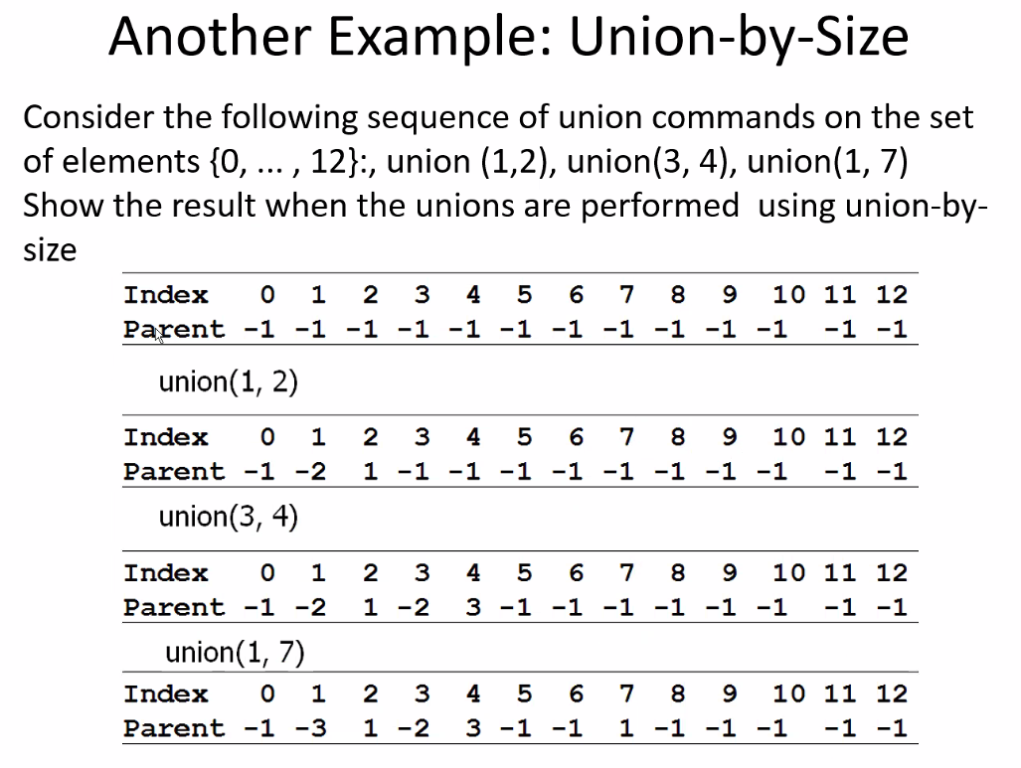
* Negative number after parent row tells us that it is a parent/representative/root of a set and tells us the number of elements in the set
* Remember as an example: union(1,7), we merge the smaller set (7) to the larger set (1)
  + This reduces depth
* Above, using the positive and negative numbers to represent nodes/sets/roots/number of nodes in a set, is how we actually implement Unions-by-size in a computer program
* You would use mappings of whatever data you have to a given set of numbers to build the tree and represent sets
* 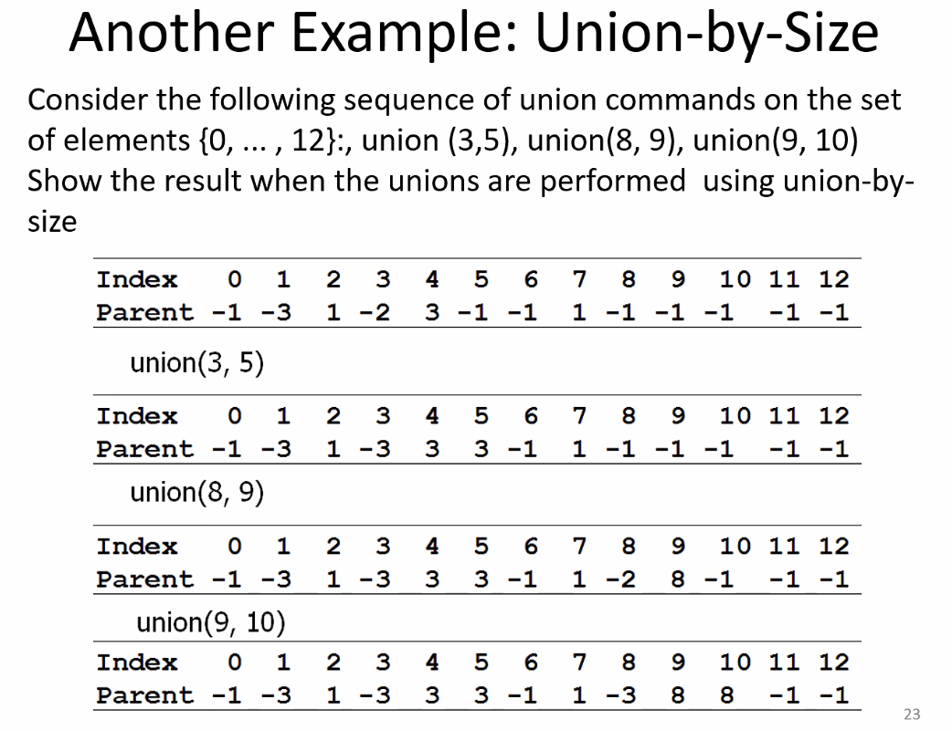
* Remember: negative value indicates that a node is a root/parent/rep of a set, and the magnitude of that negative value represents the number of elements in that set/tree
* Notice for union(9,10), root for 10 is 10 (-1), root for 9 is 8 (-2), since magnitude of 8 root is 2 versus 10 at magnitude 1, then merge smaller to larger; merge 10 into 8.
* 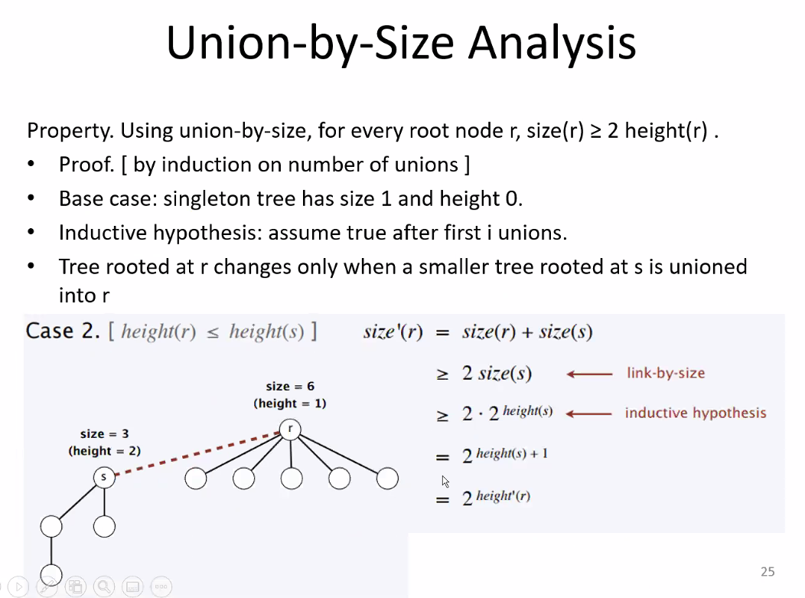
* 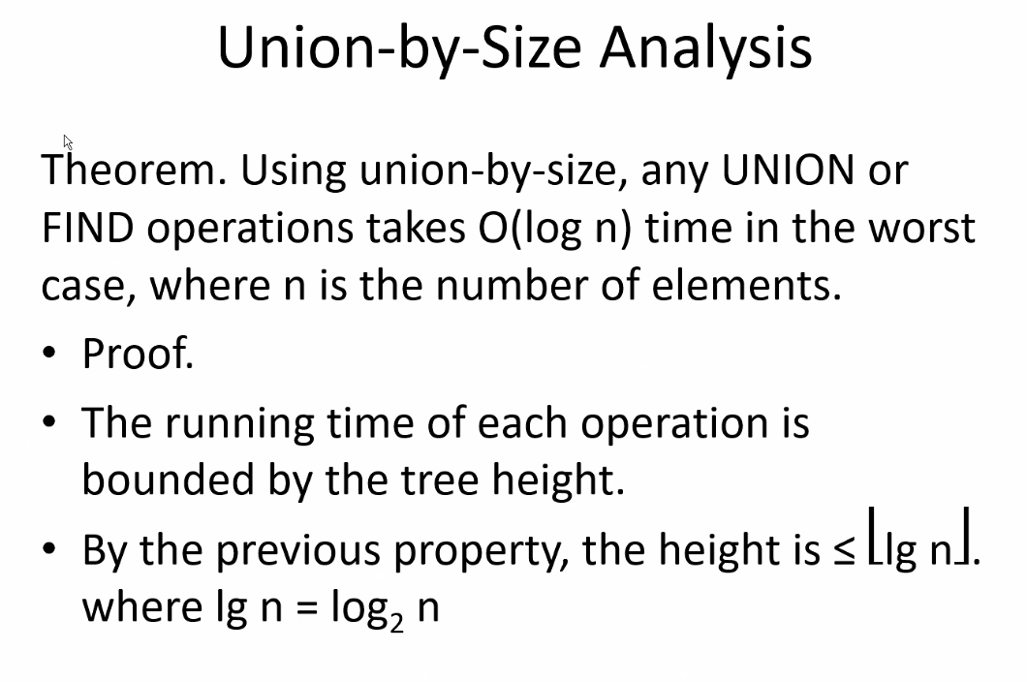
* Height <= the floor of logn

## Equivalence Relations with Unions/Sets (main difference: do not check sizes like normal union class; union (x,y), y becomes child of x automatically)

* 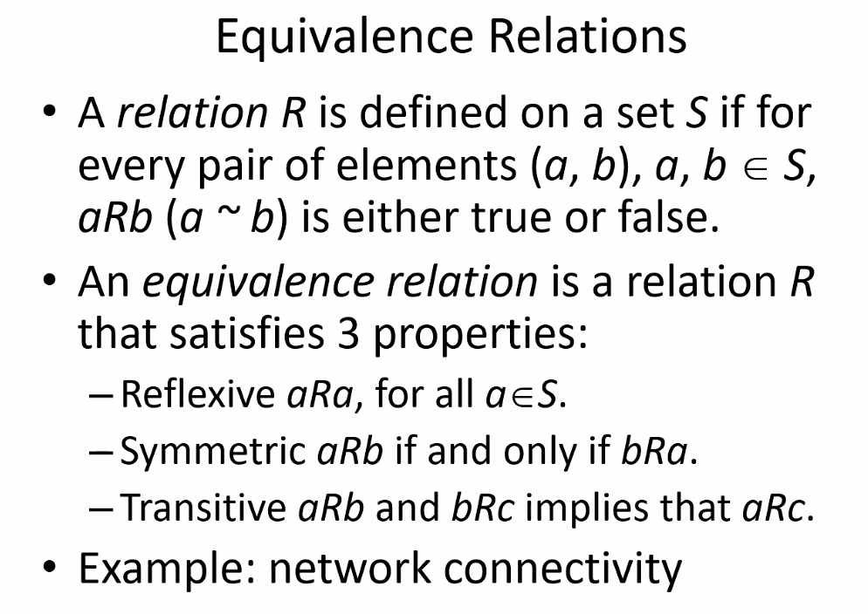
* 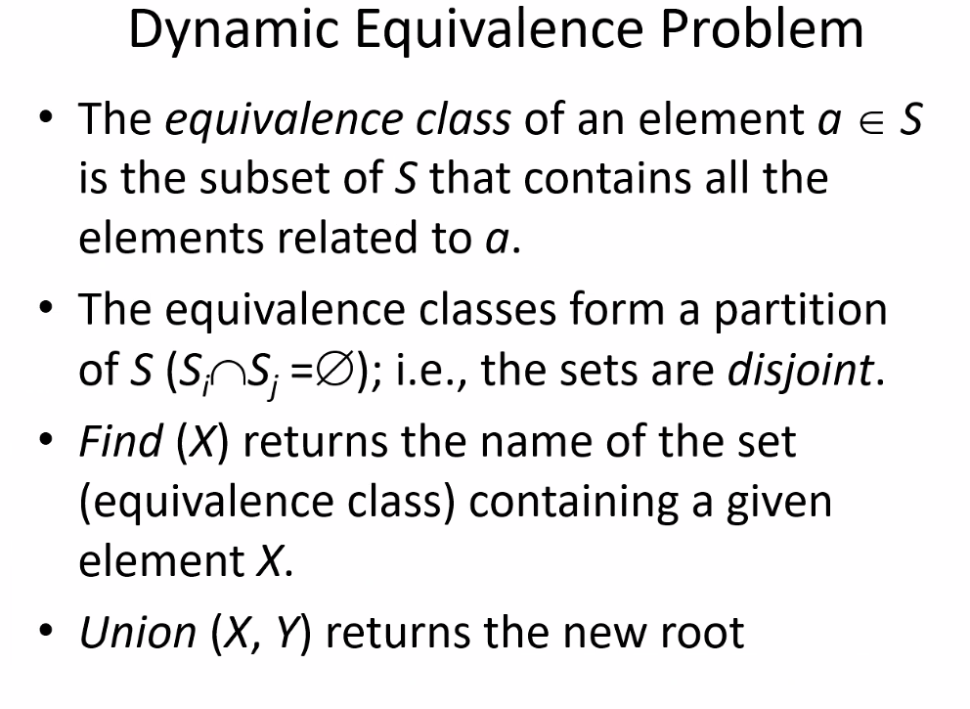
* Remember if two classes/sets do not intersect, then they are thusly disjoint
* Above is exactly basically how unions work
* 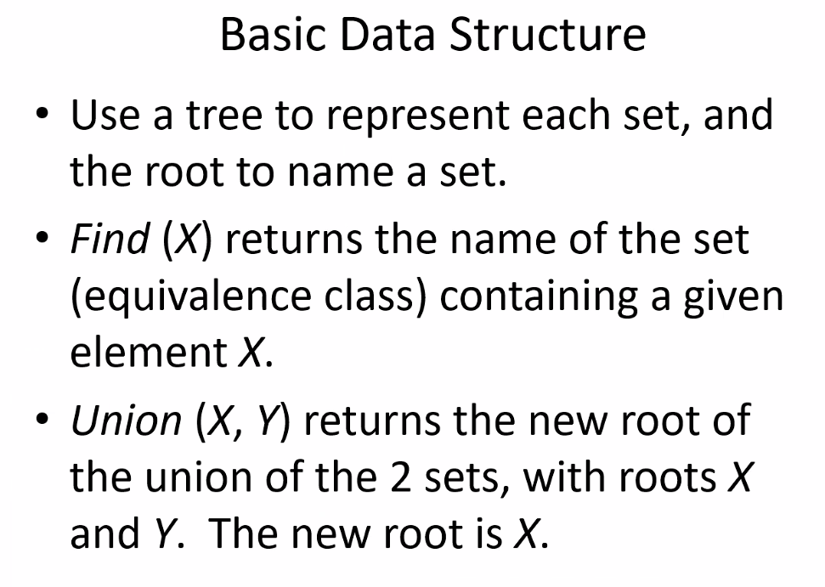
* 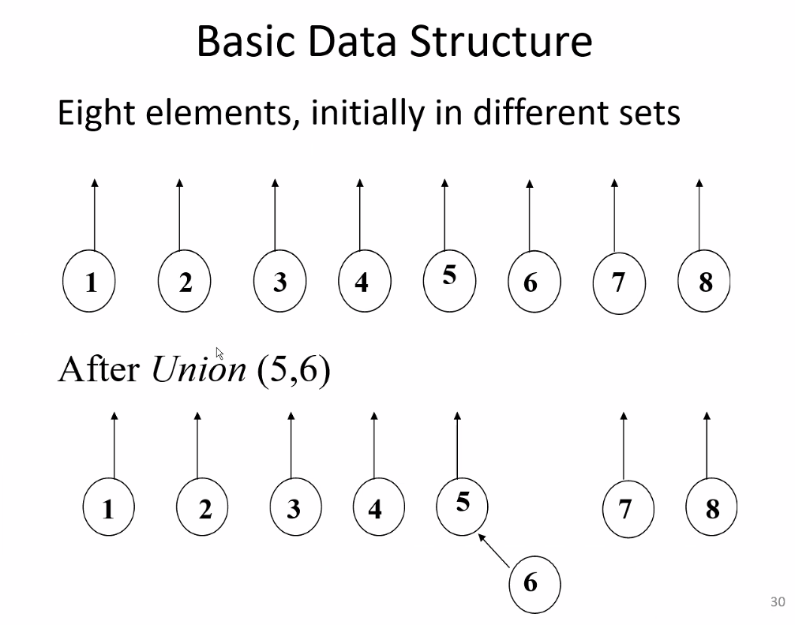
* 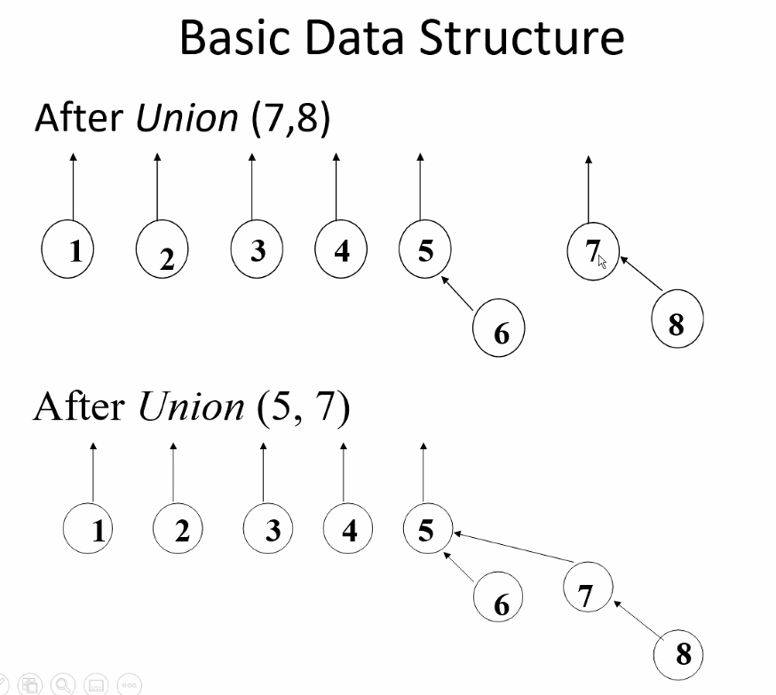
* 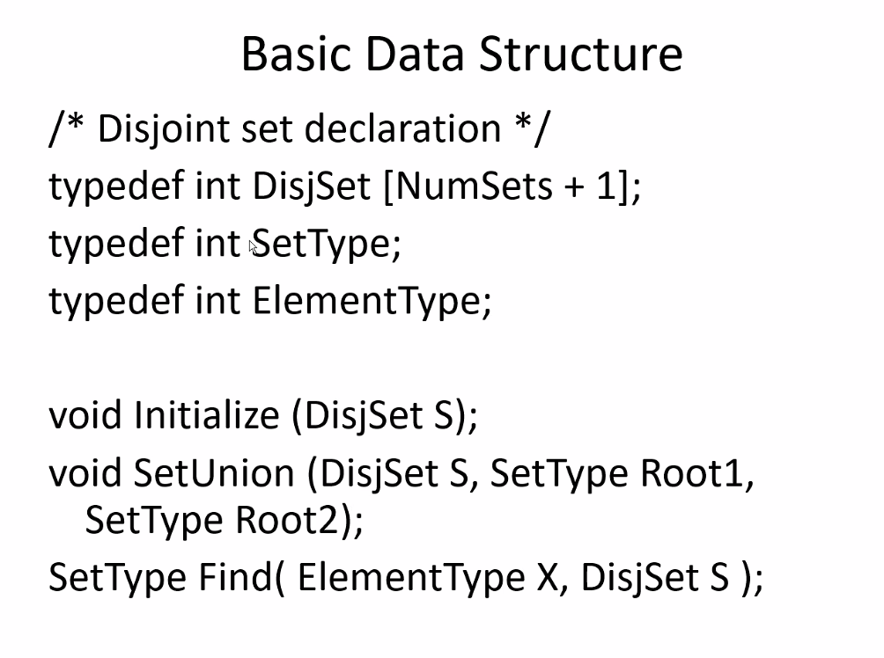
* 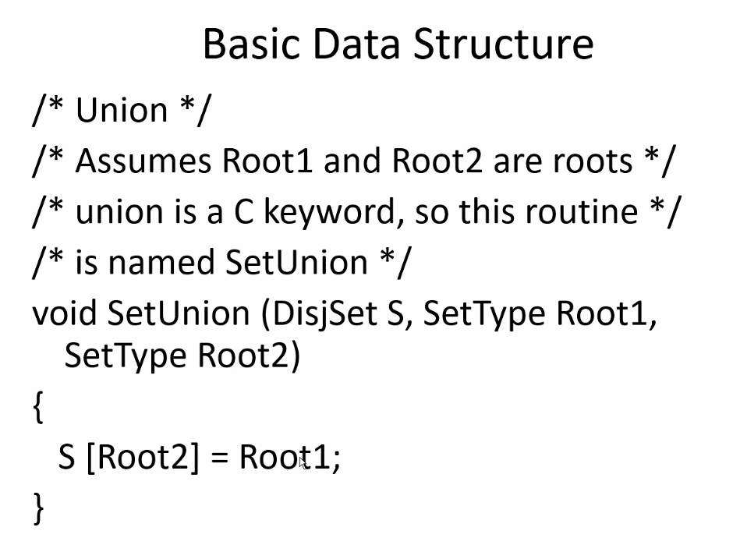
* 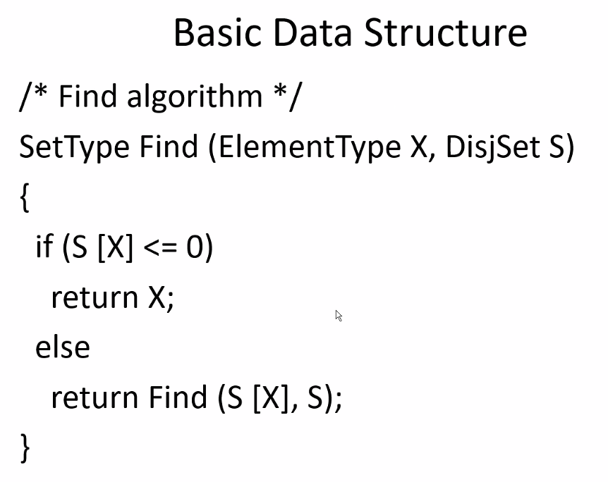
* 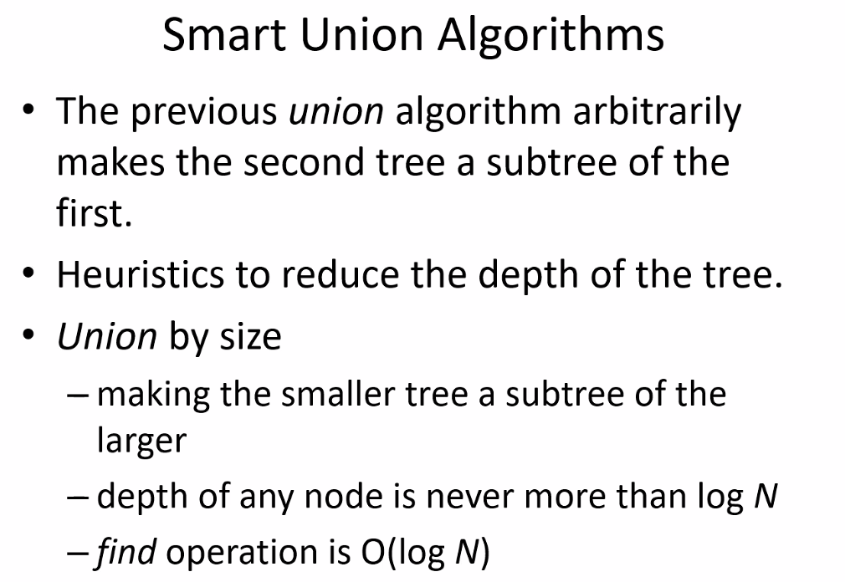
* Equivalence relations: different names of the same group; thus the relationship between the “different groups” will be equivalent.
  + Example: CIS 350 and CIS 3501
* Use equivalence class where unions take place without checking set sizes only depending on the data/how often you will have to union sets..etc…depends on the situation; we can avoid the extra work/space in tracking size of each union and making extra union steps if plausible
* Below is example again of using union by size again, which minimizes tree depth:
* 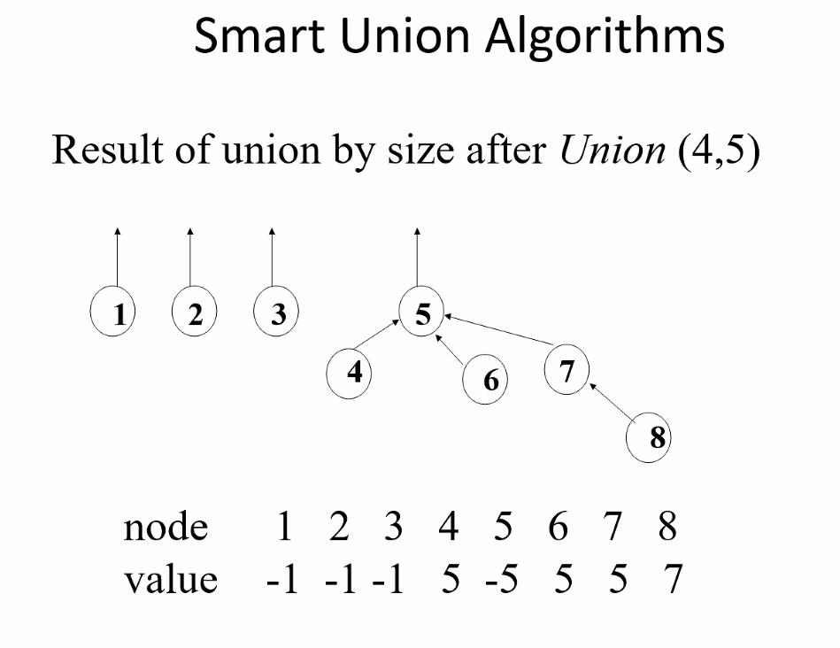
* Now again, an example of equivalence class union:
* 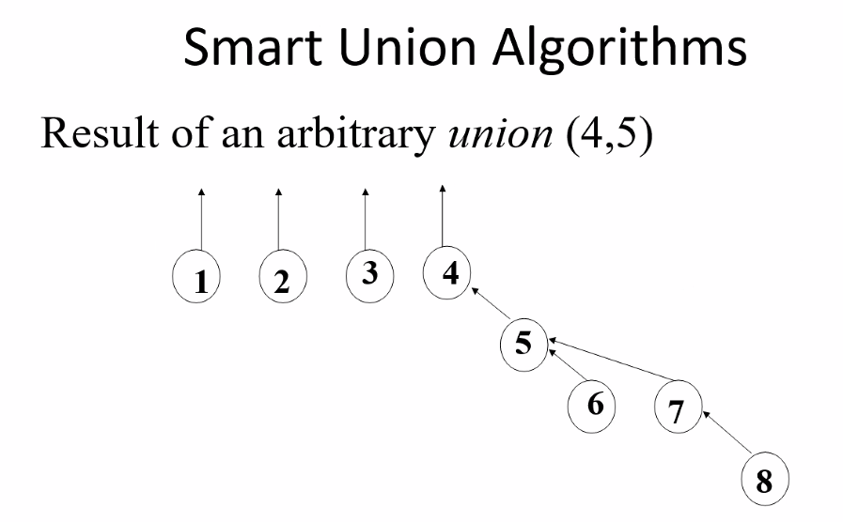
* Notice depth is increased more and is not minimized as size is not maintained/checked
* Union by height
* 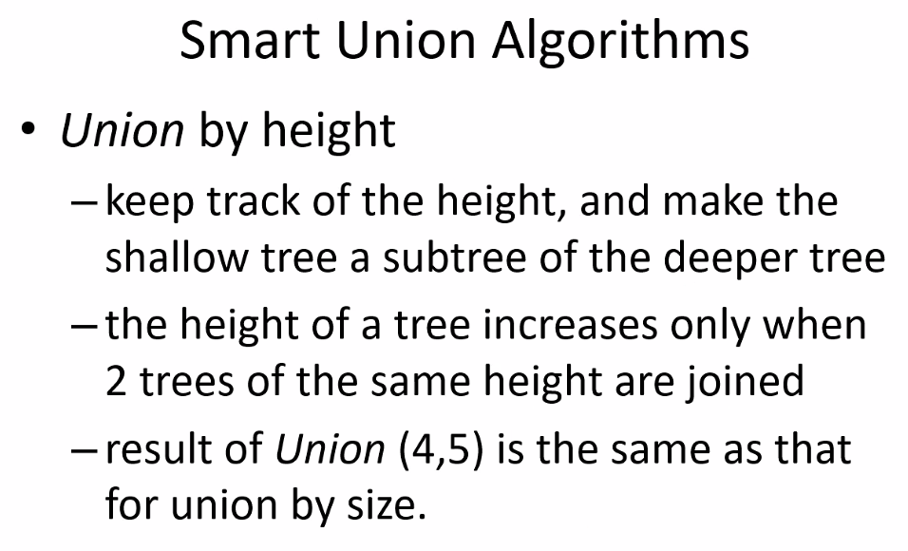
* 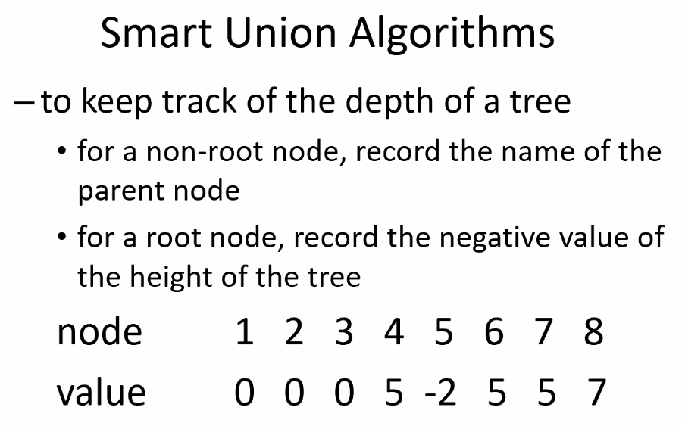
* Value now refers to height of the tree, (0 or negative value, magnitude of negative value tells you depth of tree, 0 refers to only the root/1 element in the tree), positive values refers to where a given node is pointing to
* 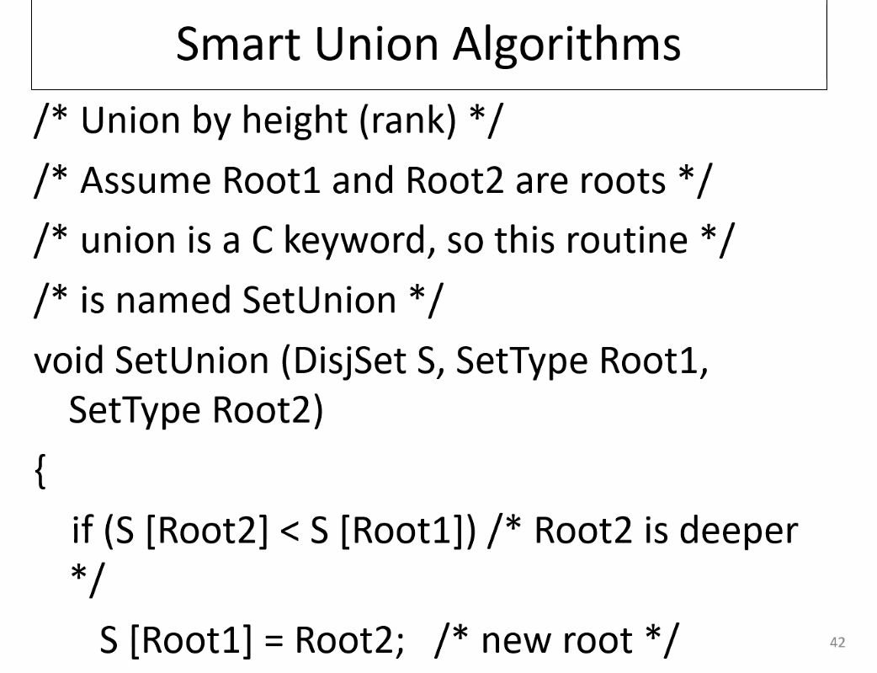
* 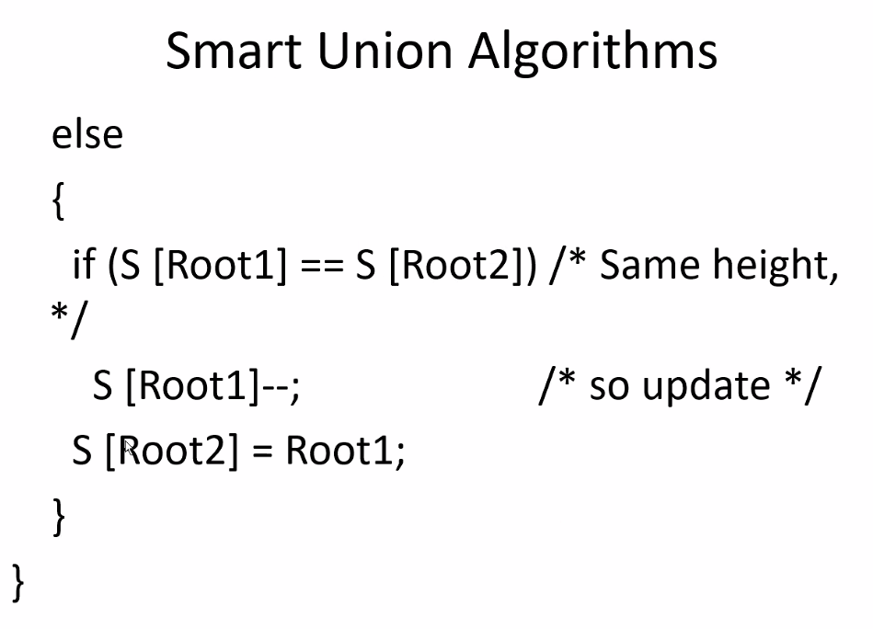
* Path compression
* 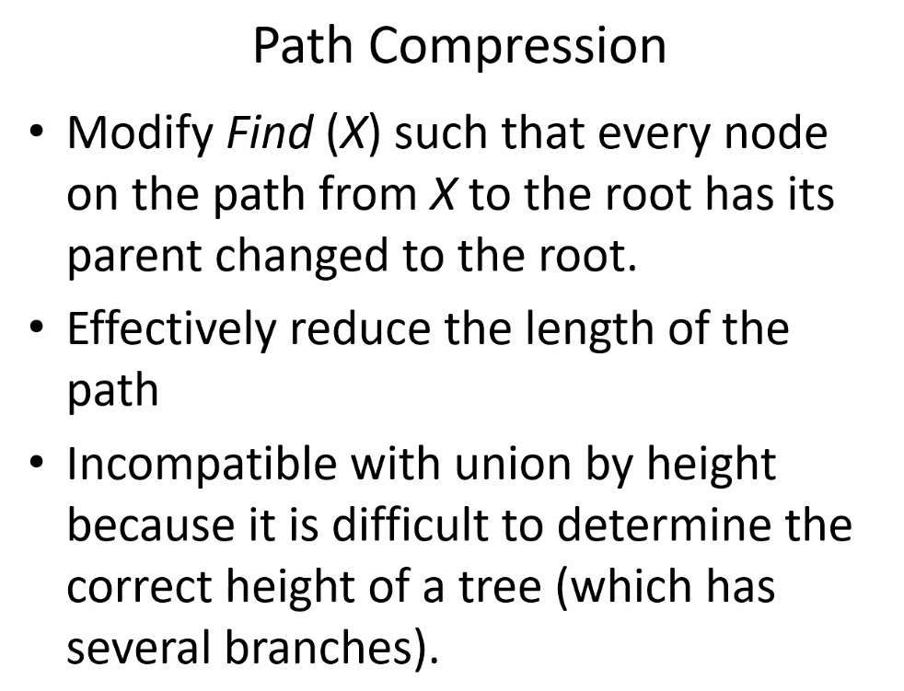
* Path reduction is good so that next time that path is traversed it is reduced
* 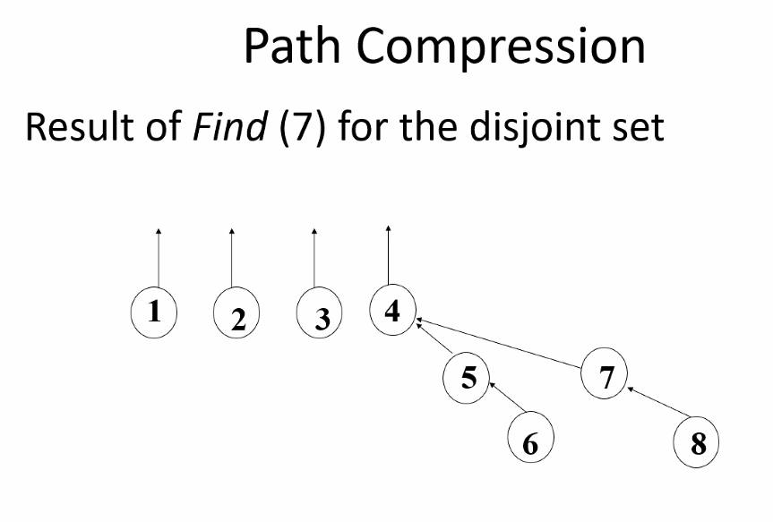
* 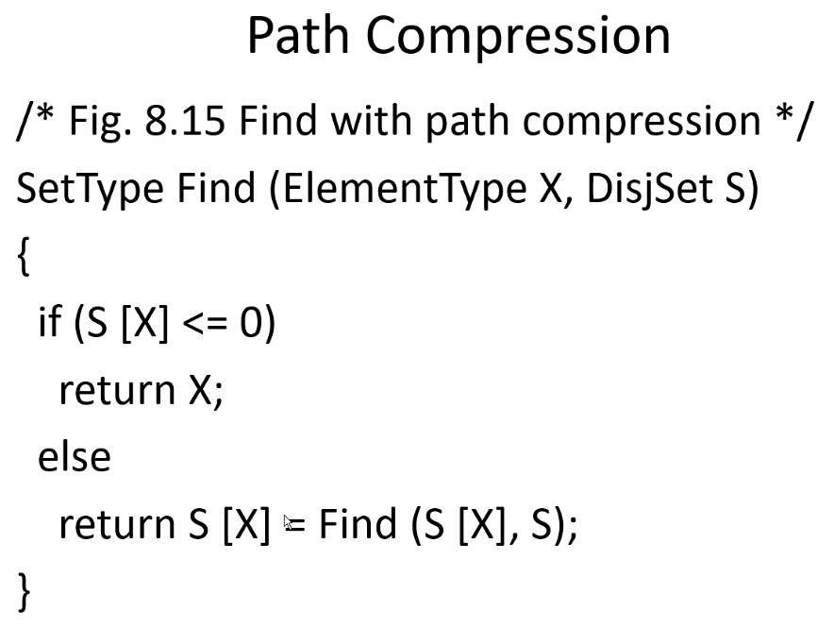
* All of these Union concepts are similar to Melding; we meld trees ( which are essentially just sets) similarly
* We just call it unions because of mathematics and set theory, but the processes and concepts are essentially equivalent, just unions deal specifically with sets/classes and not just arbitrary trees that don’t necessarily represent a set/class

## Algorithms

* 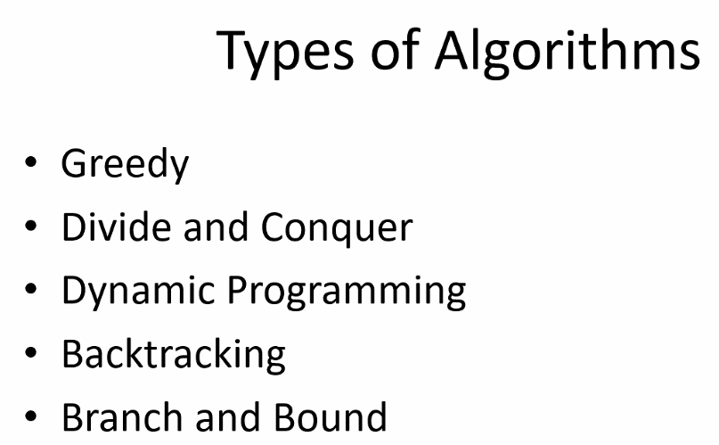
* Brute Force algorithms should be in that list as well

### Greedy Algorithms:

* 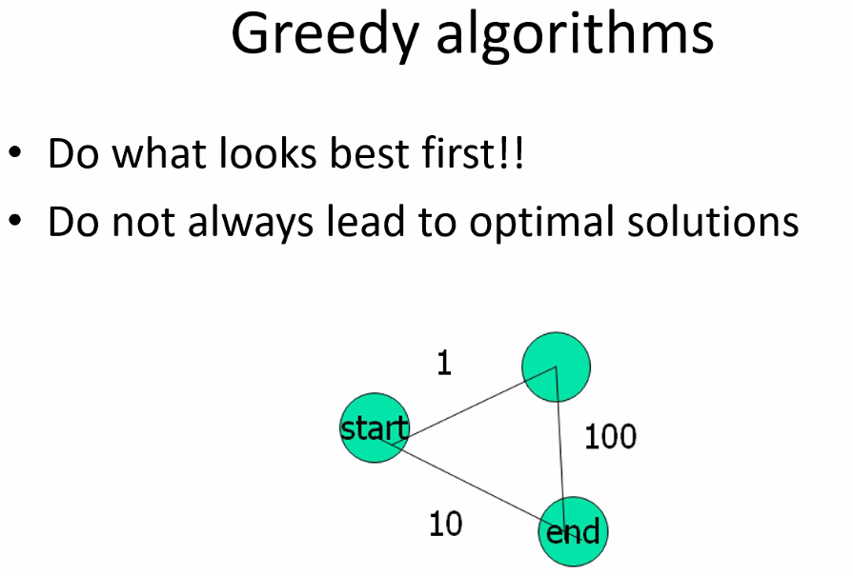
* Is there a way to write a selection algorithm?: an algorithm that can determine which algorithm to select to solve a given problem
* 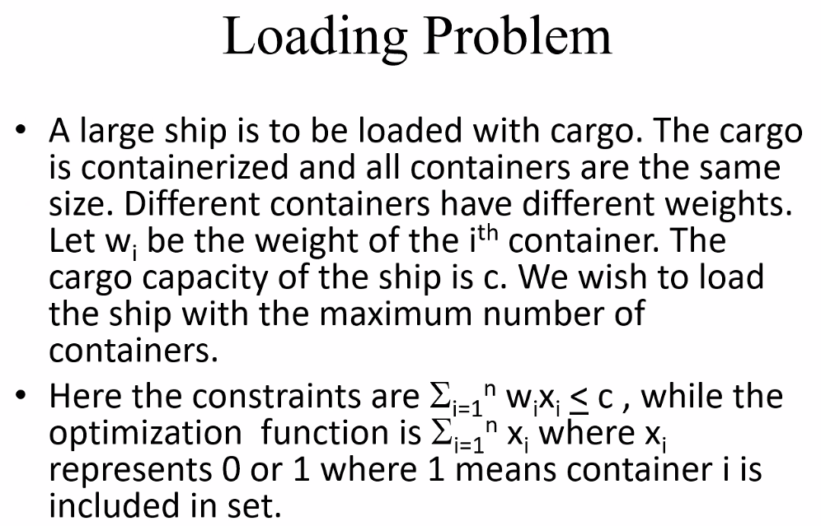
* 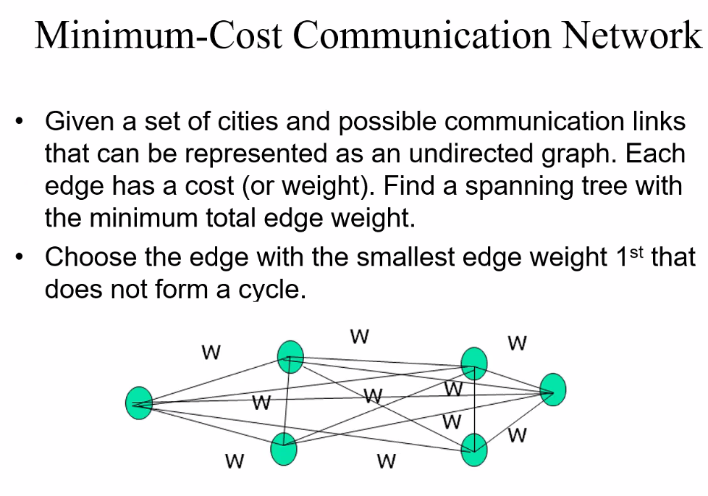
* 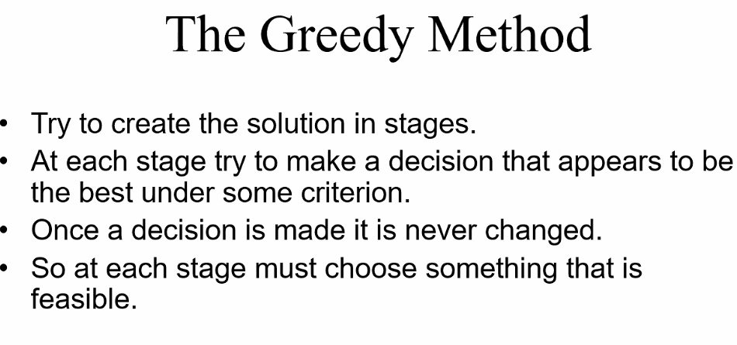
* 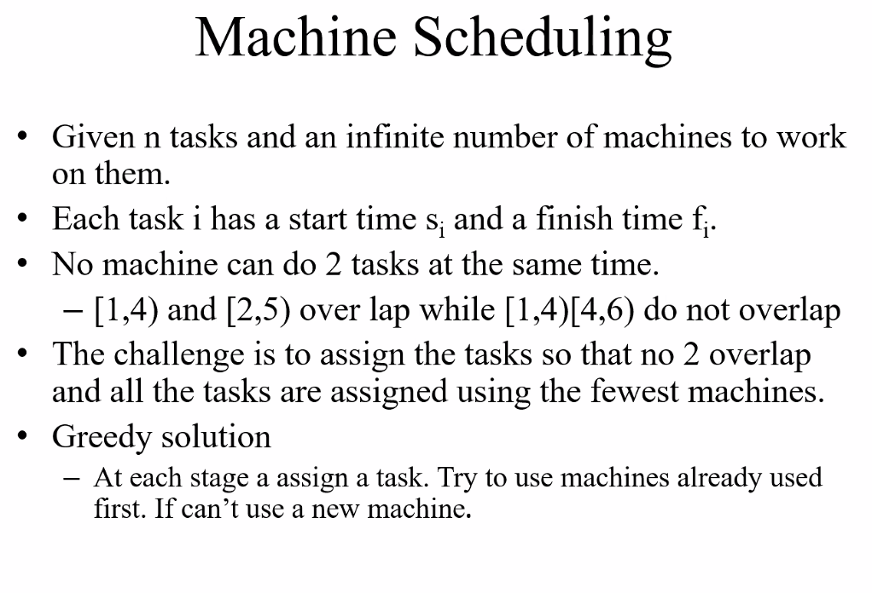
* 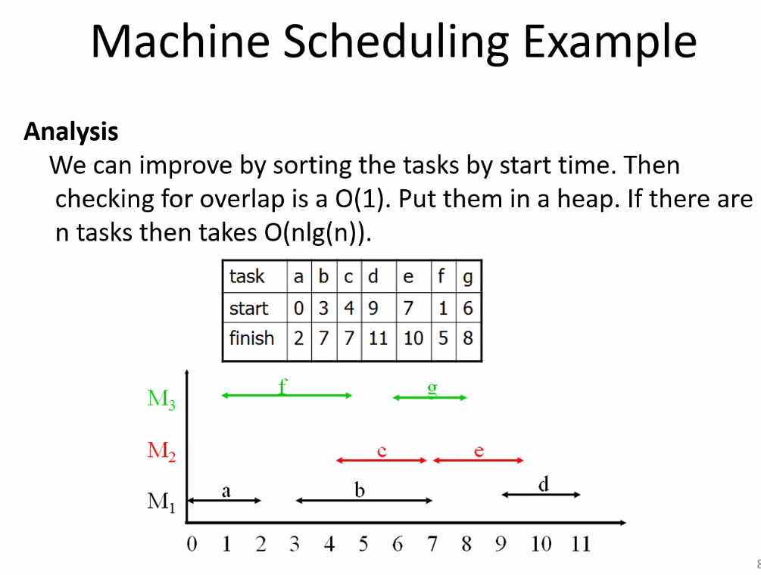
* 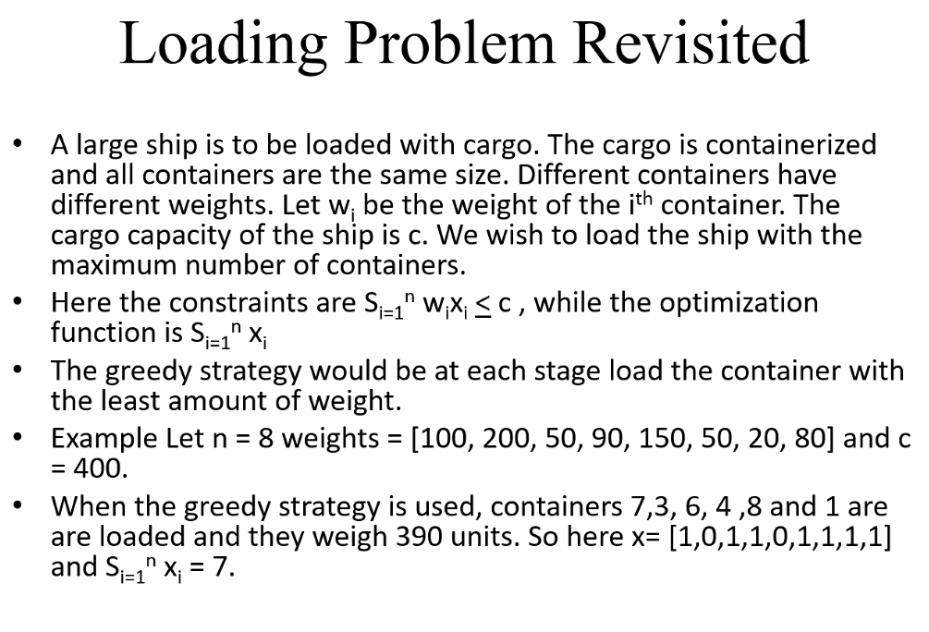
* 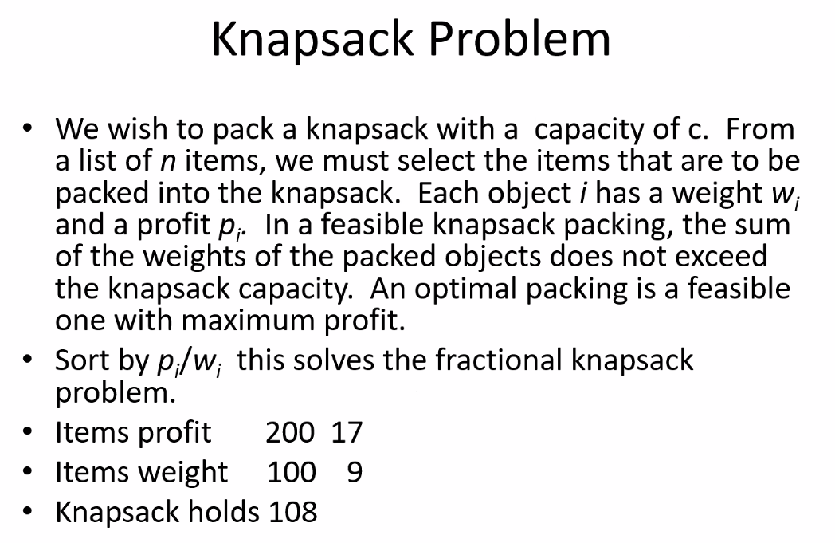
* 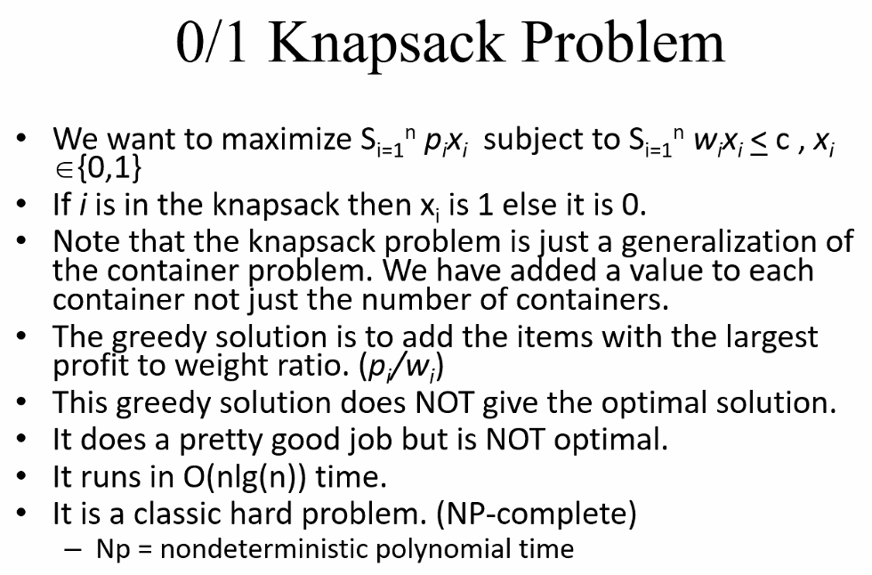
* NP-complete problem!
* In real world, a close enough optimal solution is usually good enough
* 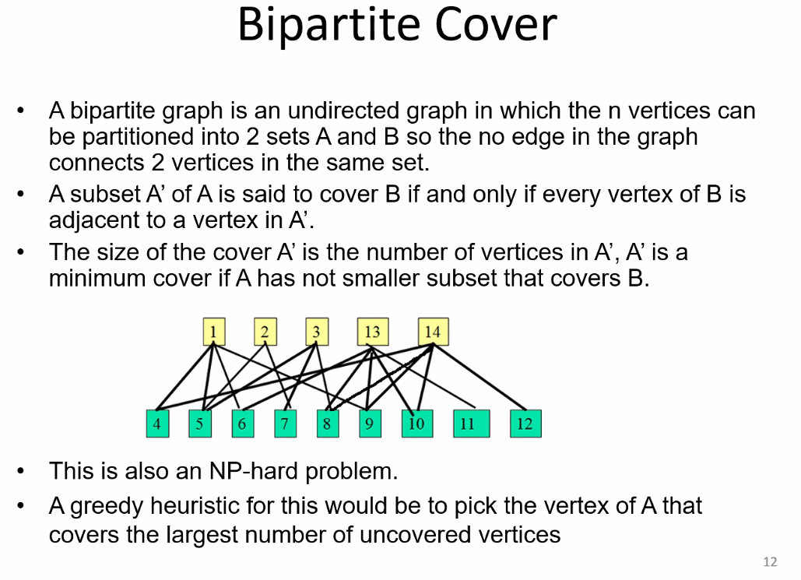
* Another NP-hard problem!
* 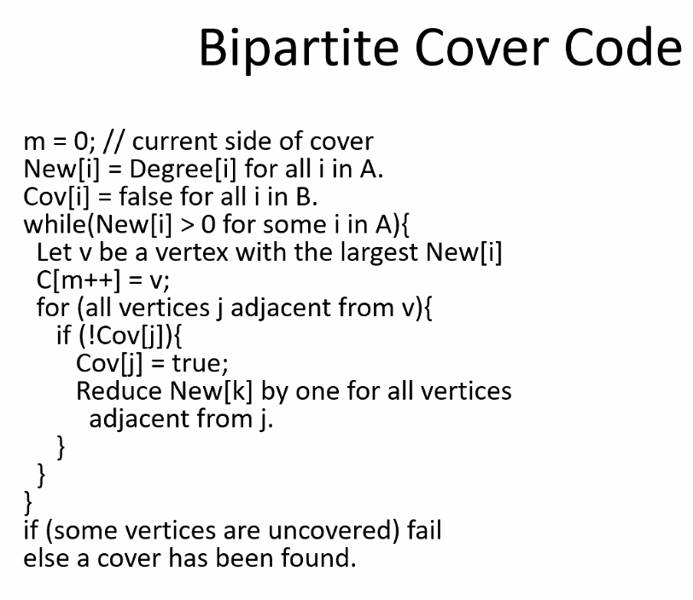
* 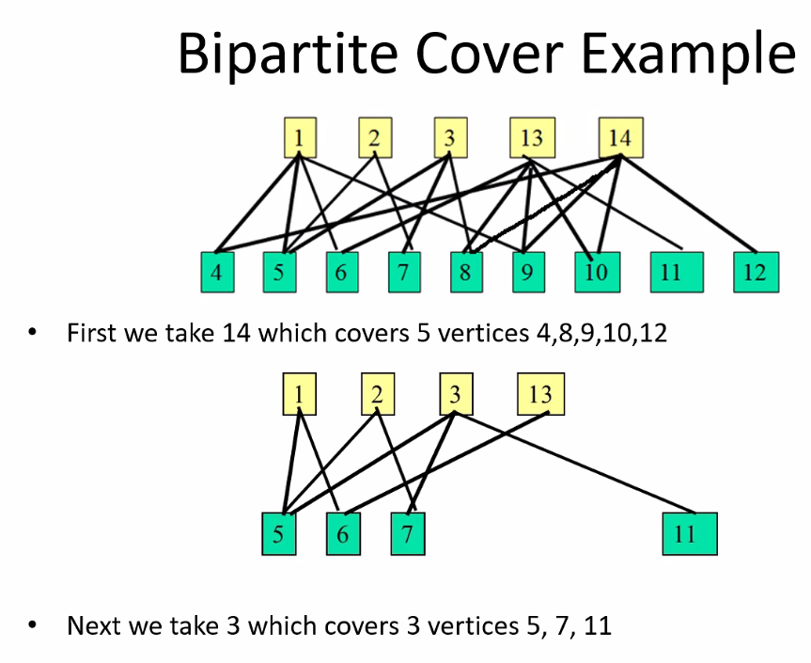
* 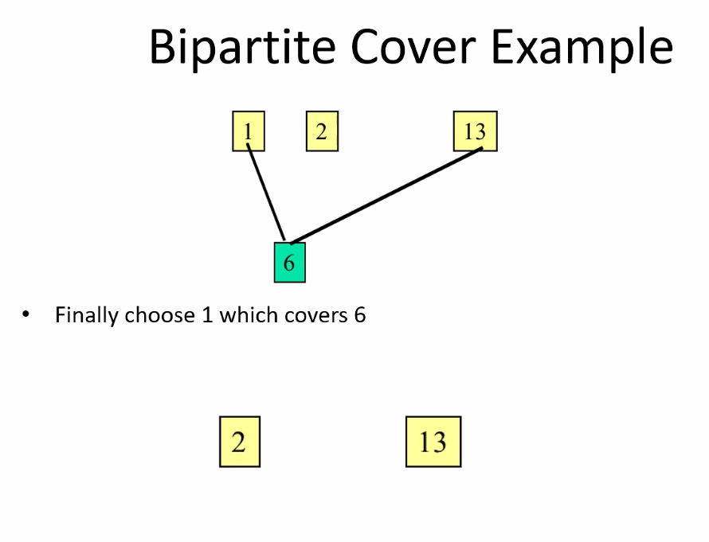
* Once we find vertices that covers all the nodes we need, we can discard/ignore all other root vertices
* 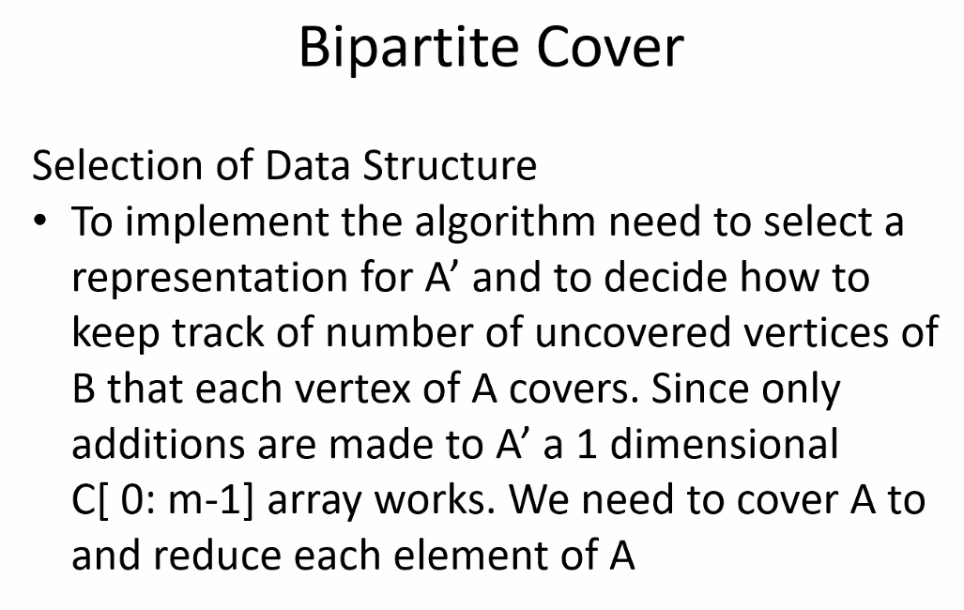
* 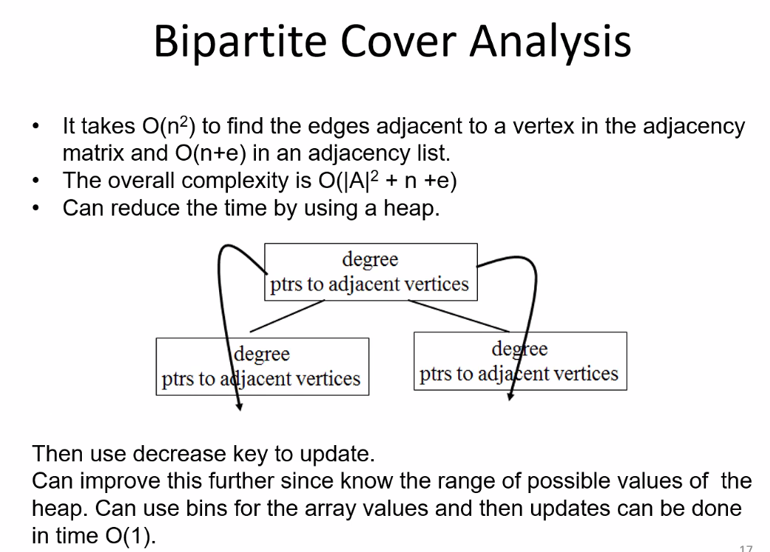
* Remember earlier learning about heaps and using keys
* Bin Packing
* 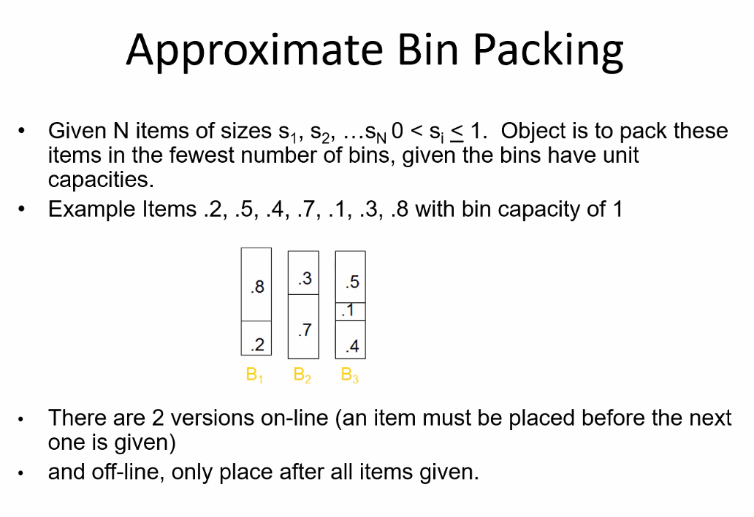
* 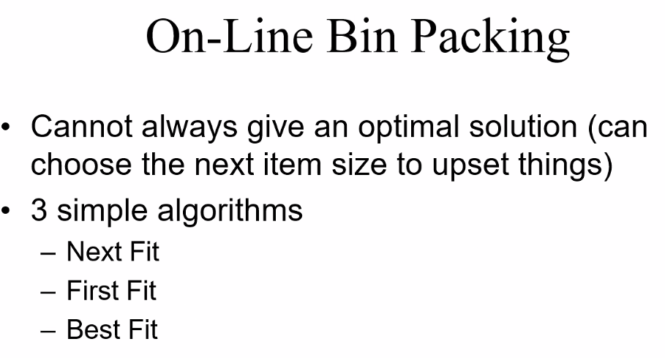
* 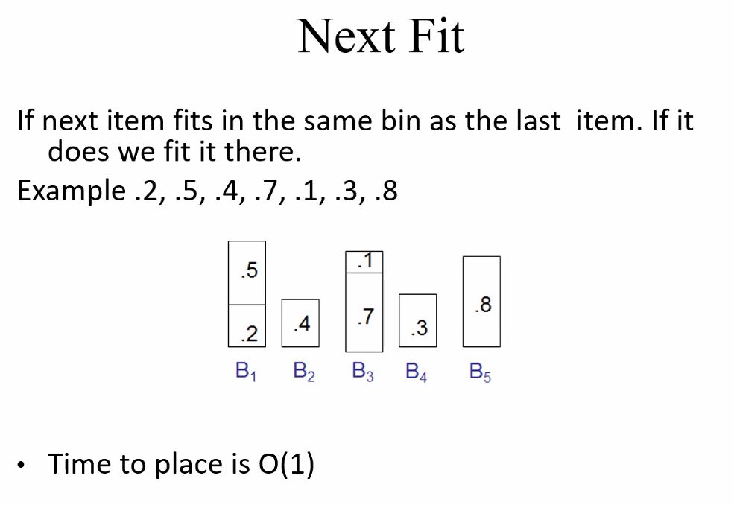
  + Note you don’t go backwards (that’s why its called next fit); once you move on to the next bin you have to consider that bin and add and if it doesn’t fit then you add it to next bin
* 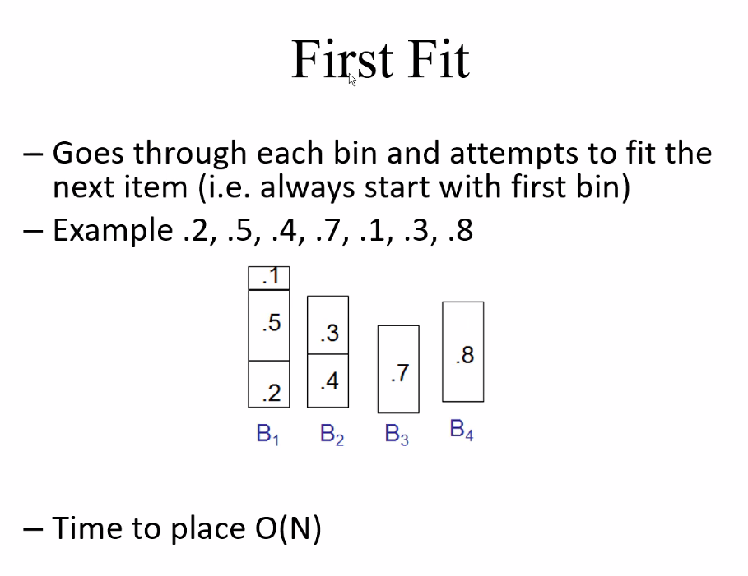
* The polynomial for placing will simplify to O(N)
* 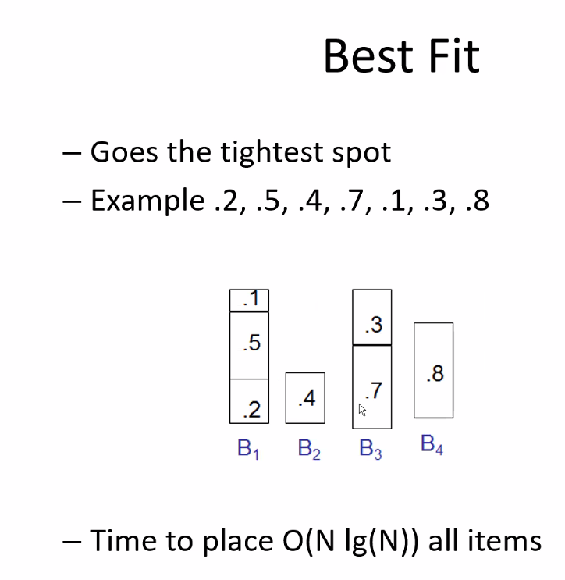
* Of course because of all of the checking, time complexity is greatest for placement in this algorithm
* 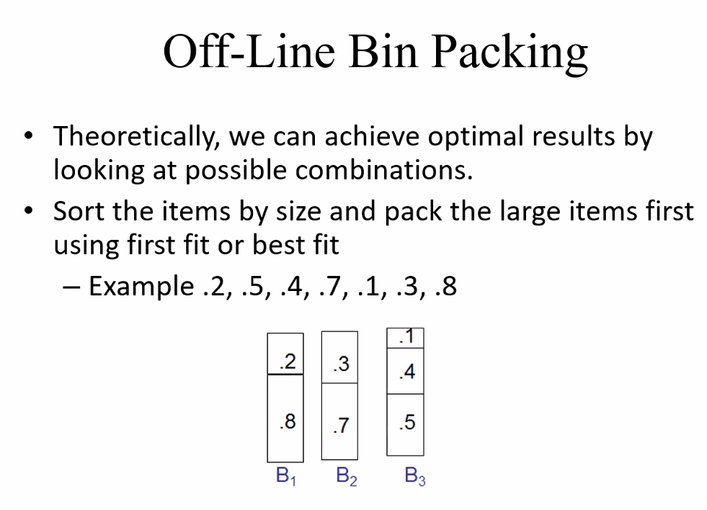
* 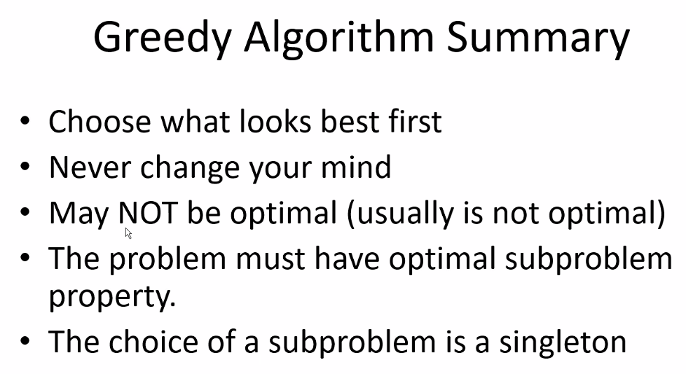
* Overall, we use greedy algorithms A LOT because they are easiest to implement and offer good enough solutions often

# Lecture 23 – 8/10/21 – Algorithms Cont’d

## Divide and conquer algorithm

* 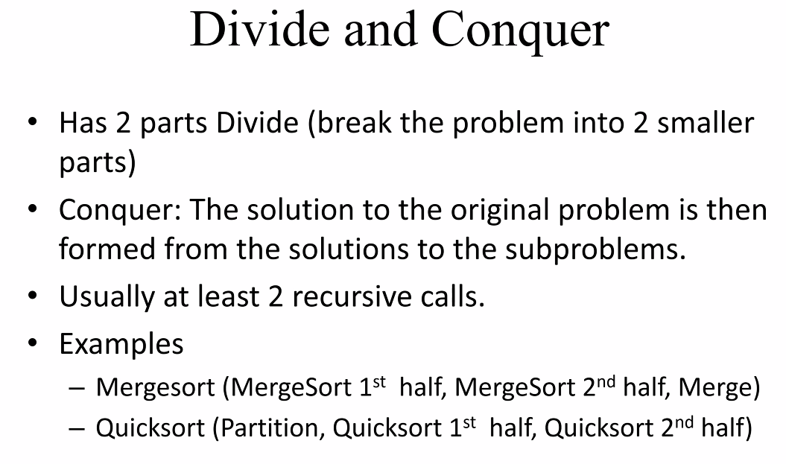
  + This does not mean that recursive calls has to be used; but the algorithm will usually be recursive in logic nature
  + Merge and quick sort however do usually use recursive calls
* Masters Theorem
* 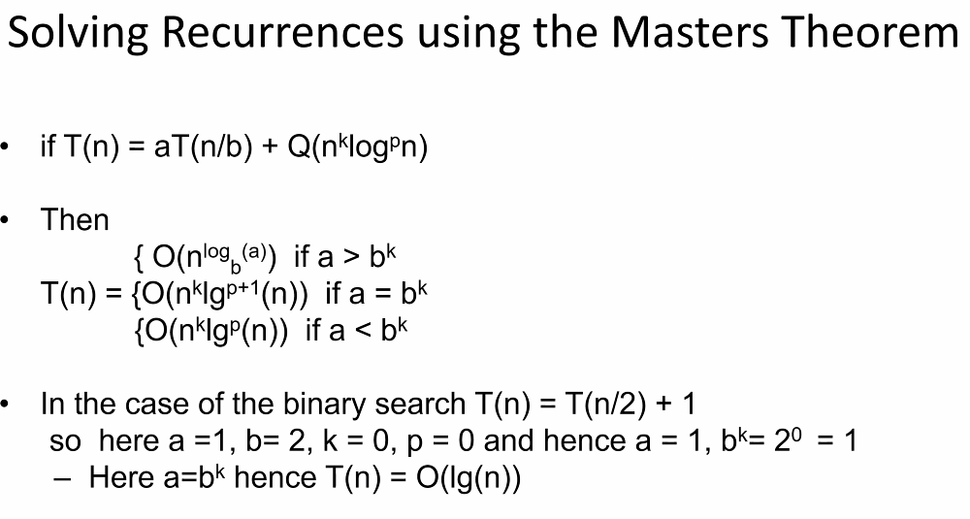
* 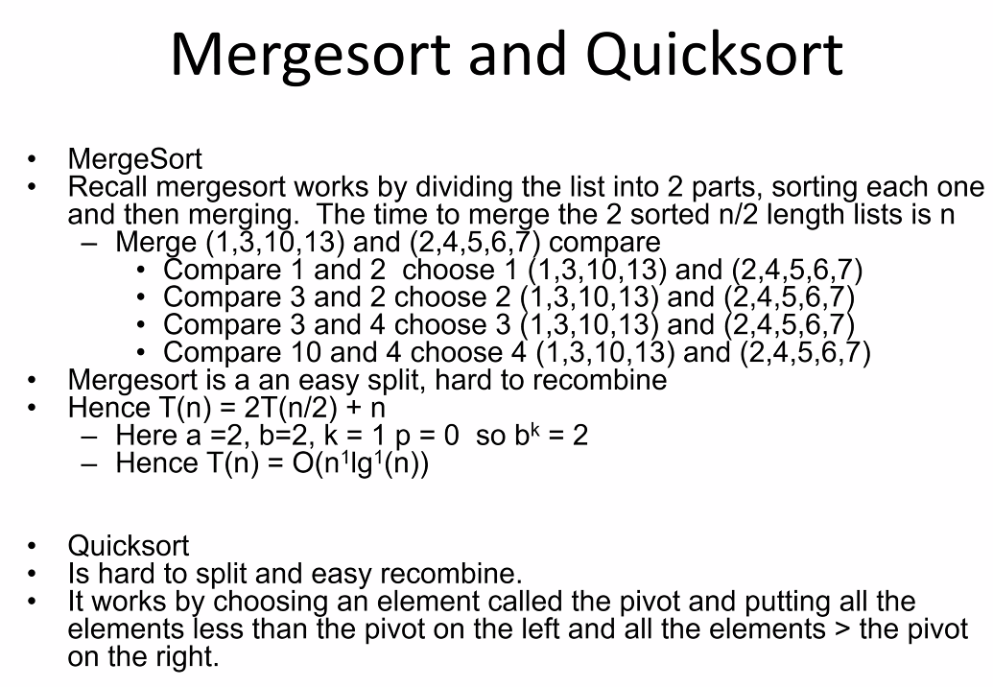
* The selection problem
* 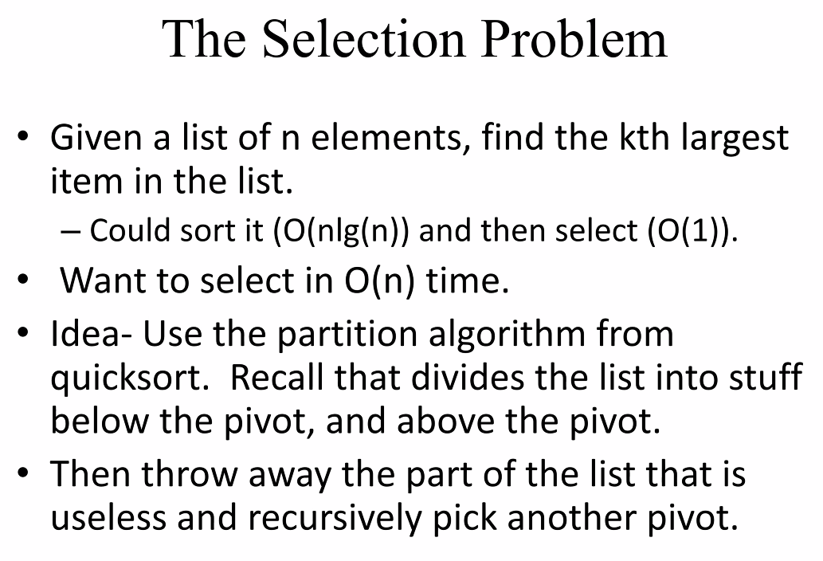
* 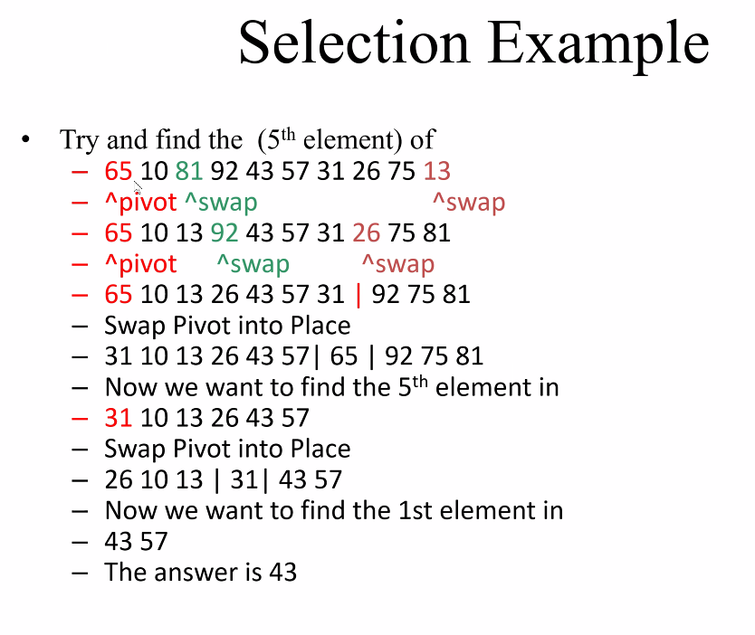
* Above: find 5th smallest element in the sorted list
* Above: swap pointers start at beginning and end of list and move through, being compared to the pivot
* A pivot point closest to the middle is most desirable/efficient
* 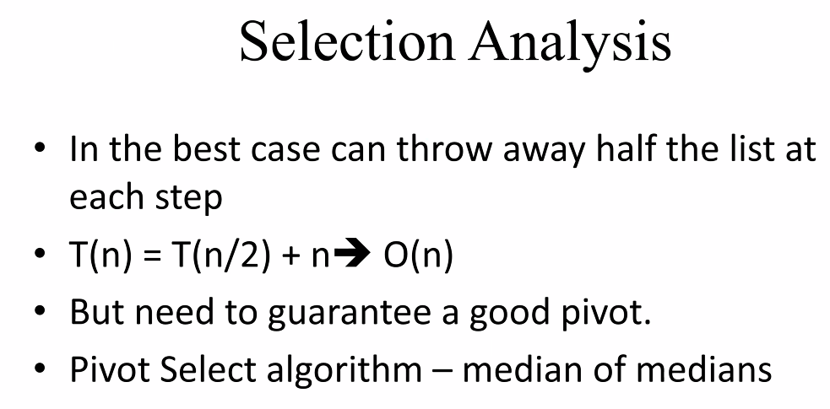
* Median of medians = take first, middle, and last element, sort those 3 elements, and then choose the median as the pivot point
* If pivot is poorly placed, then algorithm fails/is not effective in sorting and finding an element in an ordered list
* 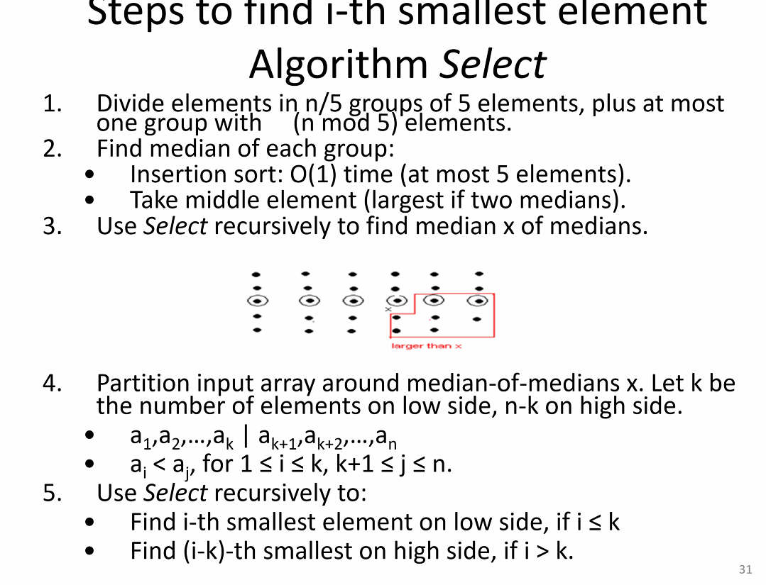
* Above, is a more intensive version of the select algorithm that does another layer of divide and conquer approach; only used if the situation calls for it: remember to think about number of elements/type of data, needs of a program..etc.
* 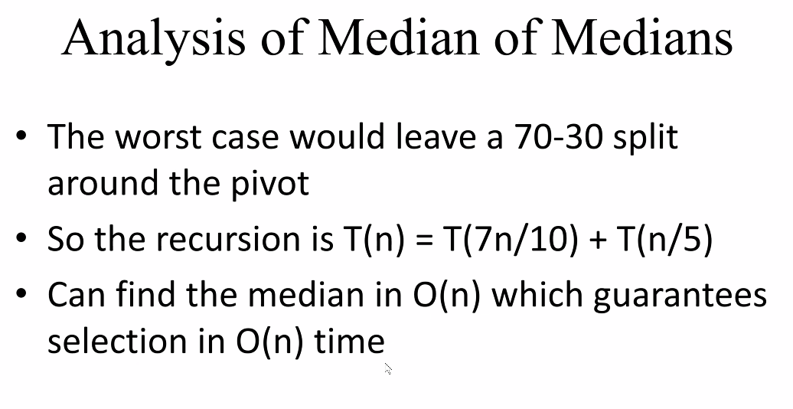

## Dynamic Programming:

* 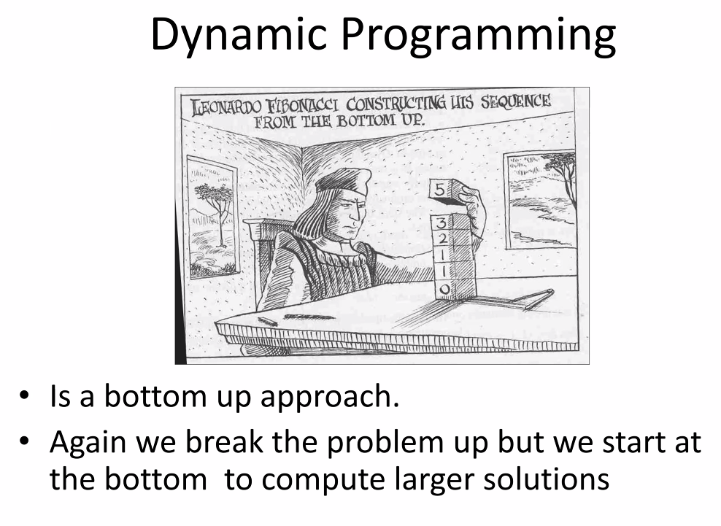
* Fibonacci Series (also factorial is a perfect example of dynamic programming)
* 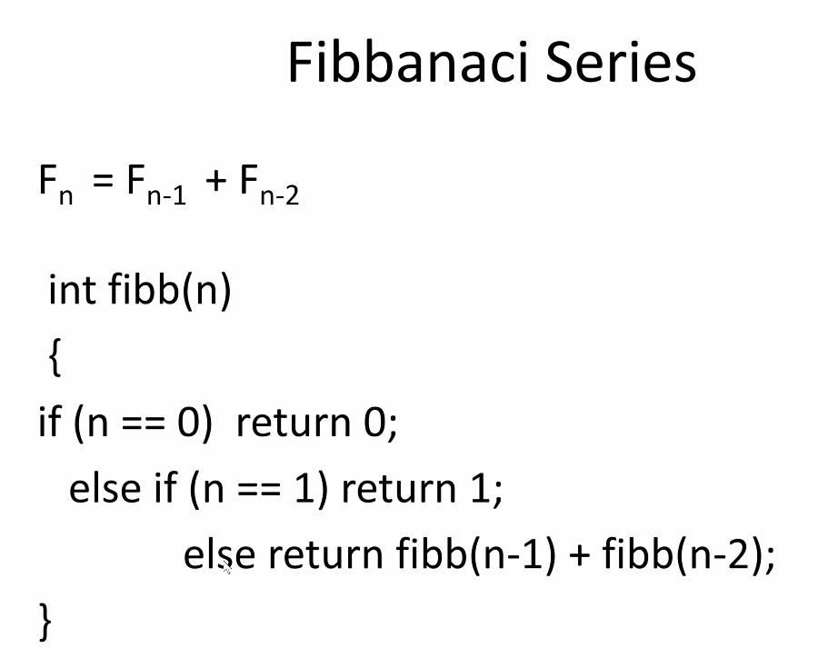
* Above algorithm is very inefficient (exponential); not good to use dynamic programming in this case unless we are dealing with smaller amounts of data
* 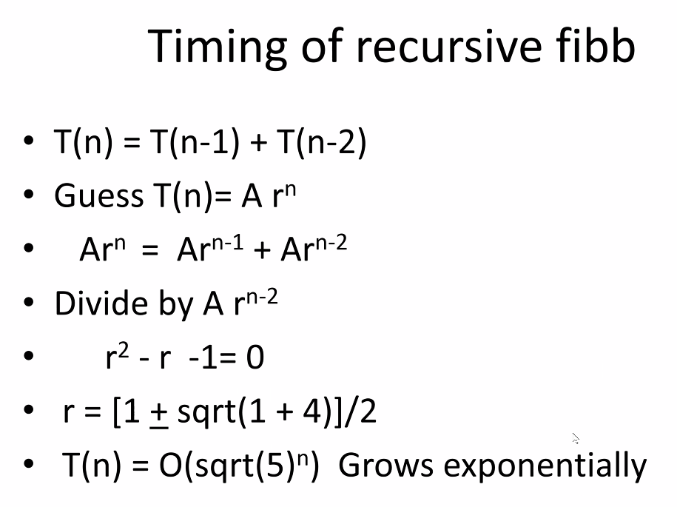
* Solution? Use a non-recursive fibb
* 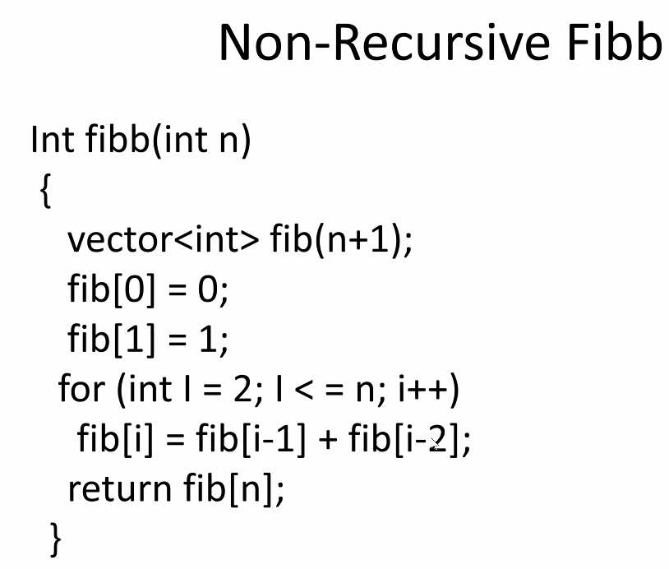
* Use a for loop for recursion instead of recursive calls
* Binomial coefficients:
* 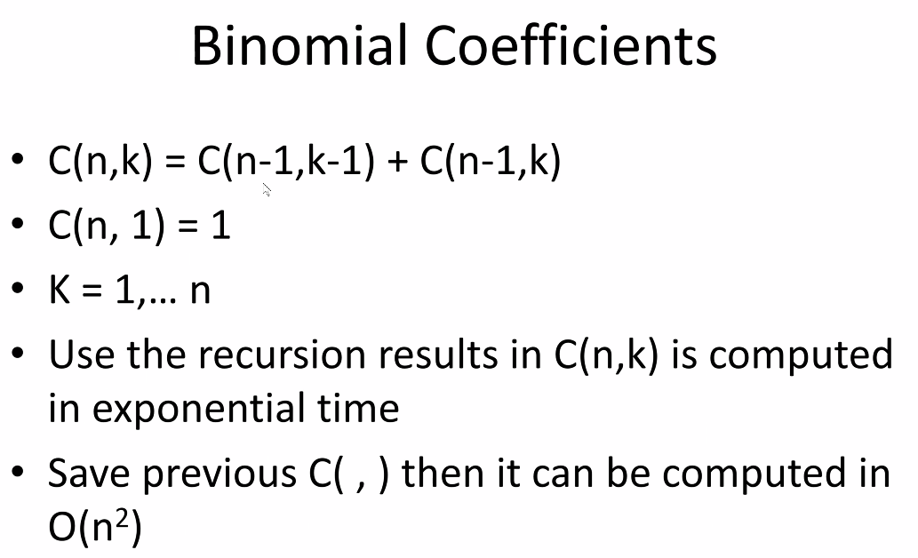
  + Save previous C(,) in order to avoid an exponential time complexity algorithm
* 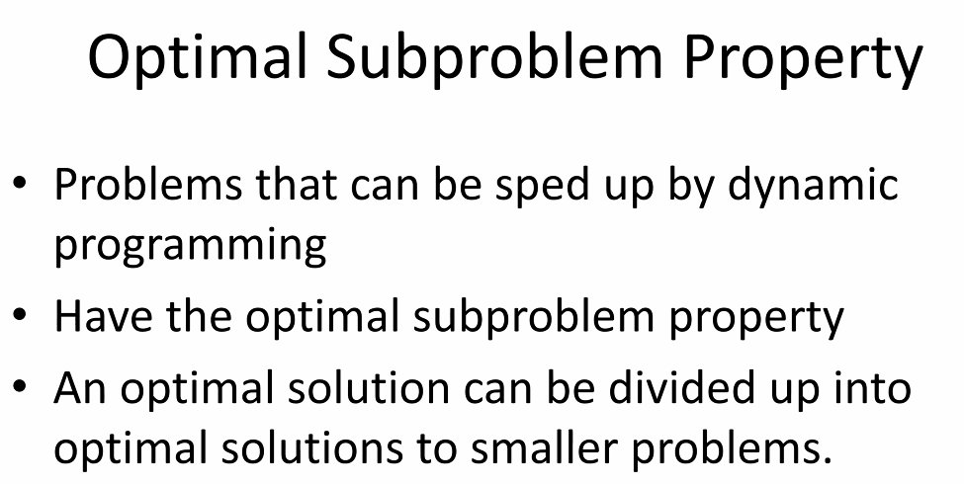
* Difference between dynamic programming algorithms and divide and conquer algorithms: both use segmentation; however dynamic program segments solutions – use smaller solutions and build up to larger solutions (that’s why Fibonacci sequence is a perfect example); divide and conquer segments the problem (and essentially does find a smaller partial solution) and works through the segmented problem until one of those segmented problems is found to contain the solution to the main combined big problem.
* 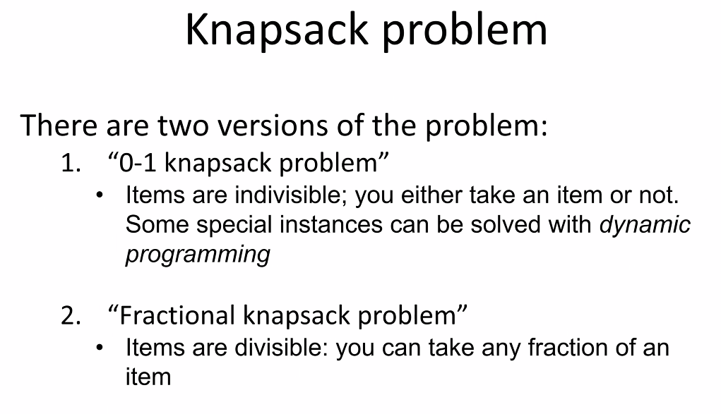
* 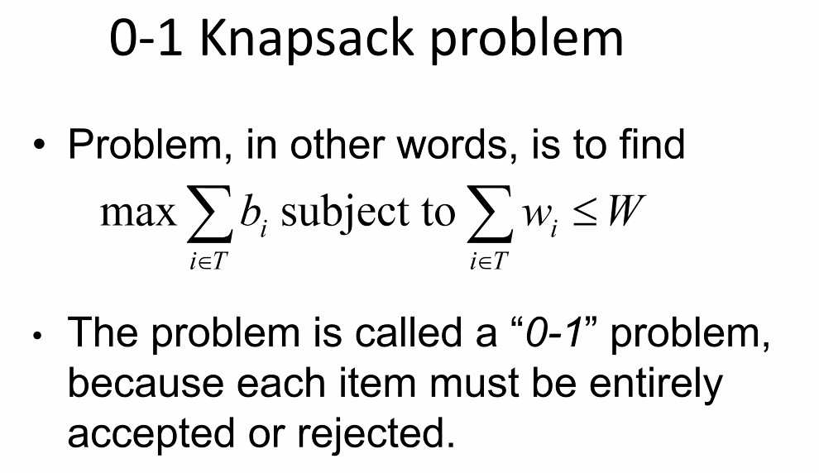
* 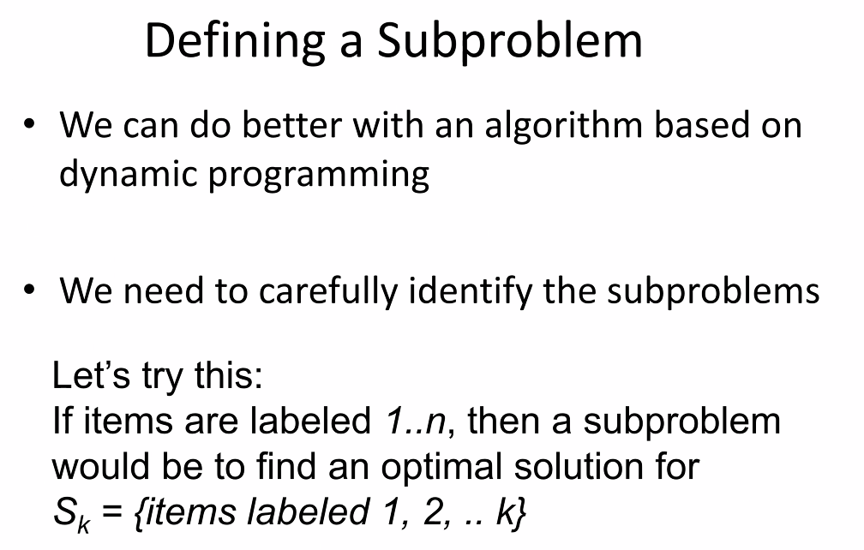
* 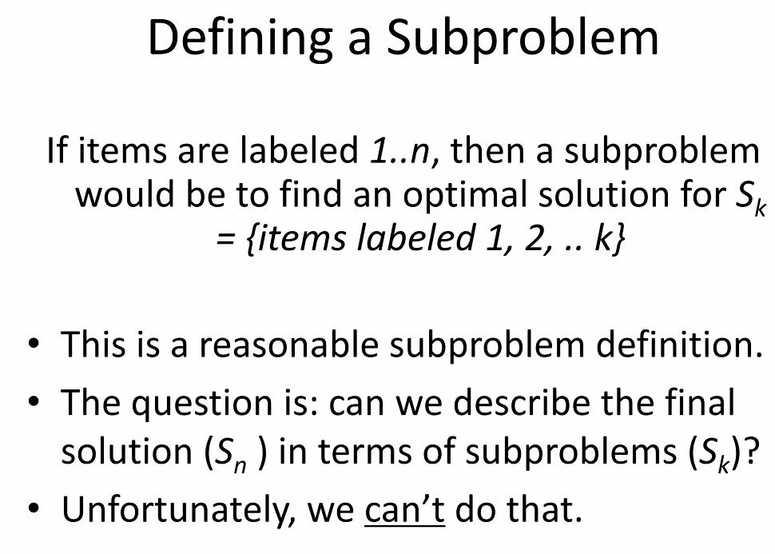
* Knapsack problem is an example where all the solutions to the smaller problems cannot add up or derive the solution to the larger problem
* 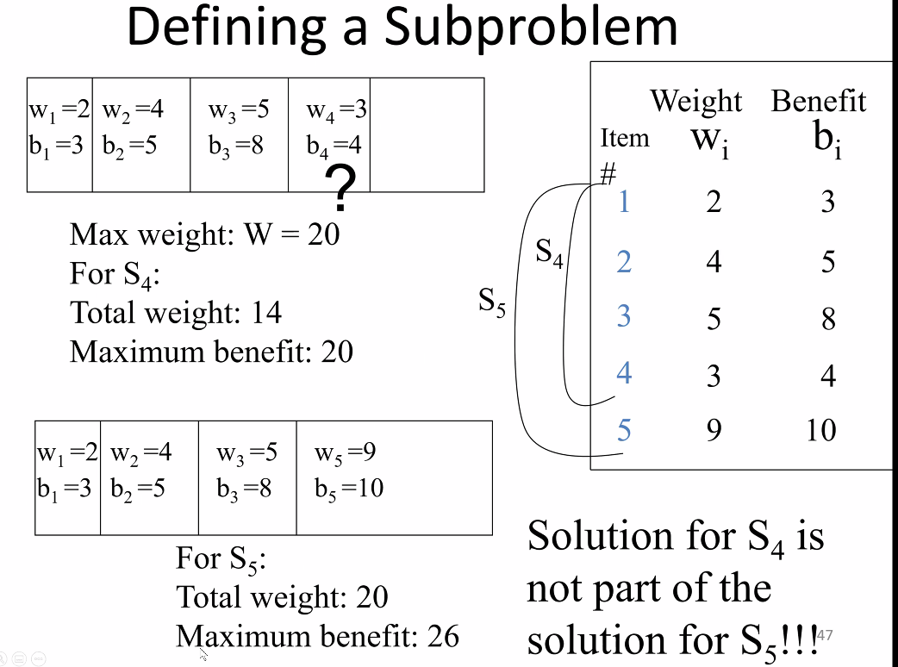
* 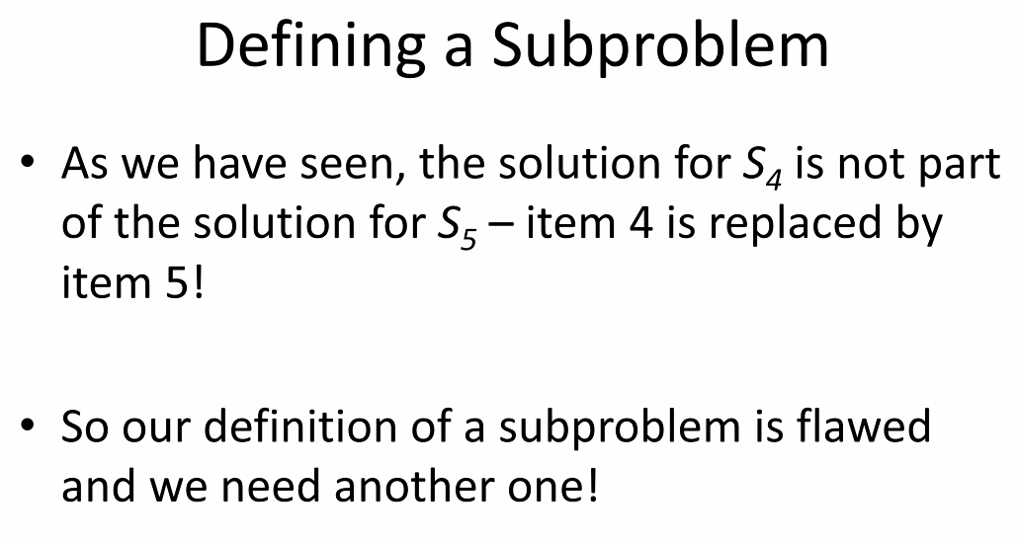
* 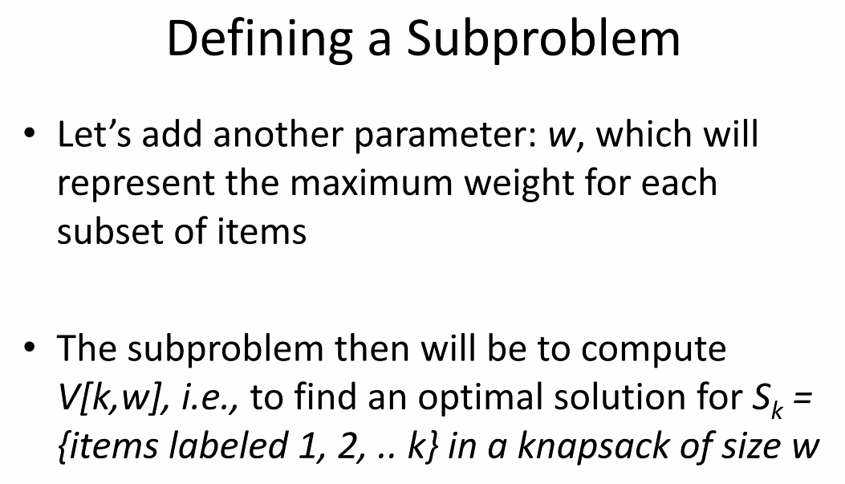
* 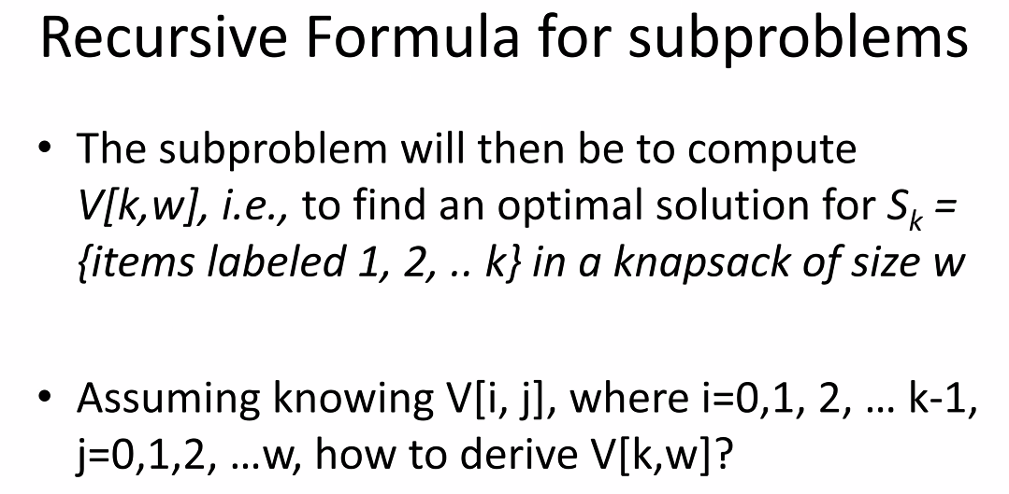
* 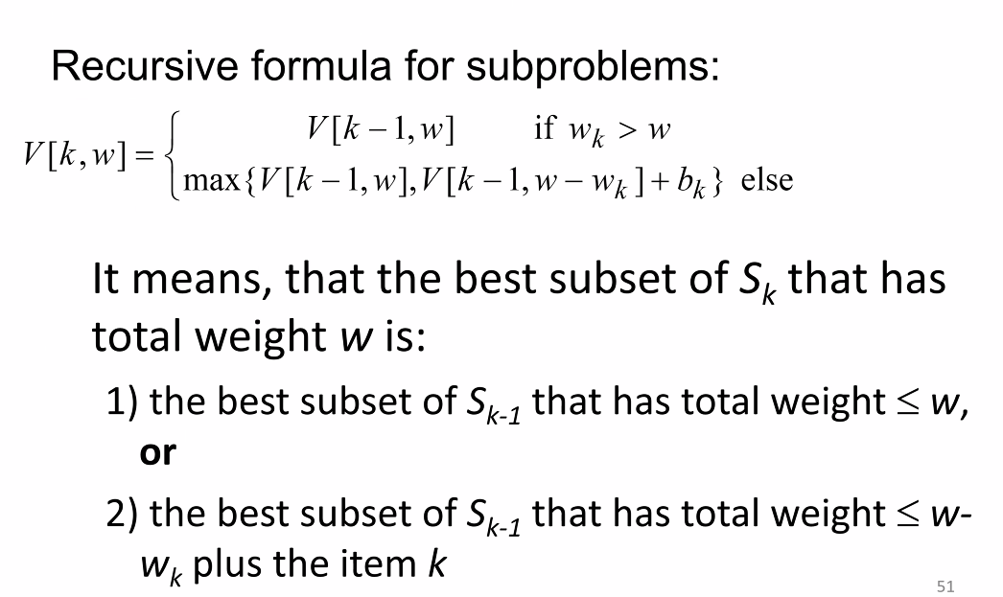
* 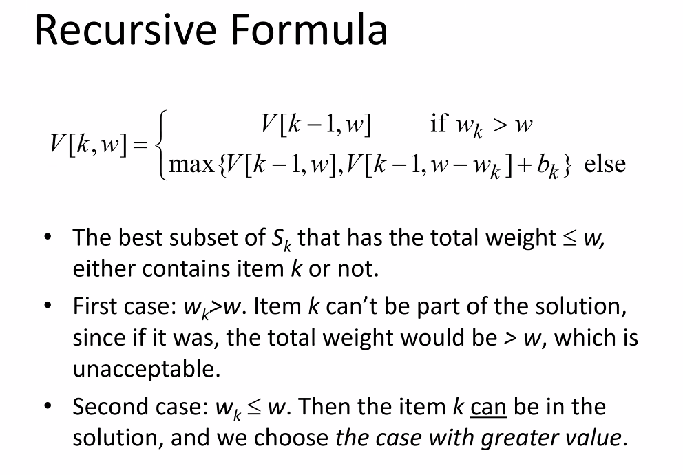
* 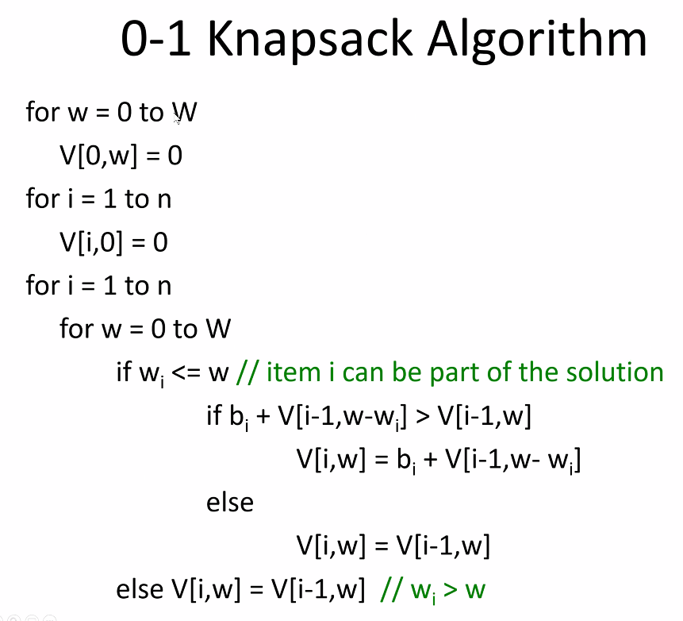
* 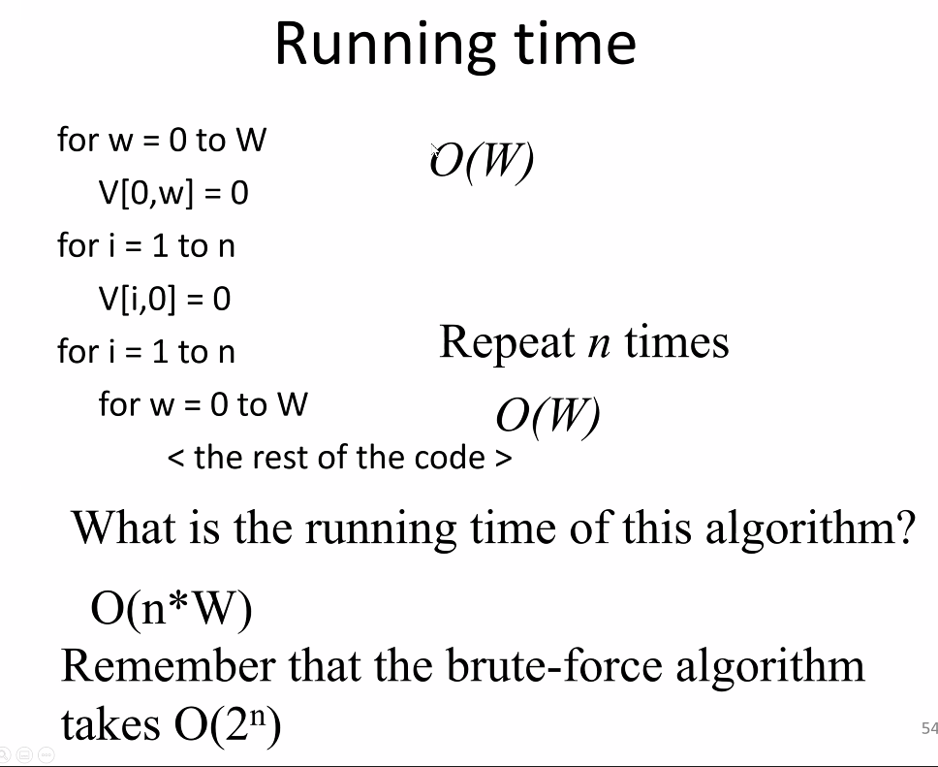
* 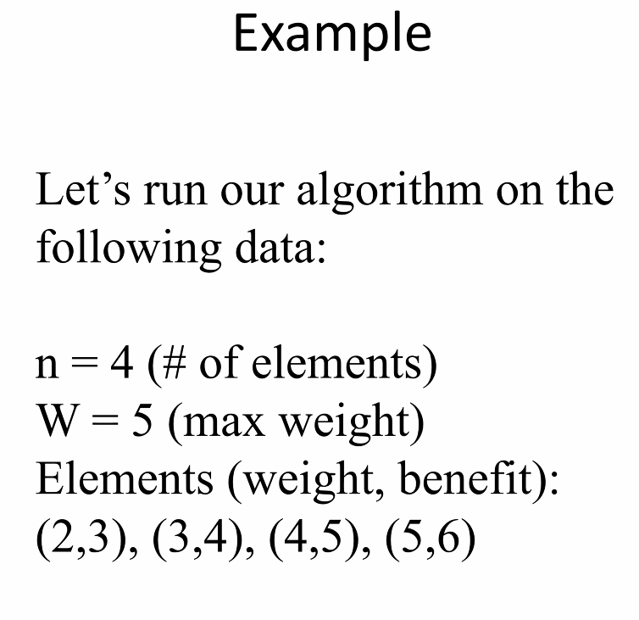
* See powerpoint for example
* 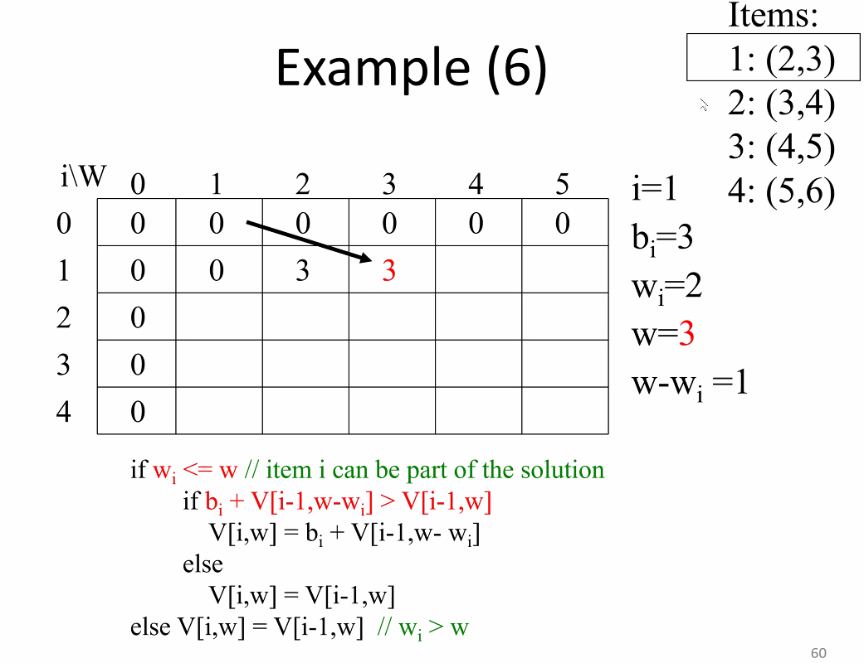
* Above, you have one of each item; determining which of the 4 items will give you optimum benefit while keeping at or under the weight limit (5)
  + You can handle more than one type of items, you just need to add more items that are duplicates to the problem
* i== item number, W == weight; items are (weight, benefit)
* the item that goes into the table is the benefit of a given item that will fit into that weight for the given item number
* each subsequent row you decide if you should replace the previous item added to the bag (from previous row) with an item that fits the weight and with better benefit, or see if you can add an additional item if the weight will allow
* 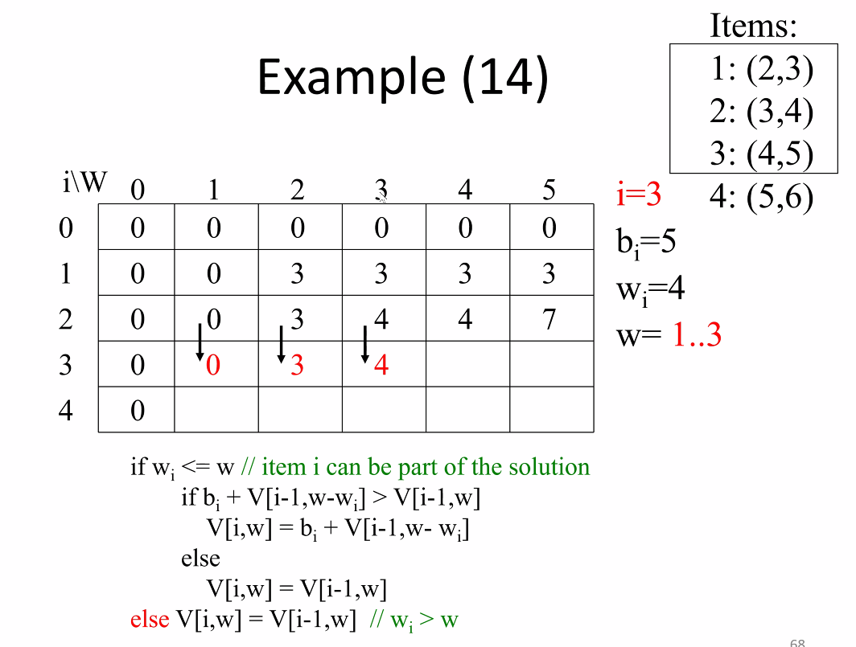
* 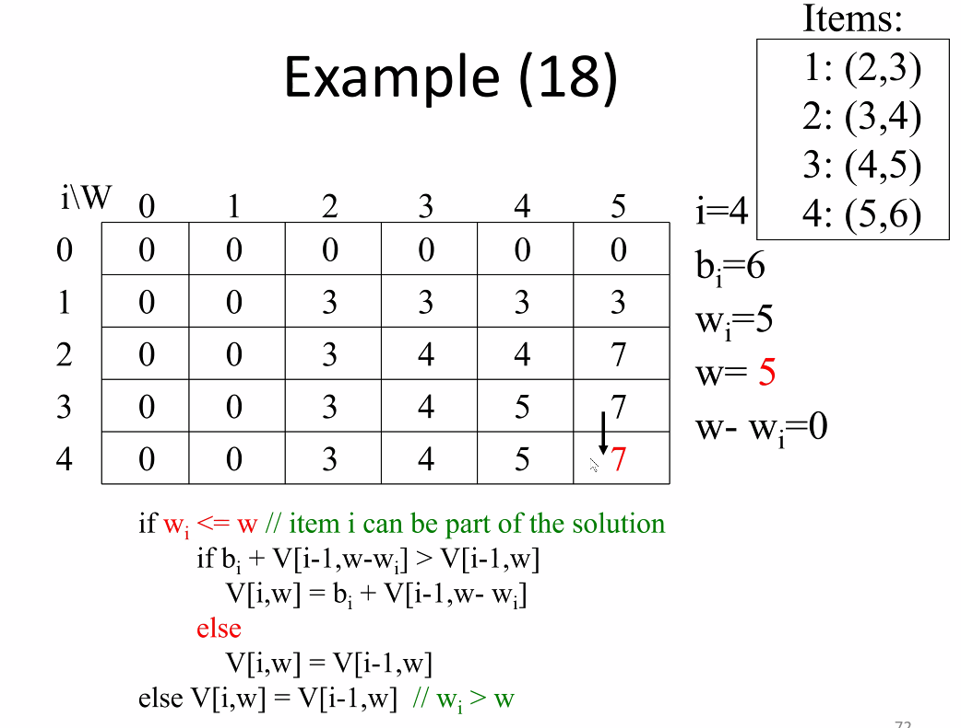
* Now above, after chart is complete (algorithm completes), you simply choose the largest value on the last row; as the table has been built (using solutions from previous rows == dynamic programming 🡪 start with lowest level solution and building from there based on previous, smaller/less optimal solutions)
* Note: i in the column refers to item; so you need to see if a given item represented by each row will fit into a bag of a given weight (represented by W across the top row)
* 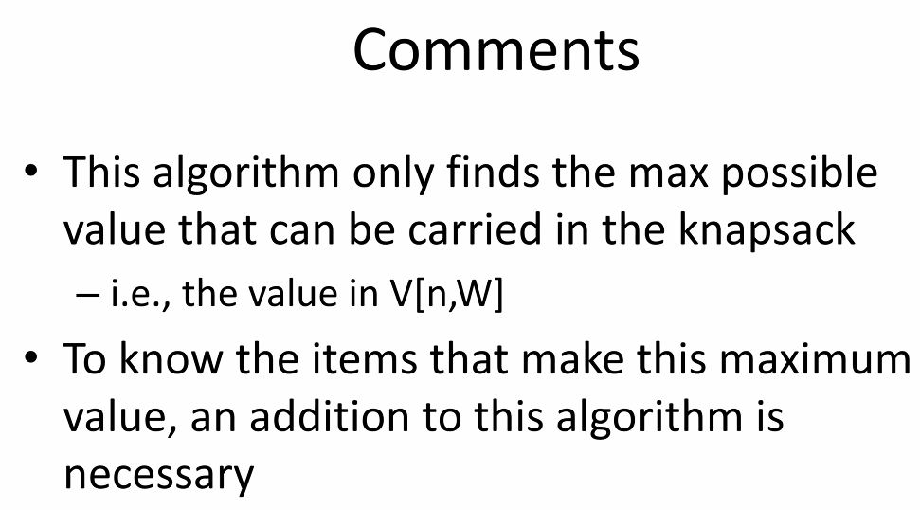
* 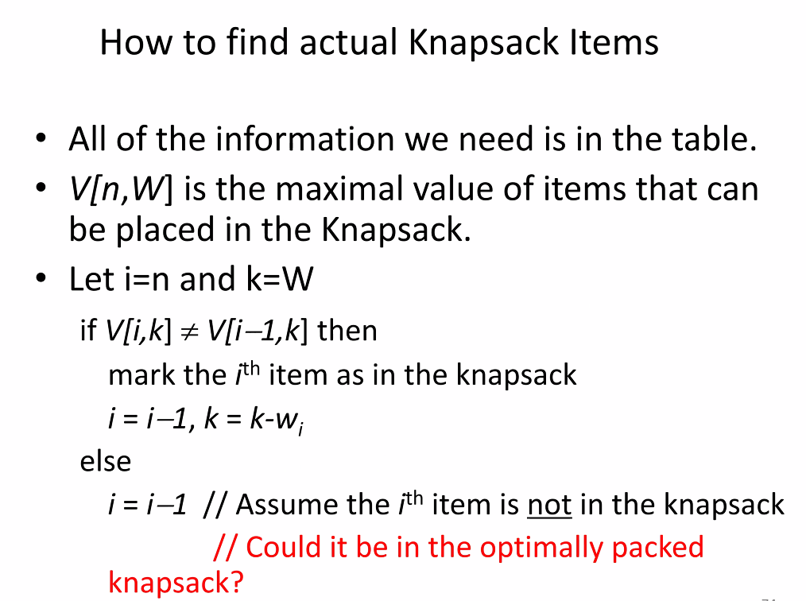
* 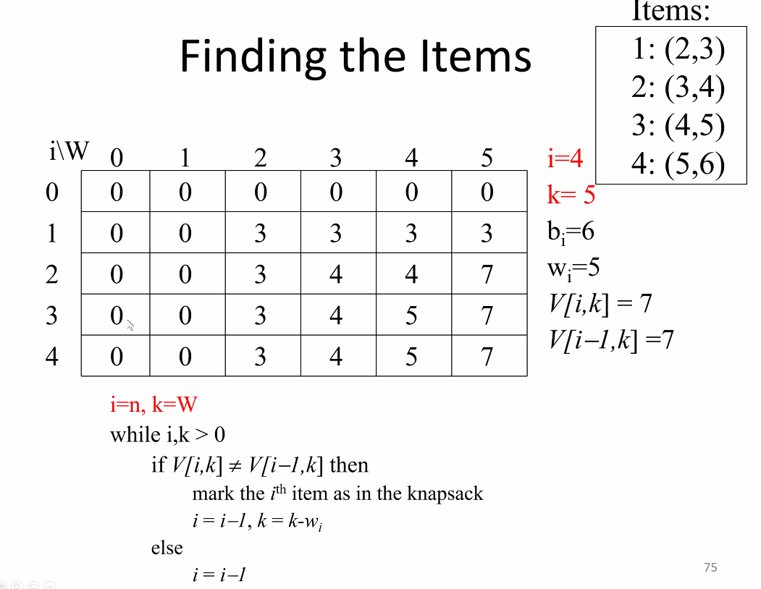
* 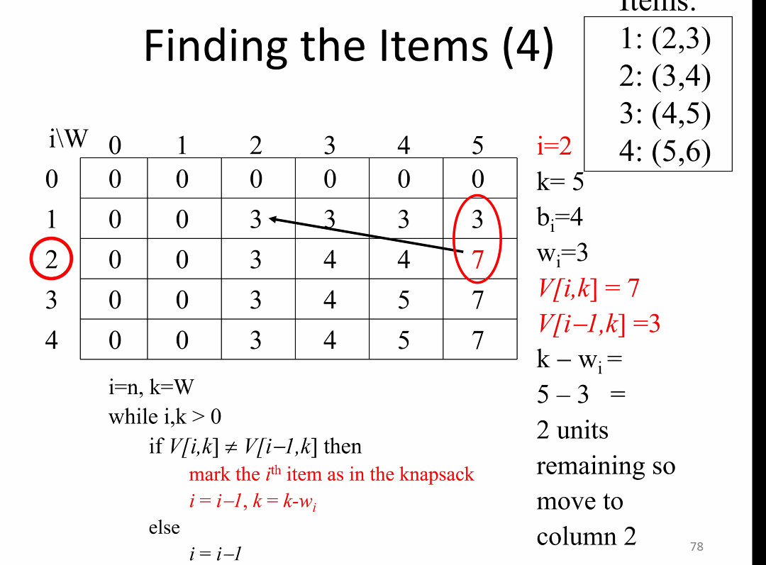
  + So above, item 1 is in the knapsack, and since we reached end we know item 2 was also added to knapsack to get total optimal benefit of 7 within weight limit (5)
* 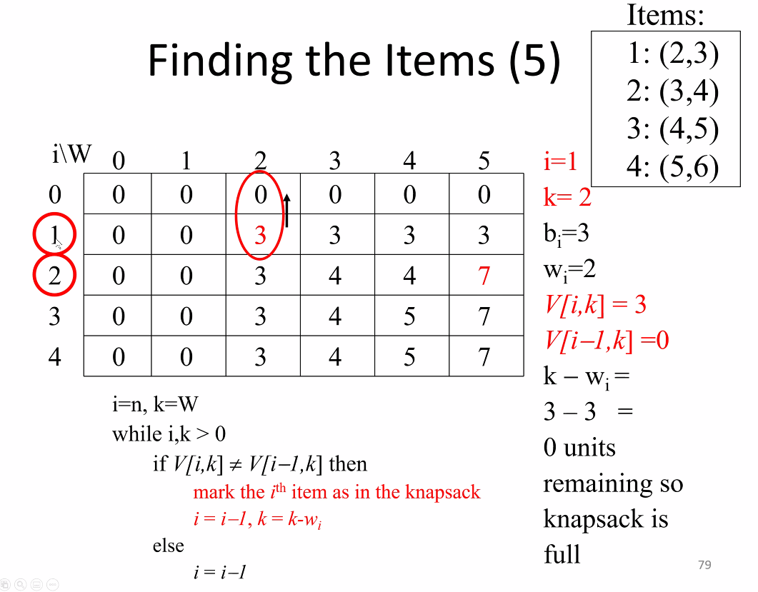
* Note: using a Boolean array would be impractical and use up a lot of memory; the above method is much better
* 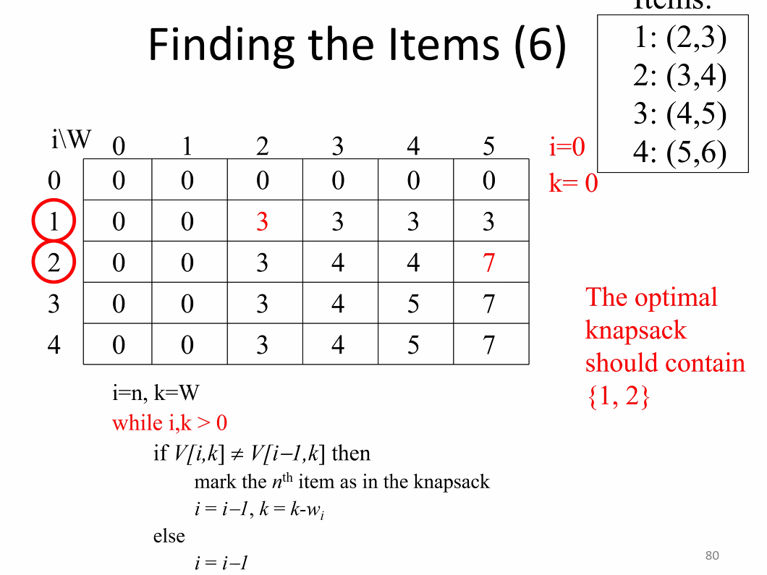
* THIS MAY BE ON EXAM!
  + You will need to show using this method all the steps to build the table and find solution to prove you would know how to do this for a large table with a large number of problems
* Memorization (memory function method):
* 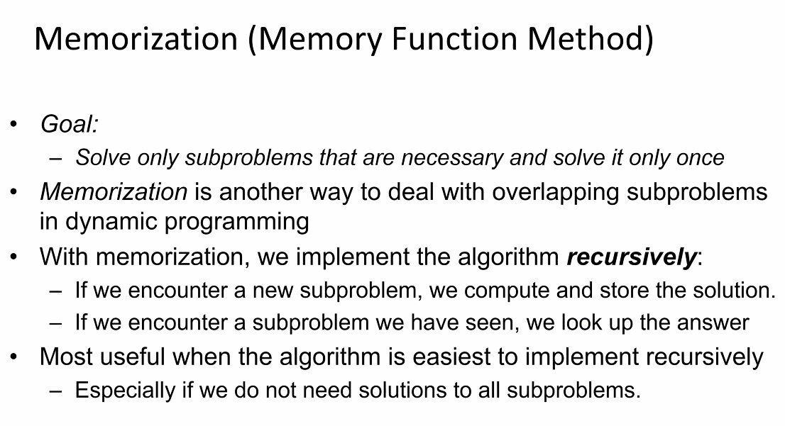
  + Its about storage (memorization): think about the fibb function
* 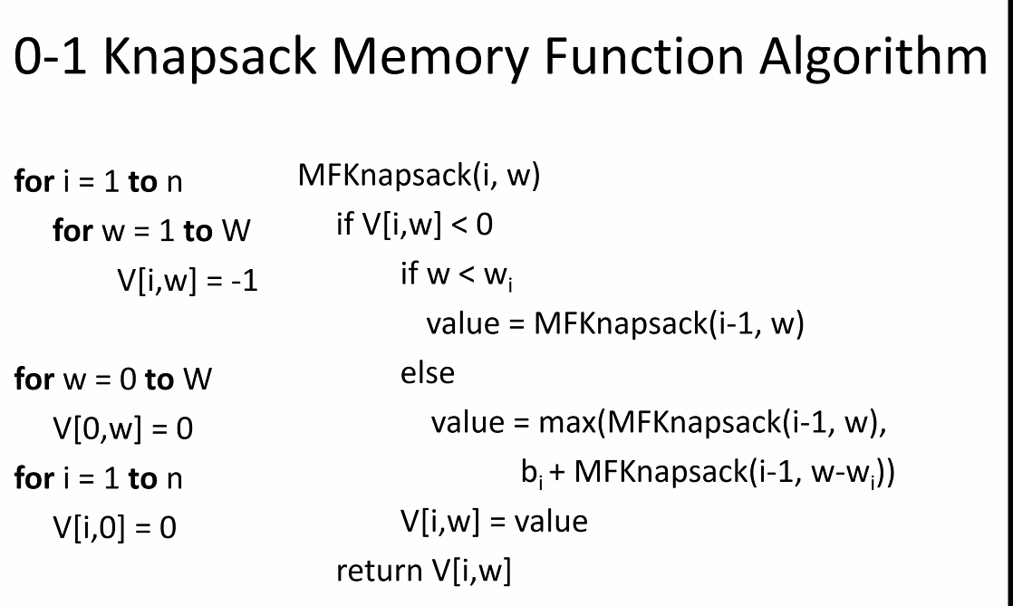
* 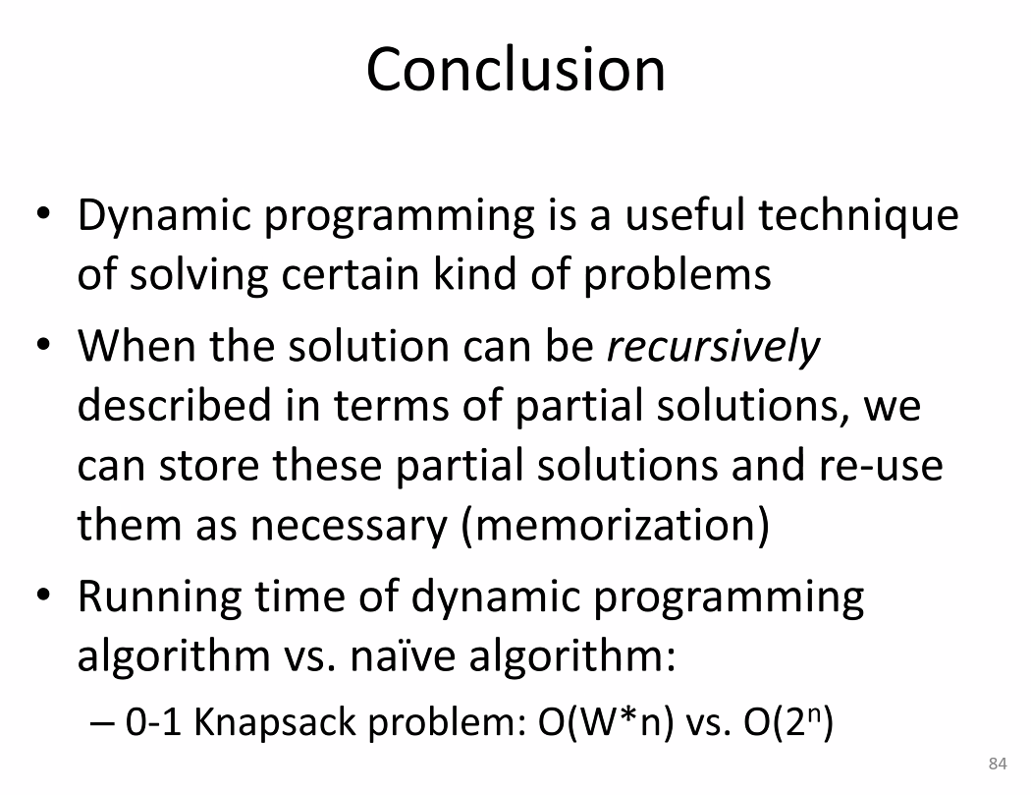
* Maximum contiguous subsequence sum:
* 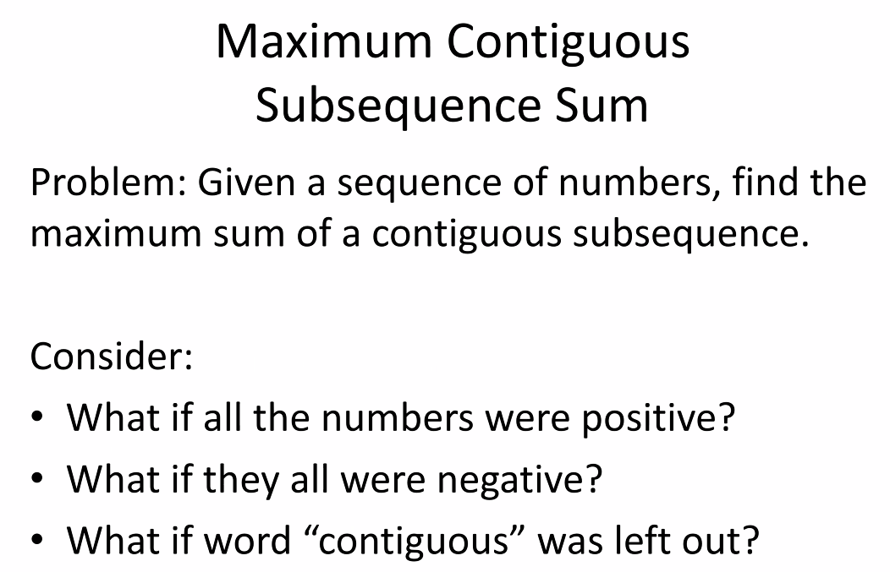
* 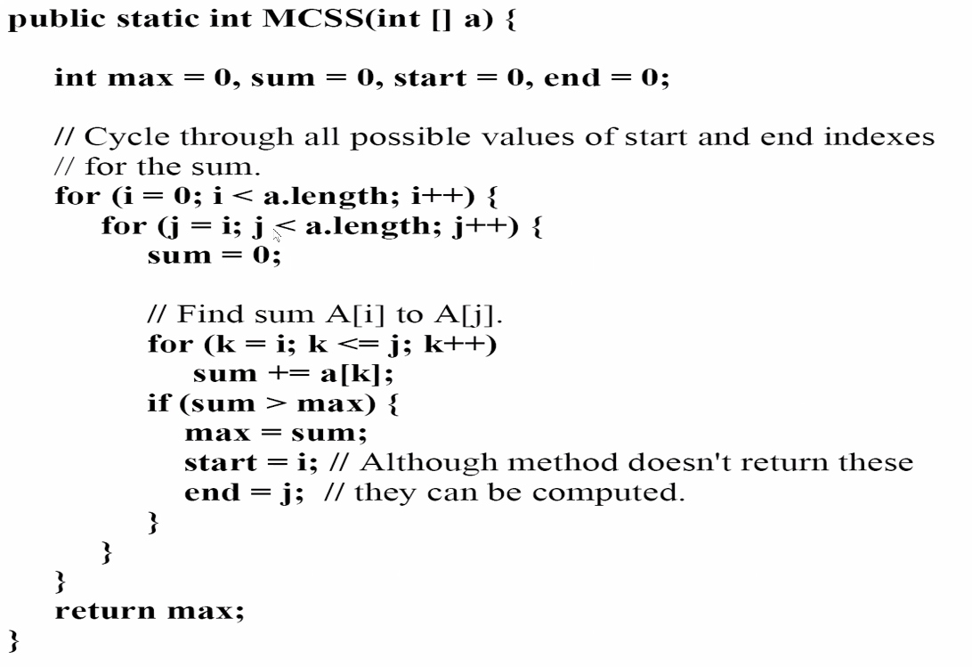
* 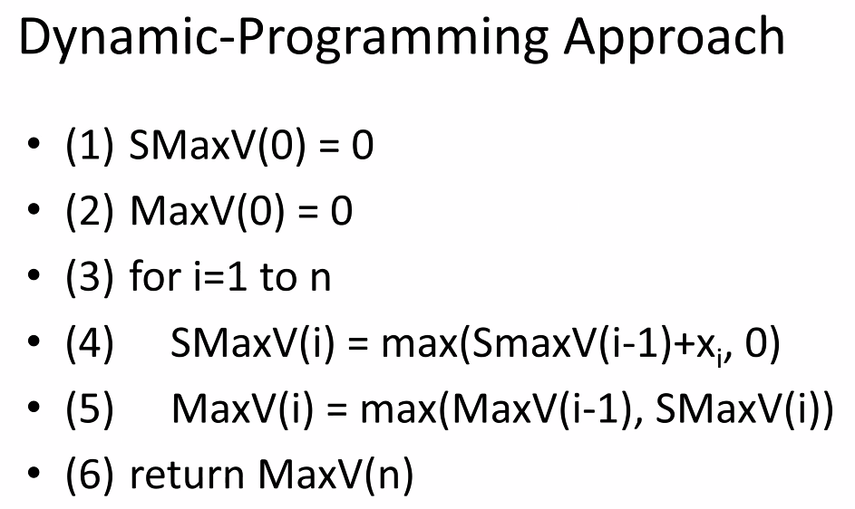
* Think about using static variables and static functions to also implement dynamic programming approaches

# Lecture 24 – 8/12/21– Sorting

* Selection sort:
* 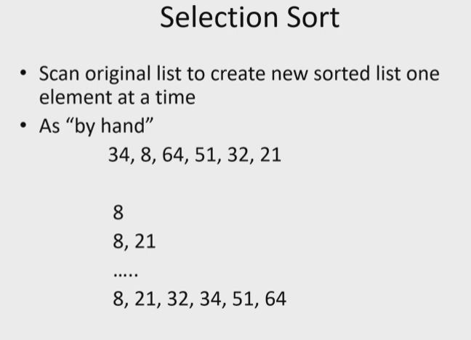
* 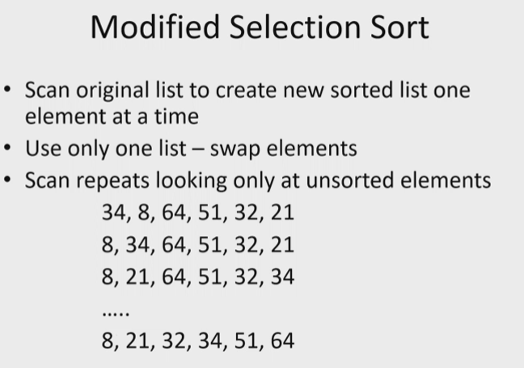
* Bubble sort
* 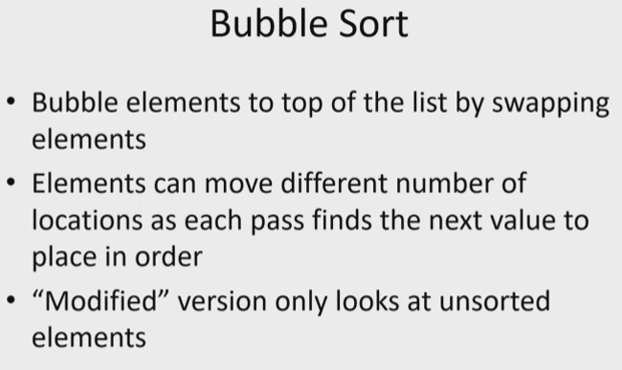
  + Remember: add elements to bottom (back of array) and swap it up the tree (up the array) as necessary to put it in the correct location
* Insertion sort
* 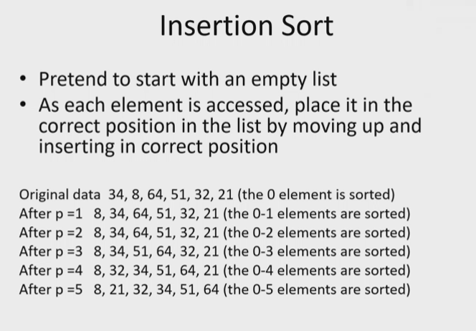
  + Biggest setback: you have to shift everything down every time you insert a new value in the correct location
* 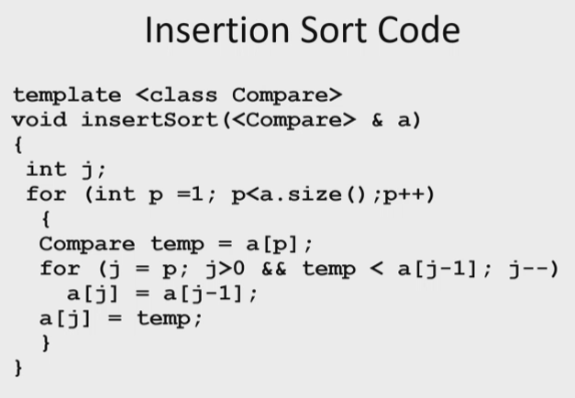
  + Start at location 1 since location 0 is considered already sorted at start of insert
* 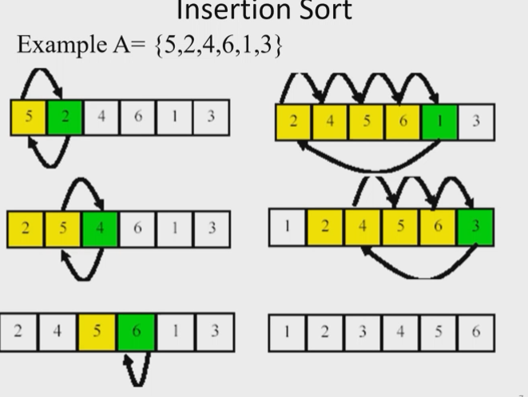
  + Start at element 1, compare down the list to find insertion point; keep moving the comparison pointer down the list to compare every location in the array to the elements before it and find its insertion point
* 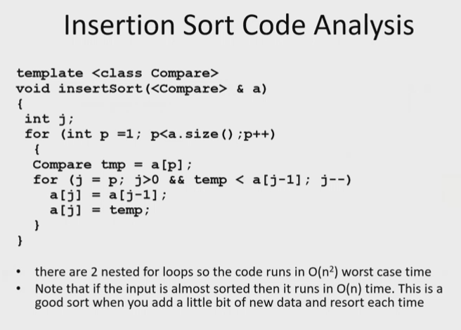
* 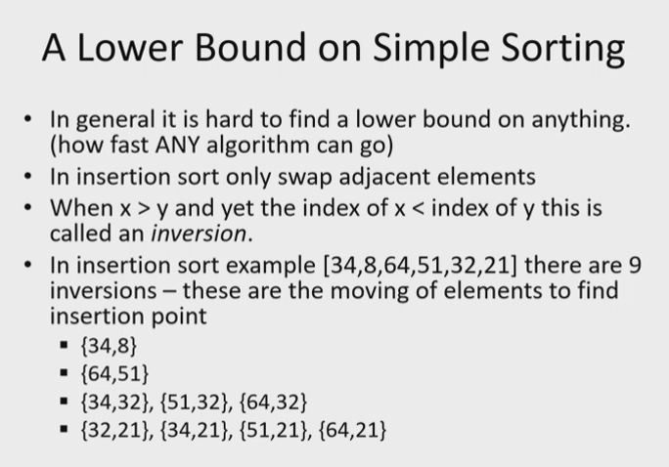
* 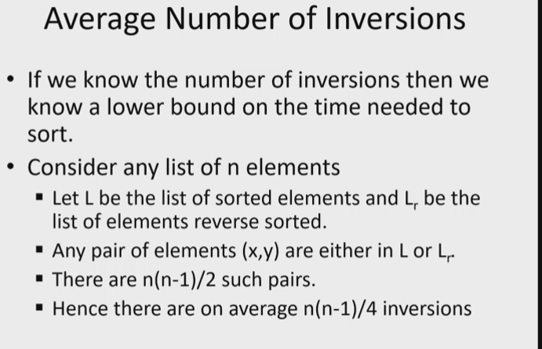
* 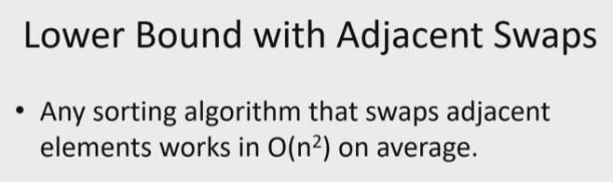
* Shell sort
* 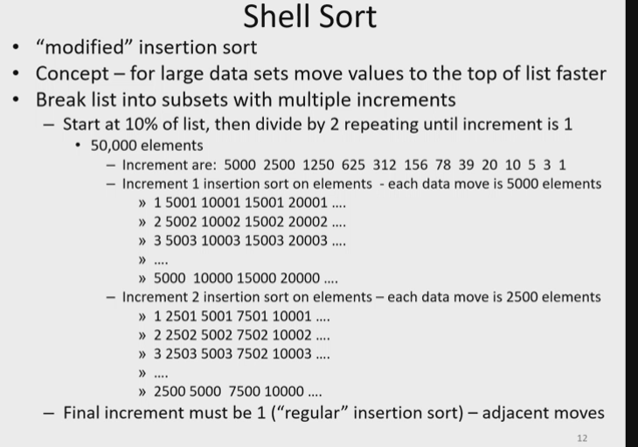
  + Concept: once all sub lists are all sorted, the final big list will take less movement/shifts which will improve time of the algorithm compared to an insertion sort on the entire set without sorting sub lists
  + In sub lists, we do the swaps/moves by larger increments – instead of one location, we look ahead (for example 5k elements) and do proper swaps/shifts, so that when we get down to the regular insertion sort with moving one element at a time, the number of shifts will be minimized – versus looking at 50k elements, and for each element making shifts while looking at each location in the array
  + Goal: smaller number of shifts/moves when sorting a larger data set
* Divide and conquer
* 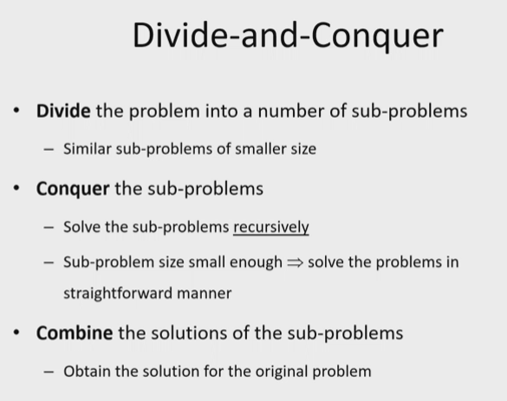
* 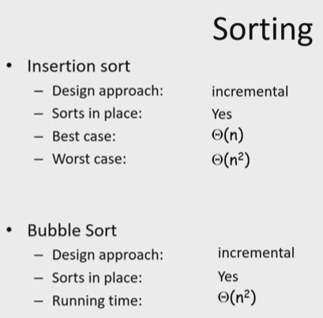
  + Sort in place: using memory that was already allocated (use swaps or overwrites)
* 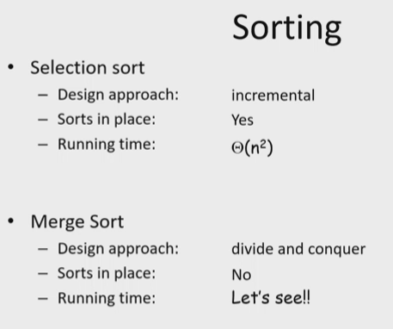
* Merge sort
* 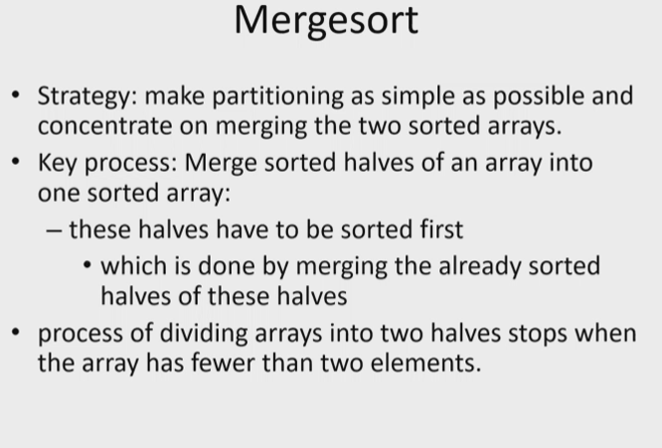
* 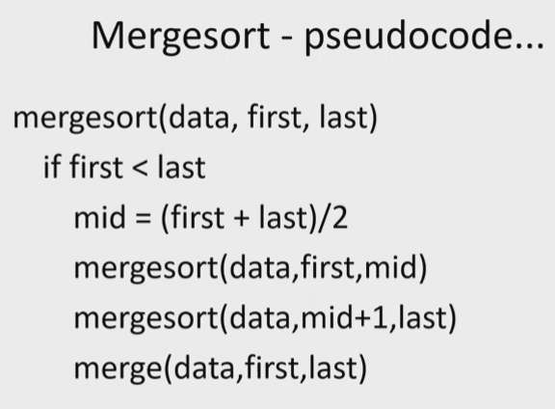
* 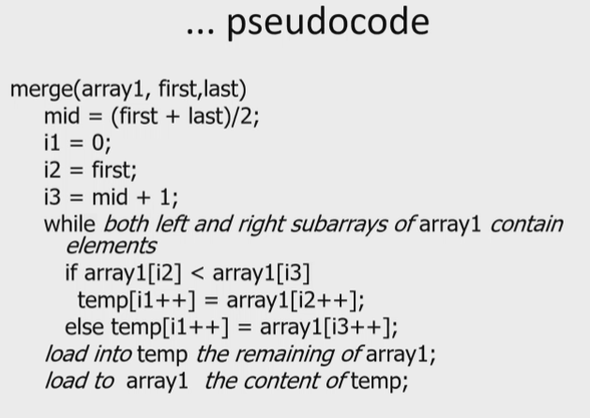
* 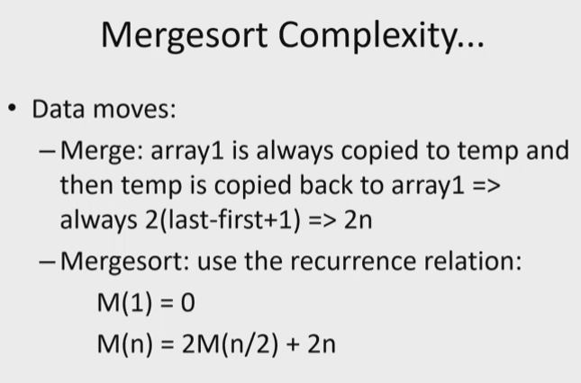
* 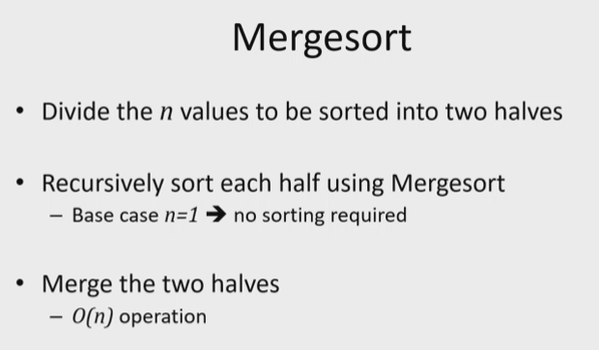
* 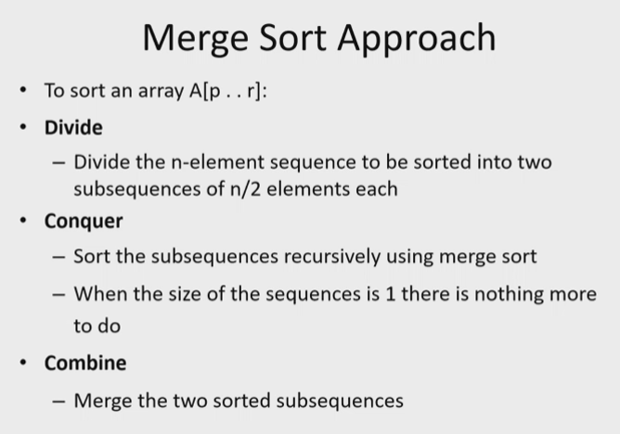
* 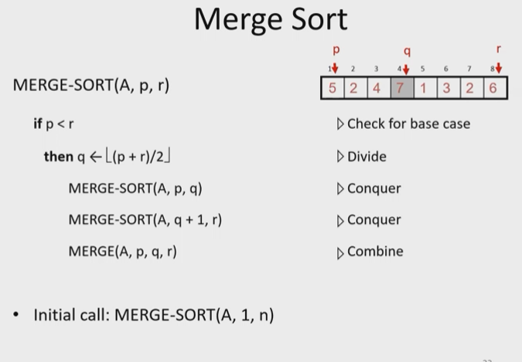
* 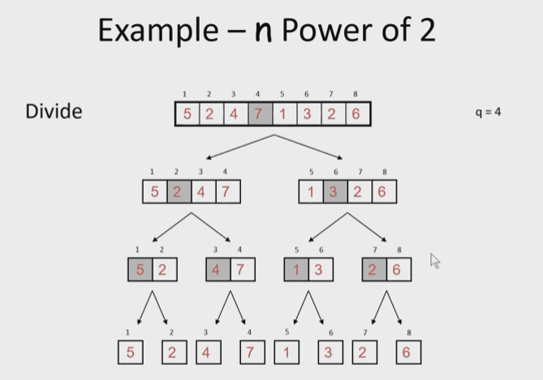
* 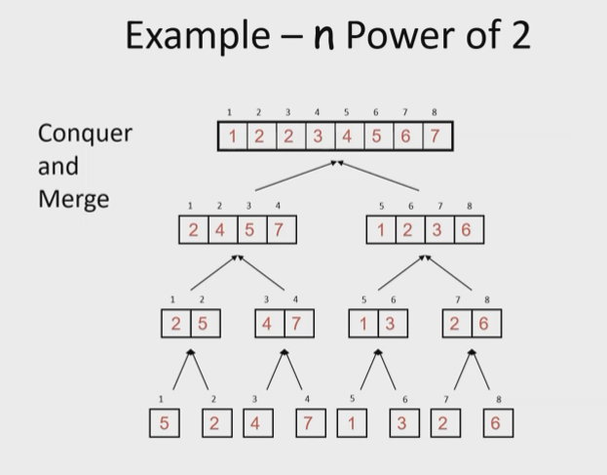
* 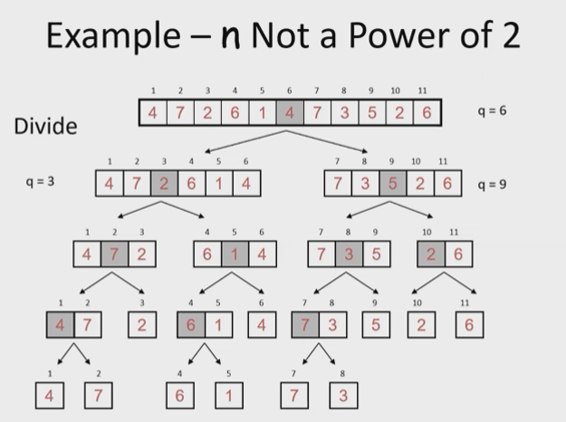
* Notice though that for merge sort, even though it is very efficient time wise, it is not so much space wise – you need to use a lot of memory
* 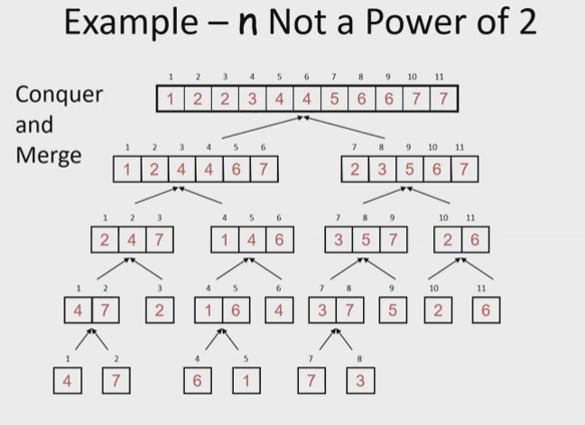
* Merging
* 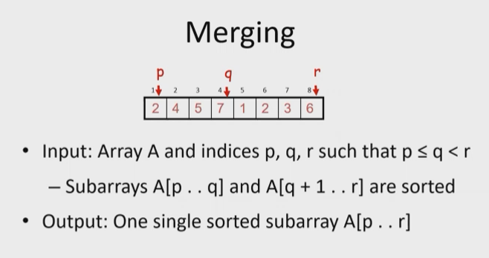
* 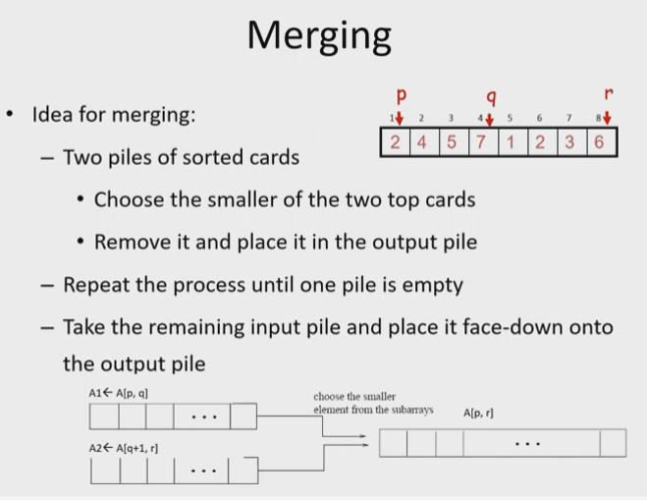
* 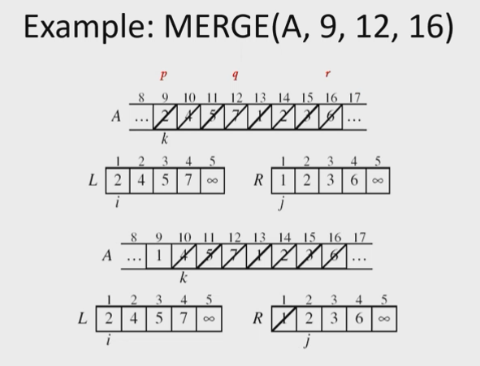
* 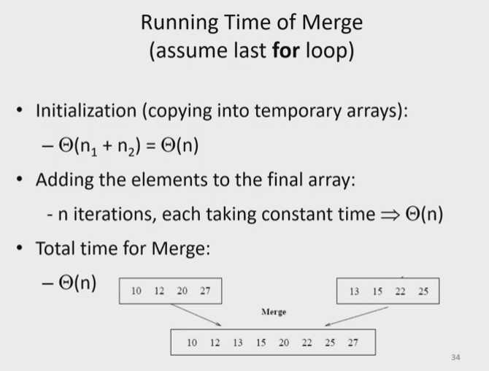
* 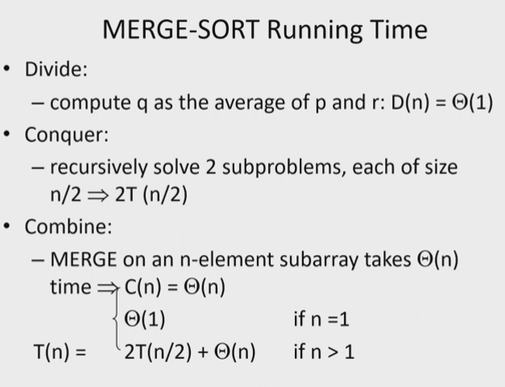
* 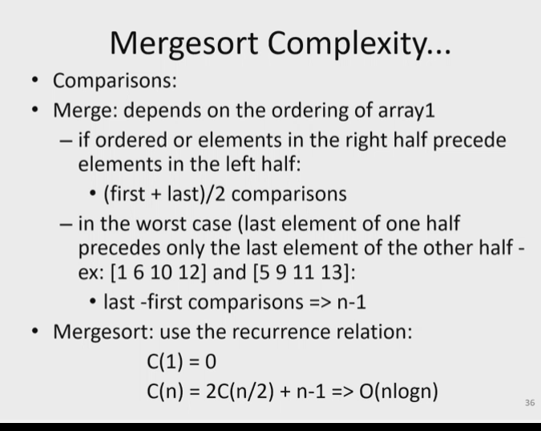
* 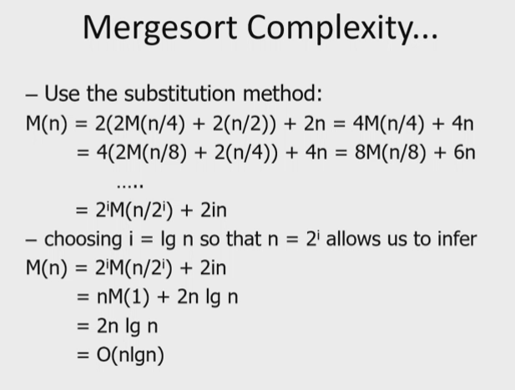
* 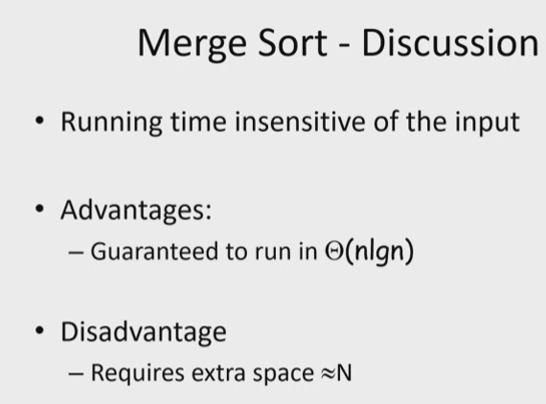
  + Because extra space, OS may have to break down tasks into groups, which will actually cause the performance/purpose of the efficient algorithm to become worthless or not as efficient as intended
* Quicksort
* 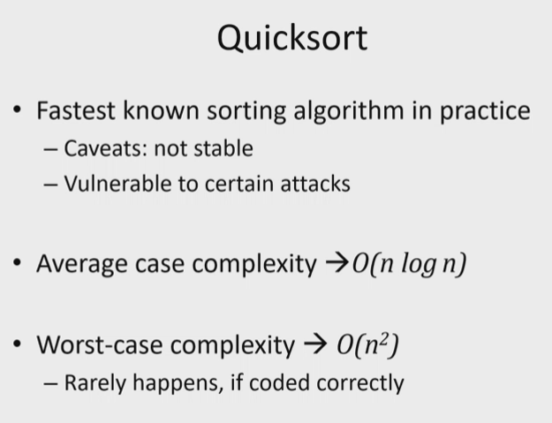
* Unstable runtime – but average case is still very good
* 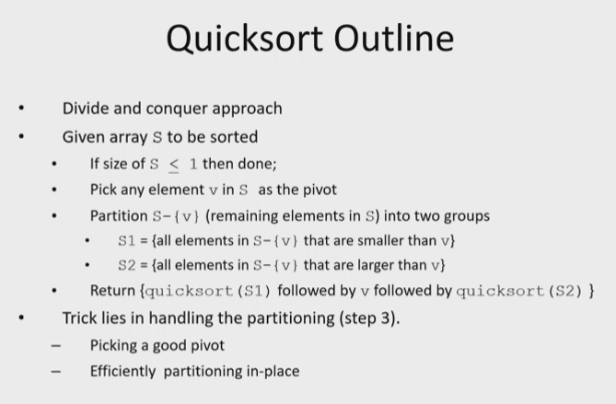
* We use the same memory – no extra memory needed for this sort
* 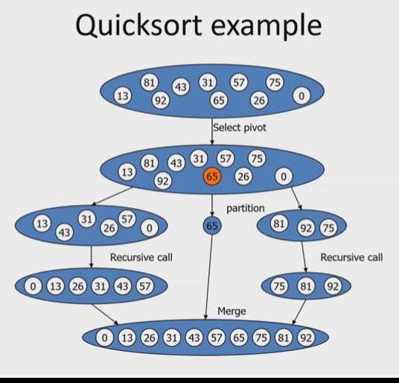
* 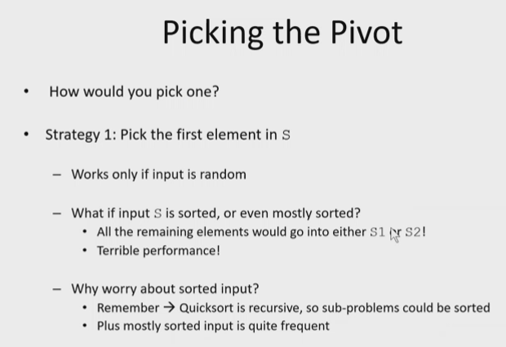
* 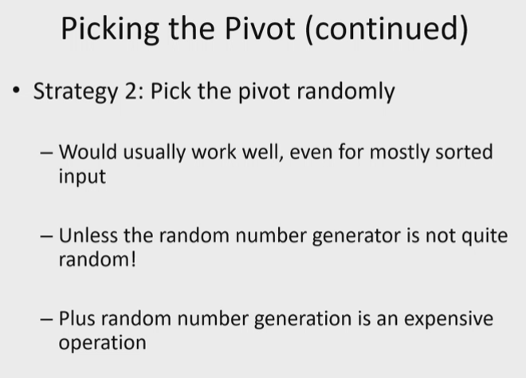
* 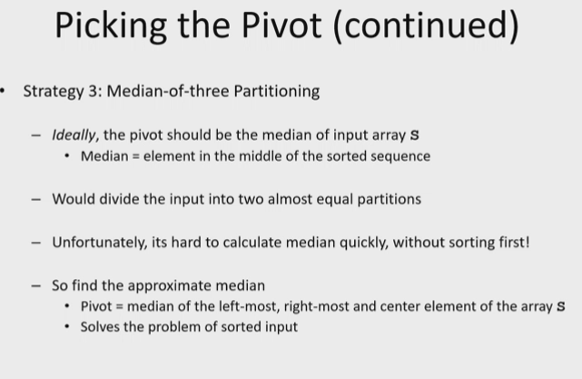
* 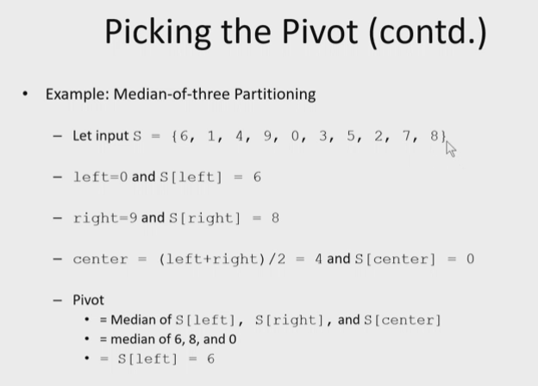
* 1 hr 13 min
* 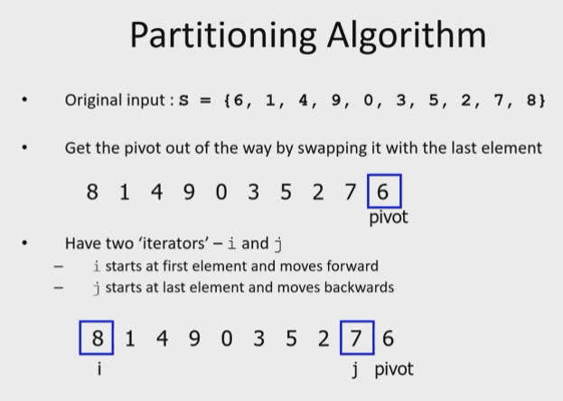
* Remember partitioning algorithms and sort algorithms is good for sorting data, including partitioning disk space for a computer or server..etc..
* 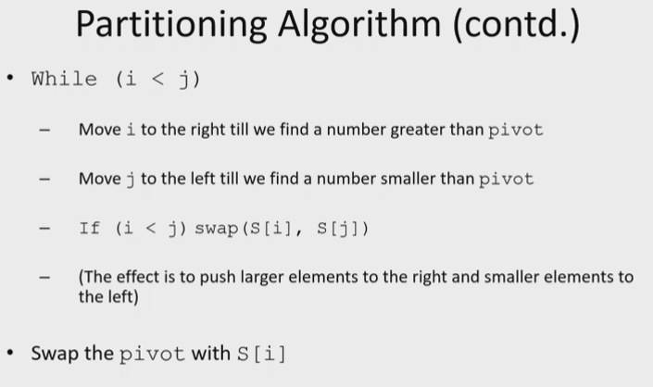
* 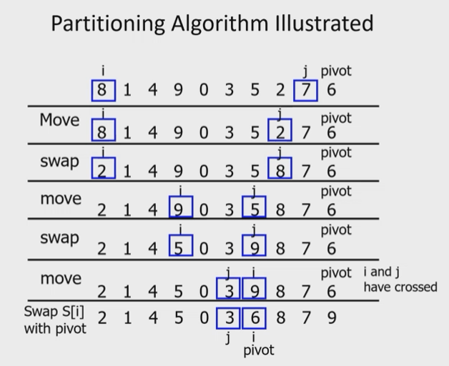
* 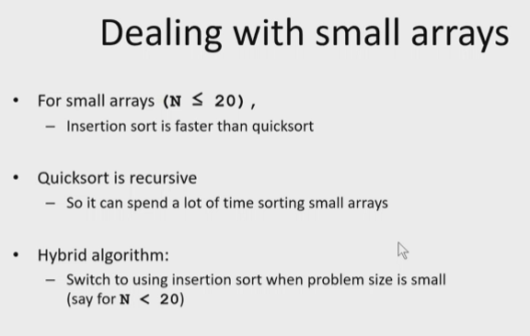
* So if you are inserting small amounts of data, you wouldn’t use a quicksort algorithm for example because it would defeat the purpose/efficiency algorithm
* You could however, have an algorithm where, depending on the size of data inserted, the algorithm selects the most appropriate algorithm to use in order to insert the elements while maintaining order!
  + Of course only do this if necessary for the application: only if there will be lots of variance in the amount of data inserted into a list
  + And also of course this will be more complex/difficult to implement, but overall efficiency will be best
* 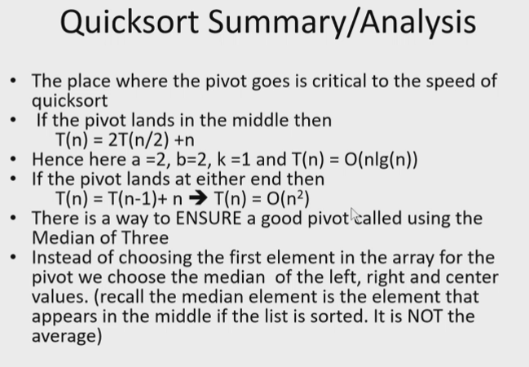
* Heap sort
* 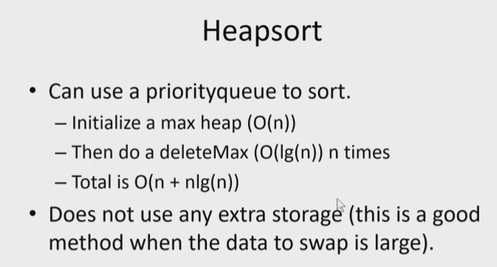
* 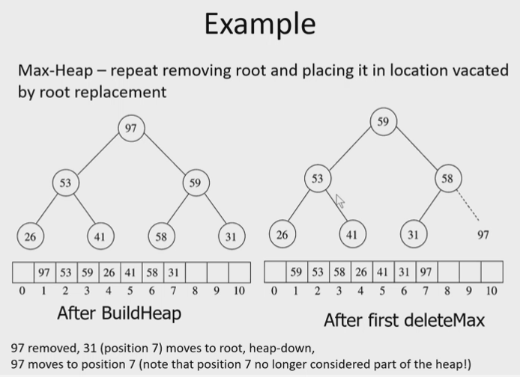
* Liner Sorting – Radix sorting
* 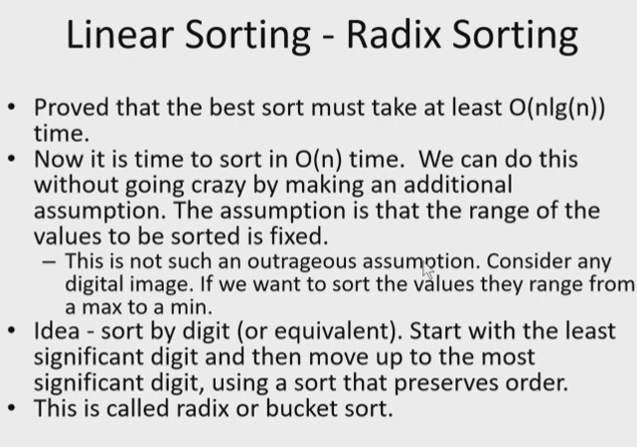
* 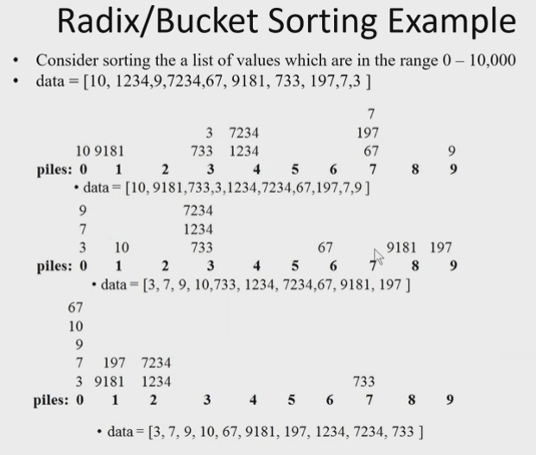
* 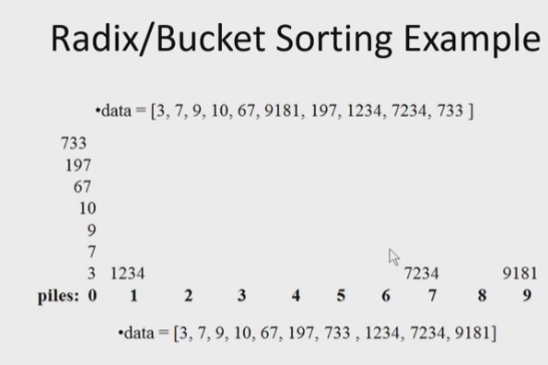
* 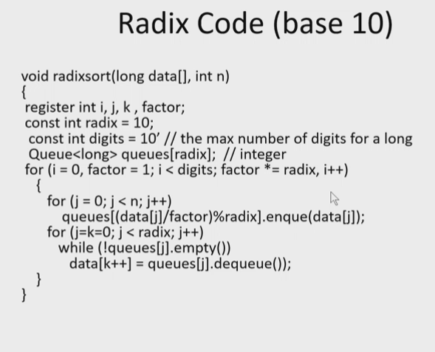
* 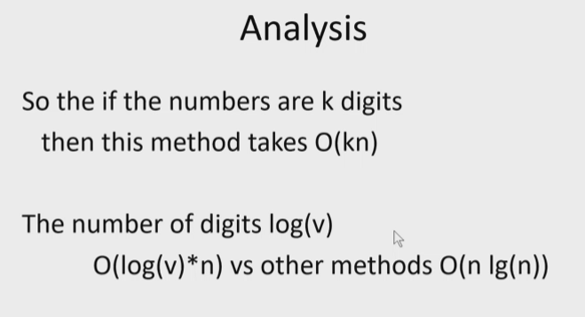
* 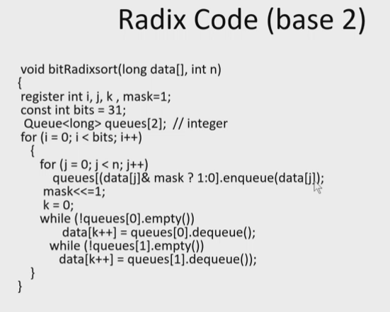
* Comparison summary of sorts:
* 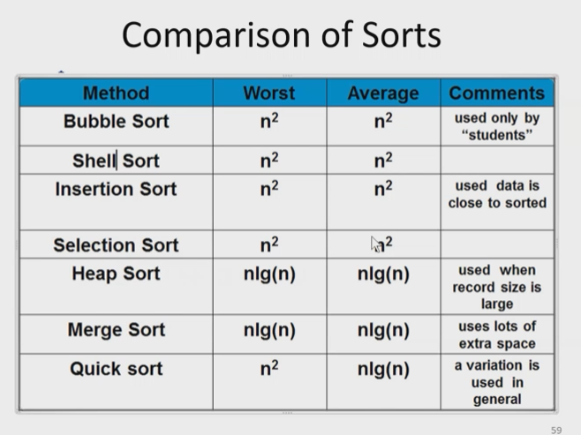
* Frequency sort
* 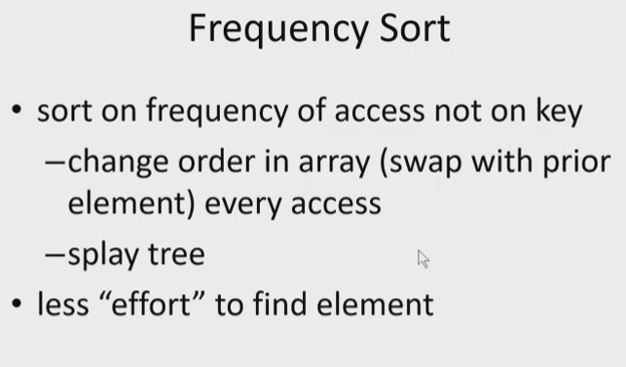
  + We covered this concept in first part of semester by using Splaying to the root methods
  + This allows the most frequently accessed elements to be higher up in the tree (closer to root) so that it takes less time to find them
* 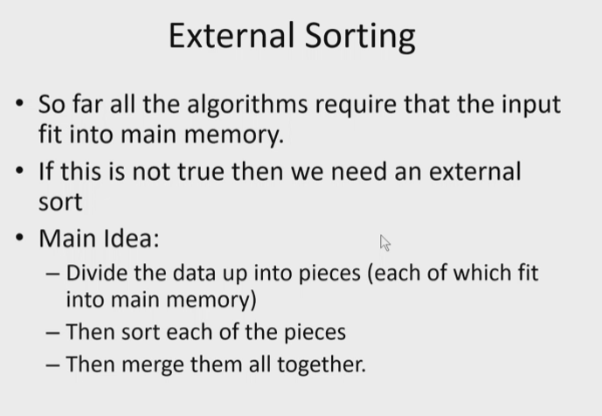
* Searching
* 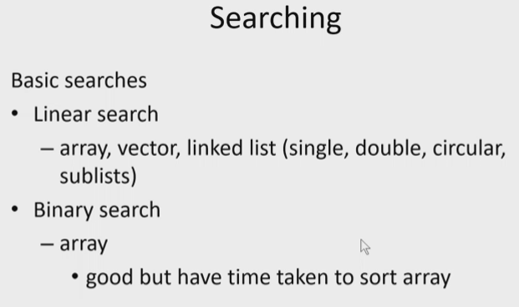
* 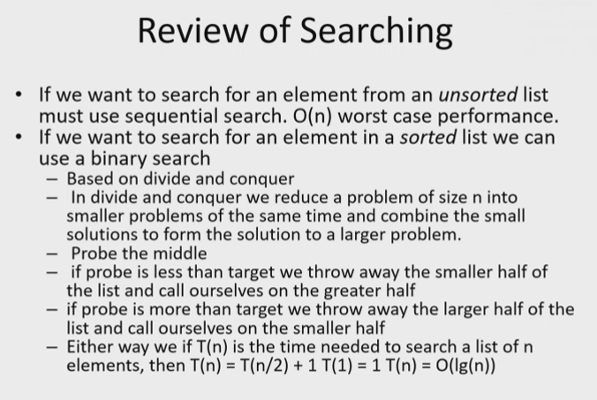
* 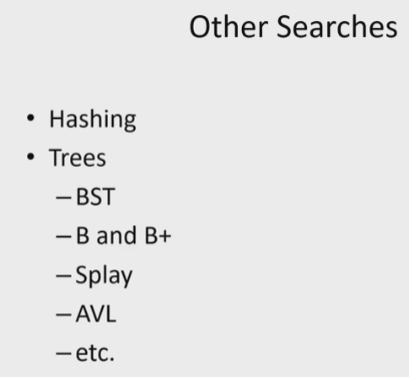
* 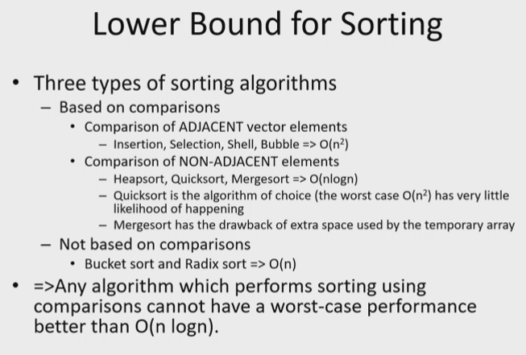
* 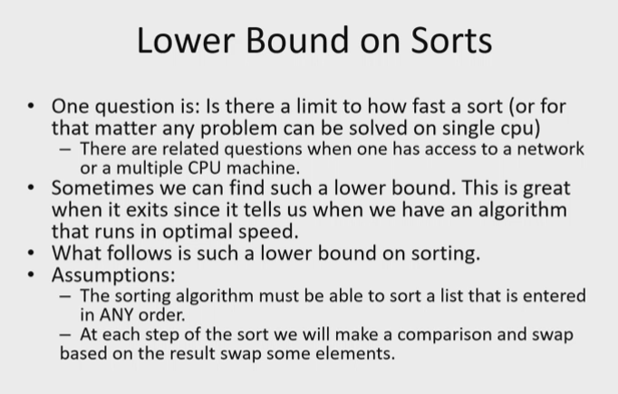
* 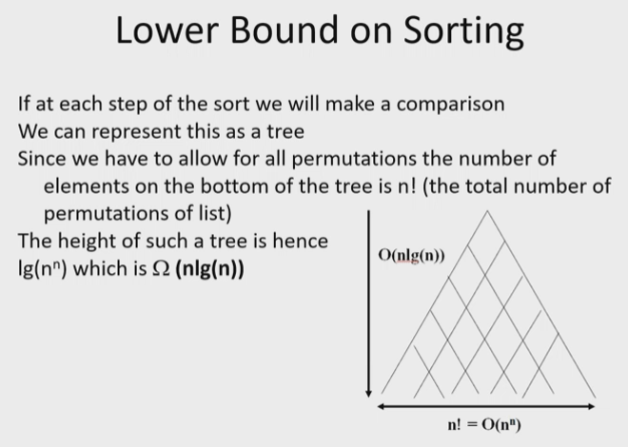
* 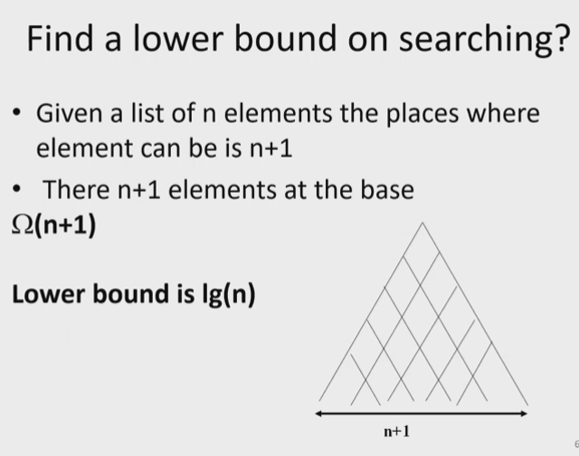
* 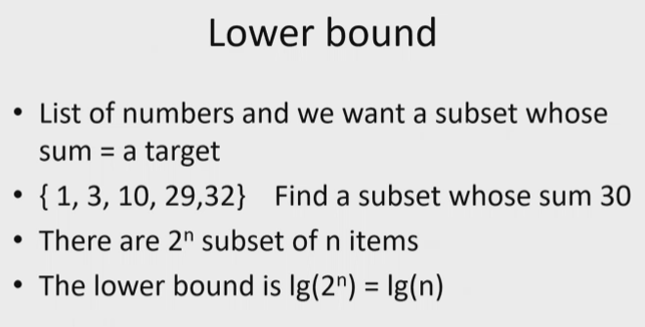
* 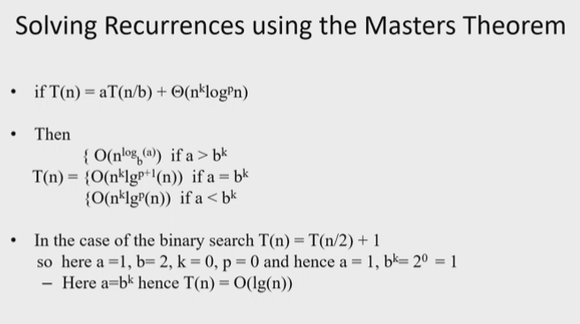
* 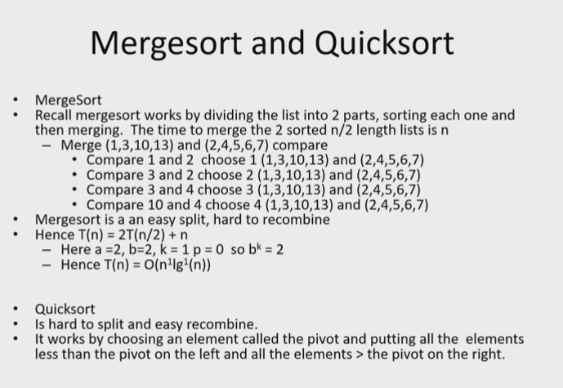

# Lecture 25 – 8/17/21 – Branch and Bound

## Final Exam will be opened on August 22, and due on the 23rd -> Monday at midnight ( a little over a full day to do it)

* Make sure to show all steps

## Branch and Bound

* 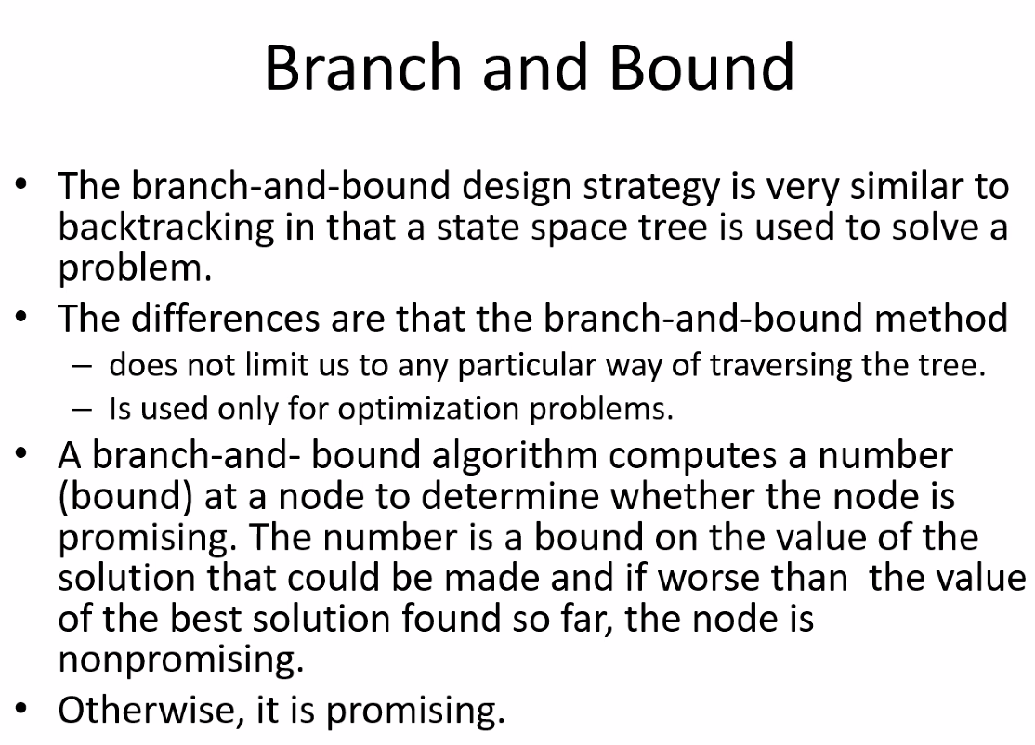
* 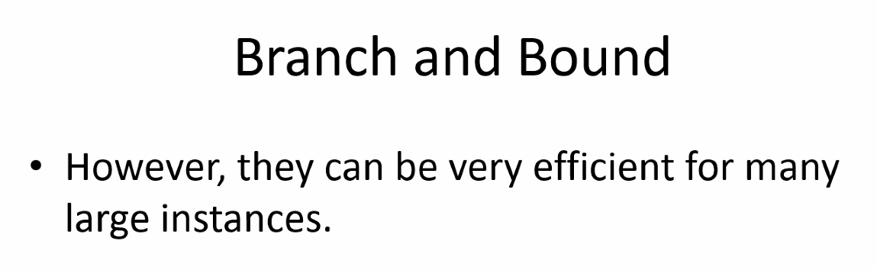
* 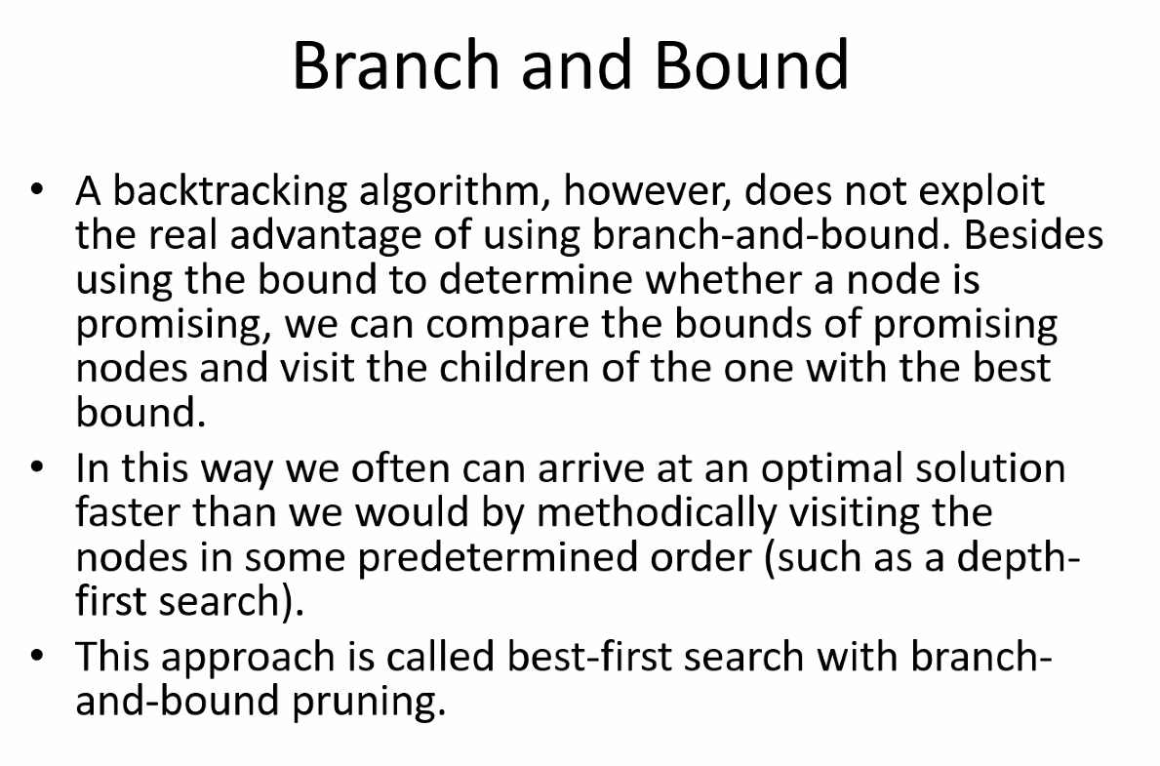
* NOTE FOR PROGRAM 5: If a word or phrase is not in the table, then YOU WILL HAVE TO PASS EVERY ELEMENT IN THE TABLE. ONCE THAT HAPPENS THEN YOU KNOW WORD/PHRASE IS NOT IN TABLE. BOOM!!!!
* 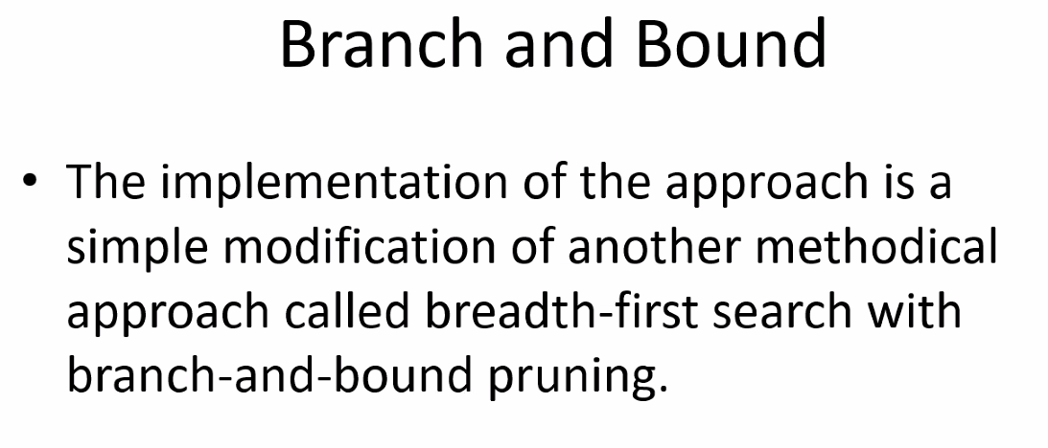
* Breadth: searching along level by level
* 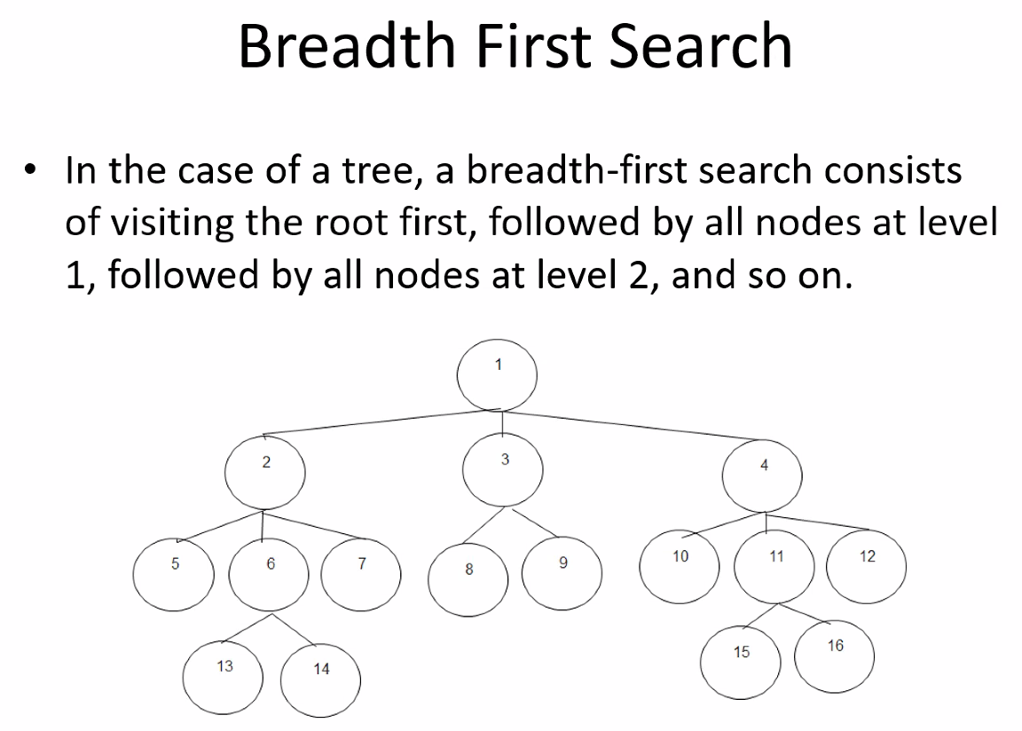
* 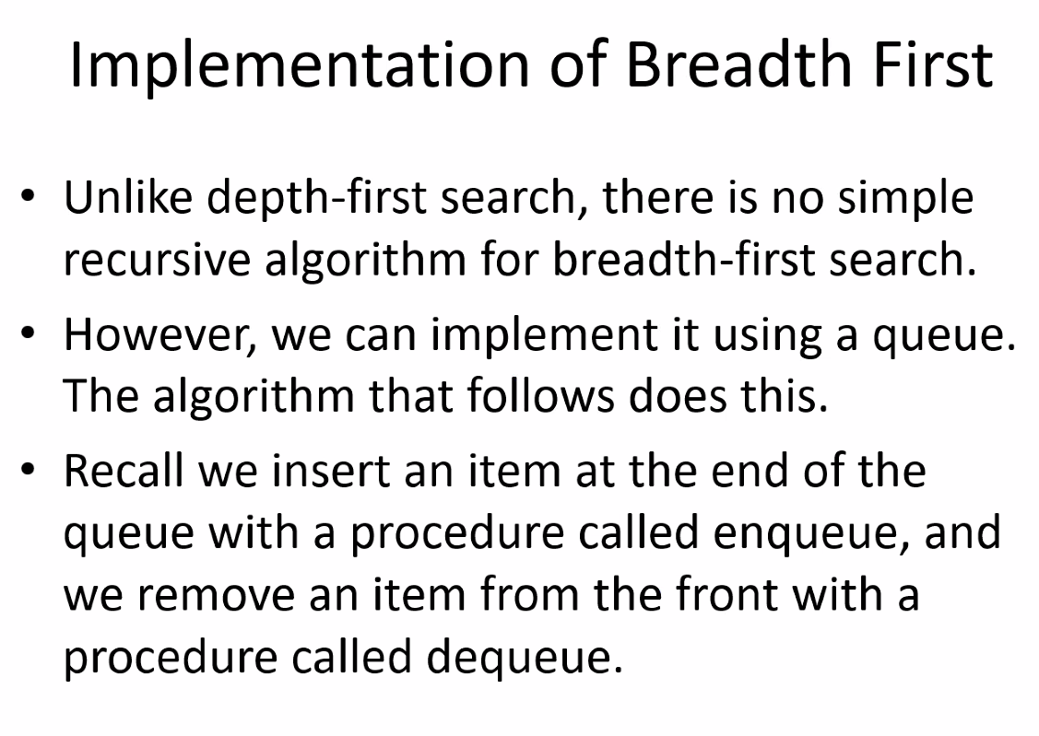
* 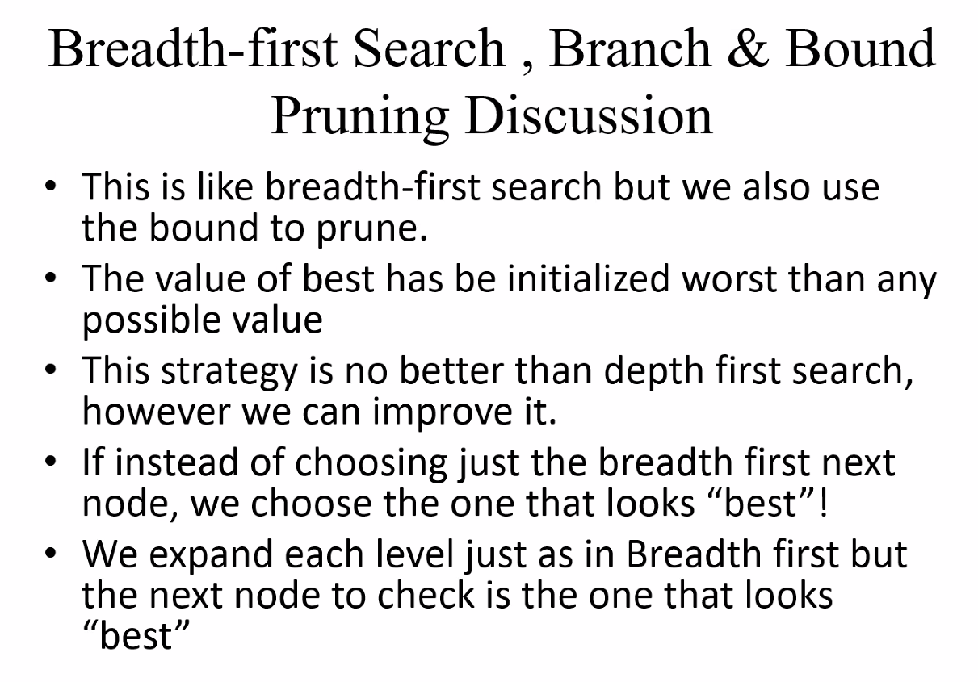
* 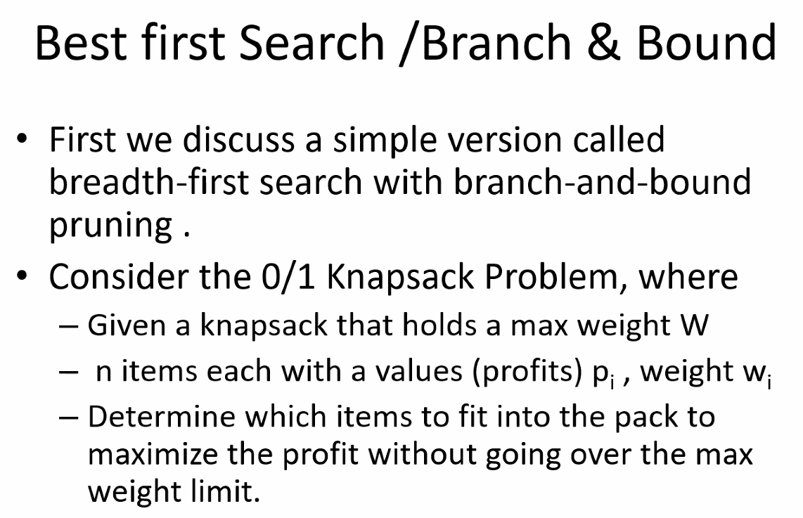
* 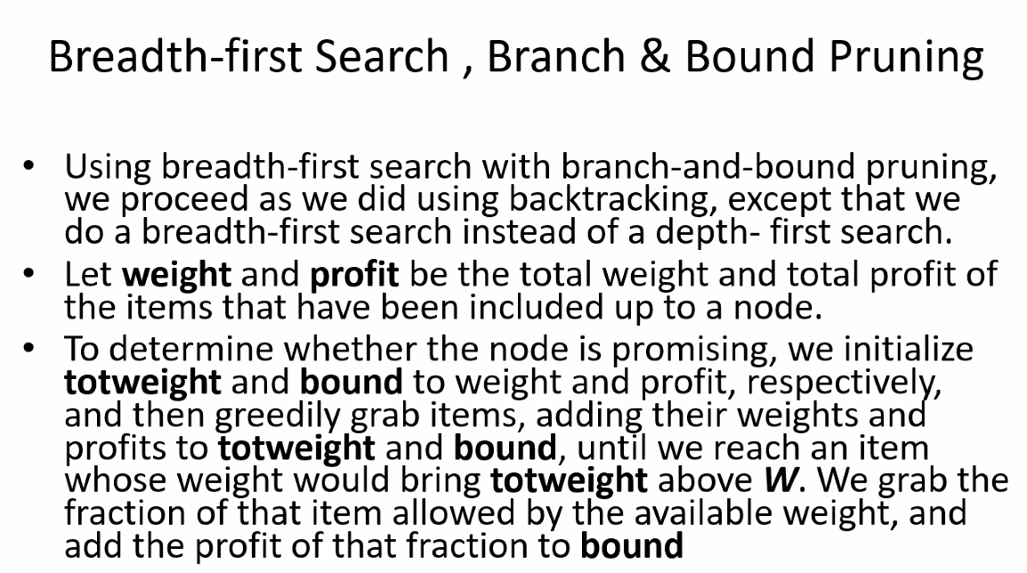
* 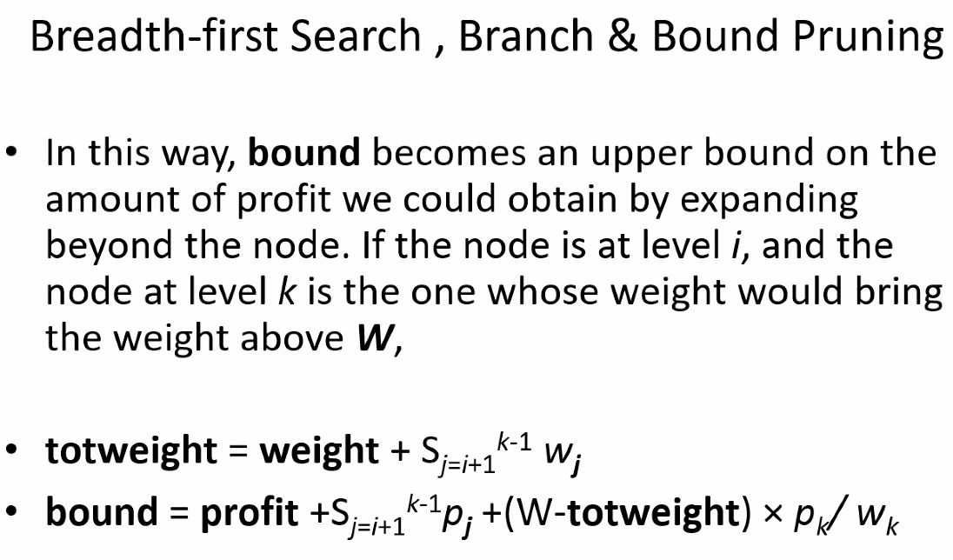
* 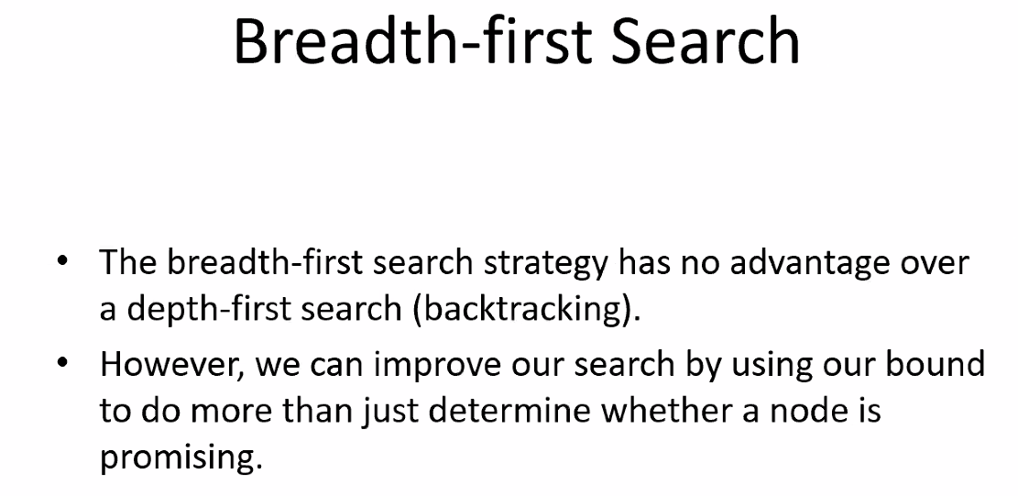
* 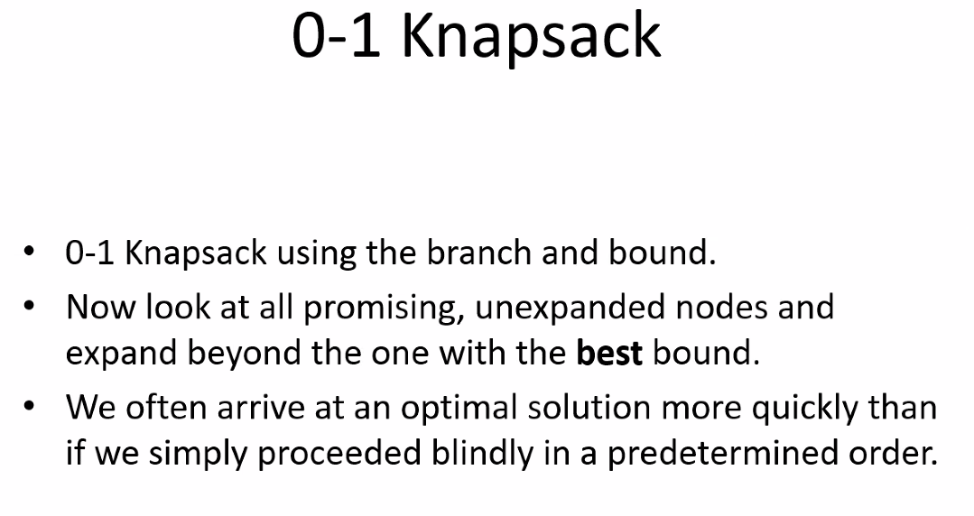
* Tree is usually a state space tree on which you do a breadth first search, with each node having a respective bound
* 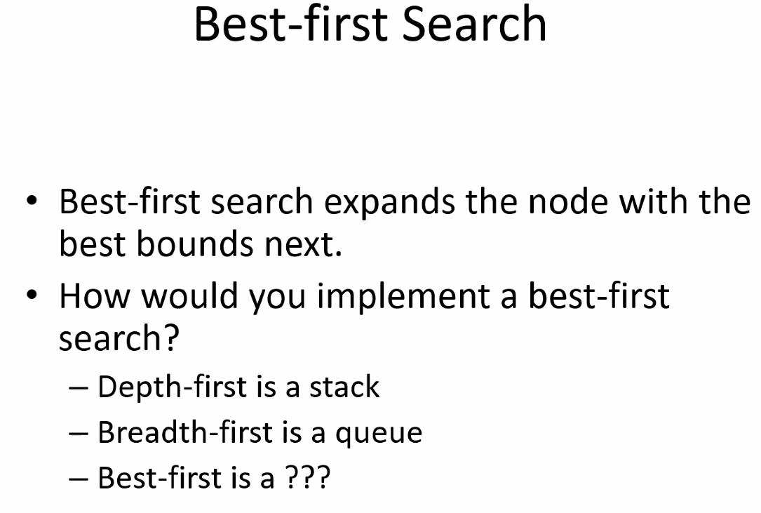
  + Best first could maybe be a priority queue; but you have to determine the approach for best first
* 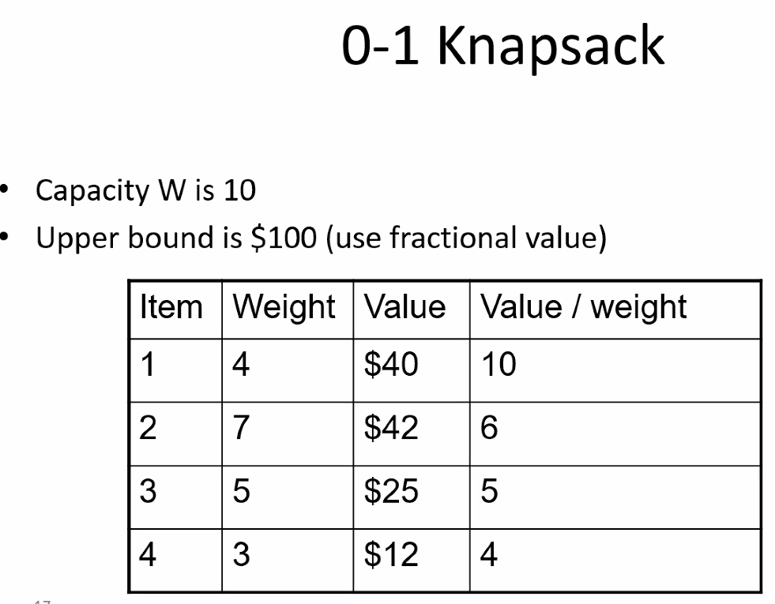
* 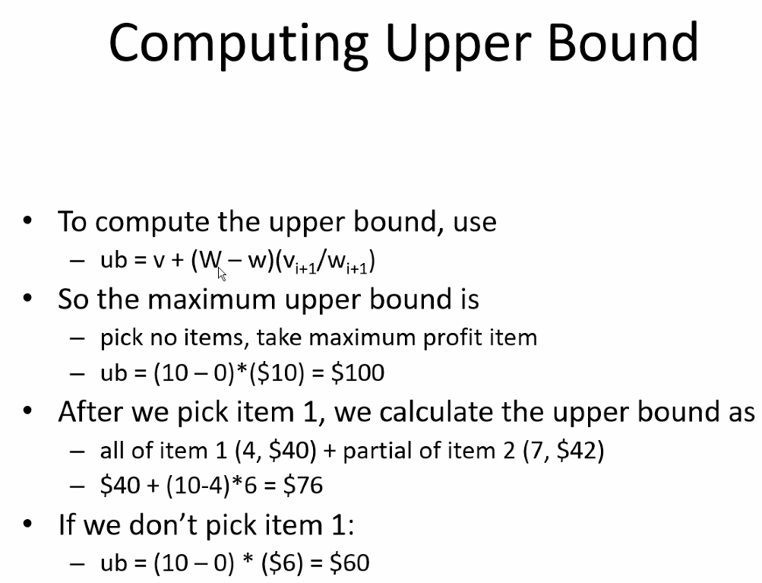
* 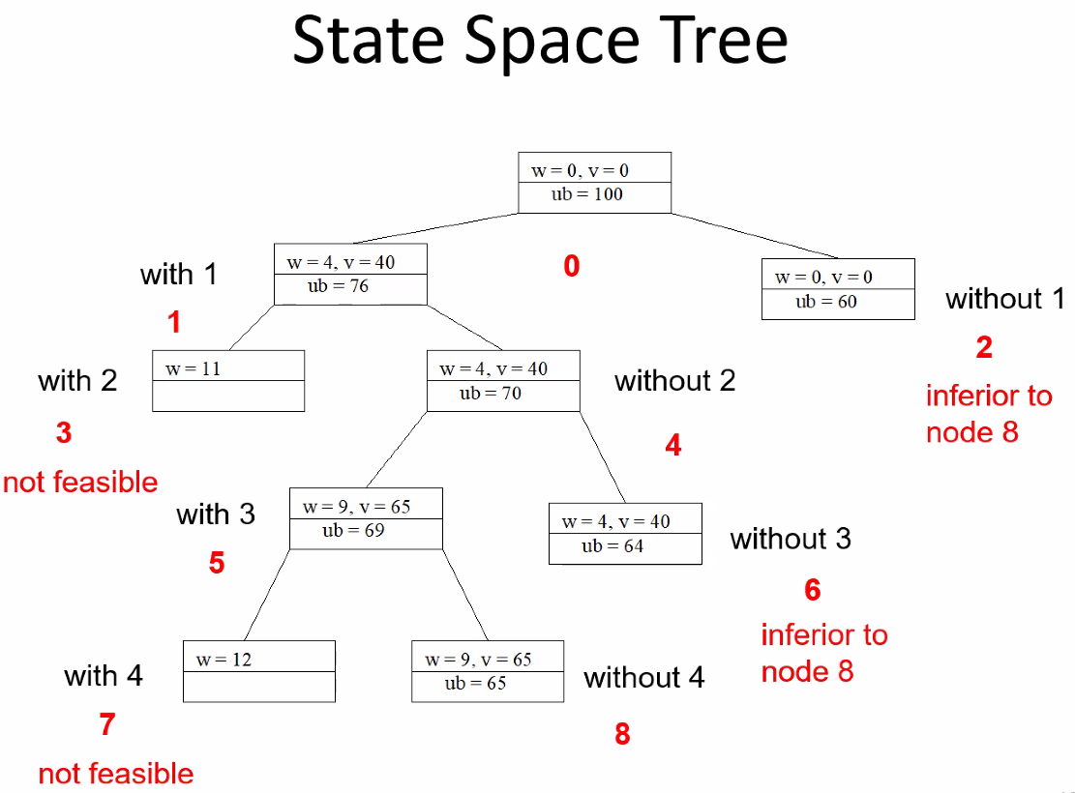
* Remember to keep in mind how upper bound is calculated given a set of items that are in the bag
* **Above, node 8 is considered the optimal solution: so with 1, without 2, with 3, without 4 is the solution path**
* Note: state space tree is typically built as you go; number of children that nodes have depends on the scenario – you have to determine that; for example: if your first pick is out of four things, then you might have the first level have four nodes (root has four children)
* 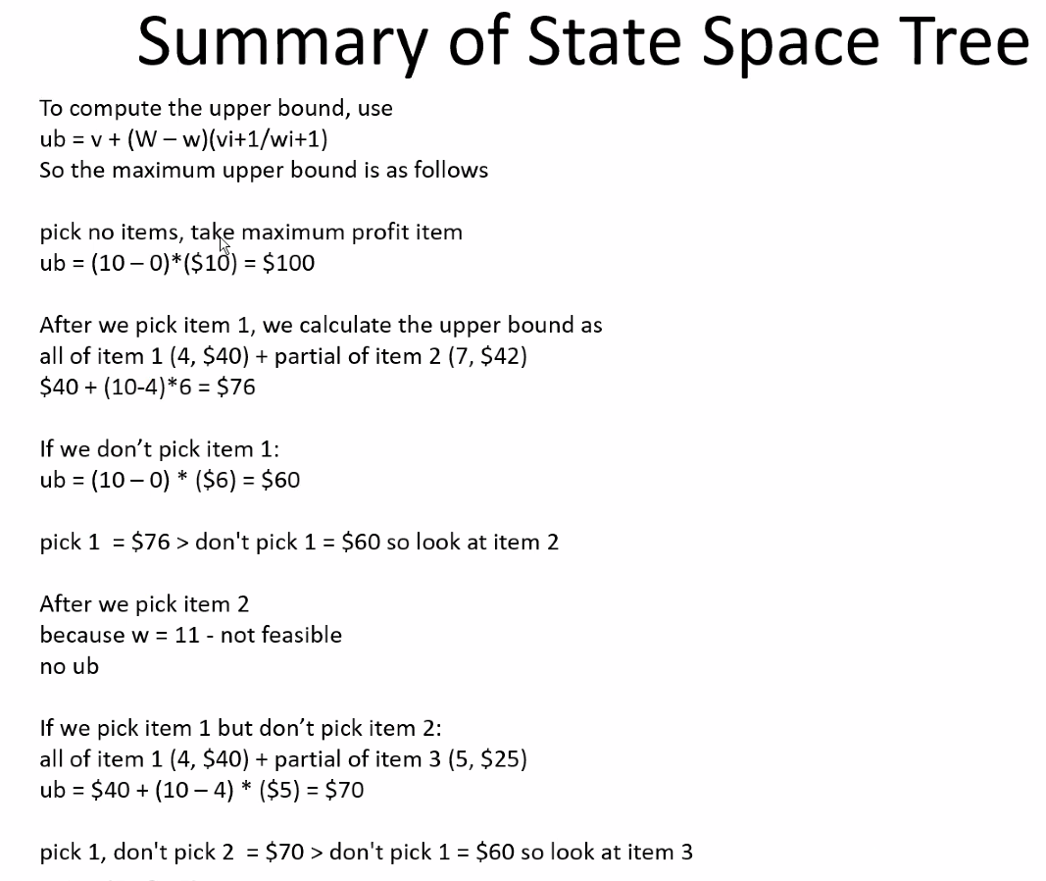
* 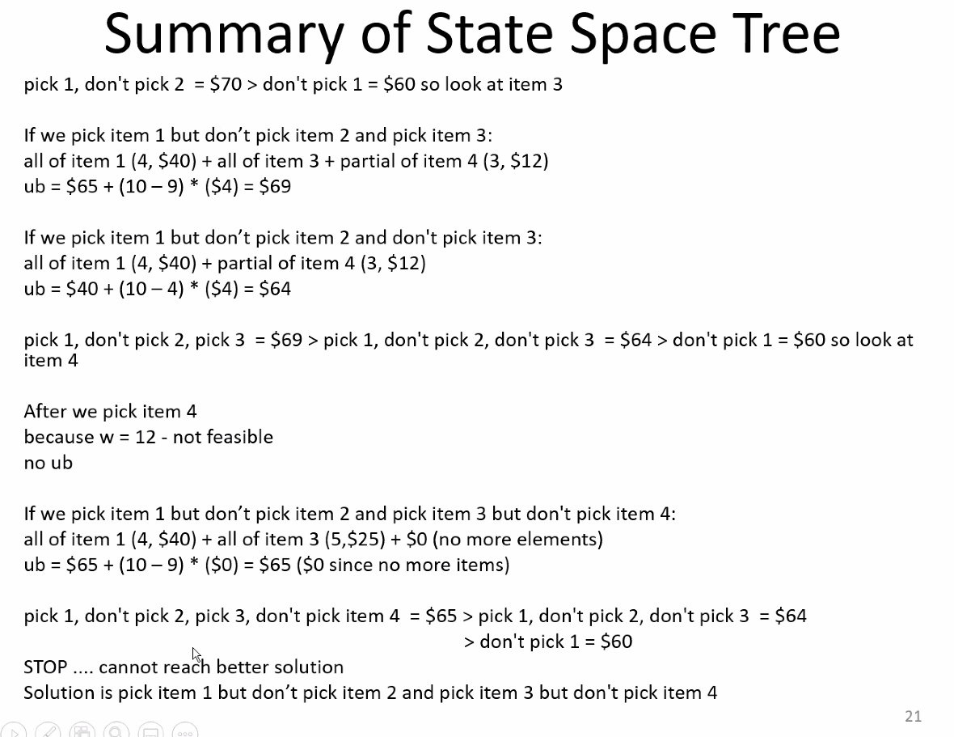
* This is not considered a greedy algorithm because calculations are made to predict the future scenarios and pick the best path rather than the best at the moment approach (greedy)
* Bounding:
* 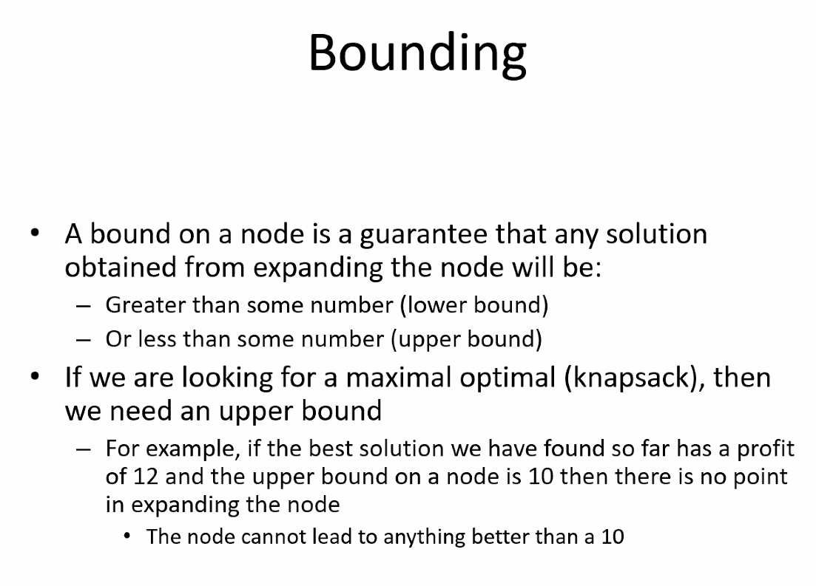
* 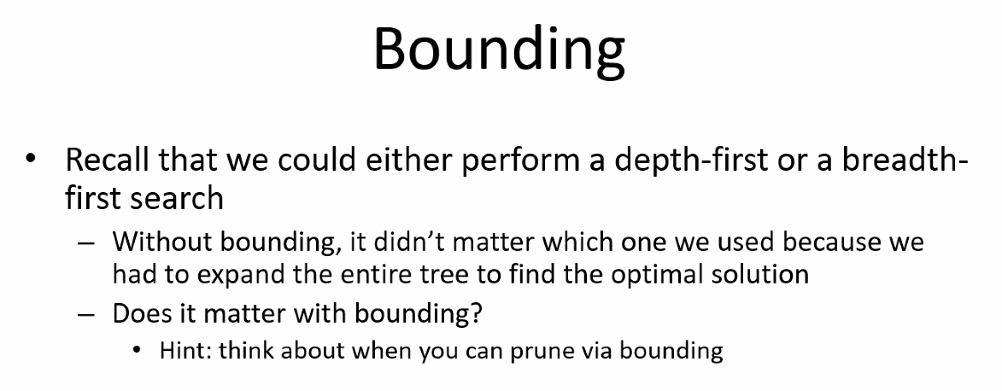
* Prune == ignore/cancel out/close out a path
* 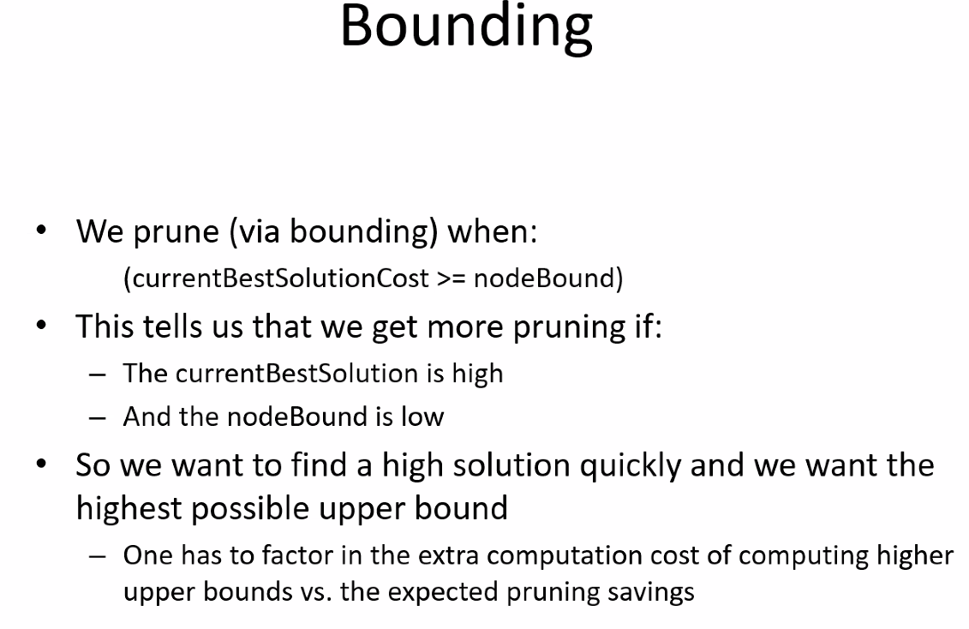
  + So for small amount of data you would not want the extra overhead of calculating bounds every time you check nodes on a given level( but you do not calculate bounds for all nodes at once! – bounds are calculated only for all nodes on the current level so that they can be compared) – even still, it may be inefficient to use such an approach
    - Remember: bounds are calculated as you go and as you build table based on the bounds calculated for all nodes only on the current level
* 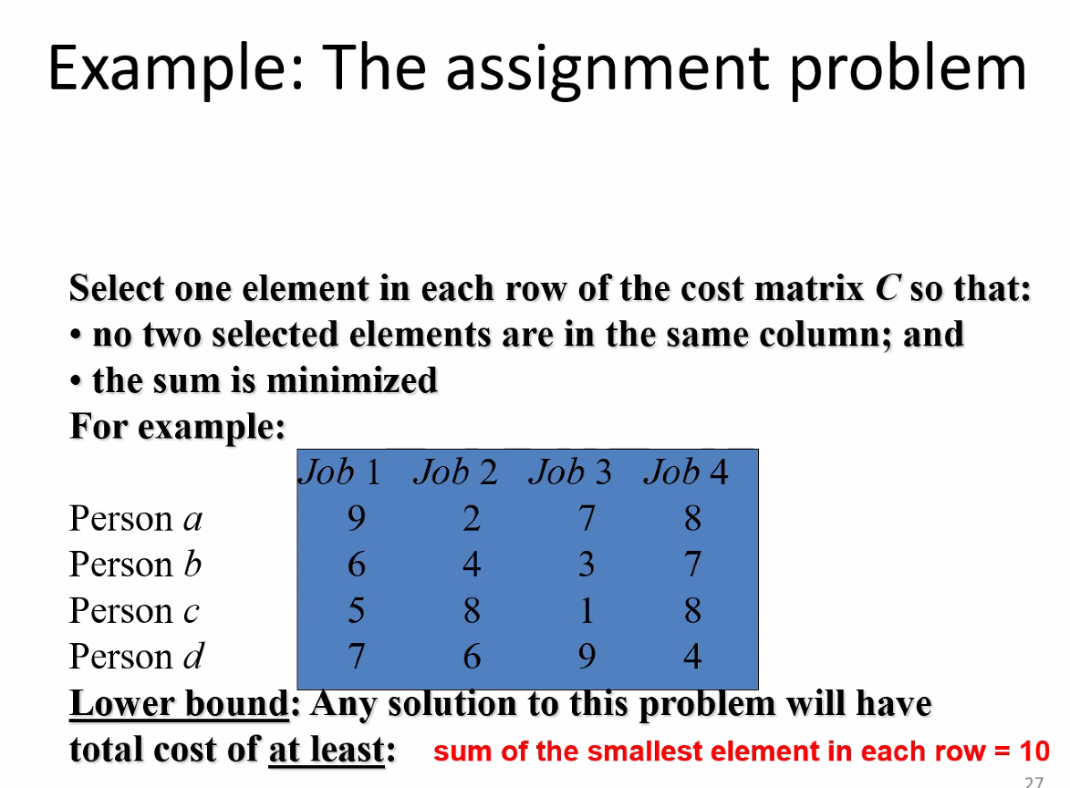
* 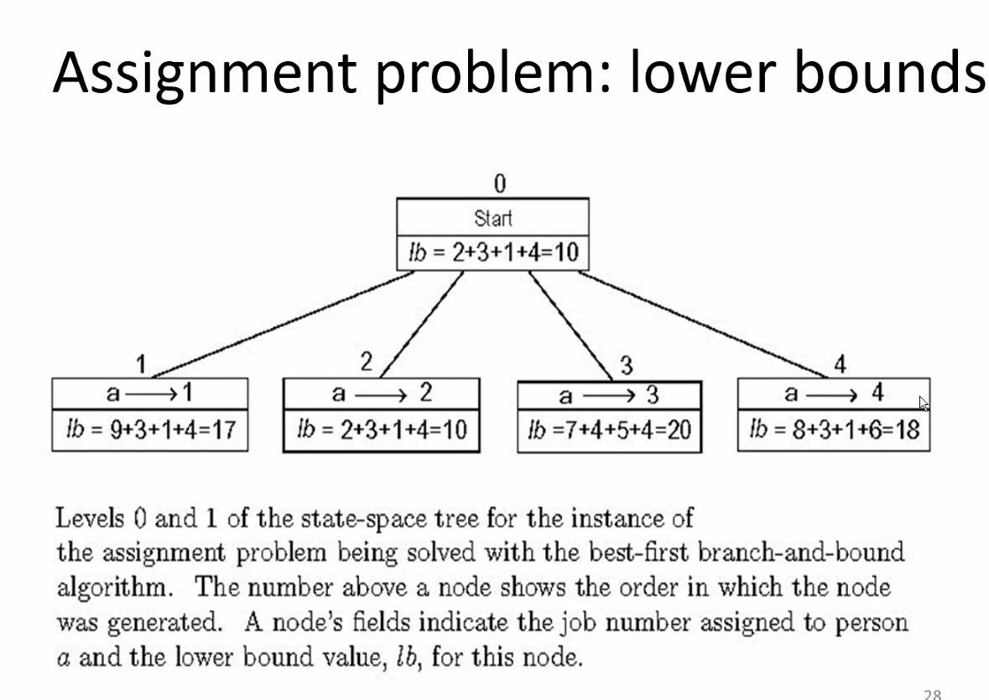
* 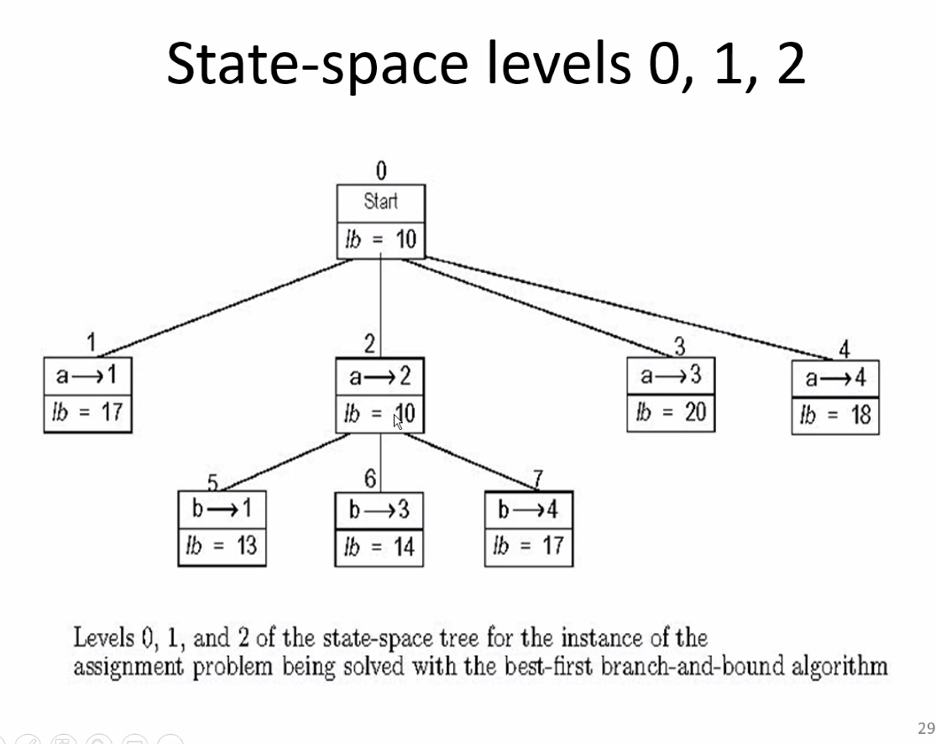
* Now because no jobs selected can be in same column, notice how next level only has 3 children each node, then the next level will only have 2 per node..etc…and notice how we pruned off the other nodes as we do the breadth search first and find the smallest cost/value
* 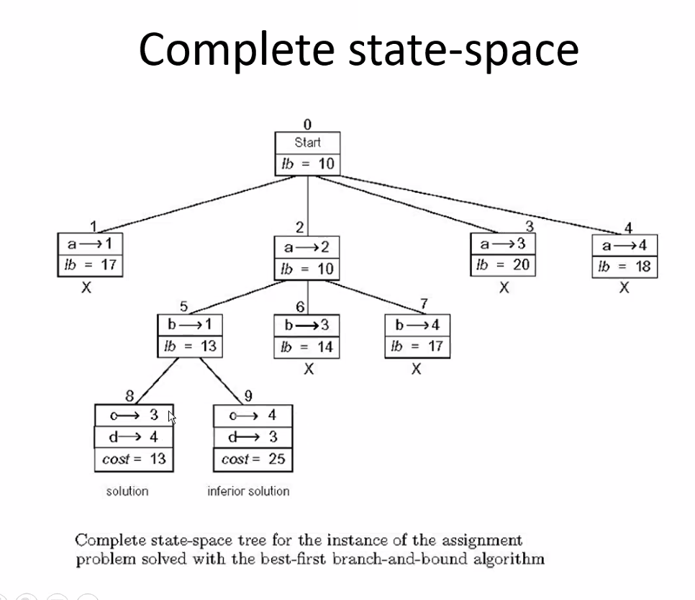
* Notice how in this perfect example we see how the state space tree is built, how each level calculates bounds for comparison, and then how paths/nodes are pruned
* The X’s above show the nodes that were pruned off and then continuing until we find the solution path
* 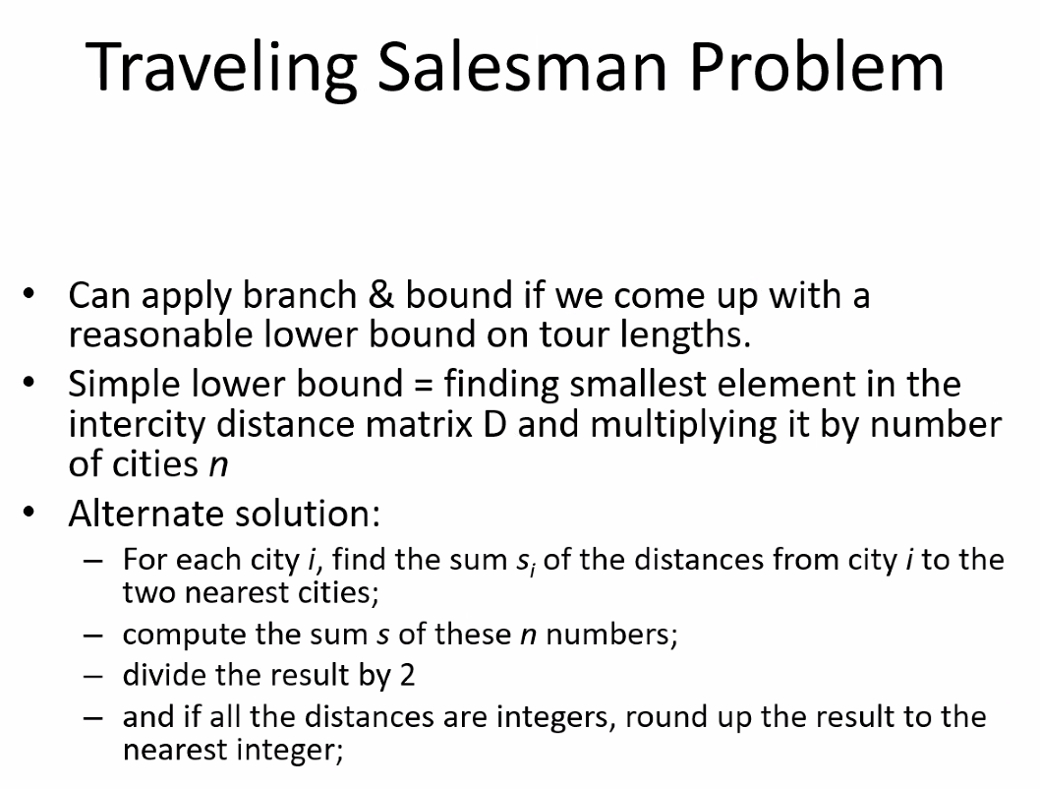
* 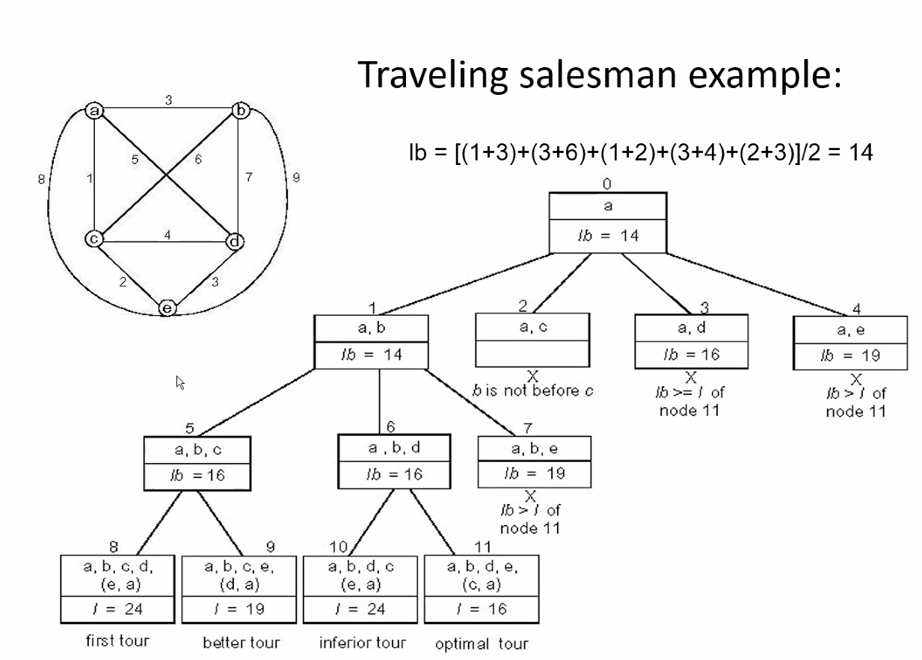
* 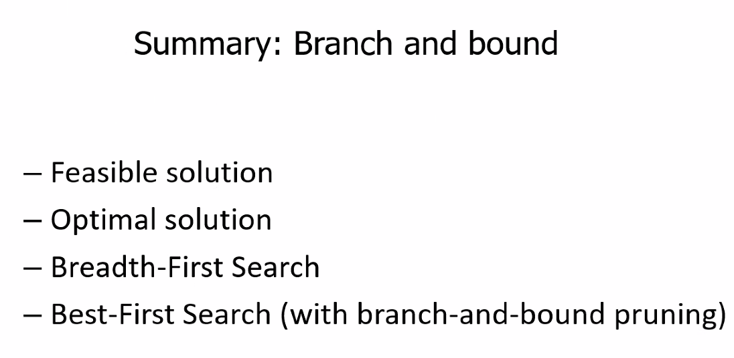
* 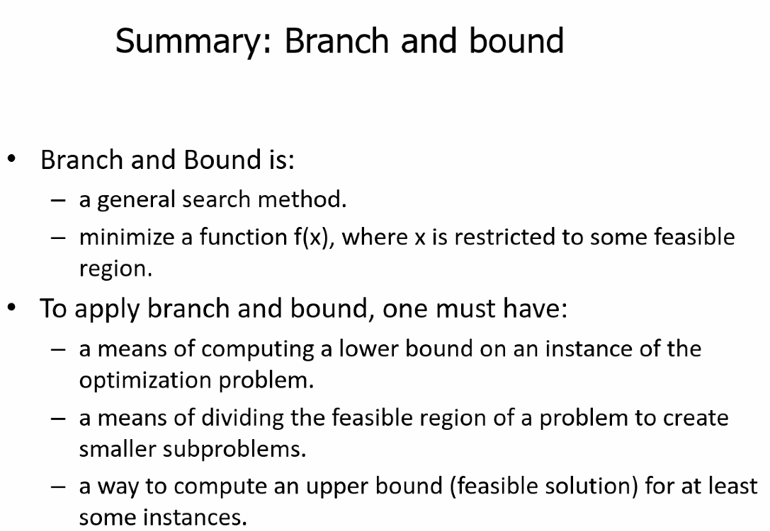
* 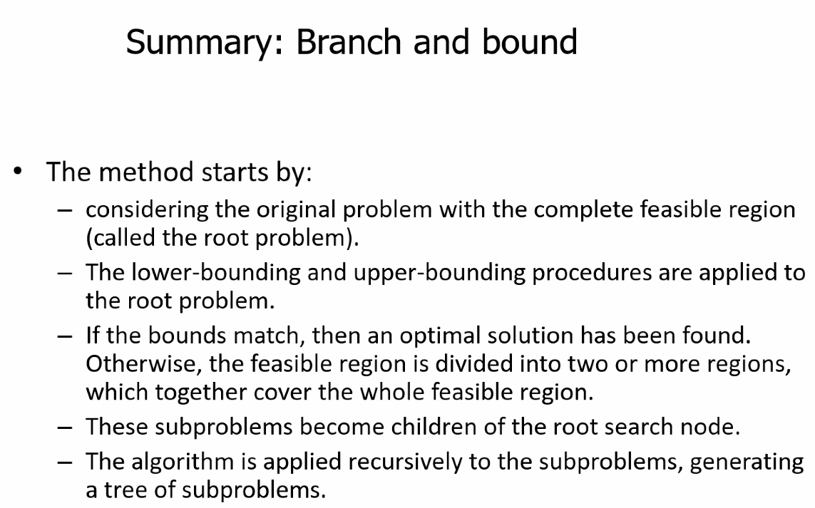

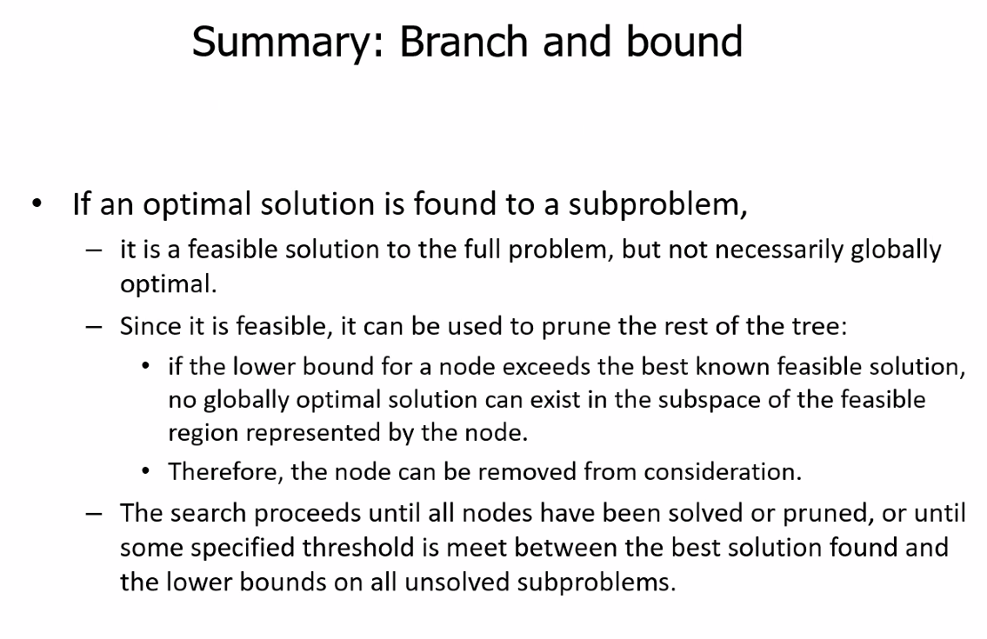

## Amortized analysis

* 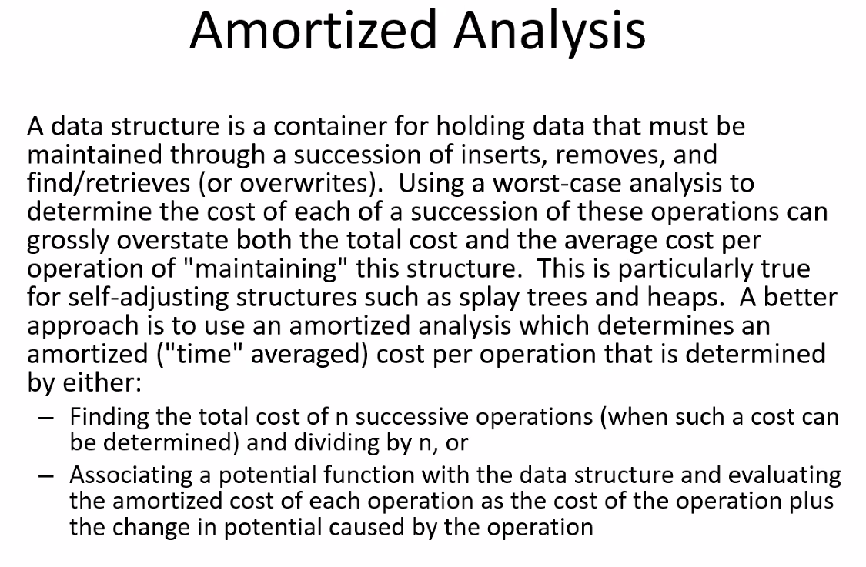
* 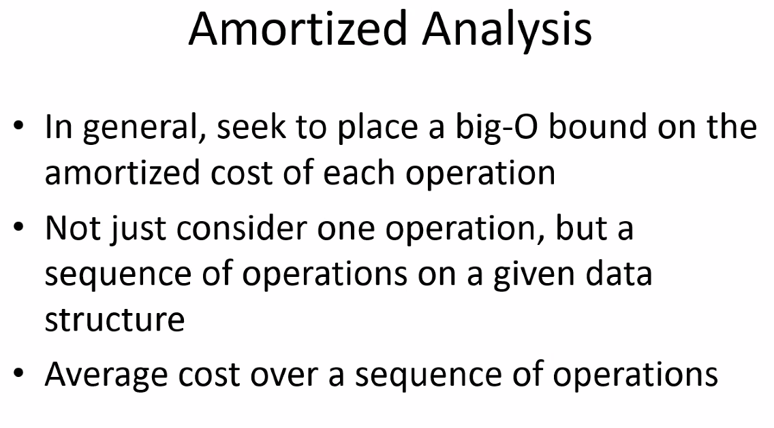
* 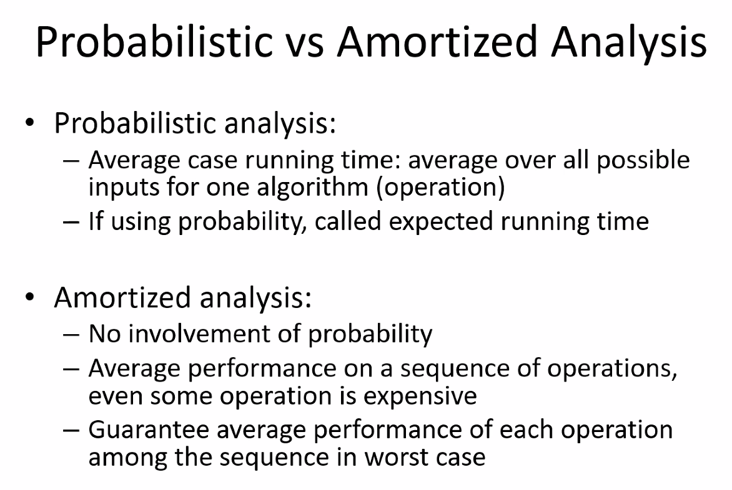
* 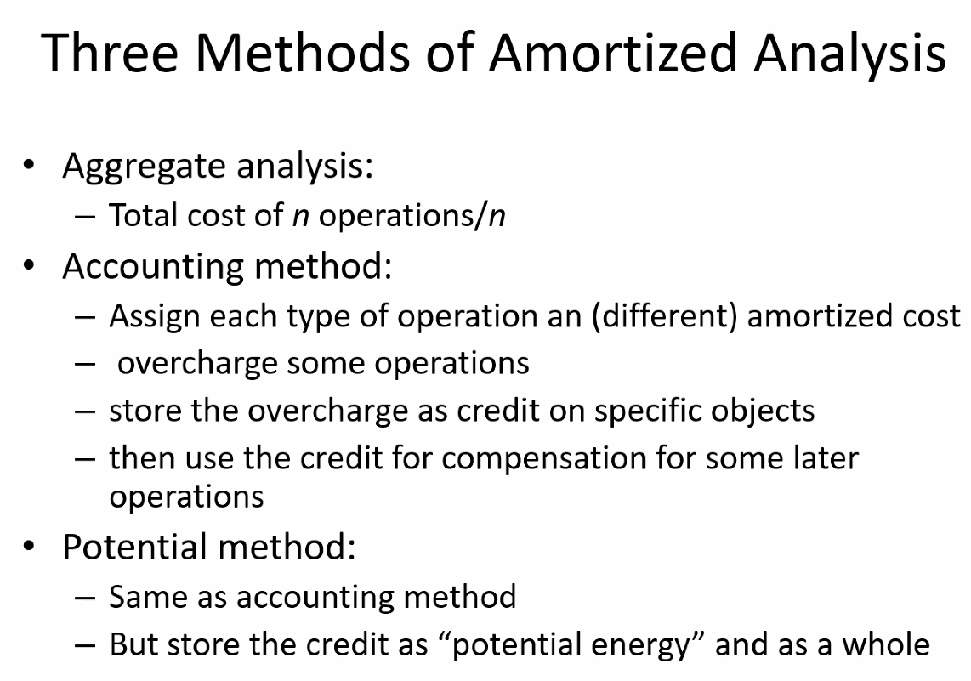
* 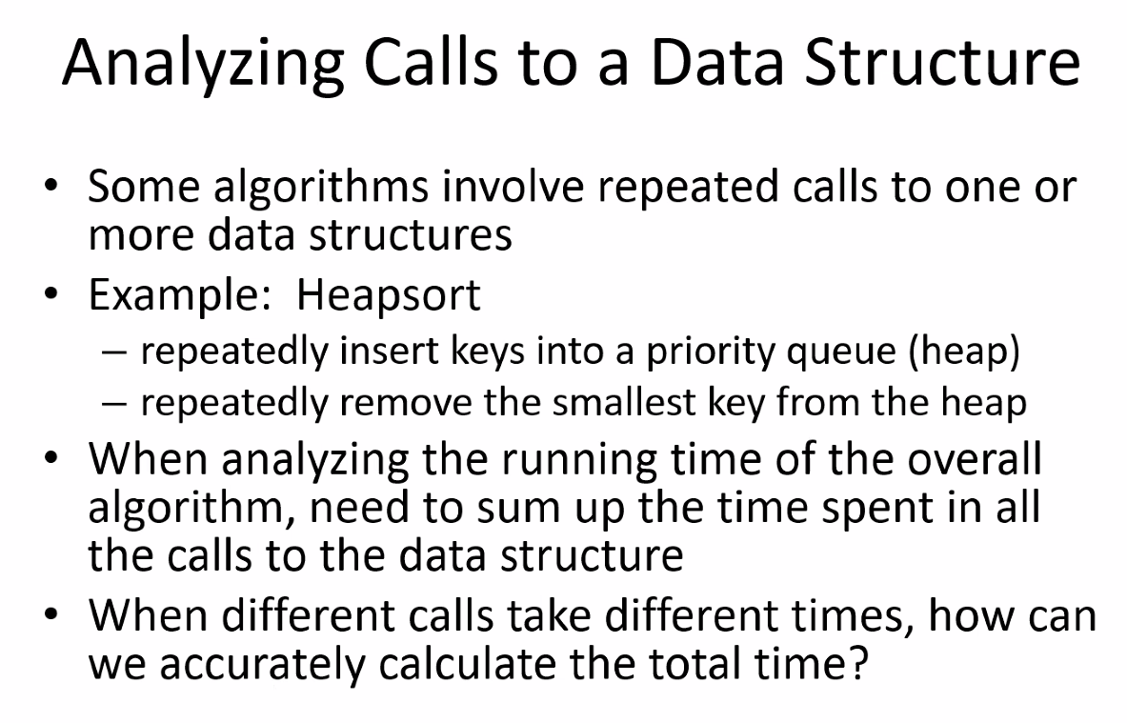
* 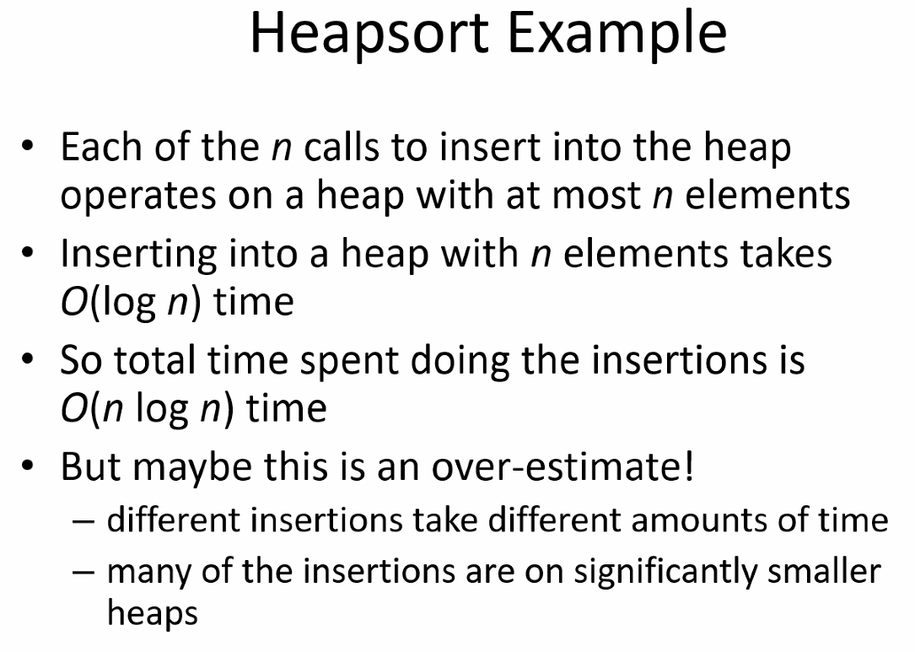
* 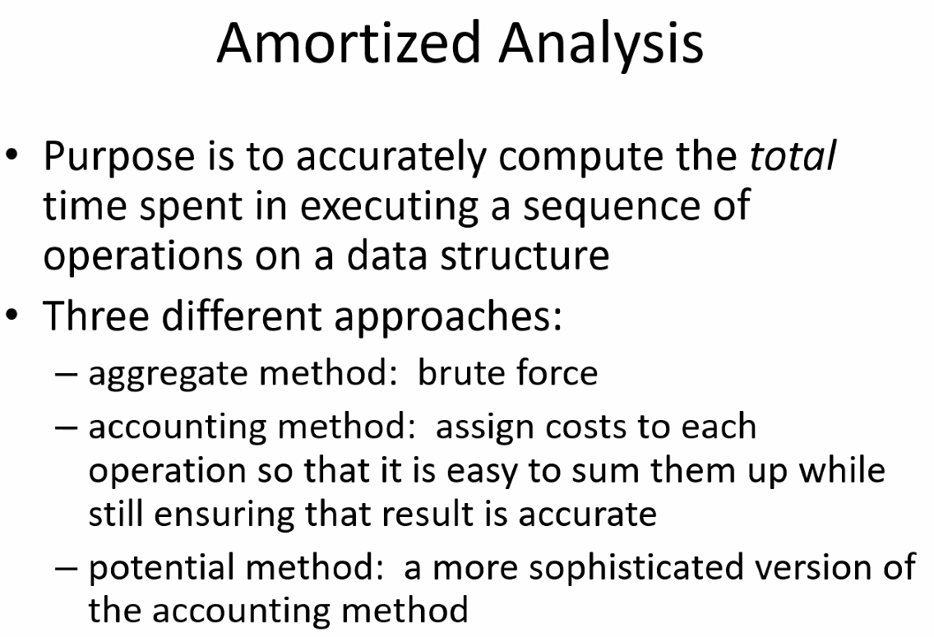
* 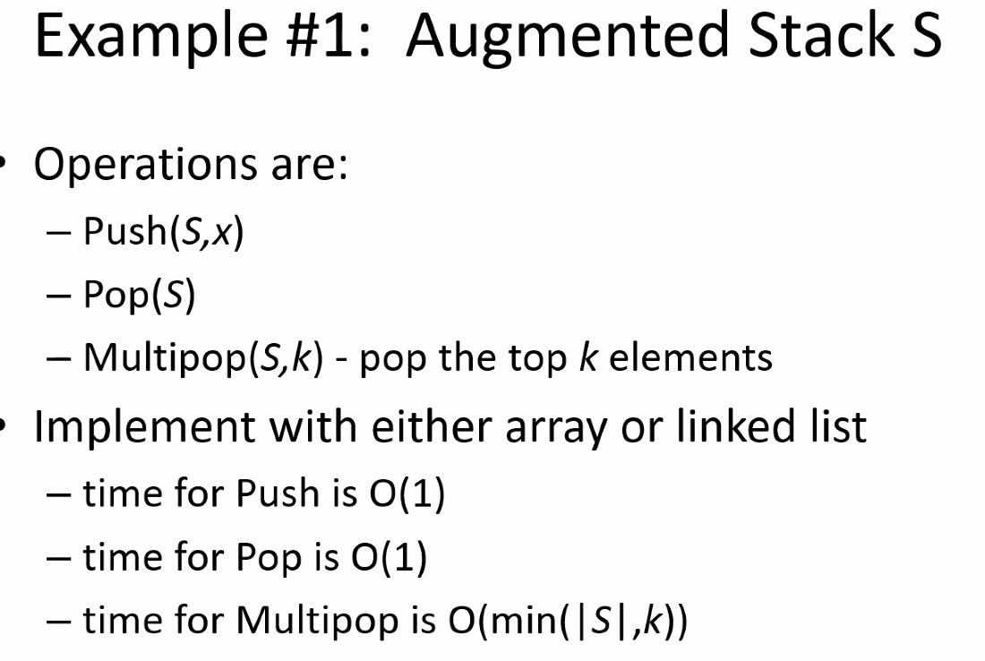
* 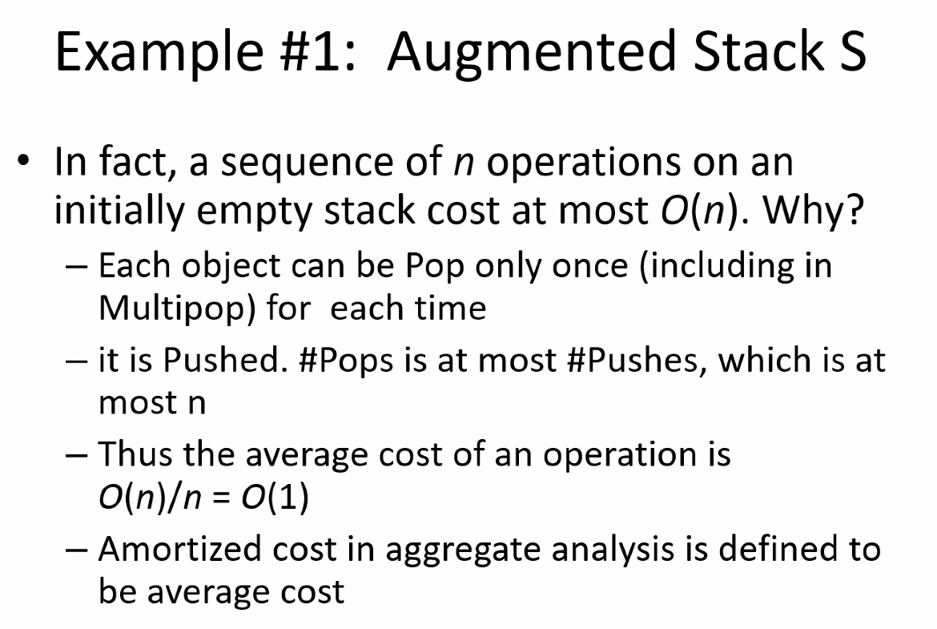
* 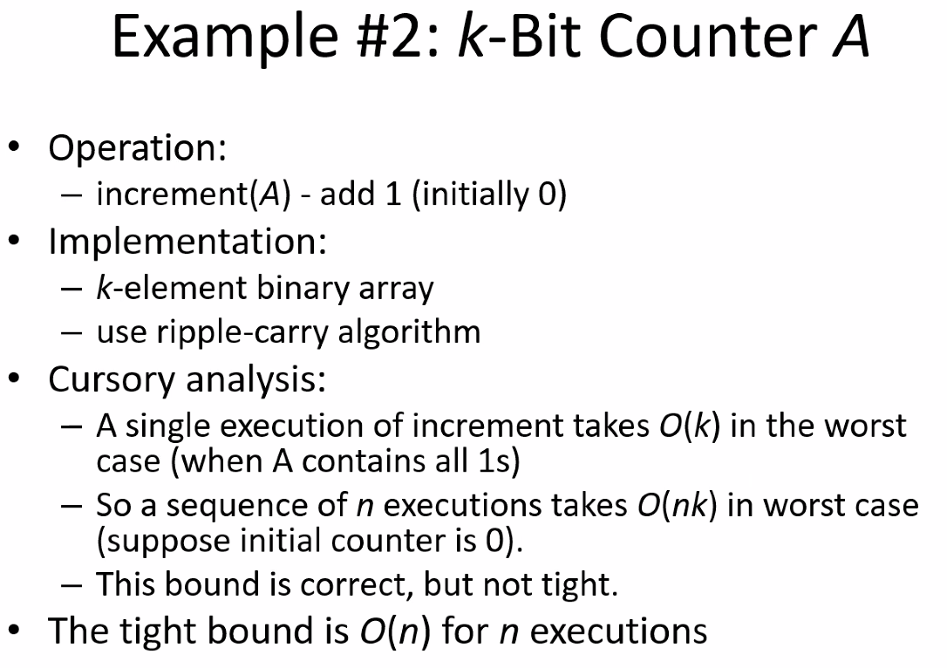
* 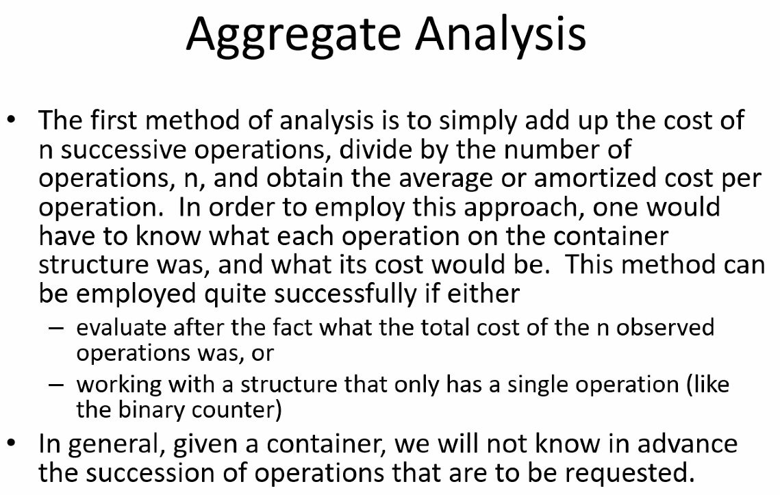
* 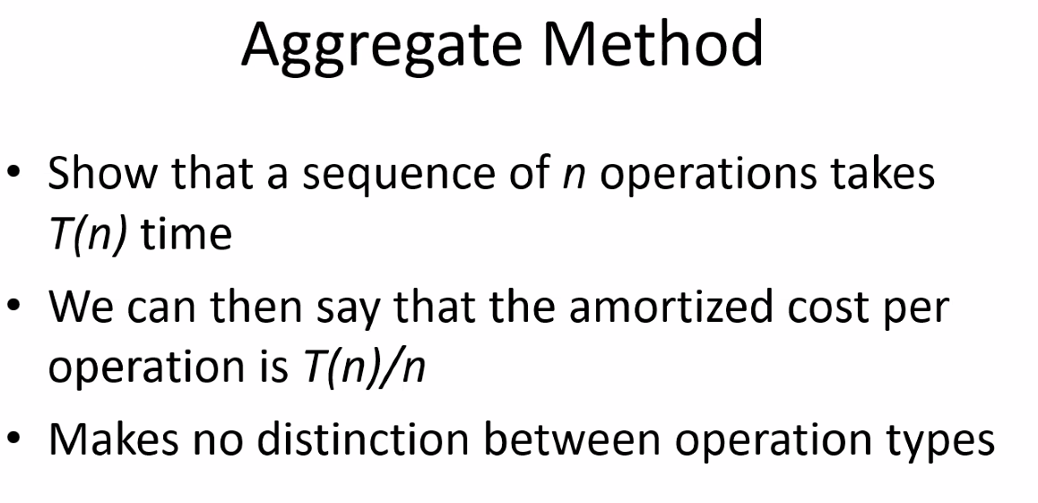
* 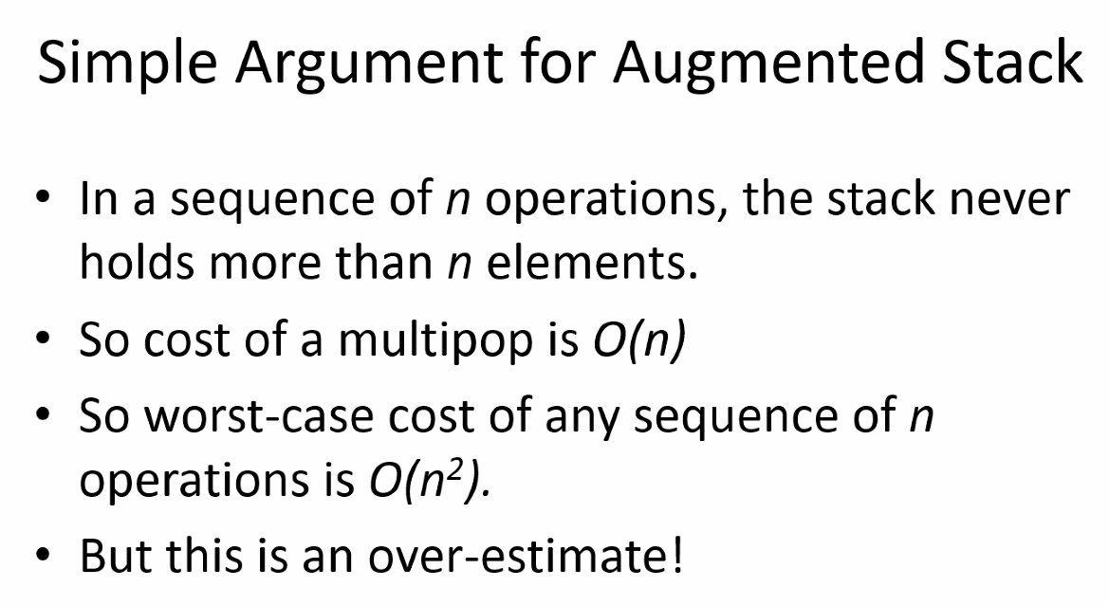
* 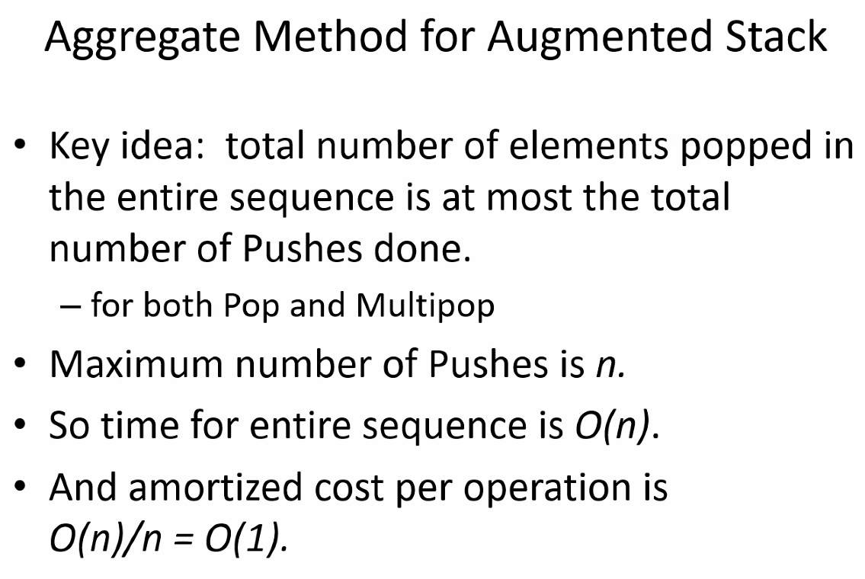
* 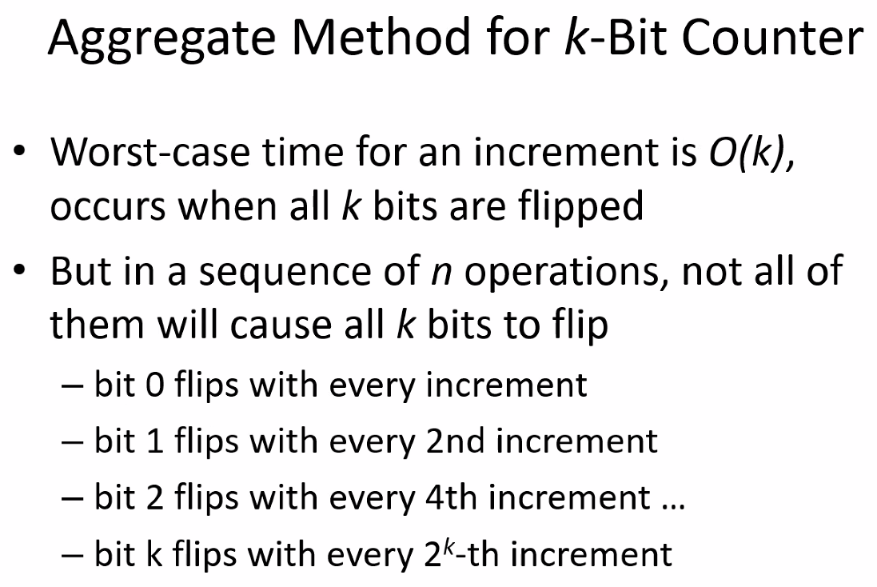
* 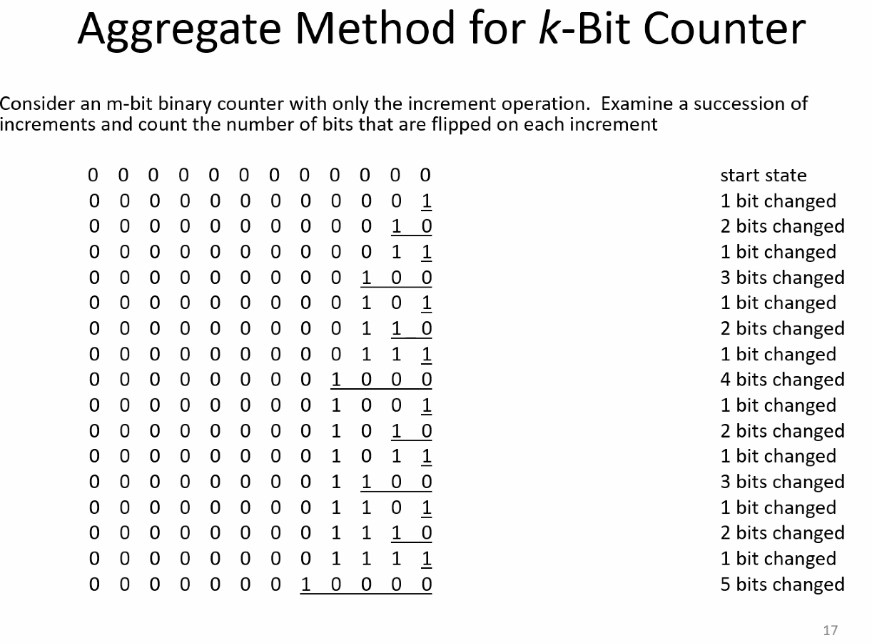
* Notice each line is an additional value; its simply a clock; above the table shows how many bits/how often bits are flipped based on the counter incrementing
* 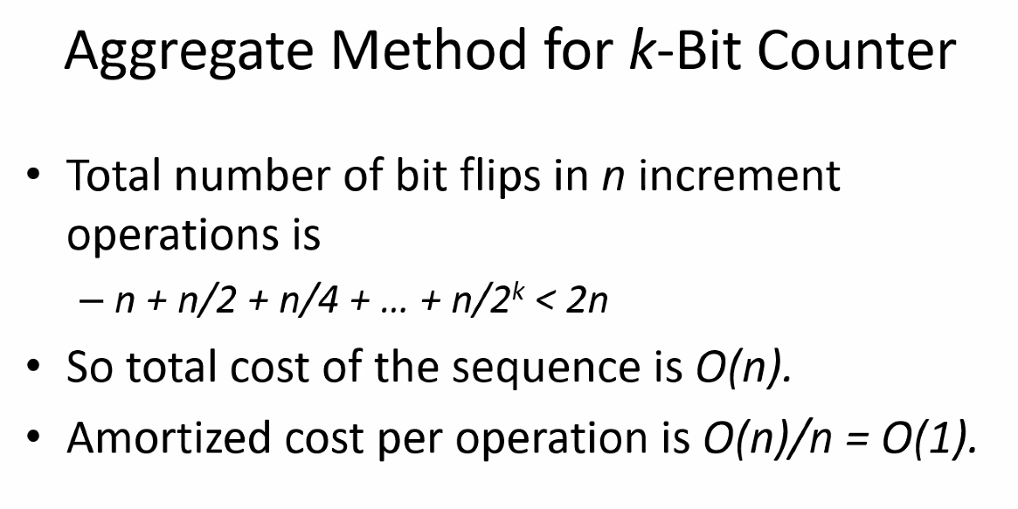
* 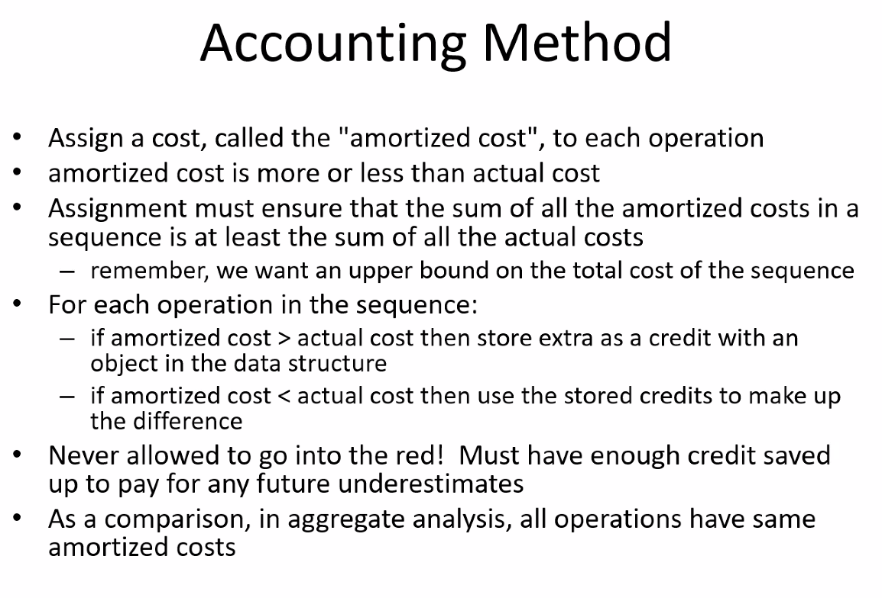
* 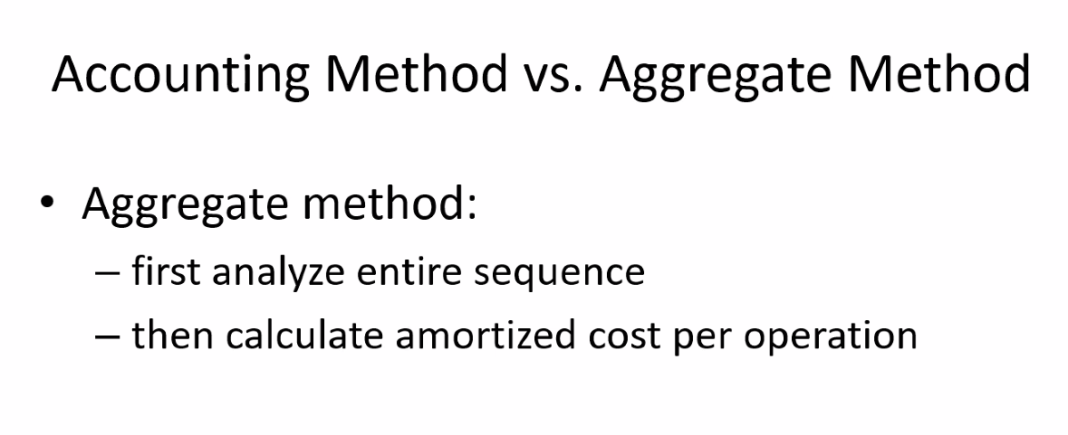
* 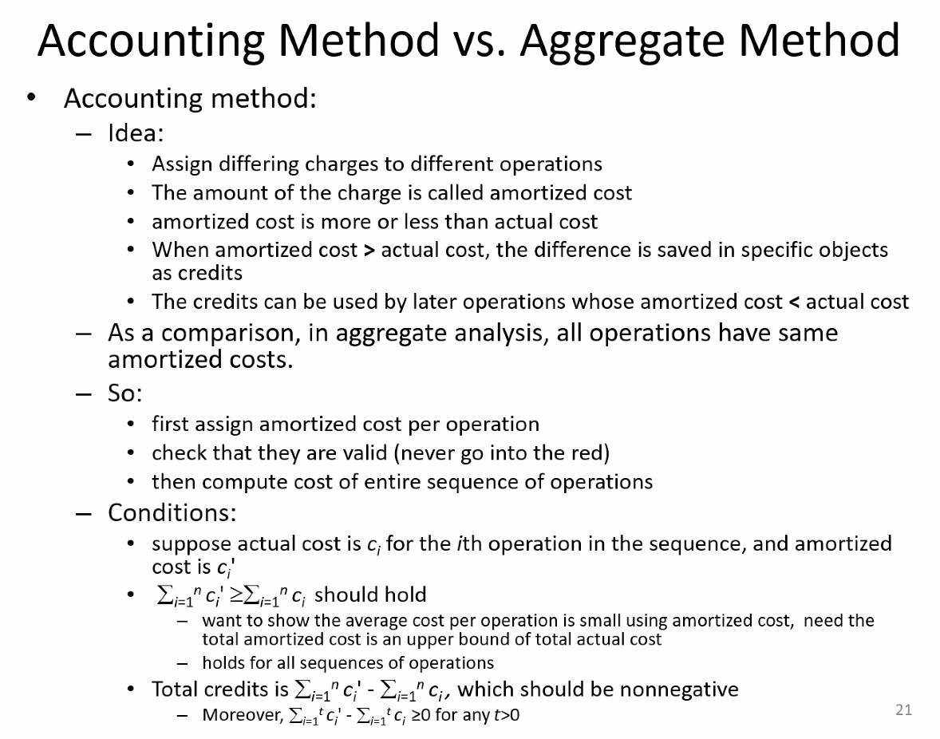
* 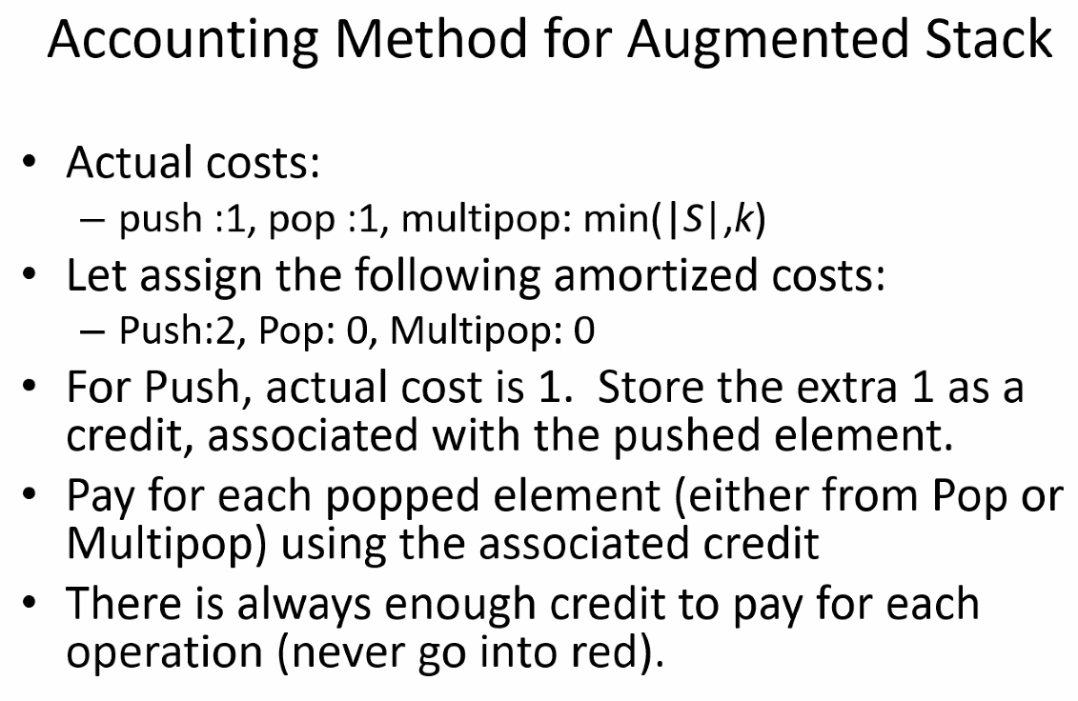
* 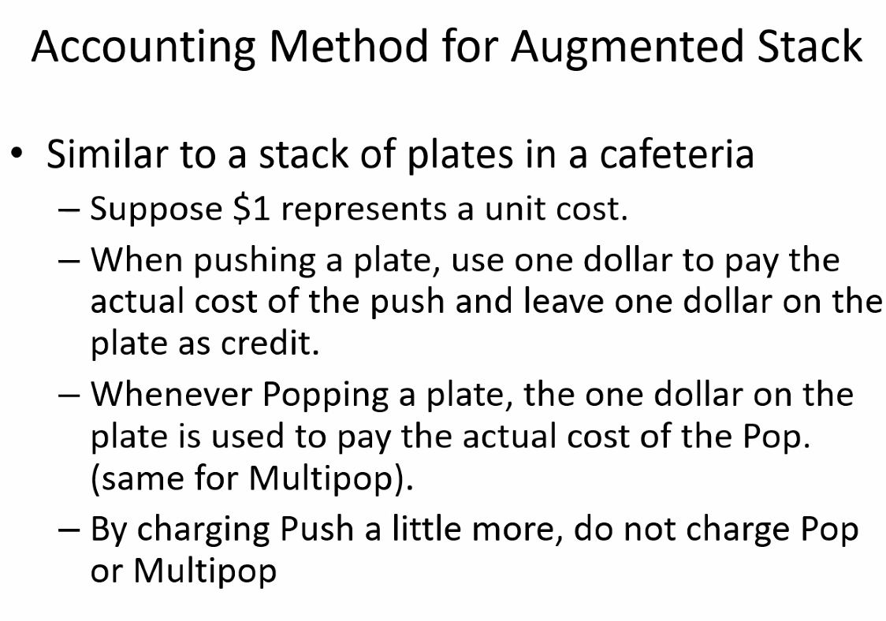
* 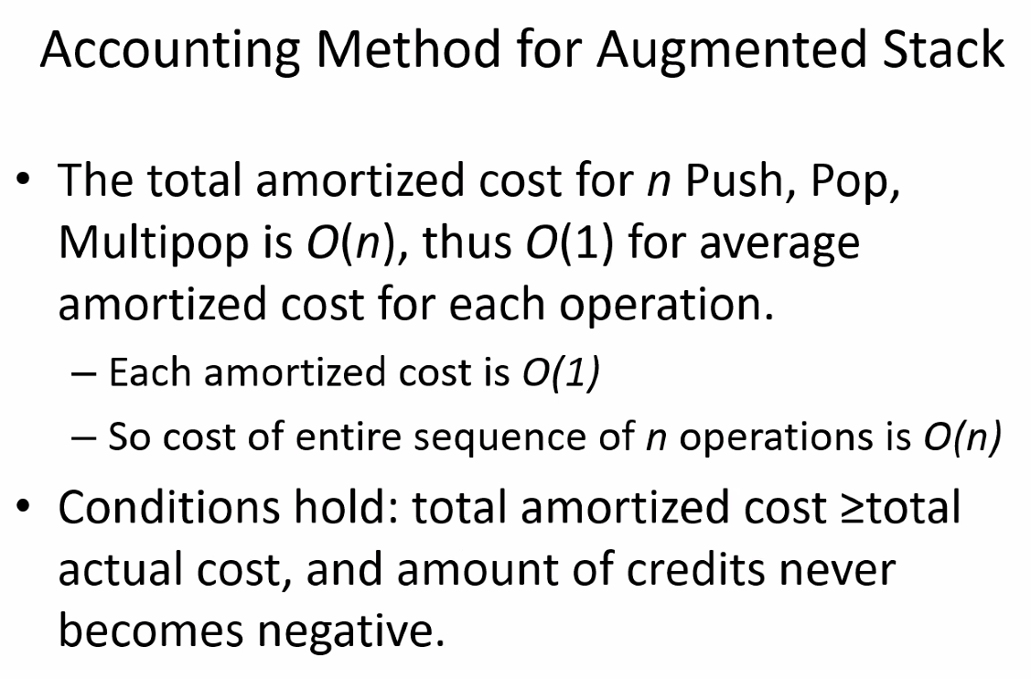
* 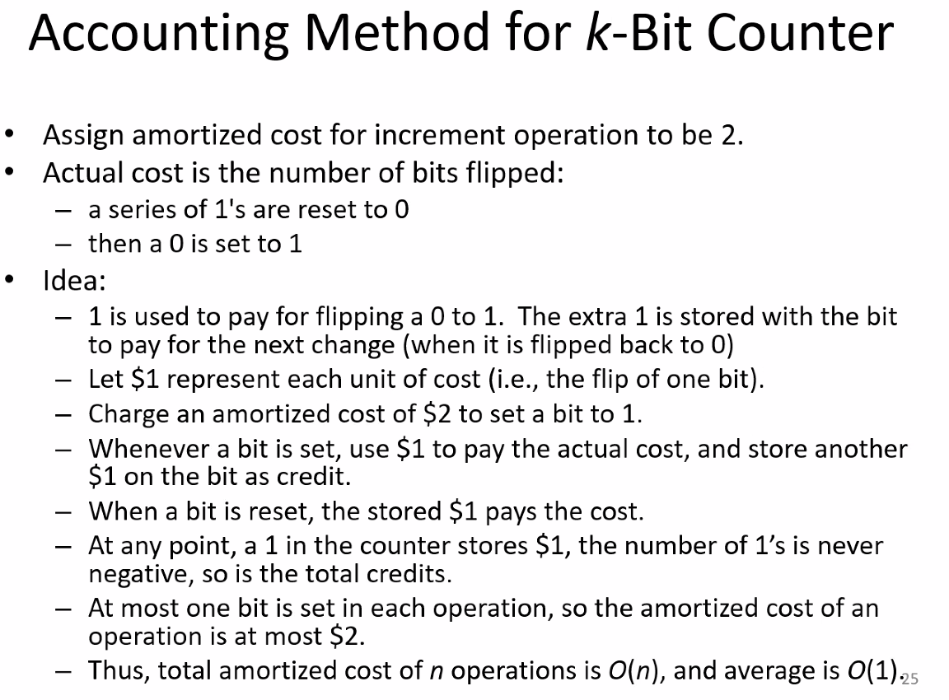
* 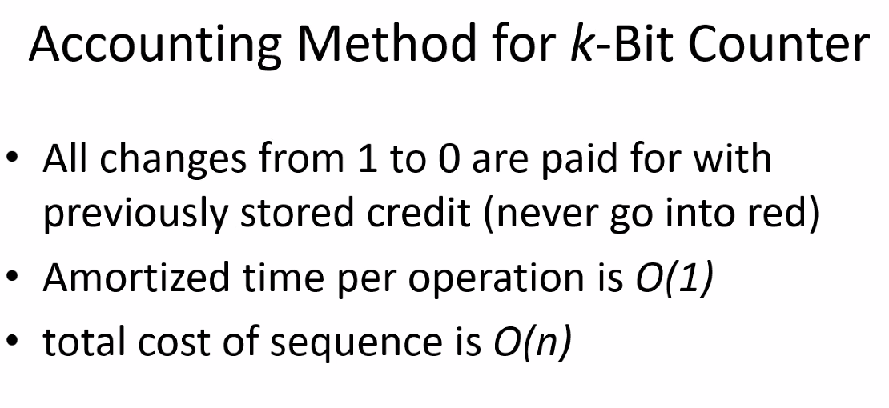
* Potential method
* 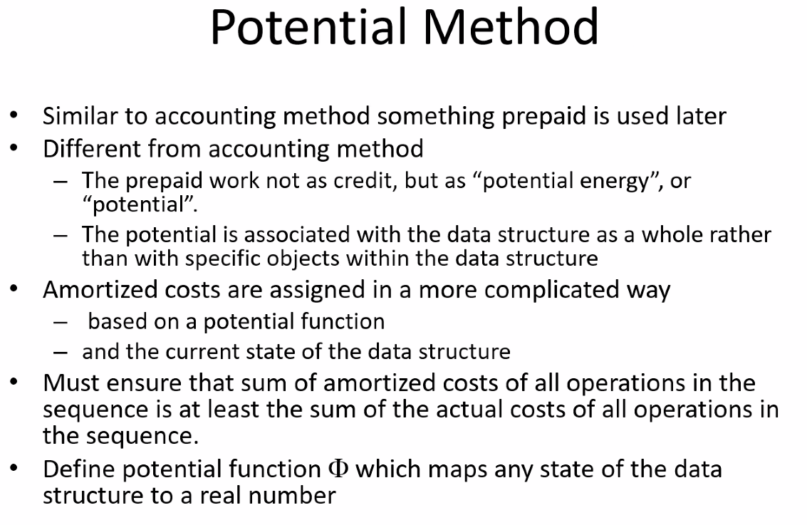
* 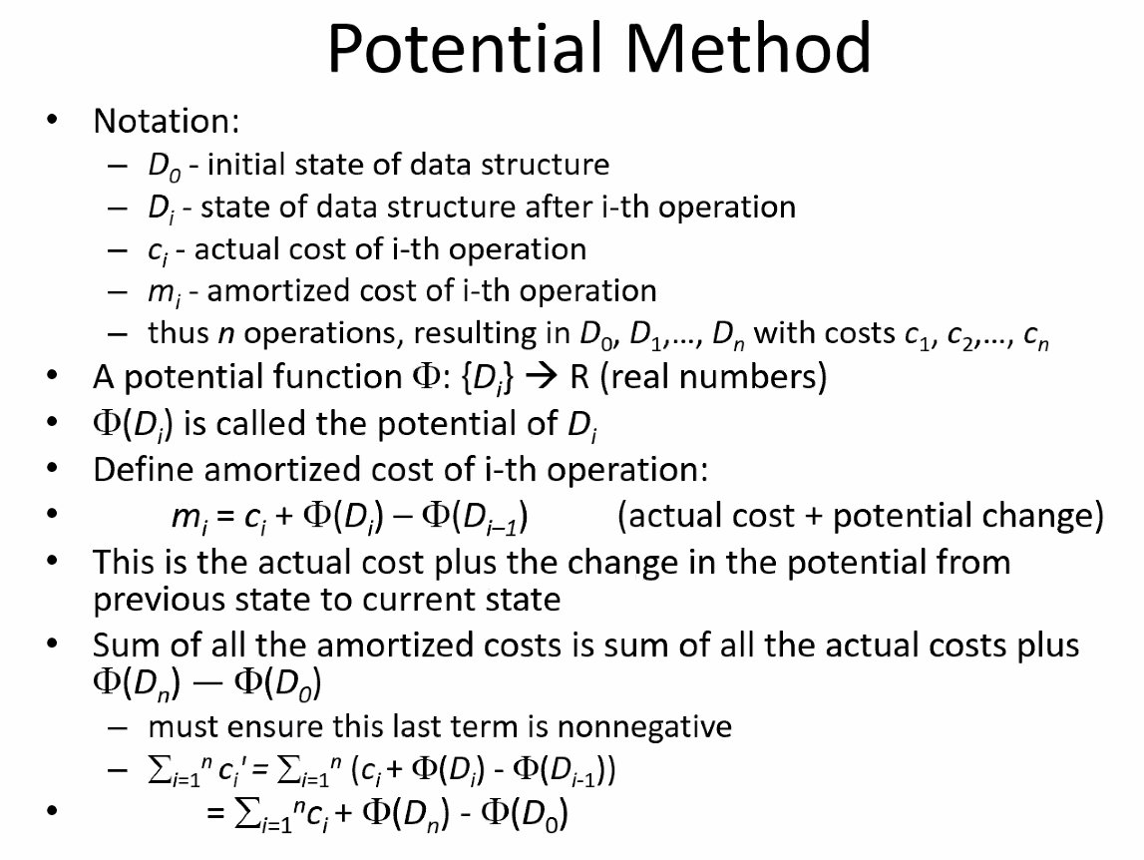
* 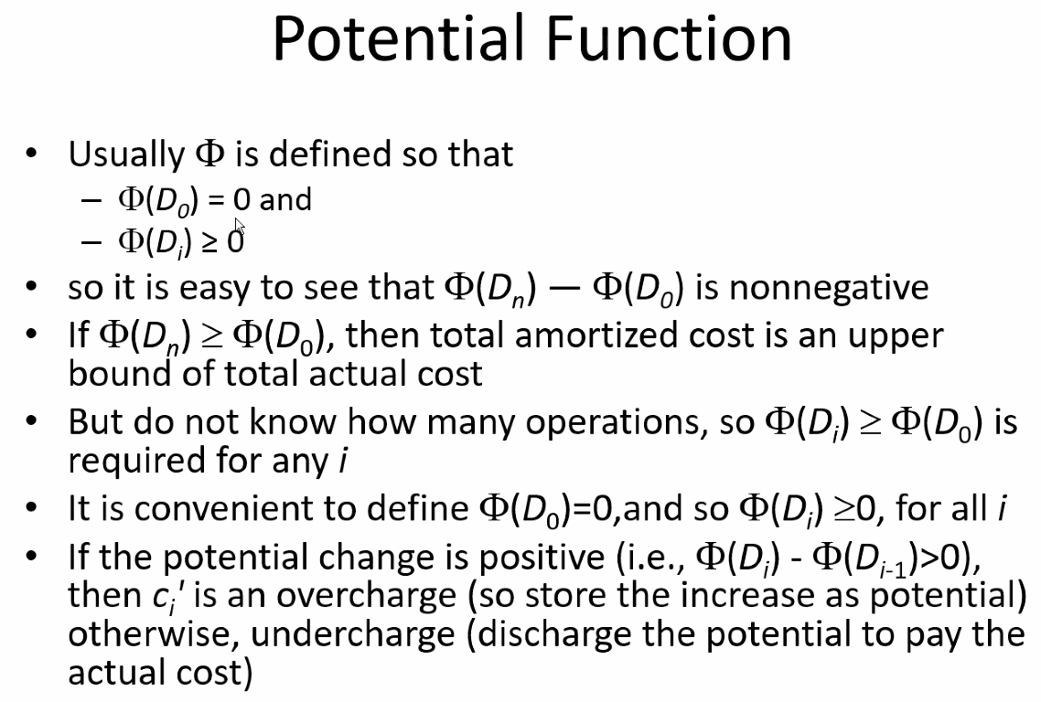
* 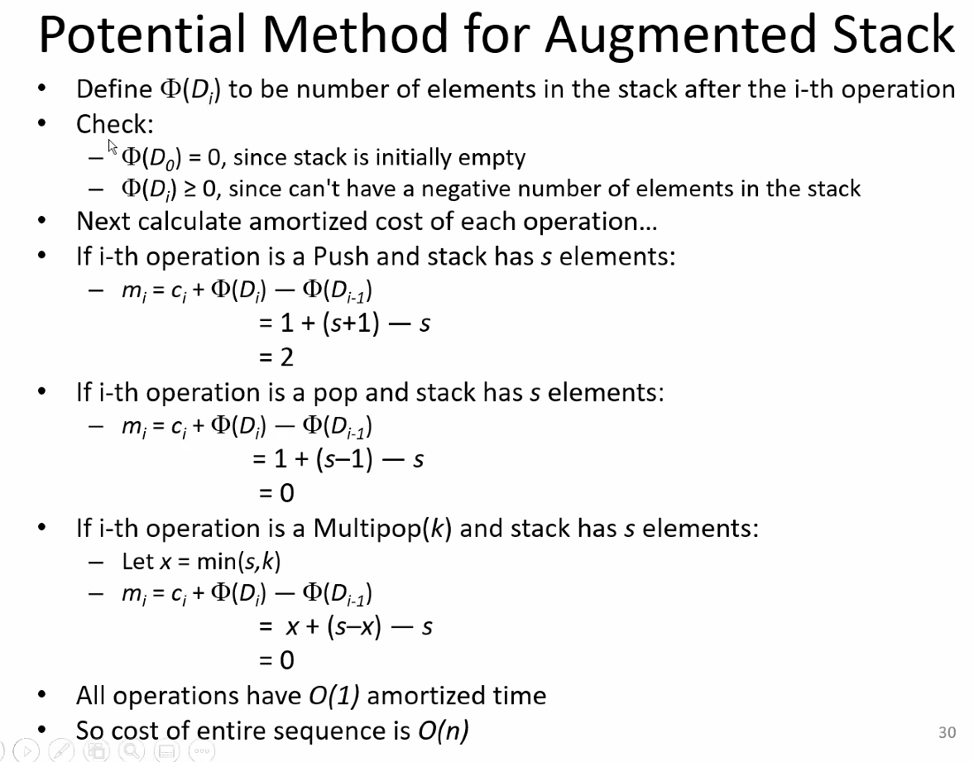
* 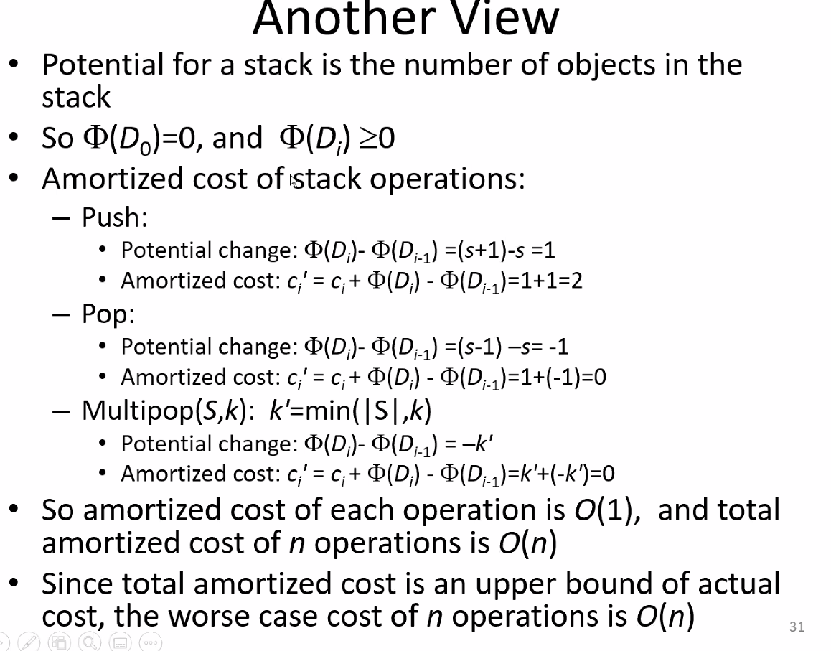
* 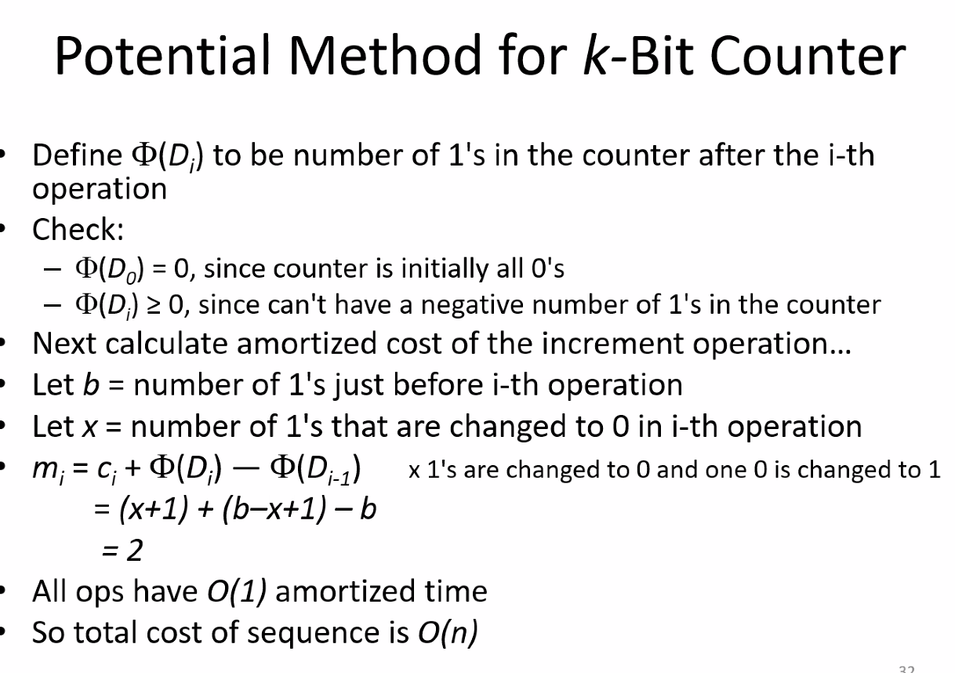
* The Aggregate, Accounting, and Potential methods all exists to give the same amortized time analysis; but you have to pick the best one to apply in order to solve the amortized time cost.
  + Aggregate method is often not used because you rarely know the exact size of input/calls/operations that will be performed using the function
  + You pick the best method that applies to the situation to solve the amortized time
* Randomized algorithms: we did not get to this, so scan through the slides, but it will not be a part of the exam